Title: Funnel Plots of Outcome Measures in Virtual Reality Subgroups

This additional file contains a series of funnel plots depicting the results of various outcome measures across full-immersive, semi-immersive, and non-immersive virtual reality subgroups. Each figure corresponds to a specific outcome measure. For each outcome measure, funnel plots are presented under both random effect and fixed effect models, providing insights into potential publication bias across different VR intervention subgroups.

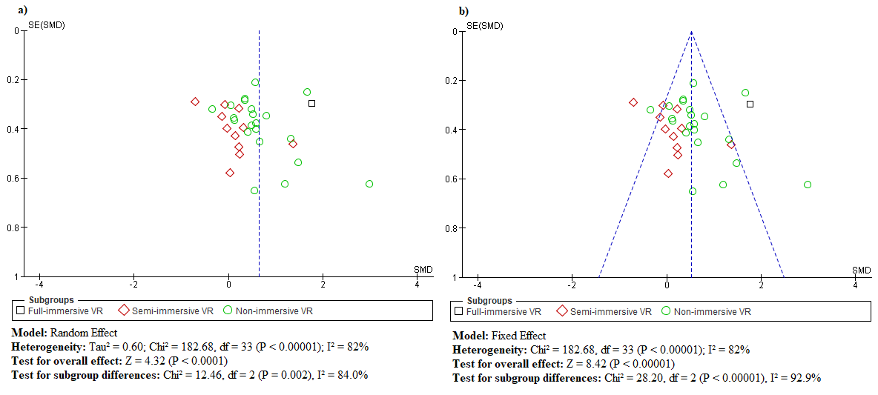
Fig 1: Funnel plot of Fugle-Meyer Assessment (FMA) across VR subgroups: full-immersive, semi-immersive, and non-immersive. a) Funnel plot in random effect model, b) Funnel plot in fixed effect model.

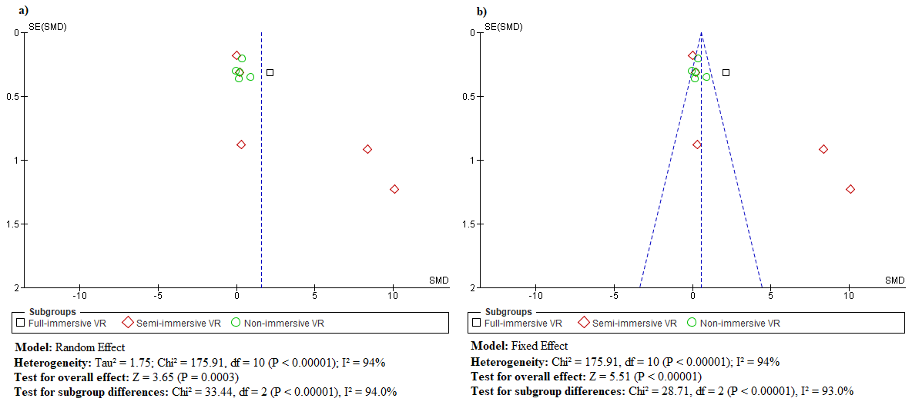
Fig 2: Funnel plot of Action Research Arm Test (ARAT) across full-immersive, semi-immersive, and non-immersive virtual reality subgroups.

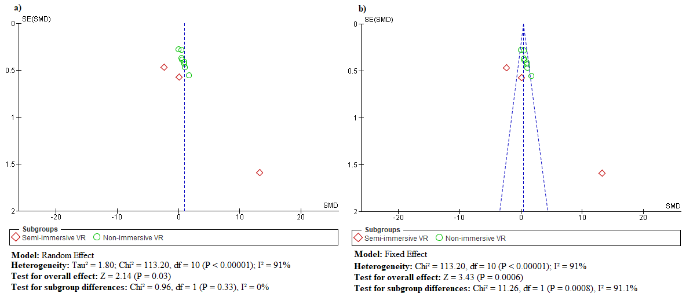
Fig 3: Funnel plot of Wolf Motor Function Test (WMFT) across VR subgroups: full-immersive, semi-immersive, and non-immersive. a) Funnel plot in random effect model, b) Funnel plot in fixed effect model.

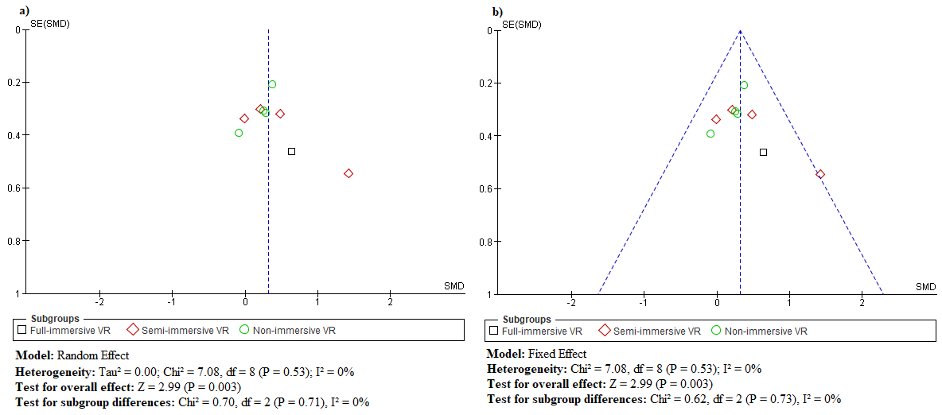
Fig 4: Funnel plot of Grip Strength across VR subgroups: full-immersive, semi-immersive, and non-immersive. a) Funnel plot in random effect model, b) Funnel plot in fixed effect model.

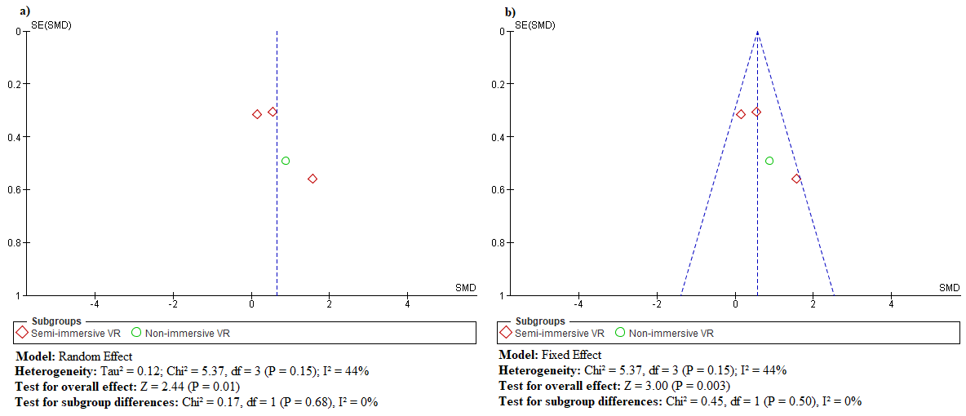
Fig 5: Funnel plot of Jebsen Test of Hand Function (JTHF) across VR subgroups: full-immersive, semi-immersive, and non-immersive. a) Funnel plot in random effect model, b) Funnel plot in fixed effect model.

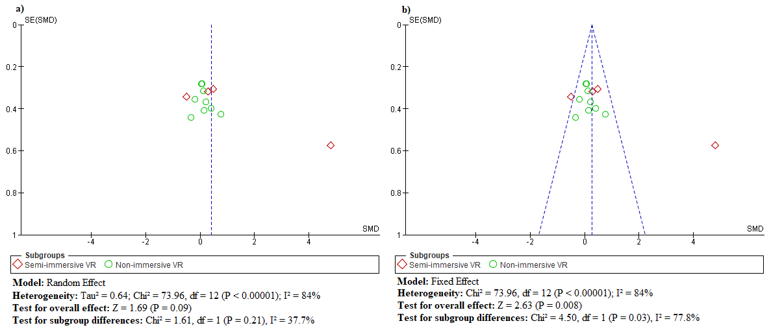
Fig 6: Funnel plot of Barthal Index (BI) across VR subgroups: full-immersive, semi-immersive, and non-immersive. a) Funnel plot in random effect model, b) Funnel plot in fixed effect model.

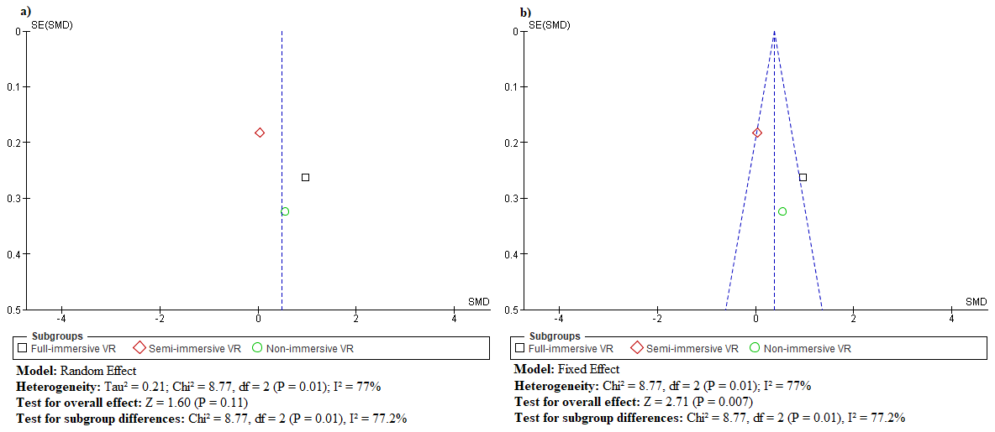
Fig 7: Funnel plot of Functional Independence Measure (FIM) across VR subgroups: full-immersive, semi-immersive, and non-immersive. a) Funnel plot in random effect model, b) Funnel plot in fixed effect model.

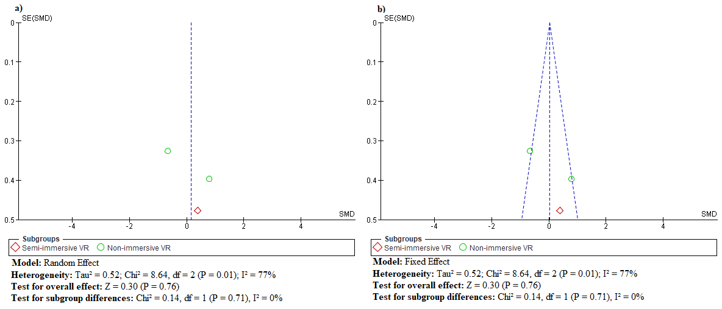
Fig 8: Funnel plot of Stroke Impact Scale (SIS) across VR subgroups: full-immersive, semi-immersive, and non-immersive. a) Funnel plot in random effect model, b) Funnel plot in fixed effect model.

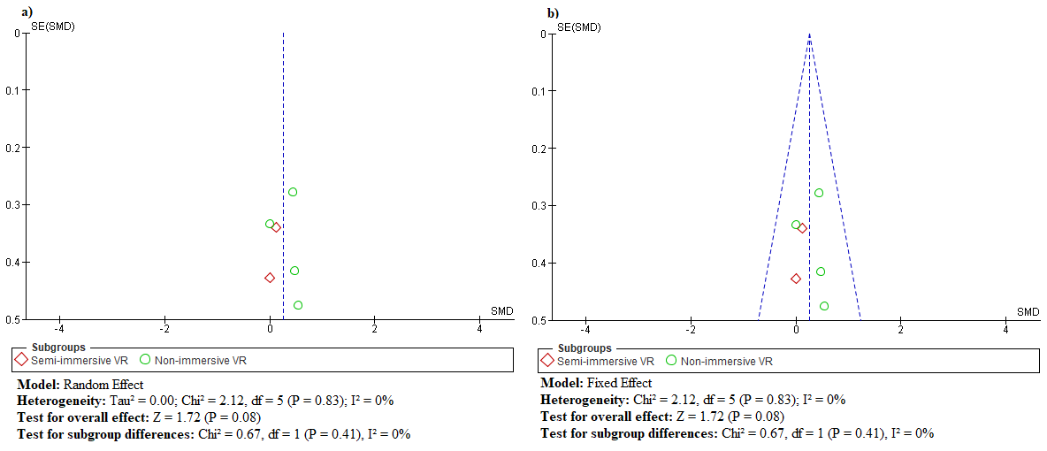
Fig 9: Funnel plot of Modified Ashworth Scale (MAS) across VR subgroups: full-immersive, semi-immersive, and non-immersive. a) Funnel plot in random effect model, b) Funnel plot in fixed effect model.

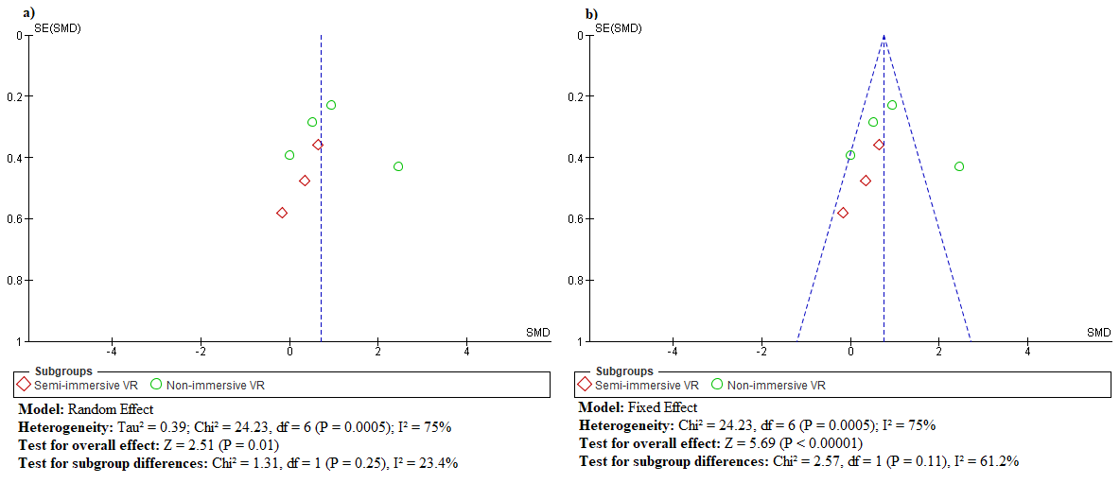
Fig 10: Funnel plot of Motor Activity Log – Amount of Use Scale (MAL-AUS) across VR subgroups: full-immersive, semi-immersive, and non-immersive. a) Funnel plot in random effect model, b) Funnel plot in fixed effect model.

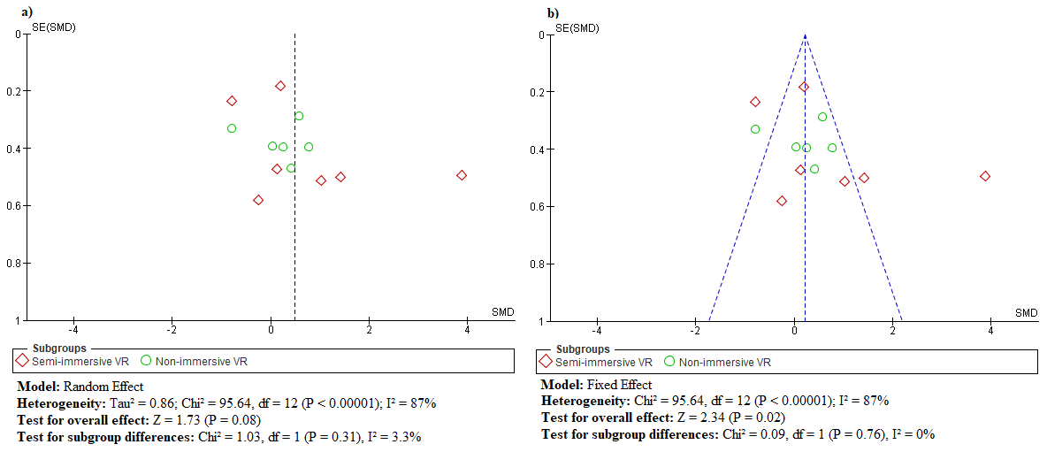
Fig 11: Funnel plot of Box and Block Test (BBT) across VR subgroups: full-immersive, semi-immersive, and non-immersive. a) Funnel plot in random effect model, b) Funnel plot in fixed effect model.

