Additional file 1
Figure S1. The ORs of the predictors from all 19 de-identified datasets and original dataset
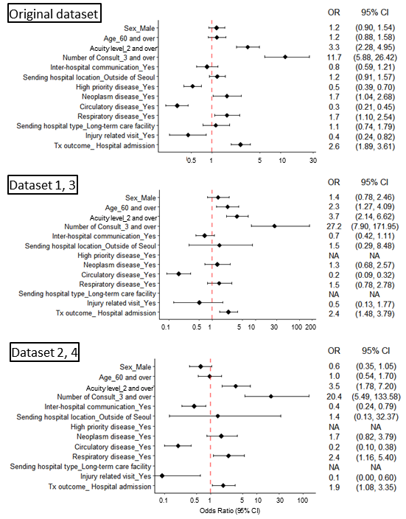

Figure S1. (Continued)The ORs of the predictors from all 19 de-identified datasets and original dataset
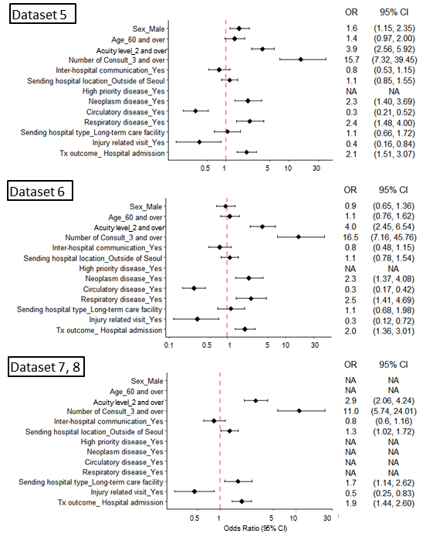

Figure S1. (Continued)The ORs of the predictors from all 19 de-identified datasets and original dataset
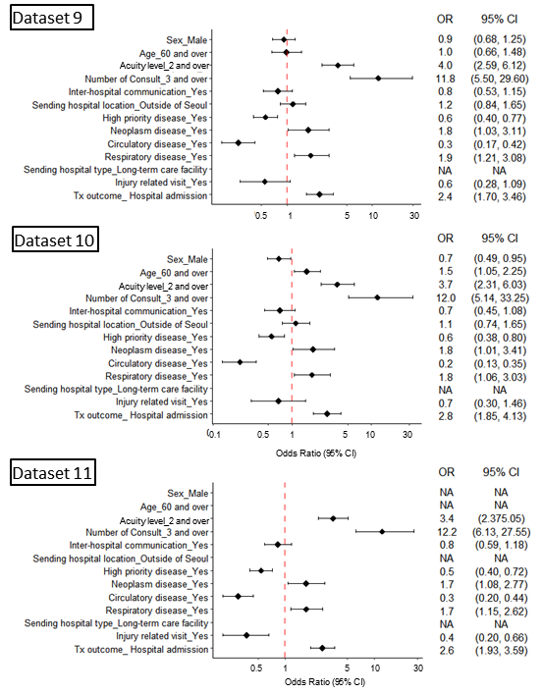

Figure S1. (Continued)The ORs of the predictors from all 19 de-identified datasets and original dataset
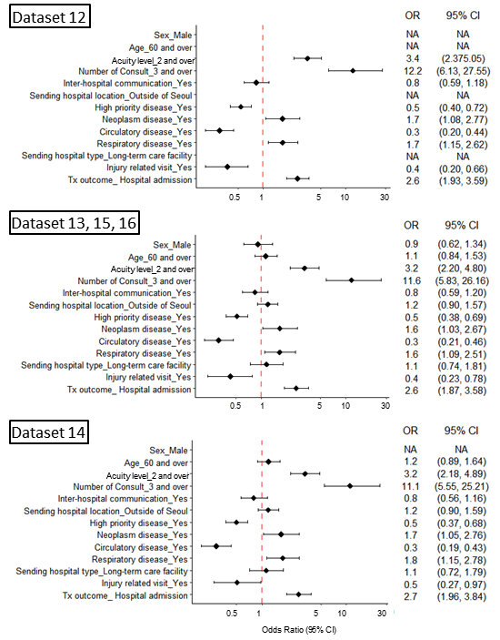

Figure S1. (Continued)The ORs of the predictors from all 19 de-identified datasets and original dataset
