Supplementary information:

Appendix A. Diagnosis codes
- PTSD:
309.81, F43.10, F43.11, F43.12

- ASUD:
291.0, 291.1, 291.2, 291.3, 291.4, 291.5, 291.8, 291.81, 291.82, 291.89, 291.9, 292.0, 292.11, 292.12, 292.2, 292.81, 292.82, 292.83, 292.84, 292.85, 292.89, 292.9, 357.5, 425.5, 535.30, 535.31, 571.0, 571.1, 571.2, 571.3, 648.30, 648.31, 648.32, 648.33, 648.34, 965.00, 965.01, 965.02, 965.09, 968.5, 969.6, E850.0, E854.1, E860.0, E935.0, E938.5,E939.6,V654.2, 303, 303.0, 303.00, 303.01, 303.02, 303.03, 303.9, 303.90, 303.91, 303.92, 303.93, 304, 304.0, 304.00, 304.01, 304.02, 304.03, 304.1, 304.10, 304.11, 304.12, 304.13, 304.2, 304.20, 304.21, 304.22, 304.23, 304.3, 304.30, 304.31, 304.32, 304.33, 304.4, 304.40, 304.41, 304.43, 304.5, 304.50, 304.51, 304.52, 304.6, 304.60, 304.61, 304.62, 304.63, 304.7, 304.70, 304.71, 304.72, 304.73, 304.8, 304.80, 304.81, 304.82, 304.83, 304.9, 304.90, 304.91, 304.92, 304.93, 305, 305.0, 305.00, 305.01, 305.02, 305.03, 305.1, 305.10, 305.12, 305.13, 305.2, 305.20, 305.21, 305.22, 305.23, 305.3, 305.30, 305.31, 305.33, 305.4, 305.40, 305.41, 305.42, 305.43, 305.5, 305.50, 305.51, 305.52, 305.53, 305.6, 305.60, 305.61, 305.62, 305.63, 305.7, 305.70, 305.71, 305.72, 305.73, 305.8, 305.80, 305.81, 305.83, 305.9, 305.90, 305.91, 305.92, 305.93, F10.10, F10.11, F10.120, F10.121, F10.129, F10.14, F10.151, F10.159, F10.180, F10.188, F10.19, F10.20, F10.21, F10.220, F10.221, F10.229, F10.230, F10.231, F10.232, F10.239, F10.24, F10.250, F10.251, F10.259, F10.26, F10.27, F10.280, F10.288, F10.29, F10.920, F10.921, F10.929, F10.94, F10.951, F10.959, F10.96, F10.97, F10.980, F10.982, F10.988, F10.99, F11.10, F11.11, F11.120, F11.121, F11.129, F11.14, F11.159, F11.188, F11.19, F11.20, F11.21, F11.220, F11.221, F11.222, F11.229, F11.23, F11.24, F11.250, F11.259, F11.288, F11.29, F11.90, F11.921, F11.929, F11.93, F11.94, F11.988, F11.99, F12.10, F12.11, F12.121, F12.122, F12.129, F12.150, F12.151, F12.159, F12.180, F12.188, F12.19, F12.20, F12.21, F12.220, F12.23, F12.250, F12.259, F12.288, F12.29, F12.90, F12.920, F12.921, F12.922, F12.929, F12.959, F12.980, F12.988, F12.99, F13.10, F13.11, F13.129, F13.14, F13.180, F13.188, F13.19, F13.20, F13.21, F13.220, F13.221, F13.229, F13.230, F13.231, F13.232, F13.239, F13.24, F13.259, F13.27, F13.280, F13.29, F13.90, F13.920, F13.921, F13.929, F13.930, F13.931, F13.939, F13.94, F13.97, F13.980, F13.99, F14.10, F14.11, F14.120, F14.121, F14.122, F14.129, F14.14, F14.151, F14.159, F14.180, F14.182, F14.188, F14.19, F14.20, F14.21, F14.220, F14.221, F14.222, F14.229, F14.23, F14.24, F14.250, F14.251, F14.259, F14.280, F14.282, F14.288, F14.29, F14.90, F14.920, F14.921, F14.929, F14.94, F14.951, F14.959, F14.980, F14.988, F14.99, F15.10, F15.11, F15.121, F15.129, F15.14, F15.159, F15.180, F15.188, F15.20, F15.21, F15.220, F15.222, F15.229, F15.23, F15.259, F15.29, F15.90, F15.920, F15.921, F15.929, F15.93, F15.94, F15.950, F15.951, F15.959, F15.980, F15.982, F15.988, F15.99, F16.10, F16.11, F16.129, F16.159, F16.20, F16.21, F16.221, F16.24, F16.259, F16.283, F16.90, F16.921, F16.929, F16.950, F16.959, F16.980, F16.983, F16.988, F16.99, F17.200, F17.201, F17.203, F17.208, F17.209, F17.210, F17.211, F17.213, F17.218, F17.219, F17.220, F17.223, F17.228, F17.229, F17.290, F17.298, F17.299, F18.10, F18.11, F18.19, F18.20, F18.24, F18.90, F19.10, F19.11, F19.120, F19.121, F19.129, F19.14, F19.150, F19.159, F19.180, F19.181, F19.188, F19.19, F19.20, F19.21, F19.221, F19.229, F19.230, F19.231, F19.232, F19.239, F19.24, F19.259, F19.280, F19.29, F19.90, F19.920, F19.921, F19.922, F19.929, F19.930, F19.931, F19.939, F19.94, F19.950, F19.951, F19.959, F19.96, F19.980, F19.982, F19.988, F19.99.

- SRE:

V62.84,R45.851,E950.3,E956,E950.4,E950.0,E958.8,T14.91,E950.9,E958.9,T14.91XA,E950.5,E950.2,E953.0,E958.1,E953.8,E950.1,E950.7,E952.0,E958.0,E957.1,E957.0,E958.5,E952.1,E955.4,T14.91XD,E950.6,E953.9,E955.0,E957.9,E958.7,E958.3,E954,T14.91XS,E951.0,E951.8,E952.8,E953.1,E955.1,E958.6,E958.2,E955.9,E955.2,X83.8XXA,T42.42A,T43.592A,T39.1X2A,X78.8XXA,X78.9XXD,T42.6X2A,X78.9XXA,T43.222A,T50.902A,X83.8XXD,T39.312A,T43.212A,T45.0X2A,X78.1XXA,X78.8XXD,T50.992A,T40.2X2A,T43.292A,T43.012A,T39.012A,T42.8X2A,X78.0XXA,T51.0X2A,T40.5X2A,T40.4X2A,T40.1X2A,T44.7X2A,T38.3X2A,T44.6X2A,T48.1X2A,T46.5X2A,T71.162A,T48.3X2A,T43.022A,T44.3X2A,T50.902D,X79.XXXA,T65.92XA,X78.1XXD,T51.92XA,T42.1X2A,T65.892A,T56.892A,T43.622A,X80.XXXA,T42.4X2D,X78.0XXD,T42.72XA,T43.3X2A,X76.XXXD,T48.4X2A,T51.2X2A,T46.4X2A,T39.1X2D,T40.7X2A,T54.92XA,T40.602A,T45.512A,X76.XXXA,T43.222D,T39.392A,T47.1X2A,T50.902S,X74.9XXD,T39.092A,T38.1X2A,X74.9XXA,T39.312D,T38.892A,T43.612A,X82.8XXA,T42.6X2D,T43.632A,T46.1X2A,T45.0X2D,T50.992D,T54.2X2A,T40.3X2A,T39.012D,T43.4X2A,T58.02XA,T43.592D,X81.0XXA,T43.202A,T43.8X2A,T44.992A,T45.2X2A,T40.1X2D,T41.292A,T50.2X2A,T48.6X2A,T50.7X2A,T49.0X2A,T46.3X2A,T42.0X2A,T36.1X2A,T36.0X2A,X74.9XXS,X72.XXXD,T43.012D,T51.8X2A,T51.0X2D,T54.92XS,T54.3X2A,T65.892D,T65.92XD,T65.222D,T50.3X2A,T48.5X2A,T47.0X2A,T46.6X2A,T65.92XS,T54.1X2A,T52.4X2A,T52.0X2A,T55.1X2A,T59.892A,T42.4X2S,T42.3X2A,T36.3X2A,T37.8X2A,T38.2X2A,T38.3X2D,T40.992A,T40.8X2A,T44.4X2A,T43.692A,T45.2X2D,T44.7X2D,T43.502A,T71.192A,X79.XXXD,X83.2XXA,X83.8XXS,X72.XXXA,X71.9XXA,T48.202A,T40.2X2D,X74.8XXS,T48.3X2D,T39.8X2A,T47.4X2A,T47.6X2A,T50.6X2A,T49.6X2D,T43.3X2D,T50.5X2A,X74.01XA,X73.0XXA,T49.6X2A,X72.XXXS,X78.9XXS,T39.92XA,X80.XXXD,X81.8XXA,T39.4X2A,X77.8XXA,T50.2X2D,T43.622D,T43.292D,T45.4X2A,T46.0X2A,T41.3X2A,T42.5X2A,T42.6X2,T46.7X2A,T46.8X2A,T46.5X2D,T43.1X2A,T43.92XA,T40.5X2D,X71.0XXS,X71.3XXA,X71.8XXA,T43.212D,T46.2X2A,T40.8X2D,T40.602D,T43.022D,T44.1X2A,T46.4X2D,T65.222S,T62.0X2A,T71.162D,T51.1X2A,T51.2X2D,T51.2X2S,T52.8X2A,T51.92XD,T50.8X2A,T56.892D,T58.92XA,T54.3X2S,T54.3X2D,T54.0X2A,T55.0X2A,T36.0X2D,T36.4X2A,T38.5X2A,T36.8X2A,T37.5X2A.

Appendix B. Categories of Co-Morbid Diseases
Category 1 (ICD9: 291* or 292* or 303* or 304* or (305* and not 305.1))
Category 2 (ICD9: 295* or 301.2)
Category 3 (ICD9: 296* or 298.0 or 300.4 or 301.1 or 309* or 311*)
Category 4 (ICD9: 297* or (298* and not 298.0))
Category 5 (ICD9: 308* or (300* and not 300.4))
Category 6 (ICD9: 301* not 301.1 and not 301.2)
Category 7 (ICD9: 302*)
Category 8 (ICD9: 306* or 316*)
Category 9 (ICD9: 307*)
Category 10 (ICD9: 290* or 293* or 294* or 310*)
Category 11 (ICD9: 299* or 312* or 313* or 314* or 315*)
Category 12 (ICD9: 317* or 318* or 319*)
Appendix: Table A1: Categories of Co-Morbid Diseases
ICD9 Code | Disease Name | Category | ICD9 Code | Disease Name | Category
291 | Alcohol-induced mental disorders | 1 | 301 (not 301.1 or 301.2) | Personality disorders (not Affective personality disorder or Schizoid personality disorder) | 6
292 | Drug-induced mental disorders | 1 | 302 | Sexual and gender identity disorders | 7
303 | Alcohol dependence syndrome | 1 | 306 | Physiological malfunction arising from mental factors | 8
304 | Drug dependence | 1 | 316 | Psychic factor w oth dis. | 8
305 | Nondependent abuse of drugs | 1 | 307 | Special symptoms or syndromes not elsewhere classified | 9
(not 305.1) | (not Tobacco use disorder)
295 | Schizophrenic disorders | 2 | 290 | Dementias | 10
301.2 | Schizoid personality disorder | 2 | 293 | Transient mental disorders due to conditions classified elsewhere | 10
296 | Episodic mood disorders | 3 | 294 | Persistent mental disorders due to conditions classified elsewhere | 10
298 | Depressive type psychosis | 3 | 310 | Specific nonpsychotic mental disorders due to brain damage | 10
300.4 | Dysthymic disorder | 3 | 299 | Autistic disorder-current | 11
301.1 | Affective personality disorder | 3 | 312 | Disturbance of conduct not elsewhere classified | 11
309 | Adjustment reaction | 3 | 313 | Disturbance of emotions specific to childhood and adolescence | 11
311 | Depressive disorder NEC | 3 | 314 | Hyperkinetic syndrome of childhood | 11
297 | Delusional disorders | 4 | 315 | Specific delays in development | 11
298 | Other nonorganic psychoses | 4 | 317 | Mild intellectual disabilities | 12
(but not 2980) | (not Depressive type psychosis)
308 | Acute reaction to stress | 5 | 318 | Other specified intellectual disabilities | 12
300 | Anxiety, dissociative and somatoform disorders | 5 | 319 | Unspecified intellectual disabilities | 12
(but not 300.4) | (not Dysthymic disorder)

Table S1. RDoC Domain-Specific Keyword Dictionary

Arousal Regulatory System | Negative Valence System | Positive Valence System
Sadness, sarcasm, satiation, self-assessment, self-consciousness, self-knowledge, self-monitoring, self-perception, self-referential, self-understanding, semantic memory, sensation, sensory arousal threshold, sensory reactivity, separation distress, shame, situation, sleep, sleepiness, sleep-wake, smell, social anhedonia, social approach, social communication, social motivation, social responsiveness, somatosensory, spatial attention, speech, startle, stereotypic, stimulus detection, story learning, strain, stranger, Stroop, SUD, suicidal, suppression, sustained attention, sustained threat, switching, therapy, thought, threat, total sleep time, uncertainty, understanding, updating, valuation, visual hallucination, visual acuity, vocalization, wakefulness, wake time, waking, withdrawal, worried, worry. | Aberrant, abuse, anger, angry, anxiety disorder, anxious, aphasic, appetite, ashamed, attack, attentive, auditory hallucination, avoidant, behavior, belief, blackout, calm, chest pain, compare, compliance, compulsive, concentration, constricted, continuity, conversation, conviction, current episode, deficit, delusional, dependence, depressed, depressive, depressive disorder, deprivation, diaphoretic, diarrhea, difficulty, disinhibit, disorganization, disorganized behavior, distracted, distractible, dysphoric, dysthymic, elicit, empathic, engage, EtOH, fatigue, fearful, feelings, flight, forget, forgetful, frighten, gamble, grandiose, grandiosity, guilt, hallucinate, heavy, helpless, heroin, high-risk, idea, inappropriate, incoherent, induce, induce mood, injurious, insertion, insomnia, intoxicate, intoxication, irritable, isolated, melatonin, memory, misunderstand, money, moody, nervous, night, OSA, outburst, palpitation, panic, paranoid, perception, pessimistic, phobia, posttraumatic, prominent, psychotic disorder, remission, restoration, schizophrenia, tearful, tense, these problems, threaten, trauma, ultimately, understand, vague, vigilance, violence, weight gain, worsen, worth, worthless, worthlessness. | Abnormality, agitation, alcohol abuse, alcohol withdrawal, alertness, cigarette, control, cortisol, disorganize, dizziness, emotional, executive function, expressive, fast, financial, guilty, hallucination, hoard, hopeful, hopelessness, identify, illusion, impairment, impulse, impulse control, impulsive behavior, intake, interest, irritability, lonely, lose, meaningless, misinterpret, motivate, motor activity, notice, ongoing, optimistic, panic disorder, paranoia, posttraumatic stress, psychotic, psychotic feature, quantity, reactivity, recall, refuse, repetitive, respond, restless, sad, scare, sensitivity, sensory deficit, sexual, sexual abuse, sleep study, sleepiness, stability, startle, stereotype, strategy, stress, stressor, sweat, tachycardia, thought broadcasting, tingle, tired, tremulous, user, violent, voluntary, waking, withdrawn.
Cognitive System | Sensorimotor System | Social Processing System
ADHD, affiliation, aggression, agitation, alert, amotivation, analgesia, anergia, anhedonia, animacy, anticipation, anxiety, approach, arousal, assaultive, attachment, attention, attentional, auditory, avoidance, barbiturate, behavioral activation, bereavement, biological motion, brief, capacity, capture, categorization, childhood trauma, circadian, cognition, cognitive, competition, complex span, compulsive behavior, consolidation, craving, cry, declarative, decreased appetitive behavior, decreased libido, delay, delayed reward, delusion, desire, detection, devaluation, disability, discourse, discrimination, distractibility, distraction, effect, emotion, empathy, employment, energy, episodic memory, facial, familiarity, fear, flexible, freezing, frustration, frustrative, gain, generalized reward, gestural expression, gesture comprehension, goal, grief, head turning, heart rate variability, hypervigilant, imitation, impulsive, impulsivity, ingestion, language, learning, limited capacity, listening, listening time, list learning, perseverative, threat. | Action, adaptation, apathy, calculation, dynamic, execution, habit, hyposensitivity, inhibition, initiation, motor, motor control, motor action, move, perseveration, planning, psychomotor, reaction time, response inhibition, retardation, selection, sensorimotor, sensory, temporal, termination. | Conflict, local, loss, loss drive, maintenance, manipulation, masking, mental state, metaphor, mimicry, monitoring, morbid, motivated behavior, movement, multimodal, multi-stability, naming, nausea, neurobehavioral, noise, non-facial, nonlocal, non-reward, off-task, olfactory, others, ownership, perceptual, performance, phobic, physical aggression, possibly, postural expression, potential threat, priming, probabilistic, probability, punishment, reading, recognition, reinforcement learning, relational aggression, relaxed, repetitive behavior, representation, response, retrieval, reward, rhythm, risk, risky family, routine, rumination, sleep latency, social support.

Table S2. Representative sentences of RDoC Sentence Dictionary

RDoC Domains | Examples of Sentences in Dictionary
Arousal Regulatory System | Examples:  Suicidal: Endorsed suicidal thoughts with a plan to overdose on medications  Withdrawal: Having difficulties with withdrawal symptoms
Cognitive System | Examples:  Threat: Patient made suicide threat  Hallucinations: Pregnant, admitted to hospital for auditory hallucinations
Negative Valence System | Examples:  Insomnia: Noted chronic issues with insomnia patient self-medicates with daily heavy marijuana use  Aggressive: Admitted for aggressive behavior
Positive Valence System | Examples:  Motivated: Motivated to get better for children  Identify: The patient identify alcohol use as a problem
Sensorimotor System | Examples:  Retardation: 45 y/o male with pmhx of retardation and tobacco abuse Psychomotor: Psychomotor slowing or agitation
Social Processing System | Examples:  Loss: Loss of a child  Panic: Missing work due to panic attack

Table S3. Number of patients identified by the Sentence Transformer and number of randomly selected cases to review and manually annotated by subject matter experts

RDoC | No. of Patient cases | Randomly selected cases to review and manually annotated by Subject matter experts
Arousal regulation | 18724 | 443
Cognitive systems | 17740 | 2165
Negative valence | 21829 | 2629
Positive valence | 18360 | 2797
Sensorimotor systems | 9770 | 74
Social process | 17014 | 243

Table S4. Top 10 keywords in each RDoC domain.

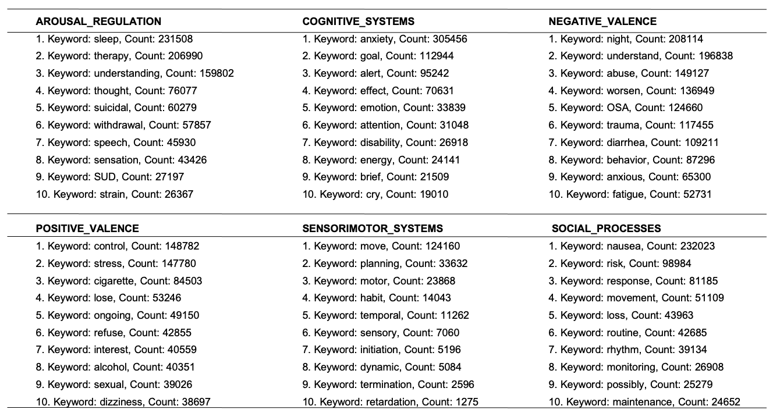

Table S5. Top keyword and sentence in each RDoC domain:

Domain | Keyword | Sentence
Arousal regulation | Sleep | pain woke from sleep, take valium
Cognitive systems | Anxiety | psychiatric history: history of anxiety and depression
Negative valence | Night | reports nightmares/flashbacks, trial of prazosin to target nightmares
Positive valence | Control | eventually his symptoms were controlled
Sensorimotor systems | Move | worsens with movement
Social process | Nausea | missed appointment due to nausea/vomiting

Table S6. RDoC domains across different patient populations: Male and Female

Domain | Male | Female | Normalized Male | Normalized Female
Arousal regulation | 4055 | 9533 | 0.552 | 0.641
Cognitive systems | 3875 | 9046 | 0.528 | 0.609
Negative valence | 4746 | 10862 | 0.647 | 0.731
Positive valence | 3983 | 9360 | 0.543 | 0.630
Sensorimotor systems | 2101 | 5125 | 0.287 | 0.928
Social process | 3554 | 8846 | 0.485 | 0.923

Table S7. RDoC domains across different patient populations: Veterans and Non-Veterans

Domain | Veterans | Non-Veterans | Normalized Veterans | Normalized Non-Veterans
Arousal regulation | 3073 | 10505 | 0.660 | 0.614
Cognitive systems | 2933 | 9988 | 0.630 | 0.584
Negative valence | 3460 | 12148 | 0.743 | 0.710
Positive valence | 3047 | 10296 | 0.654 | 0.602
Sensorimotor systems | 1701 | 5525 | 0.365 | 0.323
Social process | 2815 | 9585 | 0.604 | 0.560

Table S8. RDoC domains across different patient populations: PTSD patients based on gender and veteran status

Domain | Female Veterans | Male  Veterans | Normalized Female Veterans | Normalized Male  Veterans
Arousal regulation | 2255 | 2154 | 0.815 | 0.754
Cognitive systems | 2142 | 2027 | 0.774 | 0.710
Negative valence | 2520 | 2524 | 0.911 | 0.884
Positive valence | 2207 | 2168 | 0.798 | 0.759
Sensorimotor systems | 1249 | 1153 | 0.452 | 0.404
Social process | 2077 | 1912 | 0.751 | 0.670

Table S9. RDoC domains across different patient populations: PTSD patients based on gender and non-veteran status

Domain | Female Non-Veterans | Male  Non-Veterans | Normalized Female Non-Veterans | Normalized Male  Non-Veterans
Arousal regulation | 10532 | 3699 | 0.765 | 0.708
Cognitive systems | 9945 | 3548 | 0.722 | 0.679
Negative valence | 12209 | 4485 | 0.886 | 0.858
Positive valence | 10303 | 3602 | 0.748 | 0.689
Sensorimotor systems | 5456 | 1876 | 0.396 | 0.359
Social process | 9712 | 3243 | 0.705 | 0.620

Table S10. RDoC domains across different patient populations: PTSD patients before psychotherapy and after psychotherapy

Domain | PTSD patients before psychotherapy | PTSD patients after psychotherapy | Normalized PTSD patients before psychotherapy | Normalized PTSD patients after psychotherapy
Arousal regulation | 1223 | 1493 | 0.541 | 0.468
Cognitive systems | 1204 | 1441 | 0.532 | 0.452
Negative valence | 1314 | 11602 | 0.581 | 0.502
Positive valence | 1224 | 1482 | 0.541 | 0.465
Sensorimotor systems | 825 | 964 | 0.365 | 0.302
Social process | 1157 | 1407 | 0.511 | 0.441

Table S11. RDoC domains across PTSD disease trajectory with a 4-year follow-up period

Domain | 2 years before PTSD Diagnosis | 2 years after PTSD Diagnosis | Normalized 2 years before PTSD Diagnosis | Normalized 2 years after PTSD Diagnosis
Arousal regulation | 9410 | 8255 | 0.372 | 0.424
Cognitive systems | 8693 | 7947 | 0.358 | 0.392
Negative valence | 11413 | 9820 | 0.442 | 0.514
Positive valence | 9033 | 8167 | 0.368 | 0.407
Sensorimotor systems | 4345 | 4117 | 0.185 | 0.196
Social process | 8254 | 7310 | 0.329 | 0.372

Table S12. RDoC domains across PTSD disease trajectory with a 2-year follow-up period

Domain | 1 years before PTSD Diagnosis | 1 years after PTSD Diagnosis | Normalized 1 years before PTSD Diagnosis | Normalized 1 years after PTSD Diagnosis
Arousal regulation | 5634 | 6738 | 0.254 | 0.304
Cognitive systems | 5158 | 6501 | 0.232 | 0.293
Negative valence | 6940 | 8152 | 0.313 | 0.367
Positive valence | 5399 | 6670 | 0.243 | 0.300
Sensorimotor systems | 2573 | 3212 | 0.116 | 0.145
Social process | 4890 | 5892 | 0.220 | 0.265

Table S13. RDoC domains across PTSD disease trajectory with a 1-year follow-up period

Domain | 0.5 years before PTSD Diagnosis | 0.5 years after PTSD Diagnosis | Normalized 0.5 years before  PTSD Diagnosis | Normalized 0.5 years after PTSD Diagnosis
Arousal regulation | 3771 | 5236 | 0.194 | 0.236
Cognitive systems | 3441 | 5013 | 0.189 | 0.226
Negative valence | 4730 | 6509 | 0.250 | 0.293
Positive valence | 3623 | 5178 | 0.196 | 0.233
Sensorimotor systems | 1580 | 2329 | 0.083 | 0.105
Social process | 3181 | 4406 | 0.167 | 0.198

Table S14. RDoC domains across SRE disease trajectory with a 4-year follow-up period

Domain | 2 years before SRE Diagnosis | 2 years after SRE Diagnosis | Normalized 2 years before SRE Diagnosis | Normalized 2 years after SRE Diagnosis
Arousal regulation | 2070 | 2278 | 0.370 | 0.408
Cognitive systems | 1906 | 2150 | 0.341 | 0.385
Negative valence | 2525 | 2601 | 0.452 | 0.465
Positive valence | 1965 | 2155 | 0.352 | 0.386
Sensorimotor systems | 1014 | 1163 | 0.181 | 0.208
Social process | 1773 | 1887 | 0.317 | 0.338

Table S15. RDoC domains across SRE disease trajectory with a 2-year follow-up period

Domain | 1 years before SRE Diagnosis | 1 years after SRE Diagnosis | Normalized 1 years before SRE Diagnosis | Normalized 1 years after SRE Diagnosis
Arousal regulation | 1388 | 1750 | 0.248 | 0.313
Cognitive systems | 1275 | 1608 | 0.228 | 0.288
Negative valence | 1712 | 2004 | 0.306 | 0.358
Positive valence | 1313 | 1600 | 0.235 | 0.286
Sensorimotor systems | 666 | 825 | 0.119 | 0.148
Social process | 1151 | 1366 | 0.206 | 0.244

Table S16. RDoC domains across SRE disease trajectory with a 1-year follow-up period

Domain | 0.5 years before SRE Diagnosis | 0.5 years after SRE Diagnosis | Normalized 0.5 years before SRE Diagnosis | Normalized 0.5 years after SRE Diagnosis
Arousal regulation | 971 | 1368 | 0.200 | 0.245
Cognitive systems | 880 | 1227 | 0.178 | 0.219
Negative valence | 1209 | 1563 | 0.231 | 0.280
Positive valence | 904 | 1229 | 0.175 | 0.220
Sensorimotor systems | 434 | 571 | 0.077 | 0.102
Social process | 779 | 996 | 0.142 | 0.178

Table S17. RDoC domains across ASUD disease trajectory with a 4-year follow-up period

Domain | 2 years before ASUD Diagnosis | 2 years after ASUD Diagnosis | Normalized 2 years before ASUD Diagnosis | Normalized 2 years after ASUD Diagnosis
Arousal regulation | 2313 | 6312 | 0.165 | 0.451
Cognitive systems | 2028 | 6095 | 0.145 | 0.436
Negative valence | 2835 | 7561 | 0.203 | 0.540
Positive valence | 2088 | 6428 | 0.149 | 0.459
Sensorimotor systems | 950 | 3304 | 0.068 | 0.236
Social process | 1895 | 5809 | 0.135 | 0.415

Table S18. RDoC domains across ASUD disease trajectory with a 2-year follow-up period

Domain | 1 years before ASUD Diagnosis | 1 years after ASUD Diagnosis | Normalized 1 years before ASUD Diagnosis | Normalized 1 years after ASUD Diagnosis
Arousal regulation | 1621 | 4089 | 0.116 | 0.292
Cognitive systems | 1447 | 3945 | 0.103 | 0.282
Negative valence | 2049 | 5063 | 0.146 | 0.362
Positive valence | 1468 | 4200 | 0.105 | 0.300
Sensorimotor systems | 651 | 2031 | 0.047 | 0.145
Social process | 1340 | 3743 | 0.096 | 0.267

Table S19. RDoC domains across ASUD disease trajectory with a 1 year follow up period

Domain | 0.5 years before ASUD Diagnosis | 0.5 years after ASUD Diagnosis | Normalized 0.5 years before ASUD Diagnosis | Normalized 0.5 years after ASUD Diagnosis
Arousal regulation | 1192 | 2781 | 0.085 | 0.199
Cognitive systems | 1068 | 2679 | 0.076 | 0.191
Negative valence | 1525 | 3570 | 0.109 | 0.255
Positive valence | 1061 | 2927 | 0.076 | 0.209
Sensorimotor systems | 469 | 1339 | 0.034 | 0.096
Social process | 951 | 2498 | 0.068 | 0.179

Figure S1. RDoC Keywords based on Domain Types: Arousal Regulation

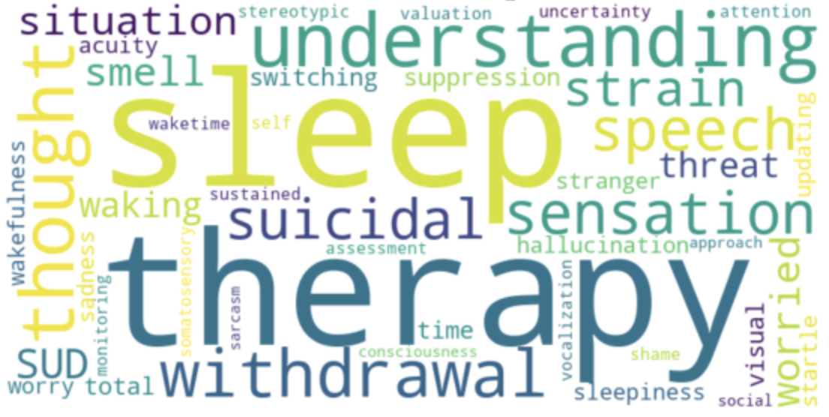

Figure S2. RDoC Keywords based on Domain Types: Cognitive System

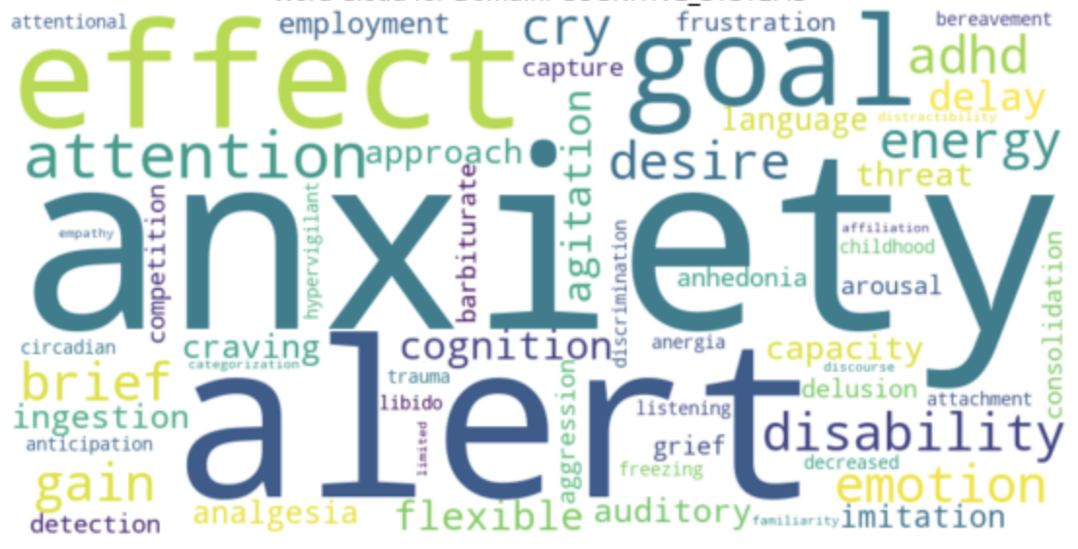

Figure S3. RDoC Keywords based on Domain Types: Negative Valence System

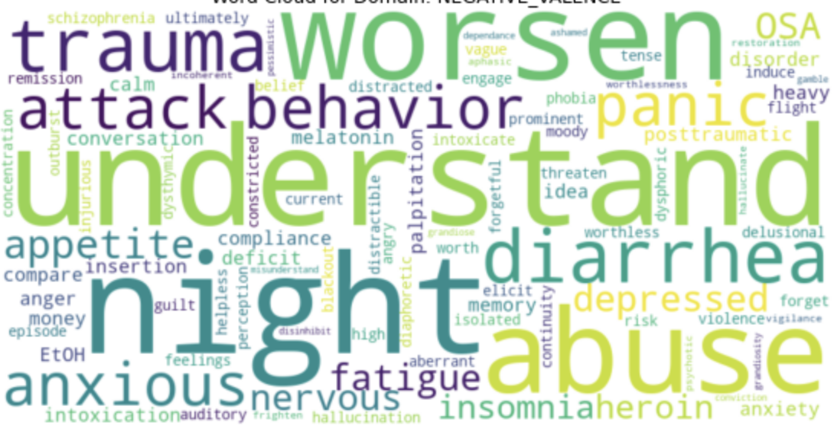

Figure S4. RDoC Keywords based on Domain Types: Positive Valence System

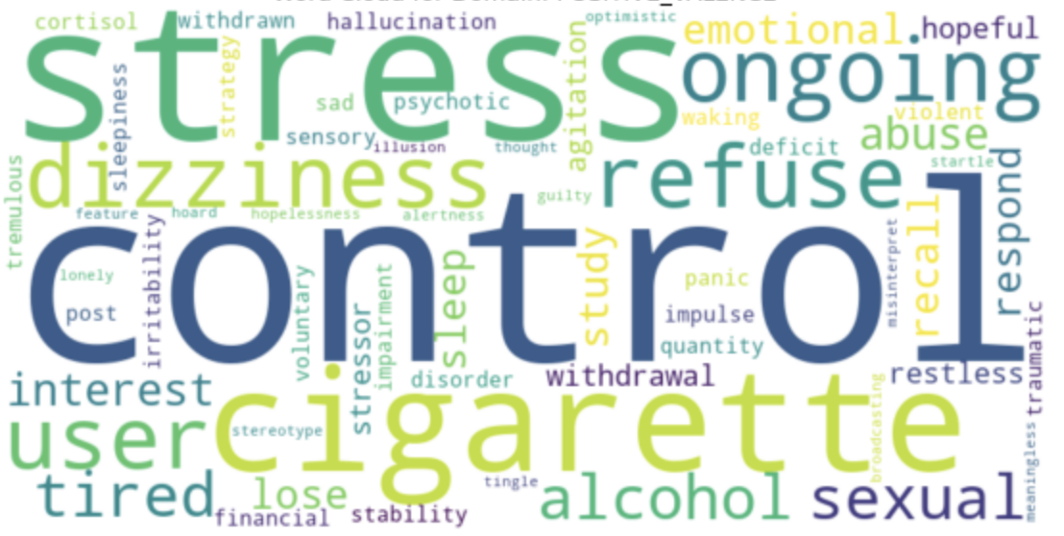
Figure S5. RDoC Keywords based on Domain Types: Sensorimotor Systems

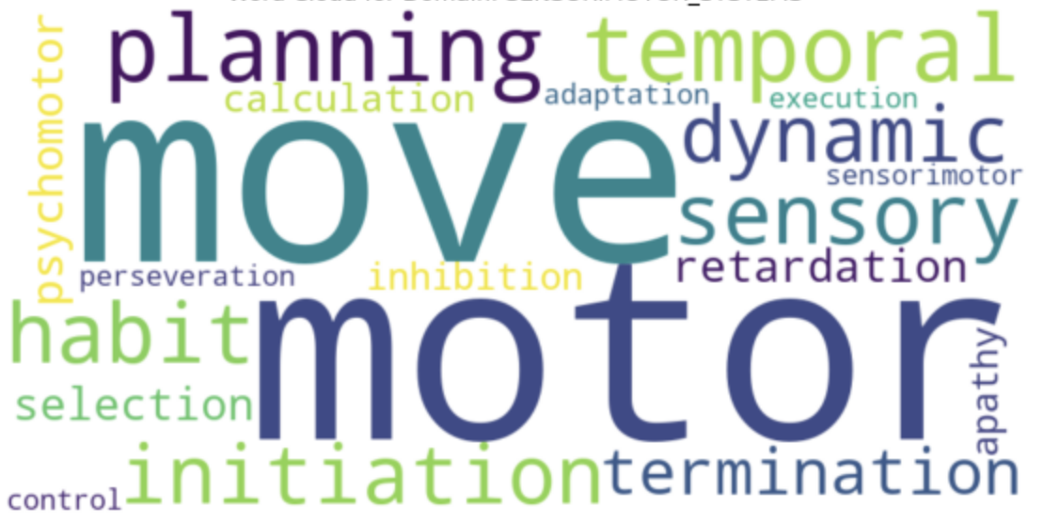

Figure S6. RDoC Keywords based on Domain Types: Social Process

