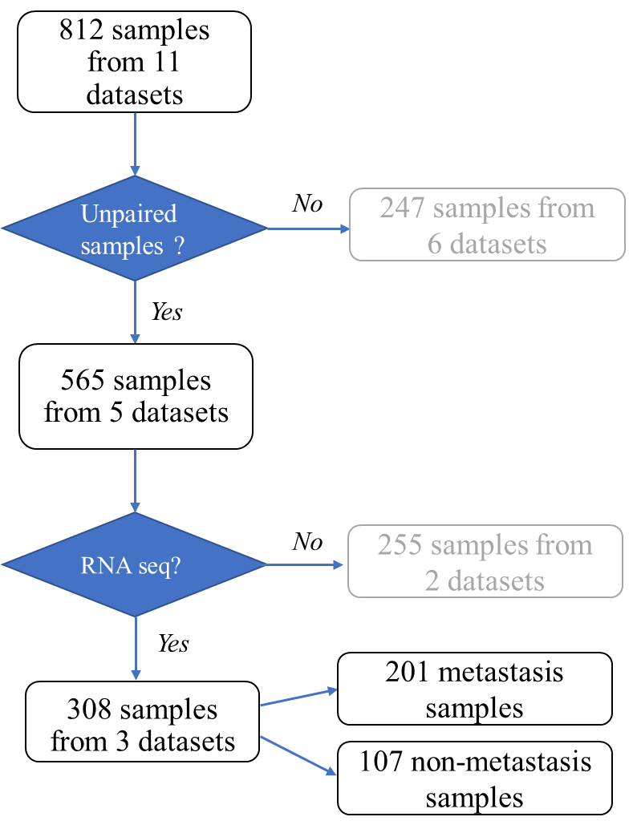
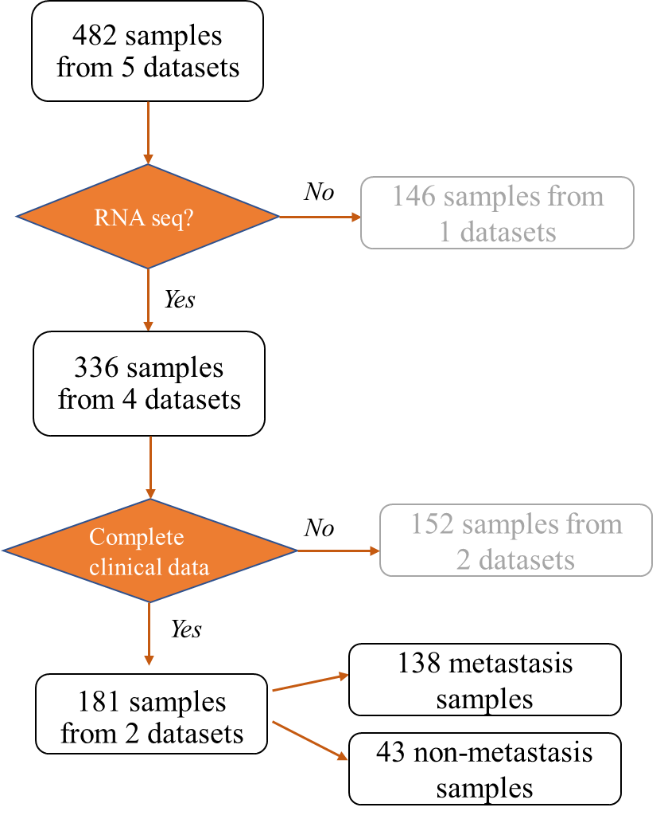
Supplementary data 1

A B
Figure S1-Dataset selection flowchart, train data (A): 308 samples from 3 datasets and validation data(B) : 181 samples from 2 datasets were included after applying filter-out criteria.

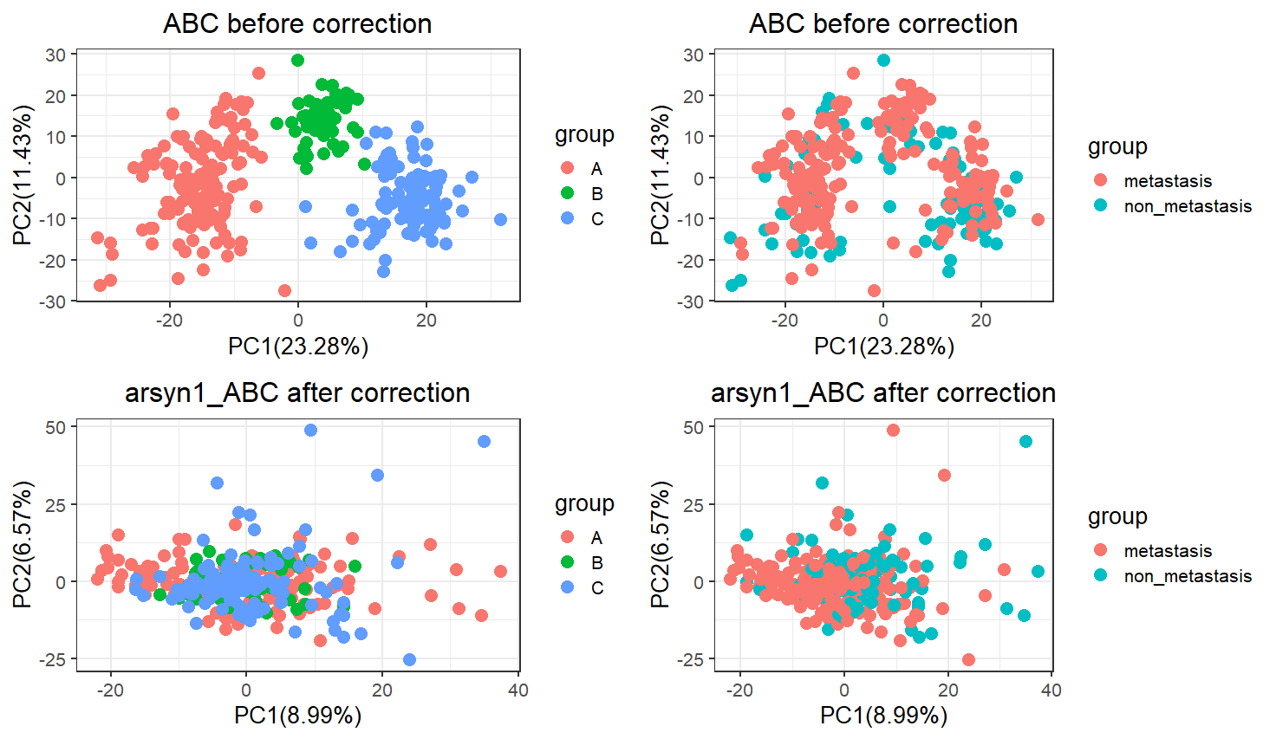
Figure S2 : Train data (ABC) before (upper) and after ARSyN correction (lower) by data source : A =TCGA-PAAD,B= PACA-AU and C= PACA-CA ,and class of patients (metastasis and non-metastasis)
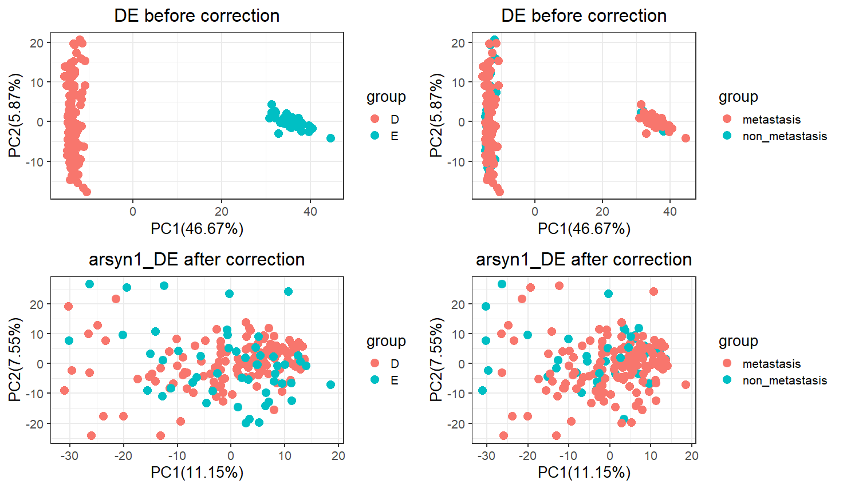
Figure S3 : Validation data (DE) before (upper) and after ARSyN correction (lower) by data source : D= CPTAC-PDAC and E= GSE79668,and class of patients (metastasis and non-metastasis)

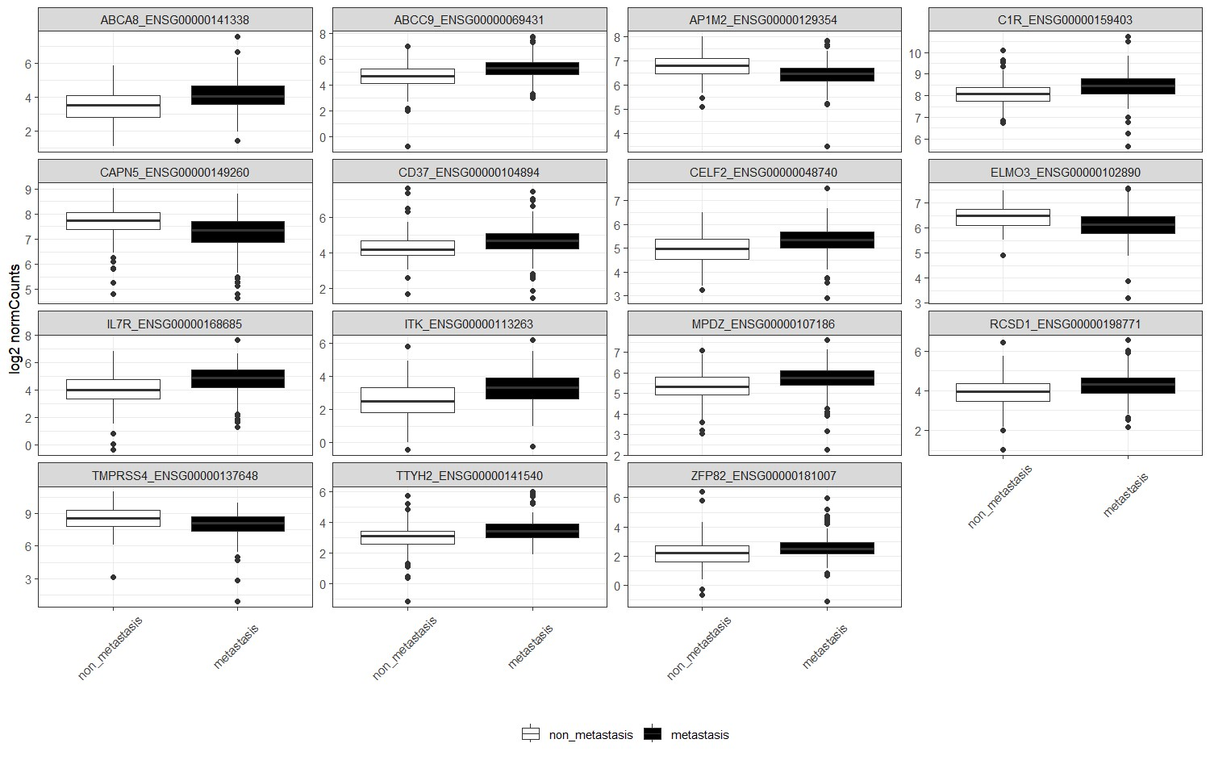
Figure S4 – boxplots of selected biomarker candidate genes showing gene expression by class

No | Gene name | Protein class | Pancreatic cell types enrichment | Antibody staining in PDAC samples
1 | C1R | Human disease related genes | Fibroblasts | Mainly low staining and weak intensity
2 | CELF2 | Disease related genes,Human disease related genes | Macrophages | Mostly undetected
3 | ABCC9 | Disease related genes,FDA approved drug targets,Human disease related genes,Metabolic proteins, and Transporters | Endothelial cells | Mainly low staining and weak intensity
4 | ELMO3 | NA | Ductal cells and endothelial cells | Low to medium staining ,Weak to moderate intensity
5 | CD37 | CD markers | Macrophages | Mostly undetected
6 | MPDZ | Disease related genes,Human disease related genes,Plasma proteins | Endothelial cells | Various staining from low to high and strong to weak intensity
7 | ITK | Cancer-related genes, disease related genes,Enzymes,Human disease related genes,Potential drug targets,Human disease related genes | T cells | NA
8 | AP1M2 | NA | Ductal cells and Macrophages | NA
9 | TMPRSS4 | Enzymes,Plasma proteins | Ductal cells | Various staining from low to high and strong to weak intensity
10 | ABCA8 | Metabolic proteins, Transporters | Fibroblasts | Mostly undetected
11 | TTYH2 | Transporters | Endothelial cells | NA
12 | IL7R | Cancer-related genes,CD markers, disease related genes,Human disease related genes | T cells | NA
13 | ZFP82 | Transcription factors | Endothelial cells | Mostly undetected
14 | RCSD1 | NA | Macrophages | Mostly undetected
15 | CAPN5 | Disease related genes,Enzymes,Human disease related genes,Potential drug targets | Fibroblasts and T cells | Various staining from low to high and strong to weak intensity
Table 1S –Validation in Human Protein Atlas

