Biological Contextualisation
GeneMANIA
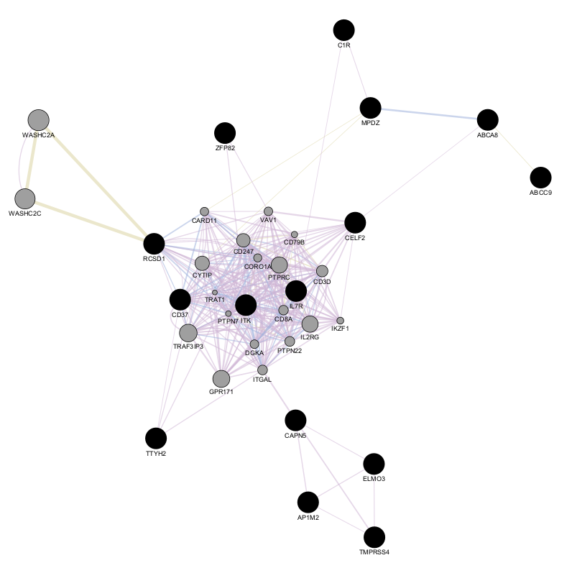
Figure 5S – Gene network of 15 final genes and top 20 relevant genes by GeneMANIA

Table 2S – Significant GO biological processes from GeneMANIA
GO id | Description | q-value | Occurrences in Sample | Occurrences in Genome
GO:0050851 | antigen receptor-mediated signalling pathway | 8.17E-05 | 8 | 222
GO:0098802 | plasma membrane signalling receptor complex | 0.003563728 | 6 | 161
GO:0043235 | receptor complex | 0.01220029 | 6 | 217
GO:0050854 | regulation of antigen receptor-mediated signalling pathway | 0.01220029 | 4 | 54
GO:0030098 | lymphocyte differentiation | 0.013913889 | 6 | 238
GO:0038093 | Fc receptor signalling pathway | 0.040094436 | 5 | 171
GO:0006909 | phagocytosis | 0.059131822 | 5 | 200
GO:0050856 | regulation of T cell receptor signalling pathway | 0.059131822 | 3 | 31
GO:0050852 | T cell receptor signalling pathway | 0.059131822 | 3 | 33

Table 3S – Node information of gene network from GeneMANIA
Gene | Score | Description
ZFP82 |  | ZFP82 zinc finger protein
ABCC9 |  | ATP binding cassette subfamily C member 9
RCSD1 |  | RCSD domain containing 1
TTYH2 |  | tweety family member 2
ABCA8 |  | ATP binding cassette subfamily A member 8
MPDZ |  | multiple PDZ domain crumbs cell polarity complex component
ELMO3 |  | engulfment and cell motility 3
CELF2 |  | CUGBP Elav-like family member 2
AP1M2 |  | adaptor related protein complex 1 subunit mu 2
TMPRSS4 |  | transmembrane serine protease 4
CAPN5 |  | calpain 5
ITK |  | IL2 inducible T cell kinase
CD37 |  | CD37 molecule
IL7R |  | interleukin 7 receptor
C1R |  | complement C1r
WASHC2A | 0.57 | WASH complex subunit 2A
WASHC2C | 0.57 | WASH complex subunit 2C
TRAF3IP3 | 0.54 | TRAF3 interacting protein 3
GPR171 | 0.54 | G protein-coupled receptor 171
IL2RG | 0.53 | interleukin 2 receptor subunit gamma
PTPRC | 0.53 | protein tyrosine phosphatase receptor type C
CYTIP | 0.52 | cytohesin 1 interacting protein
CD247 | 0.51 | CD247 molecule
CD3D | 0.49 | CD3d molecule
PTPN22 | 0.48 | protein tyrosine phosphatase non-receptor type 22
ITGAL | 0.48 | integrin subunit alpha L
CD8A | 0.47 | CD8a molecule
DGKA | 0.47 | diacylglycerol kinase alpha
VAV1 | 0.47 | vav guanine nucleotide exchange factor 1
CARD11 | 0.46 | caspase recruitment domain family member 11
CORO1A | 0.46 | coronin 1A
IKZF1 | 0.45 | IKAROS family zinc finger 1
CD79B | 0.45 | CD79b molecule
PTPN7 | 0.44 | protein tyrosine phosphatase non-receptor type 7
TRAT1 | 0.43 | T cell receptor associated transmembrane adaptor 1

Table 4S – Edge information of gene network from GeneMANIA
Network | Weight | Title
Co-expression | 85.69%
Arijs-Rutgeerts-2009 | 14.07 | Mucosal gene expression of antimicrobial peptides in inflammatory bowel disease before and after first infliximab treatment.
Chen-Brown-2002 | 13 | Gene expression patterns in human liver cancers.
Wang-Maris-2006 | 11.76 | Integrative genomics identifies distinct molecular classes of neuroblastoma and shows that multiple genes are targeted by regional alterations in DNA copy number.
Innocenti-Brown-2011 | 9.67 | Identification, replication, and functional fine-mapping of expression quantitative trait loci in primary human liver tissue.
Roth-Zlotnik-2006 | 9.67 | Gene expression analyses reveal molecular relationships among 20 regions of the human CNS.
Mallon-McKay-2013 | 7.22 | StemCellDB: the human pluripotent stem cell database at the National Institutes of Health.
Dobbin-Giordano-2005 | 5.27 | Interlaboratory comparability study of cancer gene expression analysis using oligonucleotide microarrays.
Bild-Nevins-2006 B | 4.97 | Oncogenic pathway signatures in human cancers as a guide to targeted therapies.
Perou-Botstein-2000 | 4.67 | Molecular portraits of human breast tumours.
Rosenwald-Staudt-2001 | 3.51 | Relation of gene expression phenotype to immunoglobulin mutation genotype in B cell chronic lymphocytic leukemia.
Wang-Cheung-2015 | 1.87 | Genetic variation in insulin-induced kinase signaling.
Co-localization | 12.53%
Johnson-Shoemaker-2003 | 12.53 | Genome-wide survey of human alternative pre-mRNA splicing with exon junction microarrays.
Shared protein domains | 1.78%
INTERPRO | 1.19
PFAM | 0.59

QIAGEN IPA
Top conical pathways in variable set 1-3
Table 5S – Set 1, final genes from ML analysis (Final)
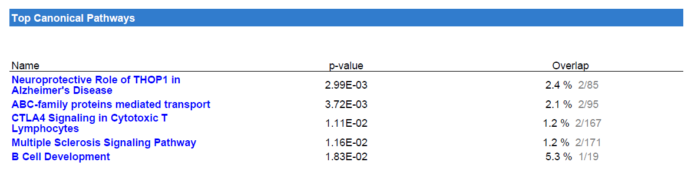

Table 6S – Set 2 , differentially secreted proteins(DE)
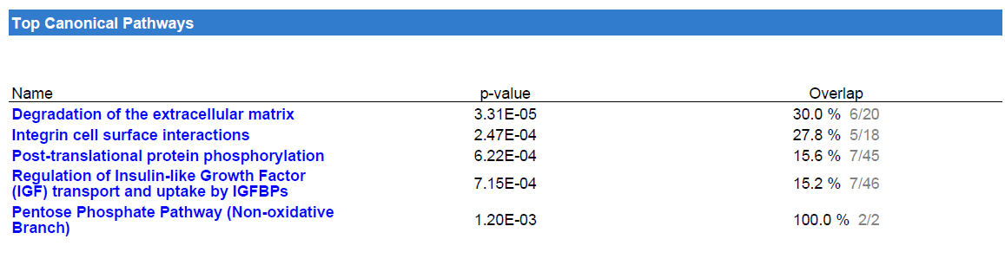
Table 7S – Set 3,exclusively secreted proteins (EXCLU)
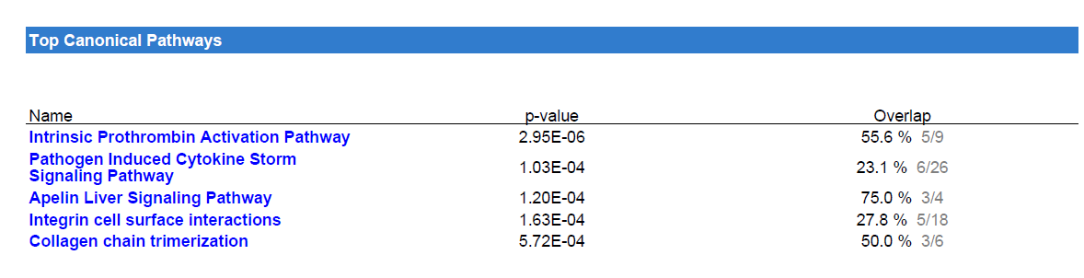

Table 8S – Networks of Top Diseases and Functions enriched from set 1- 3
ID | Analysis | Score | Focus Molecules | Top Diseases and Functions
1 | Final only | 28 | 11 | [Cancer, Cellular Development, Organismal Injury and Abnormalities]
1 | DE only | 41 | 18 | [Cellular Movement, Hematological System Development and Function, Immune Cell Trafficking]
1 | EXCLU only | 34 | 15 | [Cellular Movement, Hematological System Development and Function, Tissue Development]
2 | Final only | 3 | 1 | [Cell Morphology, Cellular Assembly and Organization, DNA Replication, Recombination, and Repair]
2 | DE only | 24 | 12 | [Cell Morphology, Cellular Assembly and Organization, Cellular Movement]
2 | EXCLU only | 18 | 9 | [Cell Death and Survival, Lipid Metabolism, Organismal Injury and Abnormalities]
3 | Final only | 3 | 1 | [Auditory and Vestibular System Development and Function, Cell Cycle, Cellular Development]
3 | DE only | 8 | 5 | [Cardiovascular Disease, Connective Tissue Development and Function, Organismal Injury and Abnormalities]
3 | EXCLU only | 9 | 5 | [Cell Death and Survival, Inflammatory Response, Organismal Injury and Abnormalities]
4 | DE only | 2 | 1 | [Hereditary Disorder, Neurological Disease, Organismal Injury and Abnormalities]
4 | EXCLU only | 2 | 1 | [Hereditary Disorder, Organismal Injury and Abnormalities, Reproductive System Disease]

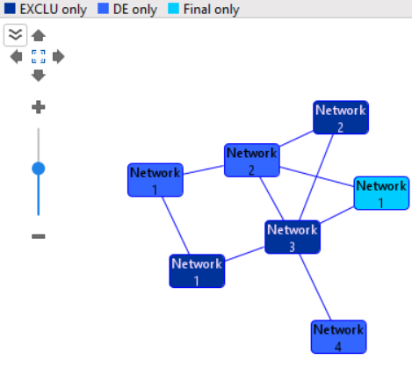

Figure 6S – Overlapping network from set 1- 3 : Network 1 of set1 is overlapping with network 2 of set2(DE) and network 3 of set3 (EXCLU)

