Supplement

Supplementary Table 1: Normalisation process theory (NPT) domains and subdomains conceptualised for remote wound surveillance
Domain | Sub-domain | Conceptualisation for remote postoperative wound surveillance
Coherence | - Differentiation | Is remote wound surveillance distinct from routine postoperative care?
Coherence | - Individual specification | Is it clear what tasks are involved for individual stakeholders in remote wound surveillance?
Coherence | - Communal specification | Is there general agreement about the purpose of routine wound surveillance?
Coherence | - Internalisation | Is it clear what the potential benefits and value of routine wound surveillance are?
Cognitive Participation | - Enrolment | Do stakeholders believe they are the correct people to be involved in remote wound surveillance?
Cognitive Participation | - Initiation | Are stakeholders willing to participate and/or engage others in routine wound surveillance?
Cognitive Participation | - Activation | Do stakeholders believe remote wound surveillance is an appropriate intervention for patients?
Cognitive Participation | - Legitimation | What tasks and activities are required to integrate and sustain remote wound surveillance?
Collective Action | - Interactional workability | Does remote wound surveillance make it easier or harder for patients to be assessed for infection?
Collective Action | - Skill set workability | Do stakeholders have the correct skills and training to be involved in remote wound surveillance?
Collective Action | - Relational integration | Do stakeholders have confidence in remote wound surveillance compared to in-person assessment?
Collective Action | - Contextual integration | Is there sufficient organisation support and resources to allow implementation of remote wound surveillance?
Reflexive Monitoring | - Systemisation | Will stakeholders be able to judge the effectiveness of remote wound surveillance?
Reflexive Monitoring | - Individual / communal appraisal | How will individuals / stakeholders overall judge the effectiveness of the remote wound surveillance?
Reflexive Monitoring | - Reconfiguration | Are there suggestions from stakeholders that aim to modify and enhance the utility remote wound surveillance?

Supplementary Table 2: Characteristics and outcomes of patients interviewed

 |  | Patients Interviewed (n=14)
Age | Median (IQR) | 54.5 (48.8 to 57.2)
Sex | Male | 3 (21.4)
 | Female | 11 (78.6)
Ethnicity | White | 14 (100.0)
 | BAME | 0 (0.0)
Socioeconomic quintile | Median (IQR) | 4.5 (4.0 to 5.0)
Body Mass Index (BMI) | Not obese | 9 (64.3)
 | Obese | 5 (35.7)
Immunosuppression | No | 14 (100.0)
 | Yes | 0 (0.0)
Diabetes Mellitus | No | 13 (92.9)
 | Yes | 1 (7.1)
Operative approach | Minimally-invasive | 9 (64.3)
 | Open | 5 (35.7)
Operative complexity | Minor/Intermediate | 1 (7.1)
 | Major | 12 (85.7)
 | Complex Major | 1 (7.1)
Operative contamination | Clean-Contaminated | 14 (100.0)
 | Contaminated / Dirty | 0 (0.0)
Operative Urgency | Elective | 8 (57.1)
 | Emergency | 6 (42.9)
Clinical diagnosis of SSI (within 30-days) | No | 13 (92.9)
Clinical diagnosis of SSI (within 30-days) | Yes | 1 (7.1)

Supplementary Figure 1: Schemata for exemplar smartphone-based intervention on remote postoperative wound monitoring.

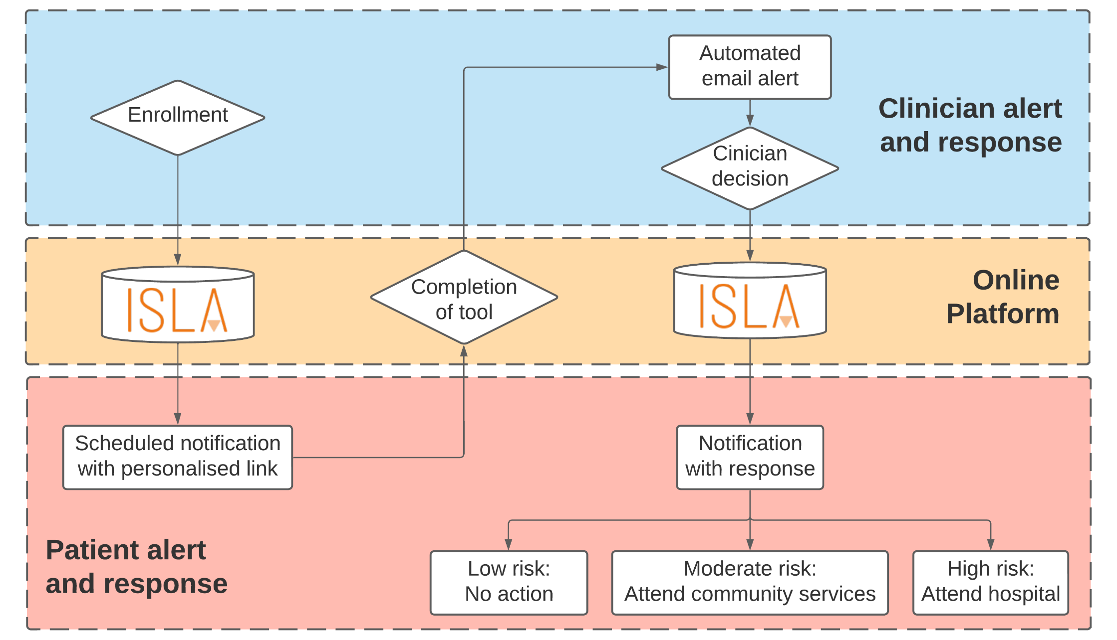

Supplementary Figure 2: Patient stakeholder sentiment heatmap regarding implementation of remote postoperative monitoring

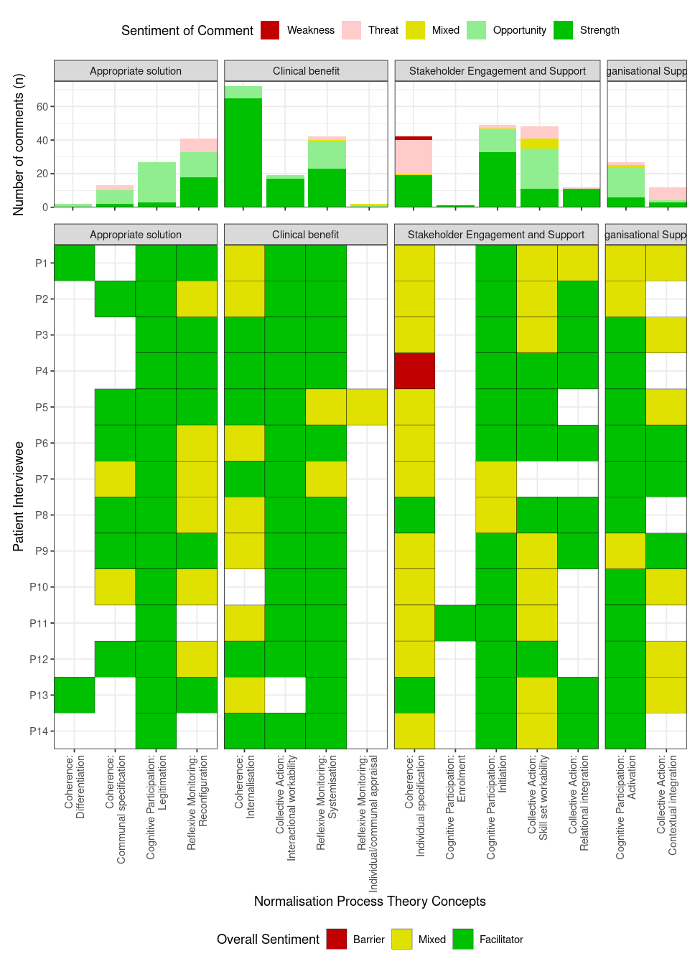

Supplementary Figure 3: Healthcare staff stakeholder sentiment heatmap regarding implementation of remote postoperative monitoring

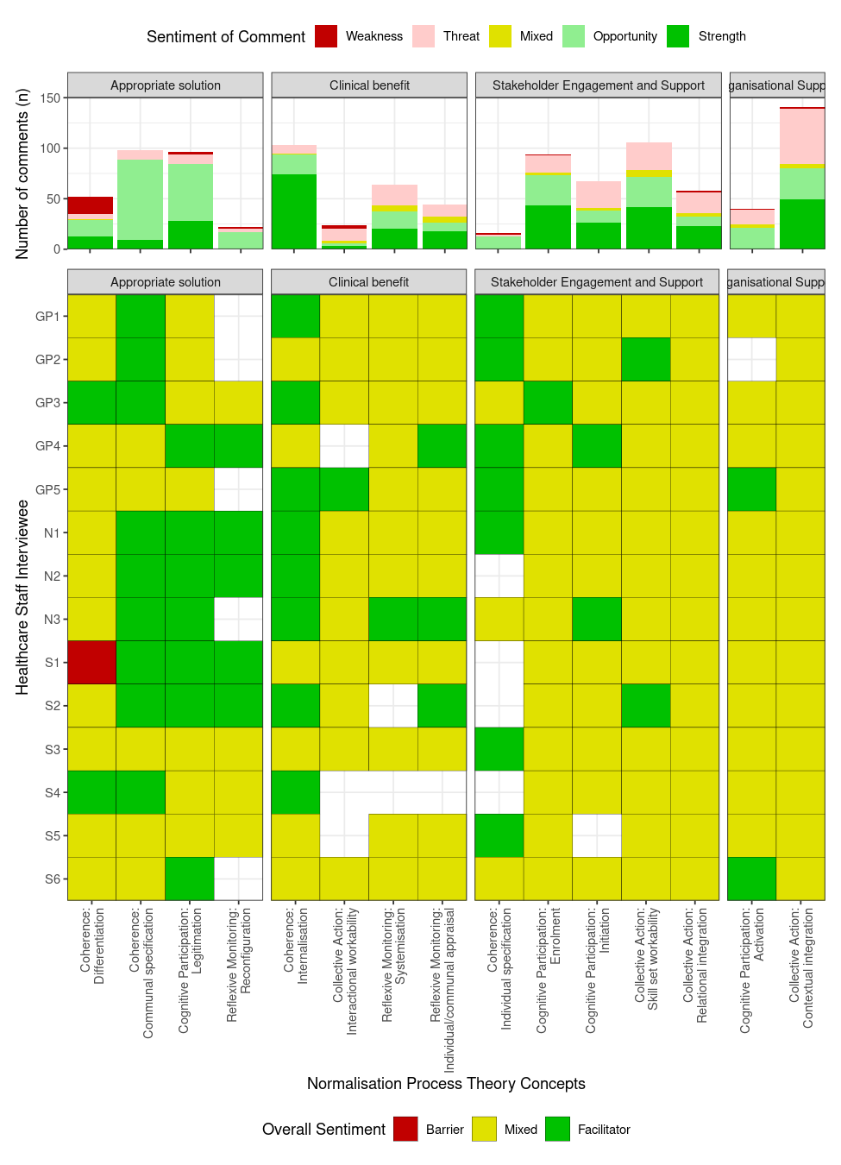
Appendix A: Semi-structured interview guide for patients
Experience of surgery and postoperative care
- Did you or the hospital staff have any concerns about your wound prior to discharge home?
- How confident would you be in identifying problems with your wound?
- What advice (written or spoken) were you given about what to do if you had any problems related to your surgery after you went home?
- Did you have any concerns about how to get advice or care after you went home?
Experience of the intervention
- Did you or the hospital staff have any concerns about your wound prior to discharge home?
- How confident would you be in identifying problems with your wound?
- What advice (written or spoken) were you given about what to do if you had any problems related to your surgery after you went home?
- Did you have any concerns about how to get advice or care after you went home?
- How comfortable were you communicating with healthcare staff online? Any concerns?
- How frequently would you like a mobile app to enquire about your recovery?
- Prompt: Daily, every two days, twice per week, once per week? (if it was optional)
- Would you prefer to have the ability to submit concerns about your wound when you wish, or would you prefer to be prompted?
- Did you have any issues logging into the ISLA platform? Did the process feel secure to you?
- Were there any questions asked on the form that you found confusing? How could this be improved?
- Did you have any issues uploading photographs of your wound? How could this be improved?
- How long did you have to wait before you got advice? Did you feel this was too long?
- Did the advice provided seem correct? Did you follow this advice or did you seek a second opinion? How could the advice be improved?
- Were you advised to see a doctor or nurse about your wound? If so, were you able to? If you were not able to, why was this?
- If there were 100 people who get asked to go for a wound review (at their GP or hospital), what is the HIGHEST number of people you think should be asked to go but actually don’t have a wound infection?
- If there were 100 people who are told their wound doesn’t need a review (at their GP or hospital), what is the HIGHEST number of missed infections you think would be ok?

Appendix B: Semi-structured interview guide for healthcare staff
Interviewee Details
- What is your Job Title? Could you briefly describe your Role?
- How long have you been in this position?
Structure of the general surgical service
- What parts of the electronic patient record do you access on a daily basis?
- Are these fit for purpose / how could these be improved?
- How often do postoperative complications arise in your experience? (in hospital and after discharge). What are the most frequent you see?
- How are postoperative complications currently detected or come to the attention of the service / consultant? (in hospital and after discharge).
- How are complications triaged / prioritised?
- What do you consider serious postoperative complications?
Current practice regarding SSI in postoperative care
- If contacted regarding a patient in the community with a potential SSI, how are they cared for? (before covid and during covid)
- On an average week, how many patients to you speak to (or review) with concerns regarding their surgical wound?
- How reliable do you think diagnosing an SSI in-person is?
- How important is it that surgical site infections are picked up early?
Telemedicine applied to clinical practice
- What areas of your practice or delivery of care could you see telemedicine affecting?
- In your experience, do you think SSI can be reliably diagnosed using patient-reported symptoms?
- In your experience, do you think SSI can be reliably diagnosed visually?
- Would closer monitoring of patients in the community make you more comfortable sending patients home earlier?
- How comfortable would you be communicating with your patients online? Any concerns?
Design requirements for intervention
- Should patients be able to contact any time with concerns with their wound or only at preset time periods? (e.g. on day 3, 7, and 15 after surgery).
- Should all potential surgical-site infections in the community be reviewed (dealt with) by surgical teams?
- If there were 100 people who get asked to go for a wound review (at their GP or hospital), what is the HIGHEST number of people you think should be asked to go but actually don’t have a wound infection?
- If there were 100 people who are told their wound doesn’t need a review (at their GP or hospital), what is the HIGHEST number of missed infections you think would be ok?

