Application of smartphone in the management of oral anticoagulation in patients with atrial fibrillation: Alfalfa App trial
Wenlin Xu; Xinhai Huang; Qiwang Lin; Tingting Wu; Chengfu Guan; Meina Lv; Wei Hu; Hengfen Dai; Pei Chen; Meijuan Li; Feilong Zhang; Jinhua Zhang

Figure of Contents
Supplemental Figure 1. Patients' educational program.
Supplemental Figure 2. Remote consultation.
Supplemental Figure 3. Medication and blood test time reminder.
Supplemental Figure 4. Score on the JAKQ over time in NOAC patients in the standard care group (red triangles) and the Alfalfa App group (green dots).
Supplemental Figure 5. Score on the MMAS-8 over time in NOAC patients in the standard care group (red triangles) and the Alfalfa App group (green dots).
Supplemental Figure 6. Score on the TSQM-II in NOAC patients in the standard care group and the Alfalfa App group.
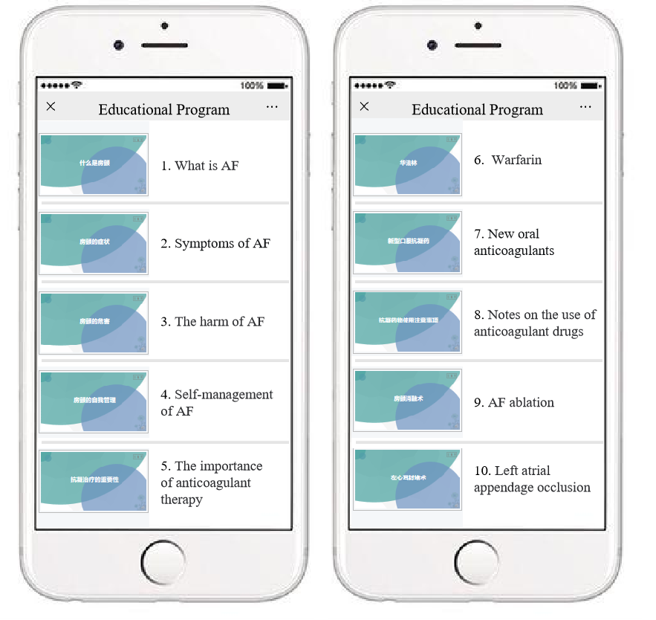

Supplemental Figure 1. Patients' educational program.

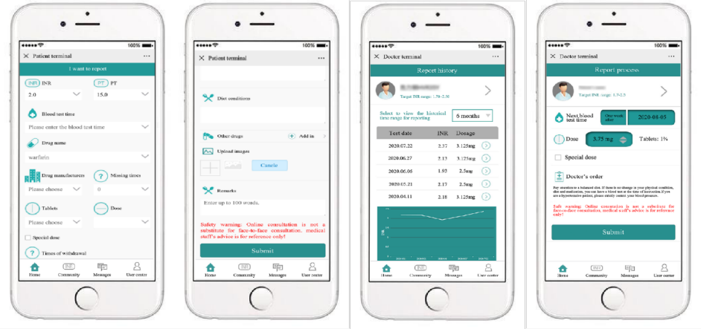Supplemental Figure 2. Remote consultation.

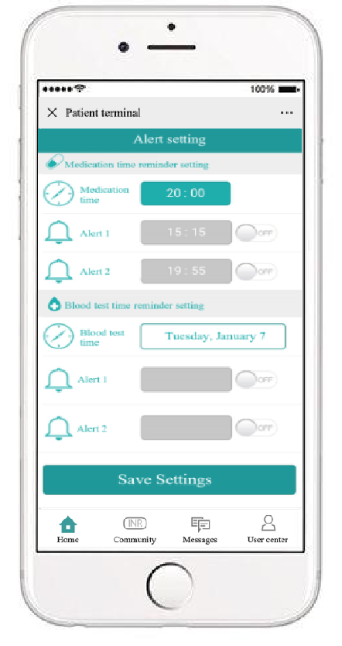
Supplemental Figure 3. Medication and blood test time reminder.

Supplemental Figure 4. Score on the JAKQ over time in NOAC patients in the standard care group (red triangles) and the Alfalfa App group (green dots).

Supplemental Figure 5. Score on the MMAS-8 over time in NOAC patients in the standard care group (red triangles) and the Alfalfa App group (green dots).

Supplemental Figure 6. Score on the TSQM-II in NOAC patients in the standard care group and the Alfalfa App group.

