Additional file 1
Supplement to:
Early prediction of mortality upon intensive care unit admission
Yu-Chang Yeh, Yu-Ting Kuo, Kuang-Cheng Kuo, Yi-Wei Cheng, Ding-Shan Liu, Feipei Lai, Lu-Cheng Kuo, Tai-Ju Lee, Wing-Sum Chan, Ching-Tang Chiu, Ming-Tao Tsai, Anne Chao, Nai-Kuan Chou, Chong-Jen Yu, Shih-Chi Ku

Corresponding authors (equal contribution):
Dr. Yu-Chang Yeh
Department of Anaesthesiology, National Taiwan University Hospital
No 7, Chung Shan South Road, Taipei, Taiwan
ORCID: 0000-0001-5143-5520
E-mail: tonyyeh@ntuh.gov.tw
Dr. Shih-Chi Ku
Department of Internal Medicine, National Taiwan University Hospital
No 7, Chung Shan South Road, Taipei, Taiwan
E-mail: scku1015@gmail.com

Content
1. Information
2. Supplementary Tables
Table S1 Characteristics of patients in the ADM Training and Testing data sets
Table S2 Number of participants with missing data in the ADM data sets
Table S3 Characteristics of patients in the 24H training and testing data sets
Table S4 Characteristics of patients from the MIMIC−IV and CORE database in the 24H sets
Table S5 Number of patients with missing data in the 24H training and testing data sets
Table S6 Performance of models trained with ADM different training datasets on different ADM testing datasets
Table S7 Performance of models trained with 24H different training datasets on different 24H testing datasets

3. Supplementary Figures
Figure S1 Performance of ADM and 24H models in the training datasets
Figure S2 Calibration plots of the 24H models
Figure S3 Feature importance of logistic regression models
Figure S4 Feature importance of deep learning models
Figure S5 AUROC of the ADM and 24H models on different days after ICU admission
Figure S6 Personalized risk assessment and simulator

1. Information
- MIMIC IV Code information from https://github.com/MIT-LCP/mimic-iv
select
ce.subject_id
, ce.stay_id
, ce.charttime
, AVG(case when itemid in (220045) and valuenum > 0 and valuenum < 300 then valuenum else null end) as heart_rate
, AVG(case when itemid in (220179,220050) and valuenum > 0 and valuenum < 400 then valuenum else null end) as sbp
, AVG(case when itemid in (220180,220051) and valuenum > 0 and valuenum < 300 then valuenum else null end) as dbp
, AVG(case when itemid in (220052,220181,225312) and valuenum > 0 and valuenum < 300 then valuenum else null end) as mbp
, AVG(case when itemid = 220179 and valuenum > 0 and valuenum < 400 then valuenum else null end) as sbp_ni
, AVG(case when itemid = 220180 and valuenum > 0 and valuenum < 300 then valuenum else null end) as dbp_ni
, AVG(case when itemid = 220181 and valuenum > 0 and valuenum < 300 then valuenum else null end) as mbp_ni
, AVG(case when itemid in (220210,224690) and valuenum > 0 and valuenum < 70 then valuenum else null end) as resp_rate
, ROUND(
AVG(case when itemid in (223761) and valuenum > 70 and valuenum < 120 then (valuenum-32)/1.8 -- converted to degC in valuenum call
when itemid in (223762) and valuenum > 10 and valuenum < 50 then valuenum else null end)
, 2) as temperature
, MAX(CASE WHEN itemid = 224642 THEN value ELSE NULL END) AS temperature_site
, AVG(case when itemid in (220277) and valuenum > 0 and valuenum <= 100 then valuenum else null end) as spo2
, AVG(case when itemid in (225664,220621,226537) and valuenum > 0 then valuenum else null end) as glucose
FROM mimic_icu.chartevents ce
where ce.stay_id IS NOT NULL
and ce.itemid in
(
220045, -- Heart Rate
225309, -- ART BP Systolic
225310, -- ART BP Diastolic
225312, -- ART BP Mean
220050, -- Arterial Blood Pressure systolic
220051, -- Arterial Blood Pressure diastolic
220052, -- Arterial Blood Pressure mean
220179, -- Non Invasive Blood Pressure systolic
220180, -- Non Invasive Blood Pressure diastolic
220181, -- Non Invasive Blood Pressure mean
220210, -- Respiratory Rate
224690, -- Respiratory Rate (Total)
220277, -- SPO2, peripheral
-- GLUCOSE, both lab and fingerstick
225664, -- Glucose finger stick
220621, -- Glucose (serum)
226537, -- Glucose (whole blood)
-- TEMPERATURE
223762, -- "Temperature Celsius"
223761, -- "Temperature Fahrenheit"
224642 -- Temperature Site
-- 226329 -- Blood Temperature CCO (C)
)
group by ce.subject_id, ce.stay_id, ce.charttime
;
SELECT
MAX(subject_id) AS subject_id
, MAX(hadm_id) AS hadm_id
, MAX(charttime) AS charttime
, le.specimen_id
-- convert from itemid into a meaningful column
, MAX(CASE WHEN itemid = 50862 AND valuenum <= 10 THEN valuenum ELSE NULL END) AS albumin
, MAX(CASE WHEN itemid = 50930 AND valuenum <= 10 THEN valuenum ELSE NULL END) AS globulin
, MAX(CASE WHEN itemid = 50976 AND valuenum <= 20 THEN valuenum ELSE NULL END) AS total_protein
, MAX(CASE WHEN itemid = 50868 AND valuenum <= 10000 THEN valuenum ELSE NULL END) AS aniongap
, MAX(CASE WHEN itemid = 50882 AND valuenum <= 10000 THEN valuenum ELSE NULL END) AS bicarbonate
, MAX(CASE WHEN itemid = 51006 AND valuenum <= 300 THEN valuenum ELSE NULL END) AS bun
, MAX(CASE WHEN itemid = 50893 AND valuenum <= 10000 THEN valuenum ELSE NULL END) AS calcium
, MAX(CASE WHEN itemid = 50902 AND valuenum <= 10000 THEN valuenum ELSE NULL END) AS chloride
, MAX(CASE WHEN itemid = 50912 AND valuenum <= 150 THEN valuenum ELSE NULL END) AS creatinine
, MAX(CASE WHEN itemid = 50931 AND valuenum <= 10000 THEN valuenum ELSE NULL END) AS glucose
, MAX(CASE WHEN itemid = 50983 AND valuenum <= 200 THEN valuenum ELSE NULL END) AS sodium
, MAX(CASE WHEN itemid = 50971 AND valuenum <= 30 THEN valuenum ELSE NULL END) AS potassium
FROM mimic_hosp.labevents le
WHERE le.itemid IN
(
-- comment is: LABEL | CATEGORY | FLUID | NUMBER OF ROWS IN LABEVENTS
50862, -- ALBUMIN | CHEMISTRY | BLOOD | 146697
50930, -- Globulin
50976, -- Total protein
50868, -- ANION GAP | CHEMISTRY | BLOOD | 769895
-- 52456, -- Anion gap, point of care test
50882, -- BICARBONATE | CHEMISTRY | BLOOD | 780733
50893, -- Calcium
50912, -- CREATININE | CHEMISTRY | BLOOD | 797476
-- 52502, Creatinine, point of care
50902, -- CHLORIDE | CHEMISTRY | BLOOD | 795568
50931, -- GLUCOSE | CHEMISTRY | BLOOD | 748981
-- 52525, Glucose, point of care
50971, -- POTASSIUM | CHEMISTRY | BLOOD | 845825
-- 52566, -- Potassium, point of care
50983, -- SODIUM | CHEMISTRY | BLOOD | 808489
-- 52579, -- Sodium, point of care
51006 -- UREA NITROGEN | CHEMISTRY | BLOOD | 791925
-- 52603, Urea, point of care
)
AND valuenum IS NOT NULL
-- lab values cannot be 0 and cannot be negative
-- .. except anion gap.
AND (valuenum > 0 OR itemid = 50868)
GROUP BY le.specimen_id

WITH bg AS
(
select
-- specimen_id only ever has 1 measurement for each itemid
-- so, we may simply collapse rows using MAX()
MAX(subject_id) AS subject_id
, MAX(hadm_id) AS hadm_id
, MAX(charttime) AS charttime
-- specimen_id *may* have different storetimes, so this is taking the latest
, MAX(storetime) AS storetime
, le.specimen_id
, MAX(CASE WHEN itemid = 52028 THEN value ELSE NULL END) AS specimen
, MAX(CASE WHEN itemid = 50801 THEN valuenum ELSE NULL END) AS aado2
, MAX(CASE WHEN itemid = 50802 THEN valuenum ELSE NULL END) AS baseexcess
, MAX(CASE WHEN itemid = 50803 THEN valuenum ELSE NULL END) AS bicarbonate
, MAX(CASE WHEN itemid = 50804 THEN valuenum ELSE NULL END) AS totalco2
, MAX(CASE WHEN itemid = 50805 THEN valuenum ELSE NULL END) AS carboxyhemoglobin
, MAX(CASE WHEN itemid = 50806 THEN valuenum ELSE NULL END) AS chloride
, MAX(CASE WHEN itemid = 50808 THEN valuenum ELSE NULL END) AS calcium
, MAX(CASE WHEN itemid = 50809 and valuenum <= 10000 THEN valuenum ELSE NULL END) AS glucose
, MAX(CASE WHEN itemid = 50810 and valuenum <= 100 THEN valuenum ELSE NULL END) AS hematocrit
, MAX(CASE WHEN itemid = 50811 THEN valuenum ELSE NULL END) AS hemoglobin
, MAX(CASE WHEN itemid = 50813 and valuenum <= 10000 THEN valuenum ELSE NULL END) AS lactate
, MAX(CASE WHEN itemid = 50814 THEN valuenum ELSE NULL END) AS methemoglobin
, MAX(CASE WHEN itemid = 50815 THEN valuenum ELSE NULL END) AS o2flow
-- fix a common unit conversion error for fio2
-- atmospheric o2 is 20.89%, so any value <= 20 is unphysiologic
-- usually this is a misplaced O2 flow measurement
, MAX(CASE WHEN itemid = 50816 THEN
CASE
WHEN valuenum > 20 AND valuenum <= 100 THEN valuenum
WHEN valuenum > 0.2 AND valuenum <= 1.0 THEN valuenum*100.0
ELSE NULL END
ELSE NULL END) AS fio2
, MAX(CASE WHEN itemid = 50817 AND valuenum <= 100 THEN valuenum ELSE NULL END) AS so2
, MAX(CASE WHEN itemid = 50818 THEN valuenum ELSE NULL END) AS pco2
, MAX(CASE WHEN itemid = 50819 THEN valuenum ELSE NULL END) AS peep
, MAX(CASE WHEN itemid = 50820 THEN valuenum ELSE NULL END) AS ph
, MAX(CASE WHEN itemid = 50821 THEN valuenum ELSE NULL END) AS po2
, MAX(CASE WHEN itemid = 50822 THEN valuenum ELSE NULL END) AS potassium
, MAX(CASE WHEN itemid = 50823 THEN valuenum ELSE NULL END) AS requiredo2
, MAX(CASE WHEN itemid = 50824 THEN valuenum ELSE NULL END) AS sodium
, MAX(CASE WHEN itemid = 50825 THEN valuenum ELSE NULL END) AS temperature
, MAX(CASE WHEN itemid = 50807 THEN value ELSE NULL END) AS comments
FROM mimic_hosp.labevents le
where le.ITEMID in
-- blood gases
(
52028 -- specimen
, 50801 -- aado2
, 50802 -- base excess
, 50803 -- bicarb
, 50804 -- calc tot co2
, 50805 -- carboxyhgb
, 50806 -- chloride
-- , 52390 -- chloride, WB CL-
, 50807 -- comments
, 50808 -- free calcium
, 50809 -- glucose
, 50810 -- hct
, 50811 -- hgb
, 50813 -- lactate
, 50814 -- methemoglobin
, 50815 -- o2 flow
, 50816 -- fio2
, 50817 -- o2 sat
, 50818 -- pco2
, 50819 -- peep
, 50820 -- pH
, 50821 -- pO2
, 50822 -- potassium
-- , 52408 -- potassium, WB K+
, 50823 -- required O2
, 50824 -- sodium
-- , 52411 -- sodium, WB NA +
, 50825 -- temperature
)
GROUP BY le.specimen_id
)
, stg_spo2 as
(
select subject_id, charttime
-- avg here is just used to group SpO2 by charttime
, AVG(valuenum) as SpO2
FROM mimic_icu.chartevents
where ITEMID = 220277 -- O2 saturation pulseoxymetry
and valuenum > 0 and valuenum <= 100
group by subject_id, charttime
)
, stg_fio2 as
(
select subject_id, charttime
-- pre-process the FiO2s to ensure they are between 21-100%
, max(
case
when valuenum > 0.2 and valuenum <= 1
then valuenum * 100
-- improperly input data - looks like O2 flow in litres
when valuenum > 1 and valuenum < 20
then null
when valuenum >= 20 and valuenum <= 100
then valuenum
else null end
) as fio2_chartevents
FROM mimic_icu.chartevents
where ITEMID = 223835 -- Inspired O2 Fraction (FiO2)
and valuenum > 0 and valuenum <= 100
group by subject_id, charttime
)
, stg2 as
(
select bg.*
, ROW_NUMBER() OVER (partition by bg.subject_id, bg.charttime order by s1.charttime DESC) as lastRowSpO2
, s1.spo2
from bg
left join stg_spo2 s1
-- same hospitalization
on bg.subject_id = s1.subject_id
-- spo2 occurred at most 2 hours before this blood gas
and s1.charttime between DATETIME_SUB(bg.charttime, INTERVAL 2 HOUR) and bg.charttime
where bg.po2 is not null
)
, stg3 as
(
select bg.*
, ROW_NUMBER() OVER (partition by bg.subject_id, bg.charttime order by s2.charttime DESC) as lastRowFiO2
, s2.fio2_chartevents
-- create our specimen prediction
, 1/(1+exp(-(-0.02544
+ 0.04598 * po2
+ coalesce(-0.15356 * spo2 , -0.15356 * 97.49420 + 0.13429)
+ coalesce( 0.00621 * fio2_chartevents , 0.00621 * 51.49550 + -0.24958)
+ coalesce( 0.10559 * hemoglobin , 0.10559 * 10.32307 + 0.05954)
+ coalesce( 0.13251 * so2 , 0.13251 * 93.66539 + -0.23172)
+ coalesce(-0.01511 * pco2 , -0.01511 * 42.08866 + -0.01630)
+ coalesce( 0.01480 * fio2 , 0.01480 * 63.97836 + -0.31142)
+ coalesce(-0.00200 * aado2 , -0.00200 * 442.21186 + -0.01328)
+ coalesce(-0.03220 * bicarbonate , -0.03220 * 22.96894 + -0.06535)
+ coalesce( 0.05384 * totalco2 , 0.05384 * 24.72632 + -0.01405)
+ coalesce( 0.08202 * lactate , 0.08202 * 3.06436 + 0.06038)
+ coalesce( 0.10956 * ph , 0.10956 * 7.36233 + -0.00617)
+ coalesce( 0.00848 * o2flow , 0.00848 * 7.59362 + -0.35803)
))) as specimen_prob
from stg2 bg
left join stg_fio2 s2
-- same patient
on bg.subject_id = s2.subject_id
-- fio2 occurred at most 4 hours before this blood gas
and s2.charttime between DATETIME_SUB(bg.charttime, INTERVAL 4 HOUR) and bg.charttime
AND s2.fio2_chartevents > 0
where bg.lastRowSpO2 = 1 -- only the row with the most recent SpO2 (if no SpO2 found lastRowSpO2 = 1)
)
select
stg3.subject_id
, stg3.hadm_id
, stg3.charttime
-- raw data indicating sample type
, specimen
-- prediction of specimen for obs missing the actual specimen
, case
when specimen is not null then specimen
when specimen_prob > 0.75 then 'ART.'
else null end as specimen_pred
, specimen_prob

-- oxygen related parameters
, so2
, po2
, pco2
, fio2_chartevents, fio2
, aado2
-- also calculate AADO2
, case
when po2 is null
OR pco2 is null
THEN NULL
WHEN fio2 IS NOT NULL
-- multiple by 100 because fio2 is in a % but should be a fraction
THEN (fio2/100) * (760 - 47) - (pco2/0.8) - po2
WHEN fio2_chartevents IS NOT NULL
THEN (fio2_chartevents/100) * (760 - 47) - (pco2/0.8) - po2
else null
end as aado2_calc
, case
when PO2 is null
THEN NULL
WHEN fio2 IS NOT NULL
-- multiply by 100 because fio2 is in a % but should be a fraction
then 100 * PO2/fio2
WHEN fio2_chartevents IS NOT NULL
-- multiply by 100 because fio2 is in a % but should be a fraction
then 100 * PO2/fio2_chartevents
else null
end as pao2fio2ratio
-- acid-base parameters
, ph, baseexcess
, bicarbonate, totalco2

-- blood count parameters
, hematocrit
, hemoglobin
, carboxyhemoglobin
, methemoglobin

-- chemistry
, chloride, calcium
, temperature
, potassium, sodium
, lactate
, glucose

-- ventilation stuff that's sometimes input
-- , intubated, tidalvolume, ventilationrate, ventilator
-- , peep, o2flow
-- , requiredo2
from stg3
SELECT
MAX(subject_id) AS subject_id
, MAX(hadm_id) AS hadm_id
, MAX(charttime) AS charttime
, le.specimen_id
-- convert from itemid into a meaningful column
, MAX(CASE WHEN itemid = 51221 THEN valuenum ELSE NULL END) AS hematocrit
, MAX(CASE WHEN itemid = 51222 THEN valuenum ELSE NULL END) AS hemoglobin
, MAX(CASE WHEN itemid = 51248 THEN valuenum ELSE NULL END) AS mch
, MAX(CASE WHEN itemid = 51249 THEN valuenum ELSE NULL END) AS mchc
, MAX(CASE WHEN itemid = 51250 THEN valuenum ELSE NULL END) AS mcv
, MAX(CASE WHEN itemid = 51265 THEN valuenum ELSE NULL END) AS platelet
, MAX(CASE WHEN itemid = 51279 THEN valuenum ELSE NULL END) AS rbc
, MAX(CASE WHEN itemid = 51277 THEN valuenum ELSE NULL END) AS rdw
, MAX(CASE WHEN itemid = 52159 THEN valuenum ELSE NULL END) AS rdwsd
, MAX(CASE WHEN itemid = 51301 THEN valuenum ELSE NULL END) AS wbc
FROM mimic_hosp.labevents le
WHERE le.itemid IN
(
51221, -- hematocrit
51222, -- hemoglobin
51248, -- MCH
51249, -- MCHC
51250, -- MCV
51265, -- platelets
51279, -- RBC
51277, -- RDW
52159, -- RDW SD
51301 -- WBC

)
AND valuenum IS NOT NULL
-- lab values cannot be 0 and cannot be negative
AND valuenum > 0
GROUP BY le.specimen_id
;
SELECT
MAX(subject_id) AS subject_id
, MAX(hadm_id) AS hadm_id
, MAX(charttime) AS charttime
, le.specimen_id
-- convert from itemid into a meaningful column
, MAX(CASE WHEN itemid = 50861 THEN valuenum ELSE NULL END) AS alt
, MAX(CASE WHEN itemid = 50863 THEN valuenum ELSE NULL END) AS alp
, MAX(CASE WHEN itemid = 50878 THEN valuenum ELSE NULL END) AS ast
, MAX(CASE WHEN itemid = 50867 THEN valuenum ELSE NULL END) AS amylase
, MAX(CASE WHEN itemid = 50885 THEN valuenum ELSE NULL END) AS bilirubin_total
, MAX(CASE WHEN itemid = 50883 THEN valuenum ELSE NULL END) AS bilirubin_direct
, MAX(CASE WHEN itemid = 50884 THEN valuenum ELSE NULL END) AS bilirubin_indirect
, MAX(CASE WHEN itemid = 50910 THEN valuenum ELSE NULL END) AS ck_cpk
, MAX(CASE WHEN itemid = 50911 THEN valuenum ELSE NULL END) AS ck_mb
, MAX(CASE WHEN itemid = 50927 THEN valuenum ELSE NULL END) AS ggt
, MAX(CASE WHEN itemid = 50954 THEN valuenum ELSE NULL END) AS ld_ldh
FROM mimic_hosp.labevents le
WHERE le.itemid IN
(
50861, -- Alanine transaminase (ALT)
50863, -- Alkaline phosphatase (ALP)
50878, -- Aspartate transaminase (AST)
50867, -- Amylase
50885, -- total bili
50884, -- indirect bili
50883, -- direct bili
50910, -- ck_cpk
50911, -- CK-MB
50927, -- Gamma Glutamyltransferase (GGT)
50954 -- ld_ldh
)
AND valuenum IS NOT NULL
-- lab values cannot be 0 and cannot be negative
AND valuenum > 0
GROUP BY le.specimen_id
SELECT
MAX(subject_id) AS subject_id
, MAX(hadm_id) AS hadm_id
, MAX(charttime) AS charttime
, le.specimen_id
-- convert from itemid into a meaningful column
, MAX(CASE WHEN itemid = 50889 THEN valuenum ELSE NULL END) AS crp
-- , CAST(NULL AS NUMERIC) AS il6
-- , CAST(NULL AS NUMERIC) AS procalcitonin
FROM mimic_hosp.labevents le
WHERE le.itemid IN
(
50889 -- crp
-- 51652 -- high sensitivity CRP
)
AND valuenum IS NOT NULL
-- lab values cannot be 0 and cannot be negative
AND valuenum > 0
GROUP BY le.specimen_id

- CORE rule of the upper and lower limit of variable
Name | Limit
Age (years) | 18 - 120
Height (cm) | 100-200
Weight (kg) | 20 - 180
BMI (kg/m²) | 10 - 80
Temperature (°C) | 20 - 46
Heart Rate (beats per minute) | 1 - 300
Respiratory Rate (breaths per minute) | 1 - 80
Systolic Blood Pressure (SBP) (mmHg) | 1 - 350
Diastolic Blood Pressure (DBP) (mmHg) | 1 - 250
Mean Arterial Pressure (MAP) (mmHg) | 1 - 300
Hemoglobin (g/dL) | 1 - 25
White Cell Count (cells/μL) | 0 - 300
Platelet Count (×10³/μL) | 0 - 1500
Sodium Concentration (mmol/L) | 100 - 215
Potassium Concentration (mmol/L) | 0.05 - 15
Creatinine (mg/dL) | 0.1 - 28.3
Blood Urea Nitrogen (mg/dL) | 1.4 - 280
Albumin (g/dL) | 0.5 - 6.5
BIlirubin ( mg/dL ) | 0.05 - 70.2
Blood Sugar (mg/dL) | 0 - 1622
pH | 6.8-7.8
Partial Pressure of Oxygen (PaO₂) (mmHg) | 15-550
Partial Pressure of Carbon Dioxide (PaCO₂) (mmHg) | 10-150
Lactate (mmol/L) | 0-50

- RapidMiner histogram view examples

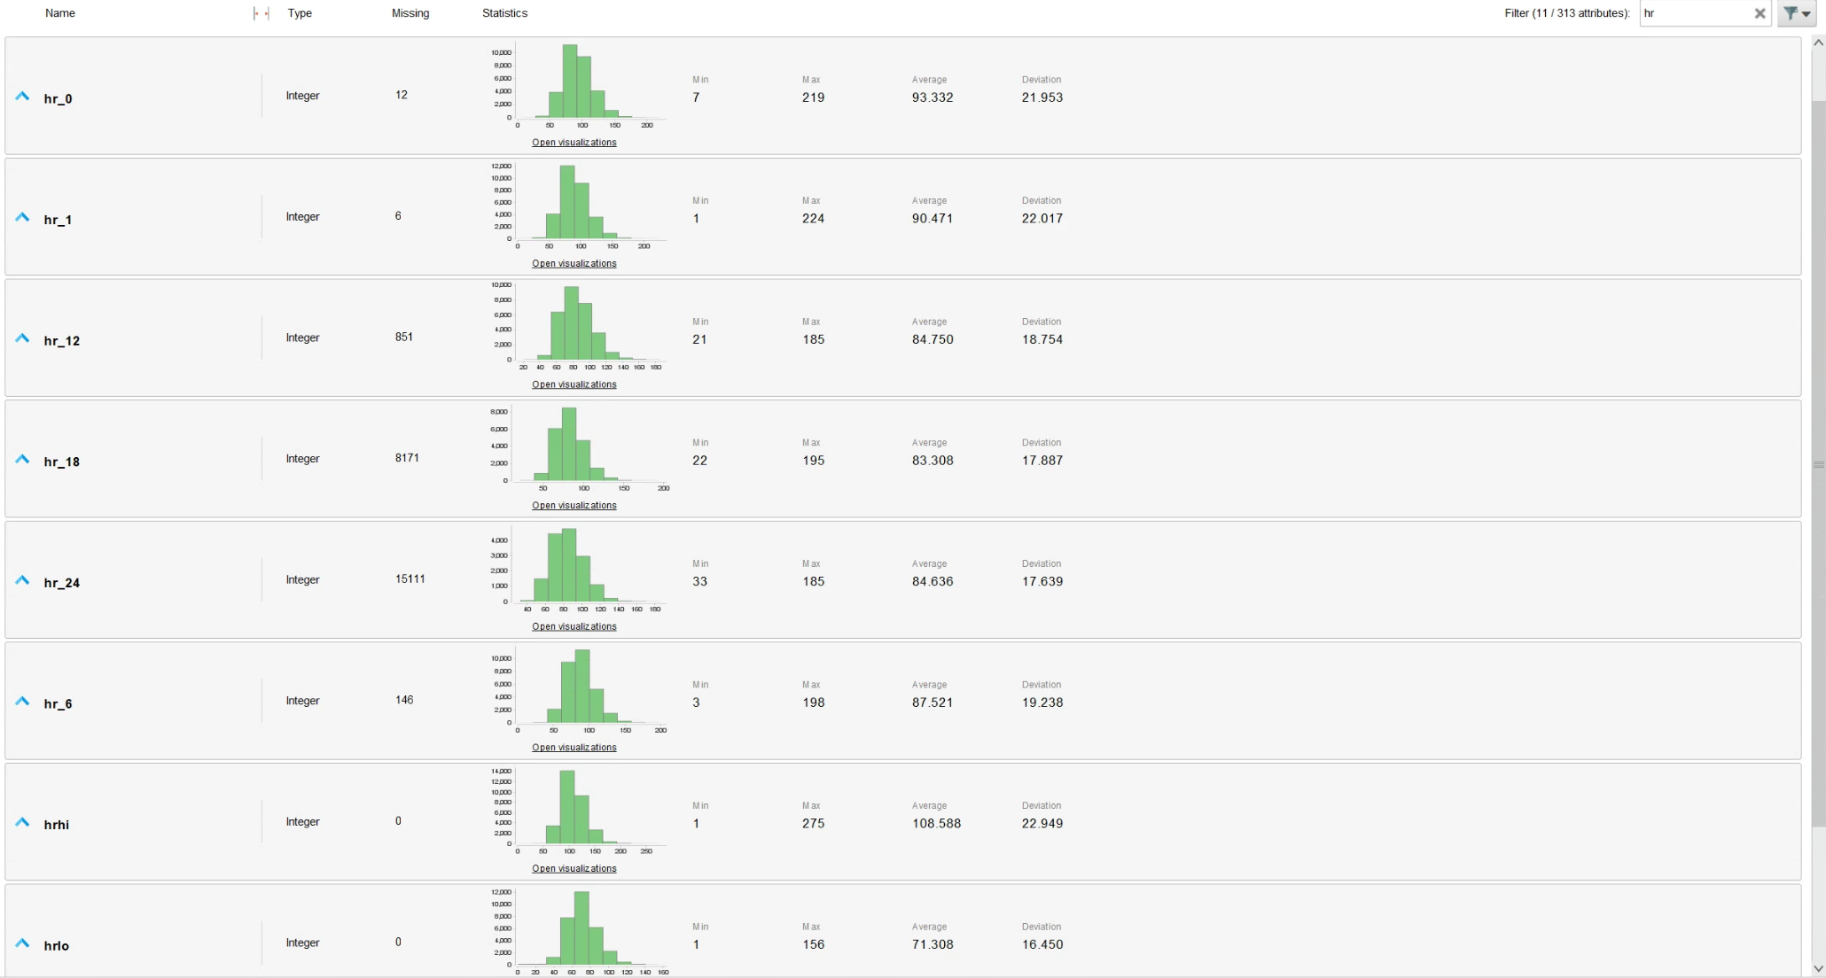

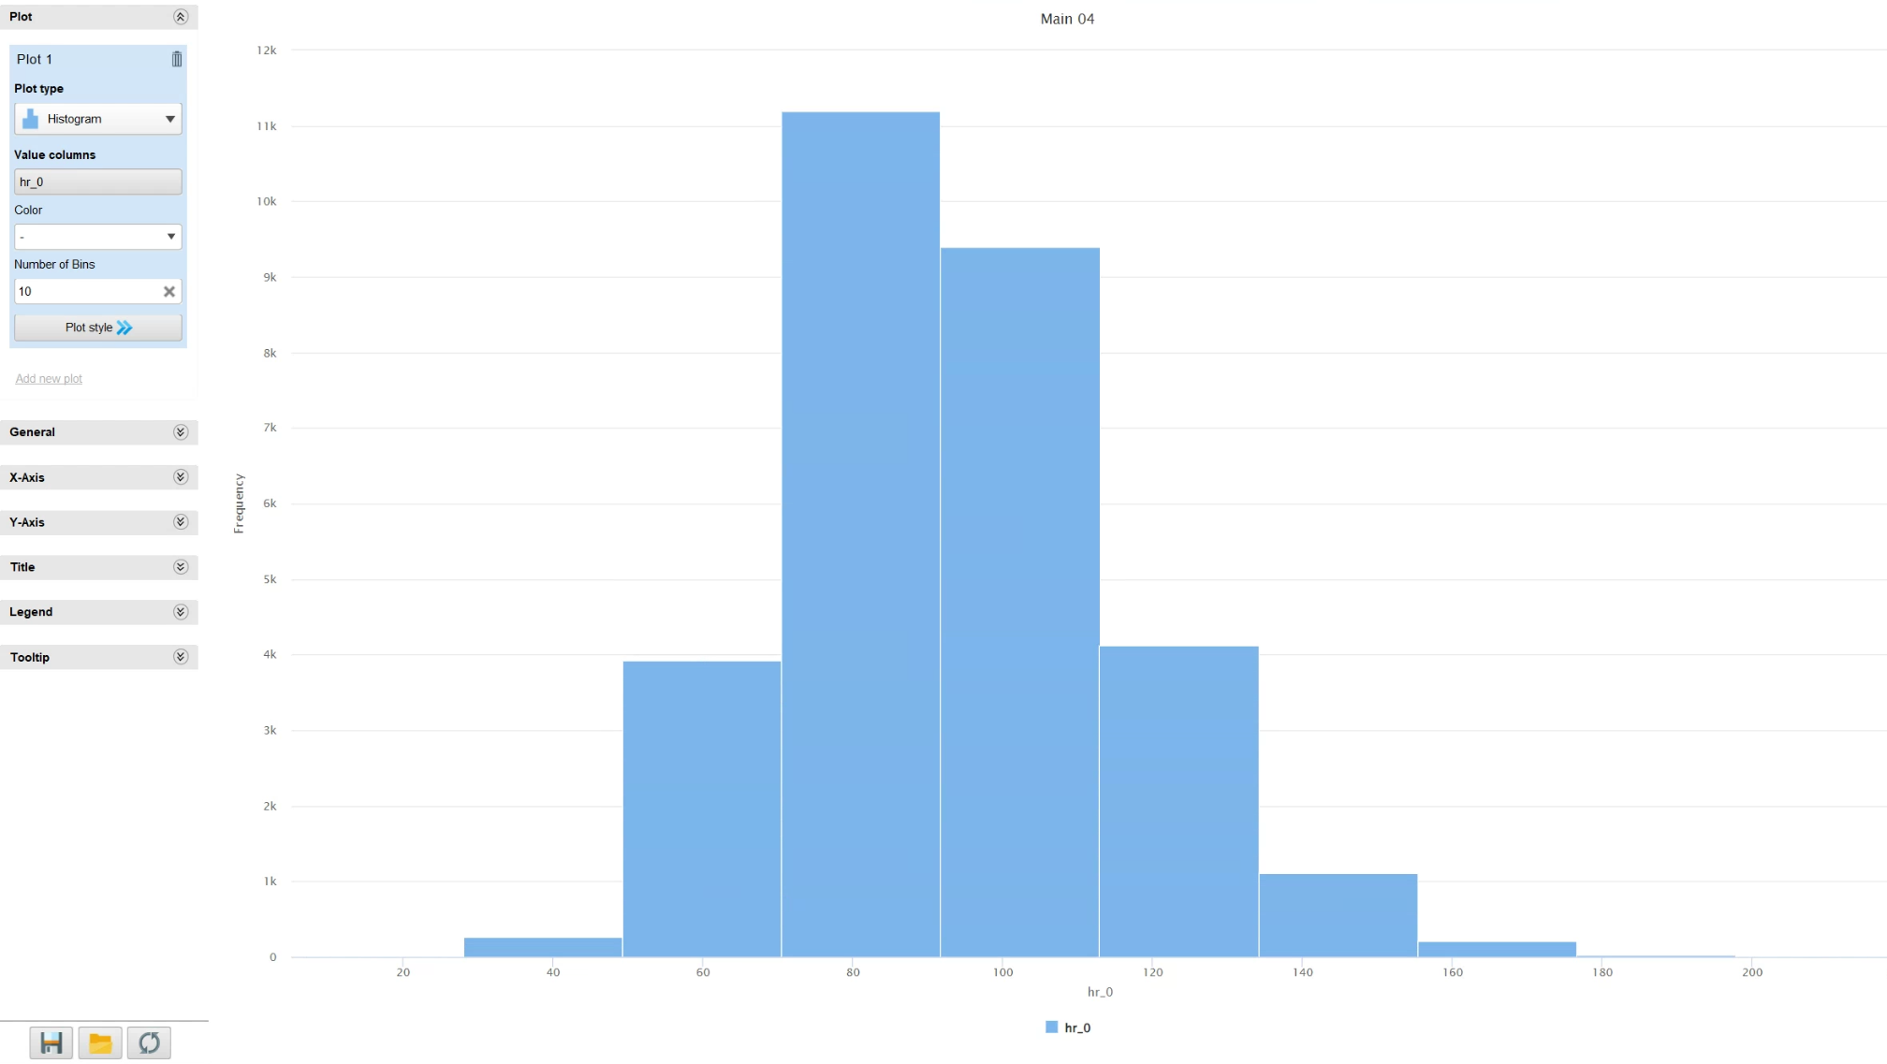

2. Supplementary tables
Table S1 Characteristics of patients in ADM Training and Testing data sets
 | Training |  |  | Testing
 | Survivors | Nonsurvivors | p values | Survivors | Nonsurvivors | p values
Number | 60925 | 4325 |  | 13395 | 1012
Age (years) | 66 (54-77) | 72 (61-82) | <0.001 | 66 (54-76) | 70 (59-81) | <0.001
Female (%) | 26872 (44.1%) | 1944 (44.9%) | 0.288 | 5567 (41.6%) | 404 (39.9%) | 0.307
Height (cm) | 168 (160-175) | 166 (158-175) | <0.001 | 168 (160-176) | 168 (160-175) | 0.139
Weight (kg) | 75 (62.9-90.2) | 71.4 (59.7-86.5) | <0.001 | 75.5 (62.9-90) | 74 (61.7-90) | 0.273
CAD | 9531 (15.6%) | 862 (19.9%) | <0.001 | 2293 (17.1%) | 231 (22.8%) | <0.001
CHF | 15228 (25%) | 1379 (31.9%) | <0.001 | 2740 (20.5%) | 286 (28.3%) | <0.001
ESRD | 12087 (19.8%) | 1090 (25.2%) | <0.001 | 1957 (14.6%) | 207 (20.5%) | <0.001
Diabetes | 18461 (30.3%) | 1363 (31.5%) | 0.097 | 3638 (27.2%) | 282 (27.9%) | 0.626
Dementia | 1955 (3.2%) | 167 (3.9%) | 0.021 | 670 (5%) | 61 (6%) | 0.152
Metastatic cancer | 3832 (6.3%) | 552 (12.8%) | <0.001 | 755 (5.6%) | 82 (8.1%) | 0.001
Postoperative care | 11621 (19.1%) | 249 (5.8%) | <0.001 | 3107 (23.2%) | 73 (7.2%) | <0.001
Elective operation | 6719 (11%) | 53 (1.2%) | <0.001 | 1840 (13.7%) | 12 (1.3%) | <0.001
Pre-ICU hospital stay | 0 (0-1) | 0 (0-2) | <0.001 | 0 (0-1) | 0 (0-2) | <0.001
Upon ICU admission
Glasgow Coma Scale | 15 (12-15) | 10 (4-15) | <0.001 | 15 (9-15) | 8 (3-15) | <0.001
Body temperature (℃) | 36.7 (36.3-37) | 36.6 (36.1-36.9) | <0.001 | 36.7 (36.4-37) | 36.7 (36.3-37) | <0.001
Respiratory rate (bpm) | 18 (15-22) | 21 (17-26) | <0.001 | 18 (15-22) | 21 (18-26) | <0.001
Heart rate (bpm) | 87 (75-101) | 96 (81-114) | <0.001 | 85 (74-99) | 96 (80-113) | <0.001
SBP (mm Hg) | 124 (110-143) | 119 (101-137) | <0.001 | 125 (111-142) | 118 (101-133) | <0.001
DBP (mm Hg) | 69 (58-80) | 66 (54-78) | <0.001 | 69 (60-82) | 68 (56-78) | <0.001
MAP (mm Hg) | 88 (77-100) | 84 (71-98) | <0.001 | 89 (78-101) | 85 (71-96) | <0.001
SOFA score | 4 (2-6) | 10 (6-13) | <0.001 | 4 (2-6) | 11 (7-14) | <0.001
APS | 41 (31-55) | 85 (64-108) | <0.001 | 38 (28-53) | 85 (62-109) | <0.001
LOS in ICU (days) | 2 (1-3) | 3 (1-8) | - | 2 (1-4) | 3 (1-8) | -
LOS in hospital (days) | 7 (4-13) | 4 (2-11) | - | 8 (4-15) | 5 (2-12) | -
Values are presented as numbers (%) or medians (interquartile ranges). APS acute physiology score of the acute physiologic assessment and chronic health evaluation (APACHE) III, bpm beats or breaths per minute for heart rate and respiratory rate, respectively, CAD coronary artery diseases, CHF congestive heart failure, DBP diastolic blood pressure, MAP mean arterial pressure, ESRD end-stage renal disease, ICU intensive care unit, LOS length of stay, SBP systolic blood pressure, SOFA sequential organ failure assessment.

Table S2 Number of participants with missing data in the ADM data sets
 | Training |  | Testing
 | MIMIC−IV | CORE | MIMIC−IV | CORE
Number | 56,478 | 8,772 | 12,103 | 2,304
Height | 30,200 (53.5%) | 844 (9.6%) | 5,721 (47.3%) | 218 (9.5%)
Weight | 1,307 (2.3%) | 502 (5.7%) | 260 (2.1%) | 135 (5.9%)
Glasgow Coma Scale | 1,870 (3.3%) | 2,857 (21.2%) | 420 (3.5%) | 522 (22.7%)
Body temperature | 2,900 (5.1%) | 0 (0%) | 603 (5.0%) | 0 (0%)
Respiratory rate | 927 (1.6%) | 14 (0.2%) | 338 (2.8%) | 2 (0.1%)
Heart rate | 838 (1.5%) | 1 (0%) | 252 (2.1%) | 3 (0.1%)
SBP | 1,737 (3.1%) | 76 (0.9%) | 577 (4.8%) | 18 (0.8%)
DBP | 1,737 (3.1%) | 76 (0.9%) | 575 (4.8%) | 18 (0.8%)
MAP | 1,626 (2.9%) | 76 (0.9%) | 493 (4.1%) | 18 (0.8%)
Values are presented as numbers (%). CORE Center of Outcome and Resource Evaluation critical care database, DBP diastolic blood pressure, ESRD end-stage renal disease, ICU intensive care unit, LOS length of stay, MAP mean arterial pressure, MIMIC Medical Information Mart for Intensive Care, SBP systolic blood pressure, SOFA sequential organ failure assessment.

Table S3 Characteristics of patients in the 24H training and testing data sets
 | Training |  |  | Testing
 | Survivors | Nonsurvivors | p values | Survivors | Nonsurvivors | p values
Number | 34,383 | 2,912 |  | 8,171 | 704
Age (years) | 67 (55-78) | 71 (61-81) | <0.001 | 66 (55-77) | 69 (58-79) | <0.001
Female (%) | 15,052 (43.8%) | 1,276 (43.8%) | 0.966 | 3,413 (41.8%) | 281 (39.9%) | 0.338
Height (cm) | 168 (160-175) | 167 (159-175) | <0.001 | 168 (160-175) | 168 (160-175) | 0.465
Weight (kg) | 75 (62.9-90.2) | 71.1 (59.1-86.5) | <0.001 | 75 (62.8-90) | 74.8 (61.9-91.9) | 0.567
CAD | 5,804 (16.9%) | 589 (20.2%) | <0.001 | 1,427 (17.5%) | 167 (23.7%) | <0.001
CHF | 9,673 (28.1%) | 990 (34%) | <0.001 | 1,837 (22.5%) | 202 (28.7%) | <0.001
ESRD | 7,350 (21.4%) | 763 (26.2%) | <0.001 | 1,279 (15.7%) | 143 (20.3%) | 0.001
Diabetes | 10,975 (31.9%) | 944 (32.4%) | 0.580 | 2,271 (27.8%) | 204 (29%) | 0.502
Dementia | 1,179 (3.4%) | 108 (3.7%) | 0.427 | 427 (5.2%) | 40 (5.7%) | 0.603
Metastatic cancer | 2,176 (6.3%) | 376 (12.9%) | <0.001 | 492 (6%) | 56 (8%) | 0.041
Postoperative care | 6,322 (18.4%) | 178 (6.1%) | <0.001 | 1,625 (19.9%) | 56 (8%) | <0.001
Elective operation | 3,428 (10%) | 44 (1.5%) | <0.001 | 919 (11.2%) | 12 (1.7%) | <0.001
Emergency departments | 11,964 (34.8%) | 1,129 (38.8%) | <0.001 | 1,060 (13%) | 107 (15.2%) | 0.094
Intubated on day 0 or 1 | 4,556 (13.3%) | 766 (26.3%) | <0.001 | 1,143 (14%) | 223 (31.7%) | <0.001
Upon ICU admission
GCS | 15 (9-15) | 12 (6-15) | <0.001 | 15 (9-15) | 9 (4-15) | <0.001
BT (℃) | 36.7 (36.4-37.1) | 36.6 (36.2-37) | <0.001 | 36.7 (36.4-37) | 37.1 (36.7-37.1) | 0.001
RR (bpm) | 19 (15-22) | 21 (17-26) | <0.001 | 19 (16-22) | 21 (17-26) | <0.001
Heart rate (bpm) | 89 (76-103) | 96 (81-113) | <0.001 | 87 (75-101) | 95 (79-113) | <0.001
SBP (mm Hg) | 125 (109-143) | 121 (103-138) | <0.001 | 125 (110-143) | 122 (105-136) | <0.001
DBP (mm Hg) | 68 (57-79) | 67 (55-79) | 0.002 | 69 (60-82) | 69 (58-80) | 0.053
MAP (mm Hg) | 88 (76-100) | 85 (73-98) | <0.001 | 89 (79-101) | 87 (75-98) | <0.001
Within 24h
BT_hi (℃) | 37.2 (36.9-37.8) | 37.2 (36.9-37.9) | 0.002 | 37.2 (37-37.7) | 37,2 (37-37.9) | 0.741
Heart rate_hi (bpm) | 104 (90-119) | 113 (97-130) | <0.001 | 102 (90-117) | 114 (96-129) | <0.001
SBP_hi (mm Hg) | 149 (134-166) | 146 (131-163) | <0.001 | 149 (134-165) | 146 (130-165) | 0.012
MAP_hi (mm Hg) | 103 (92-117) | 102 (91-116) | 0.612 | 105 (95-119) | 106 (93-117) | 0.214
GCS_lo | 14 (11-15) | 7 (3-12) | <0.001 | 14 (12-15) | 6 (3-11) | <0.001
Heart rate_lo (bpm) | 70 (60-81) | 76 (63-89) | <0.001 | 68 (59-79) | 73 (61-89) | <0.001
RR_lo (bpm) | 12 (10-14) | 14 (11-16) | <0.001 | 12 (10-14) | 13 (10-16) | <0.001
SBP_lo (mm Hg) | 91 (81-102) | 84 (74-94) | <0.001 | 92 (83-104) | 86 (75-97) | <0.001
Lactate_hi (mmol/L) | 2.4 (1.6-4) | 3.3 (1.9-6.5) | <0.001 | 2.4 (1.6-3.9) | 3.8 (2.1-7.8) | <0.001
hemoglobin_hi (g/dL) | 11.3 (9.8-12.9) | 10.9 (9.5-12.5) | <0.001 | 11.5 (9.9-13.1) | 10.9 (9.1-12.8) | <0.001
WCC_hi (10⁹/L) | 12.1 (8.8-16.7) | 14.1 (9.7-19.8) | <0.001 | 12.6 (9.2-17.1) | 14.9 (10.1-21.6) | <0.001
BUN_hi (mg/dL) | 21 (15-26) | 33 (21-54) | <0.001 | 19 (13-29) | 32 (20-56) | <0.001
Creatinine_hi (mg/dL) | 1.1 (0.8-1.6) | 1.5 (0.9-2.5) | <0.001 | 1 (0.7-1.4) | 1.5 (0.9-2.6) | <0.001
Platelet_hi (10⁹/L) | 212 (157-281) | 195 (126-278) | <0.001 | 202 (156-263) | 172 (105-245) | <0.001
Glucose_hi (mg/dL) | 169 (135-211) | 185 (136-258) | <0.001 | 175 (140-218) | 189 (142-264) | <0.001
Bilirubin (mg/dL) | 0.8 (0.4-1.3) | 0.9 (0.5-2.2) | <0.001 | 0.7 (0.5-1.2) | 1 (0.6-2.6) | <0.001
Sodium_hi (mEq/L) | 139 (137-142) | 140 (136-143) | 0.003 | 140 (137-143) | 141 (136-145) | <0.001
Potassium_hi (mEq/L) | 4.3 (4-4.8) | 4.5 (4.1-5.1) | <0.001 | 4.4 (4-4.9) | 4.6 (4.1-5.2) | <0.001
pH | 7.35 (7.29-7.41) | 7.32 (7.21-7.4) | <0.001 | 7.35 (7.29-7.41) | 7.3 (7.2-7.39) | <0.001
PaO₂ (mm Hg) | 92 (70-134) | 79 (61-113) | <0.001 | 87 (64-123) | 77 (58-101) | <0.001
WCC_lo (10⁹/L) | 9.3 (6.8-12.6) | 10.4 (6.9-14.8) | <0.001 | 9.7 (7.2-12.9) | 10.7 (7.4-15.2) | <0.001
Platelet_lo (10⁹/L) | 180 (126-242) | 156 (89-227) | <0.001 | 177 (128-232) | 138 (70-195) | <0.001
Albumin_lo (g/dL) | 3.3 (2.8-3.6) | 3 (2.5-3.3) | <0.001 | 3.3 (2.9-3.7) | 3.1 (2.6-3.4) | <0.001
Glucose_lo (mg/dL) | 113 (95-139) | 119 (92-154) | <0.001 | 116 (97-141) | 119 (92-158) | 0.043
SOFA score | 4 (2-6) | 10 (6-13) | <0.001 | 4 (2-6) | 11 (7-14) | <0.001
APS | 41 (31-55) | 85 (64-108) | <0.001 | 38 (28-53) | 85 (62-109) | <0.001
LOS in ICU (days) | 2 (1-3) | 3 (1-8) | - | 2 (1-4) | 3 (1-8) | -
LOS in hospital (days) | 7 (4-13) | 4 (2-11) | - | 8 (4-15) | 5 (2-12) | -
Values are presented as numbers (%) or medians (interquartile ranges). APS acute physiology score of acute physiologic assessment and chronic health evaluation (APACHE) III, bpm beats or breaths per minute for heart rate and respiratory rate, respectively, BT body temperature, BUN blood urea nitrogen, CAD coronary artery diseases, CHF congestive heart failure, DBP diastolic blood pressure, ESRD end-stage renal disease, GCS Glasgow coma scale, hi highest, ICU intensive care unit, lo lowest, LOS length of stay, MAP mean arterial pressure, pH potential of hydrogen, RR respiratory rate, SBP systolic blood pressure, SOFA sequential organ failure assessment, WCC white cell count.

Table S4 Characteristics of patients from the MIMIC−IV and CORE database in the 24H data sets
 | Training |  | Testing
 | MIMIC−IV | CORE | MIMIC−IV | CORE
Number | 31,260 | 6,035 | 7,333 | 1,542
Age (years) | 67 (55-78) | 67 (57-77) | 67 (55-77) | 67 (56-77)
Female (%) | 14,020 (44.8%) | 2,308 (38.2%) | 3,120 (42.5%) | 574 (37.2%)
Height (cm) | 170 (163-178) | 162 (156-168) | 170 (163-178) | 163 (156-168)
Weight (kg) | 78 (65.3-93.2) | 62.3 (53.5-70) | 79 (66-94) | 61.3 (53.3-71)
CAD | 5,468 (17.5%) | 925 (15.3%) | 1,366 (18.2%) | 258 (16.7%)
CHF | 10,272 (32.9%) | 391 (6.5%) | 1,933 (26.4%) | 106 (6.9%)
ESRD | 7,660 (24.5%) | 453 (7.5%) | 1,308 (17.8%) | 114 (7.4%)
Diabetes | 9,976 (31.9%) | 1,943 (32.2%) | 1,975 (26.9%) | 50 (32.2%)
Dementia | 1,074 (3.4%) | 213 (2.5%) | 417 (5.7%) | 50 (3.2%)
Metastatic cancer | 2,005 (6.4%) | 547 (9.1%) | 498 (6.8%) | 50 (3.2%)
Postoperative care | 4,106 (13.1%) | 2,394 (39.7%) | 1,044 (14.2%) | 637 (41.3%)
Elective operation | 1,719 (5.5%) | 1,753 (29%) | 428 (5.8) | 503 (32.6%)
Emergency departments | 10,572 (33.8%) | 2,521 (41.8%) | 547 (7.5%) | 620 (50.2%)
Intubated on day 0 or 1 | 1,980 (6.3%) | 3,342 (55.4%) | 540 (7.4%) | 826 (53.6%)
Upon IC admission
GCS | 14 (7-15) | 15 (12-15) | 14 (7-15) | 15 (13-15)
BT (℃) | 36.7 (36.4-37.1) | 36.4 (36-36.9) | 36.8 (36.5-37.1) | 36.3 (35.8-36.8)
RR (bpm) | 18 (15-23) | 19 (16-23) | 19 (16-23) | 19 (16-23)
Heart rate (bpm) | 88 (76-103) | 95 (81-110) | 86 (74-100) | 93 (80-109)
SBP (mm Hg) | 123 (107-141) | 132 (114-153) | 124 (108-141) | 134 (116-154)
DBP (mm Hg) | 67 (56-79) | 71 (60-83) | 70 (59-82) | 72 (60-84)
MAP (mm Hg) | 86 (75-99) | 93 (80-105) | 88 (77-101) | 93 (81-106)
Within 24h
BT_hi (℃) | 37.1 (36.7-37.7) | 37.3 (36.7-37.9) | 37 (36.7-37/5) | 37.2 (36.6-37.8)
Heart rate_hi (bpm) | 103 (90-119) | 109 (96-125) | 102 (89-116) | 108 (95-124)
SBP_hi (mm Hg) | 146 (132-163) | 161 (146-180) | 146 (132-161) | 162 (147-180)
MAP_hi (mm Hg) | 101 (91-115) | 111 (101-123) | 104 (93-118) | 112 (102-124)
GCS_lo | 14 (10-15) | 14 (9-15) | 14 (11-15) | 14 (11-15)
Heart rate_lo (bpm) | 70 (60-81) | 72 (62-84) | 68 (59-79) | 71 (61-82)
RR_lo (bpm) | 12 (10-15) | 12 (9-14) | 12 (10-14) | 11 (9-13)
SBP_lo (mm Hg) | 89 (80-100) | 95 (85-108) | 91 (82-102) | 96 (84-107)
Lactate_hi (mmol/L) | 2.1 (1.4-3.4) | 2.4 (1.5-4.1) | 2.3 (1.5-3.6) | 2.4 (1.5-4.1)
hemoglobin_hi (g/dL) | 11.2 (9.8-12.9) | 11.3 (9.8-12.9) | 11.4 (9.8-13.1) | 11.5 (9.9-13.1)
WCC_hi (10⁹/L) | 12.4 (8.9-17.1) | 11.9 (8.5-16.1) | 13 (9.3-17.8) | 11.7 (8.6-15.5)
BUN_hi (mg/dL) | 22 (15-38) | 22 (15-39) | 19 (13-30) | 22 (15-37)
Creatinine_hi (mg/dL) | 1.1 (0.8-1.8) | 1 (0.7-1.7) | 1 (0.8-1.5) | 1 (0.7-1.7)
Platelet_hi (10⁹/L) | 215 (158-287) | 192 (137-253) | 204 (154-266) | 188 (141-244)
Glucose_hi (mg/dL) | 145 (117-192) | 183 (142-243) | 140 (114-180) | 187 (144-245)
Bilirubin (mg/dL) | 0.7 (0.4-1.4) | 0.8 (0.6-1.3) | 0.7 (0.4-1.3) | 0.9 (0.6-1.4)
Sodium_hi (mEq/L) | 140 (137-142) | 138 (135-140) | 140 (138-143) | 138 (135-140)
Potassium_hi (mEq/L) | 4.4 (4-4.9) | 4 (3.7-4.4) | 4.5 (4.1-5) | 4 (3.7-4.4)
pH | 7.34 (7.27-7.4) | 7.40 (7.33-7.46) | 7.33 (7.26-7.39) | 7.39 (7.32-7.45)
PaO₂ (mm Hg) | 85 (66-119) | 116 (85-168) | 79 (59-108) | 108 (83-153)
WCC_lo (10⁹/L) | 9.2 (6.6-12.6) | 10.3 (7.4-13.9) | 9.7 (7.2-12.9) | 10.2 (7.6-13.7)
Platelet_lo (10⁹/L) | 178 (124-243) | 175 (122-238) | 173 (123-231) | 175 (126-226)
Albumin_lo (g/dL) | 3.2 (2.7-3.7) | 3.2 (2.8-3.6) | 3.3 (2.7-3.8) | 3.3 (2.9-3.7)
Glucose_lo (mg/dL) | 112 (94-135) | 115 (94-142) | 112 (95-133) | 120 (97-148)
SOFA score | 5 (3-8) | 8 (5-11) | 4 (2-8) | 8 (5-11)
APS | 47 (35-64) | 62 (46-85) | 41 (29-59) | 62 (46-83)
ICU mortality | 2313 (7.4%) | 599 (9.9) | 539 (7.4%) | 165 (10.7%)
Hospital Mortality | 3651 (11.7%) | 1181 (19.6%) | 818 (11.2%) | 279 (18.1%)
LOS in ICU (days) | 3 (2-5) | 4 (2-9) | 3 (2-6) | 4 (2-8)
LOS in hospital (days) | 8 (5-14) | 20 (12-38) | 9 (5-16) | 19 (11-34)
Values are presented as numbers (%) or medians (interquartile ranges). APS acute physiology score of the acute physiologic assessment and chronic health evaluation (APACHE) III, bpm beats or breaths per minute for heart rate and respiratory rate, respectively, BT body temperature, BUN blood urea nitrogen, CAD coronary artery diseases, CHF congestive heart failure, CORE Center of Outcome and Resource Evaluation critical care database, DBP diastolic blood pressure, ESRD end-stage renal disease, GCS Glasgow coma scale, hi highest, ICU intensive care unit, lo lowest, LOS length of stay, MAP mean arterial pressure, MIMIC Medical Information Mart for Intensive Care, pH potential of hydrogen, RR respiratory rate, SBP systolic blood pressure, SOFA sequential organ failure assessment, WCC white cell count.

Table S5 Number of patients with missing data in the 24H training and testing data sets
 | Training |  | Testing
 | MIMIC−IV | CORE | MIMIC−IV | CORE
Number | 31,260 | 6,035 | 7,333 | 1,542
Height | 13,890 (44.4%) | 707 (11.7%) | 3,041 (41.5%) | 167 (10.8%)
Weight | 675 (2.2%) | 409 (6.8%) | 146 (2%) | 101 (6.5%)
Upon IC admission
GCS | 1,125 (3.6%) | 1,181 (19.6%) | 215 (2.9%) | 353 (23%)
BT | 1,841 (5.9%) | 0 (%) | 347 (4.7%) | 0 (0%)
RR | 620 (2.0%) | 10 (0.2) | 215 (2.9%) | 1 (0.1%)
Heart rate | 567 (1.8%) | 1 (0%) | 148 (2%) | 2 (0.1%)
SBP | 1,176 (3.8%) | 51 (0.8%) | 372 (5.1%) | 13 (0.8%)
DBP | 1,191 (3.8%) | 51 (0.8%) | 369 (5%) | 13 (0.8%)
MAP | 1,100 (3.5%) | 51 (0.8%) | 316 (4.3%) | 13 (0.8%)
Within 24h
BT_hi | 24,106 (77.1%) | 1,385 (22.9%) | 6,221 (84.8%) | 231 (15%)
Heart rate_hi | 70 (0.2%) | 0 (0%) | 0 (0%) | 0 (0%)
SBP_hi | 176 (0.6%) | 0 (0%) | 30 (0.4%) | 0 (0%)
MAP_hi | 77 (0.2%) | 0 (0%) | 4 (0.1%) | 0 (0%)
GCS_lo | 14 (0%) | 2 (0%) | 1 (0%) | 0 (0%)
Heart rate_lo | 70 (0.2%) | 0 (0%) | 0 (0%) | 0 (0%)
RR_lo | 83 (0.3%) | 0 (0%) | 22 (0.3%) | 0 (0%)
SBP_lo | 176 (0.6%) | 0 (0%) | 30 (0.4%) | 0 (0%)
Lactate_hi | 14,109 (45.1%) | 893 (0.8%) | 3,464 (47.2%) | 210 (13.6%)
hemoglobin_hi | 113 (0.4%) | 158 (2.6%) | 69 (0.9%) | 26 (1.7%)
WCC_hi | 109 (0.3%) | 229 (3.8%) | 67 (0.9%) | 39 (2.5%)
BUN_hi | 83 (0.3%) | 588 (9.7%) | 67 (0.9%) | 104 (6.7%)
Creatinine_hi | 81 (0.3%) | 646 (10.7%) | 67 (0.9%) | 139 (9%)
Platelet_hi | 112 (0.4%) | 262 (4.3%) | 67 (0.9%) | 82 (5.3%)
Glucose_hi | 192 (0.6%) | 325 (5.4%) | 88 (1.2%) | 76 (4.9%)
Bilirubin | 13,969 (44.7%) | 1,397 (23.1%) | 3,029 (41.3%) | 240 (15.6%)
Sodium_hi | 105 (0.3%) | 183 (3%) | 76 (1%) | 23 (1.5%)
Potassium_hi | 120 (0.4%) | 171 (2.8%) | 78 (1.1%) | 21 (1.4%)
pH | 11,077 (35.4%) | 412 (6.8%) | 2,972 (40.5%) | 87 (5.6%)
PaO₂ | 11,075 (35.4%) | 407 (6.7%) | 2,972 (40.5%) | 88 (5.7%)
WCC_lo | 109 (0.3%) | 229 (3.8%) | 67 (0.9%) | 39 (2.5%)
Platelet_lo | 112 (0.4%) | 262 (4.3%) | 67 (0.9%) | 82 (5.3%)
Albumin_lo | 17,932 (57.4%) | 2,436 (40.4%) | 3,973 (54.2%) | 613 (39.8%)
Glucose_lo | 192 (0.6%) | 325 (5.4%) | 88 (1.2%) | 76 (4.9%)
Values are presented as numbers (%). APS acute physiology score of acute physiologic assessment and chronic health evaluation (APACHE) III, BT body temperature, BUN blood urea nitrogen, CORE Center of Outcome and Resource Evaluation critical care database, DBP diastolic blood pressure, ESRD end-stage renal disease, GCS Glasgow coma scale, hi highest, ICU intensive care unit, lo lowest, LOS length of stay, MAP mean arterial pressure, MIMIC Medical Information Mart for Intensive Care, pH potential of hydrogen, RR respiratory rate, SBP systolic blood pressure, SOFA sequential organ failure assessment, WCC white cell count.

Table S6 Performance of models trained with different ADM training datasets on different ADM testing datasets

AUROC values |  | Testing
Training | Model | CORE | MIMIC IV | Hybrid
CORE | LR | 0.879 | 0.785 | 0.801
CORE | GBT | 0.884 | 0.727 | 0.751
CORE | DL | 0.879 | 0.748 | 0.772
MIMIC IV | LR | 0.843 | 0.823 | 0.820
MIMIC IV | GBT | 0.780 | 0.849 | 0.836
MIMIC IV | DL | 0.810 | 0.844 | 0.836
Hybrid | LR | 0.853 | 0.820 | 0.822
Hybrid | GBT | 0.854 | 0.857 | 0.856
Hybrid | DL | 0.854 | 0.843 | 0.844
ADM admission, AUROC area under the receiver operating characteristic curve, CORE Center of Outcome and Resource Evaluation critical care database, DL deep learning, GBT gradient boosting trees, LR logistic regression, MIMIC Medical Information Mart for Intensive Care database.

Table S7 Performance of models trained with different 24H training datasets on different 24H testing datasets

AUROC values |  | Testing
Training | Model | CORE | MIMIC IV | Hybrid
CORE | LR | 0.898 | 0.814 | 0.836
CORE | GBT | 0.897 | 0.832 | 0.848
CORE | DL | 0.890 | 0.790 | 0.814
MIMIC IV | LR | 0.862 | 0.892 | 0.879
MIMIC IV | GBT | 0.827 | 0.912 | 0.893
MIMIC IV | DL | 0.821 | 0.886 | 0.866
Hybrid | LR | 0.881 | 0.890 | 0.886
Hybrid | GBT | 0.894 | 0.914 | 0.910
Hybrid | DL | 0.881 | 0.893 | 0.890
AUROC area under the receiver operating characteristic curve, CORE Center of Outcome and Resource Evaluation critical care database, DL deep learning, GBT gradient boosting trees, LR logistic regression, MIMIC Medical Information Mart for Intensive Care database.

3. Supplementary Figures
Figure S1 Performance of the ADM and 24H models in the training data sets
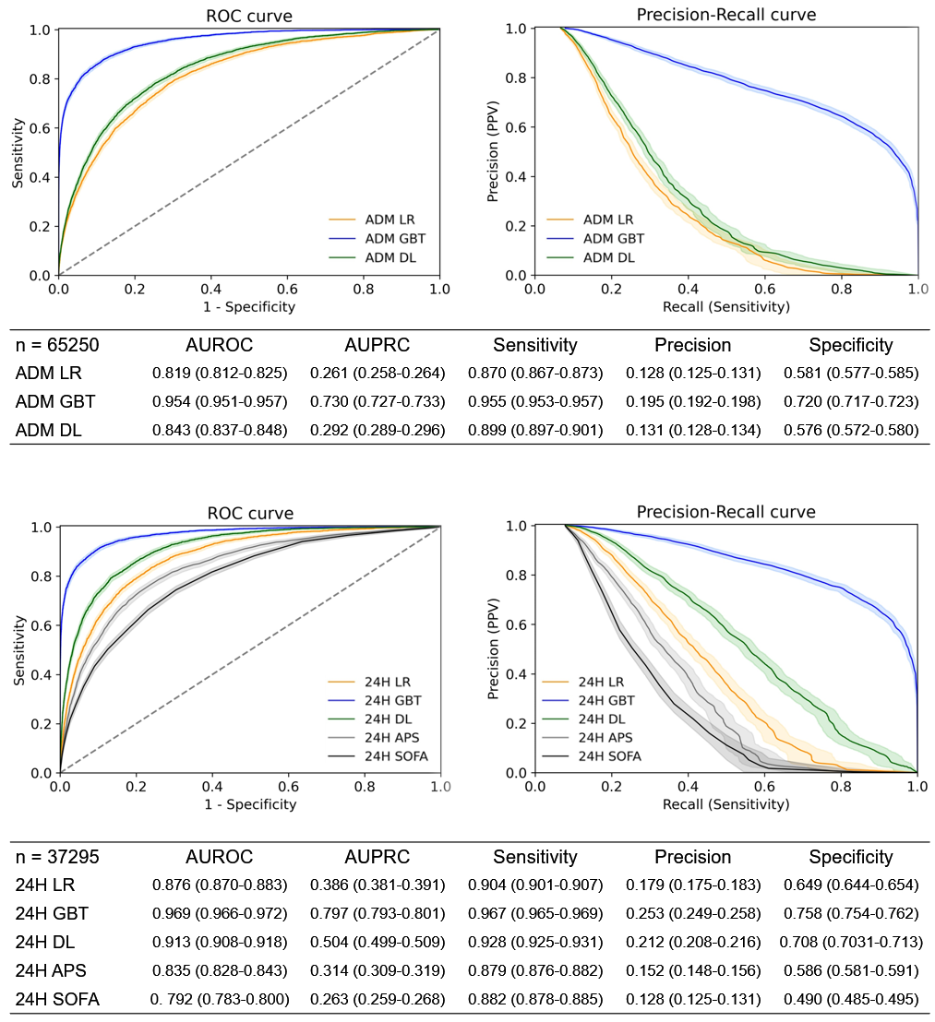
Performance measures are presented as values with corresponding 95% confidence intervals. The cutoff value for sensitivity, precision, and specificity was 0.04 for all models. ADM admission, APS acute physiology score of the acute physiologic assessment and chronic health evaluation (APACHE) III, AUPRC area under the precision-recall curve, AUROC area under the receiver operating characteristic curve, DL deep learning, GBT gradient boosting trees, LR logistic regression, SOFA sequential organ failure assessment.

Figure S2 Calibration plots of the 24H models
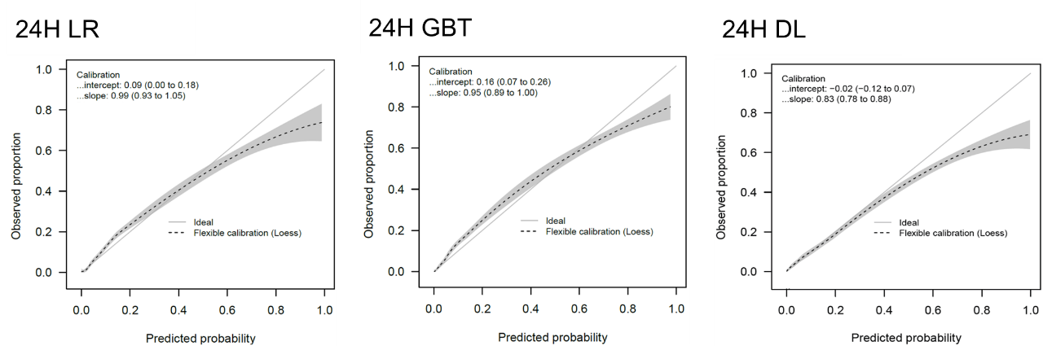
DL deep learning, GBT gradient boosting trees, LR logistic regression.

Figure S3 Feature importance of logistic regression models
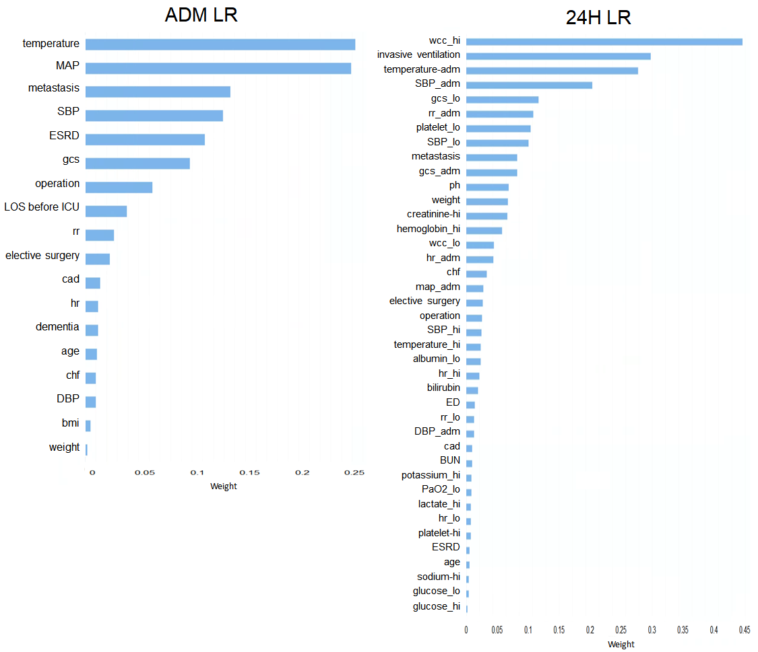
ADM admission, bmi body mass index, BUN blood urine nitrogen, cad coronary artery diseases, chf congestive heart failure, DBP diastolic blood pressure, ED emergency department, ESRD end stage renal disease, gcs Glasgow coma scale, hr heart rate, ICU intensive care unit, inv invasive ventilation, LOS length of stay, LR logistic regression, MAP mean arterial pressure, ph power of hydrogen, plat platelet, rr respiratory rate, SBP systolic blood pressure, wcc white cell counts.

Figure S4 Feature importance of deep learning models
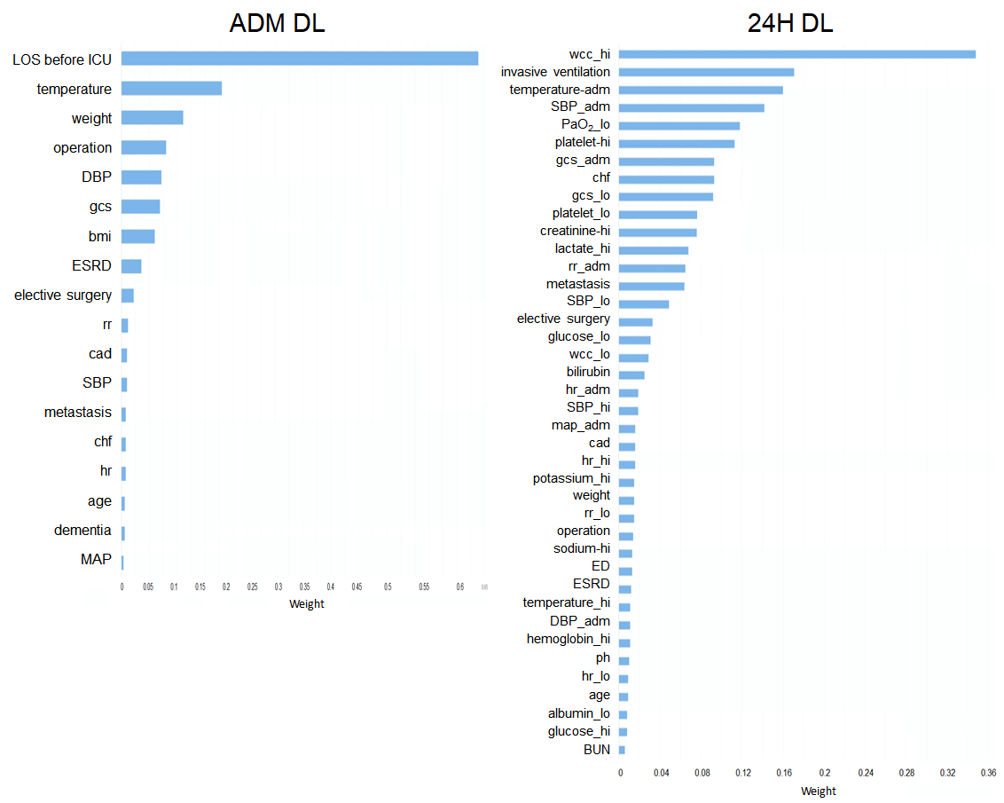
ADM admission, bmi body mass index, BUN blood urine nitrogen, cad coronary artery diseases, chf congestive heart failure, DBP diastolic blood pressure, DL deep learning, ED emergency department, ESRD end stage renal disease, gcs Glasgow coma scale, hr heart rate, ICU intensive care unit, inv invasive ventilation, LOS length of stay, MAP mean arterial pressure, ph power of hydrogen, plat platelet, rr respiratory rate, SBP systolic blood pressure, wcc white cell counts.

Figure S5 AUROC of the ADM and 24H models on different days after ICU admission
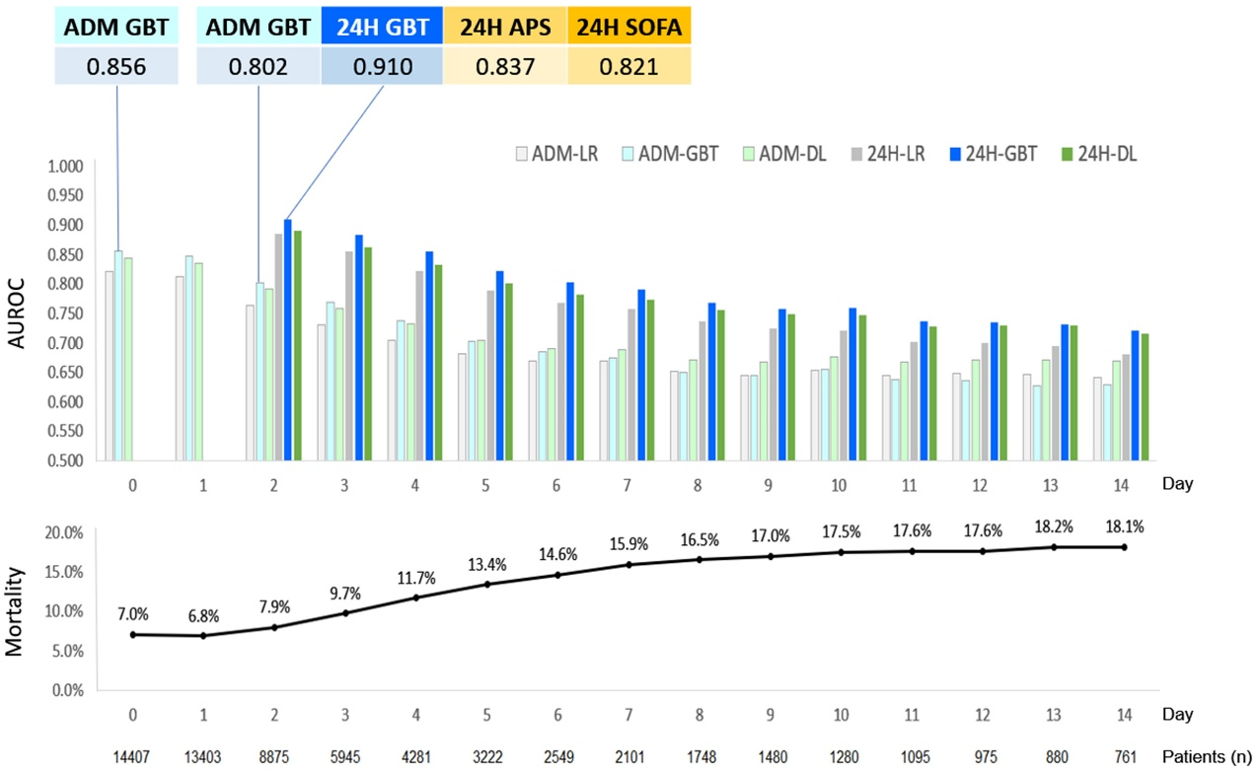
The AUROC values of the ADM and 24H models and mortality rate of patients who remained in the ICU on day 0 to 14 of ICU admission. ADM admission, APS acute physiology score of the acute physiologic assessment and chronic health evaluation (APACHE) III, AUROC area under the receiver operating characteristic curve, DL deep learning, GBT gradient boosting trees, ICU intensive care unit, LR logistic regression, SOFA sequential organ failure assessment.

Figure S6 Personalized risk assessment and simulator
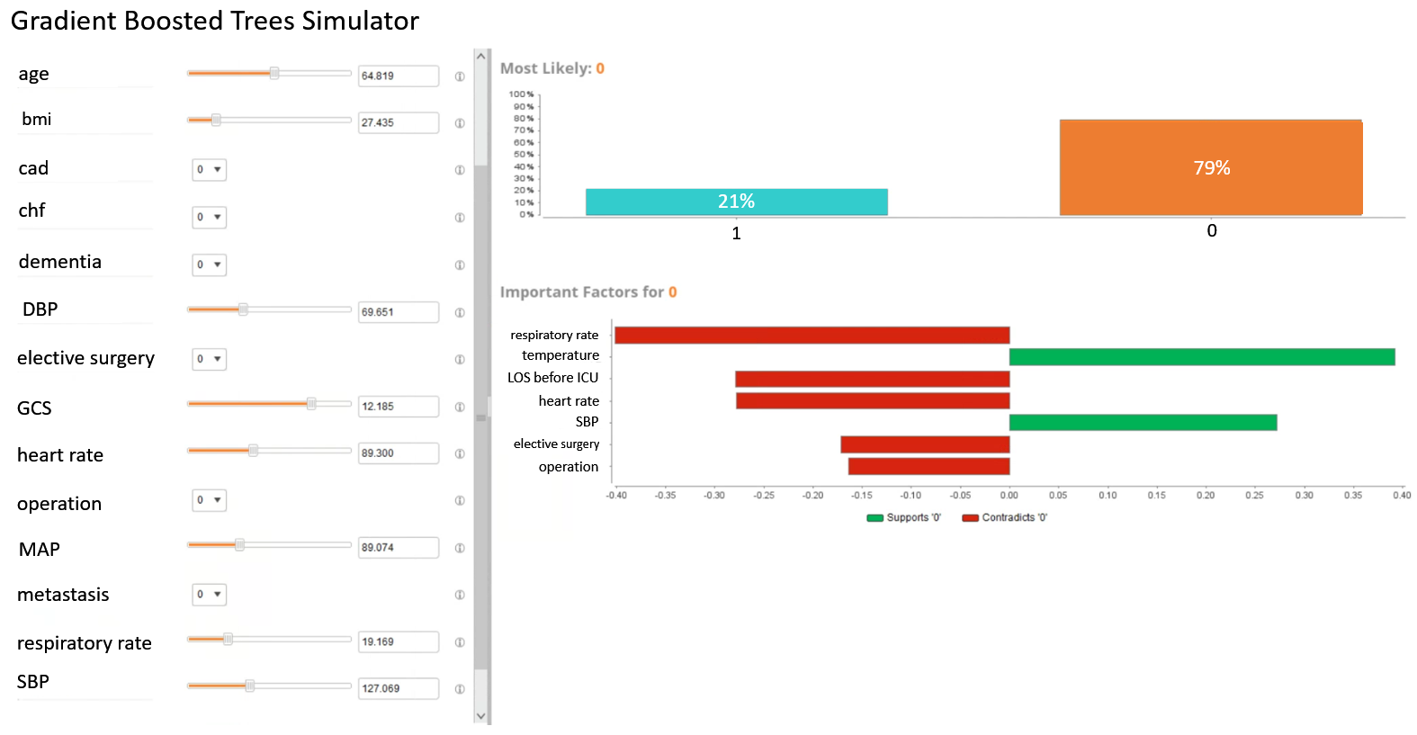
Personal risk is assessed with the contribution of each important factor. If the value of any risk factor was changed in the gradient boosted trees algorithm simulator, the simulator recalculated the predicted risk accordingly. bmi body mass index, cad coronary artery diseases, chf congestive heart failure, DBP diastolic blood pressure, GCS Glasgow coma scale, MAP mean arterial pressure, SBP systolic blood pressure.

