Supplementary Materials for
Death risk prediction model for patients with non-traumatic intracerebral hemorrhage

The file includes:
Supplemental Table 1、Table 2 、Table 3 and Table 4
Supplemental Figure 1
Supplementary statement

Supplemental Table 1. Variables extracted from the MIMIC-Ⅳ database
 | Variable
Demographics | BMI, Gender, Age
Vital signs | PO2, PCO2, Blood oxygen saturation, Positive End-Expiratory Pressure, PH, Body temperature, Heart rate, Systolic pressure, Respiratory rate
Comorbidities | Type 2 diabetes, Atrial fibrillation, Pulmonary embolism, Lower extremity venous thrombosis, Hypertension
Laboratory test | Albumin, C-reactive protein, High density lipoprotein, Low density lipoprotein, cholesterol, Creatinine, White blood cell, ALT, AST, Platelet, Hemoglobin
ICU related indicators | GCS min, GCS motor, GCS eyes, Ventilation status,
Other indicators | End time, Start time
Abbreviations: End time: End time records the end time of the ventilator treatment; Start time: Start time is also used to record the exact start time of ventilator treatment; GCS min: The minimum GCS score of a patient over a certain period reflects the patient's consciousness state at the worst time during that period. GCS motor: The "motor response" component of the Glasgow Coma Scale (GCS) represents; GCS eyes: The term " GCS eyes" refers to the "Eye Response" component of the Glasgow Coma Scale (GCS); Ventilation status: "Ventilation status" is typically used to describe a patient's status or relevant information regarding mechanical ventilation.

Supplemental Table 2. The meaning of ICD-10 codes for disease
Serial number | Variable | Diagnostic code (icdCode) | Description
1 | Non-traumatic intracerebral hemorrhage | I61 | Nontraumatic intracerebral hemorrhage
 |  | I610 | Nontraumatic intracerebral hemorrhage in hemisphere, subcortical
 |  | I611 | Nontraumatic intracerebral hemorrhage in hemisphere, cortical
 |  | I612 | Nontraumatic intracerebral hemorrhage in hemisphere, unspecified
 |  | I613 | Nontraumatic intracerebral hemorrhage in brain stem
 |  | I614 | Nontraumatic intracerebral hemorrhage in cerebellum
 |  | I615 | Nontraumatic intracerebral hemorrhage, intraventricular
 |  | I616 | Nontraumatic intracerebral hemorrhage, multiple localized
 |  | I618 | Other nontraumatic intracerebral hemorrhage
 |  | I619 | Nontraumatic intracerebral hemorrhage, unspecified
2 | BMI | Z68.1 - Z68.45 | Body mass index (BMI)
3 | Gender | N/A | There is no direct corresponding ICD-10 code
4 | Age | N/A | There is no direct corresponding ICD-10 code
5 | Death | R99 | Unexplained death
6 | Type 2 diabetes | E11.0 - E11.9 | Type 2 diabetes
7 | Atrial fibrillation | I48.0 - I48.92 | Atrial fibrillation and flutter
8 | Pulmonary embolism | I26.01 - I26.99 | Pulmonary embolism
9 | Lower extremity venous thrombosis | I82.401 - I82.4Z9 | Lower extremity venous thrombosis
10 | Hypertension | I10 - I16.9 | Hypertension
11 | PO2 | R79.81 | Abnormal blood gas
12 | Hemoglobin | R79.89 | Other abnormal findings from blood chemistry
13 | PLT | R79.89 | Other abnormal findings from blood chemistry
14 | ALT | R74.0 | Elevated levels of transaminase and lactate dehydrogenase
15 | AST | R74.0 | Elevated levels of transaminase and lactate dehydrogenase
16 | PCO2 | R79.81 | Abnormal blood gas
17 | Blood oxygen saturation | R79.89 | Other abnormal findings from blood chemistry
18 | White blood cell | R72 | Leukocytosis
19 | Creatinine | R79.89 | Other abnormal findings from blood chemistry
20 | Positive End-Expiratory Pressure | N/A | There is no direct corresponding ICD-10 code
21 | Cholesterol | E78.0 | Pure hypercholesterolemia
22 | Low density lipoprotein | R79.89 | Other abnormal findings from blood chemistry
23 | High density lipoprotein | R79.89 | Other abnormal findings from blood chemistry
24 | PH | R79.81 | Abnormal blood gas
25 | C-reactive protein | Z92.82 | Other abnormal findings from blood chemistry
26 | Albumin | R77.0 | Abnormal albumin
27 | Body temperature | R50.9 | Fever, not specified
28 | Heart rate | R00.0 | Heart rate
29 | Systolic pressure | R03.0 | Elevated blood pressure readings, no diagnosis of hypertension
30 | Respiratory rate | R06.00 | Difficulty breathing, not specified
31 | GCS min | R40.20 | Coma, not specified
32 | GCS motor | R40.20 | Coma, not specified
33 | GCS eyes | R40.20 | Coma, not specified
34 | Start time | N/A | There is no direct corresponding ICD-10 code
35 | End time | N/A | There is no direct corresponding ICD-10 code
36 | Ventilation status | Z99.11 | A state of dependence on a ventilator

Supplemental Table 3. Proportion of missing data for each variable
Variable | Missing Rate
PO2 | 29.2668760
PCO2 | 29.2668760
Low density lipoprotein | 28.7755102
PH | 28.6970173
High density lipoprotein | 27.9120879
cholesterol | 26.8916797
albumin | 15.0706436
GCS min | 13.2653061
GCS motor | 12.7158556
GCS eyes | 12.1664050
ALT | 10.8320251
AST | 9.8116170
White blood cell | 0.7849294
Platelet | 0.6279435
Creatinine | 0.6279435
Gender | 0.0000000
Age | 0.0000000
Death | 0.0000000
Type 2 diabetes | 0.0000000
Atrial fibrillation | 0.0000000
Pulmonary embolism | 0.0000000
Deep vein thrombosis | 0.0000000
Hypertension | 0.0000000

Supplemental Table 4. Model-relevant variable data for external patients
Variables | Total (n = 129) | Non-Death (n = 102) | Death (n = 27) | P
Age(years) | 57.00 (50.00, 68.00) | 55.00 (49.00, 67.00) | 61.00 (57.50, 71.50) | 0.032
LDL(mg/dL) | 98.22 (80.43, 121.81) | 99.38 (81.30, 122.78) | 97.45 (79.27, 120.84) | 0.623
Albumin(g/dL) | 3.98 (3.74, 4.26) | 3.98 (3.75, 4.26) | 3.97 (3.66, 4.17) | 0.469
GCS motor | 4.00 (3.00, 6.00) | 5.00 (4.00, 6.00) | 3.00 (1.00, 4.00) | <.001
GCS eyes | 3.00 (1.00, 4.00) | 3.00 (2.00, 4.00) | 1.00 (1.00, 1.50) | <.001
Atrial fibrillation(%) |  |  |  | 0.089
No | 118 (91.47) | 96 (94.12) | 22 (81.48)
Yes | 11 (8.53) | 6 (5.88) | 5 (18.52)
Gender(%) |  |  |  | 0.161
Male | 61 (47.29) | 45 (44.12) | 16 (59.26)
Female | 68 (52.71) | 57 (55.88) | 11 (40.74)

Supplemental Figure 1. Data cleaning flow chart

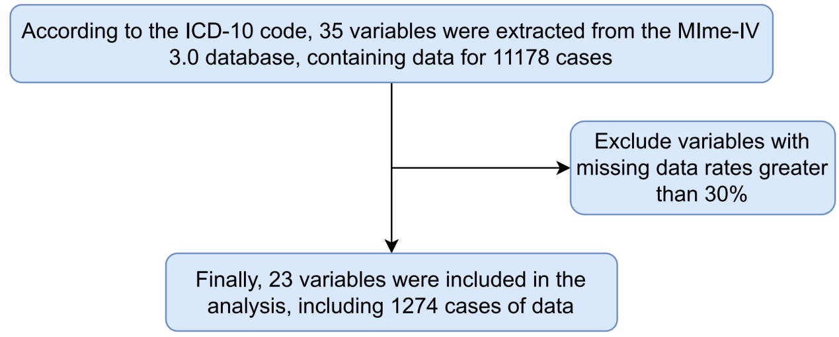

Supplementary statement
· Accuracy: Accuracy represents the proportion of correctly predicted instances, calculated as:
$$Accuracy=\frac{True Positives+True Negatives}{Total Samples}$$
​
· Sensitivity: Sensitivity, also known as recall or true positive rate, measures the model’s ability to identify positive instances, calculated as:
·
$$Sensitivity=\frac{True Positives}{True Positives+False Negatives}$$
​
· Specificity: Specificity measures the model's ability to identify negative instances, calculated as:
·
$$Specificity=\frac{True Negatives}{True Negatives+False Positives}$$
· Precision: Precision measures the proportion of positive predictions that are actually correct, calculated as:
·
$$Precision=\frac{True Positives}{True Positives+False Positives}$$
· F1 Score: The F1 score is the harmonic mean of precision and sensitivity, providing a balanced measure of model performance, calculated as:
·
$$F1 Score=2×\frac{Precision×Sensitivity}{Precision+Sensitivity}$$
· AUC (Area Under the Curve): AUC represents the area under the receiver operating characteristic (ROC) curve, which evaluates the model's ability to distinguish between positive and negative instances. A higher AUC indicates better model performance.

