Supplementary

Table S1: Interpretation for model performance metrics

Performance metrics | Definition | Formula | Interpretation
Accuracy | Accuracy is a measure of how many of the total predictions made by the model are correct | Accuracy =  (TP+TN)/ (TP+TN+FP+FN) | Accuracy tells us the overall correctness of pre- dictions. However, a highly imbalanced dataset can lead to misleadingly high accuracy if the model predicts the majority class most of the time.
Sensitivity (or Recall) | Sensitivity (or Recall) measures the ability of the model to correctly identify positive instances out of all actual positive instances | Sensitivity = TP/(TP+FN) | Recall quantifies the model’s ability to avoid missing positive cases. It’s crucial in scenarios where false negatives (missing actual positive cases) are costly or problematic.
Specificity | Specificity measures the ability of the model to correctly identify negatives instances out of all actual negative instances. | Specificity = TN/(TN+FP) | It indicates how good the model is at avoiding false positives.
Precision | Precision (or Positive Predictive Value) measures the accuracy of positive predictions made by the model | Precision = TP/(TP+FP) | Precision focuses on the accuracy of positive predictions.
AUC | Area under a receiver operating characteristic (AUC-ROC) measures the ability of a model to distinguish between the positive and negative classes by varying the classification threshold | The AUC is calculated by integrating the Receiver Operating Characteristic (ROC) curve.  AUC = 1: Perfect classifier  0.9 < AUC < 1: Excellent classifier  0.8 < AUC < 0.9: Good classifier  0.7 < AUC < 0.8: Fair classifier  0.6 < AUC < 0.7: Poor classifier  AUC = 0.5: Random chance (no discrimination between classes)  AUC < 0.5: Worse than random chance (inverse discrimination) | The ROC curve plots the True Positive Rate (Recall) against the False Positive Rate at various threshold values, and AUC-ROC calculates the area under this curve.
F1-score | The F1-score is the harmonic mean of precision and recall. It provides a single metric that balances both precision and recall. | F1-score = 2(Precision*Recall)/(Precision+Recall) | The F1-score combines the strengths of precision and recall into a single metric.
True Positives (TP) are the number of patients who are correctly diagnosed with the disease by the test.
False Positives (FP) are the number of patients who are incorrectly diagnosed with the disease by the test, when they do not actually have the disease.
False Negatives (FN) are the number of patients who are incorrectly diagnosed as not having the disease by the test, when they actually do have the disease.
True Negatives (TN) are the number of patients who are correctly diagnosed as not having the disease by the test.

Table S2: A list of the variables’ names included in the SHAP plot

 | Variable names | Definition
1 | PIR | Ratio of family income to poverty
2 | sex | Sex (1: Male, 2: Female)
3 | hyper | Hypertension (0: No, 1: Yes)
4 | sHCOT | Hydroxycotinine, Serum (ng/mL)
5 | BMI | Body mass index (kg/m²)
6 | sCOT | Cotinine, Serum (ng/mL)
7 | educ | Education level (1: Less than 9th grade, 2: 9-11th grade, 3: High school graduate, 4: Some college or AA degree, 5: College graduate or above)
8 | Glu | Blood glucose (mg/dL)
9 | age | Age (Years)
10 | masts | Marital status (1: Married, 2: Widowed, 3: Divorced, 4: Separated, 5: Never married, 6: Living with partner)
11 | eGFR | Estimated Glomerular filtration rate (mL/min/1.73m2)
12 | ALT | alanine aminotransferase (U/L)
13 | HDLc | High density lipoprotein cholesterol (mg/dL)
14 | AST | Aspartate aminotransferase (U/L)
15 | PA | Physical activity (1: Mild, 2: Moderate, 3: Vigorous)
16 | BUN | blood urea nitrogen, mg/dL
17 | TC | Total cholesterol (mg/dL)
18 | DBP | Diastolic blood pressure (mmHg)
19 | SBP | Systolic blood pressure (mmHg)
20 | smsts | Smoking status (1: Never, 2: Past, 3: Current)
21 | fa_income | Family income (1: Very low, 2: Low-Medium, 3: Medium-High, 4: High)
22 | db | Diabetes mellitus (0: No, 1: Yes)
24 | drksts | Drinking status (1: Never, 2: Past, 3: Current)
25 | ethnic | Race (1: Mexican American, 2: Other Hispanic, 3: Non-Hispanic White, 4: Non-Hispanic Black, 6: Non-Hispanic Asian, 7: Other Race - Multi-Racial)
26 | dyslip | Dyslipidemia (0: No, 1: Yes)
27 | target | Depression (0: No, 1: Yes)

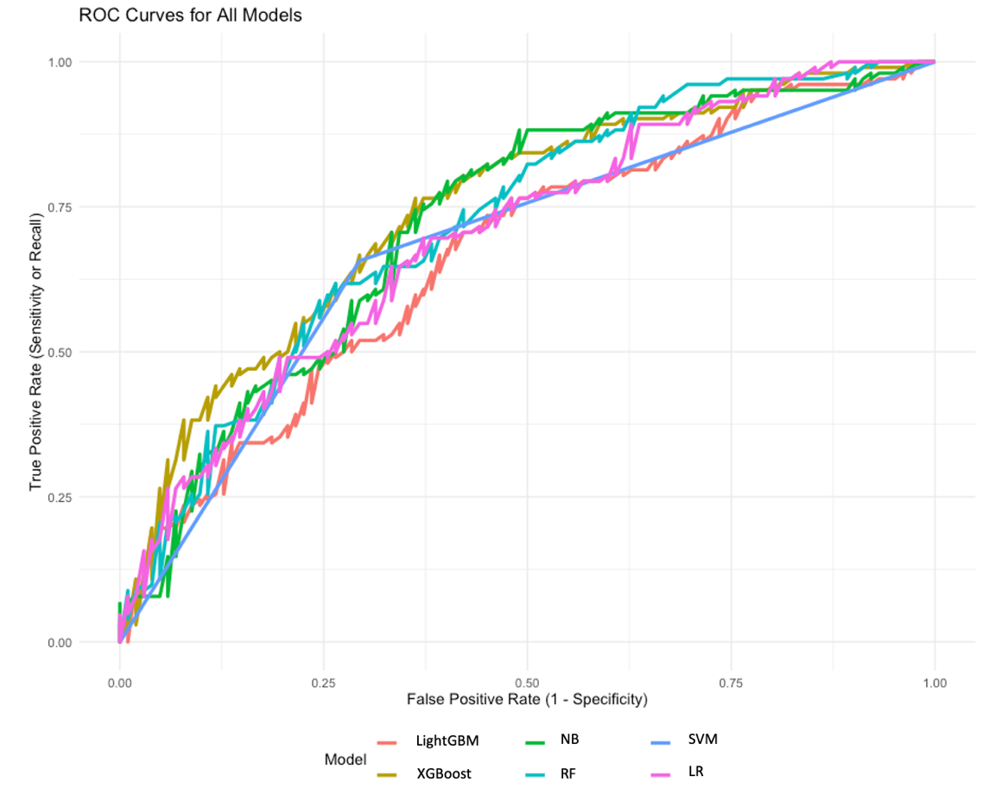
Figure S1: ROC curves for all machine learning models

