Supplementary data

Supplementary Methods

Cohort identification
ADICAP is a thesaurus elaborated by the Association for the Development of the Informatic in Cytology and Anatomic Pathology. ADICAP codes are present in every pathology report. They are composed of 8 mandatory alphanumerical characters and 7 optional alphanumerical characters. The first character informs on the sampling mode, the third and fourth characters informs on the sampled organ and the fifth to the eighth characters describe the lesion (benign or malignant nature, histological type). As an example, the code OHAFE7T0 describe a surgical specimen with complete excision (O), sampled from the nasal cavities (AF), that corresponds to an in situ (T0) squamous cell carcinoma (E7).
ADICAP codes were extracted from every pathology reports available in the CDW using natural language processing (NLP) methods*. The code list was reviewed by a surgeon (PR) and only the ones compatible with an HNC were kept.

* ESMO Real World Data and Digital Oncology Multimodal identification of rare head and neck cancer patients' cohort in the clinical data warehouse of Greater Paris Teaching Hospital, Ambre La Rosa, Marie Verdoux, Pierre Riebler, Ihsan Lolli, Christel Daniel, Xavier Tannier, Sarah Atallah, Bertrand Baujat, Emmanuelle Kempf, Accepted for publication on March 10th, 2025

HQSIs identification, algorithm building and calculation
For each HQSI, we identified the underlying elementary variables and the sources available to build such elementary variables. The computing rules of each variable were established based on completeness and quality of the data sources. For each source, we identified its structured or unstructured characteristics. One or many algorithm(s) of sources prioritization were developed, considering the data source quality (for example, considering first the most reliable source (with the least aberrant data) and in the correct format, even if there are missing data).
The performance metrics were the following:
- Positive predictive value (PPV), defined as the probability that a patient identified as having a HNC had such a disease (calculated by dividing the number of true positives (TP) by the number of people who tested positive, i.e. true positives and false positives (FP): TP/(TP + FP))
- Accuracy, defined as the ratio between the true cases (TP and true negatives (TN) and the overall population and calculated by: (TP + TN) / (TP + TN + FP + FN)
- F1-score, defined the harmonic mean of the PPV and sensitivity (TP / (TP + FN)) scores.

Identification of newly referred HNC patients
We grouped the first ICD-10 codes and ADICAP’s anatomical classification according to the French Cancer Registry anatomical groups for HNC which are ‘Lips, Oral cavity and pharynx’ (LOP) for ICD-10 codes from C00 to C14, ‘Sinuses, nasal cavity and ears’ for ICD-10 codes C30 and C31 and ‘Larynx’ for ICD-10 code C32 and we computed the accuracy considering ADICAP as the gold standard.

Supplementary results

Building HQSI algorithms
The rules of HQSI calculation and the definition of the related elementary variables are displayed in Supp Table 1.
Supp Table 1: Rules for HQSI calculation and related elementary variables.
HQSI | Rules of calculation | Elementary variables
(1) Number of yearly newly referred patients with an HNC | Method 1: ICD-10  Primary diagnosis or related diagnosis compatible with an HNC AND during the reference year  Method 2: ADICAP  Presence of a pathology report during the reference year AND possibility to extract the ADICAP code AND ADICAP code compatible with an HNC | Hospital diagnosis of HNC  Date of hospital HNC diagnosis
(2) Number of yearly cases treated by surgery as a first treatment option | Method 1: CCAM  Hospital diagnosis of HNC AND CCAM code compatible with a surgical excision of an HNC  Method 2: ADICAP  Hospital diagnosis of HNC AND possibility to extract the ADICAP code AND ADICAP code compatible with an HNC AND ADICAP code compatible with a surgery | Cancer surgical excision  Date of HNC surgery
(3) Number of patients treated by surgery requiring surgical re-intervention | Method 1: CCAM  Diagnosis of HNC AND patient treated by surgery AND surgical act with CCAM code compatible with a reintervention AND within 28 days after the initial surgery. | Postoperative surgical reintervention  Date of postoperative reintervention
(2) is calculated within the cohort identified by (1) and (3) is calculated within the cohort identified by (2).
ADICAP: Association for the Development of the Informatic in Cytology and Anatomic Pathology. CCAM: French Common Classification for Medical Acts. HNC: head and neck cancer. ICD-10: international classification of diseases 10th edition.

Elementary variables, data sources and data quality
The data sources used to populate these variables are presented in Supp Table 2. No source was used among the unstructured data sources. The ADICAP codes and dates found in the text of pathology reports were semi-structured data that could be used.
Supp Table 2 : Identification of data sources available to populate HQSI elementary variables.
Elementary variables | Structured sources | Unstructured sources
Hospital diagnosis of HNC and related date | PMSI (CIM-10)  ADICAP codes*  Pathology report’s dates* | Pathology report’s conclusion  Multidisciplinary clinical report (semi-structured field or free text)  Hospitalization report  Operative report
Cancer surgical excision and related date | PMSI (CCAM)  ADICAP codes*  Pathology report’s dates* | Multidisciplinary meeting (MDM) (semi-structured field or free text)  Hospitalization report  Operative report
Postoperative surgical reintervention and related date | PMSI (CCAM) | Multidisciplinary meeting (MDM) report (semi-structured field or free text)  Hospitalization report  Operative report
ADICAP: Association for the Development of the Informatic in Cytology and Anatomic Pathology. CCAM: French Common Classification for Medical Acts. HNC: head and neck cancer. ICD-10: international classification of diseases 10th edition.
*These data are semi-structured data
In bold, the unstructured data sources which were used to compute HQSI.

HQSI calculation

Number of yearly newly managed cases

Identification of HNC topography

Supp Figure 2 displays the number of yearly newly managed cases with respect to the French Cancer Registry anatomical groups.
The accuracy of the mapping between ICD-10 and ADICAP’s anatomical classification are presented in Supp Table 3. The results obtained by comparing the most frequent ICD-10 code and the last ICD-10 code were comparable.
Supp Table 3. Accuracy of anatomical location given by the first used ICD-10 code when compared to ADICAP code.
 | Biopsy | Surgical specimen | Biopsy or surgical specimen
LOP | 89% | 92% | 89%
Sinuses, nasal cavities and ears | 98% | 96% | 97%
Larynx | 88% | 96% | 92%

LOP : lips, oral cavity and pharynx.

Identification of hospital HNC diagnosis date source
Based on 7,608 pathology reports, 4,485 patients were identified with ADICAP codes. Sampling date was available for 4,770 reports (63%), reception date was available for 7,607 reports (> 99%) and the date of creation of the pathology report was available for every report (100%). For every pathology report for which these dates were available, we computed the difference between them (Supp Figure 3).

We estimated the hospital diagnosis date when no pathology report was available for 2,458 patients who were identified with ICD-10 codes solely. Referring to patients with an ICD-10 code, an ADICAP code (n = 3,592) and a sampling date available (n = 2,123), we computed the difference between the sampling date and the start date of the hospital stay related to the 3 types of ICD-10 codes.
- the first ICD-10 code (firstCode_date),
- the first occurrence of the most frequent ICD-10 code (lastCode_firstDate),
- the first occurrence of the last used ICD-10 code (mostFrequentCode_firstDate) (Supp Figure 4).

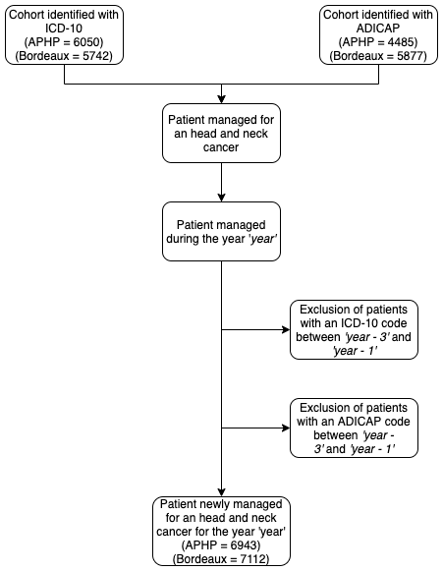
Supp Figure 1: flow diagram for the identification of yearly newly managed head and neck cancer. ICD-10: international classification of diseases 10th edition. ADICAP: Association for the Development of the Informatic in Cytology and Anatomic Pathology.

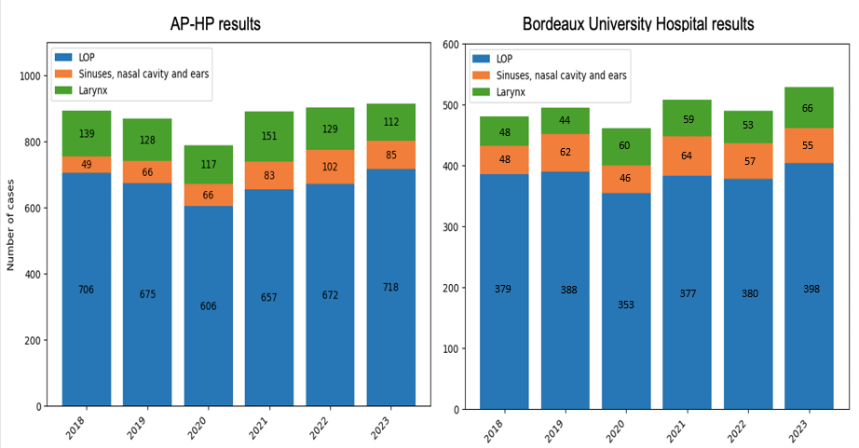
Supp Figure 2. Annual number of newly referred HNC diagnoses between 2018 and 2023 at the AP-HP and at the Bordeaux University Hospital, according to the French Cancer Registry anatomical groups
Abbreviations: AP-HP, Assistance Publique - Hôpitaux de Paris; LOP, oral cavity and pharynx

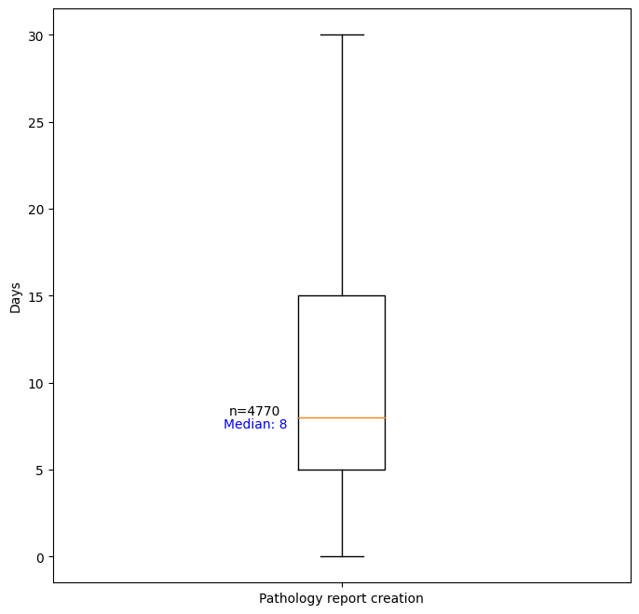

Supp Figure 3. Distribution of the difference (in days) between the sampling date and the date of pathology report creation

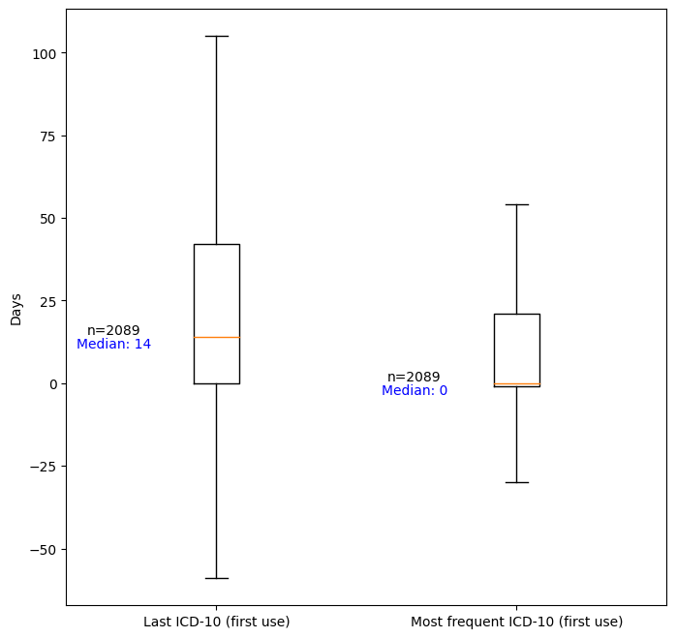

Supp Figure 4: Distribution of the difference (in days) between the sampling dateand the first occurrence of the last used international classification of diseases 10th edition (ICD-10 code) and the first occurrence of the most frequently used ICD-10 code.

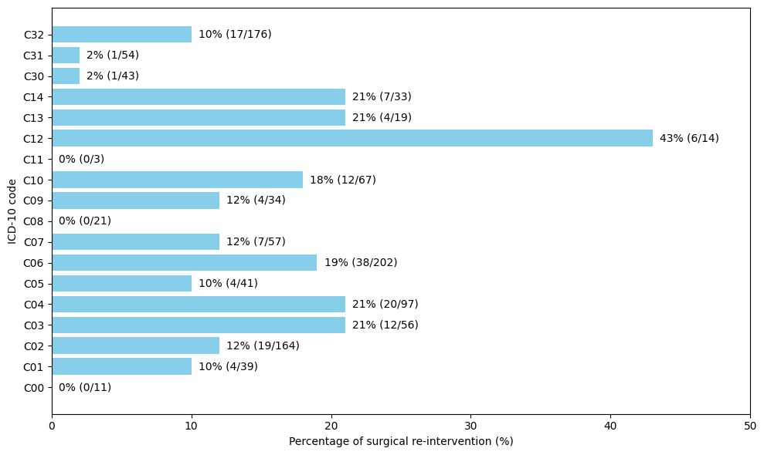
Supp Figure 5: percentage of surgical re-intervention after an surgery as a firstline treatment and within 28 post-operative days, according to ICD-10 code (n = 1,131).
ICD-10: international classification of diseases 10th edition.

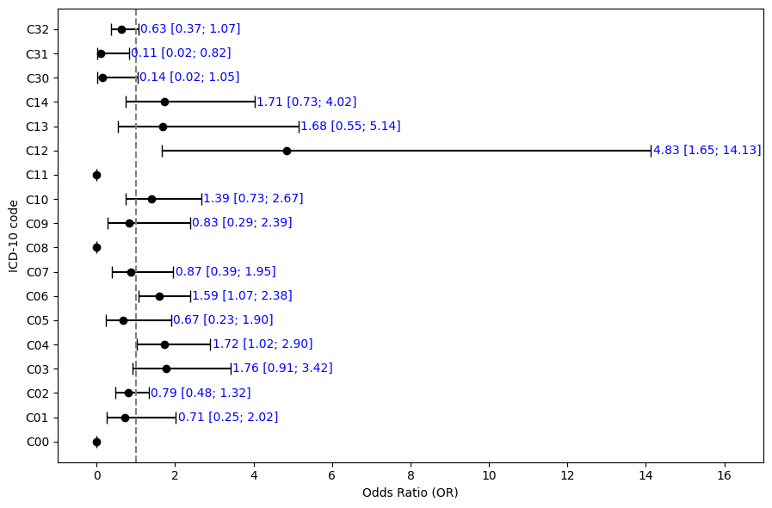
Supp Figure 6: Odd-ratio and 95% confidence interval of the risk of surgical re-intervention for each ICD-10 code (n = 1,131).
ICD-10: international classification of diseases 10th edition.

Appendix 1: list of ICD-10 codes used for head and neck cancer patients’ identification

C00: Malignant neoplasm of lip
C01: Malignant neoplasm of base of tongue
C02: Malignant neoplasm of other and unspecified parts of tongue
C03: Malignant neoplasm of gum
C04: Malignant neoplasm of floor of mouth
C05: Malignant neoplasm of palate
C06: Malignant neoplasm of other and unspecified parts of mouth
C07: Malignant neoplasm of parotid gland
C08: Malignant neoplasm of other and unspecified major salivary glands
C09: Malignant neoplasm of tonsil
C10: Malignant neoplasm of oropharynx
C11: Malignant neoplasm of nasopharynx
C12: Malignant neoplasm of piriform sinus
C13: Malignant neoplasm of hypopharynx
C14: Malignant neoplasm of other and ill-defined sites in the lip, oral cavity, and pharynx
C30: Malignant neoplasm of nasal cavity and middle ear
C31: Malignant neoplasm of accessory sinuses
C32: Malignant neoplasm of larynx
Appendix 2: list of ADICAP codes used for head and neck cancer patients’ identification
ADICAP is a thesaurus elaborated by the Association for the Development of the Informatic in Cytology and Anatomic Pathology. ADICAP codes are present in every pathology report. They are composed of 8 mandatory alphanumerical characters and 7 optional alphanumerical characters. The first character informs on the sampling mode, the third and fourth characters informs on the sampled organ and the fifth to the eighth characters describe the lesion (benign or malignant nature, histological type). As an example, the code OHAFE7T0 describe a surgical specimen with complete excision (O), sampled from the nasal cavities (AF), that corresponds to an in situ (T0) squamous cell carcinoma (E7).
Dictionary D3 – third and fourth characters
Code | Organ
AA | Palatine tonsil
AC | Cavum - nasopharynx
AF | Nasal cavity
AH | Hypopharynx
AL | Larynx
AO | Oropharynx
AP | Pharynx
AS | Facial sinuses
AZ | Upper aero-digestive system
BA | Other accessory salivary gland - salivary gland
BD | Tooth - dental arch
BG | Gum
BL | Tongue
BM | Submandibular gland
BP | Parotid gland
BS | Sublingual gland
BV | Vermilion - lip
BX | Oral cavity
BZ | Oral and salivary device
OR | Ear (outer, middle, inner, mastoid)

Dictionary D5 - sixth character
Code
5 | Cancer in situ or intraepithelial
6 | Micro-invasive cancer
7 | Invasive cancer
M | Metastatic cancer

Appendix 3: ICD-10 codes mapping towards ADICAP anatomical classification related to head and neck cancer cases
ICD-10 code | ADICAP characters | ADICAP organ
C09 | AA | Palatine tonsil
C14 | AZ | Upper aerodigestive tract
C14 | BZ | Buccal-dental-salivary apparatus
C06 | BA | Other accessory salivary gland - salivary gland
C04 | BX | Oral cavity
C05 | BX | Oral cavity
C06* | BX | Oral cavity
C11 | AC | Nasopharynx
C14 | BD | Tooth - dental arch
C30 | AF | Nasal cavity
C03 | BG | Gum
C07 | BP | Parotid gland
C08 | BM | Submandibular gland
C08 | BS | Sublingual gland
C12 | AH | Hypopharynx
C13* | AH | Hypopharynx
C01 | BL | Tongue
C02* | BL | Tongue
C32 | AL | Larynx
C30 | OR | Ear (external, middle, inner, mastoid)
C05 | AO | Oropharynx
C10* | AO | Oropharynx
C14 | AP | Pharynx
C31 | AS | Paranasal sinus
C00 | BV | Vermilion border - lip

When many ICD-10 codes are mapped to one ADICAP organ, the ICD-10 code that was attributed when a patient was only identified by ADICAP is marked with *.
Appendix 4: ADICAP anatomical classification mapping towards ICD-10 codes related to head and neck cancer cases

ADICAP caracters and label |  | ICD-10 caracters and label
AA | Palatine tonsil | C09 | Malignant tumor of the tonsil
AZ | Upper aerodigestive tract | C14 | Malignant tumor of the lip, oral cavity, and pharynx, unspecified site
BZ | Buccodental salivary apparatus | C14 | Malignant tumor of the lip, oral cavity, and pharynx, unspecified site
BA | Other accessory salivary gland - salivary gland | C06 | Malignant tumor of the mouth, other and unspecified parts
BX | Oral cavity | C06 | Malignant tumor of the mouth, other and unspecified parts
AC | Cavum - nasopharynx | C11 | Malignant tumor of the nasopharynx
BD | Teeth - dental arch | C14 | Malignant tumor of the oral cavity and pharynx, unspecified site
AF | Nasal cavities | C30 | Malignant tumor of the nasal cavities and middle ear
BG | Gum | C03 | Malignant tumor of the gum
BP | Parotid gland | C07 | Malignant tumor of the parotid gland
BM | Submaxillary gland | C08 | Malignant tumor of major salivary glands, other and unspecified
BS | Sublingual gland | C08 | Malignant tumor of major salivary glands, other and unspecified
AH | Hypopharynx | C13 | Malignant tumor of the hypopharynx
BL | Tongue | C02 | Malignant tumor of the tongue, other and unspecified parts
AL | Larynx | C32 | Malignant tumor of the larynx
OR | Ear (external, middle, internal, mastoid) | C30 | Malignant tumor of the nasal cavities and middle ear
AO | Oropharynx | C10 | Malignant tumor of the oropharynx
AP | Pharynx | C14 | Malignant tumor of the lip, oral cavity, and pharynx, unspecified site
AS | Sinuses of the face | C31 | Malignant tumor of the sinuses of the face
BV | Vermilion - lip | C00 | Malignant tumor of the lip

Appendix 5: CCAM codes compatible with the excision of an head an neck cancer
ACFA003 Excision of a tumor of the tip of the rock, by translabyrinthine approach, ACFA005 Excision of a tumor of the pontocerebellar angle and/or of the internal acoustic meatus [internal auditory canal], by presigmoid retrolabyrinthic approach, ACFA006 Excision of a tumor of the tip of the rock without diversion of the facial nerve, by transpetrous approach, ACFA007 Excision of a tumor of the pontocerebellar angle and/or the internal acoustic meatus [internal auditory canal], by translabyrinthine approach, ACFA009 Excision of a tumor from the tip of the rock, by suprapetrosal approach, ACFA010 Excision of a tumor of the pontocerebellar angle and/or the internal acoustic meatus [internal auditory canal], by retrosigmoid infraoccipital approach, ACFA012 Tumor excision of the pontocerebellar angle and/or the internal acoustic meatus [internal auditory canal], by suprapetrosal approach, ACFA014 Excision of a tumor of the pontocerebellar angle and/or the internal acoustic meatus [duct] internal auditory], by two approaches, ACFA026Excision of a tumor of the anterior level of the base of the skull, by bilateral frontal craniotomy and ethmoid approach, ACFA027 Excision of a tumor of the pontocerebellar angle and/or of the internal acoustic meatus [internal auditory canal], by transotic approach, ACFA029 Excision of a tumor of the tip of the rock with diversion of the facial nerve, by transpetreous approach, BHGA007 Enucleation of the ocular bulb [globe], with insertion of a biocolonizable implant in the bulb sheath [Tenon capsule], BKGA004 Exenteration of the orbit extended to adjacent muscle structures and/or bone walls, with filling by cutaneous autograft and temporal muscle flap, BKGA006 Exenteration of the orbit extended to adjacent muscle structures and/or bone walls, without filling, BKGA007 Exenteration of the orbit, CAFA001 Excision of the outer ear enlarged to the rock, CAFA004 Excision of the outer ear enlarged to the middle ear, CAFA007 Total excision of the atrium and cartilage of the external acoustic meatus, CAFA008 Excision of the outer ear enlarged to the rock, the parotid gland and the infratemporal fossa, CAFA009 Excision of the obliterative bone lesion of the external acoustic meatus, CAFA010 Excision of the outer ear enlarged to the parotid gland and the infratemporal fossa, CAFA011 Partial excision of the external acoustic meatus, CBFA008 Excision of a non-cholesteatomatous tumor of the middle ear, extended to all the cavities of the middle ear, without laser, CBFA009 Excision of a non-cholesteatomatous tumor of the middle ear, extended to all the cavities of the middle ear, with laser, CBFA010 Excision of a non-cholesteatomatous tumor of the middle ear, limited to the tympanic cavum, GAFA006 Excision of lesion or malformation of the nasal cavity, by paralateronasal approach, GAFA008 Amputation of the nasal pyramid, GAFD001 Excision of lesion or malformation of the nasal cavity, by the nasal route, GAFD002 Intranasal polypectomy, GAND001 Unilateral or bilateral cauterization of the mucosa of the inferior turbinate, GBBA001 Unilateral or bilateral exclusion of the frontal sinus by resection of the posterior wall [Frontal sinus cranialization], GBCA001 Unilateral or bilateral exclusion of the frontal sinus by filling, GBFA001 Excision of a lesion of the frontal sinus, by frontoeyebrow approach, GBFA002 Excision of an ethmoid sinus lesion, by paralateronasal approach or by bilateral approach of the canine fossa [bivestibular approach], GBFA003 Excision of frontal sinus lesion, by coronal approach, GBFA004 Unilateral total resection of the ethmoid sinus with excision of the sieve lamina and meninge, by paralateral, GBFA005 Unilateral total resection of the ethmoid sinus with sphenoidal and maxillary sinusotomy, by paralateral, GBFA006 Bilateral total resection of the ethmoid sinus with sphenoidal and maxillary sinusotomy, by paralateronasal and/or infrafronto-orbito-nasal approach, GBFA007, GBFA008 Bilateral anterior ethmoidectomy with nasal septoplasty, by endoscopy, GBGD001 Postoperative dismemberment and/or cleaning of the paranasal sinus, under general anesthesia, GBJA001 Unilateral or bilateral collection evacuation of the frontal sinus, by nasal endoscopy and by direct approach, GBPA001 Maxillary sinusotomy by access to the canine fossa [vestibular approach], with ethmoid and/or sphenoidal sinusotomy, GBPA002 Maxillary sinusotomy, by approach to the canine fossa [vestibular approach] and by the middle meatal approach, GBPA003 Unilateral or bilateral frontal sinusotomy with resection of the nasal septum and floor, by nasal endoscopy or direct approach, GBPA004 Maxillary sinusotomy, by approach to the canine fossa [vestibular approach], GBPE001 Middle nasal meatotomy, by endoscopy, GBPE003 Bilateral lower nasal meatotomy, by endoscopy, GCFA001 Excision of lesion of the nasopharynx and/or infratemporal fossa, by preauricular and/or transzygomatic approach, GCFA002 Excision of lesion of the nasopharynx and/or infratemporal fossa, by anterior transpetrosal approach, GCFA003 Excision of nasopharyngeal lesion, by transpalatal approach with laser, GCFA004 Excision of lesion of the nasopharynx and/or infratemporal fossa, by transmandibular approach, GCFA005 Excision of lesion of the nasopharynx, by transpalatal approach without laser, GCFA006 Excision of lesion of the nasopharynx and/or infratemporal fossa, by transmaxillary approach and by transmandibular approach, GCFA007 Excision of lesion of the nasopharynx and/or infratemporal fossa, by transmaxillary approach, GCFD001 Excision of lesion of the nasopharynx, by nasal and/or oral approach without laser, GCFD002 Excision of nasopharyngeal lesions, nasal and/or oral with laser, GDFA001 Hyothyro-epiglottectomy, GDFA002 Bilateral laryngeal cordectomy, by thyrotomy, GDFA003 Horizontal glotectectomy, GDFA004 Unilateral laryngeal cordectomy, by thyrotomy, GDFA005 Total laryngectomy, GDFA006 Vertical partial laryngectomy, GDFA007 Excision of infraglottic laryngeal lesion, by laryngotomy, GDFA008 Supraglottic laryngectomy extended to the base of the tongue, GDFA009 Supracricoid laryngectomy with cricohyoidopexy, GDFA010 Arytenoidectomy or arytenoidopexy, by thyrotomy, GDFA011 Supracricoid laryngectomy with crico-hyoido-epiglottopexy, GDFA012 Supracricoid Laryngopharyngectomy with Cricohyoidopexy, GDFA013 Hemilaryngopharyngectomy, GDFA014 Supraglottic Laryngectomy, GDFA015, GDFA016 Anterior Frontal Laryngectomy with Epiglottoplasty, GDFA017 Supraglottic Laryngopharyngectomy, GDFA018 Total Laryngectomy Extended to the Base of the Tongue, GDFE001 Ararytenoidectomy, by Direct Laryngoscopy, GDFE002 Excision of Lesion or Peeling of the Mucosa of the Glottic Plan, by Direct Laryngoscopy with Laser, GDFE003 Laryngeal cordectomy, by direct laryngoscopy with laser, GDFE004 Excision of lesion or peeling of the mucosa of the glottic plane, by direct laryngoscopy without laser, GDFE005 Resection or section of aryepiglottic folds, by direct laryngoscopy without laser, GDFE006 Excision of infraglottic laryngeal lesion, by direct laryngoscopy with laser, GDFE007 Laryngeal cordectomy, by direct laryngoscopy without laser, GDFE008 Partial epiglottectomy, by direct laryngoscopy without laser, GDFE009 Partial epiglottectomy, by direct laryngoscopy with laser, GDFE010 Excision of the vestibule of the larynx, by direct laryngoscopy with laser, GDFE011 Excision of infraglottic laryngeal lesion, by direct laryngoscopy without laser, GDFE013 Resection or section of aryepiglottic folds, by direct laryngoscopy with laser, GDFE014 Excision of submucosal lesion of the glottic plane, by direct laryngoscopy, GDFE015 Excision of the vestibule of the larynx, by direct laryngoscopy without laser, GDNE002 Destruction of lesion of the larynx, by direct laryngoscopy without laser, GDNE003 Destruction of lesion of the larynx, by direct laryngoscopy with laser, GDPE001 Unobstruction of the larynx, by direct laryngoscopy with laser, HAFA001 Basic partial glossectomy, by cervicotomy, HAFA002 Non-interruptive pelvi-glosso-mandibulectomy, by intraoral approach, HAFA003 Total glossectomy of the mobile tongue, by cervicofacial approach, HAFA004 Interrupting pelvimandibulectomy, by cervicofacial approach, HAFA005 Partial excision of the base of the tongue and/or tonsillostal sulcus, by intraoral approach, HAFA006 Pelviglossectomy of the mobile tongue, by intraoral approach, HAFA007 partial oral elvectomy, by intraoral approach, HAFA008 Non-transfixing excision of lip lesion, HAFA012 Basic total glossectomy, HAFA013 Total glossectomy of the mobile tongue, by intraoral approach, HAFA014 Vermilionectomy with reconstruction of the lip by retrolabial mucosal flap, HAFA015 Excision of lesions of the mucosa of the mouth or oropharynx with less than 2 cm of a long axis, by intraoral approach, HAFA016 Total glossectomy with total pharyngolaryngectomy, HAFA017 Interrupting pelvic-glosso-mandibulectomy, by cervicofacial approach, HAFA019 Excision of lesion of the mucosa of the mouth or oropharynx of more than 4 cm in long axis, by intraoral approach, HAFA020 Transfixing excision of lip lesion, or excision of a labial commissure, HAFA021 Non-transfixing excision of infiltrating lesion of the cheek, by intraoral approach, HAFA022 Transfixing excision of cheek lesion, by facial approach, HAFA023 Transfixing excision of lip lesion, or excision of a labial commissure, HAFA024 Non-interruptive pelvimandibulectomy, by cervicofacial approach, HAFA026 Non-interruptive pelvi-glosso-mandibulectomy, by cervicofacial approach, HAFA027 Mobile tongue pelviglossectomy, by cervicofacial approach, HAFA029 Basic total glossectomy of tongue and mobile tongue, HAFA032 Excision of lesions of the mucous membrane of the mouth or oropharynx from 2 cm to 4 cm in the long axis, by intraoral approach, HAFA033 Non-interruptive pelvimandibulectomy, by intraoral approach, HAFA034 Excision of a cyst from the floor of the mouth, by intraoral approach, HAND001 Destruction of lesions of the mucosa of the mouth or oropharynx of 2 cm to 4 cm of long axis, by oral approach without laser, HAND002 Destruction of lesions of the mucosa of the mouth or oropharynx of less than 2 cm of major axis, orally without laser, HAND003 Destruction of lesions of the mucosa of the mouth or oropharynx of more than 4 cm in the long axis, in the oral route without laser, HAND004 Destruction of lesions in the mucosa of the mouth or oropharynx of less than 2 cm in the long axis, orccal in the mouth with laser, HAND005 Destruction of lesions of the mucosa of the mouth or oropharynx of more than 4 cm of long axis, by oral approach with laser, HAND006 Destruction of lesions of the mucosa of the mouth or oropharynx of 2 cm to 4 cm of long axis, by oral approach with laser,HCFA001 Submandibular gland excision [Submandibulectomy] [Submaxillectomy] enlarged to its compartment, by cervicofacial approach, HCFA002 Total parotidectomy with facial nerve resection, HCFA003 Sublingual gland excision, by direct approach, HCFA004 Partial parotidectomy without facial nerve dissection, HCFA005 Total parotidectomy with excision of the parapharyngeal prolongation [process], by cervicofacial approach, HCFA006 Total parotidectomy enlarged to the external acoustic meatus [auditory canal] external] and/or at the mandible, HCFA007 Excision of a small salivary gland [accessory salivary gland], HCFA008 Partial parotidectomy with facial nerve dissection and preservation, HCFA009 Total parotidectomy with facial nerve dissection and preservation, HCFA010 Total parotidectomy with facial nerve resection and immediate repair by suture or graft, HCFA011 Submandibular gland excision [Submandibulectomy] [Submaxillectomy], by cervicofacial approach, HCFA012 Recurrent parotid gland tumor excision with facial nerve dissection and preservation, HCFA013 Total parotidectomy by cervicofacial approach, with excision of the parapharyngeal prolongation [process] by pharyngeal approach, HDFA001 Circular total pharyngolaryngectomy with restoration of continuity by free jejunum transplant, HDFA002 Lateral oropharyngectomy with tonsillectomy, by intraoral approach, HDFA003 Total pharyngolaryngectomy extended to the base of the tongue, HDFA004 Oropharyngectomy with non-interrupting partial mandibulectomy, by direct approach, HDFA005 Total pharyngolaryngectomy,HDFA006 Circular total pharyngolaryngectomy with restoration of continuity by retrosternal coloplasty, HDFA007 Oropharyngectomy by mandibulotomy with total pharyngolaryngectomy, HDFA008 Lateral oropharyngectomy, by cervicotomy, HDFA009 Posterior oropharyngectomy, by intraoral approach, HDFA010 Circular total pharyngolaryngectomy, HDFA011 Oropharyngectomy with interrupting partial mandibulectomy, by cervicofacial approach, HDFA012 Posterior pharyngectomy, by cervicofacial approach, by cervicofacial approach, Posterior pharyngectomy, by Cervicotomy, HDFA013 Oropharyngectomy with Interrupting Partial Mandibulectomy and Total Pharyngolaryngectomy, HDFA016 Lateral Pharyngectomy, by Cervicotomy, HDFA017 Posterior Oropharyngectomy, by Cervicotomy, Posterior Oropharyngectomy, HDFA018 Oropharyngectomy by Mandibulotomy, HDFA019 Oropharyngectomy by Mandibulotomy, HDFA020 Uvulectomy, HDFA021 U Vulelectomy with Partial Palatectomy, HDFA022 Uvulokeelectomy, HDFE002 Excision of Lesion the hypopharynx, by endoscopy,HDNE001 Destruction of hypopharyngeal lesion with laser, by endoscopy, HDNE002 Destruction of hypopharyngeal lesion without laser, by endoscopy, HEFA017 Total oesophago-pharyngo-laryngectomy with oesophagocoloplasty, by cervicotomy and by laparotomy, LAFA001 Fronto-ethmoid-sphenoido-maxillary resection, by paralateronasal approach, LAFA003 Fronto-ethmoid-sphenoido-maxillary resection, by paralateronasal and infrafrontal approach, LAFA005 Total petrectomy, LAFA006 Resection fronto-ethmoid-sphenoido-maxillary with excision of the sieve lamina and meninge, by paralateronasal approach, LAFA014 mastoidectomy or total atticomastoidectomy,LAFA015 Unilateral Total Ethmoidectomy with Nasal Septoplasty and Sphenoidotomy, by Endoscopy, LAFA016 Unilateral Total Ethmoidectomy with Nasal Septoplasty, by Endoscopy, LAFA017 Unilateral Total Ethmoidectomy with Sphenoidotomy, by Endoscopy, LAFA018 Bilateral Total Ethmoidectomy with Sphenoidotomy, by Endoscopy, LAFA019 Bilateral Total Ethmoidectomy with Nasal Septoplasty and Sphenoidotomy, by Endoscopic LAFA020 Bilateral Total Ethmoidectomy with Septoplasty nasal, by endoscopy, LAFA021 Anterior ethmoidectomy, by endoscopy, LAFA022 Bilateral total ethmoidectomy, by endoscopy, LAFA023 Unilateral anterior ethmoidectomy with nasal septoplasty, by endoscopy, LAFA024 Unilateral total ethmoidectomy, by endoscopy, LAGA008 Petromastoid recess, LBFA001 Excision of the entire palatal vault, by direct approach, LBFA005 Total maxillectomy without reconstruction, LBFA006 Upper maxillectomy without reconstruction, LBFA007 Total Maxillectomy, with reconstruction of the floor of the orbit by nasal septum flap, LBFA008 Non-interruptive extracondylar resection of the mandible, by direct approach, LBFA009 Anterior segmental interruptive resection of the body of the mandible with filling, by direct approach, LBFA011 Superior Maxillectomy, with reconstruction of the floor of the orbit by nasal septum flap, LBFA017 Lateral segmental extracondylar interruptive resection of the mandible with filling, by direct approach, LBFA024 Inferior maxillectomy, LBFA026 Interruptive resection of the condylar process of the mandible by direct approach, without placement of a terminal device or filling, LBFA028 E xresis of a quadrant of the palatal vault, by direct approach, LBFA033 Medium maxillectomy, LBFA034 Lateroterminal interruptive resection of the mandible by direct approach, without placement of a lateroterminal device or filling, LBFA037 Lateroterminal switch section of the mandible by direct approach, with placement of lateroterminal retainer, without filling

Appendix 6: CCAM codes compatible with a surgical re-intervention

ADCA002 Suturing of a wound of the extrapetrosus facial nerve, BKJA001 Evacuation of the collection of the orbit, CASA001 H emostasis secondary to an act on the outer ear or middle ear, EBSA011 H secondary emostasis, by resumption of cervicotomy, EBSA012 H emostasis secondary to an act on the cervicocephalic vessels, by cervicotomy, EZSA004 Haemostasis secondary to an act on the vessels of the limbs, by direct approach, FASD001 Haemostasis secondary to tonsillectomy or adenoidectomy, FCSA002 Ligation of the thoracic duct, by cervicotomy, GHJA001 Evacuation of the mediastinum collection, by cervicotomy, GHQA001 Exploration of the mediastinum, by cervicotomy, HAJA002 Evacuation of the pelvilingual collection, by intraoral approach, HAJD004 Collection evacuation of the base of the tongue, HASA012 Closure of orostome or pharyngostoma, HCJA001 Evacuation of salivary collection, by direct approach, HDJD002 Evacuation of peritonsillar [peritonsilla] and/or retropharyngeal collection, by oral route, HEMA007 Anastomotic stenosis plasty of the oesophagus, by cervicotomy, KCJA001 Collection evacuation of the thyroid compartment, by cervicotomy, LCJA002 Collection evacuation of the masticatory muscle region, by intraoral approach and facial approach, LCJA004 Collection evacuation of the masticatory muscle region, by intraoral approach, QAJA003 Evacuation of diffuse cervicofacial and mediastinal phlegmon, by cervicotomy, QZJA009 Evacuation of superficial collection of the skin, by direct approach, QZJA011 Evacuation of deep collection of skin and soft tissues, by direct approach, EBCA006 Suturing of the external carotid artery, by cervicotomy, EBSA001 Ligation of the sphenopalatine artery or the maxillary artery, by transnasal or transantral approach, EBSA008 Unilateral ligation of the anterior ethmoid artery and/or the posterior ethmoid artery, GDGE001 Removal of foreign bodies from the larynx, by direct laryngoscopy, GECA003 Suturing of wound or rupture of the trachea, by cervicotomy, GEGE003 Removal of intratracheal and/or intrabronchial foreign bodies, by fibroscopy, GEPA004 Tracheostomy, by cervicotomy, HAJA003 Trimming and/or suturing of non-transfixing skin wounds of the lip, HAJA006 Trimming and/or suturing of a transfixing wound of the lip, ABSA003 Closure of an osteodural breach of the frontal sinus, by coronal approach, ABSA004 Closure of an osteodural breach of the middle level of the skull base, by mastoid attical approach, ABSA006 Closure of an osteodural breach of the middle level of the skull base, by suprapetrosal approach, ABSA007 Closure of an osteodural breach or a meningocele of the anterior level of the skull base, by craniotomy, ABSA008 Closure of a postoperative fistula of cerebrospinal fluid at the base of the skull, ABSA012 Closure of an osteodural breach or meningocele of the anterior level of the skull base, by endoscopy, AHCA007 Suturing of a cervicofacial nerve wound, by direct approach, HDCA002 Suturing of a pharyngeal wound, by cervicotomy, QAJA002 Trimming and/or suturing of superficial wound of the skin of the face with a greater than 10 cm long axis, QAJA004 Trimming and/or suturing of deep wounds of the skin and soft tissues of the face less than 3 cm of major axis, QAJA006 Trimming and/or suturing of deep wounds of the skin and soft tissues of the face from 3 cm to 10 cm of major axis, QAJA012 Trimming and/or suturing of deep wounds of the skin and soft tissues of the face of more than 10 cm of major axis, QZFA023 Excision of diffuse infectious lesion of the skin and soft tissues over 50 cm² to 200 cm², QZFA038 Excision of diffuse infectious lesion of skin and soft tissues over less than 50 cm², QZGA003 Ablation of a deep foreign body of soft tissues, outside the face and hands, QZJA001 Trimming and/or suturing of deep wounds of the skin and soft tissues of more than 10 cm of major axis, outside the face and hand, QZJA012 Trimming and/or suturing of deep wounds of the skin and soft tissues of 3 cm to 10 cm of major axis, outside the face and hand, QZJA013 Secondary trimming of traumatic or infectious lesions of the skin and soft tissues, under general or locoregional anesthesia, QZJA015 Trimming and/or suturing of superficial wounds of the skin with a major axis of more than 10 cm, outside the face, QZQA001 Exploration of the skin and soft tissues without dissection of a large vascular or nerve trunk, by direct approach, ZAQA001 Exploration of the neck, by cervicotomy [Exploratory cervicotomy], QZMA002 Revision of a free flap for ischemia, without repair of the vascular anastomoses, QZMA010 Repair of the vascular anastomoses of a free flap for ischemia, ECCA004 Suturing of a wound of an artery of the upper limb, by direct approach, GAMA002 Repair of loss of substance from the nose by frontal flap to the lower pedicle, GAMA018 Repair of loss of substance of the nose by local flap, HAMA002 Repair of loss of lip substance by bilateral lip or cheek flap, HAMA005 Repair of loss of lip substance by free flap, HAMA010 Repair of loss of substance of the lower lip by sliding or rotation flap, HAMA014 Repair of loss of substance of the lip by pedicled musculocutaneous flap, HAMA016 Repair of loss of lip substance by heterolabial flap, HAMA018 Repair of loss of lip substance by heterolabial flap and bilateral lip and/or cheek flap, HAMA029 Repair of loss of lip substance by unilateral lip or cheek flap, PCPA004 Fasciomyotomy for decompression of the compartment of a limb, by direct approach, QAMA002 Repair of loss of substance of the cephalic end by local or regional mucosa, cutaneous or fasciocutaneous flap, with non-individualized or non-individualizable vasculonerous pedicle ["random" flap], QAMA003 Repair of loss of substance of the cephalic end by frontal flap with inferior pedicle, QZMA004 Repair of loss of substance by local or regional cutaneous, fascial, fasciocutaneous, septocutaneous, muscular or musculocutaneous flap, with anatomical vascular pedicle or vasculonerous, outside the cephalic end, QZMA005 Repair of loss of substance by local or regional cutaneous, fasciocutaneous or osteocutaneous flap, with anatomical vascular pedicle or vasculonerous, islet dissected, QZMA007 Repair of loss of substance by local or regional muscular flap or musculocutaneous, with anatomical vascular or vascular pedicle, islet dissected

