Supplementary file
Table A1. Results of the sensitivity analysis by varying one parameter at a time and evaluating the impact on AUC and Brier score
Eta | n-rounds | Max Depth | Min Child Weight | AUC | Brier Score | Notes
0.001 | 1000 | 2 | 5 | 0.8921 | 0.0580 | Original configuration
0.01 | 500 | 2 | 5 | 0.8906 | 0.0643 | Faster convergence
0.001 | 1500 | 2 | 5 | 0.9007 | 0.0558 | Slight loss in Brier Score
0.001 | 1000 | 3 | 5 | 0.8893 | 0.0579 | No major difference
0.001 | 1000 | 2 | 10 | 0.8926 | 0.0583 | Slight increase in AUC

Table A2. AUC and Brier score from simulation study 1
n | R (%) | Model | Landmark times
 |  |  | 0.5 | 2 | 3.5 | 5 | 6.5
1500 | 90 | CL | 0.6542(0.1133) | 0.7120(0.1034) | 0.7960(0.0844) | 0.8497(0.0666) | 0.8851(0.0528)
 | 90 | LGBM | 0.6178(0.1137) | 0.7058(0.1068) | 0.8273(0.0915) | 0.8901(0.0753) | 0.9162(0.0616)
 | 90 | Joint | 0.6227(0.1051) | 0.7800(0.0903) | 0.8901(0.0697) | 0.9272(0.0561) | 0.9379(0.0483)
1500 | 50 | CL | 0.6576(0.2187) | 0.6729(0.2150) | 0.7213(0.1834) | 0.7681(0.1498) | 0.8091(0.1203)
 | 50 | LGBM | 0.6691(0.2169) | 0.7000(0.2224) | 0.7802(0.2003) | 0.8317(0.1694) | 0.8487(0.1370)
 | 50 | Joint | 0.6739(0.2170) | 0.7511(0.2004) | 0.8474(0.1579) | 0.8853(0.1305) | 0.8942(0.1115)
1500 | 30 | CL | 0.6478(0.1692) | 0.6570(0.1983) | 0.7035(0.1882) | 0.7530(0.1621) | 0.7987(0.1329)
 | 30 | LGBM | 0.6855(0.1659) | 0.6947(0.2040) | 0.7637(0.2056) | 0.8115(0.1828) | 0.8234(0.1498)
 | 30 | Joint | 0.6872(0.1693) | 0.7485(0.1872) | 0.8406(0.1623) | 0.8774(0.1389) | 0.8852(0.1175)
1000 | 90 | CL | 0.6609(0.1100) | 0.7148(0.1011) | 0.7986(0.0830) | 0.8541(0.0653) | 0.8897(0.0524)
 | 90 | LGBM | 0.6088(0.1102) | 0.6969(0.1040) | 0.8214(0.0901) | 0.8858(0.0749) | 0.9116(0.0625)
 | 90 | Joint | 0.6333(0.1025) | 0.7831(0.0884) | 0.8896(0.0685) | 0.9272(0.0552) | 0.9392(0.0472)
1000 | 50 | CL | 0.6578(0.2243) | 0.6742(0.2163) | 0.7244(0.1829) | 0.7715(0.1489) | 0.8116(0.1193)
 | 50 | LGBM | 0.6635(0.2228) | 0.6974(0.2242) | 0.7763(0.2001) | 0.8282(0.1690) | 0.8445(0.1374)
 | 50 | Joint | 0.6699(0.2222) | 0.7496(0.2021) | 0.8475(0.1577) | 0.8863(0.1294) | 0.8960(0.1103)
1000 | 30 | CL | 0.6476(0.1757) | 0.6573(0.2024) | 0.7045(0.1919) | 0.7545(0.1659) | 0.7984(0.1356)
 | 30 | LGBM | 0.6803(0.1714) | 0.6871(0.2079) | 0.7562(0.2078) | 0.7996(0.1860) | 0.8089(0.1549)
 | 30 | Joint | 0.6834(0.1760) | 0.7457(0.1910) | 0.8421(0.1623) | 0.8784(0.1386) | 0.8863(0.1173)
650 | 90 | CL | 0.6773(0.0829) | 0.7277(0.0770) | 0.8170(0.0649) | 0.8693(0.0522) | 0.9017(0.0425)
 | 90 | LGBM | 0.5864(0.0824) | 0.6904(0.0788) | 0.8184(0.0710) | 0.8872(0.0623) | 0.9095(0.0537)
 | 90 | Joint | 0.6268(0.0786) | 0.7814(0.0690) | 0.8905(0.0549) | 0.9286(0.0450) | 0.9417(0.0384)
650 | 50 | CL | 0.6589(0.2242) | 0.6755(0.2160) | 0.7264(0.1825) | 0.7737(0.1496) | 0.8175(0.1212)
 | 50 | LGBM | 0.6604(0.2236) | 0.6927(0.2253) | 0.7746(0.2014) | 0.8226(0.1716) | 0.8340(0.1412)
 | 50 | Joint | 0.6712(0.2212) | 0.7508(0.2009) | 0.8483(0.1565) | 0.8861(0.1289) | 0.8956(0.1092)
650 | 30 | CL | 0.6482(0.1728) | 0.6575(0.2030) | 0.7059(0.1933) | 0.7590(0.1730) | 0.8091(0.1426)
 | 30 | LGBM | 0.6798(0.1689) | 0.6791(0.2088) | 0.7451(0.2114) | 0.7810(0.1931) | 0.7630(0.1655)
 | 30 | Joint | 0.6887(0.1708) | 0.7448(0.1889) | 0.8420(0.1615) | 0.8751(0.1398) | 0.8825(0.1182)
300 | 90 | CL | 0.7044(0.1028) | 0.7444(0.0955) | 0.8202(0.0800) | 0.8729(0.0646) | 0.9035(0.0517)
 | 90 | LGBM | 0.5273(0.1000) | 0.6059(0.0959) | 0.7214(0.0892) | 0.7712(0.0811) | 0.7210(0.0713)
 | 90 | Joint | 0.6274(0.0874) | 0.7815(0.0765) | 0.8874(0.0614) | 0.9265(0.0509) | -
300 | 50 | CL | 0.6593(0.2267) | 0.6772(0.2243) | 0.7284(0.1925) | 0.7755(0.1609) | 0.8257(0.1349)
 | 50 | LGBM | 0.6424(0.2232) | 0.6709(0.2306) | 0.7449(0.2122) | 0.7846(0.1872) | 0.6946(0.1684)
 | 50 | Joint | 0.6685(0.2196) | 0.7468(0.2039) | 0.8446(0.1619) | 0.8854(0.1351) | 0.8938(0.1167)
300 | 30 | CL | 0.6485(0.1747) | 0.6590(0.2094) | 0.7118(0.2064) | 0.7732(0.1905) | 0.8249(0.1808)
 | 30 | LGBM | 0.6551(0.1684) | 0.6444(0.2134) | 0.7132(0.2207) | 0.6726(0.2257) | 0.6551(0.1684)
 | 30 | Joint | 0.6866(0.1718) | 0.7402(0.1916) | 0.8398(0.1651) | 0.8779(0.1445) | 0.8855(0.1223)

Table Legend: This table presents the Area Under the Curve (AUC) and Brier score results for the Cox Landmarking (CL), Landmarking Gradient Boosting model (LGBM), and Joint Model, resulting from simulation study 1.
*AUC (Brier score); R (%): Censoring Rate.

Simulation study 1: AUC and Brier score plots for different scenarios
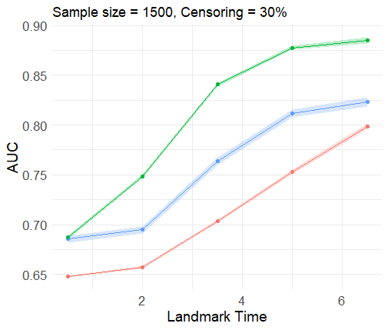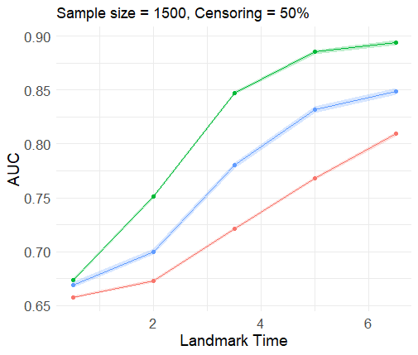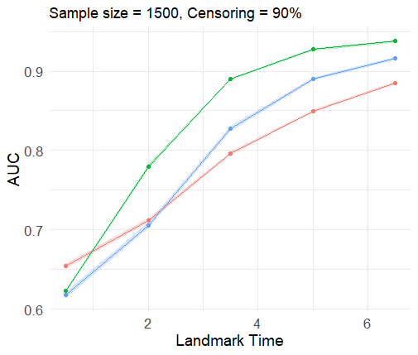

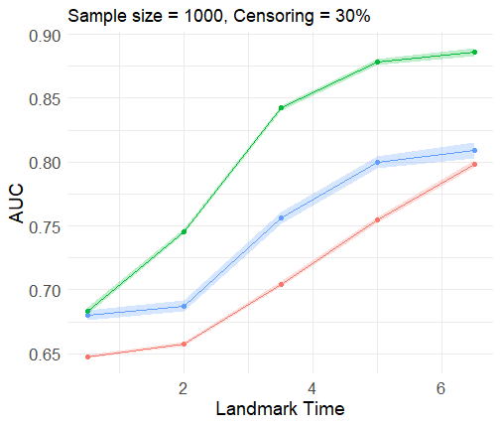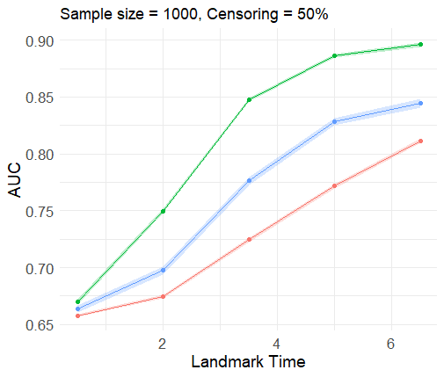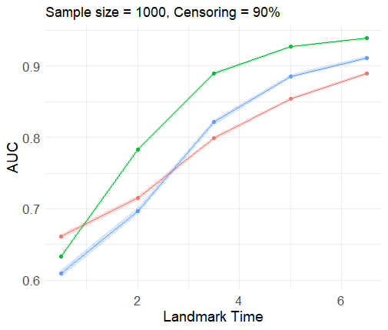

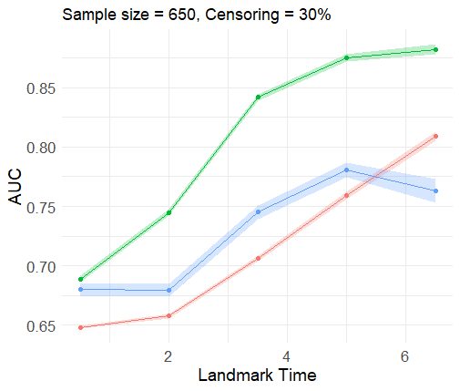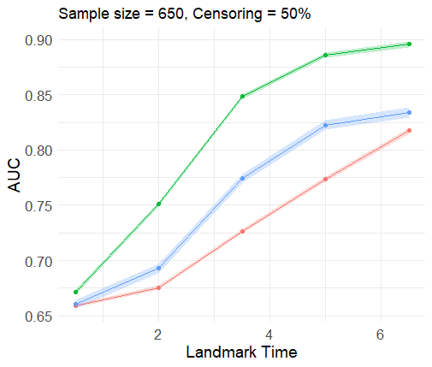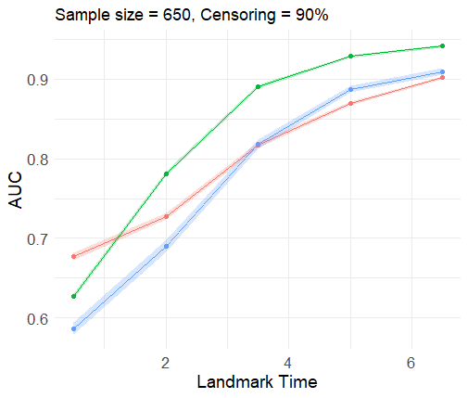

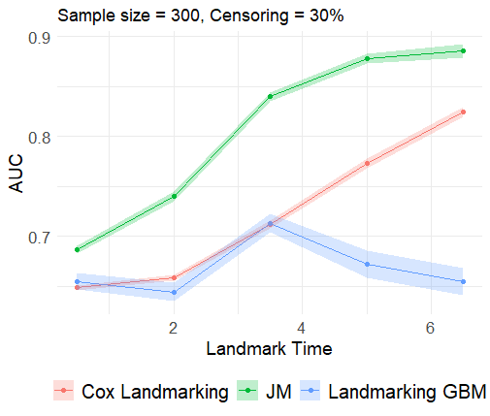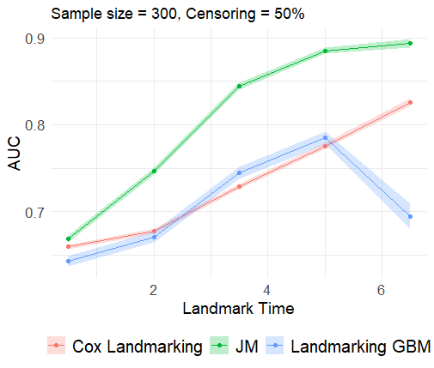

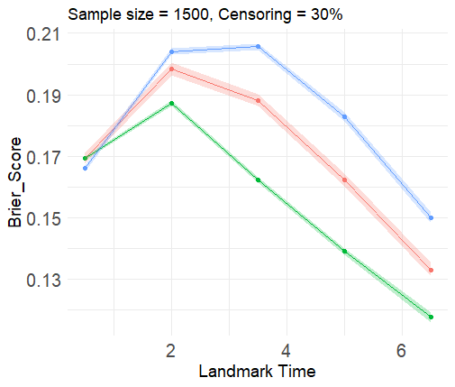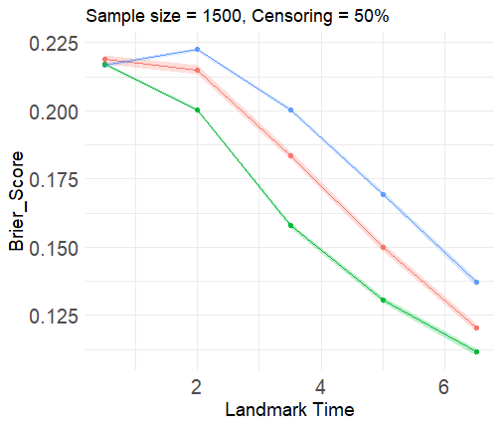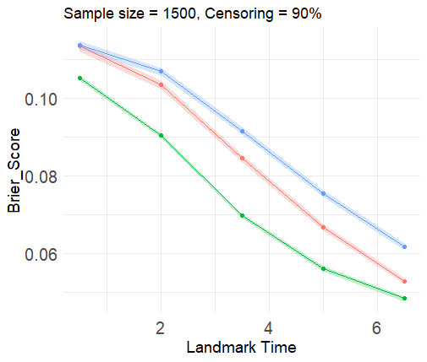

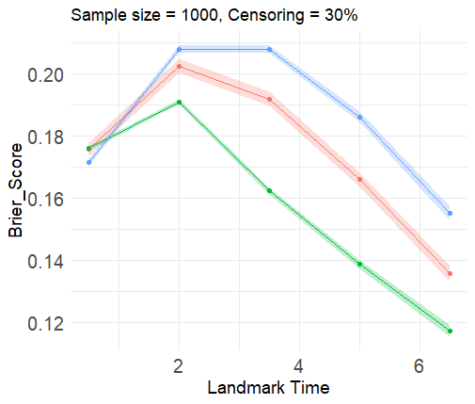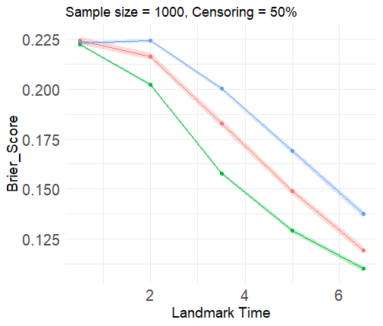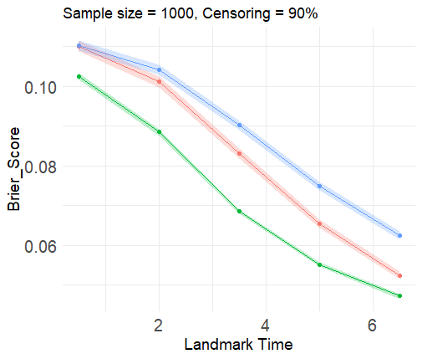

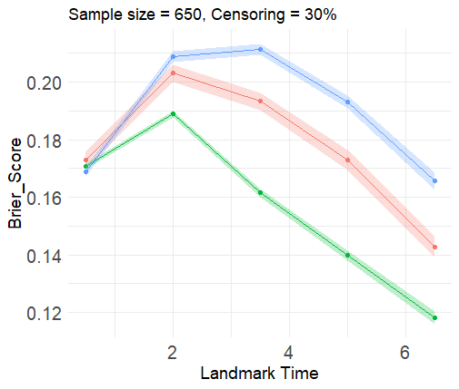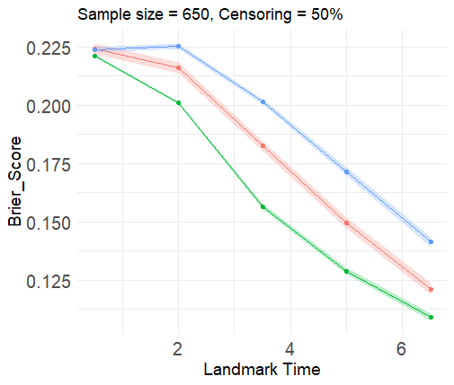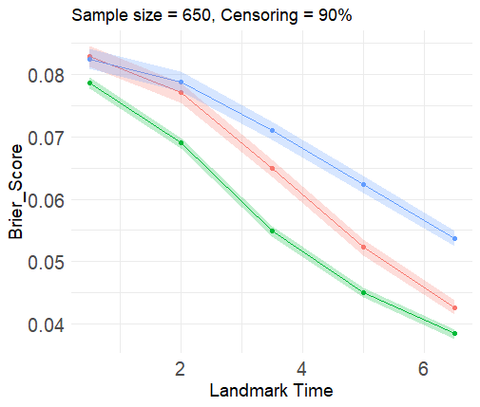
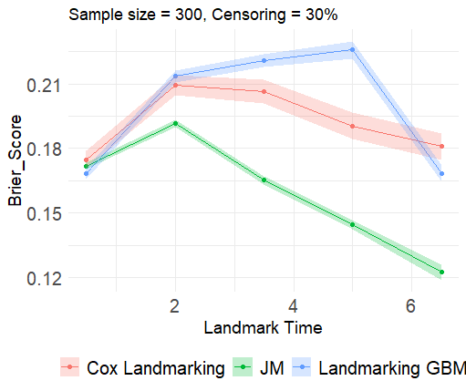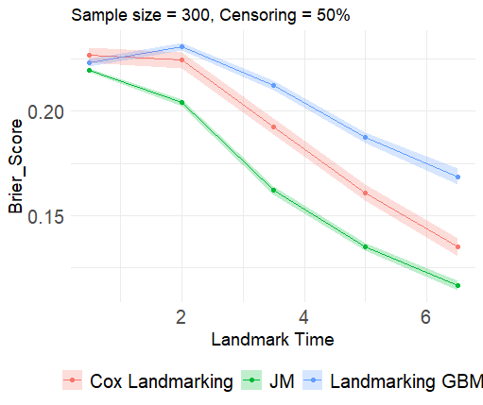
Supplementary figure 1. AUC and Brier score plots from simulation study 1
Table A3. Results of the response surface experiment for AUC and Brier score as an outcome in simulation study 1
 | AUC |  |  |  |  | Brier Score
Scenarios | Estimate | Std. Error | t value | Pr(>|t|) | Estimate |  | Std. Error | t value | Pr(>|t|)
(Intercept) | 0.8519 | 0.0114 | 74.489 | <0.001*** | 0.0486 |  | 0.0061 | 8.001 | <0.001***
Method CL | 0.0274 | 0.0162 | 1.696 | 0.0919 | -0.0110 |  | 0.0086 | -1.286 | 0.2003
Method Joint | 0.0690 | 0.0165 | 4.193 | <0.001*** | -0.0197 |  | 0.0088 | -2.257 | 0.0255*
Sample size: 300 | -0.0894 | 0.0102 | -8.740 | <0.001*** | 0.0102 |  | 0.0054 | 1.873 | 0.0631
Sample size: 650 | -0.0161 | 0.0102 | -1.574 | 0.1176 | -0.0029 |  | 0.0054 | -0.540 | 0.5902
Sample size: 1000 | -0.0066 | 0.0102 | -0.647 | 0.5189 | 0.0013 |  | 0.0054 | 0.248 | 0.8047
Censoring: 30% | -0.0310 | 0.0088 | -3.506 | <0.001*** | 0.1052 |  | 0.0047 | 22.348 | <0.001***
Censoring: 50% | -0.0079 | 0.0088 | -0.898 | 0.3706 | 0.1104 |  | 0.0047 | 23.451 | <0.001***
Landmark time: 0.5 | -0.1712 | 0.0114 | -14.967 | <0.001*** | 0.0413 |  | 0.0061 | 6.797 | <0.001***
Landmark time: 2 | -0.1304 | 0.0114 | -11.405 | <0.001*** | 0.0542 |  | 0.0061 | 8.918 | <0.001***
Landmark time: 3.5 | -0.0406 | 0.0114 | -3.554 | <0.001*** | 0.0441 |  | 0.0061 | 7.262 | <0.001***
Landmark time: 5 | 0.0030 | 0.0114 | 0.259 | 0.7957 | 0.0255 |  | 0.0061 | 4.205 | <0.001***
Method CL: sample size 300 | 0.1056 | 0.0145 | 7.300 | <0.001*** | -0.0010 |  | 0.0077 | -0.134 | 0.8940
Method Joint: sample size 300 | 0.086845 | 0.0146 | 5.944 | <0.001*** | -0.0119 |  | 0.0078 | -1.536 | 0.1267
Method CL: sample size 650 | 0.0253 | 0.0145 | 1.752 | 0.0818 | -0.0011 |  | 0.0077 | -0.145 | 0.8850
Method Joint: sample size 650 | 0.0165 | 0.0145 | 1.138 | 0.2570 | -0.0024 |  | 0.0077 | -0.314 | 0.7540
Method CL: sample size 1000 | 0.0089 | 0.0145 | 0.613 | 0.5406 | -0.0002 |  | 0.0077 | -0.031 | 0.9751
Method Joint: sample size 1000 | 0.0072 | 0.0145 | 0.498 | 0.6191 | -0.0009 |  | 0.0077 | -0.117 | 0.9069
Method CL: censoring 30 | -0.0456 | 0.0125 | -3.644 | <0.001*** | -0.0041 |  | 0.0066 | -0.614 | 0.5399
Method Joint: censoring 30 | 0.0059 | 0.0126 | 0.470 | 0.6394 | -0.0145 |  | 0.0067 | -2.160 | 0.0324*
Method CL: censoring 50 | -0.0554 | 0.0125 | -4.421 | <0.001*** | -0.0071 |  | 0.0066 | -1.071 | 0.2859
Method Joint: censoring 50 | -0.0144 | 0.0126 | -1.145 | 0.2540 | -0.0118 |  | 0.0067 | -1.756 | 0.0812
Method CL: landmark time 0.5 | -0.0082 | 0.0162 | -0.507 | 0.6129 | 0.0177 |  | 0.0086 | 2.061 | 0.0410*
Method Joint: landmark time 0.5 | -0.0719 | 0.0163 | -4.390 | <0.001*** | 0.0301 |  | 0.0087 | 3.465 | <0.001***
Method CL: landmark time 2 | -0.0233 | 0.0162 | -1.444 | 0.1508 | 0.0103 |  | 0.0086 | 1.205 | 0.2300
Method Joint: landmark time 2 | -0.0156 | 0.0164 | -0.955 | 0.3413 | 0.0130 |  | 0.0087 | 1.492 | 0.1379
Method CL: landmark time 3.5 | -0.0524 | 0.0164 | -3.242 | 0.0015** | 0.001400 |  | 0.0086 | 0.163 | 0.8708
Method Joint: landmark time 3.5 | -0.0049 | 0.0164 | -0.298 | 0.7660 | -0.006162 |  | 0.0087 | -0.708 | 0.4800
Method CL: landmark time 5 | -0.0447 | 0.0164 | -2.762 | 0.0065** | -0.003692 |  | 0.0086 | -0.430 | 0.6682
Method Joint: landmark time 5 | -0.0109 | 0.0164 | -0.664 | 0.5077 | -0.008153 |  | 0.0087 | -0.937 | 0.3503
CL: Cox Landmarking; LGBM: Landmarking gradient boosting method; Std: Standard deviation; Pr: Probability. ***P-value<0.001; **P-value<0.01; *P-value<0.05.
Simulation study 2: AUC and Brier score plots for different scenarios
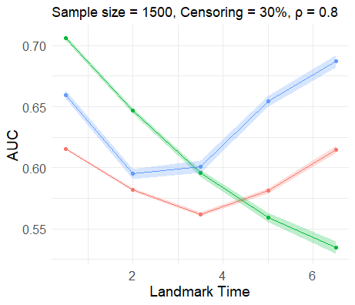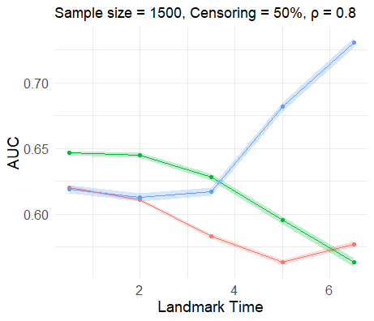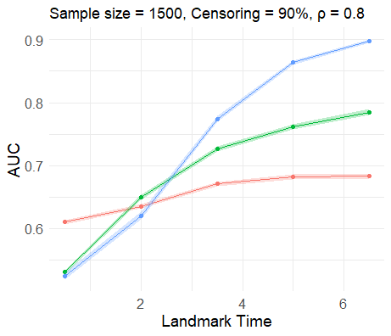

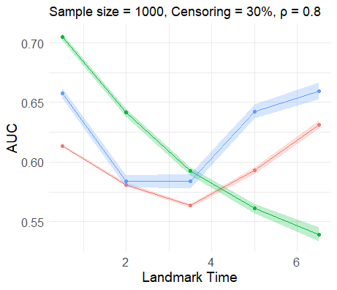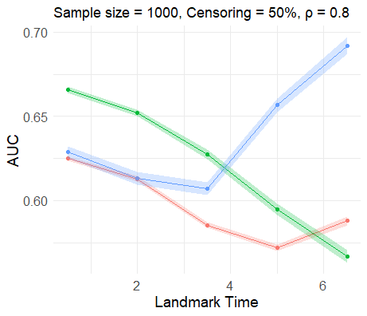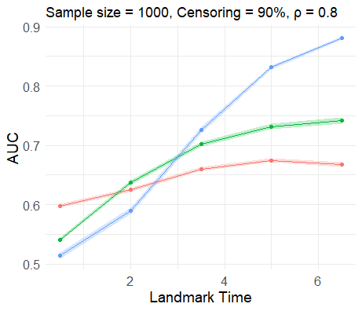

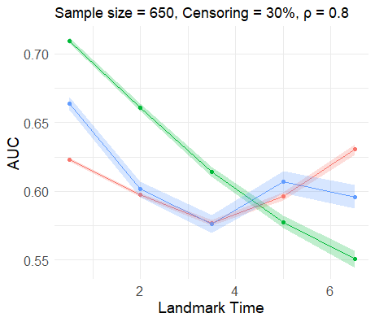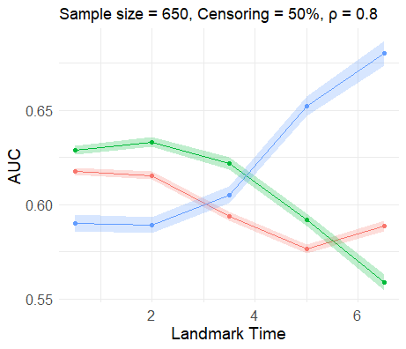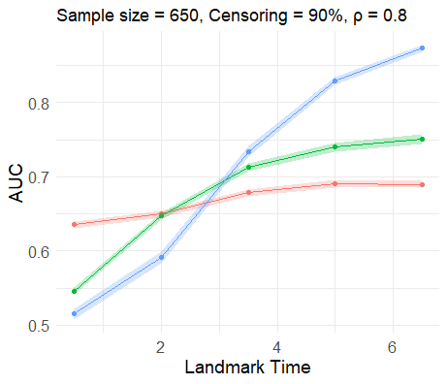
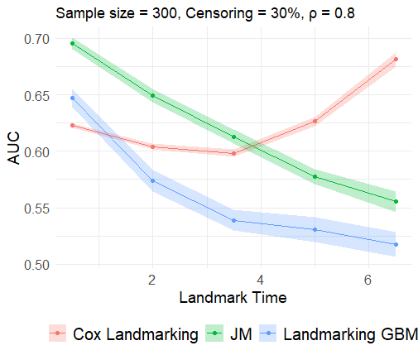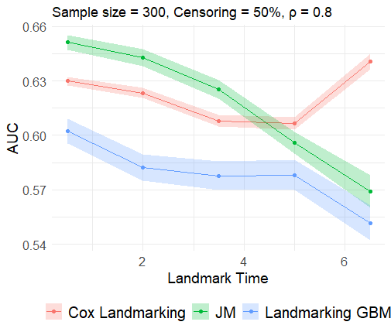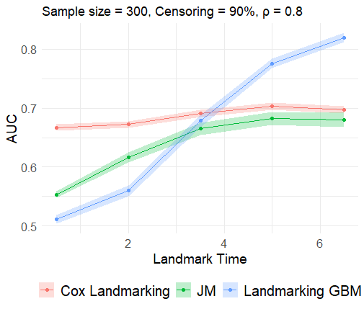

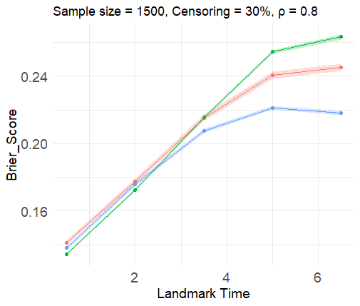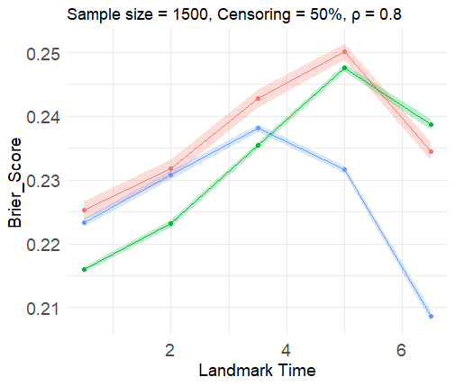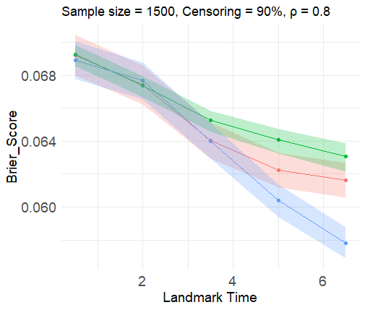

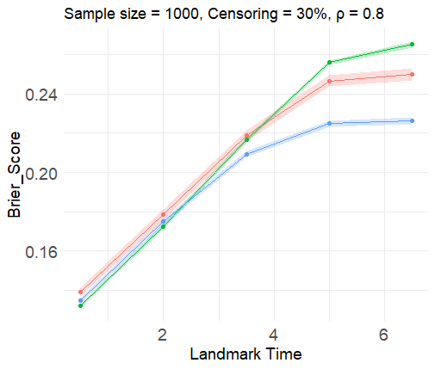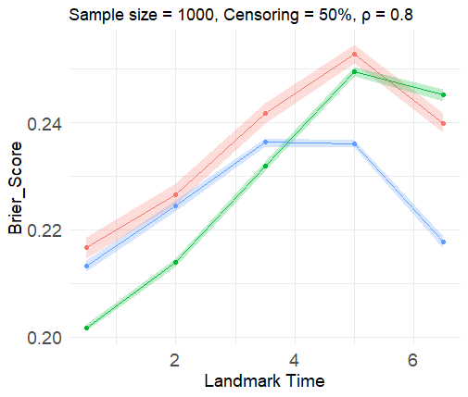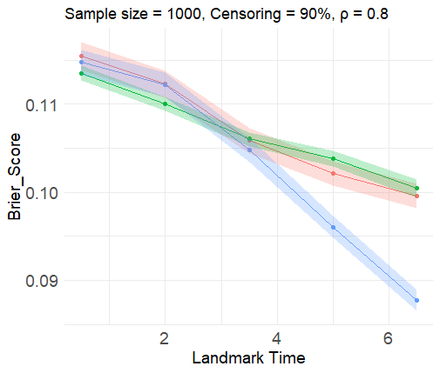

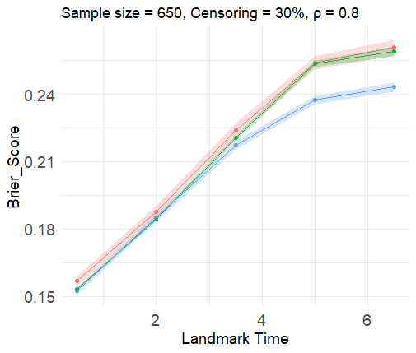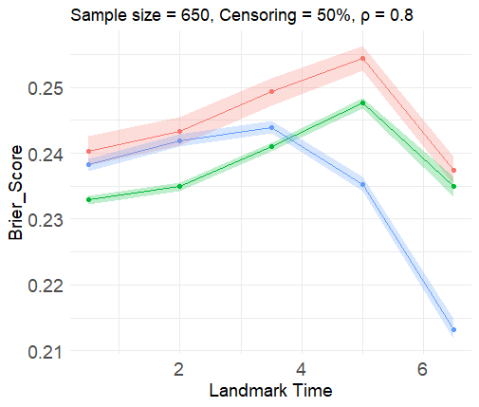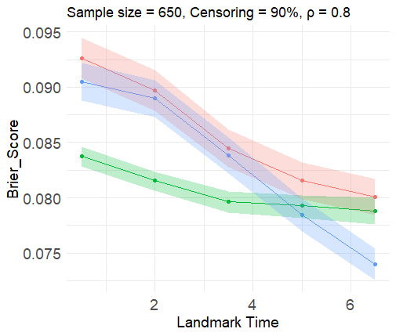

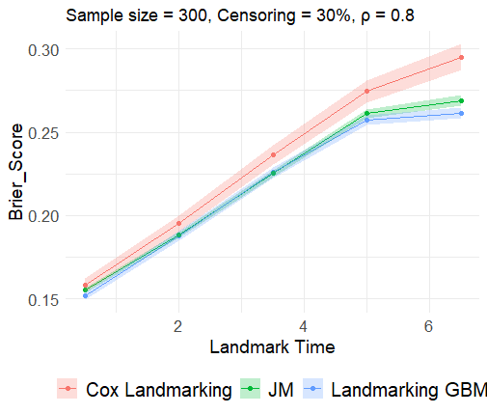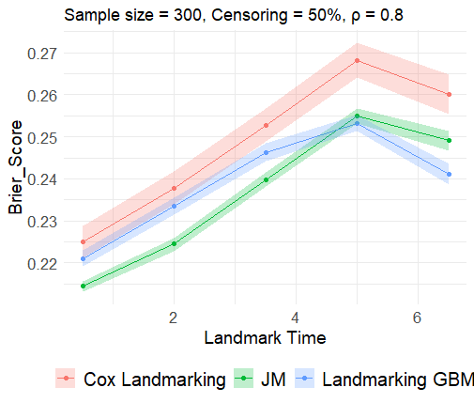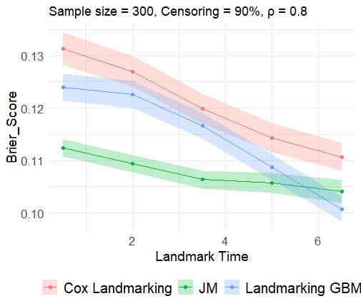
Supplementary figure 2. AUC and Brier score plots from simulation study 2 with longitudinal marker correlation = 0.8
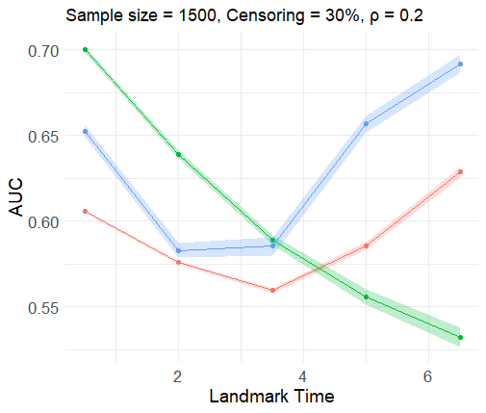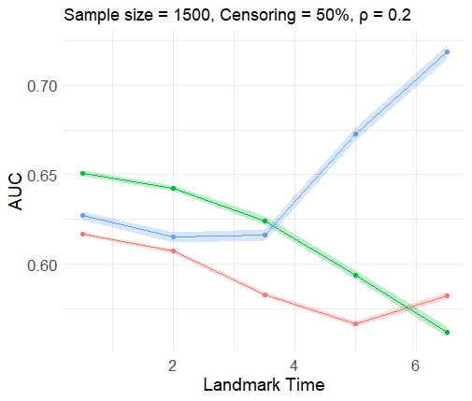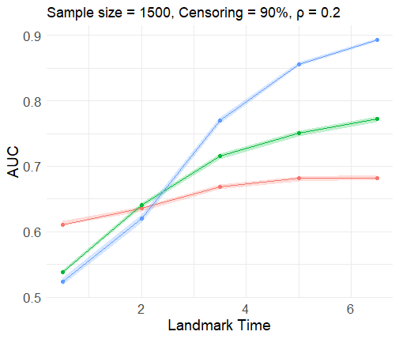

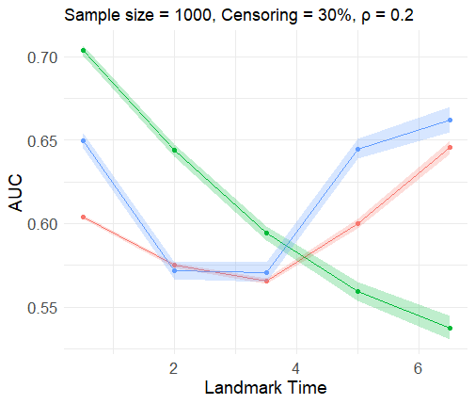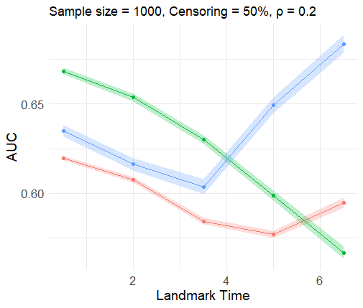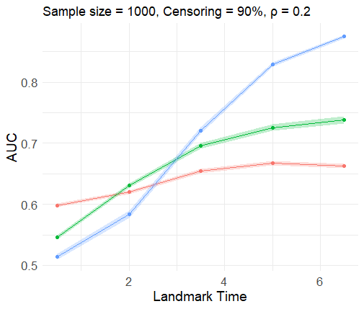

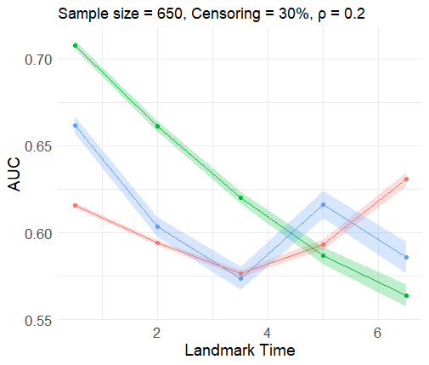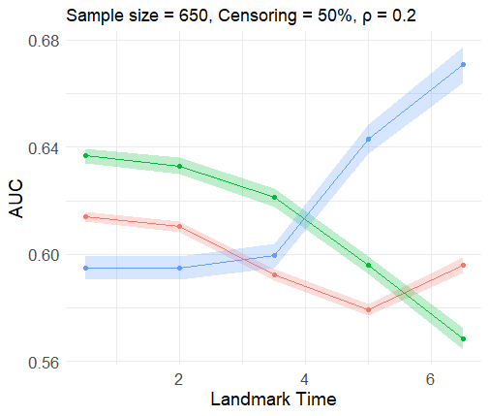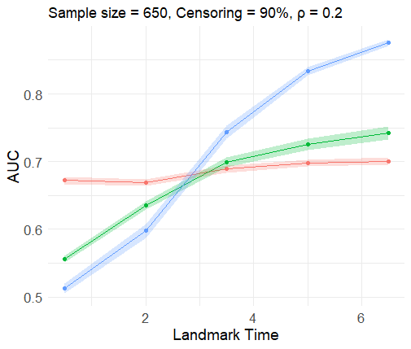

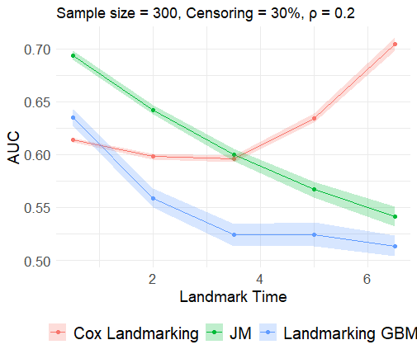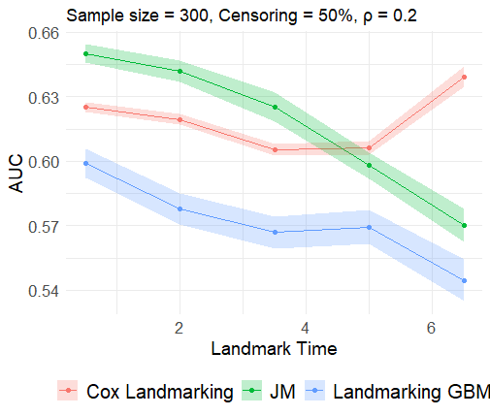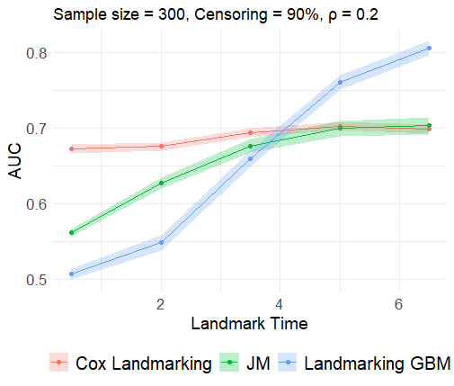

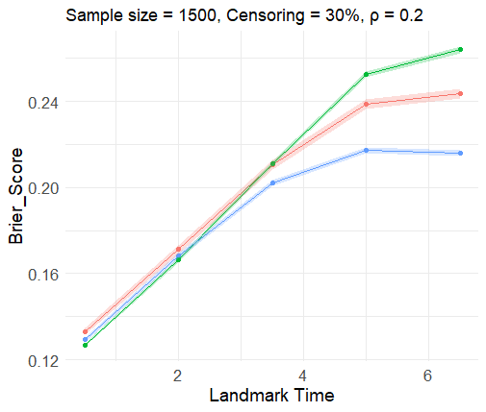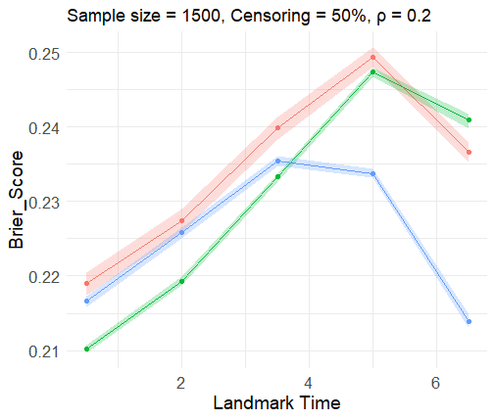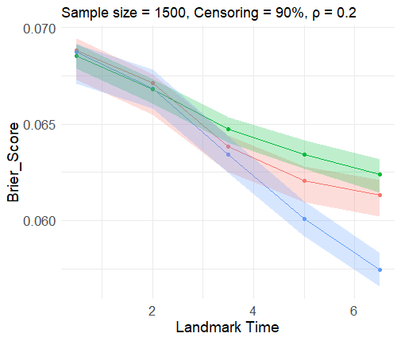

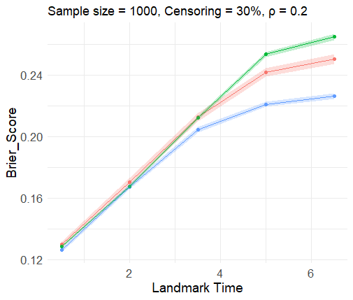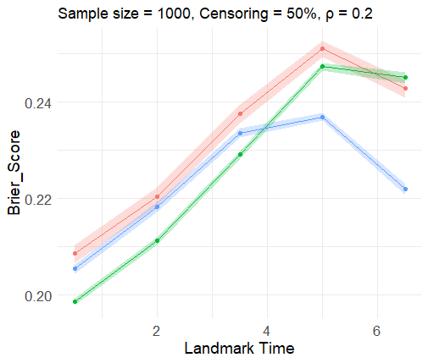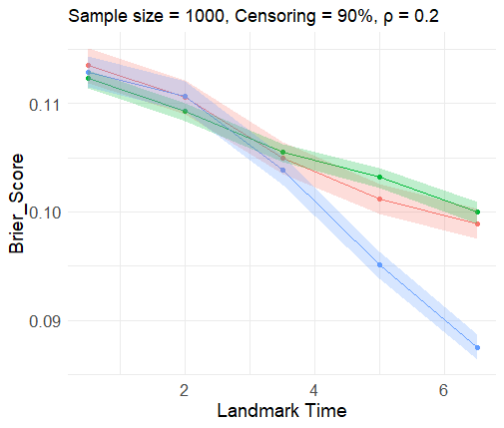

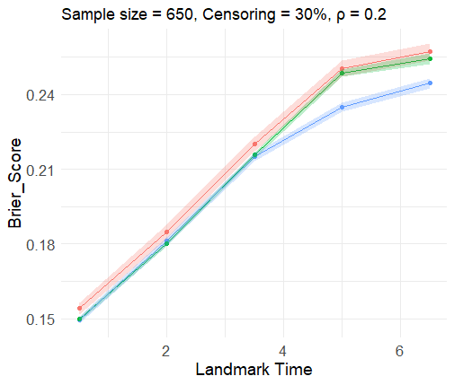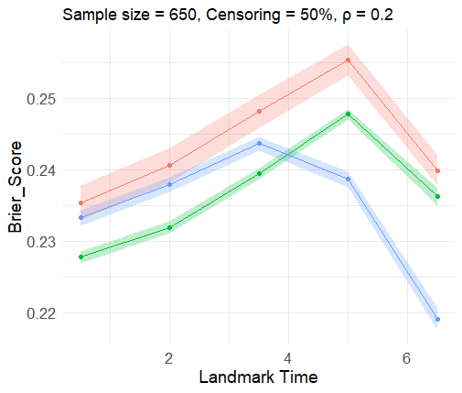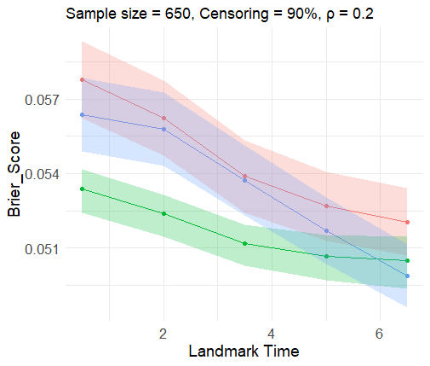
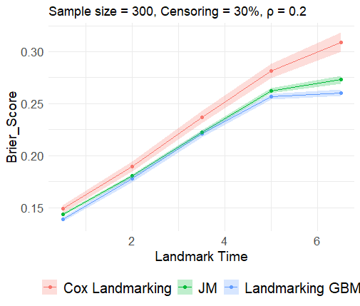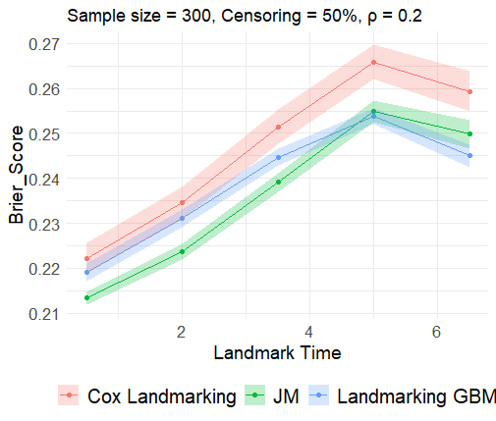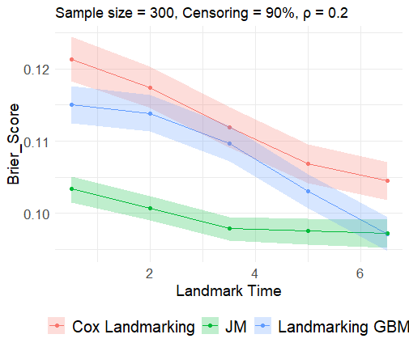
Supplementary figure 3. AUC and Brier score plots from simulation study 2 with longitudinal marker correlation = 0.2

Table A4. Results of the response surface experiment for AUC and Brier score as an outcome in simulation study 2
 | AUC |  |  |  | Brier Score
Scenarios | Estimate | Std. Error | t value | Pr(>|t|) | Estimate | Std. Error | t value | Pr(>|t|)
(Intercept) | 0.8037 | 0.0159 | 50.549 | <0.001*** | 0.0790 | 0.0071 | 11.121 | <0.001***
Method CL | -0.1291 | 0.0221 | -5.849 | <0.001*** | 0.0126 | 0.0099 | 1.279 | 0.2018
Method Joint | -0.1468 | 0.0221 | -6.650 | <0.001*** | 0.0168 | 0.0099 | 1.706 | 0.0890
Sample size: 300 | -0.0771 | 0.0140 | -5.520 | <0.001*** | 0.0283 | 0.0062 | 4.533 | <0.001***
Sample size: 650 | -0.0279 | 0.0140 | -1.997 | 0.0466* | 0.0098 | 0.0062 | 1.580 | 0.1151
Sample size: 1000 | -0.0188 | 0.0140 | -1.350 | 0.1778 | 0.0133 | 0.0062 | 2.128 | 0.0341*
Censoring: 30% | -0.0968 | 0.0121 | -8.012 | <0.001*** | 0.1145 | 0.0054 | 21.192 | <0.001***
Censoring: 50% | -0.0817 | 0.0121 | -6.757 | <0.001*** | 0.1442 | 0.0054 | 26.703 | <0.001***
Landmark time: 0.5 | -0.1185 | 0.0156 | -7.592 | <0.001*** | -0.0267 | 0.0070 | -3.833 | <0.001***
Landmark time: 2 | -0.1208 | 0.0156 | -7.744 | <0.001*** | -0.0118 | 0.0070 | -1.692 | 0.0916
Landmark time: 3.5 | -0.0806 | 0.0156 | -5.164 | <0.001*** | 0.0016 | 0.0070 | 0.234 | 0.8150
Landmark time: 5 | -0.0224 | 0.0156 | -1.437 | 0.1516 | 0.0065 | 0.0070 | 0.935 | 0.3504
Cor: 0.2 | -0.0016 | 0.0057 | -0.273 | 0.7847 | 0.0010 | 0.0025 | 0.390 | 0.6968
Method CL: sample size 300 | 0.1096 | 0.0197 | 5.548 | <0.001*** | 0.0028 | 0.0088 | 0.320 | 0.7495
Method Joint: sample size 300 | 0.0669 | 0.0197 | 3.382 | <0.001*** | -0.0010 | 0.0088 | -1.129 | 0.2596
Method CL: sample size 650 | 0.0414 | 0.0197 | 2.100 | 0.0365* | -0.0011 | 0.0088 | -0.128 | 0.8981
Method Joint: sample size 650 | 0.0285 | 0.0197 | 1.443 | 0.1499 | -0.0056 | 0.0088 | -0.637 | 0.5242
Method CL: sample size 1000 | 0.0183 | 0.0197 | 0.928 | 0.3541 | 0.0003 | 0.0088 | 0.037 | 0.9707
Method Joint: sample size 1000 | 0.0161 | 0.0197 | 0.815 | 0.4155 | -0.0007 | 0.0088 | -0.081 | 0.9351
Method CL: censoring 30 | 0.0357 | 0.0171 | 2.090 | 0.0374* | 0.0098 | 0.0076 | 1.288 | 0.1986
Method Joint: censoring 30 | 0.0404 | 0.0171 | 2.364 | 0.0187* | 0.0109 | 0.0076 | 1.427 | 0.1545
Method CL: censoring 50 | 0.0175 | 0.0171 | 1.024 | 0.3066 | 0.0065 | 0.0076 | 0.853 | 0.3942
Method Joint: censoring 50 | 0.0281 | 0.0171 | 1.644 | 0.1011 | 0.0035 | 0.0076 | 0.457 | 0.6478
Method CL: landmark time 0.5 | 0.0982 | 0.0221 | 4.448 | <0.001*** | -0.0152 | 0.0099 | -1.543 | 0.1237
Method Joint: landmark time 0.5 | 0.1351 | 0.0221 | 6.121 | <0.001*** | -0.0213 | 0.0099 | -2.163 | 0.0313*
Method CL: landmark time 2 | 0.0942 | 0.0221 | 4.268 | <0.001*** | -0.01592 | 0.0099 | -1.618 | 0.1067
Method Joint: landmark time 2 | 0.1467 | 0.0221 | 6.648 | <0.001*** | -0.0222 | 0.0099 | -2.253 | 0.0249*
Method CL: landmark time 3.5 | 0.0513 | 0.0221 | 2.324 | 0.0207* | -0.0135 | 0.0099 | -1.365 | 0.1730
Method Joint: landmark time 3.5 | 0.1065 | 0.0221 | 4.825 | <0.001*** | -0.0184 | 0.0099 | -1.869 | 0.0625
Method CL: landmark time 5 | 0.0019 | 0.0221 | 0.088 | 0.9296 | -0.0054 | 0.0099 | -0.544 | 0.5870
Method Joint: landmark time 5 | 0.0362 | 0.0221 | 1.641 | 0.1018 | -0.0066 | 0.0099 | -0.670 | 0.5036
CL: Cox Landmarking; LGBM: Landmarking gradient boosting method; Std: Standard deviation; Pr: Probability; Cor: Correlation. ***P-value<0.001; **P-value<0.01; *P-value<0.05
(A) (B)
(C)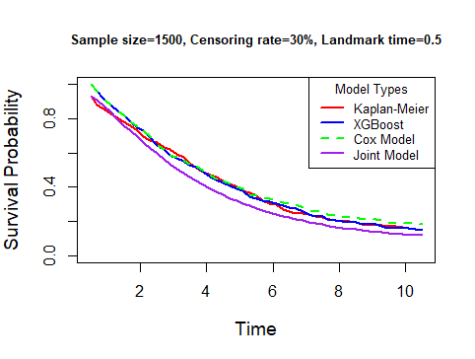(D)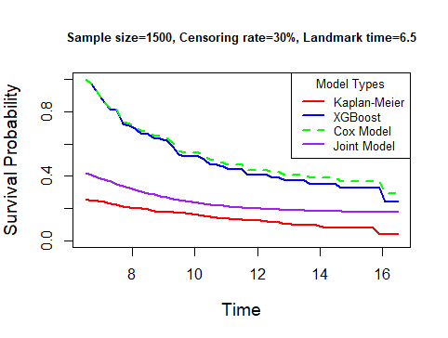
(E)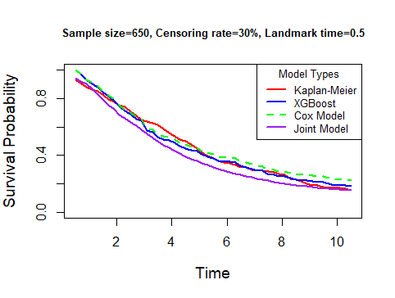 (F)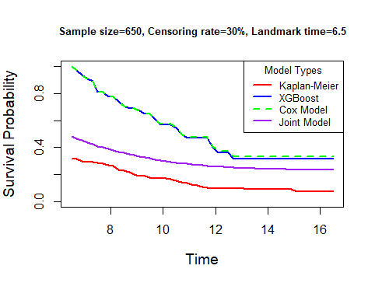
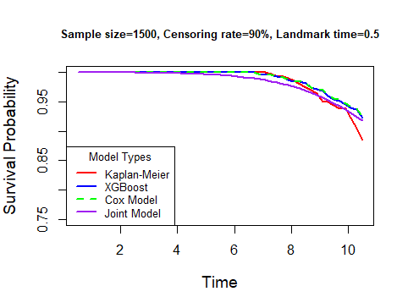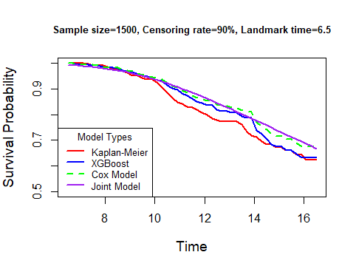

(G) (H)
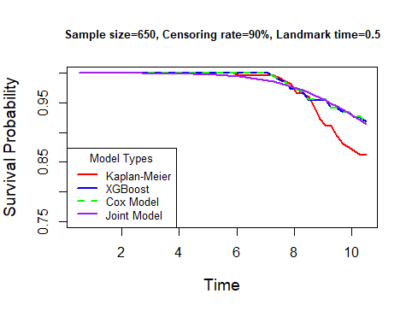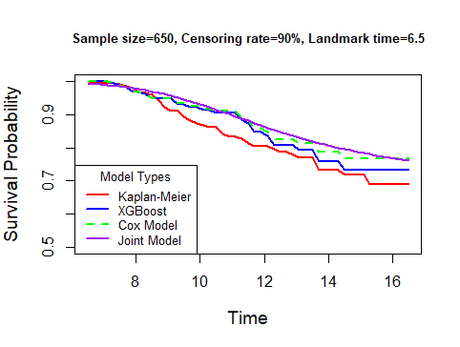
Supplementary figure 4. Comparison of survival probability plots of three dynamic survival prediction methods.
Figure Legend: This figure compares the survival probability plots of three dynamic survival prediction methods: Landmarking gradient boosting, Cox landmarking, and Joint methods with Kaplan-Meier survival probability plot for simulated data under sample size scenarios of 1500 (A, B, E and F) and 650 (C, D, G and H), censoring rate of 30% (A-D) and 90% (E-H), and landmark times of 0.5 (A, C, E, G and I) and 6.5 (B, D, F and H).

Table A5. Computational time for running the three dynamic prediction models
Sample Size | Total Runtime for 3 Models | Runtime for Joint Model Alone | Estimated Total Time for 500 Iterations (3 Models)
1500 | ~3 minutes | ~2 minutes 50 seconds | ~1000 minutes
1000 | ~2 minutes | ~1 minute 55 seconds | ~667 minutes
650 | ~1 minute 20 seconds | ~1 minute 17 seconds | ~445 minutes
300 | ~45 seconds | ~43 seconds | ~375 minutes

Table A6. Comparison of LMM and LOCF imputation methods in two dynamic prediction techniques: AUCs (Brier scores) from the Landmarking gradient boosting and Cox landmarking methods derived from simulated data in study 2 with a sample size of 650.
 | Sample size=650
Landmark times | LMM LGBM | LOCF LGBM | LMM Cox landmarking | LOCF Cox landmarking
Censoring Rate=30%
0.5 | 0.6856(0.1385) | 0.6638(0.1524) | 0.6307(0.1511) | 0.6230(0.1568)
2 | 0.7010(0.1371) | 0.6014(0.1849) | 0.6249(0.1475) | 0.5972(0.1874)
3.5 | 0.7249(0.1358) | 0.5763(0.2172) | 0.6141(0.1469) | 0.5770(0.2240)
5 | 0.7778(0.1296) | 0.6069(0.2374) | 0.6062(0.1461) | 0.5962(0.2538)
6.5 | 0.8079(0.1264) | 0.5960(0.2431) | 0.6055(0.1468) | 0.6303(0.2607)
Censoring Rate=50%
0.5 | 0.5978(0.2364) | 0.5902(0.2382) | 0.6224(0.2424) | 0.6175(0.2403)
2 | 0.6198(0.2324) | 0.5891(0.2419) | 0.6333(0.2385) | 0.6155(0.2433)
3.5 | 0.6659(0.2259) | 0.6051(0.2439) | 0.6306(0.2352) | 0.5939(0.2493)
5 | 0.7763(0.2001) | 0.6522(0.2352) | 0.6175(0.2337) | 0.5767(0.2544)
6.5 | 0.8334(0.1838) | 0.6802(0.2132) | 0.6105(0.2353) | 0.5887(0.2373)
Censoring Rate=90%
0.5 | 0.5132(0.0909) | 0.5149(0.0905) | 0.6362(0.0927) | 0.6722(0.0577)
2 | 0.5715(0.0895) | 0.5910(0.0889) | 0.6442(0.0899) | 0.6689(0.0562)
3.5 | 0.7576(0.0825) | 0.7437(0.0537) | 0.6804(0.0835) | 0.6888(0.0538)
5 | 0.8690(0.07540) | 0.8337(0.0517) | 0.6911(0.0804) | 0.6978(0.0526)
6.5 | 0.9075(0.0706) | 0.8760(0.0498) | 0.6895(0.0801) | 0.7007(0.0520)
AUC (Brier Score)
Abbreviations: LMM: Linear Mixed-Effects Model; LOCF: Last Observation Carried Forward

