Appendix A
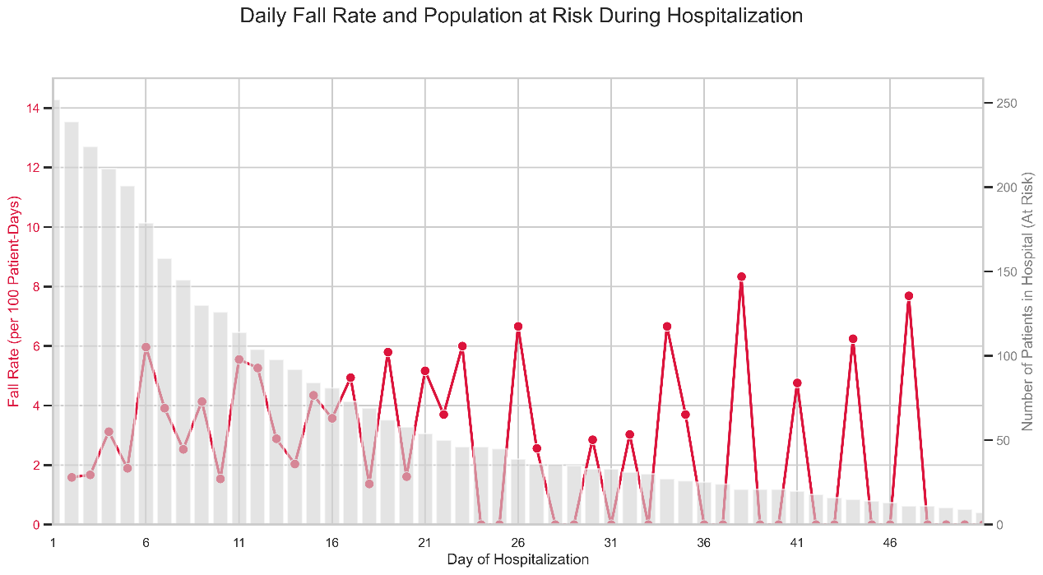
Figure A1. The distribution of time to fall for patients evaluated by the scale as being in a high-risk population.
Treatment | Accuracy | Sensitivity | Specificity | F1-score | PPV | NPV
Chemotherapy | 0.92 | 0.89 | 0.86 | 0.86 | 0.87 | 0.80
Radiotherapy | 0.93 | 0.91 | 0.83 | 0.83 | 0.87 | 0.80
Chemotherapy+Radiotherapy | 0.95 | 0.75 | 0.86 | 0.86 | 0.80 | 0.82
Chemotherapy+Immunotherapy | 1.00 | 1.00 | 1.00 | 1.00 | 1.00 | 1.00
Chemotherapy+Target Therapy | 0.91 | 0.89 | 1.00 | 1.00 | 0.94 | 0.67
Radiotherapy+ Target Therapy | 0.89 | 0.89 | 1.00 | 1.00 | 0.94 | 0.00
Target Therapy | 1.00 | 1.00 | 1.00 | 1.00 | 1.00 | 1.00
Others | 0.77 | 0.78 | 0.95 | 0.95 | 0.86 | 0.29
Table A1 Results of our model for predicting fall risk in patients receiving different treatments

Table A2 Results of our model for predicting fall risk in different risk groups distinguished by the morse scale (RF/SVM)
Morse scale result | Accuracy | Sensitivity | Specificity | F1-score | PPV | NPV
High risk | 0.93/0.93 | 0.92/0.92 | 0.94/0.93 | 0.92/0.92 | 0.92/0.91 | 0.94/0.94
Low risk | 0.82/0.84 | 0.29/0.71 | 0.92/0.87 | 0.33/0.59 | 0.40/0.50 | 0.88/0.95

