Supplementary Files
Explainable Machine Learning for Differential Diagnosis of Diabetic Foot Infection and Osteomyelitis: A Two-Center Study and Clinically Applicable Web Calculator Using Routine Blood Biomarkers

Supplementary Table 1 Detailed hyperparameters of each algorithm
Algorithm | Hyperparameter Search Space | Description
Random Forest (RF) | - max_depth: [5]  - n_estimators: [200, 300]  - max_features: [50, 100] | Ensemble of decision trees with feature randomization
XGBoost (XGB) | - max_depth: [6]  - n_estimators: [100, 300]  - reg_lambda: [1, 1.2, 1.4] | Gradient boosting with regularization (L2)
LightGBM (LGB) | - max_depth: [5]  - n_estimators: [100, 200]  - reg_lambda: [1, 1.2, 1.4] | Gradient boosting with leaf-wise growth and regularization
Logistic Regression (LR) | - C: [1, 10, 100, 200, 300]  - penalty: [“l2”]  - class_weight: [“balanced”]  - solver: [“lbfgs”] | Regularized linear classification with balanced class weighting
Decision Tree (DT) | - criterion: [“gini”, “entropy”]  - max_depth: [6, 8]  - max_features: [“sqrt”, 0.4] | Non-parametric supervised learning with feature splitting optimization
SVM (SVC) | - C: [0.1, 1, 10, 100]  - gamma: [1, 0.1, 0.01, 0.001]  - kernel: [“rbf”] | Maximum margin classifier with radial basis function kernel
k-NN (KNN) | - n_neighbors: [1-29 (odd)]  - p: [1, 2]  - weights: [“uniform”, “distance”] | Instance-based learning with Minkowski distance metric
Naive Bayes (NB) | Default parameters | Gaussian probability estimator based on Bayes’ theorem
Ensemble 1 | Base Models: LR + DT + NB  Voting: Soft | Combines probabilistic predictions from logistic regression, decision tree, and naive Bayes
Ensemble 2 | Base Models: SVC + KNN + NB  Voting: Soft | Integrates support vector machine, k-nearest neighbors, and naive Bayes
Ensemble 3 | Base Models: XGB + RF + DT  Voting: Soft | Synthesizes gradient boosting, random forest, and decision tree predictions
Ensemble 4 | Base Models: LGB + NB + LR  Voting: Soft | Combines light gradient boosting with logistic regression and naive Bayes
Ensemble 5 | Base Models: LGB + NB + LR + DT  Voting: Soft | Integrates four diverse classifiers through probabilistic consensus

Supplementary Figure 1 Detailed Comparison of Continuous Features
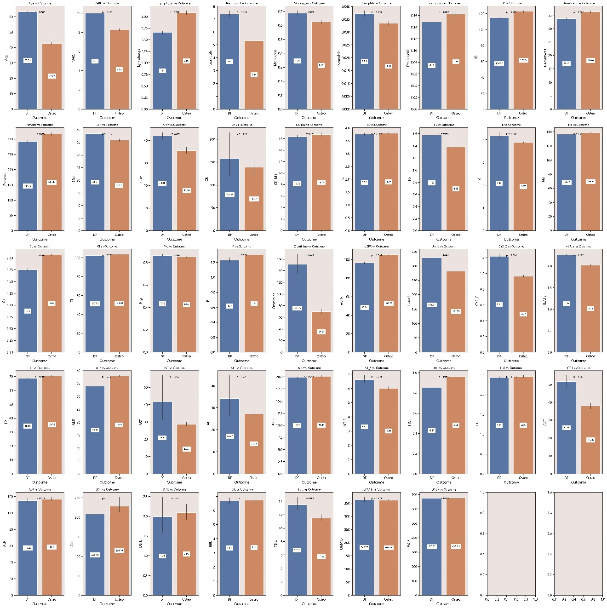
Supplementary Figure 1

Key blood biomarkers and clinical parameters distinguishing diabetic foot infection (DFI) from osteomyelitis in both cohorts. Features with statistically significant differences between outcomes included age, inflammatory markers (WBC, lymphocytes, neutrophils, monocytes, ESR, CRP), metabolic indicators (HbA1c, creatinine, eGFR, lipid profiles), electrolytes (K, Na, Ca, Cl, Mg, P), liver/kidney function tests (AST, GGT, TBIL, CYS_C), and hematologic measures (HB, hematocrit, platelets).

