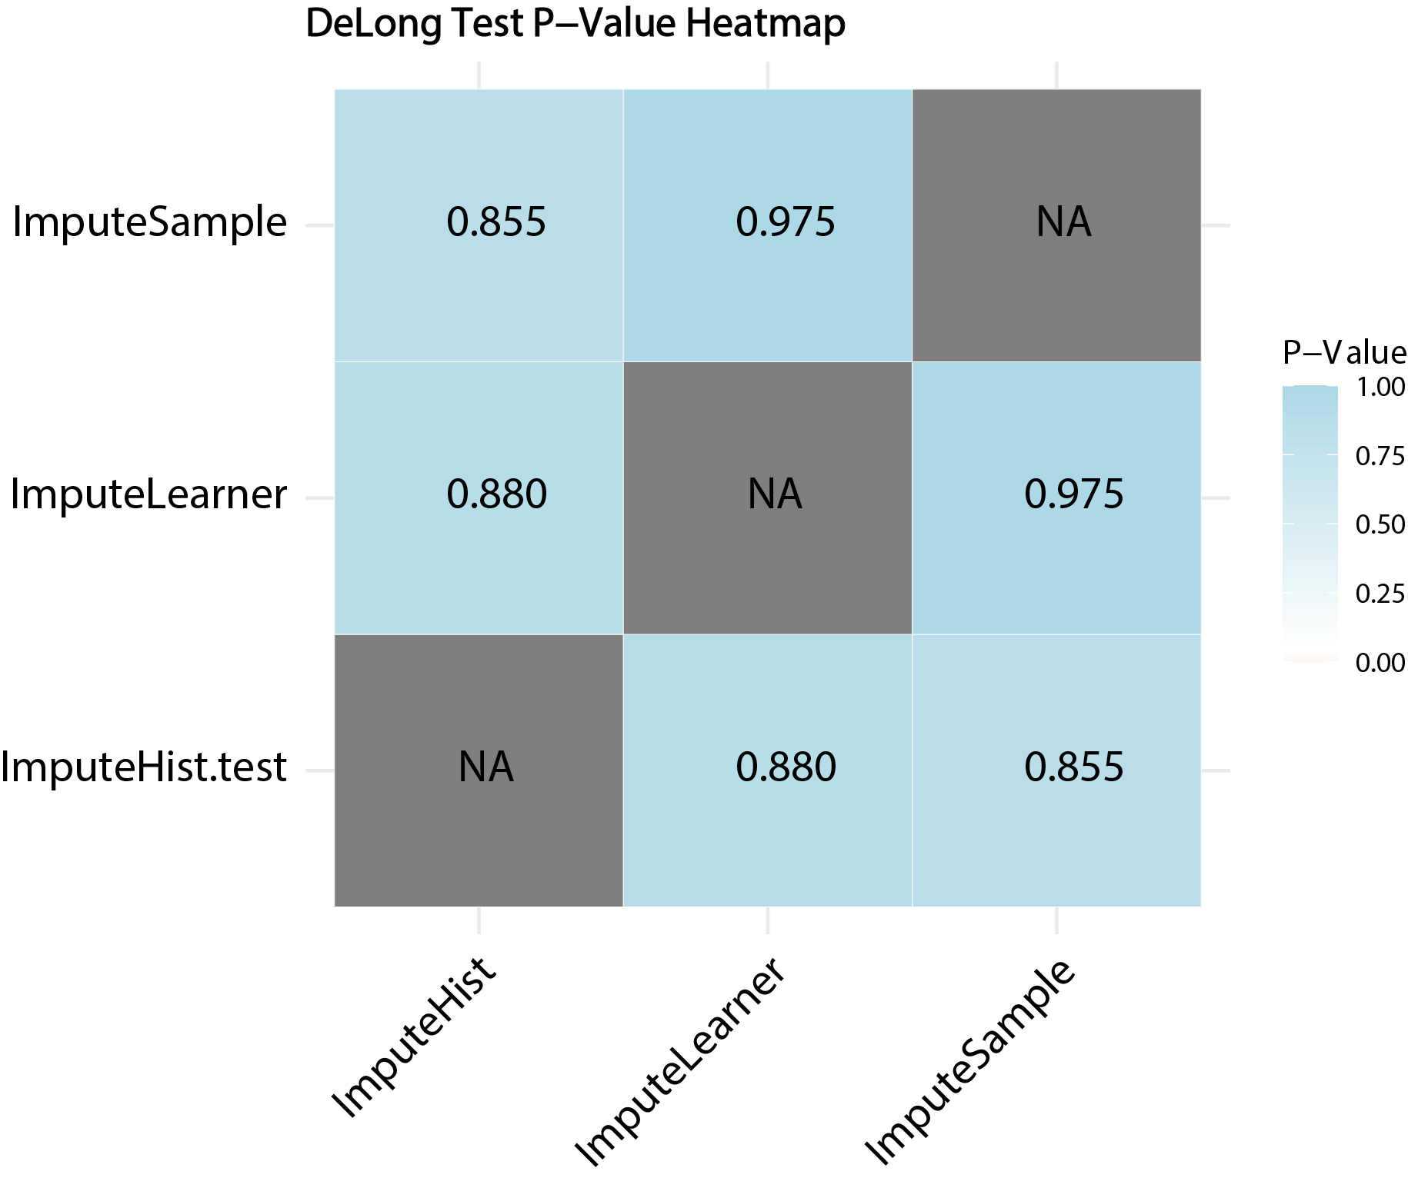
sFigure 2: DeLong test for results of different missing data imputation models in test set

