Table S1
Sample characteristics by inclusion status (included vs excluded)
Characteristic | Included | Excluded | P-Value
N | 14899 | 43845 | <0.001
Age (years) (%)
≥20, <40 | 4803 (32.3%) | 14951 (34.1%)
≥40, <60 | 4922 (33.0%) | 13417 (30.6%)
≥60 | 5174 (34.7%) | 15477 (35.3%)
Gender (%) |  |  | 0.095
Male | 7503 (50.4%) | 21703 (49.5%)
Female | 7416 (49.6%) | 22142 (50.5%)
Race (%) |  |  | <0.001
Mexican American | 2665 (17.9%) | 6928 (15.8%)
Other Hispanic | 1140 (7.7%) | 3639 (8.3%)
Non-Hispanic White | 7100 (47.7%) | 21527 (49.1%)
Non-Hispanic Black | 2966 (19.9%) | 7805 (17.8%)
Other Race | 1028 (6.8%) | 3946 (9.0%)

Table S2
Performance metrics of five machine learning models after class-weighting adjustment
Model | ROC-AUC | PR-AUC | F1 score | Balanced accuracy
Naive Bayes | 0.825 | 0.868 | 0.83 | 0.79
LASSO | 0.819 | 0.861 | 0.8 | 0.76
XGBoost | 0.819 | 0.858 | 0.81 | 0.77
Random Forest | 0.819 | 0.856 | 0.8 | 0.75
Support Vector Machine | 0.785 | 0.812 | 0.76 | 0.72
Notes:
All models were trained with class weighting to address the class imbalance (≈10.8% CVD cases). The Naive Bayes model employed adjusted class priors, while the other algorithms applied class_weight='balanced'. PR-AUC, F1 score, and balanced accuracy were reported alongside ROC-AUC to provide a more comprehensive assessment of model performance on minority (CVD) cases.

Table S3
Algorithm-specific settings for the five machine-learning models
Algorithm | CV & Selection Objective | Tuned Hyperparameters | Search Grid / Range (concise) | Fixed Settings / Notes
XGBoost | Stratified 10-fold CV (identical folds across models); select by mean AUC | eta, max_depth, min_child_weight, subsample, colsample_bytree, gamma, n_estimators (via early stopping) | eta: [0.01, 0.05, 0.1, 0.2]; max_depth: [2–6]; min_child_weight: [1, 3, 5]; subsample: [0.6, 0.8, 1.0]; colsample_bytree: [0.6, 0.8, 1.0]; gamma: [0, 1, 5] | Objective = binary:logistic; eval metric = AUC; early_stopping_rounds = 50 (max 2000 boosting rounds); fixed random seed
LASSO | Stratified 10-fold CV on λ path; select by mean AUC | λ (alpha = 1) | Package-generated ~100 λ (log-spaced); ties broken in favor of larger λ (parsimony) | Family = binomial; internal standardization enabled
Random Forest | Stratified 10-fold CV; select by mean AUC | n_estimators, max_depth, max_features (mtry), min_samples_leaf | n_estimators: [500, 1000, 1500]; max_depth: [None, 10, 20]; mtry: ⌊√P⌋、⌊log2(P)⌋、⌊P/3⌋; min_samples_leaf: [1, 5, 10] | Criterion = gini; bootstrap = True; oob_score = False (CV used); class_weight = None (stratified split maintained)
SVM | Stratified 10-fold CV; select by mean AUC | C, gamma | C: [0.1, 1, 10, 100]; gamma: [1e-4, 1e-3, 1e-2, 1e-1] (log-scaled) | Kernel = RBF; probability = True; class_weight = None
Naive Bayes | Stratified 10-fold CV; select by mean AUC | var_smoothing | var_smoothing: [1e-12, 1e-10, 1e-8, 1e-6, 1e-4] (log-scaled) | Continuous inputs only; z-score standardization before training; Gaussian NB does not use Laplace smoothing
Notes:
CV: Cross-validation; Stratified means each fold preserves class proportions.
AUC: Area under the ROC curve.
P: Number of features. ⌊·⌋: Floor (round down).Model-specific hyperparameters

Model-specific hyperparameters

XGBoost
eta: Learning rate.
max_depth: Maximum tree depth.
min_child_weight: Minimum sum of second-order gradients (Hessians) required in a child node (controls overfitting).
subsample: Row-sampling rate per boosting round.
colsample_bytree: Column-sampling rate per tree (fraction of features).
gamma (min_split_loss): Minimum loss reduction required to make a further split.
n_estimators: Maximum boosting rounds; actual rounds determined by early stopping.
early_stopping_rounds / patience: Stop if the validation metric does not improve for the specified rounds (here 50; max 2000 rounds allowed).
objective = binary:logistic: Binary classification with logistic loss; eval metric = AUC.

LASSO (logistic regression path)
λ (lambda): L1 regularization strength; alpha = 1 means pure L1.
family = binomial: Logistic regression; internal standardization: Features standardized internally before fitting.

Random Forest
n_estimators: Number of trees.
max_depth: Maximum tree depth (None = unlimited).
max_features (mtry): Number of candidate features at each split (e.g., ⌊√P⌋, ⌊log2(P)⌋, ⌊P/3⌋).
min_samples_leaf: Minimum samples required in a leaf.
bootstrap = True: Trees built on bootstrap samples.
oob_score = False: No out-of-bag evaluation (CV is used instead).
criterion = gini: Split criterion is Gini impurity.
class_weight = None: No class weighting

SVM (RBF kernel)
C: Regularization (larger = less regularization).
gamma: RBF kernel coefficient; relates to kernel width as γ=1/(2σ²).
probability = True: Enables probabilistic outputs (e.g., via Platt scaling).
class_weight = None: No class weighting.

Gaussian Naive Bayes
var_smoothing: Small additive value to variances for numerical stability (as a fraction of the largest variance).
z-score standardization before training: Inputs standardized to zero mean and unit variance.
Continuous inputs only; Gaussian NB does not use Laplace smoothing.

Figure S1 displays ROC curves for five models trained using age, gender, race, education level, PIR, LDL, alcohol use, smoking status, BMI, hypertension, and diabetes.
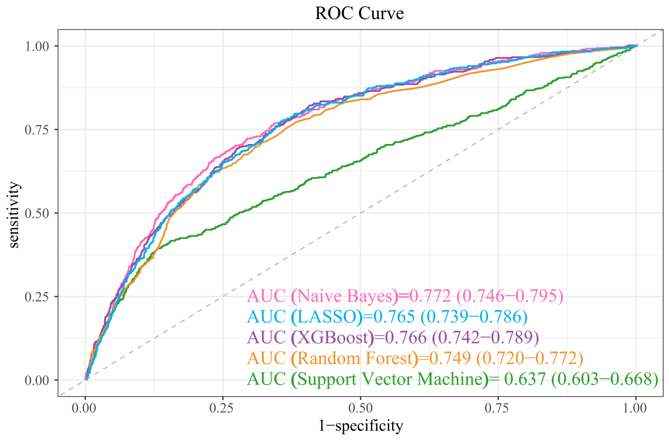
Figure S1: ROC curves for CVD risk Assessment without CTI: XGBoost, LASSO, Random Forest, SVM, and Naive Bayes

