SUPPLEMENTARY MATERIAL
Table S1. Hyperparameter search ranges and optimal values for machine learning models
Model | Parameter | Optimal Value
SVM | Kernel | Linear
SVM | Cost (C) | 1.0
SVM | Gamma (γ) | Not applicable
SVM | Numerical tolerance | 0.001
SVM | Max iterations | 1000
Neural Network | Hidden units | 200
Neural Network | Activation | ReLU
Neural Network | Optimizer | Adam
Neural Network | Regularization (α) | 0.0002
Neural Network | Max iterations | 1000
Neural Network | Replicable training | Enabled
Gradient Boosting | Number of trees | 100
Gradient Boosting | Learning rate | 0.10
Gradient Boosting | Maximum depth per tree | 3
Gradient Boosting | Minimum samples per leaf | 2
Gradient Boosting | Subsampling fraction | 1.0
Random Forest | Number of trees | 10
Random Forest | Maximum depth | Not limited
Random Forest | Minimum samples per terminal node | 5
Random Forest | Attributes per split | Default (auto)
Hyperparameter tuning was performed independently for each modality (ECG, EMG, and COP). The same optimal configurations were consistently selected across modalities.

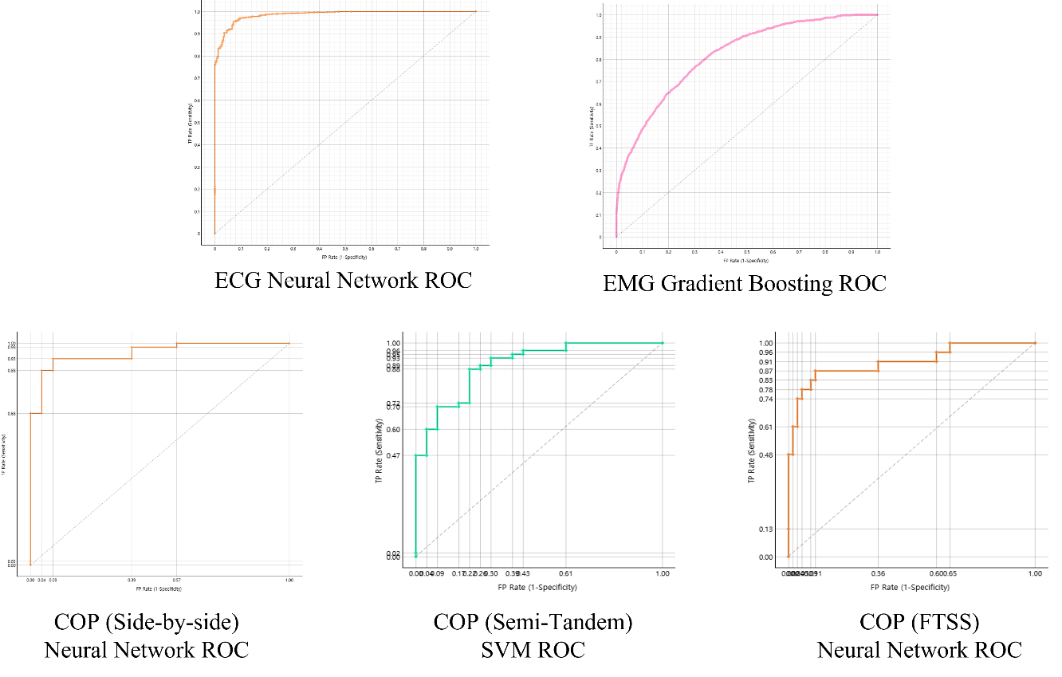
Figure S1. Receiver operating characteristic (ROC) curves of the best-performing classifiers for each physiological modality.
ROC curves are shown for the optimal machine learning models trained on features derived from ECG, EMG, and COP signals, including side-by-side stance, semi-tandem stance, and five-times sit-to-stand (FTSS) conditions. The curves illustrate the trade-off between sensitivity and specificity across varying decision thresholds and visually support the corresponding area under the curve (AUC) values reported in the Results section.

Table S2. Fold-wise variability of classification accuracy for machine learning models across physiological signal modalities
Signal | Model | Mean Accuracy | SD | Min | Max
ECG | SVM | 0.919 | 0.012 | 0.904 | 0.935
ECG | Neural Network | 0.951 | 0.011 | 0.935 | 0.963
ECG | Random Forest | 0.952 | 0.010 | 0.944 | 0.969
ECG | Gradient Boosting | 0.948 | 0.011 | 0.932 | 0.963
EMG | SVM | 0.803 | 0.015 | 0.787 | 0.822
EMG | Neural Network | 0.828 | 0.002 | 0.828 | 0.830
EMG | Random Forest | 0.809 | 0.009 | 0.797 | 0.823
EMG | Gradient Boosting | 0.829 | 0.003 | 0.826 | 0.833
COP  (Side-by-side) | SVM | 0.875 | 0.108 | 0.688 | 0.938
COP  (Side-by-side) | Neural Network | 0.912 | 0.071 | 0.812 | 1.000
COP  (Side-by-side) | Random Forest | 0.888 | 0.081 | 0.812 | 1.000
COP  (Side-by-side) | Gradient Boosting | 0.825 | 0.068 | 0.750 | 0.875
COP  (Semi-tandem) | SVM | 0.838 | 0.084 | 0.750 | 1.000
COP  (Semi-tandem) | Neural Network | 0.850 | 0.099 | 0.750 | 1.000
COP  (Semi-tandem) | Random Forest | 0.838 | 0.103 | 0.625 | 1.000
COP  (Semi-tandem) | Gradient Boosting | 0.788 | 0.119 | 0.625 | 1.000
COP  (FTSS) | SVM | 0.782 | 0.058 | 0.733 | 0.875
COP  (FTSS) | Neural Network | 0.898 | 0.056 | 0.812 | 0.938
COP  (FTSS) | Random Forest | 0.871 | 0.049 | 0.800 | 0.938
COP  (FTSS) | Gradient Boosting | 0.872 | 0.044 | 0.812 | 0.938
Note. Values represent the mean classification accuracy (Mean Accuracy), standard deviation (SD), and minimum–maximum range (Min, Max) of fold-wise accuracies obtained from stratified 10-fold cross-validation for each machine learning model and physiological signal modality.
Abbreviations: ECG, electrocardiography; EMG, electromyography; COP, center of pressure; FTSS, Five-Times Sit-to-Stand; SVM, support vector machine; NN, neural network; RF, random forest; GB, gradient boosting.

