Appendix A.2 Diagnostic performance of ACS calculator score
The difference in the value of the Risk wound infection calculated with the ACS calculator was analyzed. The following figures analyze the difference in means with the Bayesian analysis between both groups with and without infection, determining whether there is a correlation between the presence or not of infection and the highest score on the scale Figure 2 A. Then the diagnostic performance was evaluated with the roc curve and the maximum point of sensitivity and specificity Figure 2B.

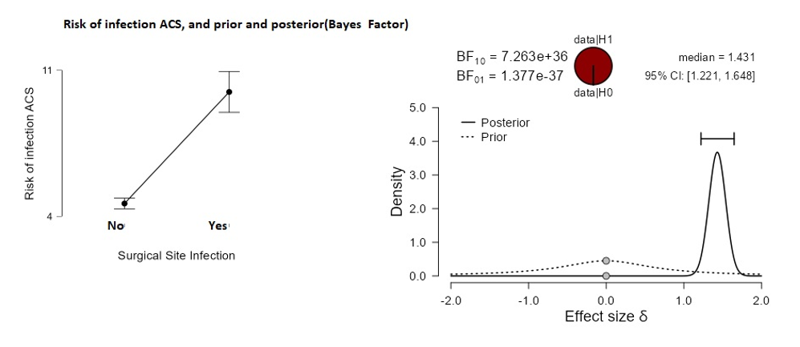

Figure 2 A. Difference of means and Bayesian analysis, ACS calculator scale score

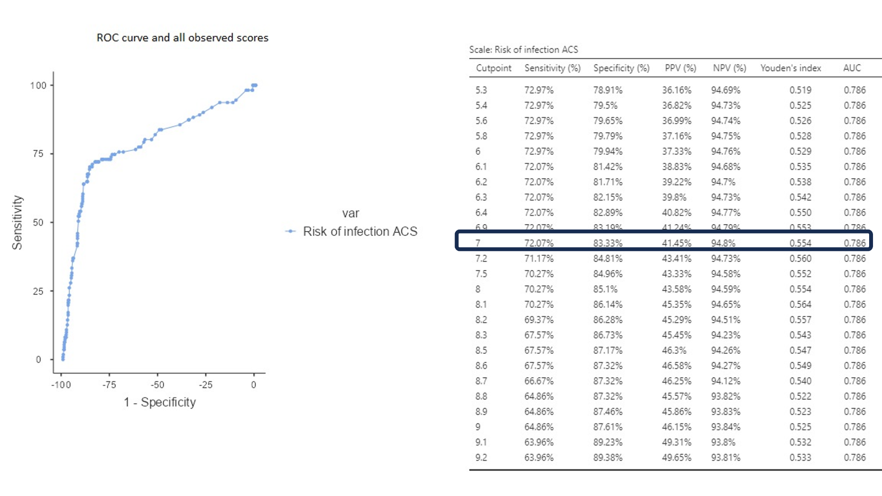

Figure 2B. ROC curve and diagnostic performance ACS calculator

