Additional file 1

Table of Contents

Supplementary Method
Method S1. Data augmentation, class imbalance handling, and ensemble modeling

Supplementary References

Supplementary Figures
Figure S1. Data flow diagram (SH)
Figure S2. Data flow diagram (SH Health Checkup Center)
Figure S3. Data flow diagram (Health Checkup Center external validation datasets)
Figure S4. Data flow diagram (UKB)
Figure S5. EfficientNet-B0 architecture
Figure S6. Boxplot of ECG-CAC model score by CAC score group in the test set
Figure S7. Calibration curves of the ECG-CAC model for detecting CAC presence
Figure S8. Integrated Gradients–based saliency visualization comparing CAC score = 0 and > 0 groups.
Figure S9. Integrated Gradients–based saliency visualization comparing CAC score = 0 and ≥ 400 groups.

Supplementary Tables
Table S1. Variables extracted from the UKB
Table S2. Performance of the ECG-CAC model for predicting CAC score > 0 in the Health Checkup Center datasets
Table S3. Subgroup analyses of model performance (AUROC) across demographic subgroups in the test and external validation datasets.
Table S4. Net reclassification improvement
Table S5. Cox regression analysis results
Table S6. C-index comparison
Table S7. Transparent Reporting of a Multivariable Prediction Model for Individual Prognosis or Diagnosis–Artificial Intelligence (TRIPOD-AI) checklist.

Supplementary Method
Method S1. Data augmentation, class imbalance handling, and ensemble modeling
During training, we implemented a data augmentation strategy by randomly selecting 2.5-second segments from 10-second electrocardiograms (ECGs) for each epoch. This approach was based on the hypothesis that calcification-related ECG changes would be primarily morphological rather than rhythm-based, similar to coronary heart disease findings [1], and thus 2.5 seconds would suffice. For validation, testing, and cohort analyses, we split each 10-second ECG into four 2.5-second segments and evaluated all segments for consistency. During each training epoch, we balanced classes by randomly oversampling the minority class and undersampling the majority class to equal sizes while maintaining the original dataset size. Ensemble learning refers to a methodology that combines multiple models for improved performance [2]. We created 25 EfficientNet-B0 models using identical training strategies. For each ECG, each model processed four non-overlapping 2.5-second segments of 10-second ECGs, yielding 100 outputs (25 models × 4 segments). We then adopted a soft voting ensemble method, averaging these 100 outputs to obtain the final result. Consequently, the average area under the receiver operating characteristics curve (AUROC) in the test set improved from 0.730 (standard deviation 0.002) for individual EfficientNet-B0 models to 0.741 for predicting coronary artery calcium (CAC) score > 0 and from 0.822 (standard deviation 0.004) for individual models to 0.837 for predicting CAC score ≥ 400 after applying the soft voting ensemble method.

Supplementary References
1. Machado DB, Crow RS, Boland LL, Hannan PJ, Taylor HA Jr, Folsom AR. Electrocardiographic findings and incident coronary heart disease among participants in the Atherosclerosis Risk in Communities (ARIC) study. Am J Cardiol. 2006;97:1176–81.
2 Mohammed A, Kora R. A comprehensive review on ensemble deep learning: Opportunities and challenges. J King Saud Univ - Comput Inf Sci. 2023;35:757–74.

Supplementary Figures
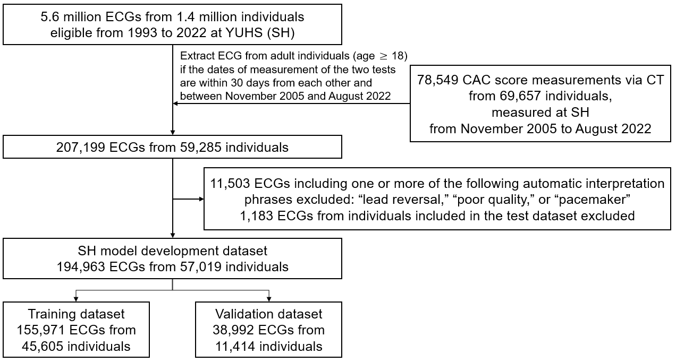
Figure S1. Data flow diagram (SH). SH model development dataset.
SH: Severance Hospital; ECG: electrocardiogram; YUHS: Yonsei University Health System; CACS: coronary artery calcium score; CT: computed tomography; PCE: Pooled Cohort Equations; KOSTAT: Statistics Korea.

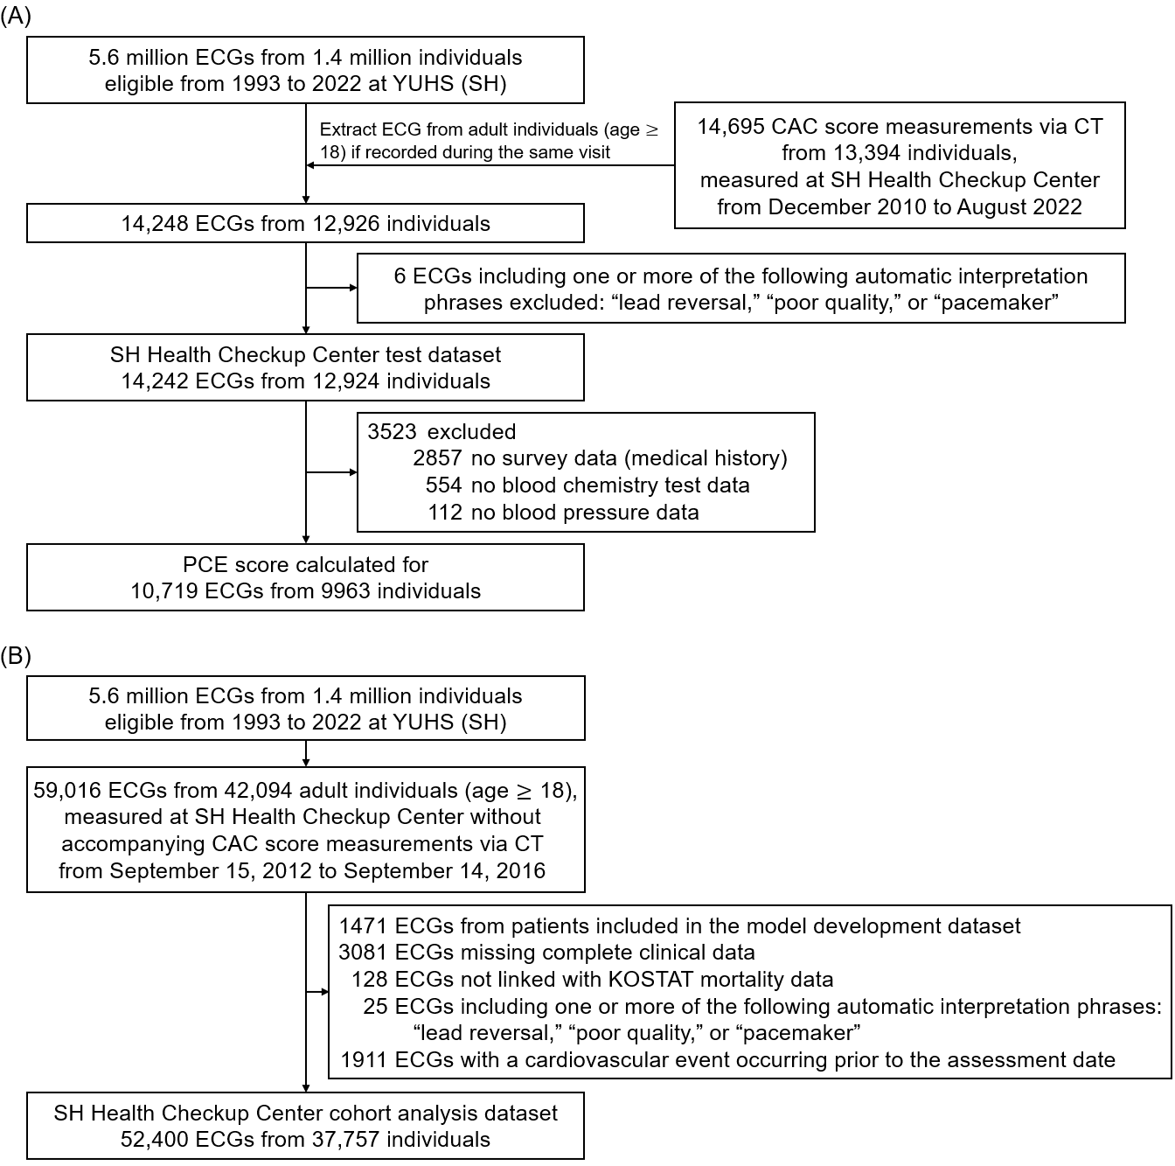
Figure S2. Data flow diagram (SH Health Checkup Center). (A) SH Health Checkup Center test dataset. (B) SH Health Checkup Center cohort analysis dataset.
SH: Severance Hospital; ECG: electrocardiogram; YUHS: Yonsei University Health System; CACS: coronary artery calcium score; CT: computed tomography; PCE: Pooled Cohort Equations; KOSTAT: Statistics Korea.
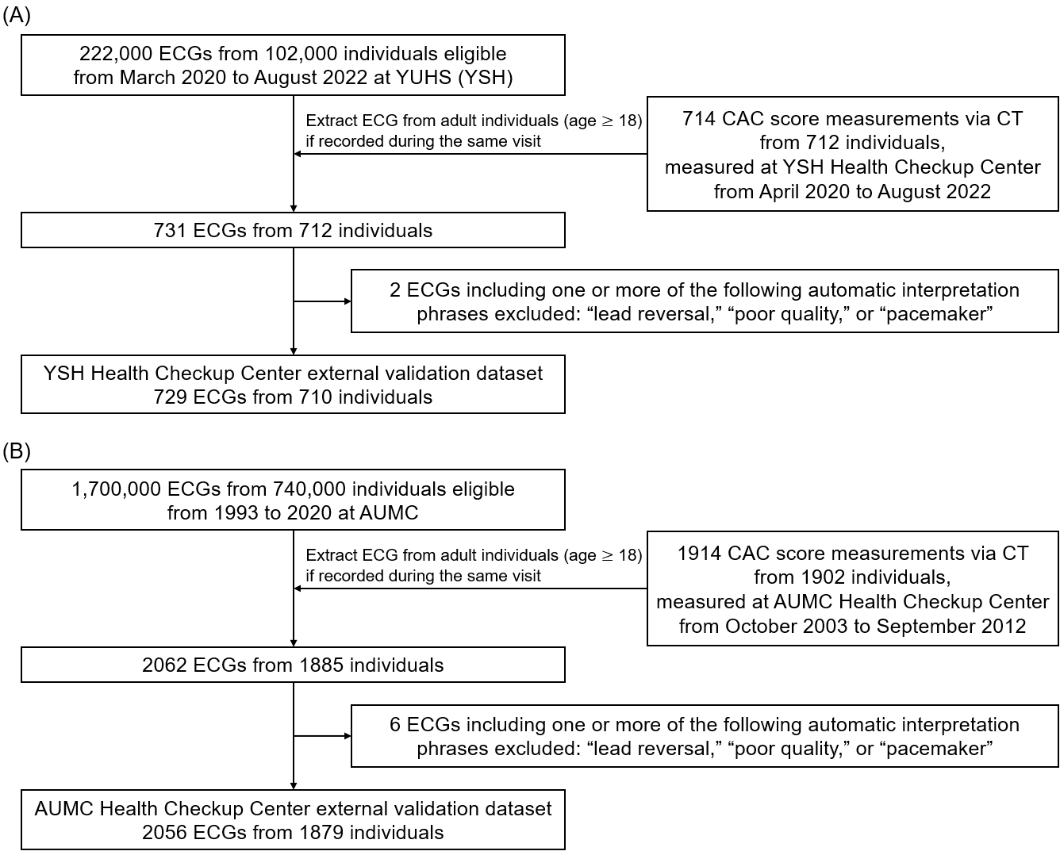
Figure S3. Data flow diagram (Health Checkup Center external validation datasets). (A) YSH Health Checkup Center external validation dataset. (B) AUMC Health Checkup Center external validation dataset.
YSH: Yongin Severance Hospital; AUMC: Ajou University Medical Center; ECG: electrocardiogram; YUHS: Yonsei University Health System; CAC: coronary artery calcium; CT: computed tomography.

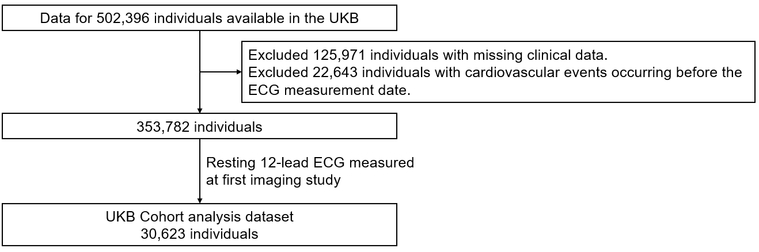
Figure S4. Data flow diagram (UKB). UKB cohort analysis dataset.
UKB: United Kingdom Biobank; ECG: electrocardiogram
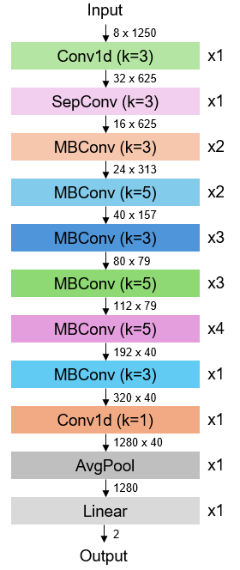
Figure S5. EfficientNet-B0 architecture.
Conv1d: 1-dimensional convolution; SepConv: depthwise separable convolution; MBConv: mobile inverted bottleneck convolution; AvgPool: average pooling

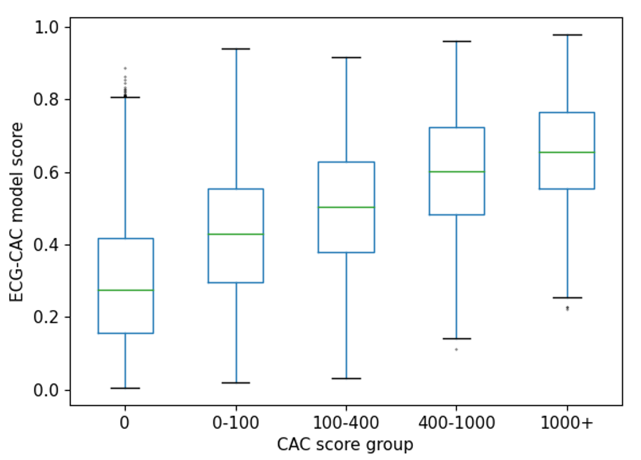
Figure S6. Boxplot of ECG-CAC model score by CAC score group in the test set. The median and IQR of the ECG-CAC model score progressively increased with higher CAC score groups.
ECG: electrocardiogram; CAC: coronary artery calcium; ECG-CAC model: ECG-based deep learning model for CAC prediction; IQR: interquartile range.
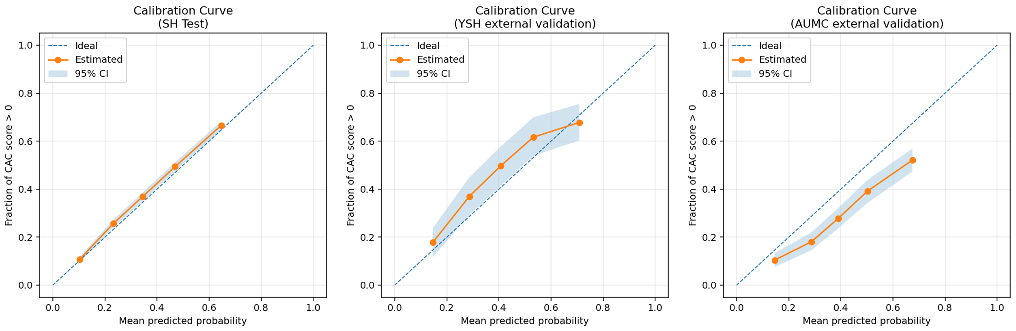
Figure S7. Calibration curves of the ECG-CAC model for detecting CAC presence. Calibration curves were constructed using quantile-based binning (five bins). The dashed line indicates perfect calibration, while the orange line represents model-estimated probabilities with shaded 95% confidence intervals. The ECG-CAC model showed excellent calibration in the SH test dataset (ECE = 0.019 [95% CI: 0.013 – 0.027]; Brier score = 0.197 [95% CI: 0.194 – 0.199]) and acceptable calibration in the YSH (ECE = 0.064 [95% CI: 0.038 – 0.098]; Brier score = 0.218 [95% CI: 0.205 – 0.231]) and AUMC (ECE = 0.105 [95% CI: 0.086 – 0.123]; Brier score = 0.197 [95% CI: 0.190 – 0.204]) external validation datasets. Overall, the model demonstrated good calibration and generalizability across institutions.
ECG: electrocardiogram; CAC: coronary artery calcium; ECG-CAC model: ECG-based deep learning model for CAC prediction; SH: Severance Hospital; ECE: expected calibration error; YSH: Yongin Severance Hospital; AUMC: Ajou University Medical Center.

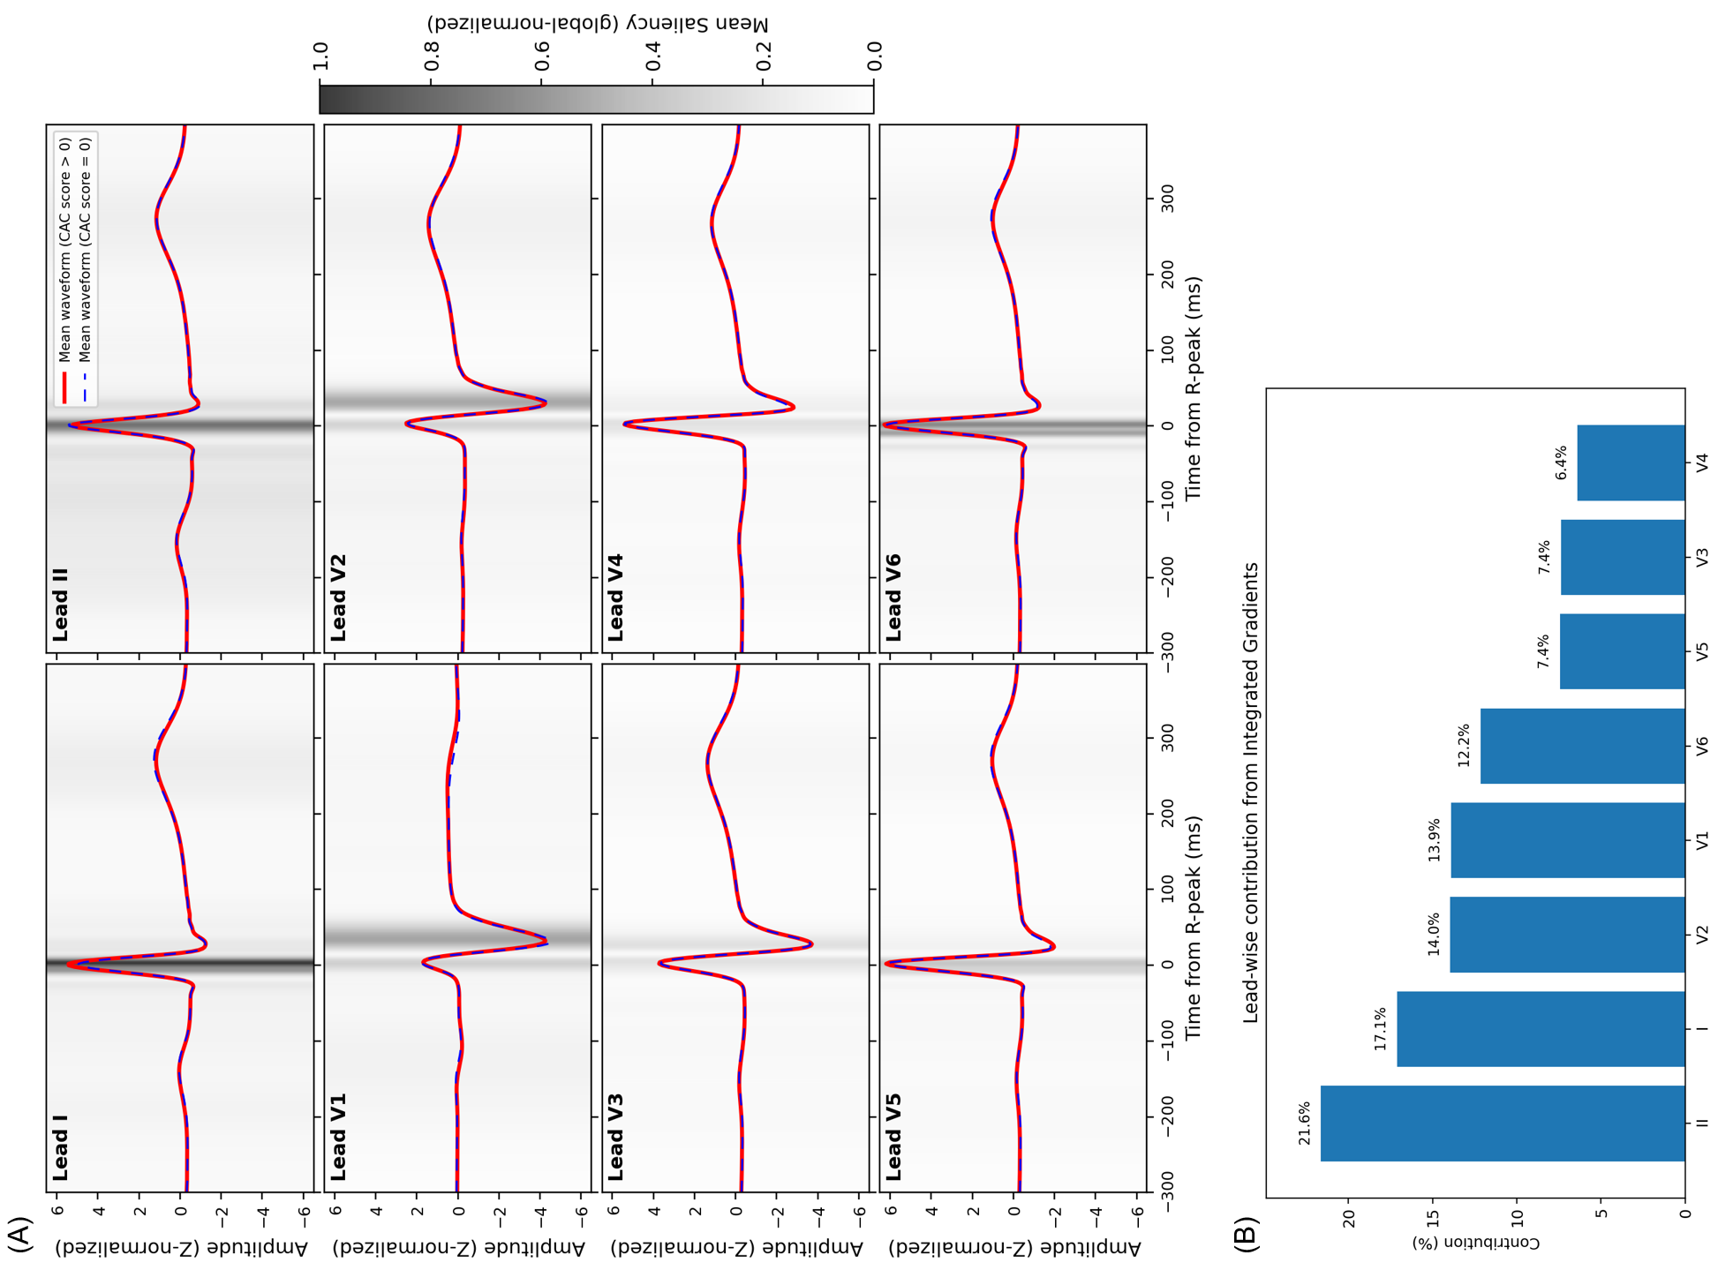
Figure S8. Integrated Gradients–based saliency visualization comparing CAC score = 0 and > 0 groups. (A) Waveforms and IG saliency maps were aligned to R-peaks (−300 to +400 ms), averaged within CAC groups, normalized, and overlaid to highlight ECG segments and leads contributing most to CAC prediction. (B) The summed IG attribution values across all ECGs were used to evaluate the relative contribution of each lead to CAC prediction.
CAC: coronary artery calcium; IG: Integrated Gradients; ECG: electrocardiogram.
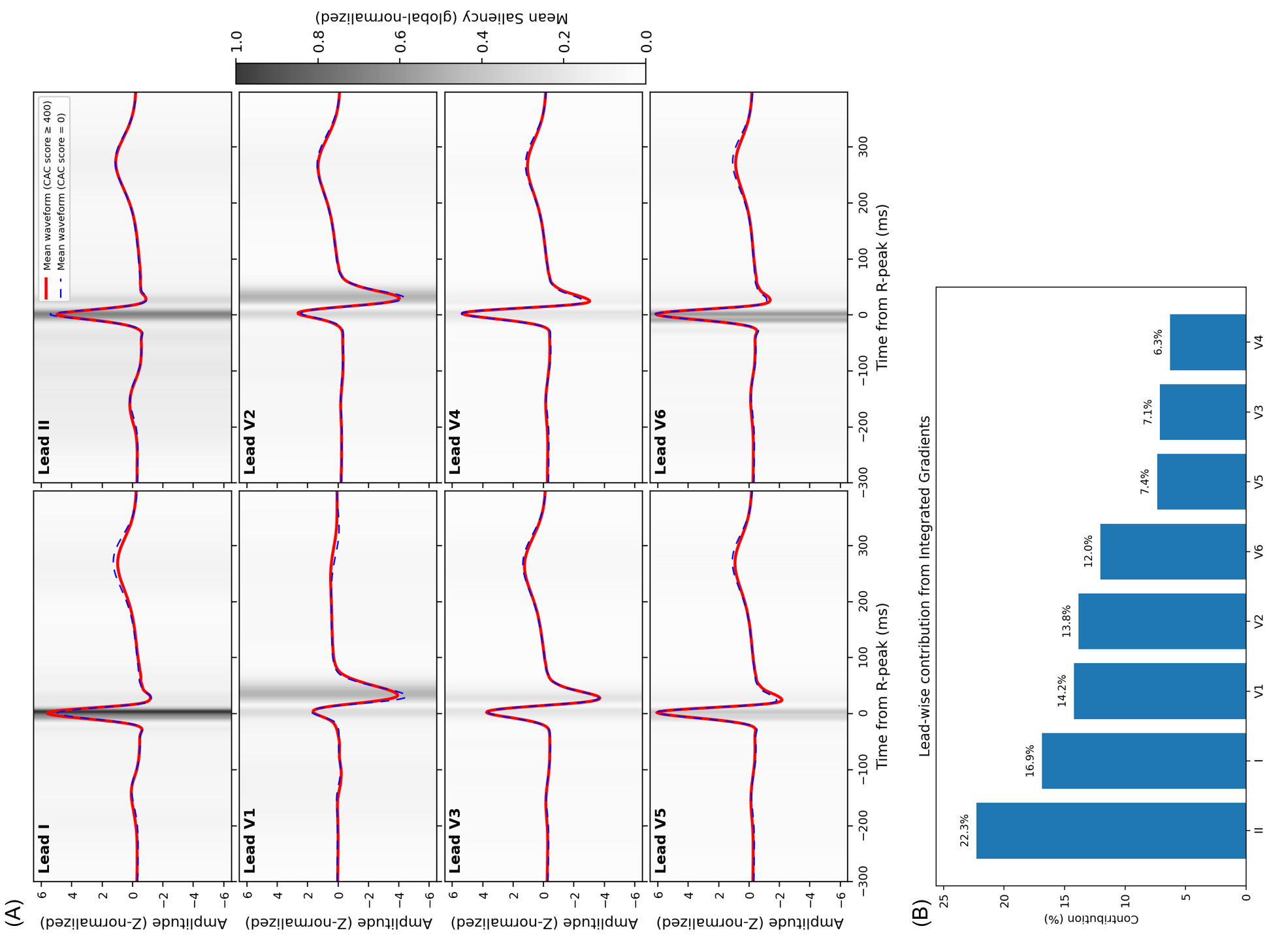
Figure S9. Integrated Gradients–based saliency visualization comparing CAC score = 0 and ≥ 400 groups. (A) Waveforms and IG saliency maps were aligned to R-peaks (−300 to +400 ms), averaged within CAC groups, normalized, and overlaid to highlight ECG segments and leads contributing most to CAC prediction. (B) The summed IG attribution values across all ECGs were used to evaluate the relative contribution of each lead to CAC prediction.
CAC: coronary artery calcium; IG: Integrated Gradients; ECG: electrocardiogram.
Supplementary Tables
Table S1. Variables extracted from the UKB
Description | Category | Coding
Age at recruitment | Baseline characteristics | Field: 21022
Sex | Baseline characteristics | Field: 31
Diabetes diagnosed by doctor | Medical conditions | Field: 2443
Medication for cholesterol, blood pressure or diabetes | Medication | Field: 6177
Medication for cholesterol, blood pressure or diabetes, or exogenous hormones | Medication | Field: 6153
Smoking status | Smoking | Field: 20116
Systolic blood pressure | Blood pressure | Field: 4080
Cholesterol | Blood chemistry | Field: 30690
HDL cholesterol | Blood chemistry | Field: 30760
Ethnic background | Ethnicity | Field: 21000
ECG datasets | ECG at rest, 12 lead | Field: 20205
Acute myocardial infarction  ICD-10: I21 | First occurrence | Field: 131298
Subsequent myocardial infarction  ICD-10: I22 | First occurrence | Field: 131300
Certain current complications following acute myocardial infarction  ICD-10: I23 | First occurrence | Field: 131302
Other acute ischemic heart disease  ICD-10: I24 | First occurrence | Field: 131304
Chronic ischemic heart disease  ICD-10: I25 | First occurrence | Field: 131306
Cerebral infarction  ICD-10: I63 | First occurrence | Field: 131366
Stroke, not specified as hemorrhage or infarction  ICD-10: I64 | First occurrence | Field: 131368

UKB: United Kingdom Biobank; HDL: high density lipoprotein; ECG: electrocardiogram; ICD-10: International Classification of Disease, 10th revision.

Table S2. Performance of the ECG-CAC model for predicting CAC score > 0 in the Health Checkup Center datasets. The table presents performance metrics at the thresholds used to define the ECG-CAC model risk categories.
 | Accuracy  (95% CI) | Sensitivity  (95% CI) | Specificity  (95% CI) | PPV  (95% CI) | NPV  (95% CI) | F1 score  (95% CI)
High risk vs. low/moderate risk category threshold for the ECG-CAC model
SH test | 0.668  (0.661 - 0.675) | 0.193  (0.183 - 0.204) | 0.957  (0.953 - 0.961) | 0.733  (0.711 - 0.757) | 0.661  (0.653 - 0.669) | 0.306  (0.291 - 0.320)
YSH external validation | 0.593  (0.557 - 0.630) | 0.240  (0.196 - 0.287) | 0.902  (0.873 - 0.930) | 0.683  (0.596 - 0.764) | 0.575  (0.536 - 0.616) | 0.356  (0.299 - 0.410)
AUMC external validation | 0.719  (0.699 - 0.738) | 0.243  (0.208 - 0.277) | 0.918  (0.904 - 0.932) | 0.553  (0.494 - 0.612) | 0.744  (0.724 - 0.763) | 0.337  (0.295 - 0.377)
High/moderate risk vs. low risk category threshold for the ECG-CAC model
SH test | 0.580  (0.572 - 0.588) | 0.897  (0.889 - 0.905) | 0.386  (0.376 - 0.396) | 0.471  (0.462 - 0.481) | 0.861  (0.850 - 0.871) | 0.618  (0.609 - 0.627)
YSH external validation | 0.591  (0.554 - 0.627) | 0.930  (0.901 - 0.956) | 0.294  (0.250 - 0.339) | 0.536  (0.496 - 0.576) | 0.826  (0.758 - 0.888) | 0.680  (0.644 - 0.714)
AUMC external validation | 0.449  (0.428 - 0.469) | 0.937  (0.918 - 0.955) | 0.246  (0.224 - 0.267) | 0.342  (0.319 - 0.363) | 0.904  (0.874 - 0.930) | 0.501  (0.476 - 0.525)
ECG: electrocardiogram; CAC: coronary artery calcium; ECG-based deep learning model for CAC prediction; CI: confidence interval; PPV: positive predictive value; NPV: negative predictive value; SH: Severance Hospital; YSH; Yongin Severance Hospital; AUMC: Ajou University Medical Center.

Table S3. Subgroup analyses of model performance (AUROC) across demographic subgroups in the test and external validation datasets.
SH Health Checkup Center test dataset
 | CAC score > 0 |  |  | CAC score $≥$ 400
 | AUROC (95% CI) | P-value for AUROC comparison |  | AUROC (95% CI) | P-value for AUROC comparison
Entire cohort | 0.741 (0.732 – 0.749) |  |  | 0.837 (0.821 – 0.853)
Subgroup analyses
Age |  | 0.314 |  |  | 0.817
< 60 years | 0.728 (0.718 – 0.738) |  |  | 0.812 (0.783 – 0.839)
≥ 60 years | 0.706 (0.688 – 0.723) |  |  | 0.773 (0.747 – 0.800)
Sex |  | 0.071 |  |  | 0.858
Female | 0.757 (0.742 – 0.770) |  |  | 0.856 (0.809 – 0.898)
Male | 0.720 (0.709 – 0.730) |  |  | 0.797 (0.777 – 0.817)
YSH Health Checkup Center external validation dataset
 | CAC score > 0 |  |  | CAC score $≥$ 400
 | AUROC (95% CI) | P-value for AUROC comparison |  | AUROC (95% CI) | P-value for AUROC comparison
Entire cohort | 0.712 (0.674 – 0.748) |  |  | 0.800 (0.732 – 0.860)
Subgroup analyses
Age |  | 0.763 |  |  | 0.785
< 60 years | 0.700 (0.650 – 0.748) |  |  | 0.859 (0.784 – 0.921)
≥ 60 years | 0.674 (0.612 – 0.731) |  |  | 0.724 (0.625 – 0.821)
Sex |  | 0.824 |  |  | 0.948
Female | 0.677 (0.618 – 0.742) |  |  | 0.805 (0.591 – 0.967)
Male | 0.697 (0.648 – 0.748) |  |  | 0.762 (0.690 – 0.831)
AUMC Health Checkup Center external validation dataset
 | CAC score > 0 |  |  | CAC score $≥$ 400
 | AUROC (95% CI) | P-value for AUROC comparison |  | AUROC (95% CI) | P-value for AUROC comparison
Entire cohort | 0.711 (0.688 – 0.735) |  |  | 0.799 (0.742 – 0.849)
Subgroup analyses
Age |  | 0.205 |  |  | 0.910
< 60 years | 0.701 (0.673 – 0.729) |  |  | 0.788 (0.723 – 0.852)
≥ 60 years | 0.603 (0.535 – 0.668) |  |  | 0.736 (0.612 – 0.849)
Sex |  | 0.447 |  |  | 0.987
Female | 0.750 (0.694 – 0.803) |  |  | 0.757 (0.465 – 0.971)
Male | 0.685 (0.658 – 0.713) |  |  | 0.785 (0.724 – 0.841)
AUROC: area under the receiver operating characteristic curve; SH: Severance Hospital; CAC: coronary artery calcium; CI: confidence interval; YSH: Yongin Severance Hospital; AUMC: Ajou University Medical Center.

Table S4. Net reclassification improvement. The NRI for up-risking or down-risking based on the ECG-CAC model within the PCE low- or moderate-risk categories.
SH Health Checkup Center cohort analysis dataset
(within PCE low- or moderate-risk categories)
 | Up-risked, %  (95% CI) | Down-risked, %  (95% CI)
Number of cases  (N = 1384) | 4.6  (3.5 – 5.8) | 1.2  (0.6 – 1.9) | Event NRI, %  (95% CI) | 3.4  (2.1 – 4.7)
Number of controls  (N = 49,470) | 2.2  (2.1 – 2.3) | 1.1  (1.0 – 1.2) | Non-event NRI, %  (95% CI) | -1.0  (-1.2 – -0.9)
 |  |  | NRI, %  (95% CI) | 2.3  (1.0 – 3.7)
UKB cohort analysis dataset
(within PCE low- or moderate-risk categories)
 | Up-risked, %  (95% CI) | Down-risked, %  (95% CI)
Number of cases  (N = 604) | 6.1  (4.3 – 8.1) | 1.7  (0.7 – 2.8) | Event NRI, %  (95% CI) | 4.5  (2.4 – 6.6)
Number of controls  (N = 28,679) | 4.3  (4.0 – 4.5) | 1.9  (1.7 – 2.0) | Non-event NRI, %  (95% CI) | -2.4  (-2.1 – -2.7)
 |  |  | NRI, %  (95% CI) | 2.1  (0.0 – 4.3)
NRI: net reclassification improvement; ECG: electrocardiogram; CAC: coronary artery calcium; ECG-based deep learning model for CAC prediction; PCE: Pooled Cohort Equations; SH: Severance Hospital; UKB: United Kingdom Biobank; CI: confidence interval.

Table S5. Cox regression analysis results. We adjusted the scale of the ECG-CAC model score from 0-1 to 0-10 by multiplying by ten for more intuitive data interpretation. The adjusted HR for “ECG-CAC model score * 10” now shows hazard change associated with a 10% absolute increase in ECG-CAC model score.
 | SH Health Checkup Center cohort analysis dataset |  | UKB  cohort analysis dataset
 | Adjusted HR  (95% CI) | P-Value | Adjusted HR  (95% CI) | P-Value
Age, years | 1.069  (1.063 – 1.075) | <0.001 | 1.064  (1.052 – 1.077) | <0.001
Sex (male) | 1.794  (1.587 – 2.028) | <0.001 | 1.665  (1.383 – 2.005) | <0.001
DM | 1.508  (1.297 – 1.753) | <0.001 | 1.698  (1.238 – 2.329) | 0.001
HTN | 1.360  (1.214 – 1.525) | <0.001 | 1.300  (1.076 – 1.571) | 0.007
Current smoker | 1.203  (1.055 – 1.371) | 0.006 | 1.413  (1.082 – 1.845) | 0.011
SBP, mmHg | 1.002  (0.999 – 1.006) | 0.195 | 1.008  (1.004 – 1.012) | <0.001
Total cholesterol, mg/dL | 1.002  (1.000 – 1.003) | 0.014 | 1.002  (1.000 – 1.004) | 0.054
HDL cholesterol, mg/dL | 0.995  (0.991 – 1.000) | 0.028 | 0.979  (0.973 – 0.986) | <0.001
ECG-CAC model score * 10 | 1.128  (1.093 – 1.164) | <0.001 | 1.101  (1.050 – 1.154) | <0.001
ECG: electrocardiogram; CAC: coronary artery calcium; ECG-based deep learning model for CAC prediction; HR: hazard ratio; SH: Severance Hospital; UKB: United Kingdom Biobank; CI: confidence interval; DM: diabetes mellitus; HTN: hypertension; SBP: systolic blood pressure; HDL: high-density lipoprotein.

Table S6. C-index comparison. The table shows the C-indexes for MACE.
 | C-index of the PCE  (95% CI) | C-index of the combined PCE plus ECG-CAC model score (95% CI) | Differences in C-index with the PCE  (95% CI)
SH Health Checkup Center cohort analysis dataset | 0.786 (0.776 – 0.796) | 0.798 (0.789 – 0.808) | 0.012 (0.008 – 0.016)
UKB cohort analysis dataset | 0.724 (0.706 – 0.743) | 0.734 (0.715 – 0.753) | 0.010 (0.003 – 0.017)
MACE: major adverse cardiovascular event; PCE: Pooled Cohort Equations; CI: confidence interval; ECG: electrocardiogram; CAC: coronary artery calcium; ECG-based deep learning model for CAC prediction; SH: Severance Hospital; UKB: United Kingdom Biobank.

Table S7. Transparent Reporting of a Multivariable Prediction Model for Individual Prognosis or Diagnosis–Artificial Intelligence (TRIPOD-AI) checklist.
Section/Topic | Item | Development  /evaluation* | Checklist item | Location in manuscript
TITLE
Title | 1 | D;E | Identify the study as developing or evaluating the performance of a multivariable prediction model, the target population, and the outcome to be predicted | Appropriate title
ABSTRACT
Abstract | 2 | D;E | See TRIPOD+AI for Abstracts checklist | Appropriate abstract
INTRODUCTION
Background | 3a | D;E | Explain the healthcare context (including whether diagnostic or prognostic) and rationale for developing or evaluating the prediction model, including references to existing models | Background, paragraph 1
Background | 3b | D;E | Describe the target population and the intended purpose of the prediction model in the context of the care pathway, including its intended users (e.g., healthcare professionals, patients, public) | Background, paragraph 1,2
Background | 3c | D;E | Describe any known health inequalities between sociodemographic groups | N/A
Objectives | 4 | D;E | Specify the study objectives, including whether the study describes the development or validation of a prediction model (or both) | Background, paragraph 4
METHODS
Data | 5a | D;E | Describe the sources of data separately for the development and evaluation datasets (e.g., randomised trial, cohort, routine care or registry data), the rationale for using these data, and representativeness of the data | Methods, Data sources and labeling, paragraph 1-5
Data | 5b | D;E | Specify the dates of the collected participant data, including start and end of participant accrual; and, if applicable, end of follow-up | Methods, Data sources and labeling, paragraph 1-5
Participants | 6a | D;E | Specify key elements of the study setting (e.g., primary care, secondary care, general population) including the number and location of centres | Methods, Data sources and labeling, paragraph 1-5
Participants | 6b | D;E | Describe the eligibility criteria for study participants | Methods, Data sources and labeling, paragraph 1-5
Participants | 6c | D;E | Give details of any treatments received, and how they were handled during model development or evaluation, if relevant | N/A
Data preparation | 7 | D;E | Describe any data pre-processing and quality checking, including whether this was similar across relevant sociodemographic groups | Methods, ECG-CAC model development, paragraph 1
Outcome | 8a | D;E | Clearly define the outcome that is being predicted and the time horizon, including how and when assessed, the rationale for choosing this outcome, and whether the method of outcome assessment is consistent across sociodemographic groups | Methods, ECG-CAC model development, paragraph 1
Outcome | 8b | D;E | If outcome assessment requires subjective interpretation, describe the qualifications and demographic characteristics of the outcome assessors | N/A
Outcome | 8c | D;E | Report any actions to blind assessment of the outcome to be predicted | Methods, ECG-CAC model development, paragraph 1
Predictors | 9a | D | Describe the choice of initial predictors (e.g., literature, previous models, all available predictors) and any pre-selection of predictors before model building | Methods, ECG-CAC model development, paragraph 1
Predictors | 9b | D;E | Clearly define all predictors, including how and when they were measured (and any actions to blind assessment of predictors for the outcome and other predictors) | Methods, Data sources and labeling, paragraph 2-5  Methods, ECG-CAC model development, paragraph 1
Predictors | 9c | D;E | If predictor measurement requires subjective interpretation, describe the qualifications and demographic characteristics of the predictor assessors | N/A
Sample size | 10 | D;E | Explain how the study size was arrived at (separately for development and evaluation), and justify that the study size was sufficient to answer the research question. Include details of any sample size calculation | Results, Dataset characteristics (model development and test datasets), paragraph 1  Results, Dataset characteristics (cohort analyses datasets), paragraph 1
Missing data | 11 | D;E | Describe how missing data were handled. Provide reasons for omitting any data | Additional file 1: Figures S1-5
Analytical methods | 12a | D | Describe how the data were used (e.g., for development and evaluation of model performance) in the analysis, including whether the data were partitioned, considering any sample size requirements | Methods, Data sources and labeling, paragraph 2
Analytical methods | 12b | D | Depending on the type of model, describe how predictors were handled in the analyses (functional form, rescaling, transformation, or any standardisation). | Methods, ECG-CAC model development, paragraph 1
Analytical methods | 12c | D | Specify the type of model, rationale, all model-building steps, including any hyperparameter tuning, and method for internal validation | Methods, ECG-CAC model development, paragraph 1
Analytical methods | 12d | D;E | Describe if and how any heterogeneity in estimates of model parameter values and model performance was handled and quantified across clusters (e.g., hospitals, countries). See TRIPOD-Cluster for additional considerations | Results, Model performance, paragraph 2
Analytical methods | 12e | D;E | Specify all measures and plots used (and their rationale) to evaluate model performance (e.g., discrimination, calibration, clinical utility) and, if relevant, to compare multiple models | Methods, Performance metrics and risk categorization, paragraph 1-2
Analytical methods | 12f | E | Describe any model updating (e.g., recalibration) arising from the model evaluation, either overall or for particular sociodemographic groups or settings | N/A
Analytical methods | 12g | E | For model evaluation, describe how the model predictions were calculated (e.g., formula, code, object, application programming interface) | Methods, ECG-CAC model development, paragraph 1
Class imbalance | 13 | D;E | If class imbalance methods were used, state why and how this was done, and any subsequent methods to recalibrate the model or the model predictions | Additional file 1: Method S1
Fairness | 14 | D;E | Describe any approaches that were used to address model fairness and their rationale | Results, Model performance, paragraph 1,2  Results, Multinational retrospective cohort analyses, paragraph 1-3
Model output | 15 | D | Specify the output of the prediction model (e.g., probabilities, classification). Provide details and rationale for any classification and how the thresholds were identified | Methods, ECG-CAC model development, paragraph 1
Training versus evaluation | 16 | D;E | Identify any differences between the development and evaluation data in healthcare setting, eligibility criteria, outcome, and predictors | Methods, Data sources and labeling, paragraph 2,3
Ethical approval | 17 | D;E | Name the institutional research board or ethics committee that approved the study and describe the participant-informed consent or the ethics committee waiver of informed consent | Ethics approval and consent to participate
OPEN SCIENCE
Funding | 18a | D;E | Give the source of funding and the role of the funders for the present study | Funding
Conflicts of interest | 18b | D;E | Declare any conflicts of interest and financial disclosures for all authors | Competing interests
Protocol | 18c | D;E | Indicate where the study protocol can be accessed or state that a protocol was not prepared | N/A
Registration | 18d | D;E | Provide registration information for the study, including register name and registration number, or state that the study was not registered | N/A
Data sharing | 18e | D;E | Provide details of the availability of the study data | Availability of data and materials
Code sharing | 18f | D;E | Provide details of the availability of the analytical code | Availability of data and materials
PATIENT & PUBLIC INVOLVEMENT
Patient & Public Involvement | 19 | D;E | Provide details of any patient and public involvement during the design, conduct, reporting, interpretation, or dissemination of the study or state no involvement. | N/A
RESULTS
Participants | 20a | D;E | Describe the flow of participants through the study, including the number of participants with and without the outcome and, if applicable, a summary of the follow-up time. A diagram may be helpful. | Figure 1  Additional file 1: Figures S1-5
Participants | 20b | D;E | Report the characteristics overall and, where applicable, for each data source or setting, including the key dates, key predictors (including demographics), treatments received, sample size, number of outcome events, follow-up time, and amount of missing data. A table may be helpful. Report any differences across key demographic groups. | Table 1  Table 2
Participants | 20c | E | For model evaluation, show a comparison with the development data of the distribution of important predictors (demographics, predictors, and outcome). | Table 1
Model development | 21 | D;E | Specify the number of participants and outcome events in each analysis (e.g., for model development, hyperparameter tuning, model evaluation) | Table 1
Model specification | 22 | D | Provide details of the full prediction model (e.g., formula, code, object, application programming interface) to allow predictions in new individuals and to enable third-party evaluation and implementation, including any restrictions to access or re-use (e.g., freely available, proprietary) | Availability of data and materials
Model performance | 23a | D;E | Report model performance estimates with confidence intervals, including for any key subgroups (e.g., sociodemographic). Consider plots to aid presentation. | Figure 2  Additional file 1: Table S3
Model performance | 23b | D;E | If examined, report results of any heterogeneity in model performance across clusters. See TRIPOD Cluster for additional details. | Figure 2  Additional file 1: Table S3
Model updating | 24 | E | Report the results from any model updating, including the updated model and subsequent performance | N/A
DISCUSSION
Interpretation | 25 | D;E | Give an overall interpretation of the main results, including issues of fairness in the context of the objectives and previous studies | Discussion, paragraph 1-6
Limitations | 26 | D;E | Discuss any limitations of the study (such as a non-representative sample, sample size, overfitting, missing data) and their effects on any biases, statistical uncertainty, and generalizability | Discussion, paragraph 8
Usability of the model in the context of current care | 27a | D | Describe how poor quality or unavailable input data (e.g., predictor values) should be assessed and handled when implementing the prediction model | N/A
Usability of the model in the context of current care | 27b | D | Specify whether users will be required to interact in the handling of the input data or use of the model, and what level of expertise is required of users | N/A
Usability of the model in the context of current care | 27c | D;E | Discuss any next steps for future research, with a specific view to applicability and generalizability of the model | Discussion, paragraph 8
*D=items relevant only to the development of a prediction model; E=items relating solely to the evaluation of a prediction model.

