Supplemental Material
Supplemental Figure 1: Flow Diagram of included study participants
Participants included in this analysis
n=135691
Excluded (n=18441)
- Age <18 years (n=311)
- Death date before index date (n=16)
- Less than 12 months of follow-up between index date and last contact date (n=18114)
Participants with diagnosis of knee OA, between January, 1st 2000 and October, 30th 2023
n=154132

Supplemental Figure 2: Area under the curve and C-index
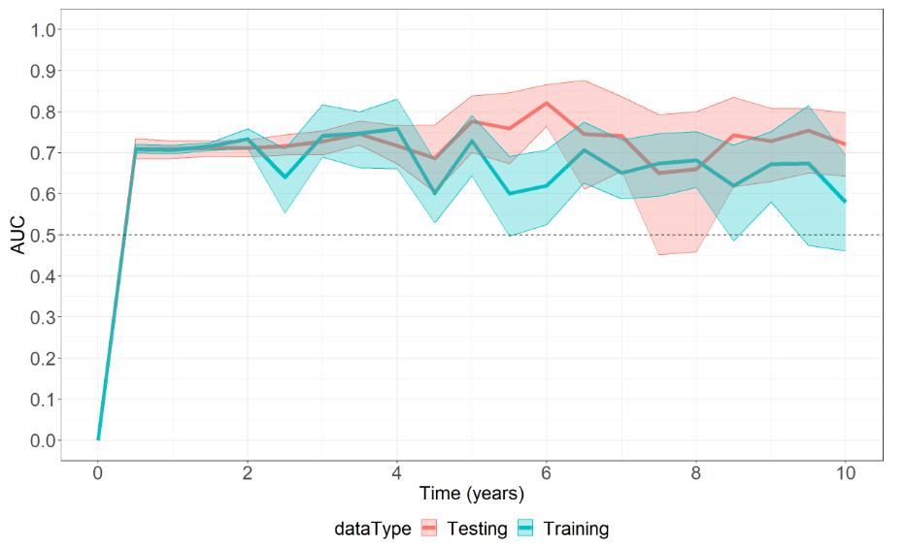
C-index with 95%CI:
Training | Test
0.703 [0.694, 0.712] | 0.702 [0.684, 0.719]

Supplemental Figure 3: Average predicted curves from the LASSO model based on the training set separated by sex
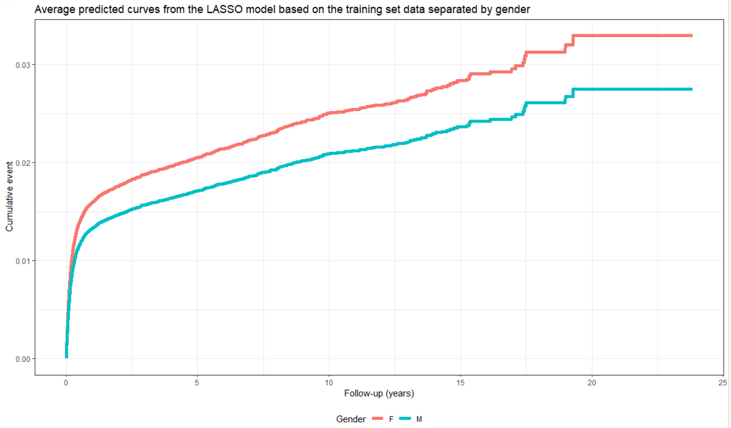

Supplemental Table 1: Details of training and test set per risk group
 |  | Training set |  | Test set
 | Total N=135691 | Low (N=81415) | High (N=27138) | Low (N=20319) | High (N=6819)
Age, years,  Mean (SD)  Median (Q1, Q3)  ≥ 65, n (%) | 65.8 (13.6)  67 (57, 76)  76012 (56%) | 63.1 (13.6)  64.0 (54.0, 73.0)  38464 (47%) | 73.9 (9.9)  74.0 (67.0, 81.0)  22454 (83%) | 63.0 (13.7)  63.0 (54.0, 73.0)  9449 (47%) | 73.7 (9.9)  74.0 (67.0, 81.0)  5645 (83%)
No. of females, n (%) | 67465 (62%) | 48171 (59%) | 19294 (71%) | 11918 (59%) | 4857 (71%)
Socioeconomic status (1-10)¹  Number of missing (%)  Mean (SD)  Median (Q1, Q3) | 871 (0.6%)  6.1 (2)  6 (5, 8) | 573 (0.7%)  5.9 (2.0)  6.0 (4.0, 7.0) | 120 (0.4%)  6.6 (2.0)  7.0 (5.0, 8.0) | 145 (0.7%)  5.9 (2.0)  6.0 (4.0, 7.0) | 33 (0.05%)  6.6 (2.0)  7.0 (5.0, 8.0)
BMI [kg/$m^{2}$]  Number of missing²  Mean (SD)  Median (Q1, Q3) | 18580 (14%)  30.2 (5.8)  29.4 (26.1, 33.4) | 13910 (17%)  29.0 (5.0)  28.4 (25.4, 32.0) | 901 (3%)  33.3 (6.4)  32.4 (28.8, 36.9) | 3505 (17%)  29.0 (5.1)  28.5 (25.5, 32.0) | 264 (4%)  33.4 (6.5)  32.5 (28.9, 37.1)
Rate of obesity based on WHO* categories³  Underweight (BMI < 18.5 kg/$m^{2}$), n (%)  Normal weight (BMI 18.5-24.9 kg/$m^{2}$), n (%)  Overweight (BMI 25-29.9 kg/$m^{2}$), n (%)  Obesity (BMI ≥ 30 kg/$m^{2}$), n (%) | 433 (0%)  19973 (15%)  42665 (31%)  54040 (40%) | 323 (0%)  14448 (18%)  27057 (33%)  25677 (32%) | 14 (0%)  1562 (6%)  7172 (26%)  17489 (64%) | 93 (0%)  3550 (17%)  6719 (33%)  6452 (32%) | 3 (0%)  413 (6%)  1717 (25%)  4422 (65%)
Smoking status  Number of missing, n (%)  Never smoked, n (%)  Quit smoking, n (%)  Smokers, n (%) | 38829 (29%)  85712 (63%)  2077 (2%)  9073 (7%) | 27490 (34%)  47346 (58%)  1129 (1%)  5450 (7%) | 3497 (13%)  21286 (78%)  554 (2%)  1801 (7%) | 6943 (34%)  11752 (58%)  261 (1%)  1363 (7%) | 899 (13%)  5328 (78%)  133 (2%)  459 (7%)
Key comorbidities⁴, n (%)  Presence of cancer  Presence of cardiovascular disease  Presence of chronic kidney disease  Presence of diabetes  Presence of COPD*  Presence of hypertension | 21025 (15%)  30682 (23%)  47751 (35%)  33376 (25%)  8963 (7%)  76951 (57%) | 10507 (13%)  16822 (21%)  27777 (34%)  17984 (22%)  5254 (6%)  40895 (50%) | 6312 (23%)  7690 (28%)  10429 (38%)  8742 (32%)  1905 (7%)  20669 (76%) | 2629 (13%)  4258 (21%)  6898 (34%)  4499 (22%)  1346 (7%)  10178 (50%) | 1577 (23%)  1912 (28%)  2647 (39%)  2151 (32%)  458 (7%)  5209 (76%)
Other comorbidities, n (%)  Prior rheumatologic disease  Presence of dementia  Presence of depression  Presence of hypothyroidism  Presence of mild liver disease  History of weight loss  Cardiac arrythmia  Presence of obesity  Presence of hypertension, uncomplicated  Presence of renal disease  Presence of Allergy | 8816 (6%)  4122 (3%)  47148 (35%)  20596 (15%)  20341 (15%)  12835 (9%)  16493 (12%)  18811(14%)  79437 (59%)  6883 (5%)  75590 (56%) | 3069 (4%)  2081 (3%)  24479 (30%)  10874 (13%)  8936 (11%)  7104 (9%)  8318 (10%)  7928 (10%)  41702 (51%)  4100 (5%)  38726 (48%) | 4071 (15%)  1279 (5%)  13058 (48%)  5632 (21%)  7230 (27%)  3178 (12%)  4903 (18%)  6995 (26%)  21835 (80%)  1419 (5%)  21732 (80%) | 749 (4%)  460 (2%)  6322 (31%)  2651 (13%)  2297 (11%)  1739 (9%)  2097 (10%)  2071 (10%)  10397 (51%)  1031 (5%)  698 (48%) | 927 (14%)  302 (4%)  3289 (48%)  1439 (21%)  1878 (28%)  814 (12%)  1175 (17%)  1817 (27%)  5503 (81%)  333 (5%)  5434 (80%)
Lab values  Platelet count [x10³/μl]  Number of missing  Mean (SD)  Median (Q1, Q3)  Hematocrit [%]  Number of missing  Mean (SD)  Median (Q1, Q3)  ALT* [U/L]  Number of missing  Mean (SD)  Median (Q1, Q3)  Creatinine [mg/dl] Number of missing  Mean (SD)  Median (Q1, Q3) | 24882 (18%)  244.9 (65)  239 (201, 282)  24482 (18%)  41.1 (3.9)  41.1 (38.6, 43.6)  31167 (23%)  20.9 (10.8)  18 (14, 25)  23913 (18%)  0.9 (0.3)  0.8 (0.7, 1) | 16662 (20%)  239.6 (62.5)  235.0 (198.0, 276.0)  16445 (20%)  40.9 (4.0)  41.0 (38.5, 43.6)  20733 (25%)  21.6 (11.4)  19.0 (14.0, 25.0)  16611 (20%)  0.9 (0.3)  0.8 (0.7, 1.0) | 3236 (12%)  259.3 (69.7)  252.0 (212.0, 298.0)  3139 (12%)  41.4 (3.8)  41.3 (39.0, 43.8)  4261 (16%)  19.3 (8.9)  17.0 (14.0, 23.0)  2582 (10%)  0.8 (0.2)  0.8 (0.6, 0.9) | 4182 (21%)  239.8 (61.8)  235.0 (198.0, 276.0)  4119 (20%)  40.9 (4.0)  41.0 (38.4, 43.6)  5123 (25%)  21.6 (11.3)  19.0 (14.0, 25.0)  4096 (20%)  0.9 (0.3)  0.8 (0.7, 1.0) | 802 (9%)  258.7 (69.1)  251.0 (212.0, 297.0)  779 (9%)  41.3 (3.8)  41.3 (38.9, 43.8)  1050 (12%)  19.4 (9.2)  17.0 (14.0, 23.0)  624 (7%)  0.8 (0.2)  0.7 (0.6, 0.9)
Elixhauser Comorbidity Index  Number of missing  Mean (SD)  Median (Q1, Q3) | 268 (0.2%)  3.9 (7.2)  0 (0, 8) | 209 (0.3%)  3.4 (6.9)  0.0 (0.0, 6.0) | 9 (0.03%)  5.4 (8.1)  4.0 (0.0, 11.0) | 46 (0.2%)  3.4 (6.9)  0.0 (0.0, 6.0) | 4 (0.05%)  5.4 (8.1)  4.0 (0.0, 11.0)
Medication use (ATC coding), n (%)  M01A anti-inflammatory and anti-rheumatic products (non-steroid)  N02B other analgesics and antipyretics  N05C hypnotics and sedatives  N06A antidepressants  A02B drugs for peptic ulcers and GERD*  A10B blood glucose lowering drugs (excl. insulins)  B01A anti-thrombotic agents  C07A beta blocking agents  C08C selective calcium channel blockers with mainly vascular effects  C09A ACE* inhibitors  C10A lipid modifying agents  R06A antihistamines for systemic use | 12192 (9%)  8579 (6%)  7540 (6%)  7923 (6%)  13894 (10%)  11280 (8%)  17315 (13%)  13360 (10%)  8211 (6%)  7722 (6%)  20012 (15%)  3377 (2%) | 7339 (9%)  4625 (6%)  3985 (5%)  4118 (5%)  7227 (9%)  6256 (8%)  9740 (12%)  7563 (9%)  5388 (7%)  5276 (6%)  11031 (14%) | 2480 (9%)  2179 (8%)  2048 (8%)  2209 (8%)  3908 (14%)  2774 (10%)  4055 (15%)  3053 (11%)  1231 (5%)  889 (3%)  4940 (18%) | 1768 (9%)  1205 (6%)  1001 (5%)  1007 (5%)  1777 (9%)  1558 (8%)  2490 (12%)  1945 (10%)  1305 (6%)  1336 (7%)  2797 (14%) | 605 (9%)  570 (8%)  506 (7%)  589 (9%)  982 (14%)  692 (10%)  1030 (15%)  799 (12%)  287 (4%)  221 (3%)  1244 (18%)
¹ values between 1-10 based on calculations by the Centra Bureau of Statistics per geographical area
² after exclusion of weight values <30 kg or >300 kg
³ A healthy lifestyle - WHO recommendations, last accessed Sept 16th 2024
⁴ based on disease specific registries
* WHO=World health organization; COPD=chronic obstructive pulmonary disease; ALT= ALT=Alanine transaminase; GERD= gastro-esophageal reflux disease; ACE= Angiotensin-converting enzyme

