Beyond Prediction: Explainable Machine Learning for Ferritin Estimation from Complete Blood Count

Authors:
Ramazan Berk Us ^{1,*}, Oguzhan Panatli ^{2,3} , Mine Büşra Bozkurk ¹, Atakan Ozturk ¹, Suadiye Sağlam ¹ , Arzu Kösem ¹ , Alpaslan Ozturk ¹, Gazi Erkan Bostanci ³

Affiliation:
¹ Department of Medical Biochemistry, Ankara Etlik City Hospital, Yenimahalle, Ankara 06170, Türkiye
² Department of Biomedical Engineering, Faculty of Engineering, Ankara University, Gölbaşı, Ankara 06830, Türkiye
³ Department of Computer Engineering, Faculty of Engineering, Ankara University, Gölbaşı, Ankara 06830, Türkiye

*Corresponding Author:
Ramazan Berk Us: berkus62@gmail.com

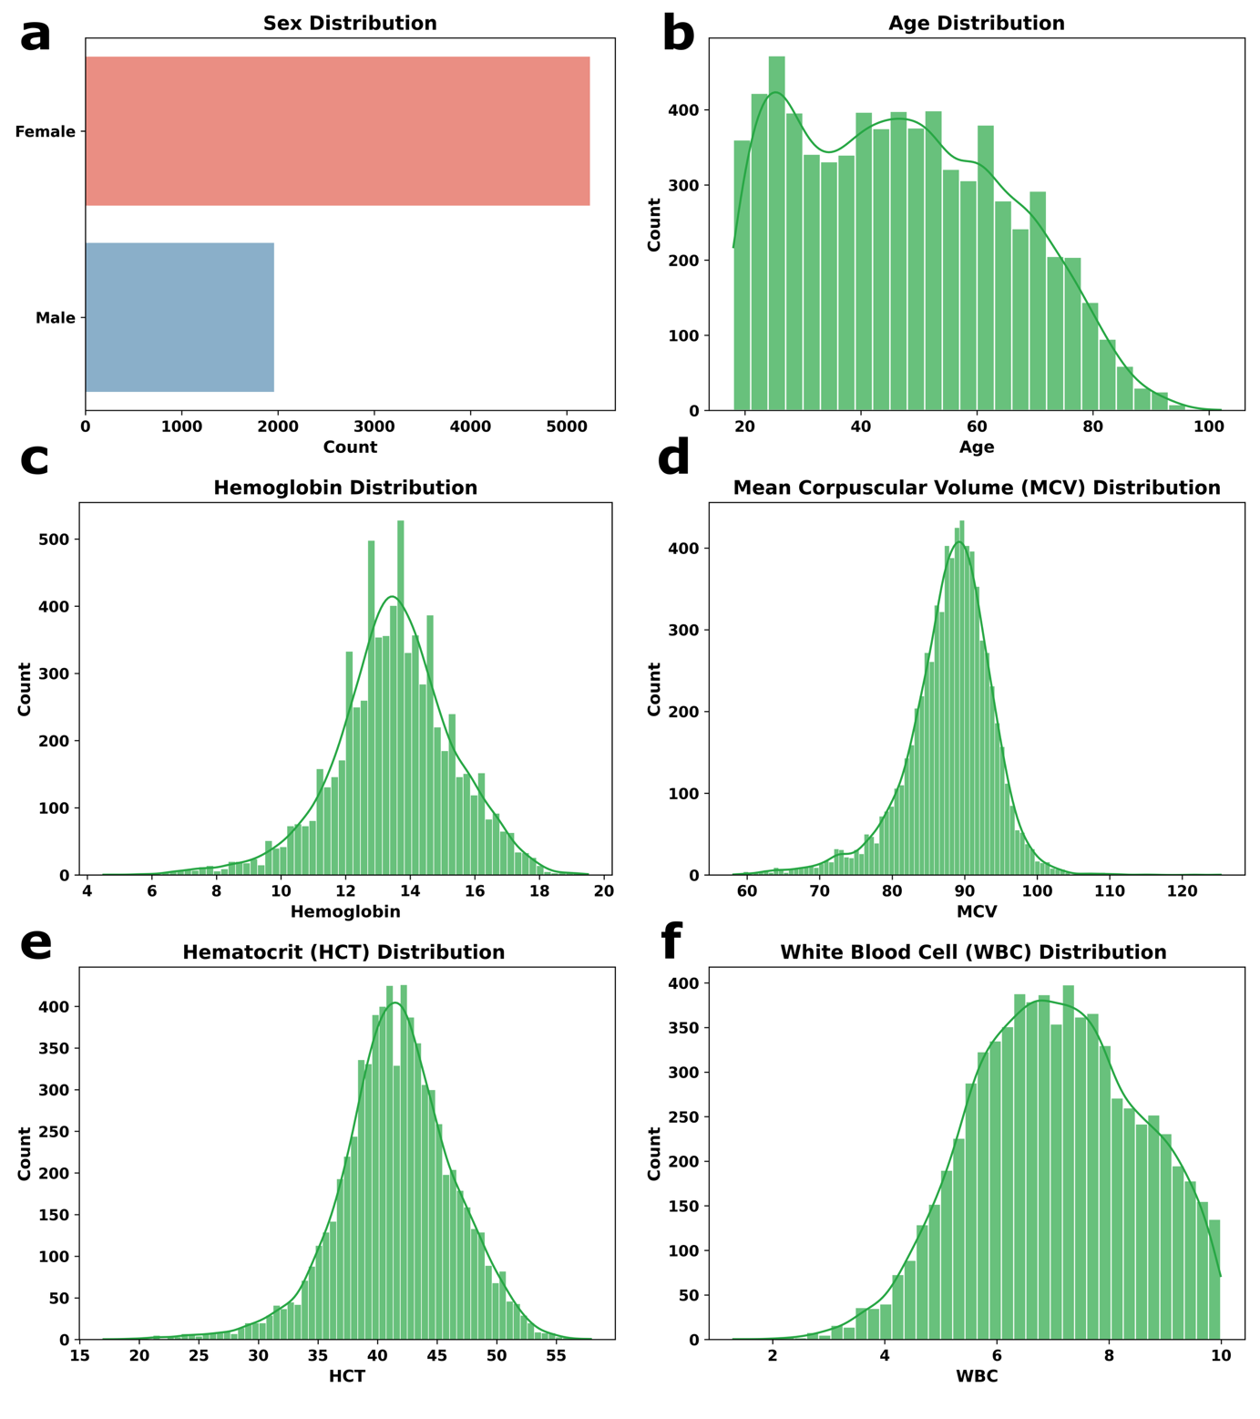
Supplementary Figure S1 Exploratory data analysis (EDA) of the dataset.

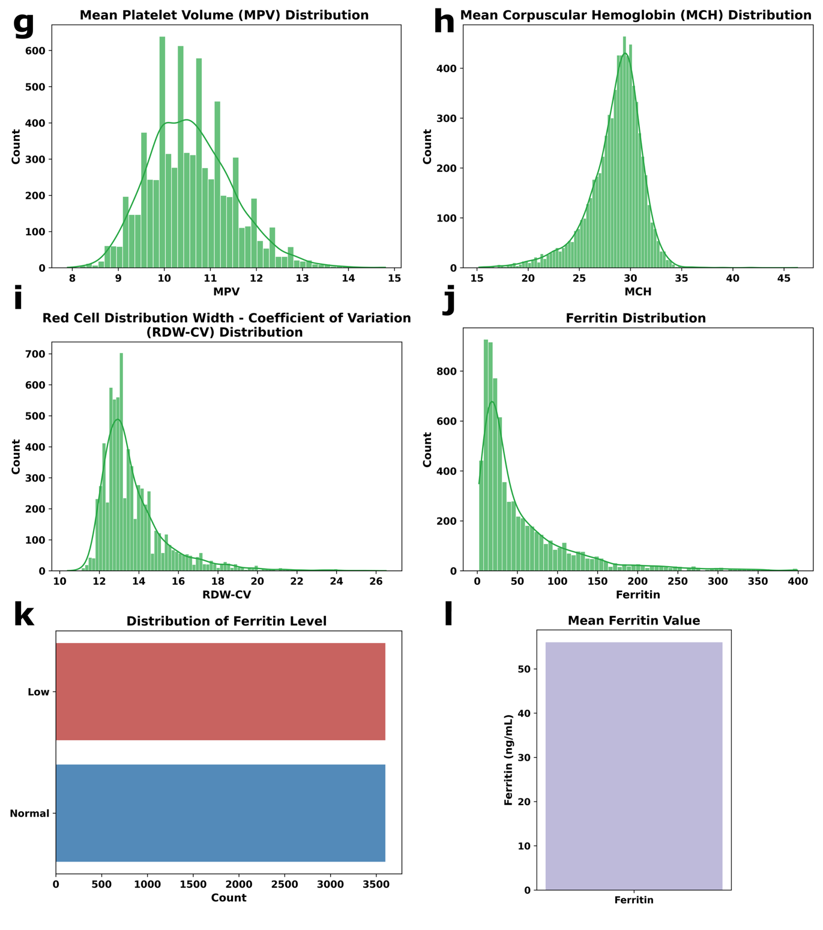
Supplementary Figure S2 Continued exploratory data analysis (EDA) of the dataset

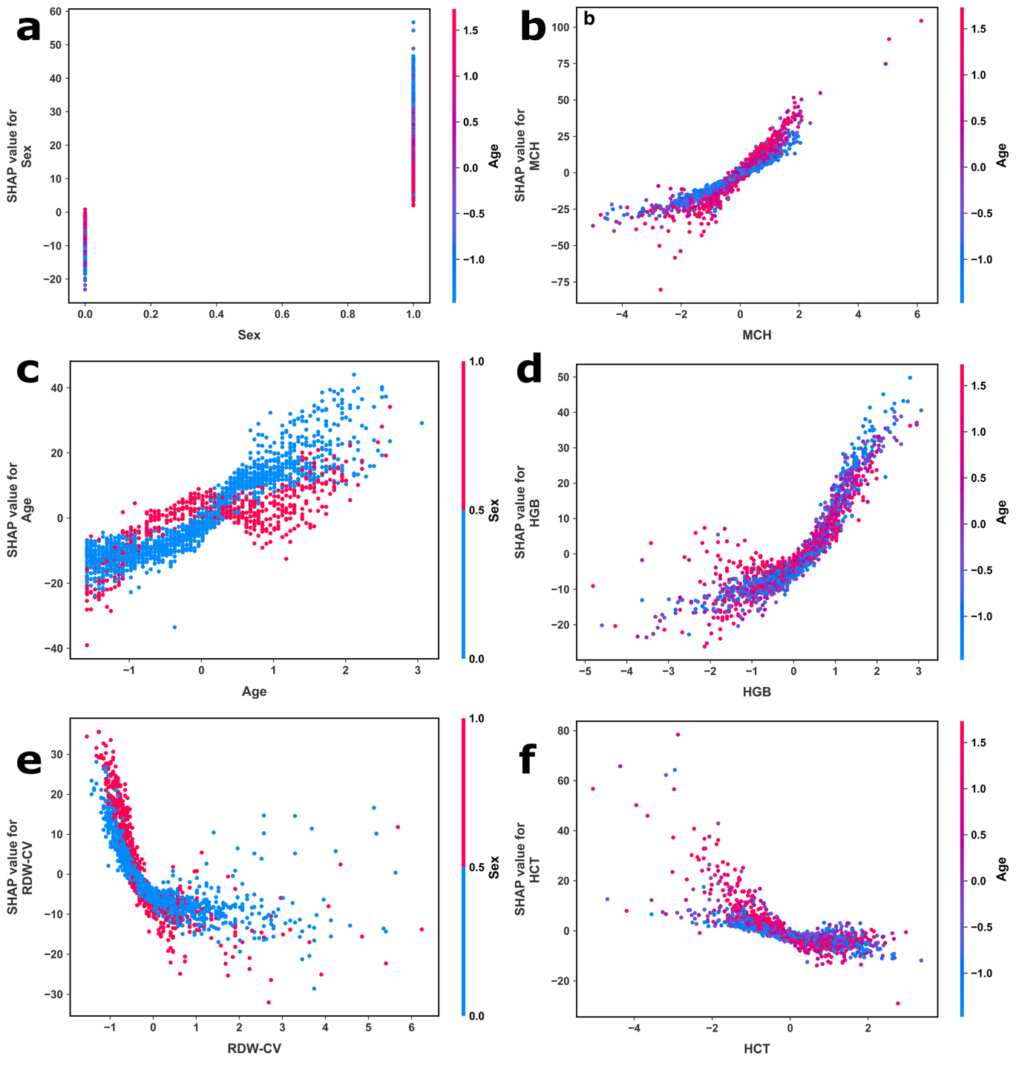
Supplementary Figure S3 SHAP dependence plots of the features.

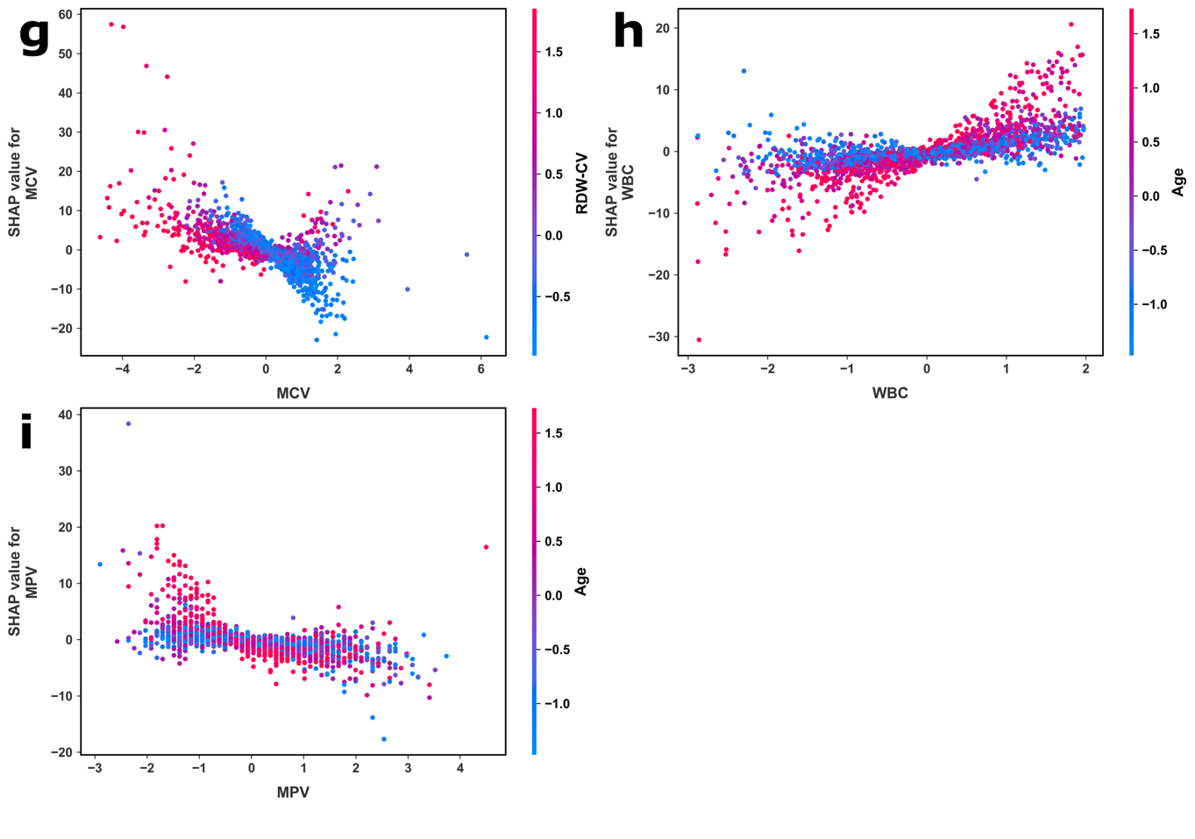
Supplementary Figure S4 Continued SHAP dependence plots of the features.

