Screenshots of Clinical Dashboard for Nephrology Inpatients
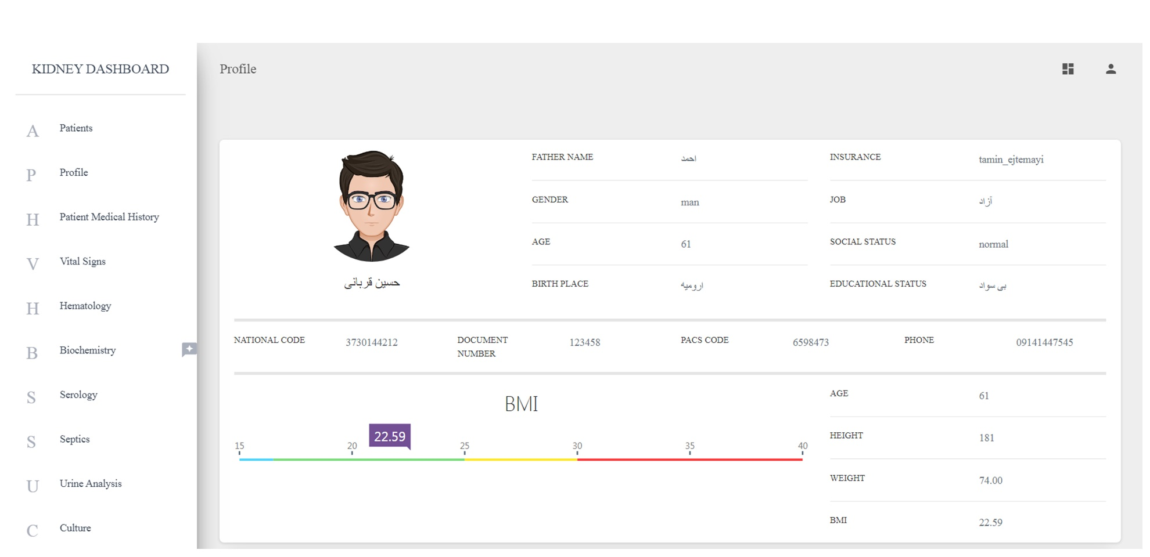
Supplementary Figure 1. Patient Profile
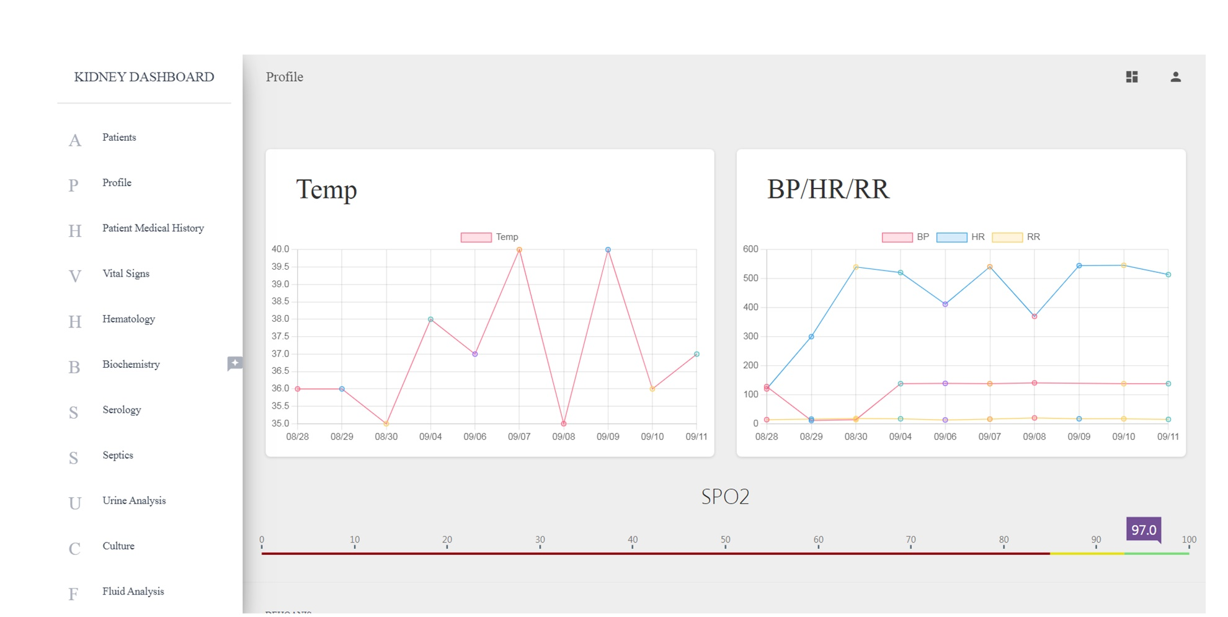
Supplementary Figure 2: Page related to some of the patient's vital signs
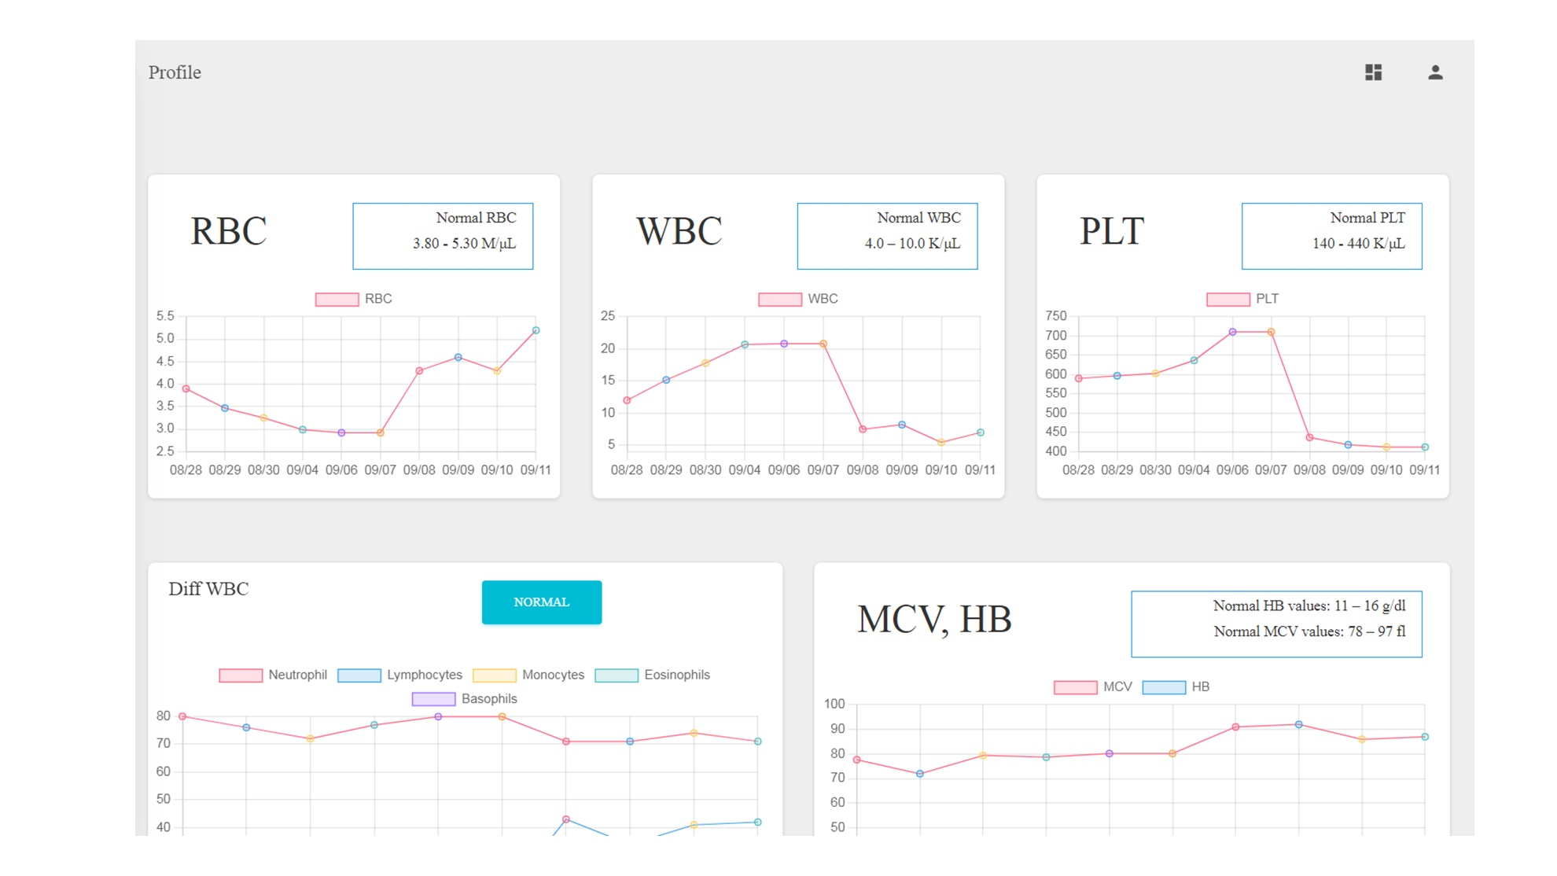
Supplementary Figure 3: Page related to some of the patient's blood tests

