Table S1. Independent Risk Factors for Non-ER After Reoperation
Variable | ER, N (%) | Non-ER, N (%) | Univariate_OR | Multivariate_OR
Preoperative Tg (ng/ml)>2.47 vs. ≤2.47 | 81 (31.3) | 253 (61.6) | 3.519[2.539,4.909] | 2.639[1.805,3.879]
Total Tumor size (cm)>2 vs. ≤2 | 85 (32.8) | 245 (59.6) | 3.021[2.187,4.198] | 2.443[1.676,3.579]
Reoperative LNR >0.22 vs. ≤0.22 | 91 (35.1) | 233 (56.7) | 2.417[1.757,3.34] | 2.696[1.853,3.958]
Recurrent disease size (cm)>1.02 vs. ≤1.02 | 98 (37.8) | 237 (57.7) | 2.238[1.63,3.083] | 1.727[1.194,2.505]
Primary LNR>0.42 vs. ≤0.42 | 101 (39.0) | 231 (56.2) | 2.008[1.465,2.761] | 1.383[0.93,2.056]
Primary PLN>5 vs. ≤5 | 94 (36.3) | 225 (54.7) | 2.123[1.546,2.928] | 1.718[1.15,2.574]
Hashimoto's thyroiditis: Yes vs. No | 102 (39.4) | 95 (23.1) | 0.463[0.329,0.649] | 0.568[0.378,0.85]
BMI (kg/m²)>23 vs ≤23 | 104 (40.2) | 220 (53.5) | 1.717[1.254,2.356] | 1.493[1.025,2.179]
Intraglandular dissemination: Yes vs. No | 13 (5.0) | 52 (12.7) | 2.741[1.505,5.351] | 2.133[1.079,4.466]
The systemic immune-inflammation index>425.6 vs. ≤425.6 | 119 (45.9) | 215 (52.3) | 1.291[0.945,1.764] | 1.262[0.871,1.831]
Initial surgery performed at a tertiary hospital: Yes vs. No | 231 (89.2) | 332 (80.8) | 0.509[0.316,0.8] | 0.528[0.302,0.901]
Site of suspicious LNM: Lateral vs. Central | 125 (48.3) | 202 (49.1) | 2.319[1.308,4.171] | 2.231[1.139,4.445]
Site of suspicious LNM: Central+Lateral vs. Central | 101 (39.0) | 186 (45.3) | 2.642[1.48,4.79] | 2.187[1.121,4.327]
RAI before reoperation > 1 | 77 (29.7) | 154 (37.5) | 1.416[1.017,1.982] | 1.265[0.852,1.887]
Age (>55 or ≤25): Yes vs. No | 34 (13.1) | 94 (22.9) | 1.962[1.291,3.044] | 1.867[1.143,3.099]

Table S2: Performance Comparison of Machine Learning Models
Set | Model | AUC-ROC | Sensitivity | Specificity | Accuracy | PPV | NPV | F1 score
train | LR | 80.3% | 79.5% | 63.2% | 73.2% | 77.4% | 66.1% | 78.4%
train | DT | 80.5% | 85.8% | 62.1% | 76.6% | 78.2% | 73.4% | 81.8%
train | SVM | 82.4% | 83.7% | 60.4% | 74.7% | 77.0% | 70.1% | 80.2%
train | KNN | 80.9% | 81.3% | 58.2% | 72.3% | 75.5% | 66.3% | 78.3%
train | NB | 80.6% | 71.2% | 72.5% | 71.7% | 80.4% | 61.4% | 75.5%
train | XGB | 87.3% | 85.8% | 69.2% | 79.4% | 81.5% | 75.4% | 83.6%
train | LightGBM | 91.4% | 91.3% | 70.3% | 83.2% | 83.0% | 83.7% | 86.9%
train | SGBT | 86.9% | 88.2% | 62.1% | 78.1% | 78.6% | 76.9% | 83.1%
train | NNET | 77.8% | 72.2% | 78.0% | 74.5% | 83.9% | 64.0% | 77.6%
train | ENET | 79.9% | 83.7% | 57.1% | 73.4% | 75.5% | 68.9% | 79.4%
train | GP | 82.2% | 82.6% | 61.5% | 74.5% | 77.3% | 69.1% | 79.9%
train | RF | 92.3% | 95.1% | 63.7% | 83.0% | 80.6% | 89.2% | 87.3%
test | LR | 85.7% | 81.3% | 70.1% | 77.0% | 81.3% | 70.1% | 81.3%
test | DT | 76.3% | 76.4% | 58.4% | 69.5% | 74.6% | 60.8% | 75.5%
test | SVM | 84.0% | 82.9% | 66.2% | 76.5% | 79.7% | 70.8% | 81.3%
test | KNN | 83.8% | 82.1% | 67.5% | 76.5% | 80.2% | 70.3% | 81.1%
test | NB | 85.1% | 76.4% | 79.2% | 77.5% | 85.5% | 67.8% | 80.7%
test | XGB | 83.0% | 79.7% | 67.5% | 75.0% | 79.7% | 67.5% | 79.7%
test | LightGBM | 84.4% | 81.3% | 64.9% | 75.0% | 78.7% | 68.5% | 80.0%
test | SGBT | 84.9% | 83.7% | 61.0% | 75.0% | 77.4% | 70.1% | 80.5%
test | NNET | 82.5% | 69.9% | 81.8% | 74.5% | 86.0% | 63.0% | 77.1%
test | ENET | 84.1% | 85.4% | 64.9% | 77.5% | 79.5% | 73.5% | 82.4%
test | GP | 84.9% | 82.1% | 68.8% | 77.0% | 80.8% | 70.7% | 81.5%
test | RF | 86.5% | 89.4% | 61.0% | 78.5% | 78.6% | 78.3% | 83.7%

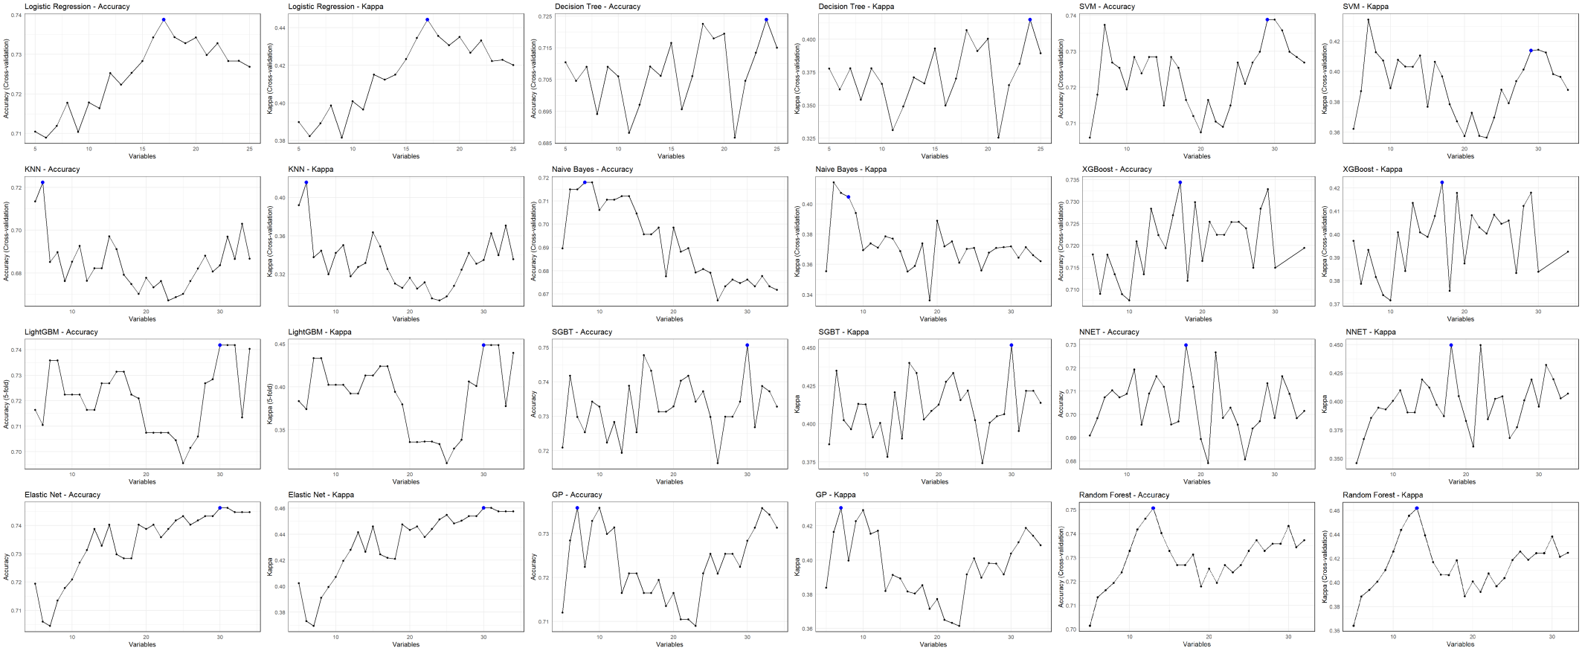
Fig. S1 Illustration of recursive feature elimination (RFE) for all machine learning models

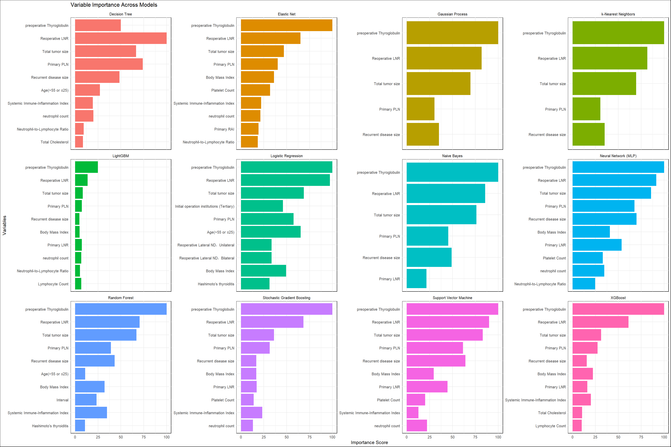
Fig. S2 Top 10 feature importance ranking from RFE for all machine learning models

