Supplementary Material
Deep Learning Analysis of 12-Lead Electrocardiograms for Bloodstream Infection Prediction: A Multi-Center Validation Study
Table of Contents
Supplementary Figure S1. Scatter plots: AI-ECG BSI model vs. mortality model
Supplementary Figure S2. 90-day all-cause mortality prediction performance
Supplementary Figure S3. One-vs-rest discrimination of each pathogen class by the primary BSI risk score
Supplementary Figure S4. Calibration curves
Supplementary Figure S5. Decision curve analysis
Supplementary Table S1. Patient characteristics, internal test set, by risk
Supplementary Table S2. Patient characteristics, external test set, by risk
Supplementary Table S3. Patient characteristics, MIMIC-IV, by risk
Supplementary Table S4. TRIPOD checklist
Supplementary Table S5. ECG diagnostic patterns and quantitative measurements
Supplementary Table S6. Operating-point analysis and subgroup performance
Supplementary Table S7. ECG acquisition timing
Supplementary Table S8. Comparison with baseline models
Supplementary Table S9. Likelihood ratios and prevalence-adjusted NPV

Supplementary Figure S1. Scatter plots comparing AI-ECG BSI model and mortality model predictions.
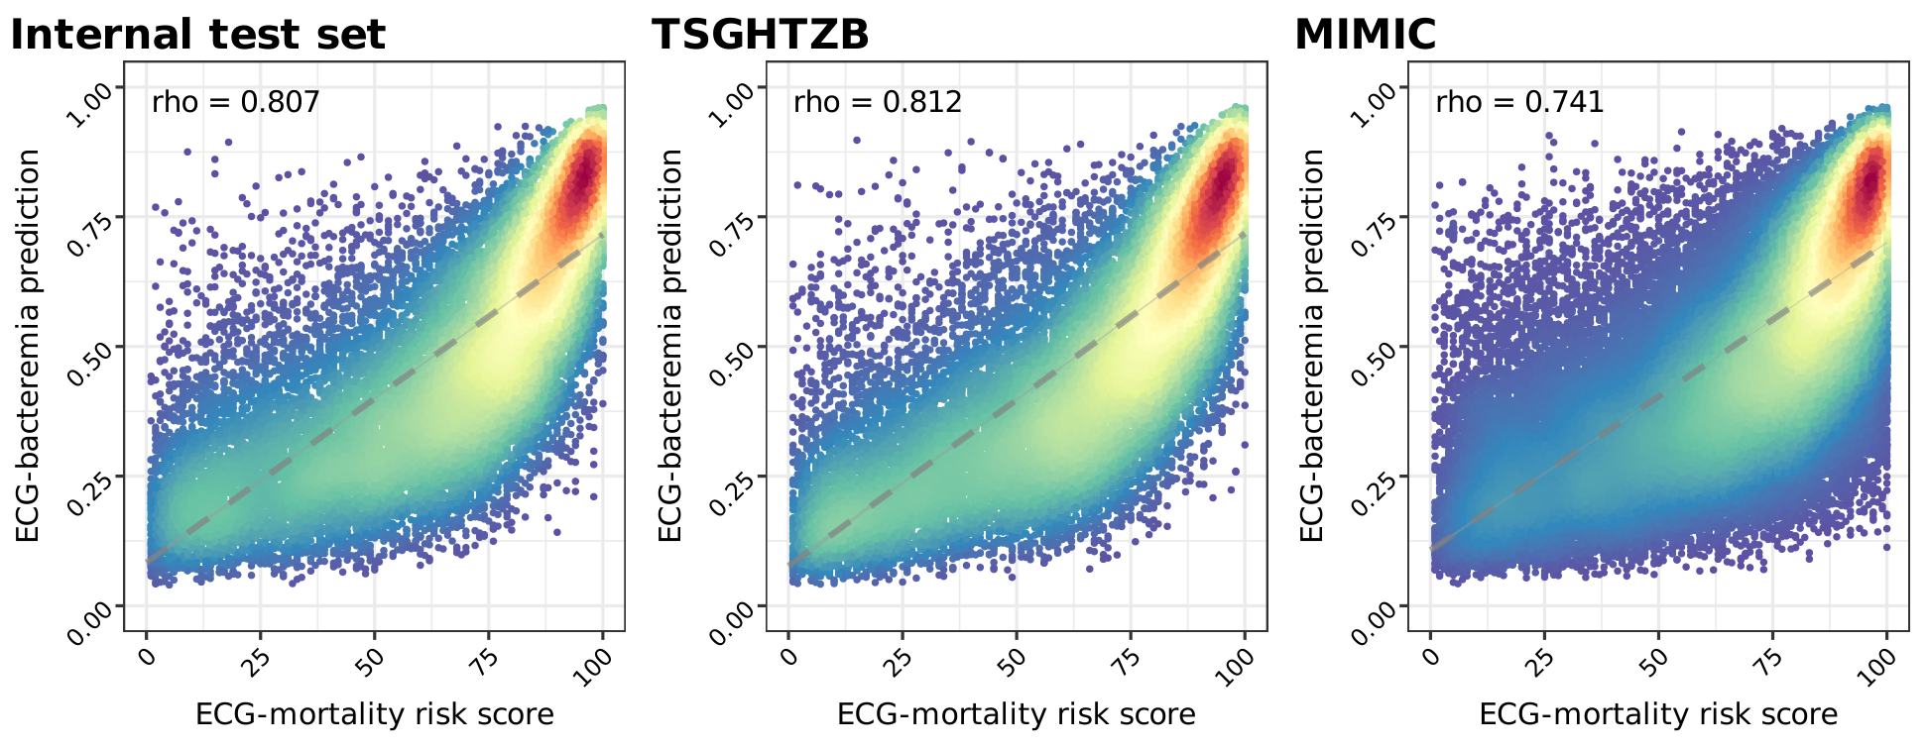
Spearman correlation coefficients across internal, TSGHTZB, and MIMIC-IV test sets.

Supplementary Figure S2. Performance of the AI-ECG model in predicting 90-day all-cause mortality.
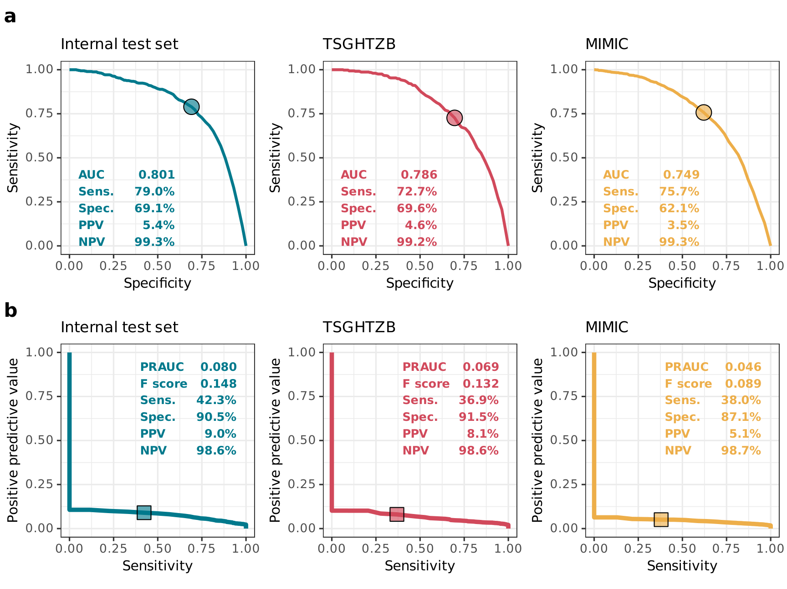
AUC and PRAUC across three test sets.

Supplementary Figure S3. Discrimination of each pathogen class versus other patients (one-vs-rest) by the primary BSI risk score, across the full test cohort.
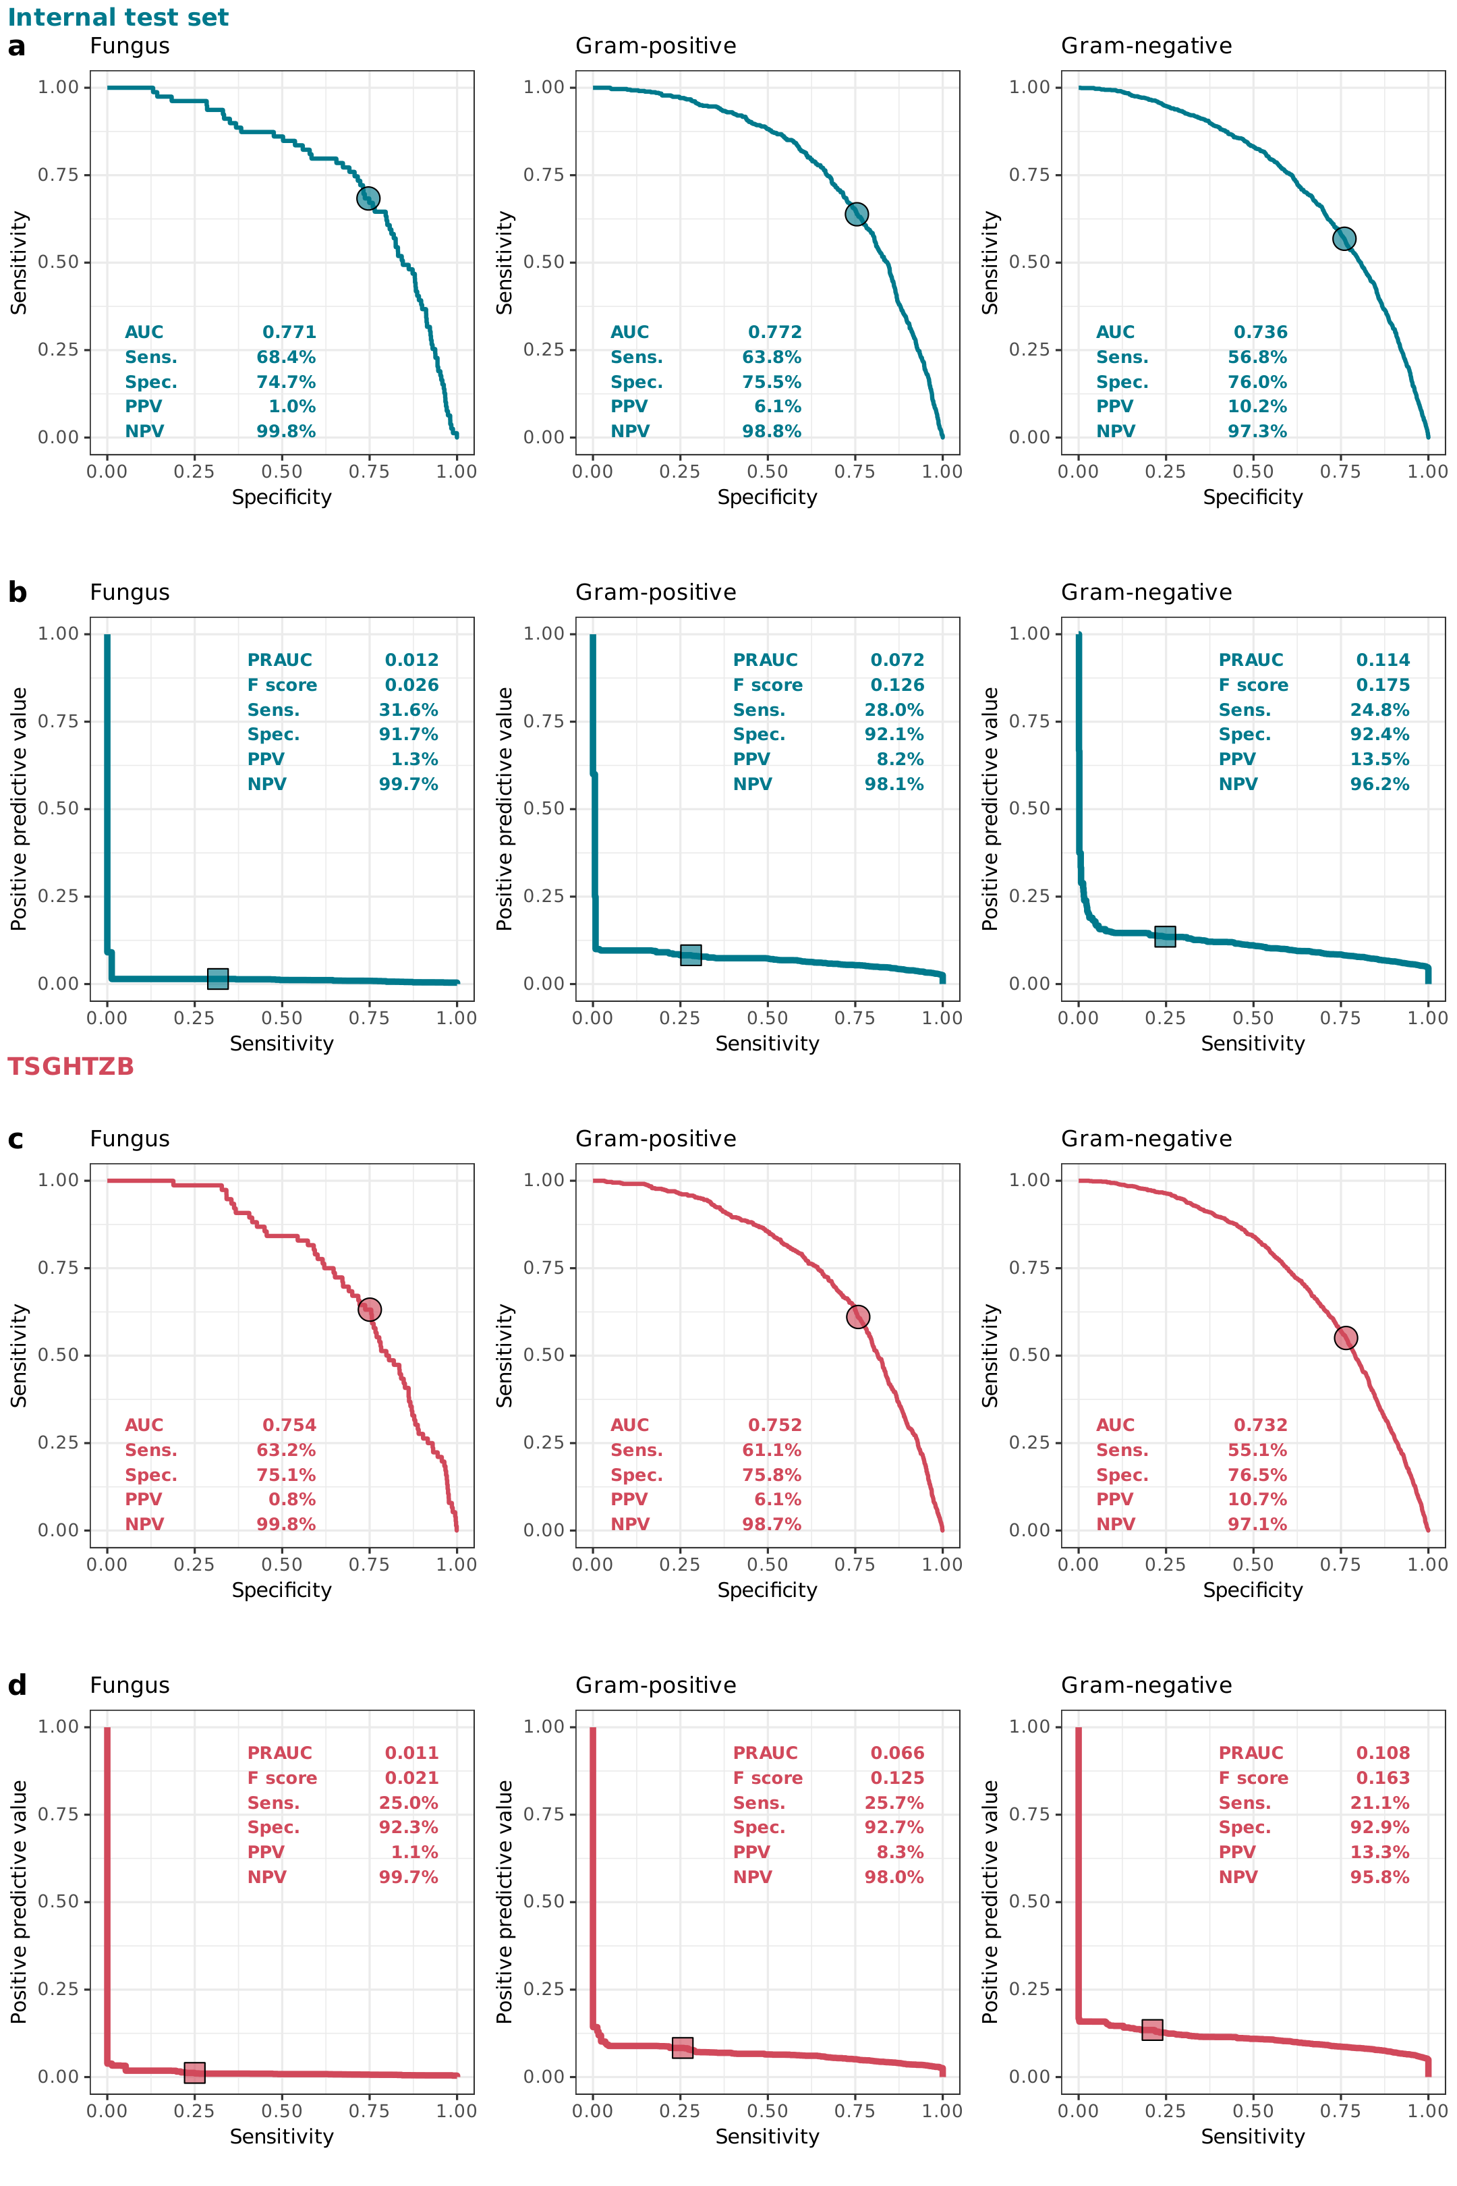
Because the comparator is predominantly culture-negative, these values reflect overall BSI detection rather than discrimination between pathogen classes; pathogen-specific prediction would require a dedicated multi-class model.

Supplementary Figure S4. Calibration curves.
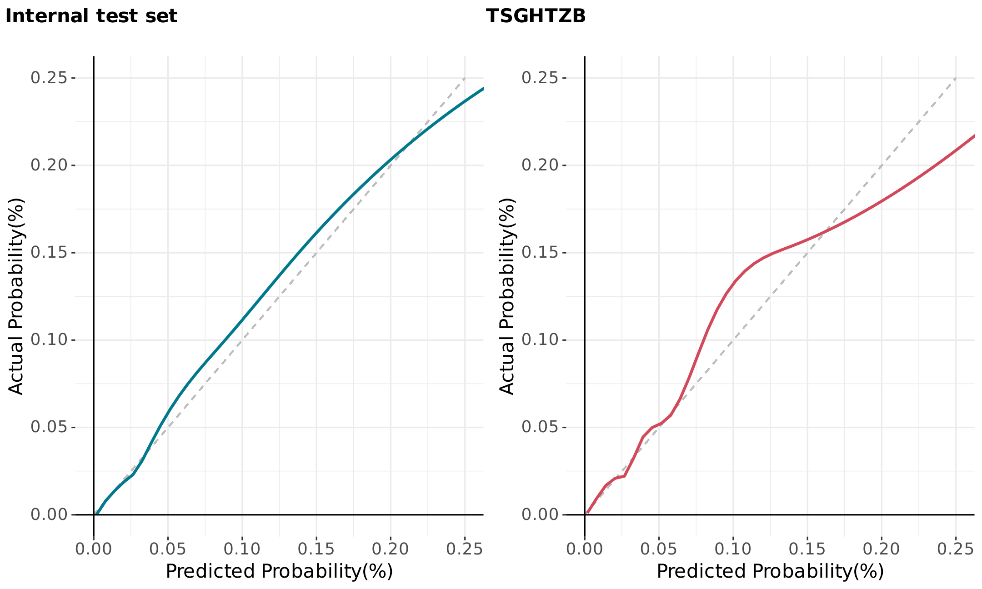
Predicted vs. observed BSI probability in internal and TSGHTZB sets. Dashed line = perfect calibration.

Supplementary Figure S5. Decision curve analysis.
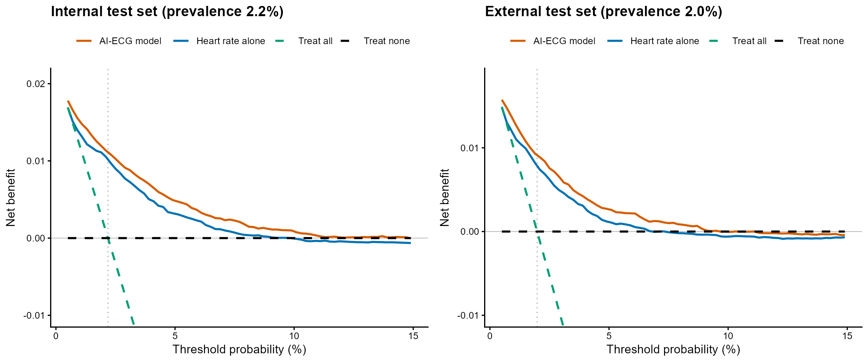
Net benefit of the AI-ECG model versus heart rate alone and the conventional treat-all and treat-none reference strategies, across the clinically relevant range of threshold probabilities near the observed prevalence (internal test set 2.2%, external test set 2.0%). The dotted vertical line marks the cohort BSI prevalence.

Supplementary Table S1. Demographic and clinical characteristics, internal test set, stratified by AI-ECG risk.
Variable | Low risk | Medium risk | High risk | P value
Age, years | 51.1 ± 16.8 | 66.4 ± 17.2 | 74.6 ± 14.9 | <0.001
Sex |  |  |  | <0.001
Female | 6292 (51.5%) | 3867 (48.9%) | 875 (41.9%)
Male | 5923 (48.5%) | 4036 (51.1%) | 1212 (58.1%)
qSOFA, points | 0.1 ± 0.3 | 0.3 ± 0.6 | 0.7 ± 0.8 | <0.001
Emergency triage level |  |  |  | <0.001
1 | 327 (2.7%) | 976 (12.3%) | 654 (31.3%)
2 | 2843 (23.3%) | 2886 (36.5%) | 954 (45.7%)
3 | 8739 (71.5%) | 3934 (49.8%) | 471 (22.6%)
4 | 301 (2.5%) | 105 (1.3%) | 8 (0.4%)
5 | 5 (0.0%) | 2 (0.0%) | 0 (0.0%)
Heart rate, bpm | 81.6 ± 16.1 | 92.9 ± 23.3 | 108.8 ± 25.9 | <0.001
Respiratory rate, breaths/min | 18.7 ± 3.5 | 19.4 ± 5.6 | 20.9 ± 5.8 | <0.001
Systolic blood pressure, mmHg | 136.1 ± 25.2 | 141.8 ± 29.5 | 134.0 ± 29.5 | <0.001
Diastolic blood pressure, mmHg | 80.4 ± 15.7 | 80.1 ± 18.7 | 78.2 ± 20.0 | <0.001
Body temperature, °C | 36.5 ± 0.8 | 36.8 ± 1.1 | 37.1 ± 1.3 | <0.001
Blood culture result
Fungus | 10 (0.1%) | 38 (0.5%) | 22 (1.1%)
Fungus + Gram-negative | 1 (0.0%) | 1 (0.0%) | 1 (0.0%)
Fungus + Gram-negative + Gram-positive | 0 (0.0%) | 0 (0.0%) | 0 (0.0%)
Fungus + Gram-positive | 0 (0.0%) | 3 (0.0%) | 3 (0.1%)
Gram-negative | 213 (1.7%) | 470 (5.9%) | 239 (11.5%)
Gram-negative + Gram-positive | 20 (0.2%) | 42 (0.5%) | 30 (1.4%)
Gram-positive | 67 (0.5%) | 246 (3.1%) | 131 (6.3%)
Negative | 11904 (97.4%) | 7103 (89.9%) | 1661 (79.6%)
None | 0 (0.0%) | 0 (0.0%) | 0 (0.0%)
Comorbidity
Myocardial infarction | 237 (1.9%) | 467 (5.9%) | 169 (8.1%) | <0.001
Congestive heart failure | 312 (2.6%) | 1094 (13.8%) | 566 (27.1%) | <0.001
Peripheral vascular disease | 342 (2.8%) | 639 (8.1%) | 220 (10.5%) | <0.001
Cerebrovascular disease | 1516 (12.4%) | 1943 (24.6%) | 626 (30.0%) | <0.001
Dementia | 357 (2.9%) | 845 (10.7%) | 413 (19.8%) | <0.001
Chronic pulmonary disease | 1328 (10.9%) | 1479 (18.7%) | 535 (25.6%) | <0.001
Rheumatic disease or connective tissue disease | 320 (2.6%) | 214 (2.7%) | 52 (2.5%) | 0.844
Peptic ulcer disease | 2027 (16.6%) | 1718 (21.7%) | 504 (24.1%) | <0.001
Mild liver disease | 1414 (11.6%) | 1378 (17.4%) | 424 (20.3%) | <0.001
Diabetes without chronic complications | 1353 (11.1%) | 2248 (28.4%) | 769 (36.8%) | <0.001
Diabetes with chronic complications | 520 (4.3%) | 1136 (14.4%) | 380 (18.2%) | <0.001
Hemiplegia or paraplegia | 164 (1.3%) | 347 (4.4%) | 124 (5.9%) | <0.001
Renal disease | 585 (4.8%) | 1319 (16.7%) | 496 (23.8%) | <0.001
Any malignancy Including leukemia and lymphoma | 818 (6.7%) | 1328 (16.8%) | 547 (26.2%) | <0.001
Moderate or severe liver disease | 96 (0.8%) | 152 (1.9%) | 79 (3.8%) | <0.001
Metastatic solid tumor | 229 (1.9%) | 462 (5.8%) | 255 (12.2%) | <0.001
Acquired immune deficiency syndrome | 11 (0.1%) | 5 (0.1%) | 2 (0.1%) | 0.724#
Notes: Triage level: Taiwan 5-level (1 = most urgent). 'Not available' = organism not reported. Internal test set.

Supplementary Table S2. Demographic and clinical characteristics, external test set, stratified by AI-ECG risk.
Variable | Low risk | Medium risk | High risk | P value
Age, years | 52.4 ± 18.6 | 70.6 ± 17.2 | 78.3 ± 14.0 | <0.001
Sex |  |  |  | <0.001
Female | 6611 (51.4%) | 3865 (48.6%) | 801 (42.0%)
Male | 6245 (48.6%) | 4083 (51.4%) | 1104 (58.0%)
qSOFA, points | 0.1 ± 0.3 | 0.3 ± 0.6 | 0.7 ± 0.8 | <0.001
Emergency triage level |  |  |  | <0.001
1 | 164 (1.3%) | 523 (6.6%) | 380 (19.9%)
2 | 2463 (19.2%) | 2910 (36.6%) | 922 (48.4%)
3 | 9931 (77.2%) | 4395 (55.3%) | 593 (31.1%)
4 | 293 (2.3%) | 117 (1.5%) | 10 (0.5%)
5 | 5 (0.0%) | 3 (0.0%) | 0 (0.0%)
Heart rate, bpm | 82.1 ± 16.6 | 92.2 ± 23.6 | 107.3 ± 24.9 | <0.001
Respiratory rate, breaths/min | 18.3 ± 4.5 | 19.1 ± 3.6 | 21.3 ± 5.2 | <0.001
Systolic blood pressure, mmHg | 138.3 ± 25.5 | 142.9 ± 29.4 | 135.9 ± 30.2 | <0.001
Diastolic blood pressure, mmHg | 76.6 ± 15.7 | 75.0 ± 18.5 | 76.0 ± 20.9 | <0.001
Body temperature, °C | 36.5 ± 0.8 | 36.8 ± 1.0 | 37.2 ± 1.3 | <0.001
Blood culture result
Fungus | 16 (0.1%) | 37 (0.5%) | 16 (0.8%)
Fungus + Gram-negative | 1 (0.0%) | 2 (0.0%) | 1 (0.1%)
Fungus + Gram-negative + Gram-positive | 0 (0.0%) | 0 (0.0%) | 0 (0.0%)
Fungus + Gram-positive | 0 (0.0%) | 1 (0.0%) | 2 (0.1%)
Gram-negative | 260 (2.0%) | 535 (6.7%) | 221 (11.6%)
Gram-negative + Gram-positive | 15 (0.1%) | 50 (0.6%) | 23 (1.2%)
Gram-positive | 98 (0.8%) | 254 (3.2%) | 122 (6.4%)
Negative | 12466 (97.0%) | 7069 (88.9%) | 1520 (79.8%)
None | 0 (0.0%) | 0 (0.0%) | 0 (0.0%)
Comorbidity
Myocardial infarction | 254 (2.0%) | 489 (6.2%) | 182 (9.6%) | <0.001
Congestive heart failure | 481 (3.7%) | 1478 (18.6%) | 584 (30.7%) | <0.001
Peripheral vascular disease | 538 (4.2%) | 950 (12.0%) | 255 (13.4%) | <0.001
Cerebrovascular disease | 1905 (14.8%) | 2379 (29.9%) | 738 (38.7%) | <0.001
Dementia | 611 (4.8%) | 1382 (17.4%) | 586 (30.8%) | <0.001
Chronic pulmonary disease | 2392 (18.6%) | 2544 (32.0%) | 751 (39.4%) | <0.001
Rheumatic disease or connective tissue disease | 554 (4.3%) | 400 (5.0%) | 94 (4.9%) | 0.042
Peptic ulcer disease | 2855 (22.2%) | 2381 (30.0%) | 655 (34.4%) | <0.001
Mild liver disease | 2259 (17.6%) | 2011 (25.3%) | 503 (26.4%) | <0.001
Diabetes without chronic complications | 2025 (15.8%) | 2877 (36.2%) | 856 (44.9%) | <0.001
Diabetes with chronic complications | 895 (7.0%) | 1658 (20.9%) | 514 (27.0%) | <0.001
Hemiplegia or paraplegia | 200 (1.6%) | 395 (5.0%) | 169 (8.9%) | <0.001
Renal disease | 870 (6.8%) | 1714 (21.6%) | 517 (27.1%) | <0.001
Any malignancy Including leukemia and lymphoma | 1159 (9.0%) | 1538 (19.4%) | 526 (27.6%) | <0.001
Moderate or severe liver disease | 90 (0.7%) | 161 (2.0%) | 49 (2.6%) | <0.001
Metastatic solid tumor | 289 (2.2%) | 482 (6.1%) | 200 (10.5%) | <0.001
Acquired immune deficiency syndrome | 29 (0.2%) | 5 (0.1%) | 1 (0.1%) | 0.007#
Notes: Triage level: Taiwan 5-level (1 = most urgent). 'Not available' = organism not reported. External test set.

Supplementary Table S3. Demographic and clinical characteristics, MIMIC-IV test set, stratified by AI-ECG risk.
Variable | Low risk | Medium risk | High risk | P value
Age, years | 50.5 ± 18.5 | 67.0 ± 17.6 | 72.1 ± 14.9 | <0.001
Sex |  |  |  | <0.001
Female | 19187 (56.0%) | 13703 (50.4%) | 2399 (43.8%)
Male | 15062 (44.0%) | 13505 (49.6%) | 3081 (56.2%)
qSOFA, points | 0.1 ± 0.3 | 0.2 ± 0.4 | 0.4 ± 0.5 | <0.001
Emergency triage level |  |  |  | <0.001
1 | 2378 (6.9%) | 4867 (17.9%) | 1913 (34.9%)
2 | 15945 (46.6%) | 15456 (56.8%) | 2809 (51.3%)
3 | 15789 (46.1%) | 6861 (25.2%) | 755 (13.8%)
4 | 135 (0.4%) | 22 (0.1%) | 3 (0.1%)
5 | 2 (0.0%) | 2 (0.0%) | 0 (0.0%)
Heart rate, bpm | 80.2 ± 16.3 | 88.8 ± 22.9 | 103.9 ± 25.0 | <0.001
Respiratory rate, breaths/min | 17.5 ± 2.2 | 18.3 ± 3.3 | 19.5 ± 4.6 | <0.001
Systolic blood pressure, mmHg | 136.1 ± 23.0 | 137.4 ± 27.1 | 129.2 ± 27.3 | <0.001
Diastolic blood pressure, mmHg | 78.3 ± 14.7 | 75.9 ± 17.1 | 75.0 ± 18.0 | <0.001
Body temperature, °C | 36.7 ± 0.5 | 36.7 ± 0.6 | 36.8 ± 0.7 | <0.001
Blood culture result
Positive | 780 (2.3%) | 2065 (7.6%) | 634 (11.6%)
Negative | 33469 (97.7%) | 25143 (92.4%) | 4846 (88.4%)
Comorbidity
Myocardial infarction | 1789 (5.2%) | 4324 (15.9%) | 1226 (22.4%) | <0.001
Congestive heart failure | 1436 (4.2%) | 6499 (23.9%) | 2253 (41.1%) | <0.001
Peripheral vascular disease | 1198 (3.5%) | 2987 (11.0%) | 833 (15.2%) | <0.001
Cerebrovascular disease | 1928 (5.6%) | 3706 (13.6%) | 878 (16.0%) | <0.001
Dementia | 406 (1.2%) | 1290 (4.7%) | 337 (6.1%) | <0.001
Chronic pulmonary disease | 4275 (12.5%) | 6090 (22.4%) | 1551 (28.3%) | <0.001
Rheumatic disease or connective tissue disease | 610 (1.8%) | 938 (3.4%) | 245 (4.5%) | <0.001
Peptic ulcer disease | 468 (1.4%) | 903 (3.3%) | 261 (4.8%) | <0.001
Mild liver disease | 1559 (4.6%) | 2460 (9.0%) | 707 (12.9%) | <0.001
Diabetes without chronic complications | 4494 (13.1%) | 7462 (27.4%) | 1767 (32.2%) | <0.001
Diabetes with chronic complications | 1120 (3.3%) | 2902 (10.7%) | 714 (13.0%) | <0.001
Hemiplegia or paraplegia | 484 (1.4%) | 903 (3.3%) | 235 (4.3%) | <0.001
Renal disease | 1814 (5.3%) | 5697 (20.9%) | 1543 (28.2%) | <0.001
Any malignancy Including leukemia and lymphoma | 2050 (6.0%) | 3721 (13.7%) | 1090 (19.9%) | <0.001
Moderate or severe liver disease | 384 (1.1%) | 853 (3.1%) | 277 (5.1%) | <0.001
Metastatic solid tumor | 779 (2.3%) | 1572 (5.8%) | 550 (10.0%) | <0.001
Acquired immune deficiency syndrome | 287 (0.8%) | 217 (0.8%) | 44 (0.8%) | 0.851
Notes: Risk tiers from the AI-ECG bloodstream-infection score. Emergency triage level uses the US Emergency Severity Index (1 = most urgent). qSOFA for MIMIC-IV is based on respiratory rate and systolic blood pressure only (Glasgow Coma Scale unavailable). Blood cultures were recorded as positive or negative without organism-level adjudication. Continuous variables, mean ± SD; categorical, n (%). MIMIC-IV test set. The positive blood-culture row reflects any positive blood-culture flag (overall 5.2%) and is broader than the 1.8% 24-hour BSI endpoint used for model evaluation.

Supplementary Table S4. TRIPOD Checklist for Prediction Model Development and Validation
Section | Item | Checklist Item | Page
Title | 1 | Identify the study as developing and/or validating a multivariable prediction model, the target population, and the outcome to be predicted | Title page
Abstract | 2 | Provide a summary of objectives, study design, setting, participants, sample size, predictors, outcome, statistical analysis, results, and conclusions | Abstract
Introduction | 3a | Explain the medical context and rationale for developing or validating the multivariable prediction model | Introduction, para 1-2
Introduction | 3b | Specify the objectives, including whether the study describes the development or validation of the model or both | Introduction, para 3-4
Methods | 4a | Describe the study design or source of data | Methods, Study Design
Methods | 4b | Specify the key study dates | Methods, Study Design
Methods | 5a | Specify key elements of the study setting | Methods, Study Design
Methods | 5b | Describe eligibility criteria for participants | Methods, Patient Cohorts
Methods | 6a | Clearly define the outcome that is predicted by the prediction model | Methods, Patient Cohorts (BSI definition)
Methods | 6b | Report any actions to blind assessment of the outcome to be predicted | Not applicable (retrospective)
Methods | 7a | Clearly define all predictors used in developing the multivariable prediction model | Methods, DL Model Architecture; Supp Table S5
Methods | 7b | Report any actions to blind assessment of predictors for the outcome and other predictors | Not applicable (automated ECG)
Methods | 8 | Explain how the study size was arrived at | Methods, Patient Cohorts (cohort sizes)
Methods | 9 | Describe how missing data were handled | Methods, Patient Cohorts (multiple imputation)
Methods | 10a-d | Describe how predictors were handled in the analyses; specify type of model, all model-building procedures, and method for internal validation | Methods, DL Model; Statistical Analysis
Methods | 11 | Provide details on how risk groups were created | Methods, Statistical Analysis (risk categories)
Results | 13a-b | Describe the flow of participants through the study and participant characteristics | Results, Patient Characteristics; Fig. 1
Results | 14a-b | Specify number of participants and outcome events; report unadjusted association between candidate predictors and outcome | Results, AI-ECG Model Performance; Table 1
Results | 15a-b | Present the full prediction model to allow predictions for individuals | Methods, DL Model (code available at GitHub)
Results | 16 | Report performance measures for the prediction model | Results, AI-ECG Model Performance; Supp Table S6
Discussion | 18 | Discuss any limitations of the study | Discussion, Limitations
Discussion | 19a-b | Provide overall interpretation of the results; discuss implications for clinical use and future research | Discussion, Clinical Utility; Conclusions
Other | 20 | Provide information about the availability of supplementary resources | Supplementary Material; Data Availability
Other | 21 | Provide the source of funding and the role of the funders | Declarations, Funding

Supplementary Table S5. Complete list of ECG features
8 Quantitative ECG Measurements
# | Measurement
1 | Heart rate
2 | PR interval
3 | QRS duration
4 | QT interval
5 | Corrected QT interval (QTc)
6 | P wave axis
7 | QRS wave axis
8 | T wave axis

31 Diagnostic ECG Patterns (Philips)
# | Pattern
1 | Sinus rhythm
2 | Sinus tachycardia
3 | Sinus bradycardia
4 | Sinus arrhythmia
5 | Atrial fibrillation
6 | Atrial flutter
7 | Supraventricular tachycardia
8 | Ventricular tachycardia
9 | Ventricular premature complex
10 | Atrial premature complex
11 | First-degree AV block
12 | Second-degree AV block
13 | Third-degree AV block
14 | Left bundle branch block
15 | Right bundle branch block
16 | Left anterior fascicular block
17 | Left posterior fascicular block
18 | Wolff-Parkinson-White syndrome
19 | ST elevation
20 | ST depression
21 | T wave inversion
22 | Old myocardial infarction
23 | Left ventricular hypertrophy
24 | Right ventricular hypertrophy
25 | Left atrial enlargement
26 | Right atrial enlargement
27 | Low voltage
28 | Prolonged QT interval
29 | Early repolarization
30 | Nonspecific ST-T wave changes
31 | Pacemaker rhythm
Note: XGBoost (Fig. 5) used 8 quantitative + ST elevation, low voltage, VPC, and OMI.

Supplementary Table S6. Operating-point analysis and subgroup performance
Panel A. Rule-out operating points across test sets
Operating point | Cohort | Sensitivity | Specificity | NPV | PPV | Low-risk (%) | BSI missed /1000 | LR-
Youden-optimal | Internal | 73.2% | 76.8% | 99.2% | 6.6% | 75.8% | 5.9 | 0.35
Youden-optimal | External | 67.6% | 76.9% | 99.2% | 5.6% | 76.1% | 6.4 | 0.42
Youden-optimal | MIMIC-IV | 61.0% | 74.3% | 99.1% | 4.1% | 73.7% | 6.9 | 0.53
High-sensitivity (~92%) | Internal | 91.8% | 49.5% | 99.6% | 3.9% | 48.6% | 1.8 | 0.17
High-sensitivity (~92%) | External | 92.0% | 49.7% | 99.7% | 3.6% | 48.9% | 1.6 | 0.16
High-sensitivity (~92%) | MIMIC-IV | 89.6% | 43.6% | 99.6% | 2.8% | 43.0% | 1.9 | 0.24
High-sensitivity (~98%) | Internal | 98.1% | 24.8% | 99.8% | 2.8% | 24.3% | 0.4 | 0.07
High-sensitivity (~98%) | External | 98.0% | 25.8% | 99.8% | 2.6% | 25.3% | 0.4 | 0.08
High-sensitivity (~98%) | MIMIC-IV | 98.2% | 19.3% | 99.8% | 2.2% | 19.0% | 0.3 | 0.10
Panel B. Performance within qSOFA subgroups
Cohort | qSOFA | n | BSI prevalence | AUC | NPV | Null NPV | NPV gain | LR-
Internal | 0 | 18,089 | 1.4% | 0.819 | 99.7% | 98.6% | +1.1% | 0.21
Internal | 1 | 3,346 | 4.9% | 0.714 | 98.7% | 95.1% | +3.7% | 0.25
Internal | 2-3 | 770 | 9.0% | 0.699 | 100.0% | 91.0% | +9.0% | 0.00
External | 0 | 18,602 | 1.4% | 0.790 | 99.7% | 98.6% | +1.1% | 0.24
External | 1 | 3,308 | 3.5% | 0.713 | 99.8% | 96.5% | +3.3% | 0.06
External | 2-3 | 799 | 9.4% | 0.641 | 100.0% | 90.6% | +9.4% | 0.00
MIMIC-IV | 0 | 57,748 | 1.4% | 0.754 | 99.6% | 98.6% | +1.0% | 0.27
MIMIC-IV | 1 | 8,710 | 4.0% | 0.684 | 99.0% | 96.0% | +3.0% | 0.25
MIMIC-IV | 2-3 | 479 | 9.0% | 0.527 | 94.0% | 91.0% | +3.0% | 0.65
Panel A reports rule-out operating points derived on the tuning set and applied to each test set (logit-scale thresholds: Youden-optimal 0.872; high-sensitivity ~92% threshold -0.028; high-sensitivity ~98% threshold -0.762). Low-risk (%) is the proportion classified below the threshold; BSI missed /1000 assumes the observed BSI prevalence (internal 2.2%, external 2.0%, MIMIC-IV 1.8%). Panel B reports performance within qSOFA subgroups; NPV, null NPV (predicting all negative), and NPV gain are evaluated at the high-sensitivity (~92%) threshold. AUC = area under the ROC curve; NPV = negative predictive value; PPV = positive predictive value; LR- = negative likelihood ratio.

Supplementary Table S7. ECG acquisition timing
Triage-to-ECG time distribution
 | Internal | External | MIMIC-IV
Median time | 0.2 h | 0.3 h | 0.2 h
Within 1 h | 100% | 100% | 100%
Within 24 h | 100% | 100% | 100%
> 24 h | 0% | 0% | 0%

3-day window = blood culture endpoint, not ECG acquisition. All ECGs obtained at triage.

Supplementary Table S8. Baseline model comparison
Model | Internal AUC | External AUC
Deep learning (raw waveform) | 0.821 | 0.800
XGBoost (39 features) | 0.790 | 0.774
XGBoost (8 quantitative) | 0.788 | 0.768
Logistic (HR+QTc+axes) | 0.792 | 0.765
Heart rate alone | 0.786 | 0.760
All trained on development set. The deep learning model showed the highest discrimination in both the internal and external test sets.

Supplementary Table S9. Likelihood ratios and prevalence-adjusted NPV
Panel A. Likelihood ratios
Metric | Internal (2.2%) | External (2.0%) | MIMIC-IV (1.8%)
LR+ | 3.16 | 2.93 | 2.37
LR- | 0.349 | 0.421 | 0.525
NPV | 99.2% | 99.2% | 99.1%
Null NPV | 97.8% | 98.0% | 98.2%

Panel B. NPV by assumed prevalence
Prevalence | Internal | External | MIMIC-IV
2% | 99.3% (+1.3%) | 99.1% (+1.1%) | 98.9% (+0.9%)
5% | 98.2% (+3.2%) | 97.8% (+2.8%) | 97.3% (+2.3%)
7% | 97.4% (+4.4%) | 96.9% (+3.9%) | 96.2% (+3.2%)
10% | 96.3% (+6.3%) | 95.5% (+5.5%) | 94.5% (+4.5%)
15% | 94.2% (+9.2%) | 93.1% (+8.1%) | 91.5% (+6.5%)
20% | 92.0% (+12.0%) | 90.5% (+10.5%) | 88.4% (+8.4%)
30% | 87.0% (+17.0%) | 84.7% (+14.7%) | 81.6% (+11.6%)
Delta = gain over null (all negative). Panel B uses Bayes' theorem.

