Title: Development and validation of an explainable machine learning model for early prediction of ICU mortality in chronic heart failure with pulmonary infection

Yihai Zhai; Bingbing Wei; Danxiu Lan; Si ying Lv; Liqin Mo

List of Supporting Information
Table S1. Hyper-parametric optimizationresults
Table S2. Candidate predictor variables, rationale for inclusion
Table S3. Comparison of various characteristics in the two groups of eICU patients
Figure S1. Probability Distribution Plots for Six Models
Figure S2. Calibration Curve of six models
Figure S3. SHAP dependence plot
Figure S4. Ten features by LVEF Groups
Figure S5. Comparison of phenotype-specific feature importance between independently trained HFrEF and HFpEF models.
Figure S6. Differences in SHAP-based feature contributions between HFrEF and HFpEF

Table S1．Hyper-parametric optimization results
Model | Hyper-parameter space | Optimal hyper-parameter
Logistic Regression | {'C': [0.001, 0.01, 0.1, 1, 10, 100],  'solver': ['newton-cg', 'liblinear', 'sag', 'saga']} | {'C': 1,  'solver': ' liblinear '}
Random Forest | {'max_features': ['sqrt','log2', None],  'min_samples_leaf': range (1,10,1),  'min_samples_split': range (2,10,1),  'n_estimators': range (30,300,5)} | {'max_features': ' sqrt ', 'min_samples_leaf': 1, 'min_samples_split': 2, 'n_estimators': 175}
Light Gradient Boosting Machine | {'colsample_bytree': [0.5, 0.7, 1.0],  'learning_rate': [0.1, 0.01, 0.001],  'max_depth': range (1,10,1),  'min_child_samples': [5, 10, 20],  'n_estimators': range (30,300,5),  'reg_alpha': [0, 0.1, 0.5],  'reg_lambda': [0, 0.1, 0.5],  'subsample': [0.5, 0.7, 1.0]} | {'colsample_bytree': 0.5,  'learning_rate': 0.1,  'max_depth': 7,  'min_child_samples': 10,  'n_estimators': 295,  'reg_alpha': 0.1,  'reg_lambda': 0.1,  'subsample': 0.5}
eXtreme Gradient Boosting | {'colsample_bytree': [0.5,0.7,1.0],  'gamma': [0,1,5],  'learning_rate': [0.01,0.1,1],  'max_depth': range (1,10,1),  'min_child_weight': range (2,10,1),  'n_estimators': range (30,300,5),  'subsample': [0.5,0.7,1.0]} | {'colsample_bytree': 0.5, 'gamma': 0,  'learning_rate': 0.1, 'max_depth': 9, 'min_child_weight': 2, 'n_estimators': 135  'subsample': 0.7}
Multilayer perceptron | {'activation': ['relu','tanh'],  'alpha': [0.0001,0.001,0.01,0.1],  'hidden_layer_sizes': [(50,), (100,), (200,)],  'learning_rate': ['constant','adaptive']} | {'activation': 'tanh',  'alpha': 0.001, 'hidden_layer_sizes': (200,), 'learning_rate': 'constant'}
K-Nearest Neighbors | {'metric': ['euclidean', 'manhattan'],  'n_neighbors': range (1, 21),  'weights': ['uniform', 'distance']} | {'metric': 'manhattan', 'n_neighbors ': 2,  'weights': 'uniform'}

Table S2. Candidate predictor variables, rationale for inclusion
Category | Variable | Rationale for inclusion
Demographic | Age | Advanced age is a consistent predictor of ICU mortality and reduced physiological reserve in heart failure and pneumonia.
 | Gender | Potential sex-related differences in heart failure phenotype and outcomes.
Comorbidity | Chronic pulmonary disease (COPD) | Pre-existing lung disease worsens gas exchange and infection susceptibility.
 | Hypertension | Reflects chronic cardiovascular remodeling and comorbidity burden.
 | Diabetes mellitus | Associated with immune dysfunction and worse infection outcomes.
 | Chronic renal disease | Renal impairment contributes to fluid/electrolyte dysregulation and mortality.
Clinical | Pneumonia type (bacterial vs other) | Pathogen type influences severity and treatment response.
Vital sign | Systolic blood pressure | Marker of hemodynamic status and perfusion.
 | Diastolic blood pressure | Marker of hemodynamic status.
 | Mean arterial pressure | Integrated measure of organ perfusion pressure.
 | Heart rate | Reflects sympathetic activation and hemodynamic stress.
 | Respiratory rate | Indicator of respiratory distress and decompensation.
 | Body temperature | Reflects infection/inflammatory response.
 | Pulse oxygen | Marker of oxygenation status.
Severity score | SAPS II score | Validated ICU severity-of-illness score summarizing physiologic derangement.
Laboratory | Base excess | Reflects metabolic acid–base balance and tissue perfusion.
 | Lactic acid | Key marker of tissue hypoperfusion and anaerobic metabolism.
 | pH | Reflects acid–base status and severity of illness.
 | PaO2 | Marker of oxygenation/respiratory function.
 | PaCO2 | Marker of ventilation adequacy.
 | Glucose | Stress hyperglycemia is associated with adverse outcomes.
 | White blood cell count | Indicator of systemic inflammation and infection severity.
 | Red blood cell count | Reflects anemia/oxygen-carrying capacity.
 | Creatinine | Marker of renal function.
 | Urea | Reflects renal function and catabolic state.
 | Sodium | Electrolyte disturbances affect cardiac stability.
 | Potassium | Dyskalemia predisposes to fatal arrhythmias.
 | Calcium | Electrolyte relevant to cardiac and neuromuscular function.
 | Platelets | Reflects coagulation status and inflammation–thrombosis interface.
 | Hemoglobin | Reflects anemia/oxygen delivery.
 | Prothrombin time | Marker of coagulation function and hepatic synthesis.
 | APTT | Marker of intrinsic coagulation pathway.
 | Total bilirubin | Reflects hepatic function and congestion.
 | LVEF | Basis for HFrEF/HFmrEF/HFpEF phenotyping; central to subgroup analysis.
Cardiac function | Norepinephrine use | Marker of vasopressor dependence and circulatory failure.
Intervention | Vasoactive agents (vasopressors/inotropes) | Reflects hemodynamic support requirement and shock.
 | Mechanical ventilation status | Marker of respiratory failure and illness severity.

Table S3. Comparison of various characteristics in the two groups of eICU patients (n=365)
Characteristics | Total  (n=365) | Survivors  (n=308) | Non-survivors  (n=57) | P-value
Age (years) | 69.99±14.49 | 73.07±13.48 | 73.86±14.00 | 0.017
Gender |  |  |  | 0.655
Male | 195 (53.42%) | 163 (52.92%) | 32 (56.14%)
Female | 170 (46.58%) | 145 (47.08%) | 25 (43.86%)
COPD |  |  |  | 0.258
Yes | 142 (38.90%) | 116 (37.66%) | 26 (45.61%)
No | 223 (61.10%) | 192 (62.34%) | 31 (54.39%)
Diabetes |  |  |  | 0.361
Yes | 161 (44.11%) | 139 (45.13%) | 22 (38.60%)
No | 204 (55.89%) | 169 (54.87%) | 35 (61.40%)
Hypertension |  |  |  | 0.191
Yes | 263 (72.05%) | 226 (73.38%) | 37 (64.91%)
No | 102 (27.95%) | 82 (26.62%) | 20 (35.09%)
Invasive vent |  |  |  | 0.318
Yes | 110 (30.14%) | 96 (31.17%) | 14 (24.56%)
No | 255 (69.86%) | 212 (68.83%) | 43 (75.44%)
Norepinephrine |  |  |  | 0.018
Yes | 141 (38.63%) | 111 (36.04%) | 30 (52.63%)
No | 224 (61.37%) | 197 (63.96%) | 27 (47.37%)
Pneumonia type |  |  |  | 0.665
Bacterial | 300 (82.19%) | 252 (81.82%) | 48 (84.21%)
Other | 65 (17.81%) | 56 (18.18%) | 9 (15.79%)
Renal disease |  |  |  | 0.931
Yes | 226 (61.92%) | 191 (62.01%) | 35 (61.40%)
No | 139 (38.08%) | 117 (37.99%) | 22 (38.60%)
Vasoactive agent |  |  |  | 0.012
Yes | 162 (44.38%) | 128 (41.56%) | 34 (59.65%)
No | 203 (55.62%) | 180 (58.44%) | 23 (40.35%)
Lvef (%) |  |  |  | 0.223
≤40 | 192 (52.60%) | 166 (53.90%) | 26 (45.61%)
41%~49 | 22 (6.03%) | 16 (5.19%) | 6 (10.53%)
≥50 | 151 (41.37%) | 126 (40.91%) | 25 (43.86%)
Activated Partial Thromboplastin Time (sec) | 37.00  (30.10-50.50) | 35.90  (30.00-50.50) | 38.50  (32.95-52.75) | 0.026
Base Excess (mEq/L) | 0.83 (-1.80-4.48) | -1.49 (-6.00-2.80) | -3.43 (-7.00-1.70) | 0.312
Blood Potassium(mEq/L) | 4.04 (3.81-4.34) | 4.03 (3.81-4.30) | 4.28 (3.82-4.69) | 0.510
Blood Sodium (mEq/L) | 139.51  (136.62-142.75) | 139.36  (136.64-142.47) | 137.30  (134.15-143.35) | 0.736
Blood calcium (mmol/L) | 8.20 (7.70-8.62) | 8.20 (7.75-8.62) | 8.10 (7.52-8.70) | 0.542
Blood chlorine (mEq/L) | 104.00  (99.10-109.00) | 104.00  (99.55-108.65) | 104.00  (98.50-110.65) | 0.679
Body temperature (ºF) | 98.35 (97.84-98.98) | 98.39 (97.78-99.19) | 98.36 (97.36-99.32) | 0.482
Breathe (breaths/min) | 20.70 (17.30-24.70) | 20.30 (17.20-24.20) | 22.80 (19.30-26.60) | 0.005
Creatinine (mg/dL) | 1.42 (0.93-2.19) | 1.44 (0.95-2.05) | 1.37 (0.82-2.36) | 0.714
Diastolic blood pressure (mmhg) | 59.90  (54.00-68.20) | 60.15  (54.23-67.95) | 58.60  (53.80-68.45) | 0.526
Glucose (mg/dL) | 139.40  (110.80-169.05) | 138.45  (135.00-142.00) | 141.00  (107.65-179.05) | 0.595
Heart Rate (bpm) | 89.20 (79.45-101.20) | 88.75 (78.03-101.28) | 90.00 (82.45-101.10) | 0.387
Hemoglobin (g/dl) | 9.62 (8.54-10.93) | 10.28 (8.80-12.00) | 10.55 (8.55-12.25) | 0.027
Lactic Acid (mmol/L) | 1.46 (1.10-1.98) | 1.60 (1.00-2.24) | 1.80 (1.33-2.50) | 0.040
Mean pressure (mmhg) | 73.90 (68.50-82.00) | 74.45 (68.73-82.05) | 72.10 (66.70-81.80) | 0.221
PH | 7.37 (7.31-7.42) | 7.36 (7.30-7.43) | 7.33 (7.29-7.42) | 0.109
PaCO2 (mmhg) | 40.50 (34.25-46.20) | 40.50 (34.15-46.73) | 40.80 (34.85-46.00) | 0.647
PaO2 (mmhg) | 87.30 (71.70-119.00) | 87.95 (72.00-119.08) | 83.90 (71.00-112.95) | 0.531
Platelets (K/uL) | 174.00  (124.75-233.65) | 216.00  (158.29-296.67) | 172.00  (108.50-232.50) | <0.001
Prothrombin time (sec) | 15.80 (12.70-20.50) | 15.15 (12.70-19.90) | 18.60 (13.95-31.60) | 0.006
Pulse oxygen (%) | 96.81 (95.06-98.31) | 96.60 (95.00-98.18) | 95.50 (94.40-97.40) | 0.029
Red blood cells (K/uL) | 3.49 (3.05-4.11) | 3.48 (3.07-4.10) | 3.54 (3.00-4.13) | 0.983
SAPS II (score) | 39.00 (31.00-51.00) | 39.00 (31.00-51.00) | 40.00 (31.00-54.00) | 0.394
Systolic blood pressure (mmhg) | 111.50  (102.60-123.65) | 110.90  (102.50-123.68) | 112.20  (104.30-123.40) | 0.521
Total bilirubin (mg/dL) | 0.50 (0.35-0.90) | 0.50 (0.35-0.85) | 0.55 (0.40-0.91) | 0.267
Urea (mg/dL) | 31.00 (20.50-47.00) | 30.25 (20.00-44.75) | 34.70 (22.35-55.45) | <0.001
White Blood Cell (K/uL) | 12.15 (8.40-17.55) | 11.60 (8.31-16.78) | 15.35 (9.40-18.88) | 0.072

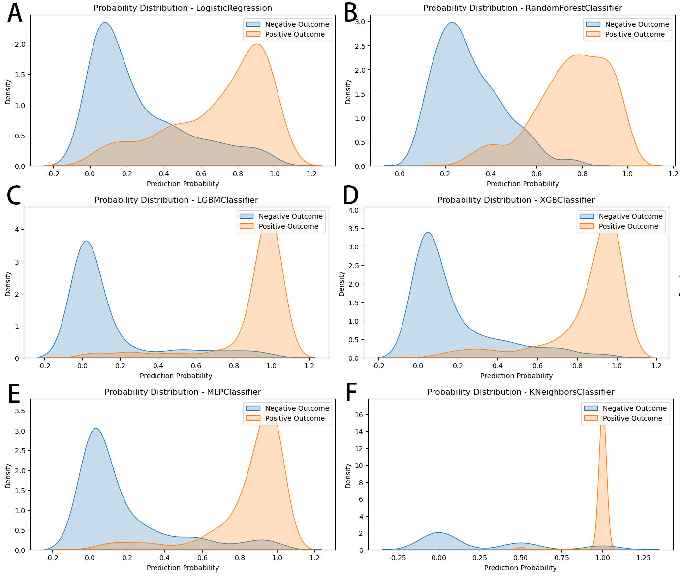
Figure S1. Probability Distribution Plots for Six Models
Note: (A) Logistic regression, (B) Random forest, (C) Light Gradient Boosting Machine, (D) Extreme Gradient Boosting, (E) Multilayer Perceptron, (F) K-nearest neighbors
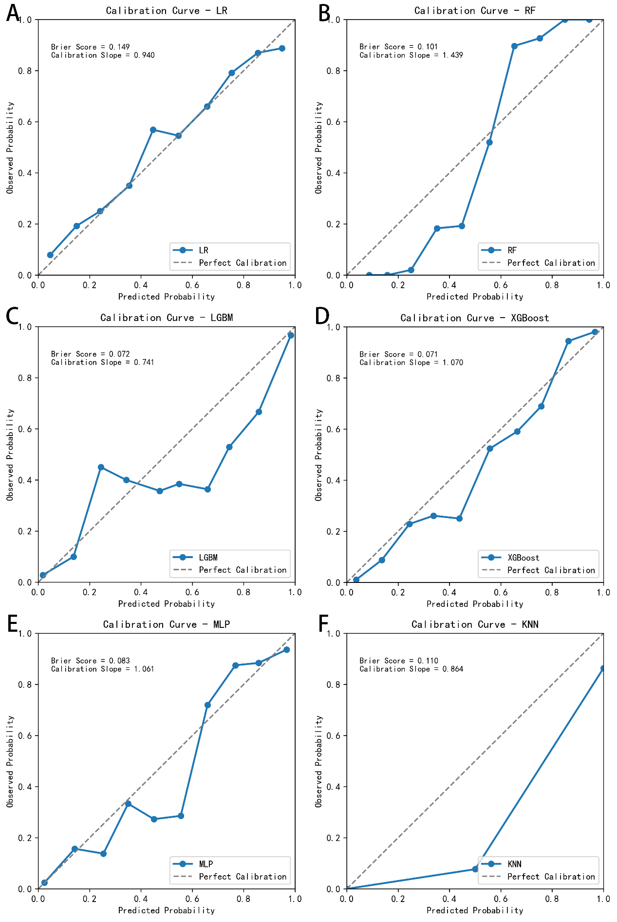
Figure S2. Calibration Curve of six models
Note: (A) Logistic regression, (B) Random forest, (C) Light Gradient Boosting Machine, (D) Extreme Gradient Boosting, (E) Multilayer Perceptron, (F) K-nearest neighbors
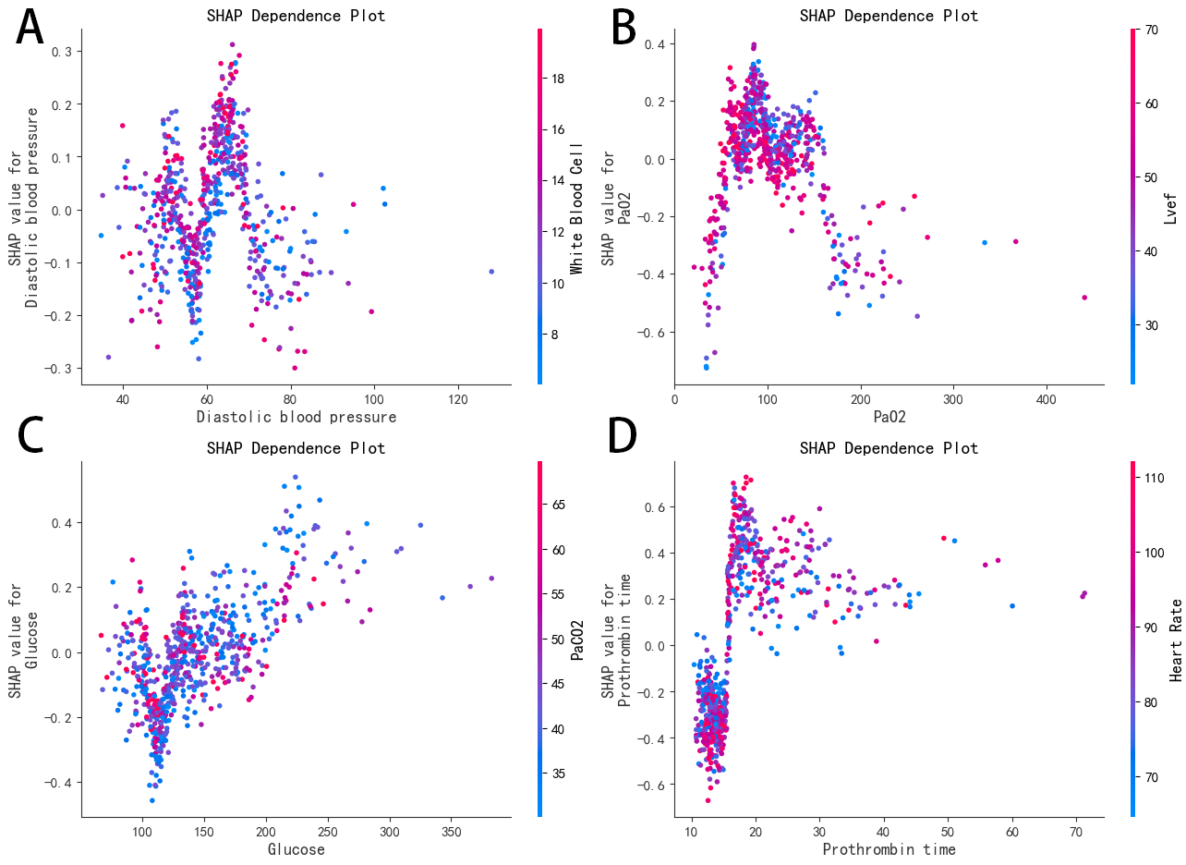
Figure S3. SHAP dependence plot
Note: (A) SHAP Dependence Plot for Diastolic Blood Pressure and White Blood Cell Count, (B) SHAP Dependence Plot for PaO₂ and LVEF, (C) SHAP Dependence Plot for Glucose and PaCO₂, (D) SHAP Dependence Plot for Prothrombin time and Heart Rate.
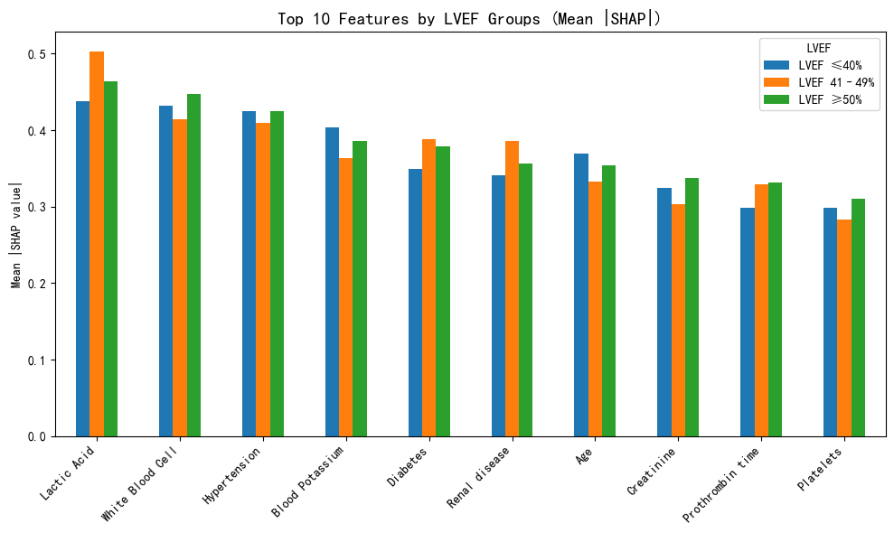
Figure S4. Ten features by LVEF Groups

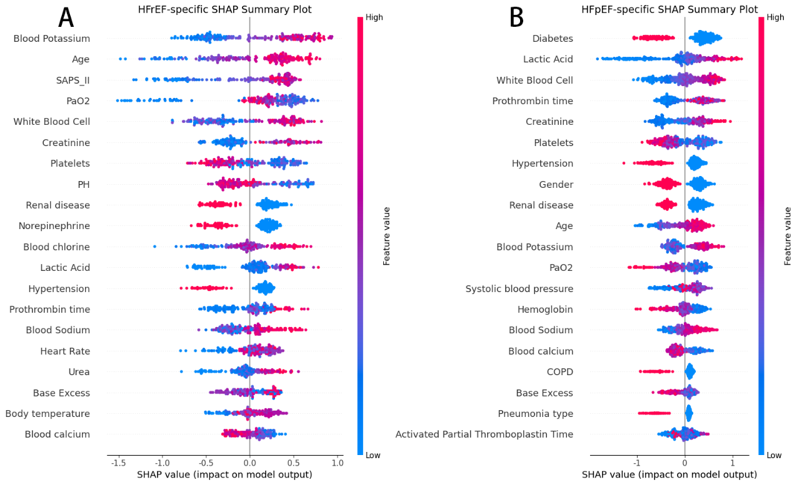
Figure S5. Comparison of phenotype-specific feature importance between independently trained HFrEF and HFpEF models

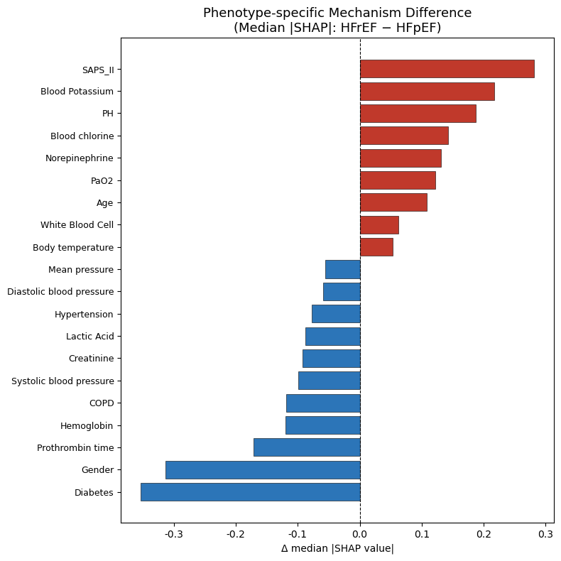
Figure S6. Differences in SHAP-based feature contributions between HFrEF and HFpEF

