Supplementary Figure 1 shows violin and box plots for the top continuous predictors (recipient age, pre-transplant dialysis duration, and length of index hospitalization). Figure 1 shows the distribution of GFR on day 7 stratified by donor type, DGF status, and readmission. Among deceased donor recipients, readmitted patients were significantly older (p = 0.005) and had significantly longer pre-transplant dialysis duration (p < 0.001) and index hospitalization length (p < 0.001) compared to non-readmitted patients. For living donor recipients, only the length of index hospitalization differed significantly between readmitted and non-readmitted patients (p < 0.001), while age (p = 0.102) and dialysis duration (p = 0.126) did not exhibit statistically significant differences. Regarding the remaining low-importance predictors identified in Figure 4, variables such as surgical site infection, diabetes mellitus, recipient sex, urinary tract infection, delayed graft function, expanded criteria donor status, and ICU admission contributed minimally [normalized importance < 0.15] to both the Random Forest and XGBoost predictive algorithms.
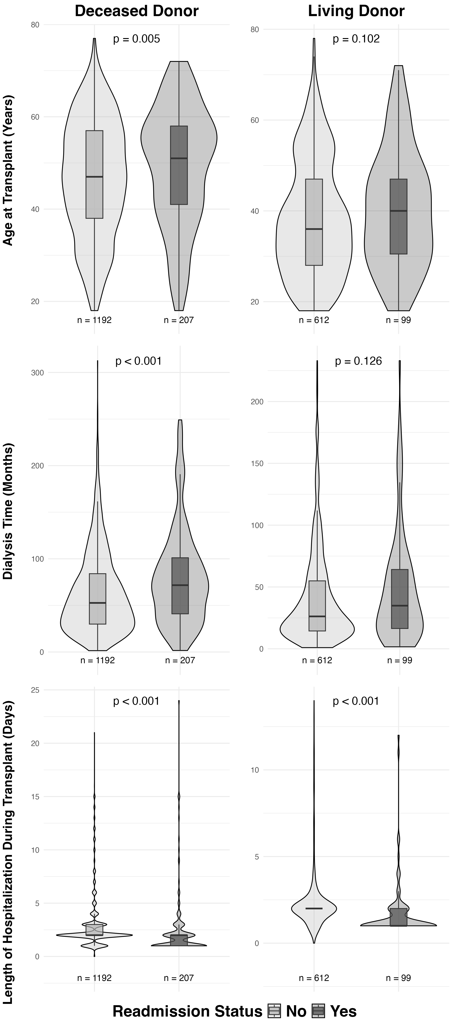
Supplementary Figure 1. Density Distributions of Continuous Clinical Predictors (Age, Pre-Transplant Dialysis, and Hospitalization Stay) Stratified by Donor Type and 30-Day Readmission Status. The violin and boxplots illustrate the probability density distributions and central tendencies of the three most influential continuous clinical predictors identified by global feature importance across both the Random Forest and XGBoost models (N = 2,110). (Top Panel) Recipient age at transplantation (years); (Middle Panel) pre-transplant calculated dialysis duration (months); and (Bottom Panel) length of the index transplant hospitalization stay (days). Subgroups are stratified by donor type (living vs. deceased) and 30-day readmission outcome (living/deceased readmitted vs. non-readmitted). P-values correspond to independent Wilcoxon rank-sum tests compared across outcomes within each donor cohort.

