Supplementary Material
Quality assessment of synthetic data in healthcare: a critical appraisal with a focus on subgroup bias

Supplementary Note S1. Multi-run robustness analysis on an independent MIMIC-IV dataset
The main manuscript reports the NSCLC case study, including the cross-classification analysis with logistic regression, a polynomial-kernel SVM and Gradient Boost classifier (GBc). The NSCLC analysis is deliberately retained as the primary use case because it reflects a realistic data-release setting: a healthcare organisation trains a generator on confidential patient-level data and shares a single synthetic derivative. In practice, data custodians do not release multiple synthetic versions of the same confidential dataset , each additional release widens the attack surface for membership- and attribute-inference and complicates the privacy accounting, so an evaluation that assumes access to many independent synthetic replicas would not correspond to how synthetic data are actually disseminated. The NSCLC case study is therefore the more faithful reflection of real-world practice.
The single-release constraint, however, makes it impossible to assess on the NSCLC data itself whether the subgroup-level findings are stable across independently generated synthetic datasets. To examine this question without departing from a realistic privacy posture, this Supplementary Note reports a complementary analysis on an independent, publicly available dataset, an acute kidney injury (AKI) cohort derived from MIMIC-IV, for which multiple synthetic datasets can legitimately be generated and retained for methodological study. This analysis should be read as a robust check on the mechanism, not as a substitute for the primary, more realistic NSCLC use case.

S1.1 Dataset, subgroup definition and experimental design
The MIMIC-IV AKI cohort comprises 17,184 training and 4,296 test patients described by 38 predictors, with AKI diagnosis (aki_diag) as the binary outcome. For each of two generator families, CTGAN and the Gaussian Copula Synthesizer (GCS) ,three synthetic datasets were generated from three independent training runs with different random seeds, giving six synthetic datasets in total.
Subgroup definition (Rule 1). The sub-cohort was identified through a data-driven subgroup-discovery procedure rather than chosen by hand. An Explainable Boosting Classifier was trained on the real training data and evaluated on the real test data; the AFISP framework (Algorithmic Framework for Identifying Predictive Subgroups) was then applied to locate the worst-performing data subsets by estimating each sample’s conditional expected loss. From the worst-performing 50% of test samples, candidate subgroup rules were extracted with a SkopeRules classifier (maximum tree depth 3) and filtered in three stages: statistical significance (per-rule p-values with Holm–Bonferroni correction for multiple testing), effect size (Cohen’s d > 0.5 for the difference in loss between samples satisfying and not satisfying the rule), and deduplication (rules overlapping by more than 80% were pruned). This procedure yielded five interpretable rules, defined principally by serum creatinine and body weight.
The top-ranked rule, Rule 1, is used as the sub-cohort throughout this Supplementary Note: admit_weight ≤ 87.75 kg AND creatinine_max > 1.85 mg/dL. Rule 1 was adopted because (i) it has the largest coverage among the candidate rules ,14.6% of the real training set and 14.2% of the real test set ,which is large enough for stable bootstrap statistics; (ii) it is clinically meaningful, isolating lower-body-weight patients with an elevated peak serum creatinine, a recognised high-risk profile for AKI; and (iii) the AKI prevalence inside Rule 1 (72.3% in real training data, 75.4% in real test data) differs markedly from the cohort-wide prevalence (~39%), providing a strong, clinically interpretable signal against which the synthetic data can be assessed.
The cross-classification framework of the main manuscript (TRTR, TRTS, TSTR, TSTS) was replicated on both the full cohort and the Rule 1 sub-cohort, using the same three classifiers (logistic regression, polynomial SVM and GBc). For every generator, run, cohort, classifier and scenario, 30 bootstrap iterations were performed, pooled across the three independent runs. Standardisation was fitted on the training data of each scenario and reused on the corresponding test set, exactly as in the main text.

S1.2 Fidelity metrics
As in the main manuscript (Tables 3–5), per-variable fidelity was assessed using the Cosine distance, Jensen–Shannon (JS) distance and Wasserstein distance between the real and synthetic distributions, computed separately for the full cohort and the Rule 1 sub-cohort. Distances are averaged over the three independent synthetic runs. Tables S1 and S2 report a representative subset of the 38 variables, including the AKI-relevant laboratory features.
Table S1. Fidelity metrics between the real and CTGAN-generated variable distributions on the MIMIC-IV AKI data, full cohort and Rule 1 sub-cohort. Values are averaged over three independent synthetic runs. Sub-cohort cells with JS distance > 0.15 are shaded.
 | Full cohort |  |  | Sub-cohort (Rule 1)
Variable | Cosine | JS | Wass. | Cosine | JS | Wass.
Admission age | 0.028 | 0.120 | 0.025 | 0.043 | 0.145 | 0.030
AKI diagnosis | 0.019 | 0.084 | 0.098 | 0.001 | 0.024 | 0.025
Urine output | 0.003 | 0.074 | 0.006 | 0.036 | 0.140 | 0.010
SOFA score | 0.063 | 0.166 | 0.014 | 0.061 | 0.168 | 0.021
Charlson index | 0.066 | 0.185 | 0.019 | 0.076 | 0.195 | 0.028
BUN (max) | 0.043 | 0.146 | 0.012 | 0.112 | 0.279 | 0.063
Creatinine (min) | 0.049 | 0.143 | 0.008 | 0.358 | 0.407 | 0.057
Creatinine (max) | 0.000 | 0.052 | 0.003 | 0.015 | 0.166 | 0.023
Creatinine | 0.012 | 0.120 | 0.014 | 0.140 | 0.305 | 0.035
Serum creatinine baseline | 0.004 | 0.081 | 0.007 | 0.047 | 0.196 | 0.027
Potassium (max) | 0.052 | 0.212 | 0.043 | 0.068 | 0.250 | 0.070
Sodium (max) | 0.040 | 0.123 | 0.009 | 0.014 | 0.147 | 0.018
Lactate | 0.000 | 0.024 | 0.001 | 0.000 | 0.020 | 0.001
BMI | 0.008 | 0.114 | 0.012 | 0.078 | 0.367 | 0.093

Table S2. Fidelity metrics between the real and GCS-generated variable distributions on the MIMIC-IV AKI data. Conventions as in Table S1.
 | Full cohort |  |  | Sub-cohort (Rule 1)
Variable | Cosine | JS | Wass. | Cosine | JS | Wass.
Admission age | 0.006 | 0.076 | 0.005 | 0.011 | 0.087 | 0.008
AKI diagnosis | 0.000 | 0.004 | 0.004 | 0.075 | 0.183 | 0.208
Urine output | 0.011 | 0.110 | 0.005 | 0.079 | 0.244 | 0.020
SOFA score | 0.028 | 0.126 | 0.023 | 0.118 | 0.267 | 0.087
Charlson index | 0.011 | 0.131 | 0.010 | 0.040 | 0.145 | 0.032
BUN (max) | 0.036 | 0.138 | 0.013 | 0.026 | 0.197 | 0.049
Creatinine (min) | 0.018 | 0.151 | 0.012 | 0.015 | 0.229 | 0.037
Creatinine (max) | 0.002 | 0.114 | 0.005 | 0.014 | 0.258 | 0.030
Creatinine | 0.019 | 0.153 | 0.012 | 0.019 | 0.246 | 0.037
Serum creatinine baseline | 0.046 | 0.182 | 0.011 | 0.032 | 0.230 | 0.035
Potassium (max) | 0.022 | 0.125 | 0.015 | 0.008 | 0.114 | 0.017
Sodium (max) | 0.027 | 0.138 | 0.011 | 0.010 | 0.137 | 0.011
Lactate | 0.000 | 0.045 | 0.003 | 0.000 | 0.050 | 0.002
BMI | 0.111 | 0.225 | 0.016 | 0.119 | 0.231 | 0.024

Across both generators, the per-variable distances are low in the full cohort (mean JS distance 0.13 for CTGAN and 0.11 for GCS) but increase substantially in the Rule 1 sub-cohort (mean JS distance 0.21 and 0.15 respectively). The increase is most pronounced for exactly the renal markers that define a clinically meaningful AKI subgroup ,for CTGAN, the JS distance of creatinine rises from 0.12 (full) to 0.31 (sub) and that of creatinine (min) from 0.14 to 0.41. The fidelity metrics therefore already show, before any classifier is trained, that the synthetic data reproduce the sub-cohort less faithfully than the full cohort.

S1.3 Descriptive evidence of subgroup smoothing
The synthetic data also show the expected smoothing of the sub-cohort outcome. The AKI prevalence inside Rule 1 is well reproduced by CTGAN (73.7%, 76.0%, 74.9% across the three runs, versus 72.3–75.4% in real data) but is collapsed towards a near-random 50% by GCS (50.8%, 51.5%, 52.2%). GCS also over-populates the sub-cohort (coverage ~19.6% versus the real 14.2–14.6%), indicating that it fails to reproduce the joint structure that defines the subgroup.

S1.4 Cross-classification results
Table S3. Balanced accuracy (%) for CTGAN on the MIMIC-IV AKI data. Values are mean (standard deviation) over 30 bootstrap iterations pooled across three independent synthetic runs. Significance is assessed against the TRTR reference (Mann–Whitney U): ** p < 0.001, * p < 0.005, ns = not significant. Shaded cells mark the real–synthetic transfer scenarios.
Cohort | Classifier | TRTR | TRTS | TSTR | TSTS
Full cohort | Logistic regression | 75.3 (0.2) | 70.1 (0.5) ** | 73.8 (0.4) ** | 83.2 (0.8) **
 | SVM (polynomial) | 64.5 (2.5) | 58.9 (2.3) ** | 68.2 (2.2) ** | 75.9 (2.5) **
 | GBc | 81.9 (0.3) | 71.0 (0.5) ** | 71.1 (0.6) ** | 86.5 (0.7) **
Sub-cohort (Rule 1) | Logistic regression | 81.1 (0.9) | 50.3 (1.0) ** | 52.5 (3.6) ** | 79.3 (3.0) **
 | SVM (polynomial) | 62.2 (1.9) | 49.0 (0.6) ** | 51.7 (0.8) ** | 61.7 (4.2) ns
 | GBc | 80.7 (0.8) | 51.0 (0.9) ** | 50.9 (0.9) ** | 80.2 (3.1) ns

Table S4. Balanced accuracy (%) for the Gaussian Copula Synthesizer (GCS) on the MIMIC-IV AKI data. Conventions as in Table S3.
Cohort | Classifier | TRTR | TRTS | TSTR | TSTS
Full cohort | Logistic regression | 75.3 (0.2) | 63.1 (0.8) ** | 70.8 (0.5) ** | 61.7 (1.5) **
 | SVM (polynomial) | 64.5 (2.5) | 57.1 (1.6) ** | 59.6 (2.1) ** | 55.9 (1.8) **
 | GBc | 81.9 (0.3) | 61.8 (0.6) ** | 70.6 (0.7) ** | 61.6 (1.4) **
Sub-cohort (Rule 1) | Logistic regression | 81.1 (0.9) | 52.5 (0.4) ** | 60.2 (3.3) ** | 59.9 (2.3) **
 | SVM (polynomial) | 62.2 (1.9) | 50.2 (0.4) ** | 57.1 (6.1) ** | 56.3 (2.8) **
 | GBc | 80.7 (0.8) | 51.2 (0.5) ** | 58.8 (3.4) ** | 58.2 (2.5) **

S1.5 Figures
Figure S1. Cross-classification balanced accuracy for CTGAN on the MIMIC-IV AKI data, full cohort (upper panels) and Rule 1 sub-cohort (lower panels). Violins show the bootstrap distribution; results for GBc, logistic regression and polynomial SVM are shown side by side.
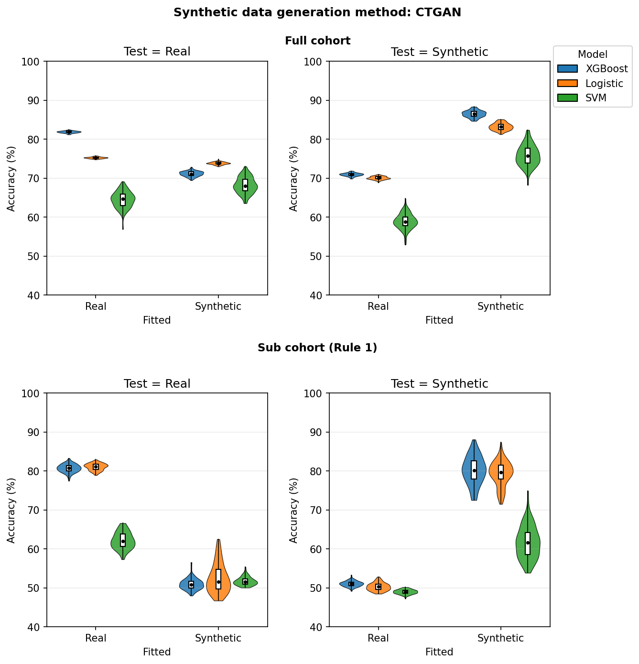

Figure S2. Cross-classification balanced accuracy for the Gaussian Copula Synthesizer (GCS) on the MIMIC-IV AKI data. Conventions as in Figure S1.
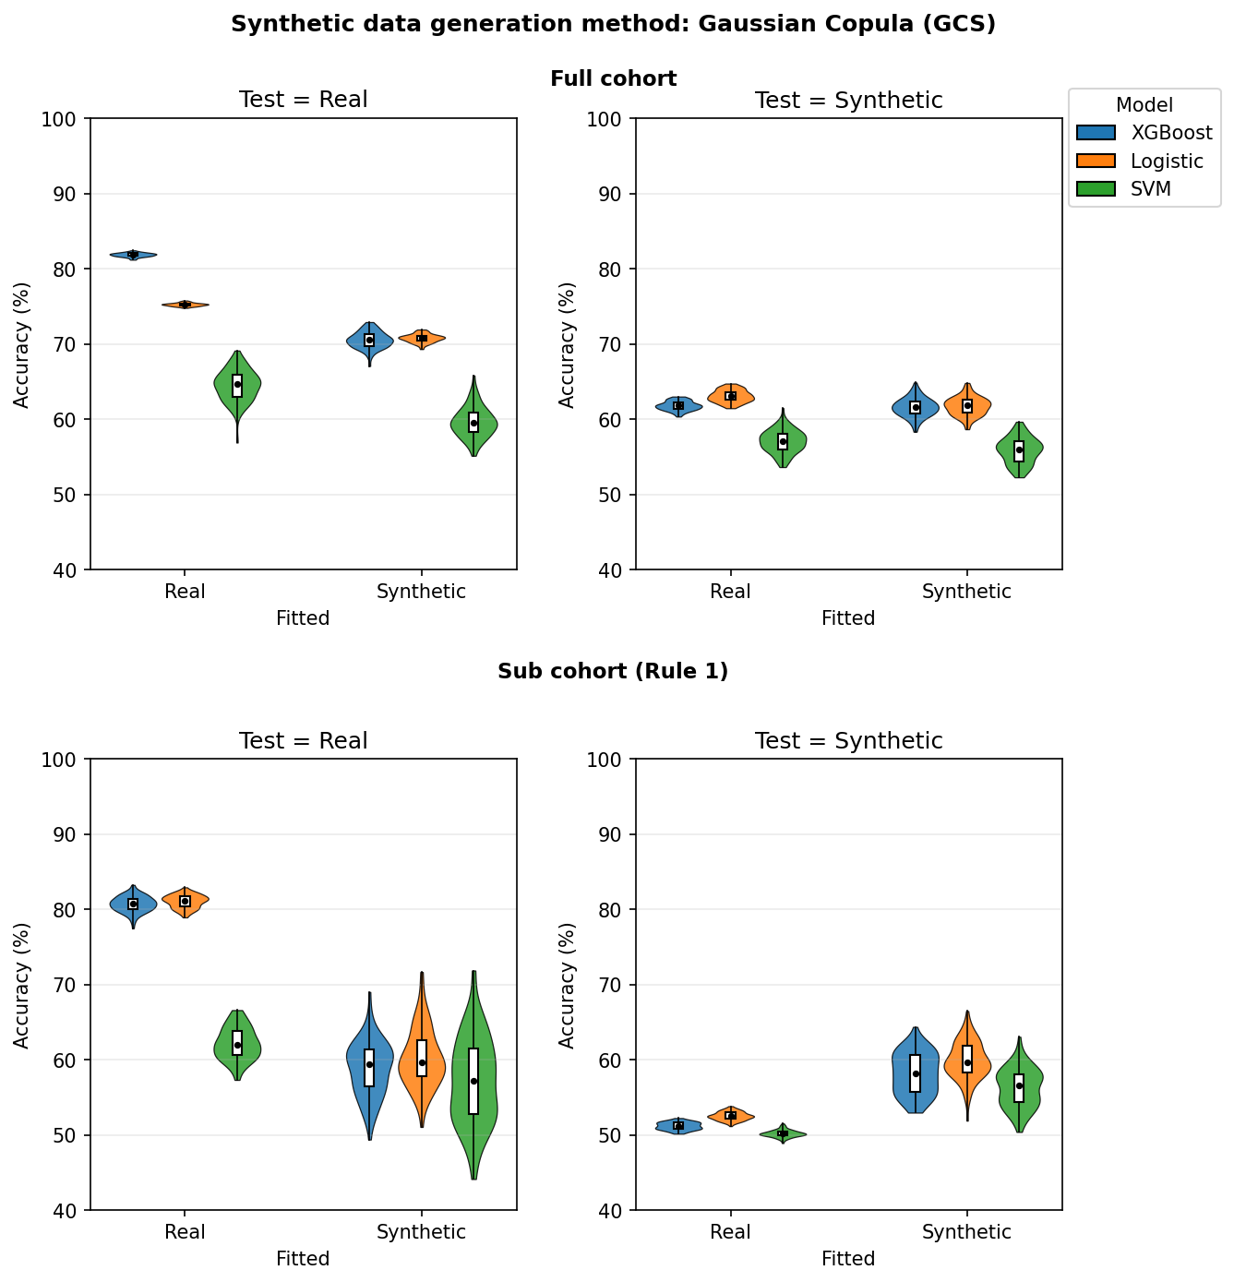

S1.6 Interpretation
Three observations follow from Tables S1–S4 and Figures S1–S2.
- GBc behaves like the other classifiers. In the full cohort it tracks logistic regression and SVM, and in the Rule 1 sub-cohort it shows the same severe degradation: for CTGAN, GBc balanced accuracy falls from 80.7% (TRTR) to 51.0% (TRTS) and 50.9% (TSTR). The subgroup failure is therefore not an artefact of one classifier family, consistent with the GBc results reported for the NSCLC case study in the main manuscript.
- The failure is stable across independent synthetic runs. Per-run GBc balanced accuracy in the CTGAN sub-cohort is 51.5% / 50.5% / 51.1% for TRTS and 50.9% / 49.7% / 52.0% for TSTR, a spread of around one percentage point. The subgroup-level breakdown is a reproducible property of the generators, not a consequence of a single unlucky training seed.
- The pattern generalises beyond the NSCLC registry. On a structurally different dataset (MIMIC-IV AKI) and with a different outcome, the full cohort again looks acceptable while the clinically defined sub-cohort collapses, in the most extreme case (GCS) to near-random performance. The fidelity metrics (Tables S1–S2) and the cross-classification metrics (Tables S3–S4) point in the same direction. This supports, on independent data, the central claim of the manuscript.
These supplementary results reinforce, rather than replace, the NSCLC case study: the subgroup-level limitation of synthetic data is observed across two datasets, three classifier families and multiple independent synthetic runs.

