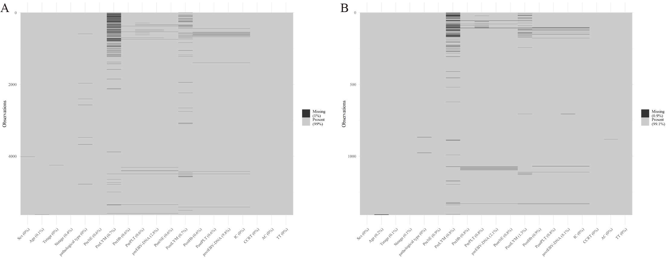
Figure S1. Overview of missing data.
The x-axis represents variables included in the analysis, and the y-axis denotes the number of patients. Black lines indicate missing entries for individual patients, illustrating the completeness of each variable. Training set (A); Test set (B).
Note: Pre, prior to initiation of RT; Post, within one week after the completion of RT; NE, neutrophil; LYM, lymphocyte; Hb, hemoglobin; PLT, platelet; EBV-DNA, Epstein-Barr virus-deoxyribonucleic acid; IC, induction chemotherapy; CCRT, concurrent chemoradiotherapy; AC, adjuvant chemotherapy; TT, targeted therapy.

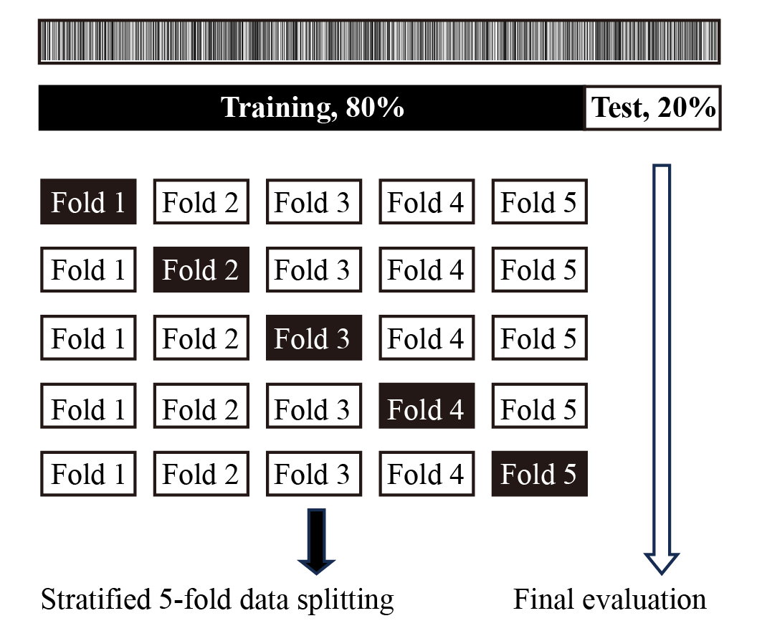
Figure S2. Stratified data-splitting strategy.

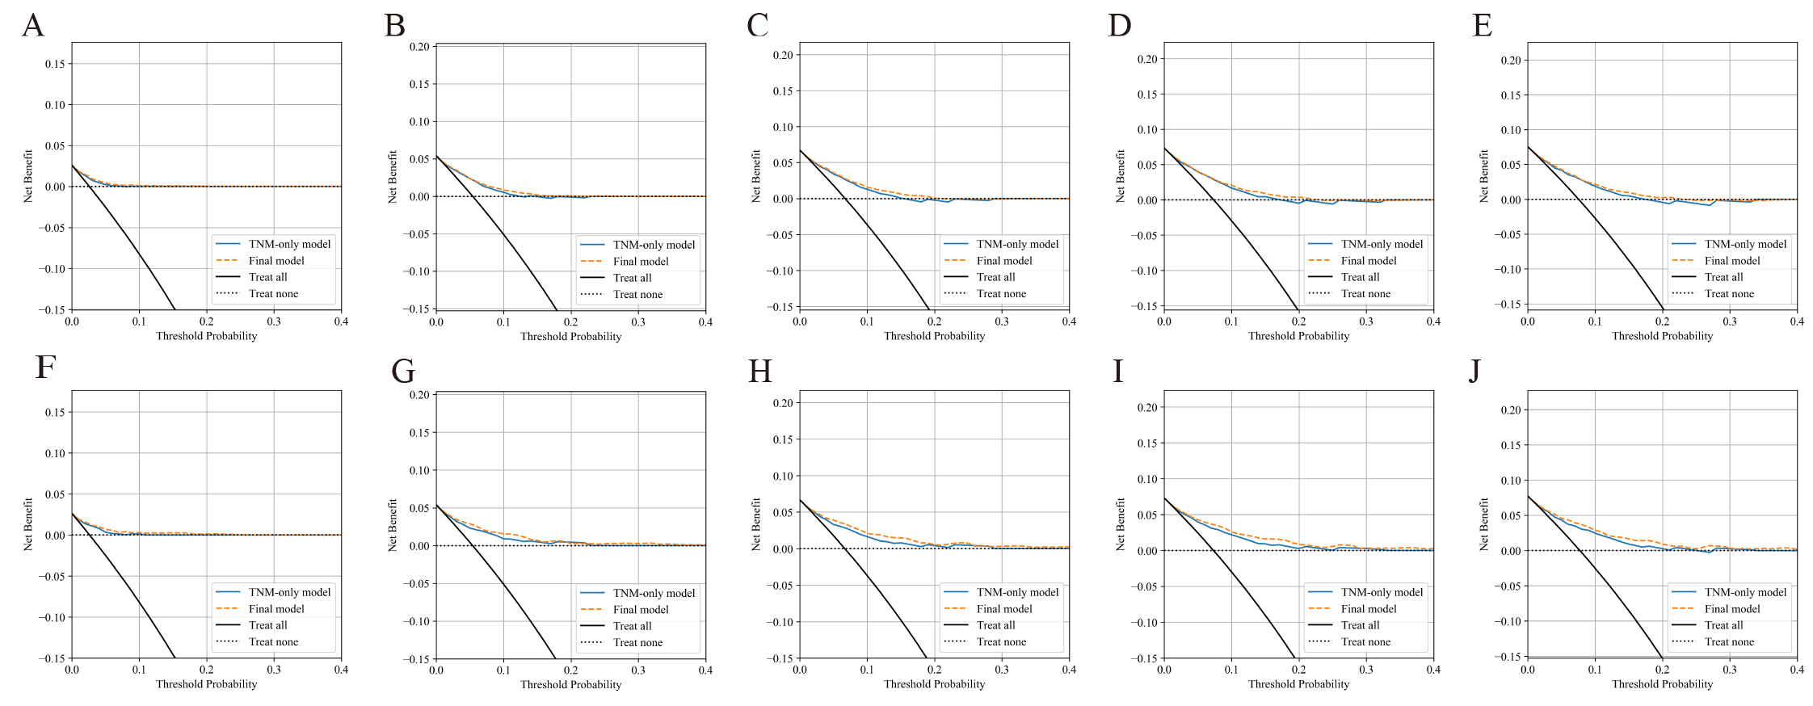
Figure S3. DCA curves comparing the final model and the TNM-only model.
Decision curve analysis (DCA; training set, A–E; test set, F–J) comparing the final model and the TNM-only model is shown. The y-axis indicates net benefit, and the x-axis indicates threshold probability.

Table S1. Hyperparameter space of the models
Model | Hyperparameter
Component-wise Gradient Boosting (CGB) | dropout_rate: 0, learning_rate: 0.05, loss: coxph, n_estimators: 500, random_state: 42, subsample: 1.0, verbose: 0
Cox proportional hazards (CoxPH) | alpha: 23.36, n_iter: 100, ties: efron, tol: 1e-09, verbose: 0
Least Absolute Shrinkage and Selection Operator (LASSO)-Cox | L1_ratio: 1; max_iter: 100000; n_alphas: 100; tol: 1e-07
Extra Survival Trees (EST) | bootstrap: True, low_memory: False, max_depth: 10, max_features: sqrt, max_leaf_nodes: None, max_samples: None, min_samples_leaf: 4, min_samples_split: 10, min_weight_fraction_leaf: 0.0, n_estimators: 500, n_jobs: 1, oob_score: False, random_state: 42, verbose: 0, warm_start: False
Gradient Boosting Survival Analysis (GBSA) | ccp_alpha: 0.0, criterion: friedman_mse, dropout_rate: 0.0, learning_rate: 0.1, loss: coxph, max_depth: 3, max_features: None, max_leaf_nodes: None, min_impurity_decrease: 0.0, min_samples_leaf: 1, min_samples_split: 2, min_weight_fraction_leaf: 0.0, n_estimators: 500, n_iter_no_change: None, random_state: 42, subsample: 1.0, tol: 0.0001, validation_fraction: 0.1, verbose: 0
Random Survival Forest (RSF) | bootstrap: True, low_memory: False, max_depth: 10, max_features: sqrt, max_leaf_nodes: None, max_samples: None, min_samples_leaf: 4, min_samples_split: 10, min_weight_fraction_leaf: 0.0, n_estimators: 200, n_jobs: 1, oob_score: False, random_state: 42, verbose: 0, warm_start: False

Table S2. Baseline characteristics of training sets
Characteristic | Overall, n=5636 | M0, n=5182 | M1, n=454 | P value
Sex, n (%) |  |  |  | <0.001
Female | 1513 (26.85) | 1429 (27.58) | 84 (18.50)
Male | 4123 (73.15) | 3753 (72.42) | 370 (81.50)
T stage, n (%) |  |  |  | <0.001
T1 | 1112 (19.73) | 1046 (20.19) | 66 (14.54)
T2 | 1021 (18.12) | 953 (18.39) | 68 (14.98)
T3 | 2136 (37.90) | 1962 (37.86) | 174 (38.33)
T4 | 1367 (24.25) | 1221 (23.56) | 146 (32.16)
N stage, n (%) |  |  |  | <0.001
N0 | 519 (9.21) | 517 (9.98) | 2 (0.44)
N1 | 2108 (37.40) | 2047 (39.50) | 61 (13.44)
N2 | 1966 (34.88) | 1761 (33.98) | 205 (45.15)
N3 | 1043 (18.51) | 857 (16.54) | 186 (40.97)
TNM stage, n (%) |  |  |  | <0.001
Ⅰ | 161 (2.86) | 161 (3.11)
Ⅱ | 751 (13.33) | 745 (14.38) | 6 (1.32)
Ⅲ | 2490 (44.18) | 2330 (44.96) | 160 (35.24)
Ⅳ | 2234 (39.64) | 1946 (37.55) | 288 (63.44)
IC, n (%) |  |  |  | <0.001
No | 850 (15.08) | 839 (16.19) | 11 (2.42)
Yes | 4786 (84.92) | 4343 (83.81) | 443 (97.58)
CCRT, n (%) |  |  |  | 0.013
No | 2022 (35.88) | 1884 (36.36) | 138 (30.40)
Yes | 3614 (64.12) | 3298 (63.64) | 316 (69.60)
AC, n (%) |  |  |  | <0.001
No | 4358 (77.32) | 4077 (78.68) | 281 (61.89)
Yes | 1278 (22.68) | 1105 (21.32) | 173 (38.11)
TT, n (%) |  |  |  | 0.001
No | 3487 (61.87) | 3173 (61.23) | 314 (69.16)
Yes | 2149 (38.13) | 2009 (38.77) | 140 (30.84)
WHO pathological type, n (%) |  |  |  | 0.075
Ⅰ | 96 (1.70) | 89 (1.72) | 7 (1.54)
Ⅱ | 388 (6.88) | 345 (6.66) | 43 (9.47)
Ⅲ | 5152 (91.41) | 4748 (91.62) | 404 (88.99)
Age, year (median, IQR) | 48.00  (40.00, 56.00) | 48.00  (40.25, 56.00) | 47.00  (39.00, 54.00) | 0.001
Pre NE, 10^9/L (median, IQR) | 4.10 (3.20, 5.10) | 4.00 (3.20, 5.10) | 4.39 (3.40, 5.40) | <0.001
Pre LYM, 10^9/L (median, IQR) | 2.00 (1.60, 2.40) | 2.00 (1.60, 2.40) | 2.00 (1.50, 2.38) | 0.057
Pre Hb, g/L (median, IQR) | 144.00  (133.00, 153.00) | 144.00  (133.00, 153.00) | 145.50  (136.00, 153.00) | 0.041
Pre PLT, 10^9/L (median, IQR) | 251.00  (214.00, 296.00) | 251.00  (214.00, 295.00) | 258.50  (217.00, 299.75) | 0.114
Pre NLR (median, IQR) | 2.05 (1.56, 2.73) | 2.04 (1.56, 2.70) | 2.26 (1.70, 2.93) | <0.001
Pre PLR (median, IQR) | 127.17  (100.00, 161.88) | 126.84  (100.00, 161.31) | 133.93  (102.53, 170.58) | 0.018
Pre EBV-DNA, copies/mL (median, IQR) | 900.00  (465.75, 7332.50) | 824.00  (424.00, 6620.00) | 2785.00  (500.00,26050.00) | <0.001
Post NE, 10^9/L (median, IQR) | 3.10 (2.30, 4.10) | 3.10 (2.30, 4.10) | 3.10 (2.20, 4.20) | 0.640
Post LYM, 10^9/L  (median, IQR) | 0.50 (0.40, 0.70) | 0.50 (0.40, 0.70) | 0.50 (0.40, 0.70) | 0.396
Post Hb, g/L (median, IQR) | 123.00  (113.00, 132.00) | 123.00  (113.00, 132.00) | 122.00  (112.00, 130.00) | 0.017
Post PLT, 10^9/L (median, IQR) | 187.00  (143.00, 234.00) | 187.04  (143.00, 235.00) | 185.00  (135.00, 229.00) | 0.168
Post NLR (median, IQR) | 6.00 (4.00, 9.00) | 6.04 (4.00, 9.00) | 6.00 (3.89, 9.40) | 0.916
Post PLR (median, IQR) | 356.00  (245.53, 517.50) | 357.04  (246.67, 513.83) | 347.89  (233.50, 550.00) | 0.773
Post EBV-DNA, copies/mL  (median, IQR) | 0.00 (0.00, 0.00) | 0.00 (0.00, 0.00) | 0.00 (0.00, 231.25) | <0.001
ΔHb, g/L (median, IQR) | -20.00  (-29.00, -11.00) | -19.00  (-29.00, -10.00) | -23.00  (-32.00, -14.00) | <0.001
DMFS, month (median, IQR) | 41.40  (20.50, 64.72) | 44.35  (22.50, 65.90) | 17.70  (10.40, 29.18) | <0.001
Follow-up, month  (median, IQR) | 44.15  (22.60, 65.70) | 44.35  (22.50, 65.90) | 39.55  (24.20, 63.08) | 0.534
Note: IQR, Interquartile Range; WHO, World Health Organization; IC, induction chemotherapy; CCRT, concurrent chemoradiotherapy; AC, adjuvant chemotherapy; TT, targeted therapy; Pre, prior to initiation of radiotherapy; Post, within one week after the completion of radiotherapy; NE, neutrophil count; LYM, lymphocyte count; Hb, hemoglobin level; PLT, platelet count; EBV-DNA, Epstein-Barr virus-deoxyribonucleic acid; NLR, NE-to-LYM ratio; PLR, PLT-to-LYM ratio; ΔHb, Pre- to Post-RT hemoglobin difference.
Values for continuous variables are expressed as the median (IQR); values for categorical variables are expressed as the number (percent).

Table S3. Baseline characteristics of test sets
Characteristic | Overall, n=1409 | M0, n=1295 | M1, n=114 | P value
Sex, n (%) |  |  |  | 0.001
Female | 417 (29.60) | 400 (30.89) | 17 (14.91)
Male | 992 (70.40) | 895 (69.11) | 97 (85.09)
T stage, n (%) |  |  |  | <0.001
T1 | 269 (19.09) | 258 (19.92) | 11 (9.65)
T2 | 254 (18.03) | 241 (18.61) | 13 (11.40)
T3 | 537 (38.11) | 493 (38.07) | 44 (38.60)
T4 | 349 (24.77) | 303 (23.40) | 46 (40.35)
N stage, n (%) |  |  |  | <0.001
N0 | 152 (10.79) | 151 (11.66) | 1 (0.88)
N1 | 512 (36.34) | 497 (38.38) | 15 (13.16)
N2 | 479 (34.00) | 434 (33.51) | 45 (39.47)
N3 | 266 (18.88) | 213 (16.45) | 53 (46.49)
TNM stage, n (%) |  |  |  | <0.001
Ⅰ | 41 (2.91) | 41 (3.17)
Ⅱ | 175 (12.42) | 174 (13.44) | 1 (0.88)
Ⅲ | 623 (44.22) | 593 (45.79) | 30 (26.32)
Ⅳ | 570 (40.45) | 487 (37.61) | 83 (72.81)
IC, n (%) |  |  |  | <0.001
No | 210 (14.90) | 209 (16.14) | 1 (0.88)
Yes | 1199 (85.10) | 1086 (83.86) | 113 (99.12)
CCRT, n (%) |  |  |  | 0.160
No | 512 (36.34) | 478 (36.91) | 34 (29.82)
Yes | 897 (63.66) | 817 (63.09) | 80 (70.18)
AC, n (%) |  |  |  | <0.001
No | 1090 (77.36) | 1020 (78.76) | 70 (61.40)
Yes | 319 (22.64) | 275 (21.24) | 44 (38.60)
TT, n (%) |  |  |  | 0.461
No | 863 (61.25) | 789 (60.93) | 74 (64.91)
Yes | 546 (38.75) | 506 (39.07) | 40 (35.09)
WHO pathological type, n (%) |  |  |  | 0.059
Ⅰ | 15 (1.06) | 14 (1.08) | 1 (0.88)
Ⅱ | 88 (6.25) | 75 (5.79) | 13 (11.40)
Ⅲ | 1306 (92.69) | 1206 (93.13) | 100 (87.72)
Age, year (mean, SD) | 48.72 (11.61) | 48.88 (11.60) | 46.91 (11.66) | 0.086
Pre NE, 10^9/L (median, IQR) | 4.10 (3.30, 5.20) | 4.10 (3.29, 5.10) | 4.70 (3.62, 5.70) | <0.001
Pre LYM, 10^9/L (median, IQR) | 2.00 (1.60, 2.40) | 2.00 (1.60, 2.40) | 2.00 (1.52, 2.30) | 0.607
Pre Hb, g/L (median, IQR) | 144.00  (132.00, 153.00) | 143.00  (132.00, 153.00) | 145.00  (139.00, 153.75) | 0.093
Pre PLT, 10^9/L (median, IQR) | 253.00  (216.00, 295.00) | 253.00  (216.00, 296.00) | 253.50  (212.25, 289.25) | 0.592
Pre NLR (median, IQR) | 2.10 (1.58, 2.80) | 2.08 (1.56, 2.76) | 2.38 (1.85, 3.28) | 0.002
Pre PLR (median, IQR) | 129.09  (101.90, 166.24) | 129.00  (102.37, 166.06) | 130.93  (95.34, 169.83) | 0.958
Pre EBV-DNA, copies/mL (median, IQR) | 938.00  (476.00, 7170.00) | 836.00  (410.00, 6060.00) | 2695.00  (534.50,19075.00) | <0.001
Post NE, 10^9/L (median, IQR) | 3.10 (2.30, 4.10) | 3.10 (2.30, 4.10) | 3.00 (2.30, 3.80) | 0.512
Post LYM, 10^9/L  (median, IQR) | 0.50 (0.40, 0.70) | 0.50 (0.40, 0.70) | 0.50 (0.40, 0.60) | 0.614
Post Hb, g/L (median, IQR) | 122.00  (113.00, 133.00) | 123.00  (113.00, 134.00) | 121.00  (113.25, 127.75) | 0.159
Post PLT, 10^9/L (median, IQR) | 187.00  (143.00, 233.00) | 188.00  (143.00, 234.00) | 182.00  (145.00, 224.75) | 0.285
Post NLR (median, IQR) | 6.11 (4.17, 9.00) | 6.09 (4.17, 9.00) | 6.33 (4.53, 9.25) | 0.762
Post PLR (median, IQR) | 356.00  (251.25, 520.00) | 355.00  (250.62, 520.00) | 366.25  (255.94, 538.75) | 0.815
Post EBV-DNA, copies/mL (median, IQR) | 0.00 (0.00, 0.00) | 0.00 (0.00, 0.00) | 0.00 (0.00, 487.25) | <0.001
ΔHb, g/L (median, IQR) | -19.00  (-30.00, -9.00) | -19.00  (-29.00, -9.00) | -23.00  (-30.00, -16.00) | 0.001
DMFS, month (median, IQR) | 40.70  (19.80, 64.50) | 43.40  (21.75, 65.60) | 17.75  (10.40, 27.38) | <0.001
Follow-up, month  (median, IQR) | 42.50  (21.90, 65.40) | 43.40  (21.75, 65.60) | 35.15  (23.95, 62.30) | 0.561
Note: SD, standard deviation; IQR, Interquartile Range; WHO, World Health Organization; IC, induction chemotherapy; CCRT, concurrent chemoradiotherapy; AC, adjuvant chemotherapy; TT, targeted therapy; Pre, prior to initiation of radiotherapy; Post, within one week after the completion of radiotherapy; NE, neutrophil count; LYM, lymphocyte count; Hb, hemoglobin level; PLT, platelet count; EBV-DNA, Epstein-Barr virus-deoxyribonucleic acid; NLR, NE-to-LYM ratio; PLR, PLT-to-LYM ratio; ΔHb, Pre- to Post-RT hemoglobin difference.
Values for continuous variables are expressed as the median (IQR) or mean (SD); values for categorical variables are expressed as the number (percent).

Table S4. Summary of the Feature Selection Procedure and Results
Item | Result
VIF threshold | 8
Features retained after VIF filtering (n = 24) | Age, Pre-RT NE, Pre-RT LYM, Pre-RT PLT, Post-RT NE, Post-RT LYM, Post-RT PLT, Sex, T stage, N stage, IC, CCRT, AC, TT, TNM stage, Pre-RT PLR, Pre-RT NLR, Post-RT PLR, Post-RT NLR, Pre-RT EBV-DNA_log, Post-RT EBV-DNA_log, WHO type Ⅰ, WHO type Ⅱ, WHO type Ⅲ
Selected feature number (k) | 11
Features selected by univariate CoxPH ranking (n = 11) | N stage, TNM stage, Pre-RT EBV-DNA_log, Post-RT EBV-DNA_log, AC, Pre-RT NLR, IC, T stage, Pre-RT NE, Sex, Pre-RT PLR
C-index (five-fold cross-validation) | 0.778, 0.796, 0.769, 0.744, 0.752
Note: VIF, variance inflation factor; CoxPH, Cox proportional hazards; C-index, Harrell's concordance index; Pre-RT, prior to initiation of radiotherapy; Post-RT, within one week after the completion of radiotherapy; WHO type Ⅰ, keratinizing squamous cell carcinoma; WHO type Ⅱ, non-keratinizing differentiated carcinoma; WHO type Ⅲ, non-keratinizing undifferentiated carcinoma; NE, neutrophil count; LYM, lymphocyte count; PLT, platelet count; EBV-DNA, Epstein-Barr virus-deoxyribonucleic acid; NLR, NE-to-LYM ratio; PLR, PLT-to-LYM ratio; IC, induction chemotherapy; CCRT, concurrent chemoradiotherapy; AC, adjuvant chemotherapy; TT, targeted therapy.

Table S5. Performance of five imputed datasets
Dataset | Imputation | Model | C-index | Time-AUC (1-5 year) | Brier score (1-5 year)
Training set | 1 | CoxPH | 0.771 (0.753-0.790) | 0.785 (0.765-0.805) | 0.061 (0.056-0.066)
Training set |  | LASSO-Cox | 0.772 (0.753-0.789) | 0.786 (0.766-0.803) | 0.061 (0.056-0.066)
Training set |  | CGB | 0.759 (0.740-0.779) | 0.772 (0.751-0.794) | 0.063 (0.058-0.068)
Training set |  | EST | 0.813 (0.797-0.829) | 0.848 (0.830-0.865) | 0.058 (0.054-0.064)
Training set |  | GBSA | 0.815 (0.798-0.831) | 0.826 (0.807-0.846) | 0.056 (0.051-0.061)
Training set |  | RSF | 0.904 (0.894-0.915) | 0.940 (0.929-0.949) | 0.048 (0.044-0.052)
Training set | 2 | CoxPH | 0.771 (0.753-0.789) | 0.785 (0.766-0.805) | 0.061 (0.057-0.066)
Training set |  | LASSO-Cox | 0.772 (0.753-0.791) | 0.786 (0.765-0.805) | 0.061 (0.056-0.066)
Training set |  | CGB | 0.759 (0.739-0.779) | 0.772 (0.748-0.793) | 0.063 (0.058-0.068)
Training set |  | EST | 0.813 (0.796-0.830) | 0.848 (0.831-0.866) | 0.058 (0.054-0.064)
Training set |  | GBSA | 0.809 (0.791-0.826) | 0.822 (0.803-0.840) | 0.056 (0.052-0.061)
Training set |  | RSF | 0.897 (0.885-0.908) | 0.935 (0.923-0.945) | 0.049 (0.046-0.054)
Training set | 3 | CoxPH | 0.773 (0.753-0.791) | 0.787 (0.764-0.806) | 0.061 (0.056-0.066)
Training set |  | LASSO-Cox | 0.772 (0.754-0.791) | 0.786 (0.765-0.806) | 0.061 (0.056-0.066)
Training set |  | CGB | 0.759 (0.739-0.778) | 0.772 (0.750-0.791) | 0.063 (0.057-0.068)
Training set |  | EST | 0.813 (0.796-0.829) | 0.848 (0.830-0.865) | 0.058 (0.054-0.064)
Training set |  | GBSA | 0.807 (0.788-0.824) | 0.820 (0.800-0.838) | 0.057 (0.052-0.061)
Training set |  | RSF | 0.896 (0.884-0.906) | 0.932 (0.921-0.942) | 0.050 (0.045-0.054)
Training set | 4 | CoxPH | 0.772 (0.755-0.790) | 0.786 (0.767-0.805) | 0.061 (0.056-0.066)
Training set |  | LASSO-Cox | 0.772 (0.755-0.789) | 0.786 (0.766-0.804) | 0.061 (0.056-0.066)
Training set |  | CGB | 0.759 (0.739-0.777) | 0.772 (0.749-0.793) | 0.063 (0.057-0.068)
Training set |  | EST | 0.826 (0.810-0.842) | 0.866 (0.850-0.882) | 0.057 (0.053-0.062)
Training set |  | GBSA | 0.815 (0.797-0.831) | 0.826 (0.807-0.845) | 0.056 (0.051-0.061)
Training set |  | RSF | 0.897 (0.885-0.907) | 0.935 (0.923-0.944) | 0.049 (0.045-0.054)
Training set | 5 | CoxPH | 0.766 (0.747-0.786) | 0.781 (0.760-0.802) | 0.061 (0.056-0.066)
Training set |  | LASSO-Cox | 0.772 (0.755-0.790) | 0.786 (0.766-0.805) | 0.061 (0.056-0.066)
Training set |  | CGB | 0.759 (0.742-0.778) | 0.772 (0.752-0.794) | 0.063 (0.058-0.068)
Training set |  | EST | 0.813 (0.796-0.829) | 0.848 (0.830-0.865) | 0.058 (0.054-0.063)
Training set |  | GBSA | 0.815 (0.797-0.832) | 0.826 (0.808-0.844) | 0.056 (0.051-0.060)
Training set |  | RSF | 0.897 (0.885-0.907) | 0.935 (0.923-0.944) | 0.049 (0.045-0.054)
Test set | 1 | CoxPH | 0.810 (0.774-0.843) | 0.824 (0.782-0.858) | 0.059 (0.051-0.069)
Test set |  | LASSO-Cox | 0.808 (0.775-0.839) | 0.821 (0.781-0.856) | 0.059 (0.050-0.069)
Test set |  | CGB | 0.772 (0.732-0.811) | 0.780 (0.734-0.824) | 0.063 (0.053-0.073)
Test set |  | EST | 0.777 (0.739-0.818) | 0.793 (0.751-0.835) | 0.061 (0.052-0.071)
Test set |  | GBSA | 0.787 (0.748-0.823) | 0.798 (0.754-0.838) | 0.062 (0.051-0.073)
Test set |  | RSF | 0.760 (0.716-0.801) | 0.768 (0.719-0.815) | 0.063 (0.053-0.073)
Test set | 2 | CoxPH | 0.809 (0.776-0.841) | 0.822 (0.784-0.858) | 0.059 (0.049-0.069)
Test set |  | LASSO-Cox | 0.808 (0.773-0.842) | 0.821 (0.782-0.859) | 0.059 (0.050-0.069)
Test set |  | CGB | 0.772 (0.731-0.811) | 0.780 (0.735-0.824) | 0.063 (0.053-0.074)
Test set |  | EST | 0.777 (0.738-0.814) | 0.793 (0.750-0.834) | 0.061 (0.052-0.072)
Test set |  | GBSA | 0.776 (0.735-0.814) | 0.785 (0.739-0.828) | 0.062 (0.052-0.073)
Test set |  | RSF | 0.774 (0.735-0.811) | 0.785 (0.739-0.827) | 0.062 (0.052-0.072)
Test set | 3 | CoxPH | 0.807 (0.770-0.839) | 0.821 (0.781-0.856) | 0.059 (0.050-0.069)
Test set |  | LASSO-Cox | 0.808 (0.776-0.841) | 0.821 (0.784-0.860) | 0.059 (0.050-0.070)
Test set |  | CGB | 0.772 (0.733-0.808) | 0.780 (0.734-0.822) | 0.063 (0.053-0.073)
Test set |  | EST | 0.777 (0.735-0.816) | 0.793 (0.748-0.835) | 0.061 (0.051-0.072)
Test set |  | GBSA | 0.767 (0.726-0.806) | 0.777 (0.730-0.819) | 0.063 (0.052-0.073)
Test set |  | RSF | 0.763 (0.721-0.802) | 0.772 (0.725-0.816) | 0.062 (0.053-0.072)
Test set | 4 | CoxPH | 0.808 (0.776-0.842) | 0.822 (0.784-0.859) | 0.059 (0.050-0.070)
Test set |  | LASSO-Cox | 0.808 (0.771-0.841) | 0.821 (0.781-0.857) | 0.059 (0.051-0.070)
Test set |  | CGB | 0.772 (0.731-0.811) | 0.780 (0.737-0.823) | 0.063 (0.053-0.074)
Test set |  | EST | 0.777 (0.737-0.815) | 0.792 (0.750-0.833) | 0.061 (0.051-0.072)
Test set |  | GBSA | 0.787 (0.743-0.827) | 0.798 (0.748-0.842) | 0.062 (0.052-0.072)
Test set |  | RSF | 0.774 (0.733-0.815) | 0.785 (0.739-0.826) | 0.062 (0.053-0.071)
Test set | 5 | CoxPH | 0.799 (0.762-0.834) | 0.810 (0.767-0.850) | 0.060 (0.051-0.070)
Test set |  | LASSO-Cox | 0.808 (0.773-0.843) | 0.821 (0.783-0.858) | 0.059 (0.050-0.069)
Test set |  | CGB | 0.772 (0.733-0.812) | 0.780 (0.735-0.825) | 0.063 (0.052-0.074)
Test set |  | EST | 0.777 (0.736-0.814) | 0.793 (0.749-0.834) | 0.061 (0.051-0.071)
Test set |  | GBSA | 0.787 (0.746-0.824) | 0.798 (0.749-0.839) | 0.062 (0.051-0.072)
Test set |  | RSF | 0.774 (0.734-0.814) | 0.785 (0.739-0.827) | 0.062 (0.052-0.072)
Note: CGB, Component-wise Gradient Boosting; CoxPH, Cox proportional hazards; LASSO, Least Absolute Shrinkage and Selection Operator; EST, Extra Survival Trees; GBSA, Gradient Boosting Survival Analysis; RSF, Random Survival Forest; C-index, Harrell's concordance index; Time-AUC, the time-dependent area under the receiver operating characteristic curve.
Time-AUC and Brier score are reported as the averages of the metrics computed at 1-, 2-, 3-, 4-, and 5-year time points. Parentheses denote the 95% bootstrap confidence intervals.

Table S6. Time-specific performance metrics of models at 1–5 years in training set
 | CoxPH | LASSO-Cox | CGB | EST | GBSA | RSF
Time-AUC (1 year) | 0.796  (0.768-0.822) | 0.796  (0.767-0.825) | 0.780  (0.750-0.812) | 0.878  (0.855-0.901) | 0.830  (0.802-0.857) | 0.959  (0.944-0.970)
Time-AUC (2 year) | 0.782  (0.760-0.802) | 0.783  (0.762-0.802) | 0.769  (0.747-0.793) | 0.841  (0.821-0.860) | 0.824  (0.803-0.845) | 0.933  (0.920-0.945)
Time-AUC (3 year) | 0.782  (0.760-0.802) | 0.783  (0.762-0.802) | 0.768  (0.745-0.790) | 0.831  (0.812-0.848) | 0.825  (0.806-0.845) | 0.931  (0.919-0.942)
Time-AUC (4 year) | 0.779  (0.756-0.801) | 0.780  (0.756-0.800) | 0.771  (0.749-0.795) | 0.832  (0.812-0.851) | 0.828  (0.806-0.848) | 0.931  (0.919-0.942)
Time-AUC (5 year) | 0.774  (0.751-0.798) | 0.775  (0.750-0.795) | 0.766  (0.744-0.789) | 0.830  (0.810-0.850) | 0.827  (0.805-0.846) | 0.931  (0.919-0.943)
Brier score (1 year) | 0.026  (0.023-0.030) | 0.026  (0.023-0.030) | 0.027  (0.023-0.030) | 0.025  (0.021-0.029) | 0.024  (0.020-0.028) | 0.022  (0.018-0.025)
Brier score (2 year) | 0.055  (0.049-0.060) | 0.055  (0.049-0.060) | 0.056  (0.050-0.061) | 0.052  (0.047-0.058) | 0.050  (0.045-0.056) | 0.045  (0.040-0.049)
Brier score (3 year) | 0.069  (0.063-0.075) | 0.069  (0.063-0.075) | 0.071  (0.065-0.077) | 0.066  (0.061-0.073) | 0.063  (0.057-0.069) | 0.055  (0.050-0.060)
Brier score (4 year) | 0.076  (0.070-0.082) | 0.076  (0.069-0.082) | 0.078  (0.072-0.085) | 0.073  (0.067-0.080) | 0.069  (0.063-0.075) | 0.059  (0.054-0.064)
Brier score (5 year) | 0.080  (0.073-0.086) | 0.080  (0.073-0.087) | 0.082  (0.075-0.089) | 0.076  (0.070-0.083) | 0.072  (0.066-0.079) | 0.061  (0.056-0.067)
Note: CGB, Component-wise Gradient Boosting; CoxPH, Cox proportional hazards; LASSO, Least Absolute Shrinkage and Selection Operator; EST, Extra Survival Trees; GBSA, Gradient Boosting Survival Analysis; RSF, Random Survival Forest; Time-AUC, the time-dependent area under the receiver operating characteristic curve.
Parentheses denote the 95% bootstrap confidence intervals.

Table S7. Time-specific performance metrics of models at 1–5 years in test set
 | CoxPH | LASSO-Cox | CGB | EST | GBSA | RSF
Time-AUC (1 year) | 0.825  (0.759-0.881) | 0.823  (0.761-0.873) | 0.774  (0.704-0.834) | 0.804  (0.738-0.866) | 0.805  (0.733-0.864) | 0.783  (0.705-0.852)
Time-AUC (2 year) | 0.829  (0.784-0.867) | 0.826  (0.785-0.863) | 0.785  (0.734-0.831) | 0.798  (0.752-0.844) | 0.803  (0.756-0.847) | 0.764  (0.709-0.814)
Time-AUC (3 year) | 0.826  (0.785-0.862) | 0.824  (0.784-0.858) | 0.787  (0.742-0.829) | 0.790  (0.748-0.835) | 0.796  (0.754-0.838) | 0.765  (0.718-0.810)
Time-AUC (4 year) | 0.819  (0.777-0.859) | 0.816  (0.774-0.853) | 0.781  (0.733-0.825) | 0.784  (0.740-0.826) | 0.795  (0.753-0.834) | 0.769  (0.723-0.812)
Time-AUC (5 year) | 0.803  (0.758-0.847) | 0.802  (0.756-0.845) | 0.767  (0.718-0.813) | 0.764  (0.715-0.812) | 0.771  (0.722-0.817) | 0.743  (0.691-0.792)
Brier score (1 year) | 0.026  (0.019-0.034) | 0.026  (0.018-0.034) | 0.027  (0.019-0.036) | 0.026  (0.019-0.034) | 0.026  (0.018-0.035) | 0.026  (0.019-0.034)
Brier score (2 year) | 0.052  (0.042-0.063) | 0.052  (0.042-0.064) | 0.055  (0.045-0.066) | 0.054  (0.043-0.064) | 0.054  (0.043-0.065) | 0.054  (0.044-0.065)
Brier score (3 year) | 0.065  (0.054-0.077) | 0.065  (0.055-0.076) | 0.069  (0.057-0.080) | 0.067  (0.056-0.079) | 0.068  (0.055-0.081) | 0.069  (0.058-0.081)
Brier score (4 year) | 0.073  (0.062-0.085) | 0.073  (0.061-0.086) | 0.077  (0.064-0.089) | 0.076  (0.064-0.087) | 0.076  (0.064-0.090) | 0.077  (0.065-0.091)
Brier score (5 year) | 0.081  (0.068-0.094) | 0.081  (0.067-0.095) | 0.085  (0.071-0.100) | 0.084  (0.070-0.098) | 0.084  (0.070-0.099) | 0.087  (0.073-0.102)
Note: CGB, Component-wise Gradient Boosting; CoxPH, Cox proportional hazards; LASSO, Least Absolute Shrinkage and Selection Operator; EST, Extra Survival Trees; GBSA, Gradient Boosting Survival Analysis; RSF, Random Survival Forest; Time-AUC, the time-dependent area under the receiver operating characteristic curve.
Parentheses denote the 95% bootstrap confidence intervals.

