Supplementary Table 1 The proportion of missing values for each variable
Basic | n | percentage, %
Age | 0 | 0
Sex male | 0 | 0
Current cigarette smoking | 0 | 0
Current alcohol drinking | 0 | 0
History of hypertension | 141 | 4.17
History of hyperlipidemia | 0 | 0
History of coronary heart disease | 0 | 0
History of diabetes mellitus | 0 | 0
Ischemic stroke subtype | 7 | 0.21
Baseline NIH Stroke Scale score | 1 | 0.03
BMI | 380 | 11.24
Family history of stroke | 233 | 6.89
Baseline systolic blood pressure | 0 | 0
Baseline diastolic blood pressure | 0 | 0
Blood routine and biochemical indicators
White Blood Cell | 70 | 2.07
Blood Glucose | 68 | 2.01
Triglycerides | 147 | 4.35
Platelet | 73 | 2.16
LDL-C | 271 | 8.02
HDL-C | 265 | 7.84
Red Blood Cell | 76 | 2.25
Total Cholesterol | 145 | 4.29
Hemoglobin | 71 | 2.09
Hematocrit | 85 | 2.51
Biomarkers
Cystatin C | 72 | 2.13
HGF | 467 | 13.81
VD | 330 | 9.76
NT-proBNP | 317 | 9.37
Complement C3 | 72 | 2.13
hsCRP | 72 | 2.13
Galectin3 | 475 | 14.05
HCY | 162 | 4.79
Lp-PLA2 | 139 | 4.11
aPS | 468 | 13.84
aCL | 468 | 13.84
GPI | 468 | 13.84
RF | 72 | 2.13
MMP-9 | 342 | 10.12
GDF-15 | 392 | 11.59
Netrin-1 | 121 | 3.58
TIMP-1 | 124 | 3.67
Dkk-1 | 282 | 8.34
Dkk-3 | 123 | 3.64
S100A8/A9 | 94 | 2.78
Thrombomodulin | 96 | 2.84
Creatinine | 60 | 1.77
CCL21 | 259 | 7.66
CCL19 | 239 | 7.07
FGF-21 | 142 | 4.20
BDNF | 144 | 4.26
Osteoprotegerin | 136 | 4.02
Osteopontin | 83 | 2.45

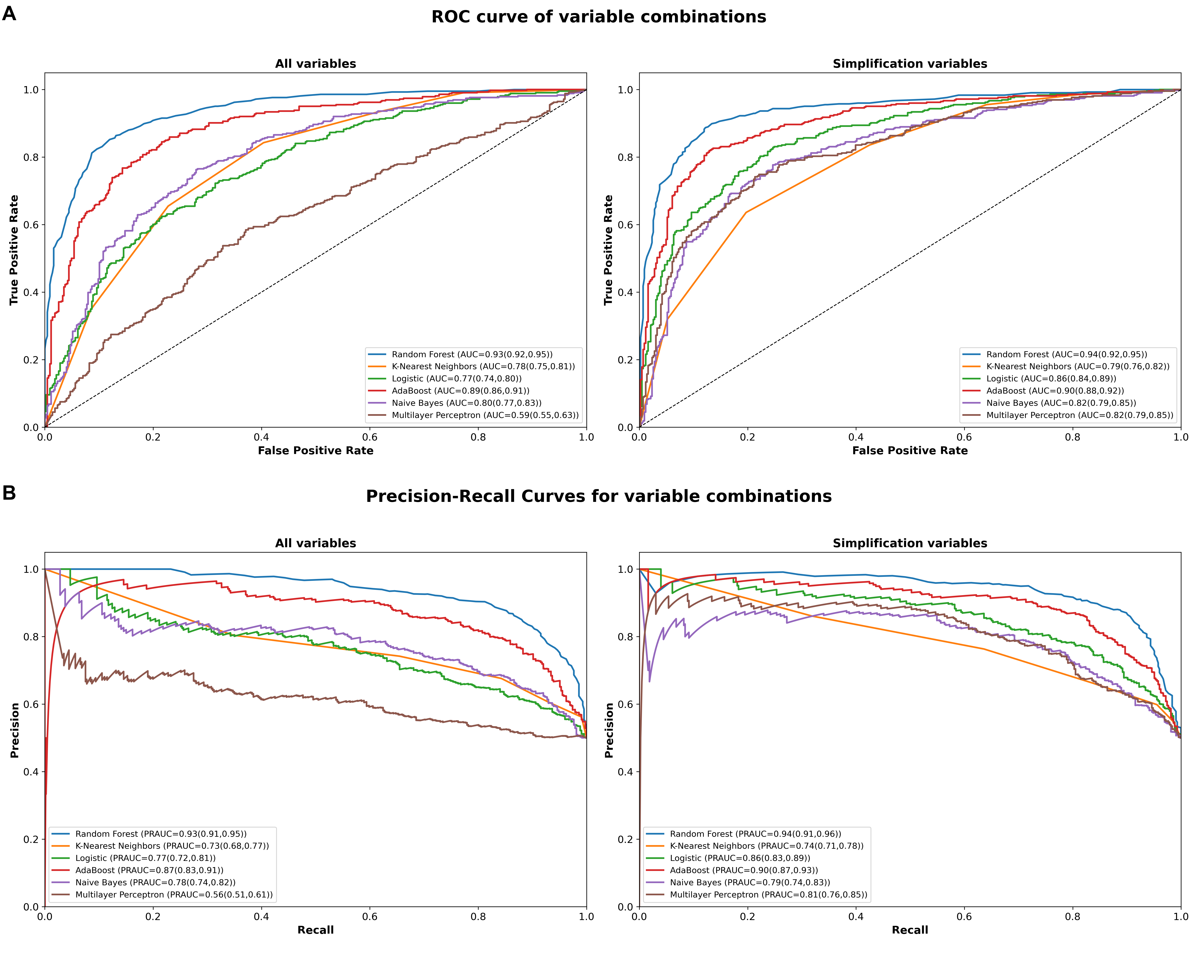
Supplementary Figure 1 Performance curves of different machine learning models in all variables and simplified variables. (A) ROC curves of six machine learning models. (B) PRC curves of six machine learning models

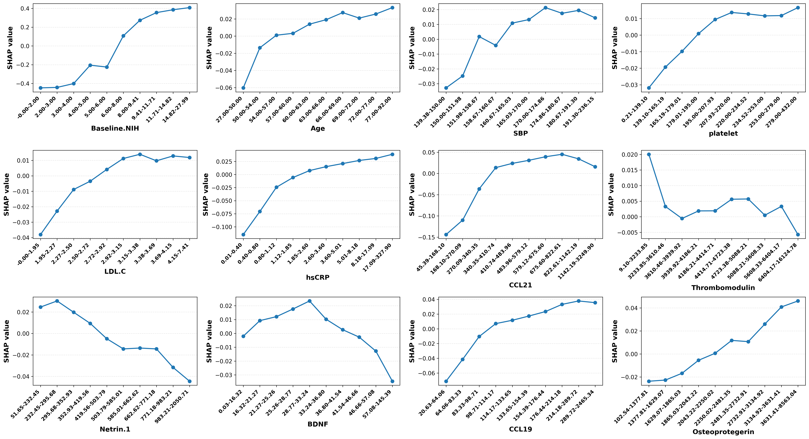
Supplementary Figure 2 The interpretable dose-response relationship between a single variable and the prognostic outcome

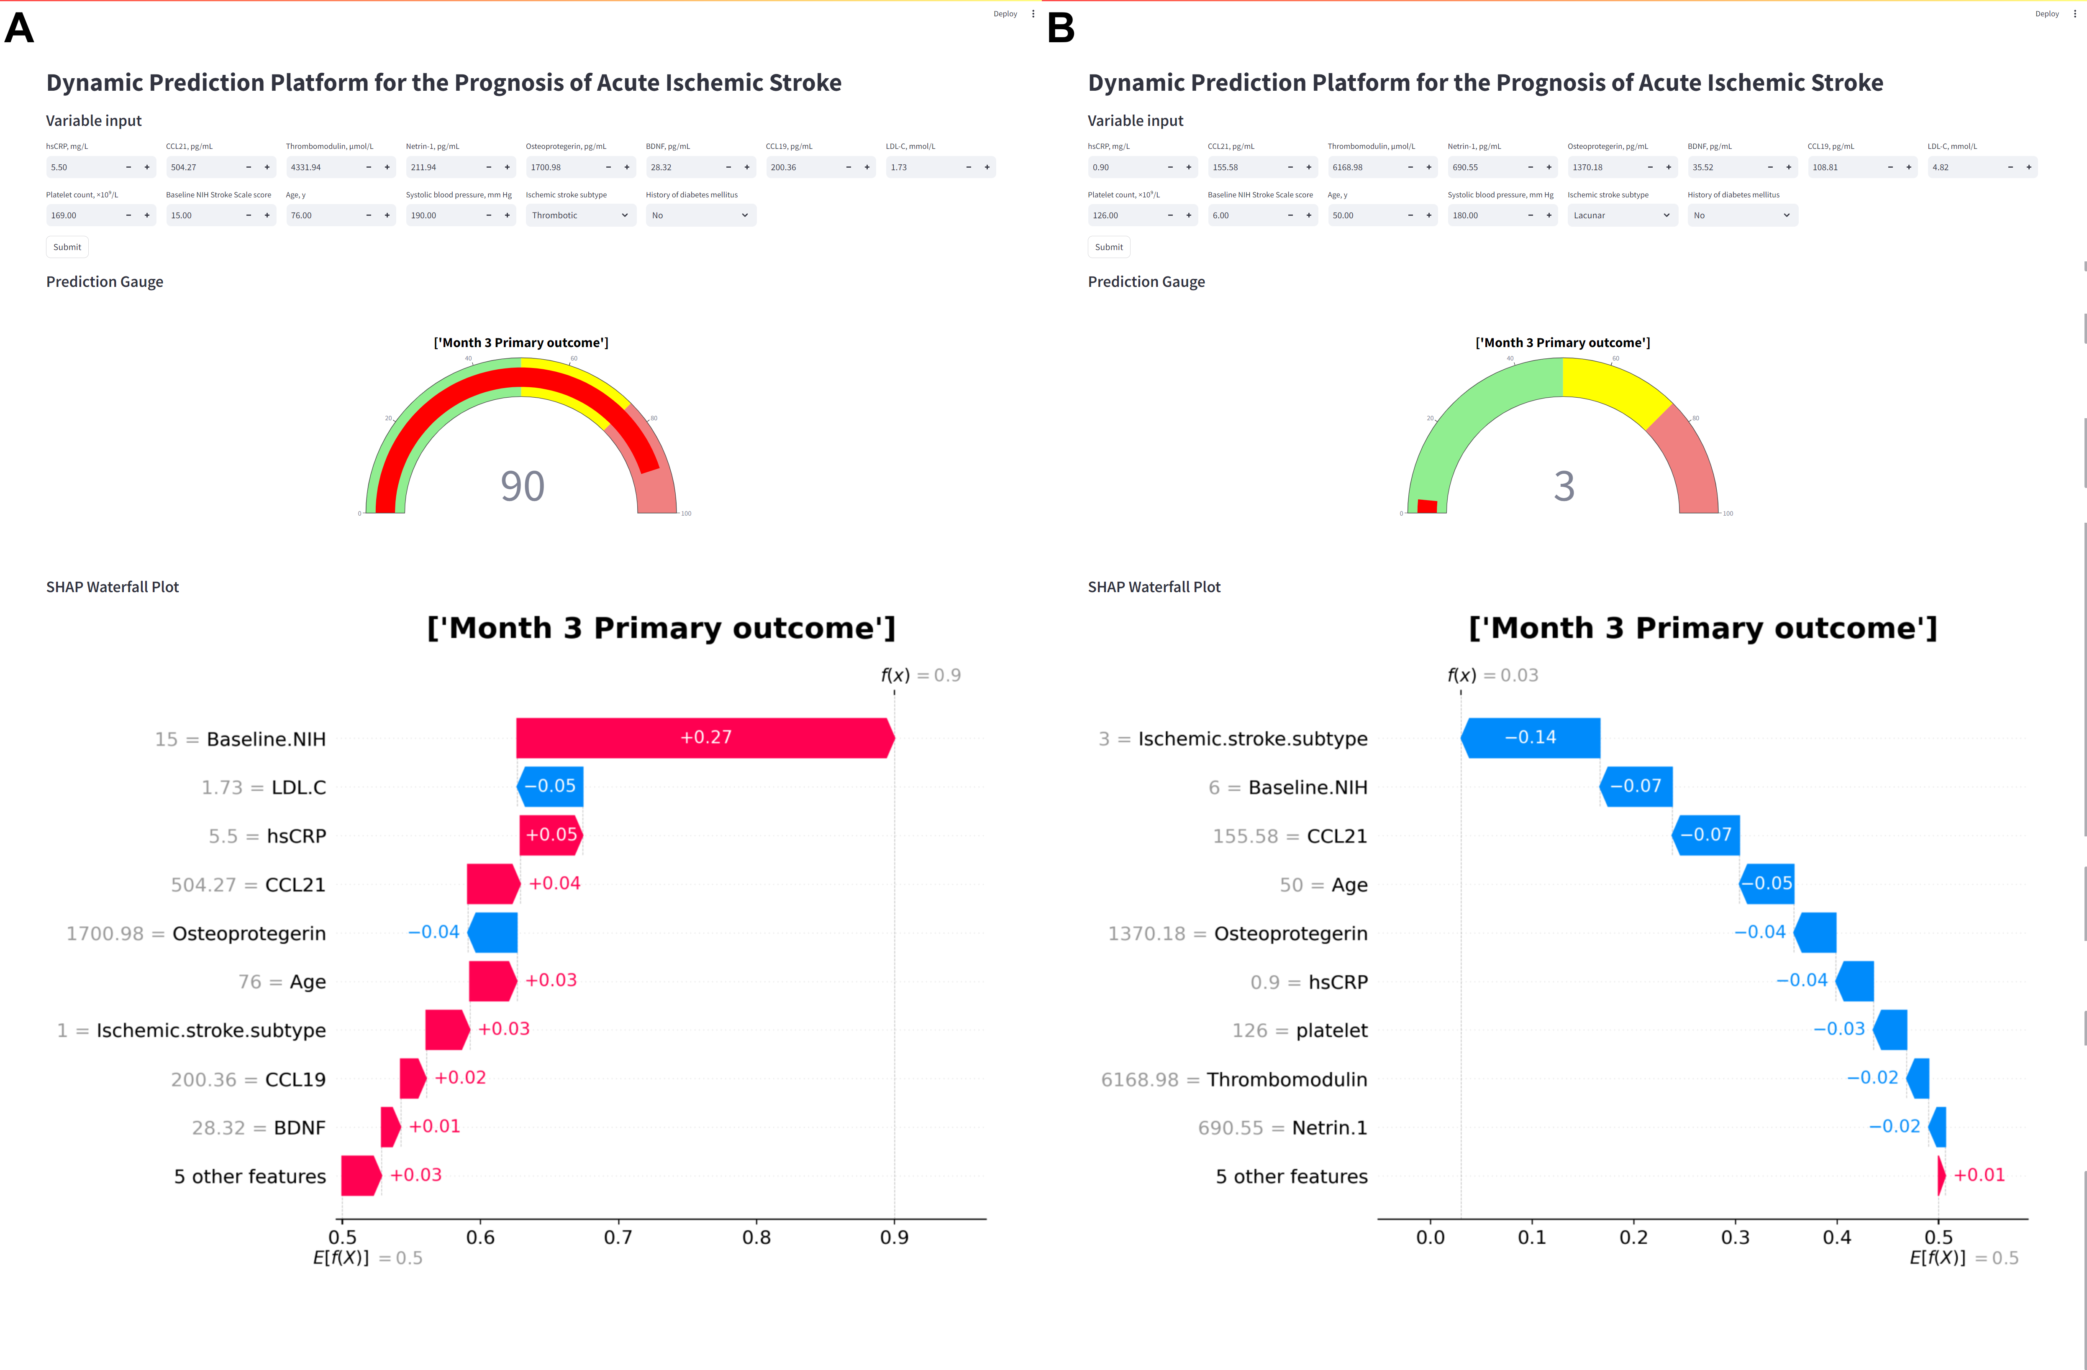
Supplementary Figure 3 Interface of the online dynamic risk prediction platform. (A) Occurs primary outcome within three months of stroke, (B) Not occurs primary outcome within three months of stroke

Supplementary Table 2 The feature selection frequency based on 100 independent bootstrap samplings
variables | First-layer |  | Second-layer
variables | Selection count | Selection frequency, % | Selection count | Selection frequency, %
Basic
Age | 100 | 100 | 100 | 100
BMI | 100 | 100 | 48 | 48
Baseline NIH Stroke Scale score | 100 | 100 | 100 | 100
Baseline diastolic blood pressure | 100 | 100 | 42 | 42
Ischemic stroke subtype | 100 | 100 | 99 | 99
Baseline systolic blood pressure | 100 | 100 | 84 | 84
History of diabetes mellitus | 92 | 92 | 54 | 54
History of hypertension | 90 | 90 | 46 | 46
Sex | 84 | 84 | 20 | 20
Current cigarette smoking | 80 | 80
Current alcohol drinking | 72 | 72
Family history | 72 | 72
History of corory heart disease | 47 | 47
History of hyperlipidemia | 45 | 45
Blood routine biochemical indices
Blood Glucose | 100 | 100 | 46 | 46
LDL-C | 100 | 100 | 87 | 87
White Blood Cell | 100 | 100 | 12 | 12
Platelet | 100 | 100 | 70 | 70
HDL-C | 98 | 98 | 27 | 27
Triglycerides | 98 | 98 | 31 | 31
Red Blood Cell | 97 | 97 | 12 | 12
Hematocrit | 91 | 91
Total Cholesterol | 86 | 86
Hemoglobin | 84 | 84
Novel biomarkers
BDNF | 100 | 100 | 86 | 86
CCL21 | 100 | 100 | 99 | 99
GDF-15 | 100 | 100 | 35 | 35
Galectin3 | 100 | 100 | 44 | 44
HGF | 100 | 100 | 27 | 27
Netrin-1 | 100 | 100 | 92 | 92
Osteoprotegerin | 100 | 100 | 70 | 70
S100A8/A9 | 100 | 100 | 16 | 16
Thrombomodulin | 100 | 100 | 82 | 82
hsCRP | 100 | 100 | 86 | 86
CCL19 | 99 | 99 | 77 | 77
Osteopontin | 99 | 99 | 49 | 49
NT-proBNP | 97 | 97 | 39 | 39
Cystatin C | 97 | 97 | 26 | 26
VD | 97 | 97 | 20 | 20
aPS | 95 | 95 | 19 | 19
MMP-9 | 94 | 94
FGF-21 | 92 | 92
RF | 90 | 90
Creatinine | 88 | 88
Lp-PLA2 | 87 | 87
TIMP-1 | 84 | 84
Dkk-3 | 81 | 81
Dkk-1 | 76 | 76
GPI | 74 | 74
aCL | 74 | 74
HCY | 70 | 70
Complement C3 | 65 | 65
Abbreviation: National Institutes of Health Stroke Scale (NIHSS), body mass index (BMI), baseline systolic blood pressure (SBP), baseline diastolic blood pressure (DBP), low-density lipoprotein cholesterol (LDL-C), high-density lipoprotein cholesterol (HDL-C), hepatocyte growth factor (HGF), vitamin D (VD), N-terminal pro-B-type natriuretic peptide (NT-proBNP), high-sensitivity C-reactive protein (hsCRP), homocysteine (HCY), phospholipase A2 (Lp-PLA2), anti-phosphatidylserine (aPS), anti-cardiolipin (aCL), glycoprotein I (GPI), rheumatoid factor (RF), matrix metalloproteinase-9 (MMP-9), growth differentiation factor-15 (GDF-15), Netrin-1, tissue inhibitor of metalloproteinases-1 (TIMP-1), dickkopf-related protein-1 and -3 (Dkk-1, Dkk-3), S100 calcium-binding protein A8/A9 (S100A8/A9), C-C motif chemokine ligand 21 and 19 (CCL21 and CCL19), fibroblast growth factor-21 (FGF-21), brain-derived neurotrophic factor (BDNF).

Supplementary Table 3 Model evaluation metrics in randomly divided test set
Model | Type | Accuracy | Sensitivity | Specificity | PPV | NPV | AUC | PR-AUC
Random Forest | All | 0.87(0.85,0.89) | 0.85(0.82,0.89) | 0.89(0.86,0.92) | 0.89(0.86,0.91) | 0.86(0.83,0.89) | 0.94(0.93,0.96) | 0.94(0.93,0.96)
Random Forest | Simplification | 0.88(0.87,0.90) | 0.88(0.85,0.91) | 0.89(0.86,0.91) | 0.89(0.86,0.91) | 0.88(0.85,0.91) | 0.95(0.93,0.96) | 0.94(0.92,0.96)
K-Nearest Neighbors | All | 0.70(0.67,0.73) | 0.85(0.82,0.88) | 0.55(0.51,0.59) | 0.65(0.62,0.69) | 0.78(0.74,0.83) | 0.76(0.73,0.79) | 0.70(0.66,0.74)
K-Nearest Neighbors | Simplification | 0.71(0.68,0.74) | 0.83(0.80,0.86) | 0.59(0.55,0.63) | 0.67(0.63,0.70) | 0.78(0.74,0.82) | 0.78(0.75,0.80) | 0.72(0.68,0.76)
Logistic | All | 0.68(0.66,0.71) | 0.69(0.65,0.73) | 0.68(0.64,0.72) | 0.68(0.64,0.72) | 0.69(0.56,0.73) | 0.77(0.74,0.80) | 0.74(0.70,0.79)
Logistic | Simplification | 0.81(0.79,0.83) | 0.79(0.76,0.83) | 0.83(0.79,0.86) | 0.82(0.79,0.85) | 0.80(0.67,0.84) | 0.88(0.86,0.90) | 0.88(0.86,0.91)
AdaBoost | All | 0.82(0.80,0.84) | 0.81(0.78,0.85) | 0.83(0.80,0.86) | 0.83(0.79,0.86) | 0.82(0.79,0.85) | 0.90(0.88,0.92) | 0.90(0.88,0.92)
AdaBoost | Simplification | 0.86(0.84,0.88) | 0.87(0.85,0.90) | 0.84(0.81,0.87) | 0.85(0.81,0.88) | 0.87(0.84,0.90) | 0.92(0.91,0.94) | 0.92(0.89,0.94)
Naive Bayes | All | 0.68(0.65,0.71) | 0.46(0.42,0.50) | 0.89(0.86,0.92) | 0.81(0.77,0.86) | 0.62(0.59,0.66) | 0.80(0.77,0.82) | 0.77(0.72,0.81)
Naive Bayes | Simplification | 0.78(0.75,0.81) | 0.70(0.65,0.74) | 0.87(0.84,0.90) | 0.84(0.81,0.88) | 0.74(0.71,0.78) | 0.86(0.84,0.88) | 0.85(0.82,0.89)
Multilayer Perceptron | All | 0.68(0.65,0.71) | 0.69(0.65,0.73) | 0.67(0.62,0.71) | 0.68(0.63,0.72) | 0.68(0.64,0.72) | 0.73(0.70,0.76) | 0.72(0.67,0.76)
Multilayer Perceptron | Simplification | 0.75(0.72,0.78) | 0.76(0.73,0.80) | 0.74(0.70,0.77) | 0.74(0.71,0.78) | 0.76(0.72,0.80) | 0.82(0.80,0.85) | 0.83(0.80,0.86)

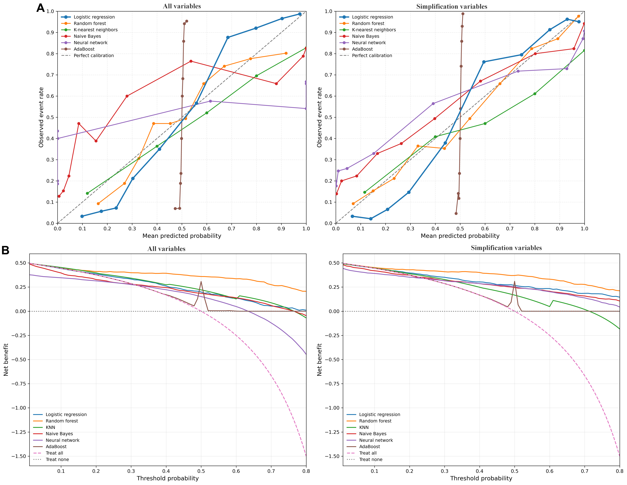
Supplementary Figure 4 Calibration curves and decision curves of six models including all variables and simplification variables

Supplementary Table 4 Model calibration indicators in the internal development set
Model | Type | Brier score | Hosmer–Lemeshow test P
Random Forest | All | 0.11(0.10,0.12) | 0.849
Random Forest | Simplification | 0.10(0.09,0.12) | 0.902
K-Nearest Neighbors | All | 0.19(0.18,0.21) | 0.803
K-Nearest Neighbors | Simplification | 0.22(0.20,0.24) | 0.864
Logistic | All | 0.20(0.19,0.21) | 0.749
Logistic | Simplification | 0.16(0.15,0.17) | 0.835
AdaBoost | All | 0.24(0.23,0.24) | 0.562
AdaBoost | Simplification | 0.25(0.24,0.25) | 0.519
Naive Bayes | All | 0.24(0.21,0.26) | 0.811
Naive Bayes | Simplification | 0.19(0.17,0.21) | 0.881
Multilayer Perceptron | All | 0.34(0.31,0.37) | 0.212
Multilayer Perceptron | Simplification | 0.20(0.18,0.23) | 0.418

Supplementary Table 5 Baseline analysis of complete and incomplete cases
Variables | Complete cases (N=2481) | Incomplete cases (N=900) | P value
Outcomes
Month 3 Primary outcome | 649 (26.2%) | 227 (25.2%) | 0.583
Basic
Age, y | 62 (55, 70) | 60 (53, 69) | <0.001
Sex male, % | 1569 (63.2%) | 601 (66.8%) | 0.058
Current cigarette smoking, % | 935 (37.7%) | 313 (34.8%) | 0.121
Current alcohol drinking, % | 769 (31.0%) | 292 (32.4%) | 0.422
History of hypertension, % | 1949 (81.8%) | 704 (82.2%) | 0.75
History of hyperlipidemia, % | 175 (7.1%) | 59 (6.6%) | 0.614
History of coronary heart disease, % | 263 (10.6%) | 84 (9.3%) | 0.283
History of diabetes mellitus, % | 451 (18.2%) | 141 (15.7%) | 0.089
Ischemic stroke subtype |  |  | 0.936
Thrombotic | 1849 (74.5%) | 671 (75.1%)
Embolic | 120 (4.8%) | 42 (4.7%)
Lacunar | 512 (20.6%) | 180 (20.2%)
Baseline NIH Stroke Scale score | 4 (2, 8) | 4 (3, 8) | 0.364
BMI | 24.73 (22.86, 26.73) | 24.8 (23.01, 26.67) | 0.402
Family history of stroke, % | 469 (20.1%) | 155 (19.1%) | 0.556
Baseline systolic blood pressure, mm Hg | 162 (152, 178.67) | 161.33 (151.33, 179.33) | 0.669
Baseline diastolic blood pressure, mm Hg | 98 (90, 100.67) | 98.67 (90, 101.75) | 0.002
Blood routine biochemical indices
White Blood Cell, 10⁹/L | 6.8 (5.5, 8.41) | 6.81 (5.7, 8.51) | 0.301
Blood Glucose, mmol/L | 5.8 (5.08, 7.2) | 5.8 (5.1, 7.2) | 0.575
Triglycerides, mmol/L | 1.48 (1.03, 2.16) | 1.42 (1, 2.05) | 0.032
Platelet,10⁹/L | 208 (171, 248) | 212 (173, 254) | 0.113
LDL-C, mmol/L | 2.88 (2.29, 3.47) | 2.88 (2.31, 3.54) | 0.652
HDL-C, mmol/L | 1.22 (1.03, 1.48) | 1.26 (1.04, 1.5) | 0.046
Red Blood Cell, 10¹²/L | 4.59 (4.27, 4.92) | 4.64 (4.29, 4.99) | 0.042
Total Cholesterol, mmol/L | 5.01 (4.29, 5.72) | 4.99 (4.3, 5.74) | 0.806
Hemoglobin, g/L | 141 (131, 151) | 143 (132, 154.65) | 0.005
Hematocrit, % | 41.86 (39, 44.95) | 42.5 (39, 45.6) | 0.001
Novel biomarkers
Cystatin C, mg/L | 0.75 (0.64, 0.89) | 0.75 (0.64, 0.89) | 0.694
HGF, pg/mL | 1575.35 (1232.31, 2110.4) | 1574.59 (1258.14, 2093.18) | 0.956
VD, ng/mL | 12.4 (8.54, 17.3) | 12.6 (8.7, 18) | 0.159
NT-proBNP, pg/mL | 142.05 (67.1, 331) | 142.97 (64.9, 314.29) | 0.598
Complement C3, g/L | 1.45 (1.26, 1.66) | 1.48 (1.27, 1.69) | 0.116
hsCRP, mg/L | 1.9 (0.7, 4.7) | 1.8 (0.6, 4.8) | 0.453
Galectin3, ng/mL | 8.51 (5.79, 11.59) | 8.98 (6.38, 12.69) | 0.005
HCY, μmol/L | 14.9 (11.5, 22.3) | 15.15 (11.6, 21.87) | 0.67
Lp-PLA2, ng/mL | 146.26 (107.05, 191.14) | 134.9 (100.54, 172.45) | <0.001
aPS, GPS | 5.94 (3.3, 9.95) | 6.01 (3.3, 10.1) | 0.66
aCL, GPL | 5.45 (4.19, 7.63) | 5.44 (4.3, 7.44) | 0.936
GPI, SGU | 2.22 (1.9, 2.72) | 2.24 (1.97, 2.67) | 0.217
RF, IU/mL | 4.45 (1.2, 8.25) | 3.75 (1.3, 7.74) | 0.326
MMP-9, ng/mL | 671.8 (415.5, 1037.23) | 663.2 (411.6, 985.3) | 0.557
GDF-15, ng/L | 994.72 (704.47, 1418.73) | 964.68 (731.82, 1423.75) | 0.962
Netrin-1, pg /mL | 475.26 (312.71, 700.97) | 472.3 (323.59, 681.98) | 0.972
TIMP-1, ng/mL | 200.3 (165.1, 242.7) | 193.9 (160.05, 238.3) | 0.006
Dkk-1, ng/mL | 4057.32 (3180.47, 5209.15) | 4003.1 (3154.26, 4995.2) | 0.269
Dkk-3, ng/mL | 61827.5 (50248.93, 76952.75) | 57293.5 (46936.55, 72153.72) | <0.001
S100A8/A9, ng/mL | 3051.12 (1666.42, 6340.32) | 3155.31 (1703.55, 6410.22) | 0.821
Thrombomodulin, μmol/L | 4486.44 (3744.12, 5466.42) | 4507.95 (3728.51, 5437.12) | 0.492
Creatinine, μmol/24h | 7044.7 (5770, 8711) | 7252.1 (5817.98, 8903.5) | 0.206
CCL21, pg/mL | 448.44 (267.45, 742.17) | 423.45 (271.2, 638.91) | 0.033
CCL19, pg/mL | 126.24 (88.64, 188.91) | 127.22 (82.22, 182.52) | 0.37
FGF-21, pg/mL | 762.88 (475.61, 1127) | 703.72 (437.47, 1099.34) | 0.025
BDNF, pg/mL | 33.16 (23.18, 45.16) | 32.44 (22.74, 42.95) | 0.15
Osteoprotegerin, pg/mL | 2206.64 (1709.39, 2872.89) | 2099.39 (1618.87, 2728.19) | <0.001
Osteopontin, pg/mL | 56479 (26575.78, 85500.27) | 58108.8 (31469.25, 84506.47) | 0.605

Supplementary Table 6 Using simplification variables model evaluation metrics in the complete case set
Model | Type | Accuracy | Sensitivity | Specificity | PPV | NPV | AUC | PR-AUC
RandomForest | Simplification | 0.84(0.81,0.87) | 0.84(0.81,0.88) | 0.84(0.80,0.88) | 0.84(0.80,0.88) | 0.84(0.80,0.88) | 0.92(0.90,0.94) | 0.92(0.90,0.94)
K-NearestNeighbors | Simplification | 0.70(0.67,0.74) | 0.83(0.79,0.87) | 0.58(0.53,0.63) | 0.66(0.62,0.70) | 0.77(0.72,0.82) | 0.78(0.75,0.81) | 0.73(0.68,0.77)
Logistic | Simplification | 0.77(0.73,0.80) | 0.74(0.70,0.79) | 0.79(0.74,0.83) | 0.78(0.73,0.82) | 0.75(0.67,0.80) | 0.84(0.82,0.87) | 0.84(0.80,0.87)
AdaBoost | Simplification | 0.77(0.74,0.80) | 0.78(0.74,0.83) | 0.76(0.72,0.80) | 0.77(0.72,0.81) | 0.78(0.74,0.82) | 0.86(0.83,0.88) | 0.85(0.81,0.89)
NaiveBayes | Simplification | 0.73(0.70,0.76) | 0.62(0.58,0.68) | 0.83(0.79,0.87) | 0.78(0.73,0.83) | 0.69(0.64,0.73) | 0.80(0.77,0.83) | 0.79(0.74,0.83)
MultilayerPerceptron | Simplification | 0.72(0.69,0.75) | 0.74(0.70,0.78) | 0.70(0.65,0.75) | 0.72(0.67,0.76) | 0.73(0.69,0.78) | 0.79(0.76,0.82) | 0.79(0.74,0.84)

Supplementary Table 7 Model evaluation metrics in internal development set (Year 1 Primary outcome)
Model | Type | Accuracy | Sensitivity | Specificity | PPV | NPV | AUC | PR-AUC
Random Forest | All | 0.83(0.80,0.85) | 0.81(0.77,0.85) | 0.84(0.80,0.87) | 0.84(0.80,0.87) | 0.82(0.77,0.85) | 0.91(0.88,0.92) | 0.91(0.88,0.93)
Random Forest | Simplification | 0.85(0.82,0.87) | 0.83(0.79,0.86) | 0.86(0.83,0.90) | 0.86(0.83,0.89) | 0.83(0.80,0.87) | 0.92(0.90,0.94) | 0.93(0.91,0.95)
K-Nearest Neighbors | All | 0.67(0.64,0.71) | 0.74(0.69,0.78) | 0.61(0.56,0.66) | 0.65(0.61,0.70) | 0.70(0.65,0.75) | 0.72(0.69,0.75) | 0.67(0.62,0.72)
K-Nearest Neighbors | Simplification | 0.69(0.66,0.72) | 0.79(0.76,0.83) | 0.59(0.54,0.63) | 0.66(0.62,0.70) | 0.74(0.69,0.79) | 0.75(0.72,0.78) | 0.70(0.66,0.75)
Logistic | All | 0.69(0.66,0.72) | 0.65(0.60,0.69) | 0.73(0.69,0.78) | 0.71(0.66,0.76) | 0.68(0.59,0.73) | 0.77(0.74,0.81) | 0.74(0.70,0.79)
Logistic | Simplification | 0.74(0.70,0.77) | 0.71(0.66,0.75) | 0.76(0.72,0.81) | 0.75(0.71,0.79) | 0.72(0.68,0.76) | 0.83(0.80,0.86) | 0.83(0.80,0.87)
AdaBoost | All | 0.80(0.77,0.82) | 0.78(0.74,0.82) | 0.82(0.78,0.86) | 0.81(0.77,0.85) | 0.79(0.75,0.83) | 0.87(0.84,0.89) | 0.88(0.85,0.91)
AdaBoost | Simplification | 0.81(0.78,0.84) | 0.78(0.75,0.82) | 0.83(0.79,0.87) | 0.82(0.78,0.86) | 0.79(0.76,0.83) | 0.88(0.85,0.90) | 0.88(0.84,0.90)
Naive Bayes | All | 0.70(0.67,0.74) | 0.62(0.57,0.66) | 0.79(0.75,0.83) | 0.75(0.70,0.79) | 0.67(0.63,0.71) | 0.78(0.75,0.81) | 0.75(0.69,0.80)
Naive Bayes | Simplification | 0.74(0.71,0.77) | 0.60(0.56,0.65) | 0.87(0.84,0.91) | 0.83(0.78,0.87) | 0.69(0.65,0.73) | 0.82(0.79,0.85) | 0.81(0.76,0.85)
Multilayer Perceptron | All | 0.63(0.60,0.67) | 0.72(0.68,0.77) | 0.54(0.49,0.59) | 0.61(0.57,0.65) | 0.66(0.60,0.72) | 0.67(0.63,0.70) | 0.64(0.59,0.69)
Multilayer Perceptron | Simplification | 0.66(0.63,0.69) | 0.48(0.43,0.53) | 0.83(0.80,0.87) | 0.74(0.69,0.79) | 0.62(0.58,0.65) | 0.73(0.70,0.77) | 0.73(0.69,0.78)

Supplementary Table 8 FDR-adjusted exploratory comparisons of candidate predictors between patients with and without the 3-month primary outcome
Variables | P value | FDR-adjusted P value
Basic
Age | <0.001 | <0.001
Sex | 0.022 | 0.036
Current cigarette smoking | <0.001 | <0.001
Current alcohol drinking | <0.001 | <0.001
History of hypertension | 0.995 | 0.997
History of hyperlipidemia | 0.308 | 0.353
History of coronary heart disease | 0.009 | 0.017
History of diabetes mellitus | 0.186 | 0.232
Ischemic stroke subtype | <0.001 | <0.001
Baseline NIH Stroke Scale score | <0.001 | <0.001
BMI | 0.895 | 0.941
Family history of stroke | 0.174 | 0.222
Baseline systolic blood pressure | <0.001 | <0.001
Baseline diastolic blood pressure | 0.773 | 0.834
Blood routine and biochemical indicators
White Blood Cell | <0.001 | <0.001
Blood Glucose | <0.001 | <0.001
Triglycerides | <0.001 | <0.001
Platelet | 0.042 | 0.045
LDL-C | 0.002 | 0.005
HDL-C | 0.022 | 0.036
Red Blood Cell | 0.284 | 0.34
Total Cholesterol | 0.291 | 0.341
Hemoglobin | 0.241 | 0.295
Hematocrit | 0.076 | 0.107
Biomarkers
Cystatin C | 0.061 | 0.089
HGF | <0.001 | <0.001
VD | 0.45 | 0.505
NT-proBNP | 0.01 | 0.018
Complement C3 | 0.002 | 0.004
hsCRP | <0.001 | <0.001
Galectin3 | <0.001 | <0.001
HCY | 0.051 | 0.075
Lp-PLA2 | 0.005 | 0.009
aPS | 0.003 | 0.005
aCL | 0.029 | 0.045
GPI | 0.084 | 0.116
RF | 0.01 | 0.017
MMP-9 | <0.001 | <0.001
GDF-15 | <0.001 | <0.001
Netrin-1 | <0.001 | <0.001
TIMP-1 | <0.001 | <0.001
Dkk-1 | 0.478 | 0.525
Dkk-3 | <0.001 | 0.002
S100A8/A9 | <0.001 | <0.001
Thrombomodulin | <0.001 | <0.001
Creatinine | 0.997 | 0.997
CCL21 | <0.001 | <0.001
CCL19 | <0.001 | <0.001
FGF-21 | 0.129 | 0.173
BDNF | 0.002 | 0.004
Osteoprotegerin | <0.001 | <0.001
Osteopontin | <0.001 | <0.001

