A Mammographic Habitat-Clinical Fusion Model for Preoperative Prediction of Ductal Carcinoma In Situ with Microinvasion

ELECTRONIC SUPPLEMENTARY MATERIAL

Intratumor Heterogeneity Generation Process
Our methodology for delineating tumor Intratumor Heterogeneity regions was multi-faceted and involved several intricate steps:
Advanced Superpixel Segmentation: Utilizing the SLIC algorithm within the scikit-learn framework, we initially segmented each tumor's Region of Interest (ROI) into 100 subregions. The segmentation was fine-tuned with a compactness parameter set at 10.0, balancing color similarity and spatial proximity.
The SLIC algorithm is a method for superpixel segmentation. It works by clustering pixels in the image based on their color similarity and proximity in the image space. The key formula for SLIC is the distance measure, which combines color and spatial proximity:
$$D=\sqrt{d_{lab}^{2}+{\left(\frac{d_{s}}{S}\right)}^{2}}$$
  - $D$ is the combined distance measure.
  - $d_{lab}$ is the Euclidean distance in color space (Lab color space).
  - $d_{s}$ is the Euclidean distance in the image plane.
  - $S$ is the grid interval or the size of the superpixel.
Comprehensive Radiomic Feature Extraction: For each of these subregions, a detailed extraction of 107 radiomic features was performed. This included an array of shape descriptors, textural features, and first-order statistical attributes, offering a multidimensional characterization of each subregion.
In-depth Clustering Analysis: The K-means algorithm was employed to analyze the multidimensional feature space. We experimented with varying numbers of cluster centers (ranging from 3 to 9) to identify distinct Intratumor Heterogeneity regions within the tumor. The clustering performance was rigorously evaluated using the Calinski-Harabasz score, allowing us to select the most statistically significant clustering arrangement.
The K-means algorithm is a method for clustering data into K distinct clusters. The algorithm iteratively updates the centroids of each cluster to minimize the within-cluster sum of squares. The key formula for K-means is the objective function to be minimized:
$$J=\sum_{i=1}^{N}{\sum_{k=1}^{K}{w_{ik}}}×∥x_{i}−μ_{k}∥^{2}$$
  - $J$ is the objective function.
  - $N$ is the number of data points.
  - $K$ is the number of clusters.
  - $w_{ik}$ is a binary indicator (1 if data point $i$ is in cluster $k$, 0 otherwise).
  - $x_{i}$ is the Habitat data point.
  - $μ_{k}$ is the centroid of cluster $k$.
  - $∥x_{i}−μ_{k}∥^{2}$ is the squared Euclidean distance between data point $i$ and centroid $k$.
Intratumor Heterogeneity Region Synthesis: Following the clustering analysis, subregions with identical cluster IDs were amalgamated. This synthesis resulted in the formation of comprehensive Intratumor Heterogeneity regions, each representing a unique microenvironmental characteristic within the tumor.
Figure S1. Intratumor Heterogeneity Regions
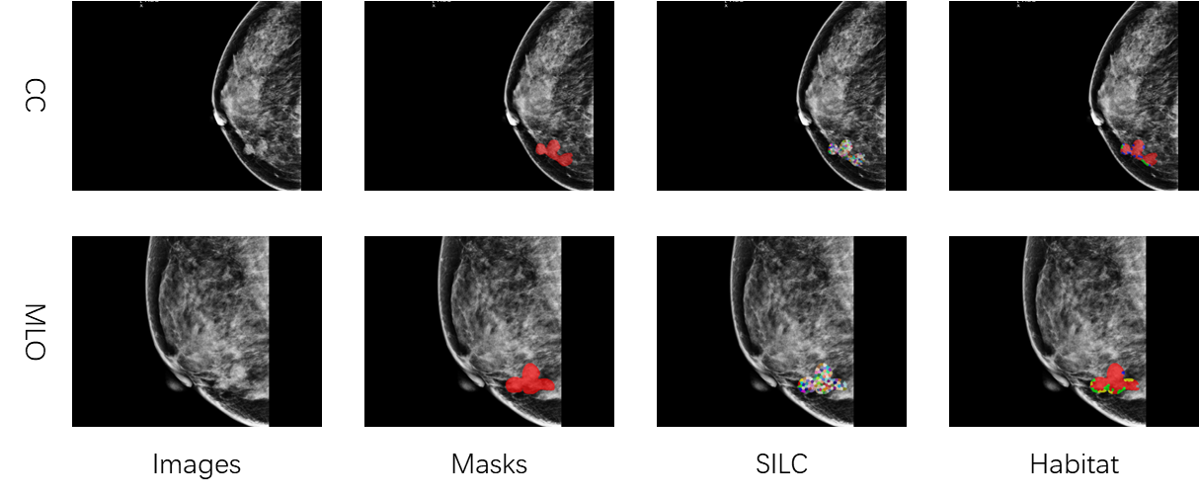

- Detailed habitat flow parameters:
- SLIC: n_segments=100，compactness=10，sigma=1
- K-means: init='k-means++'，n_init=10，max_iter=300
- Feature extraction: 833 features per habitat（14shape、162 first-order, 198 GLCM, 144 GLRLM, 144 GLSZM, 126 GLDM, and 45 NGTDM）
- Gray scale discretization: fixed bin width=25, bin count=128
- Image resolution: standardized to 0.1 mm/pixel

Details of Clinical Signature

Table S1. Model Performance of Different Machine Learning Algorithms with Clinical Signature in the different cohorts.
model_name | Accuracy | AUC | 95% CI | Sensitivity | Specificity | PPV | NPV | Cohort
LR | 0.667 | 0.706 | 0.604-0.808 | 0.750 | 0.603 | 0.589 | 0.761 | train
LR | 0.545 | 0.397 | 0.219-0.574 | 0.864 | 0.227 | 0.528 | 0.625 | val
LR | 0.667 | 0.732 | 0.575-0.890 | 0.789 | 0.565 | 0.600 | 0.765 | test1
LR | 0.750 | 0.786 | 0.625-0.947 | 0.714 | 0.769 | 0.625 | 0.833 | test2
LightGBM | 0.716 | 0.776 | 0.686-0.865 | 0.705 | 0.724 | 0.660 | 0.764 | train
LightGBM | 0.500 | 0.365 | 0.197-0.532 | 0.000 | 1.000 | 0.000 | 0.500 | val
LightGBM | 0.714 | 0.717 | 0.545-0.889 | 0.632 | 0.783 | 0.706 | 0.720 | test1
LightGBM | 0.675 | 0.791 | 0.653-0.929 | 0.857 | 0.577 | 0.522 | 0.882 | test2
ExtraTrees | 0.775 | 0.842 | 0.765-0.920 | 0.568 | 0.931 | 0.862 | 0.740 | train
ExtraTrees | 0.545 | 0.572 | 0.400-0.744 | 0.500 | 0.591 | 0.550 | 0.542 | val
ExtraTrees | 0.643 | 0.727 | 0.565-0.888 | 0.263 | 0.957 | 0.833 | 0.611 | test1
ExtraTrees | 0.675 | 0.740 | 0.586-0.895 | 0.571 | 0.731 | 0.533 | 0.760 | test2

Figure S2 ROC Curves of Different Models with Clinical Signature in Various cohorts
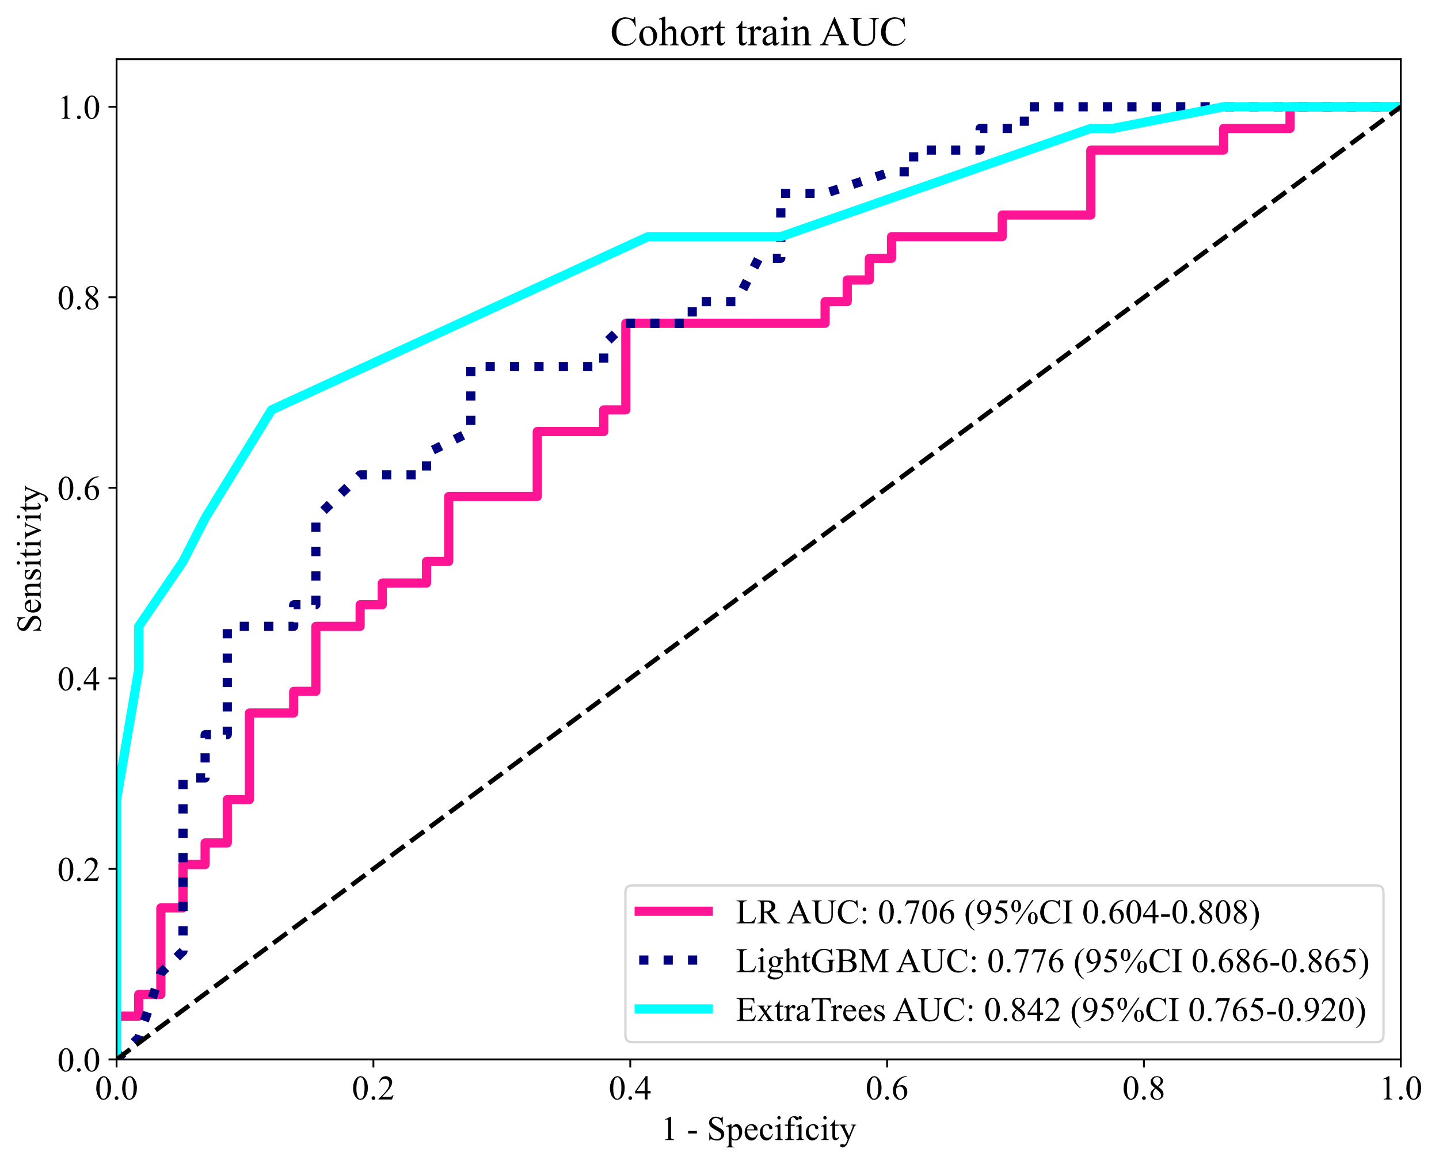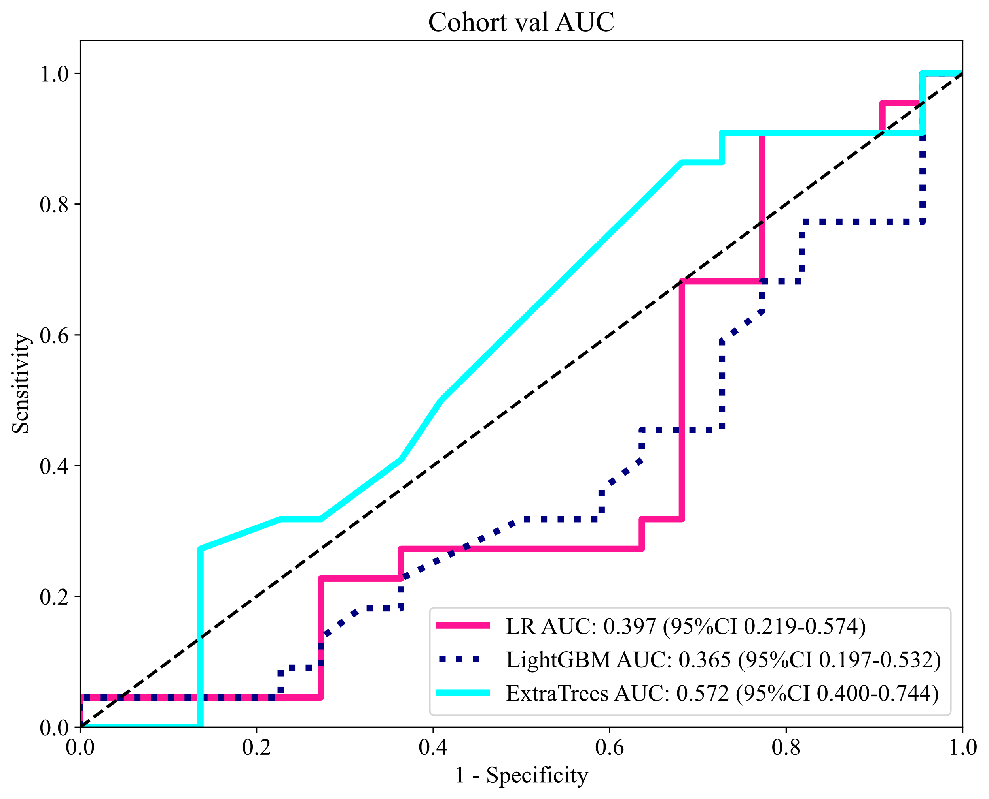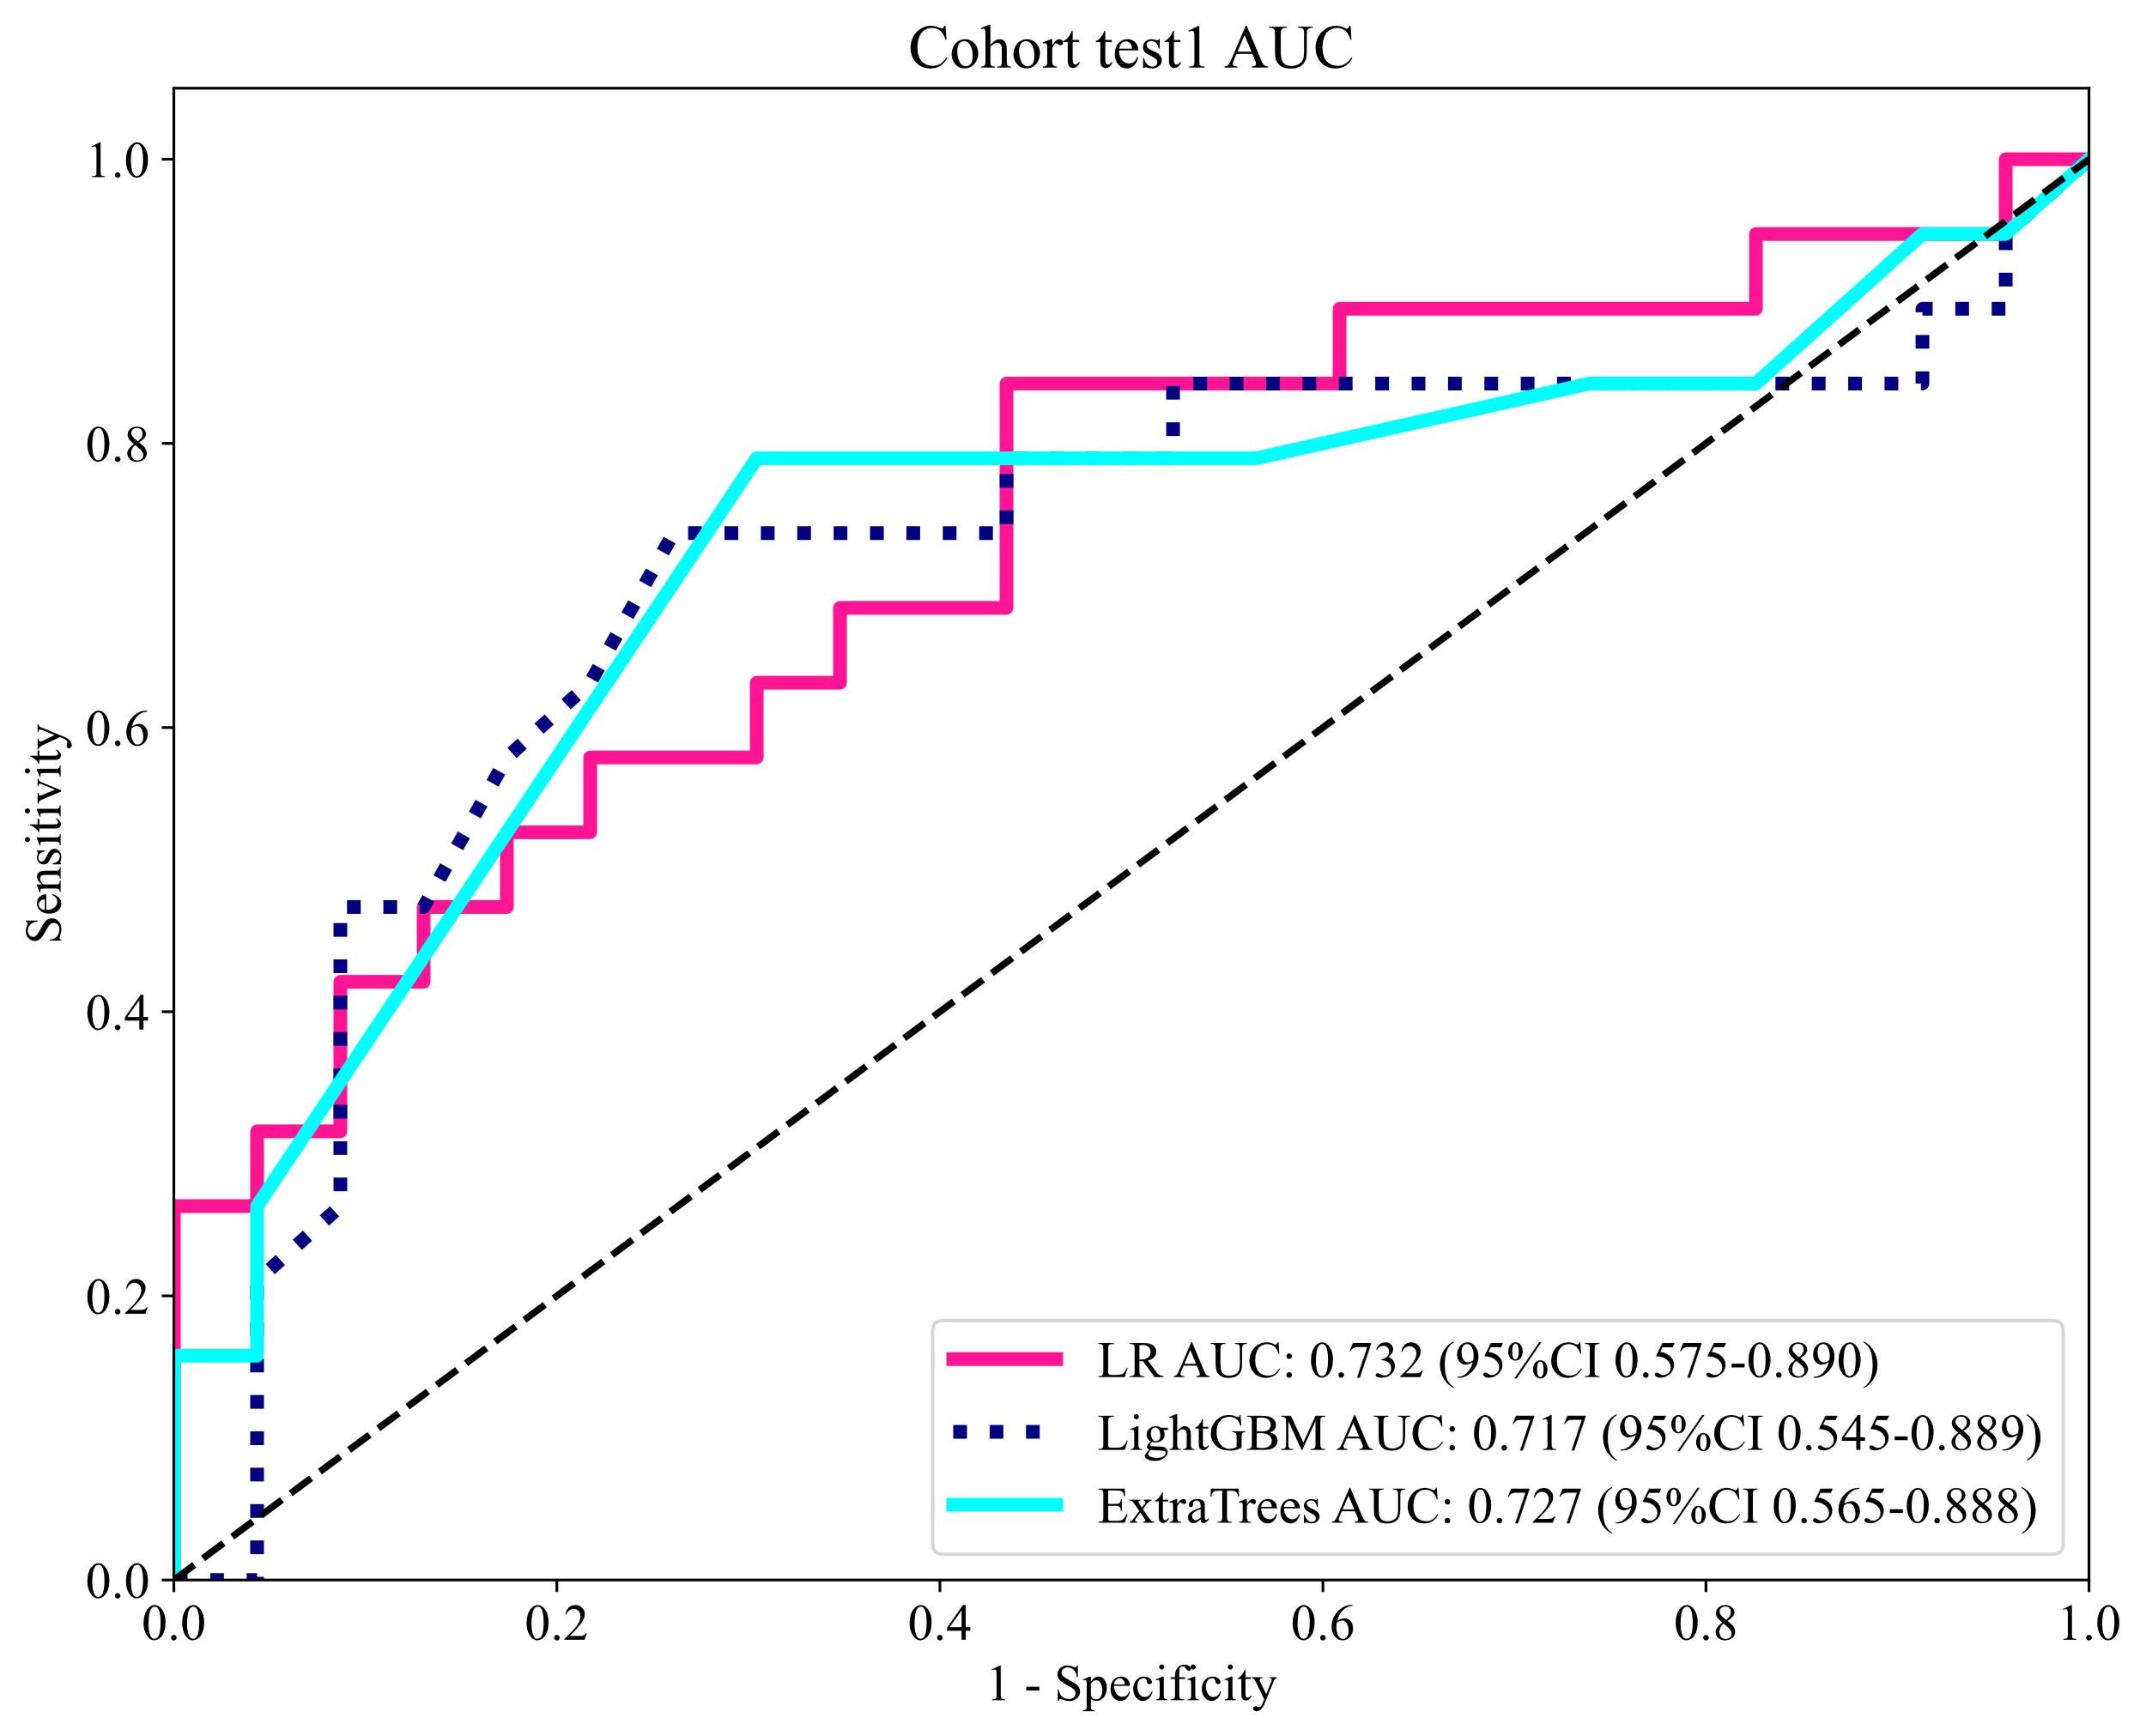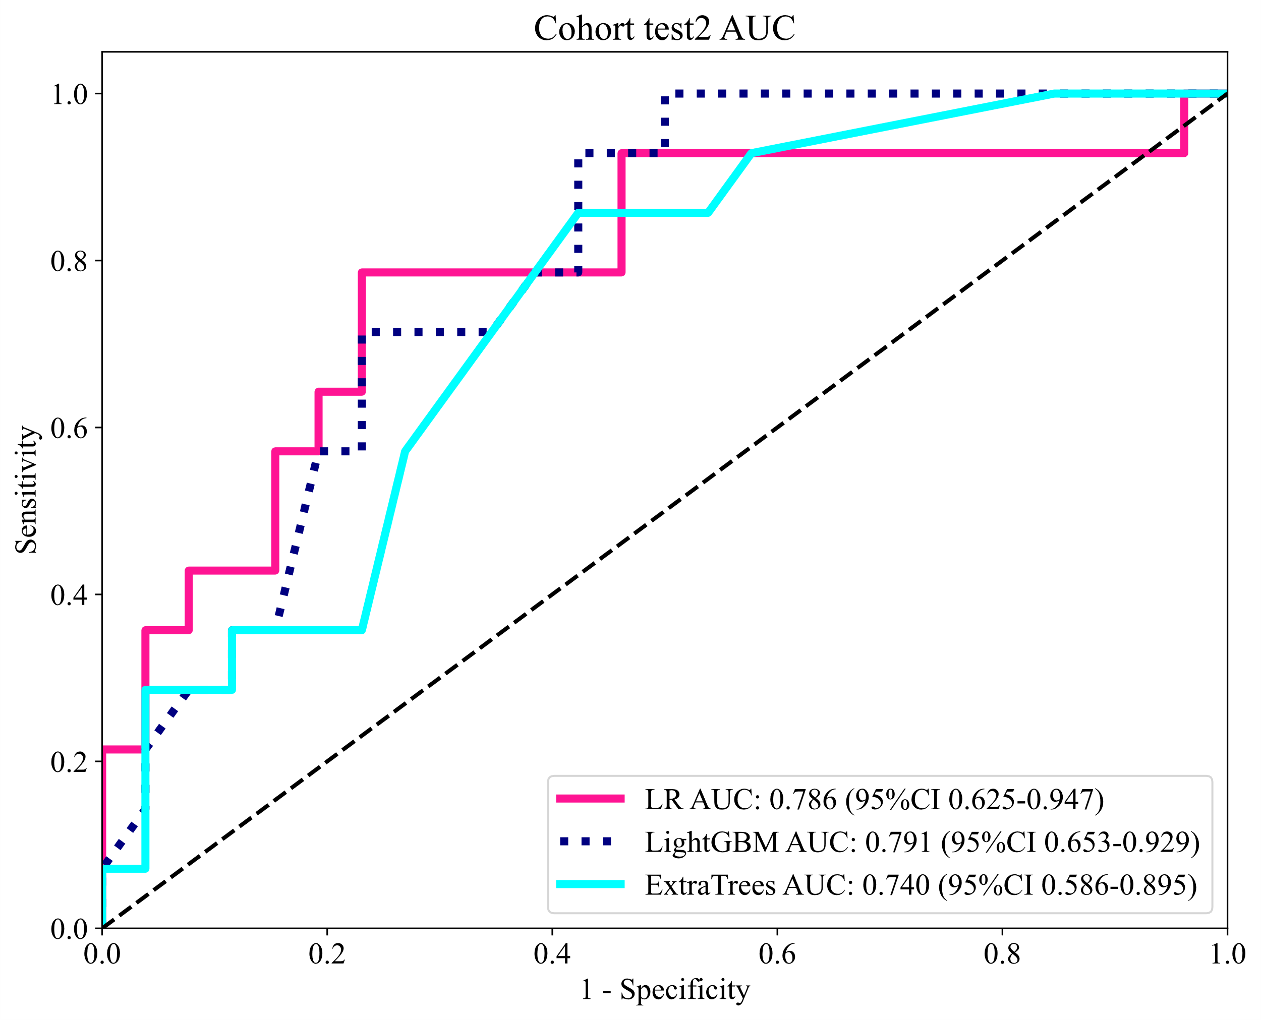

Figure S3. Calinski-Harabasz score of different cluster
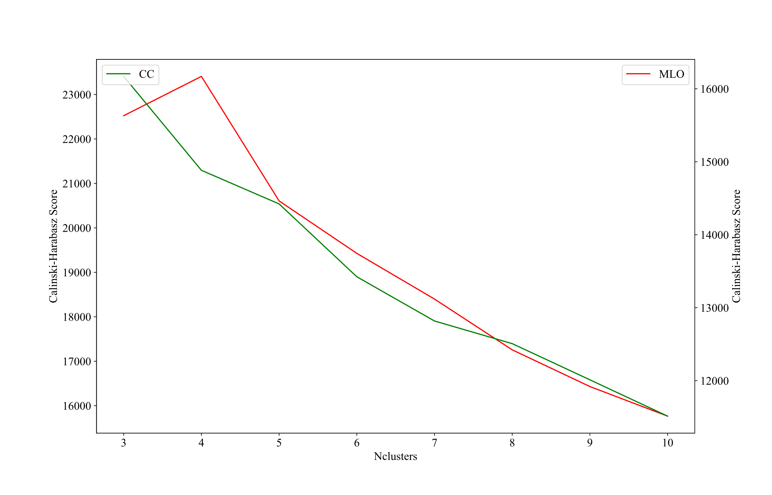
Figure S4. Number and ratio of handcrafted features

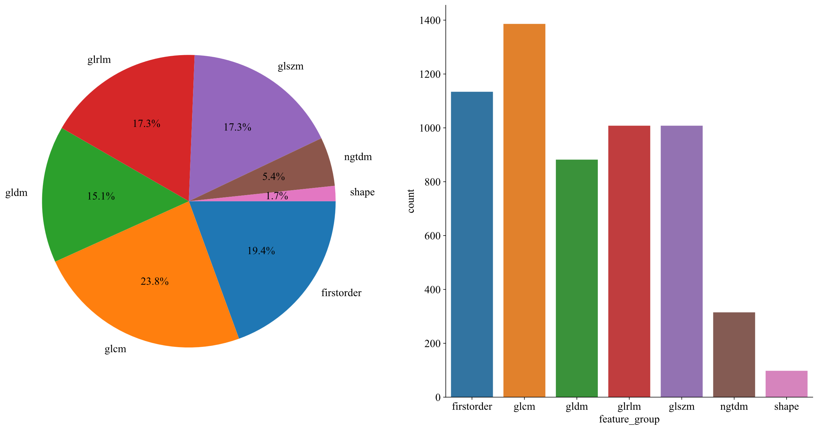

Figure.S5a. Coefficients of 10 fold cross validation, Fig.S5b MSE of 10 fold cross validation, Fig.S5c The histogram of the Rad-score based on the selected features.

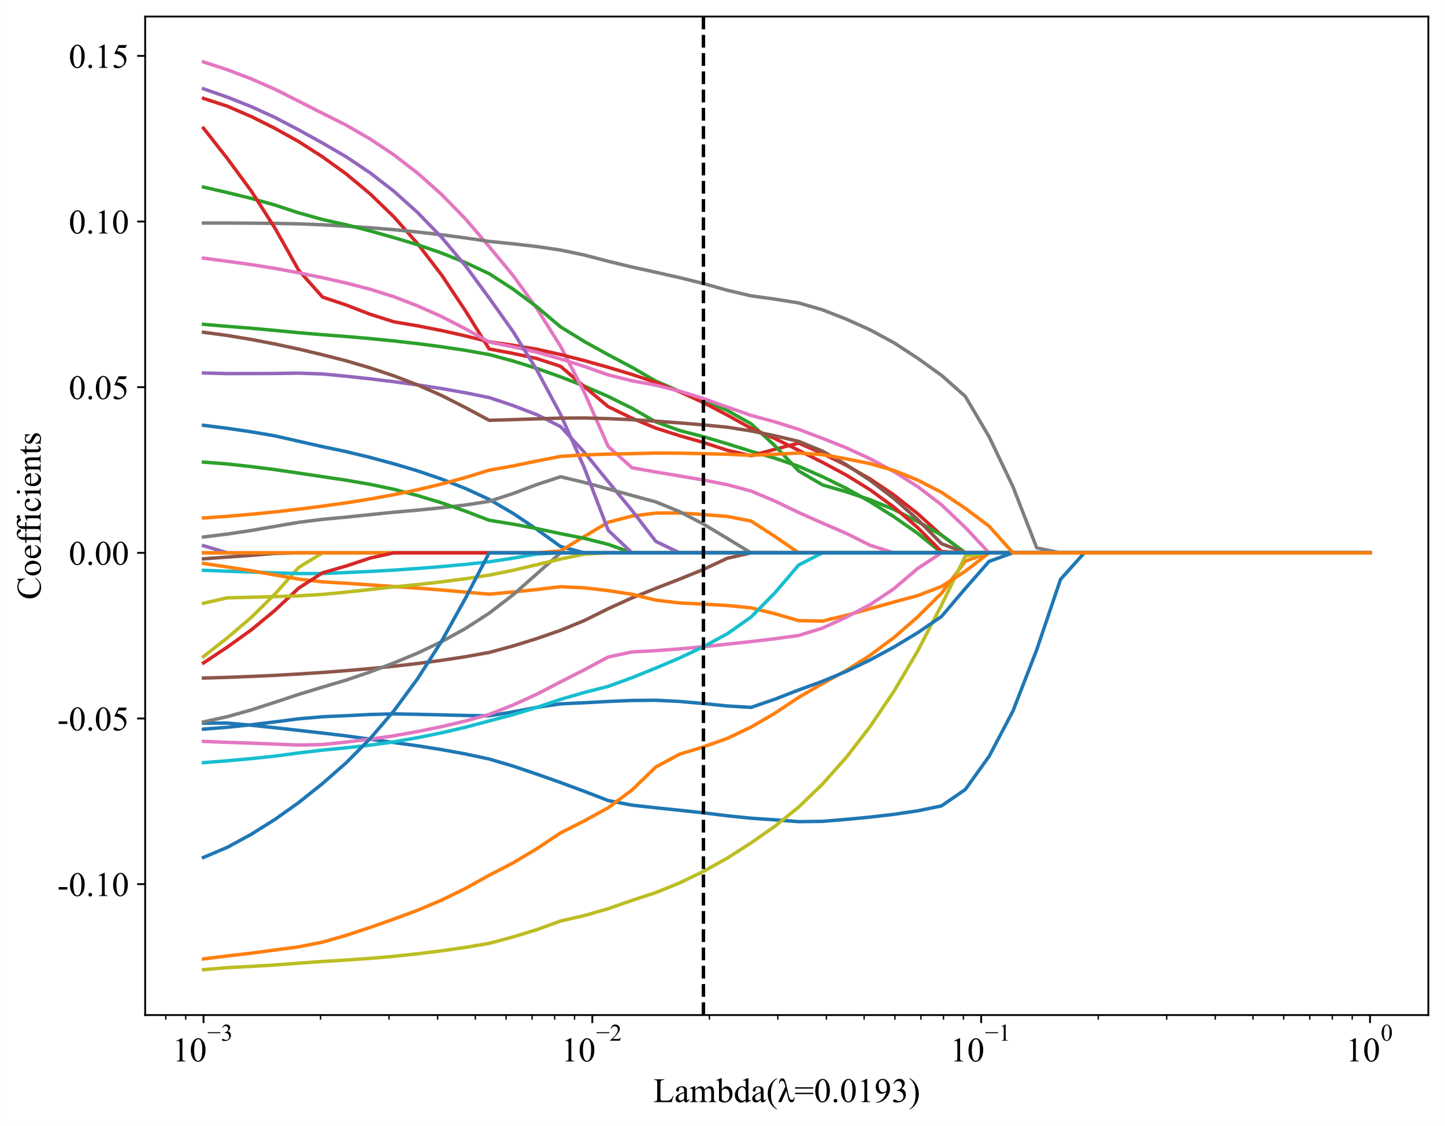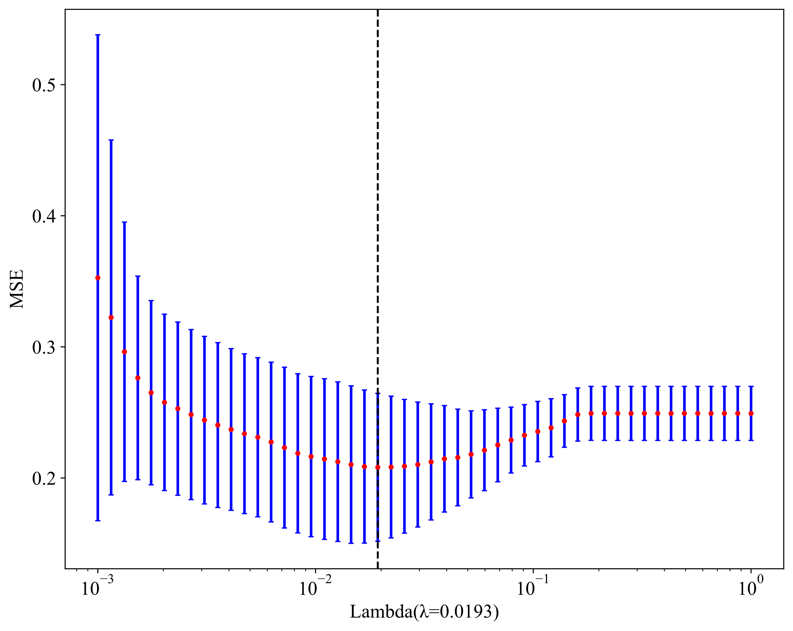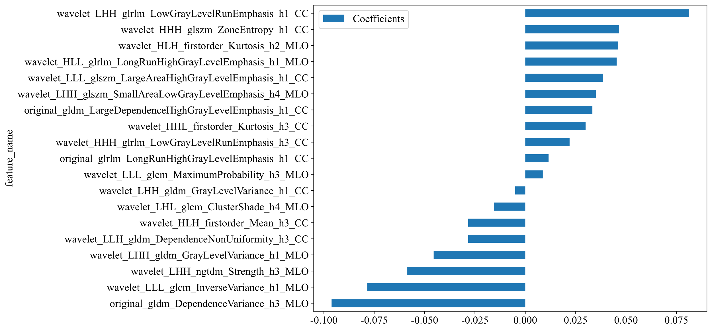
Figure S6. ROC Curves of Different Models in the Training and Testing Sets.
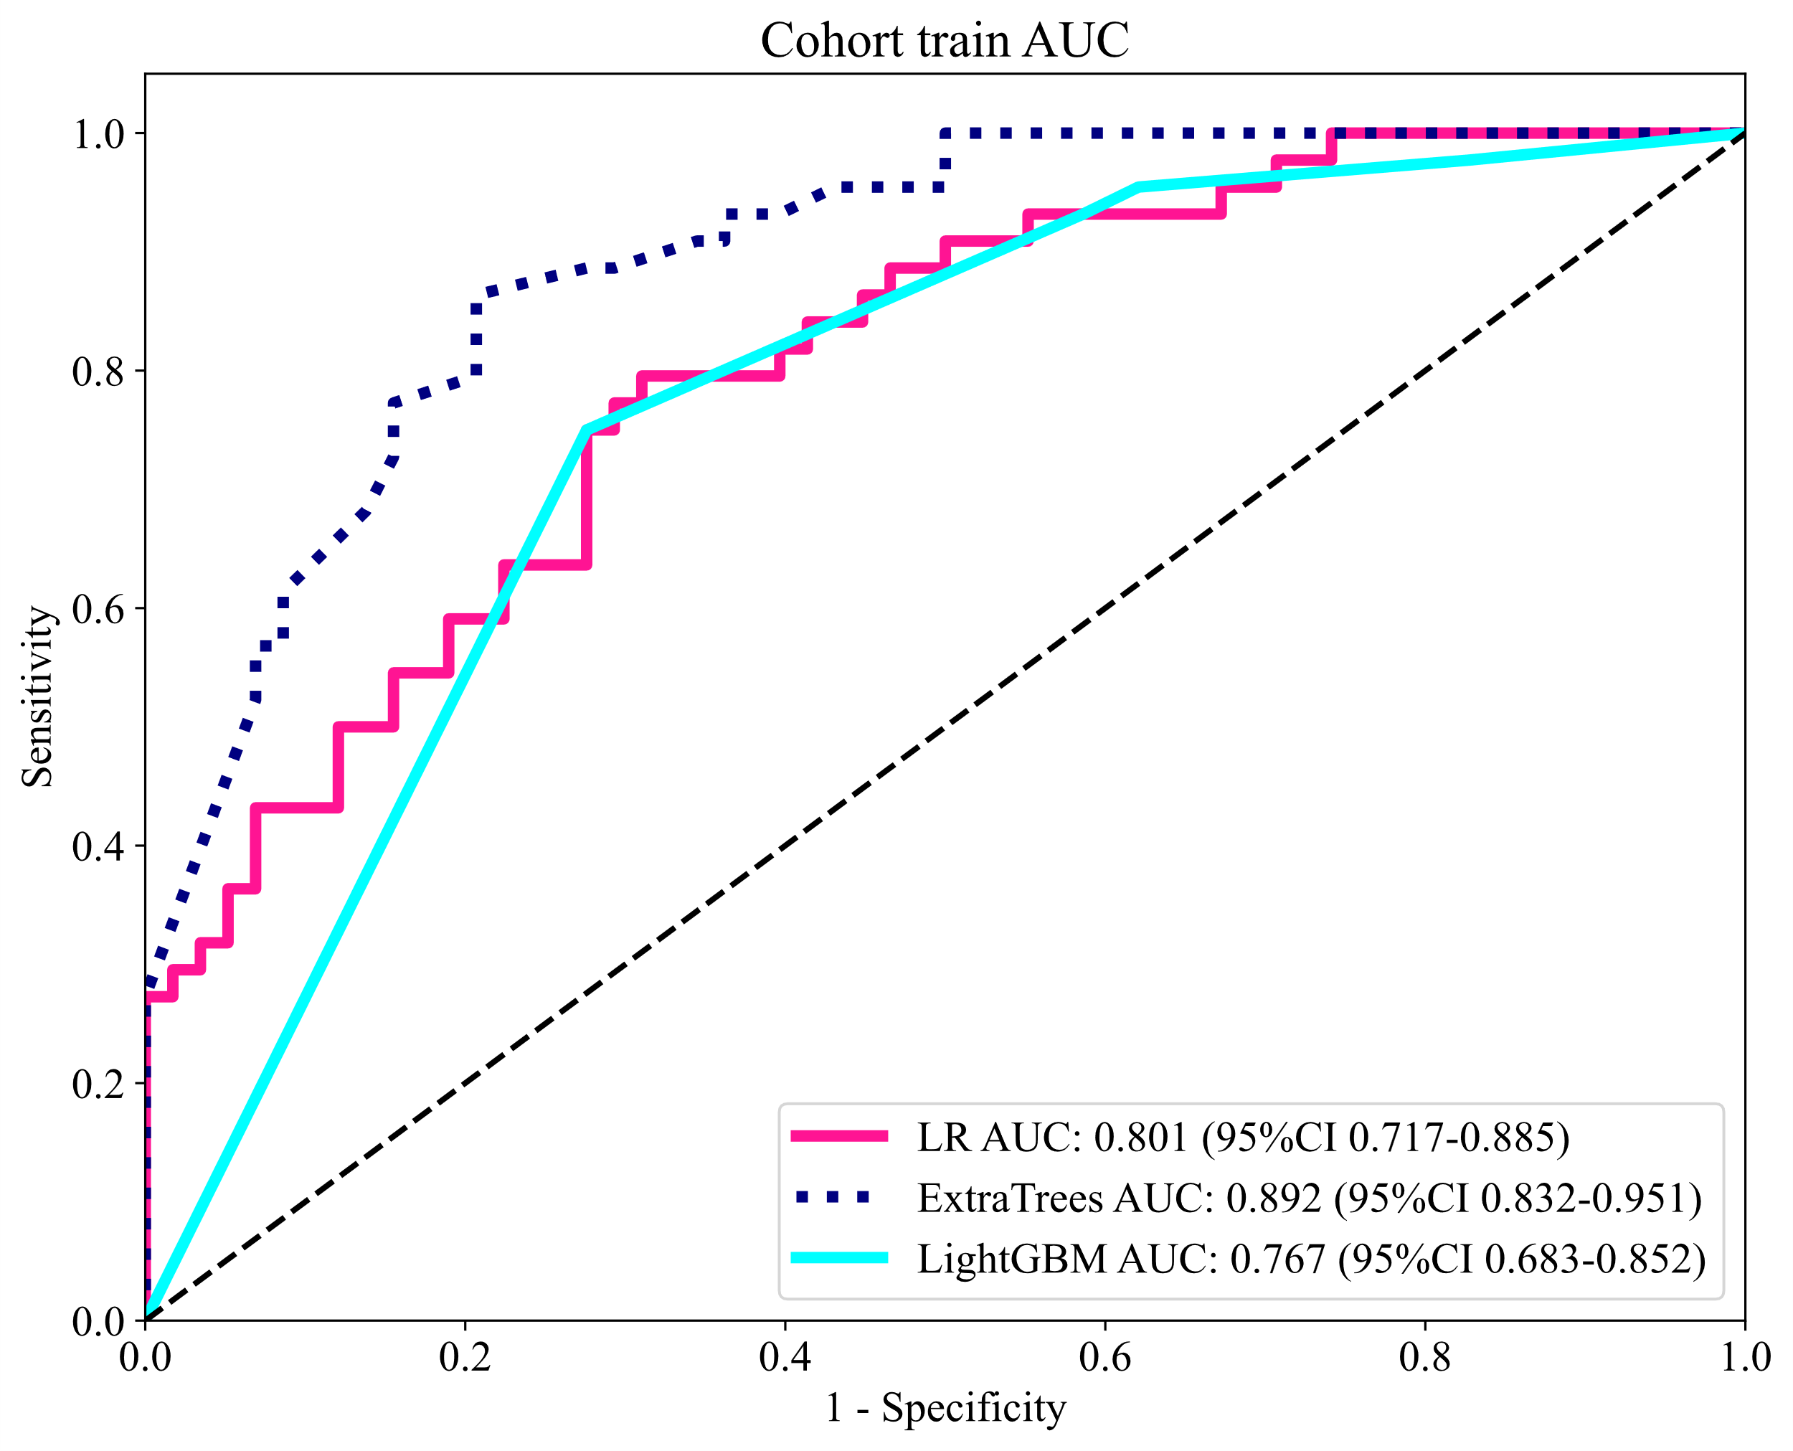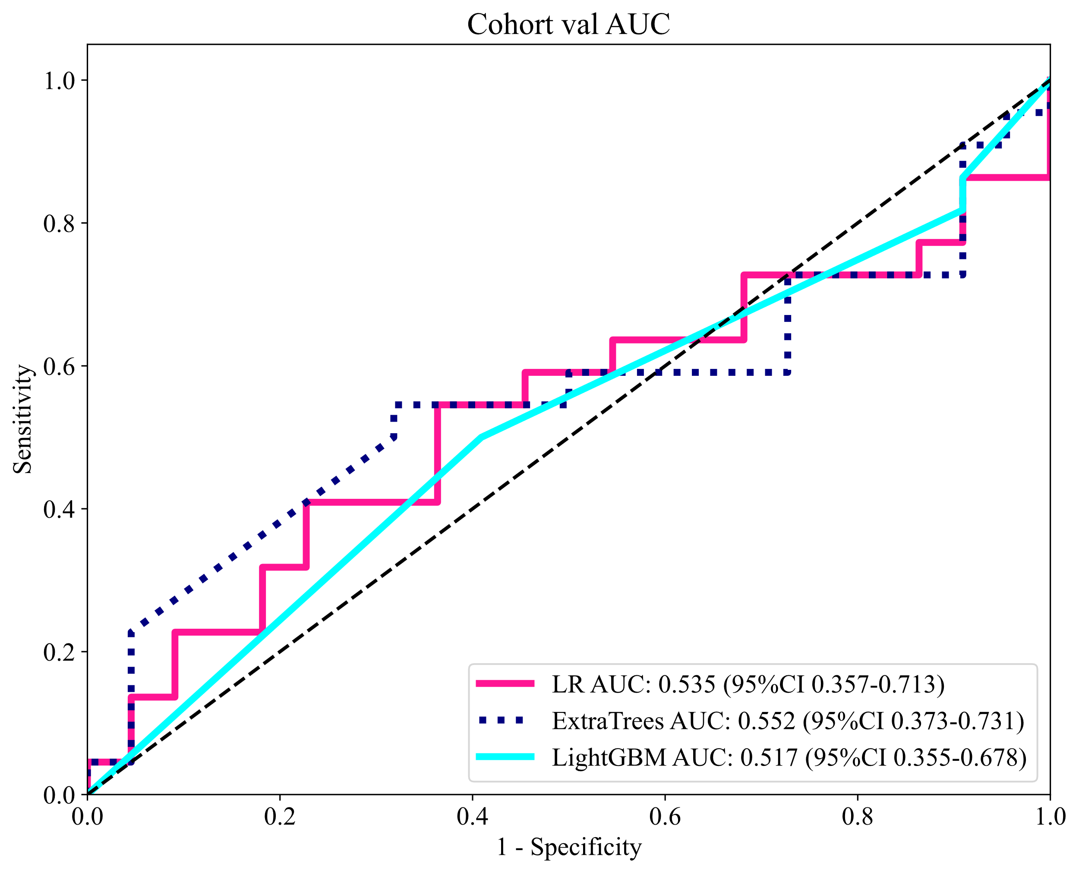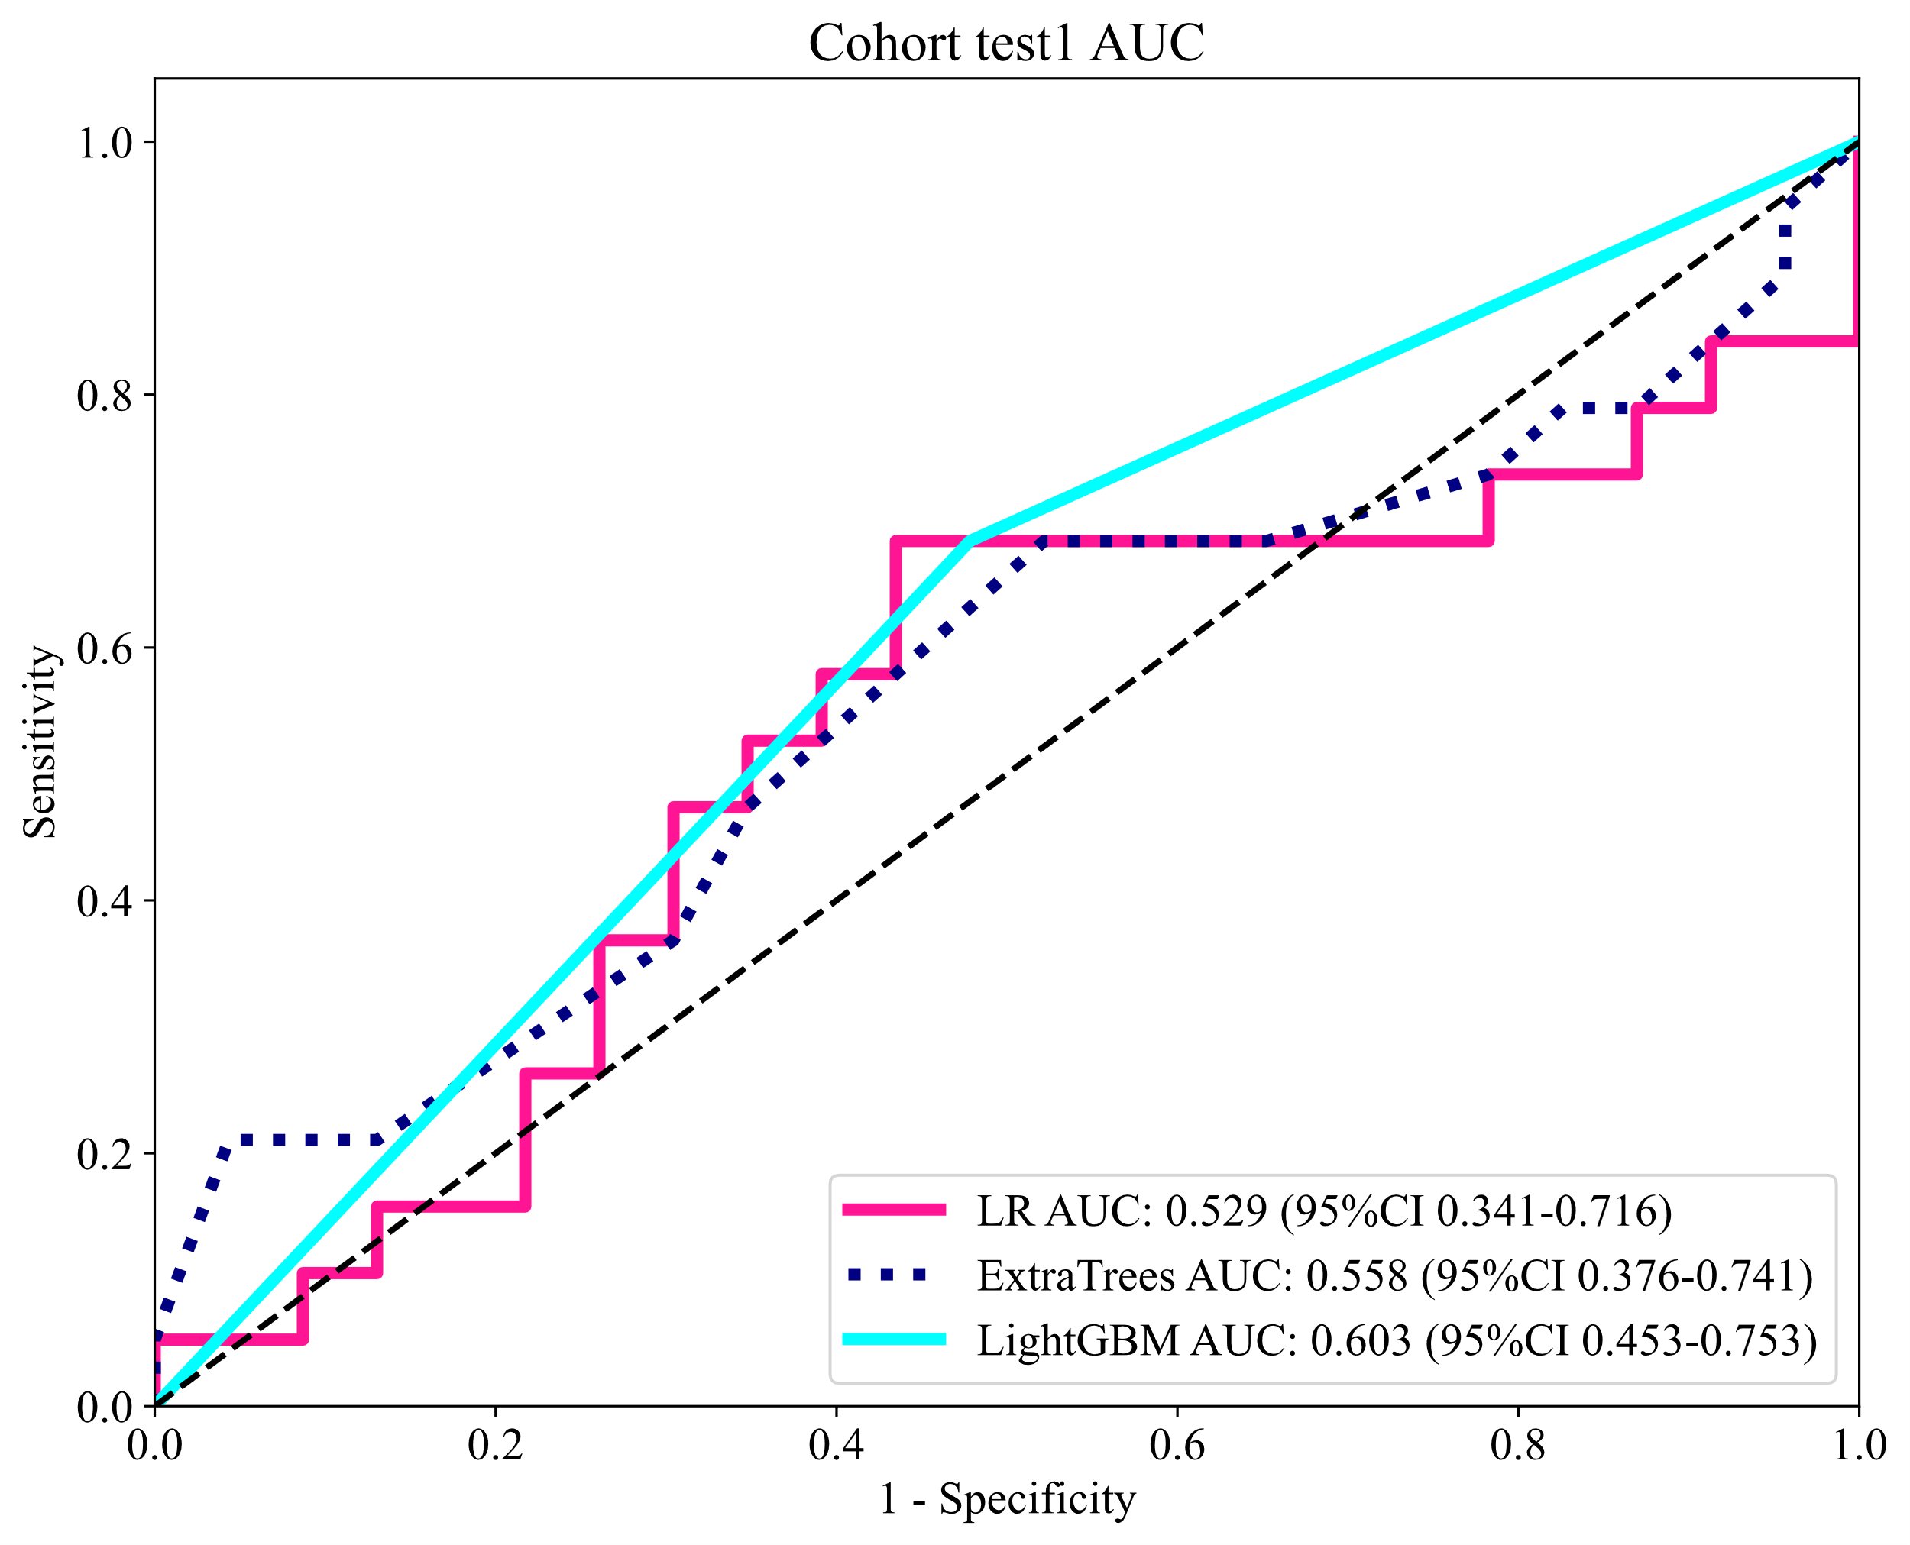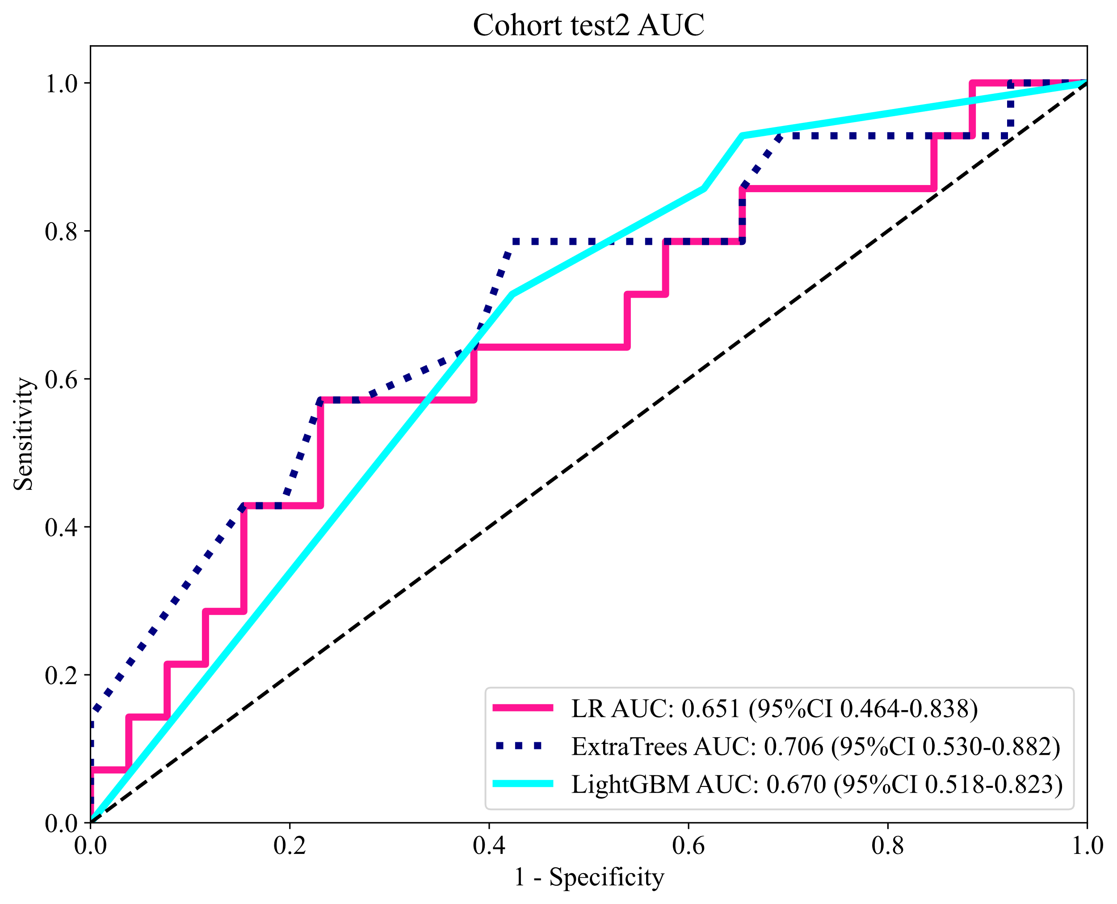

Figure S7. Different signatures' calibration curve on test cohort.
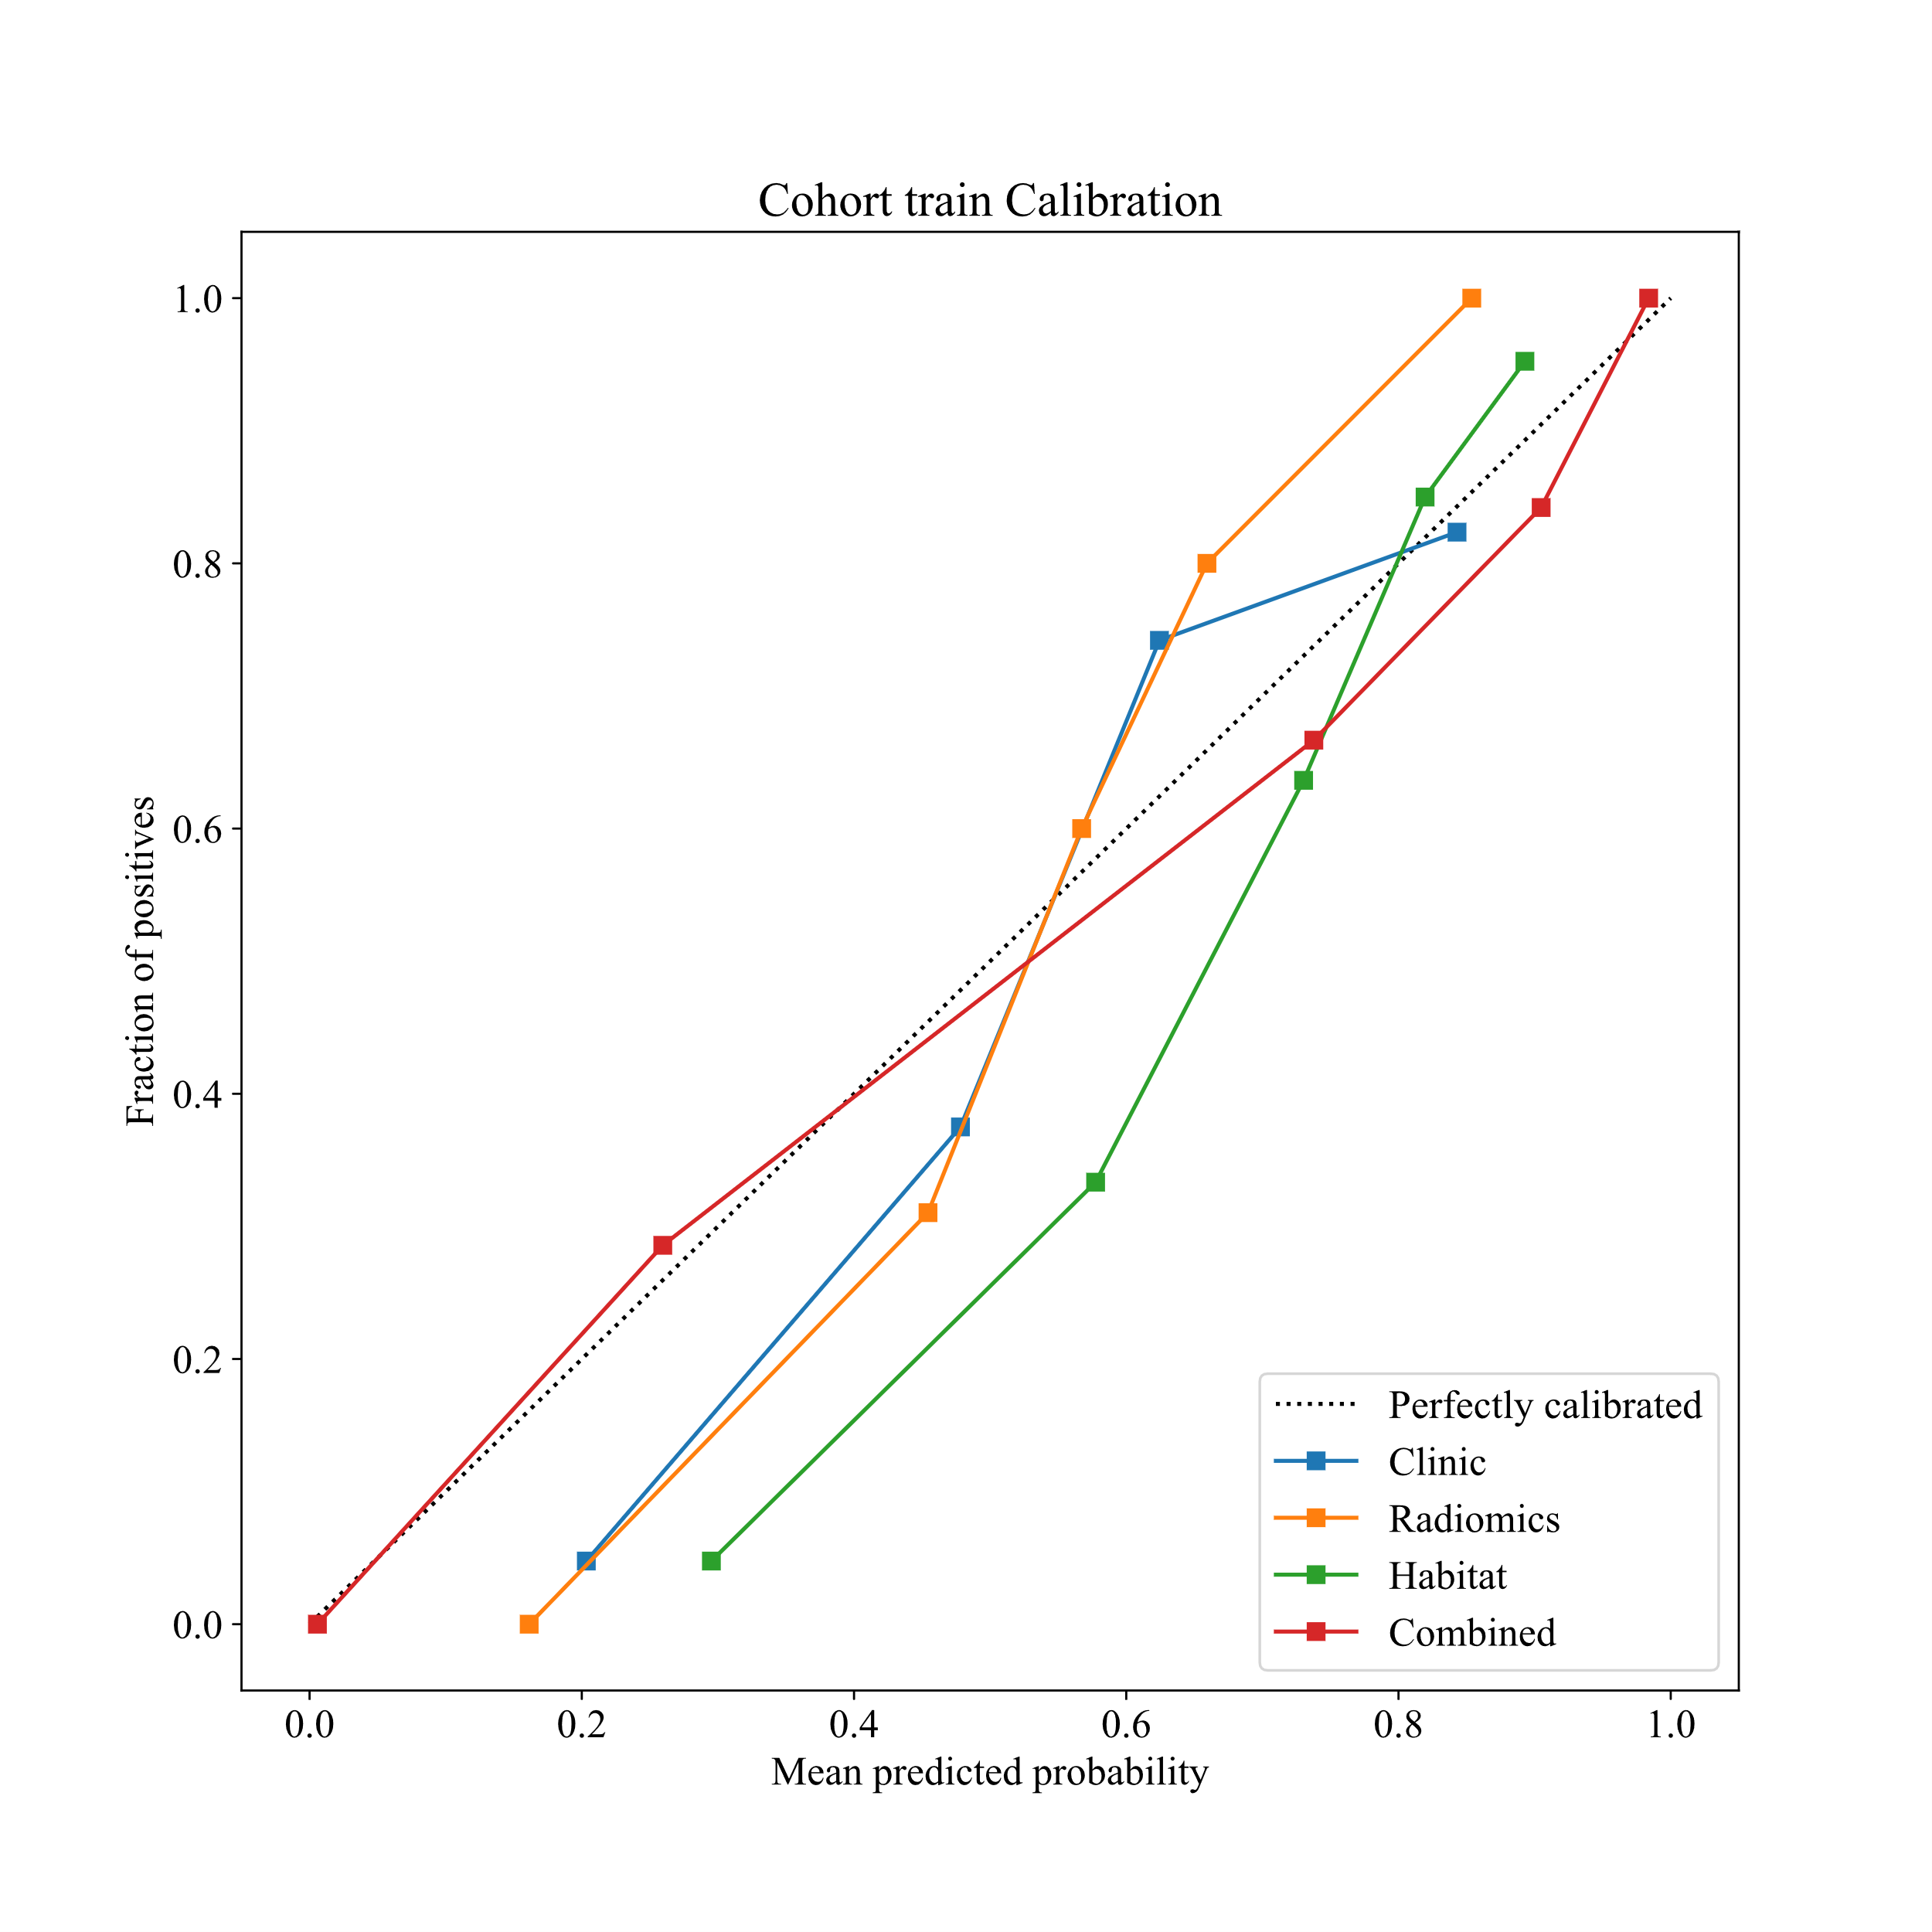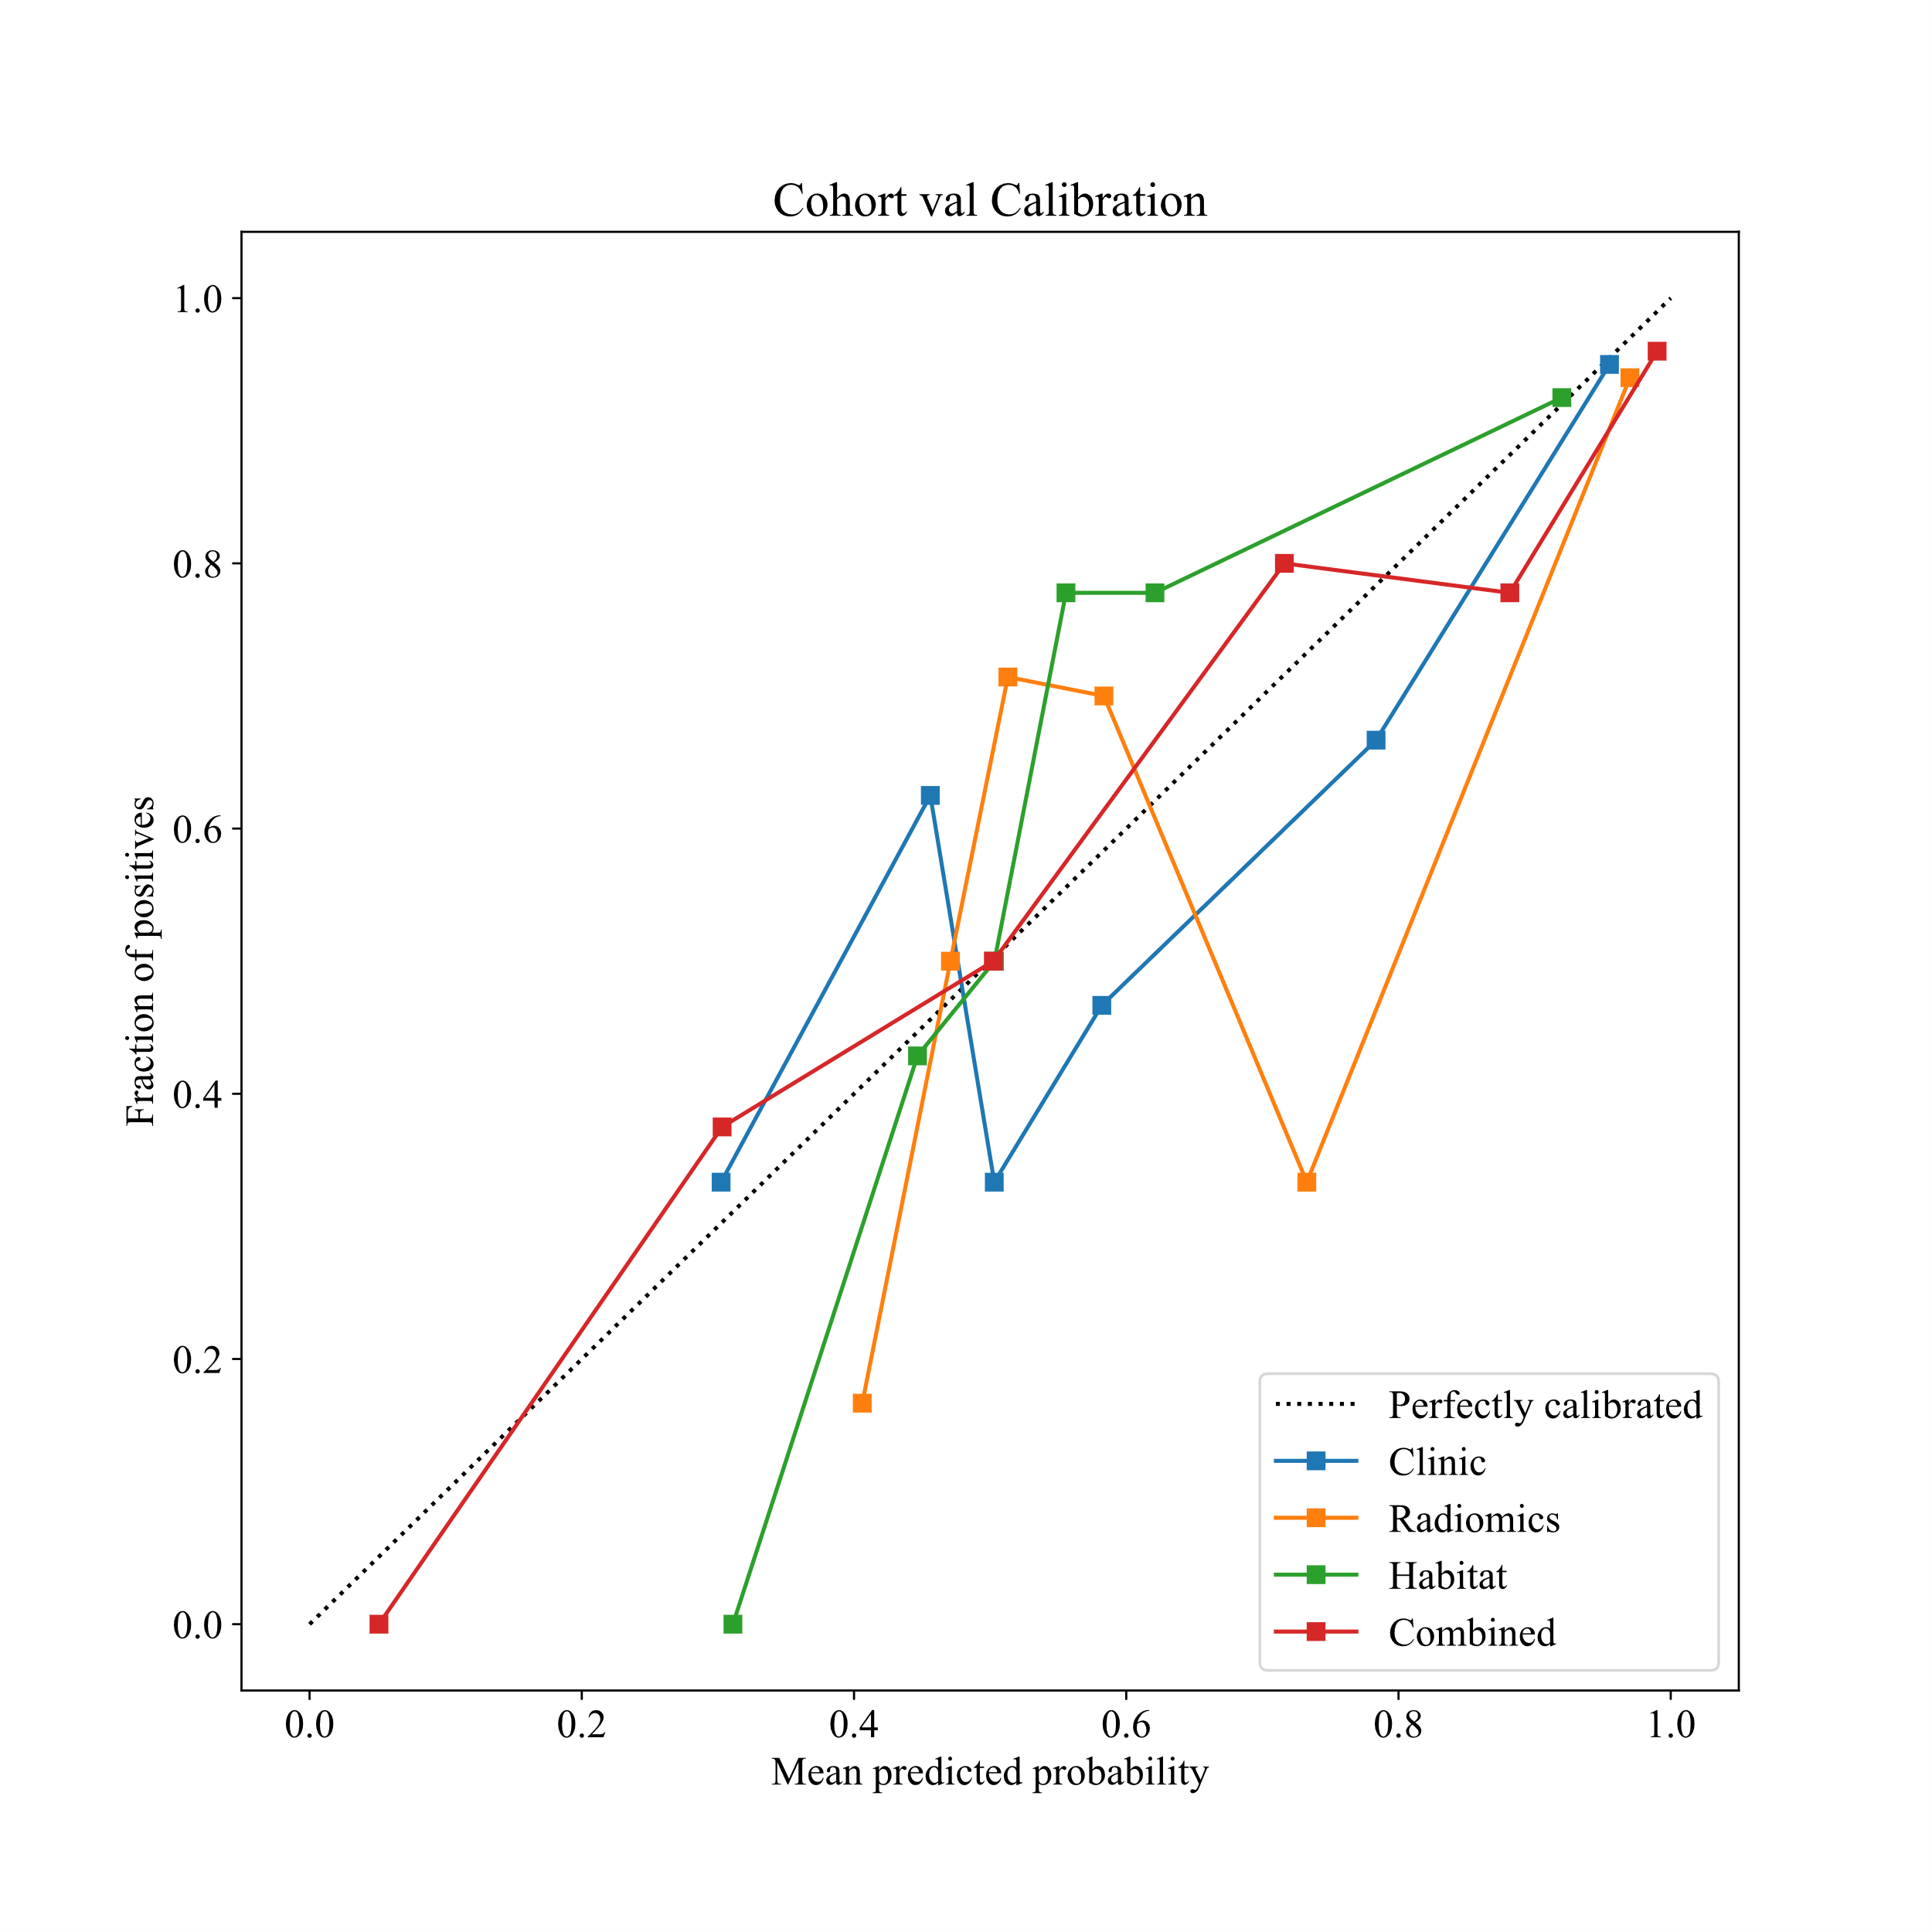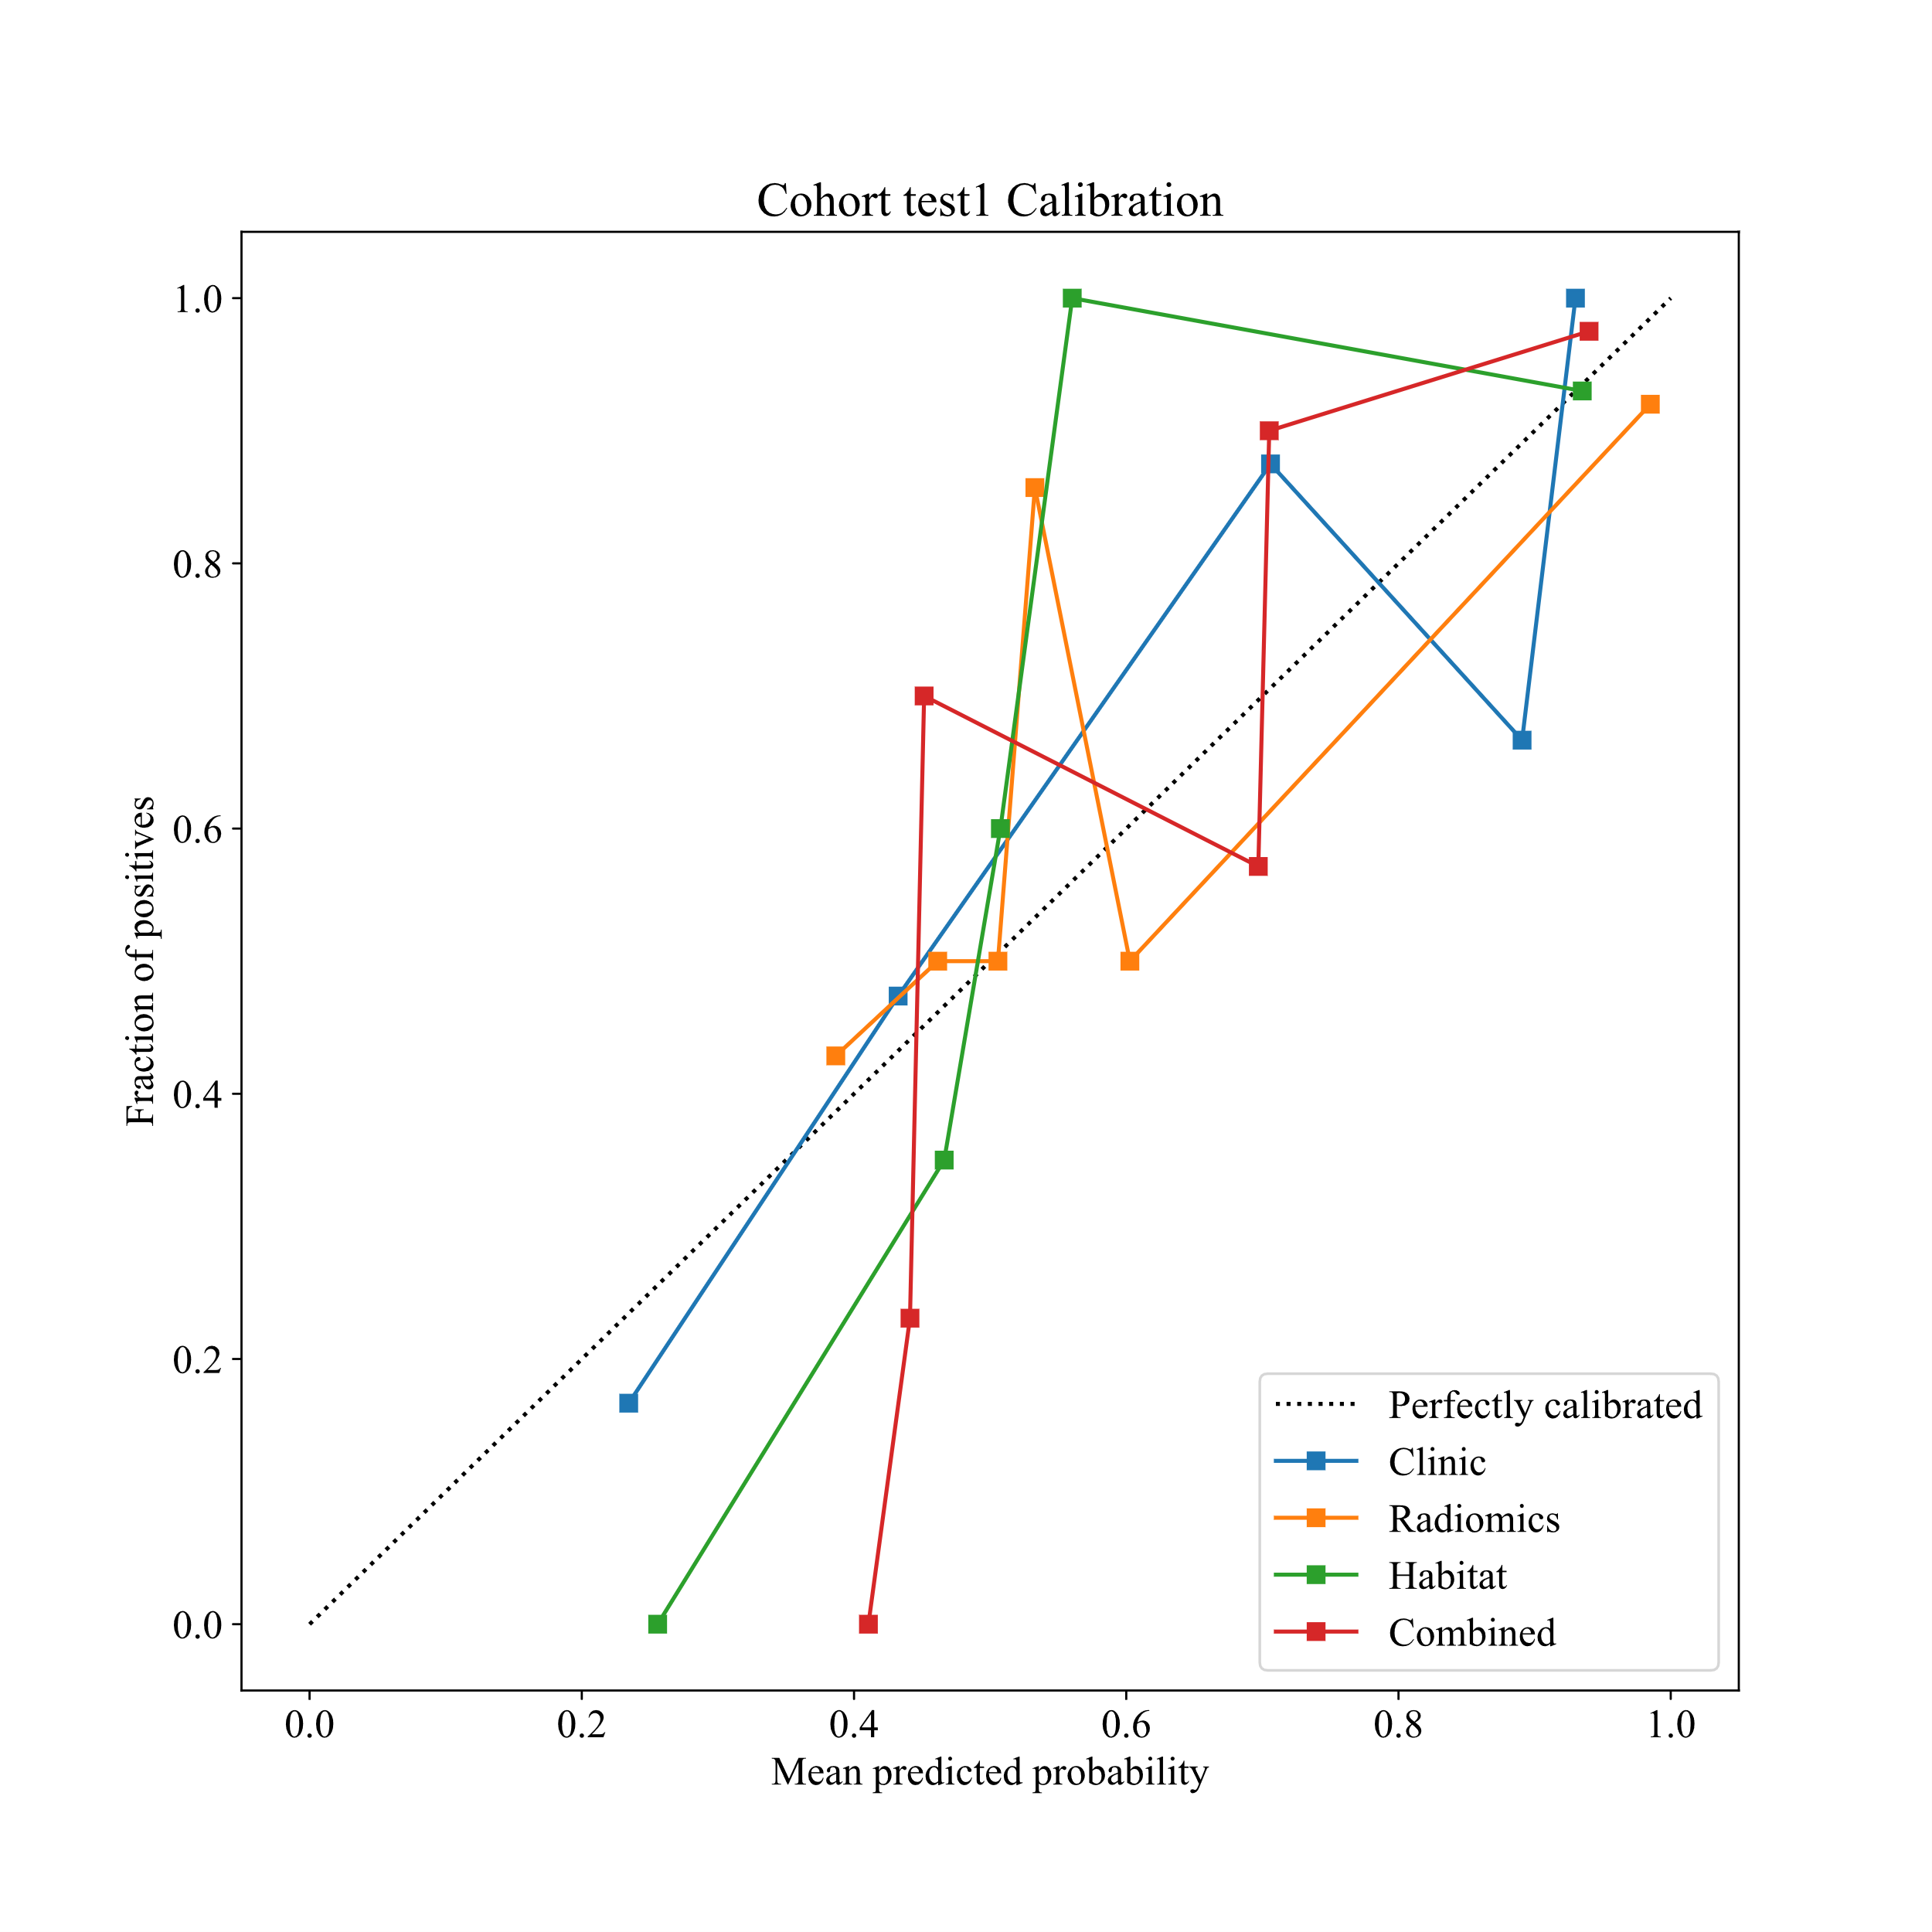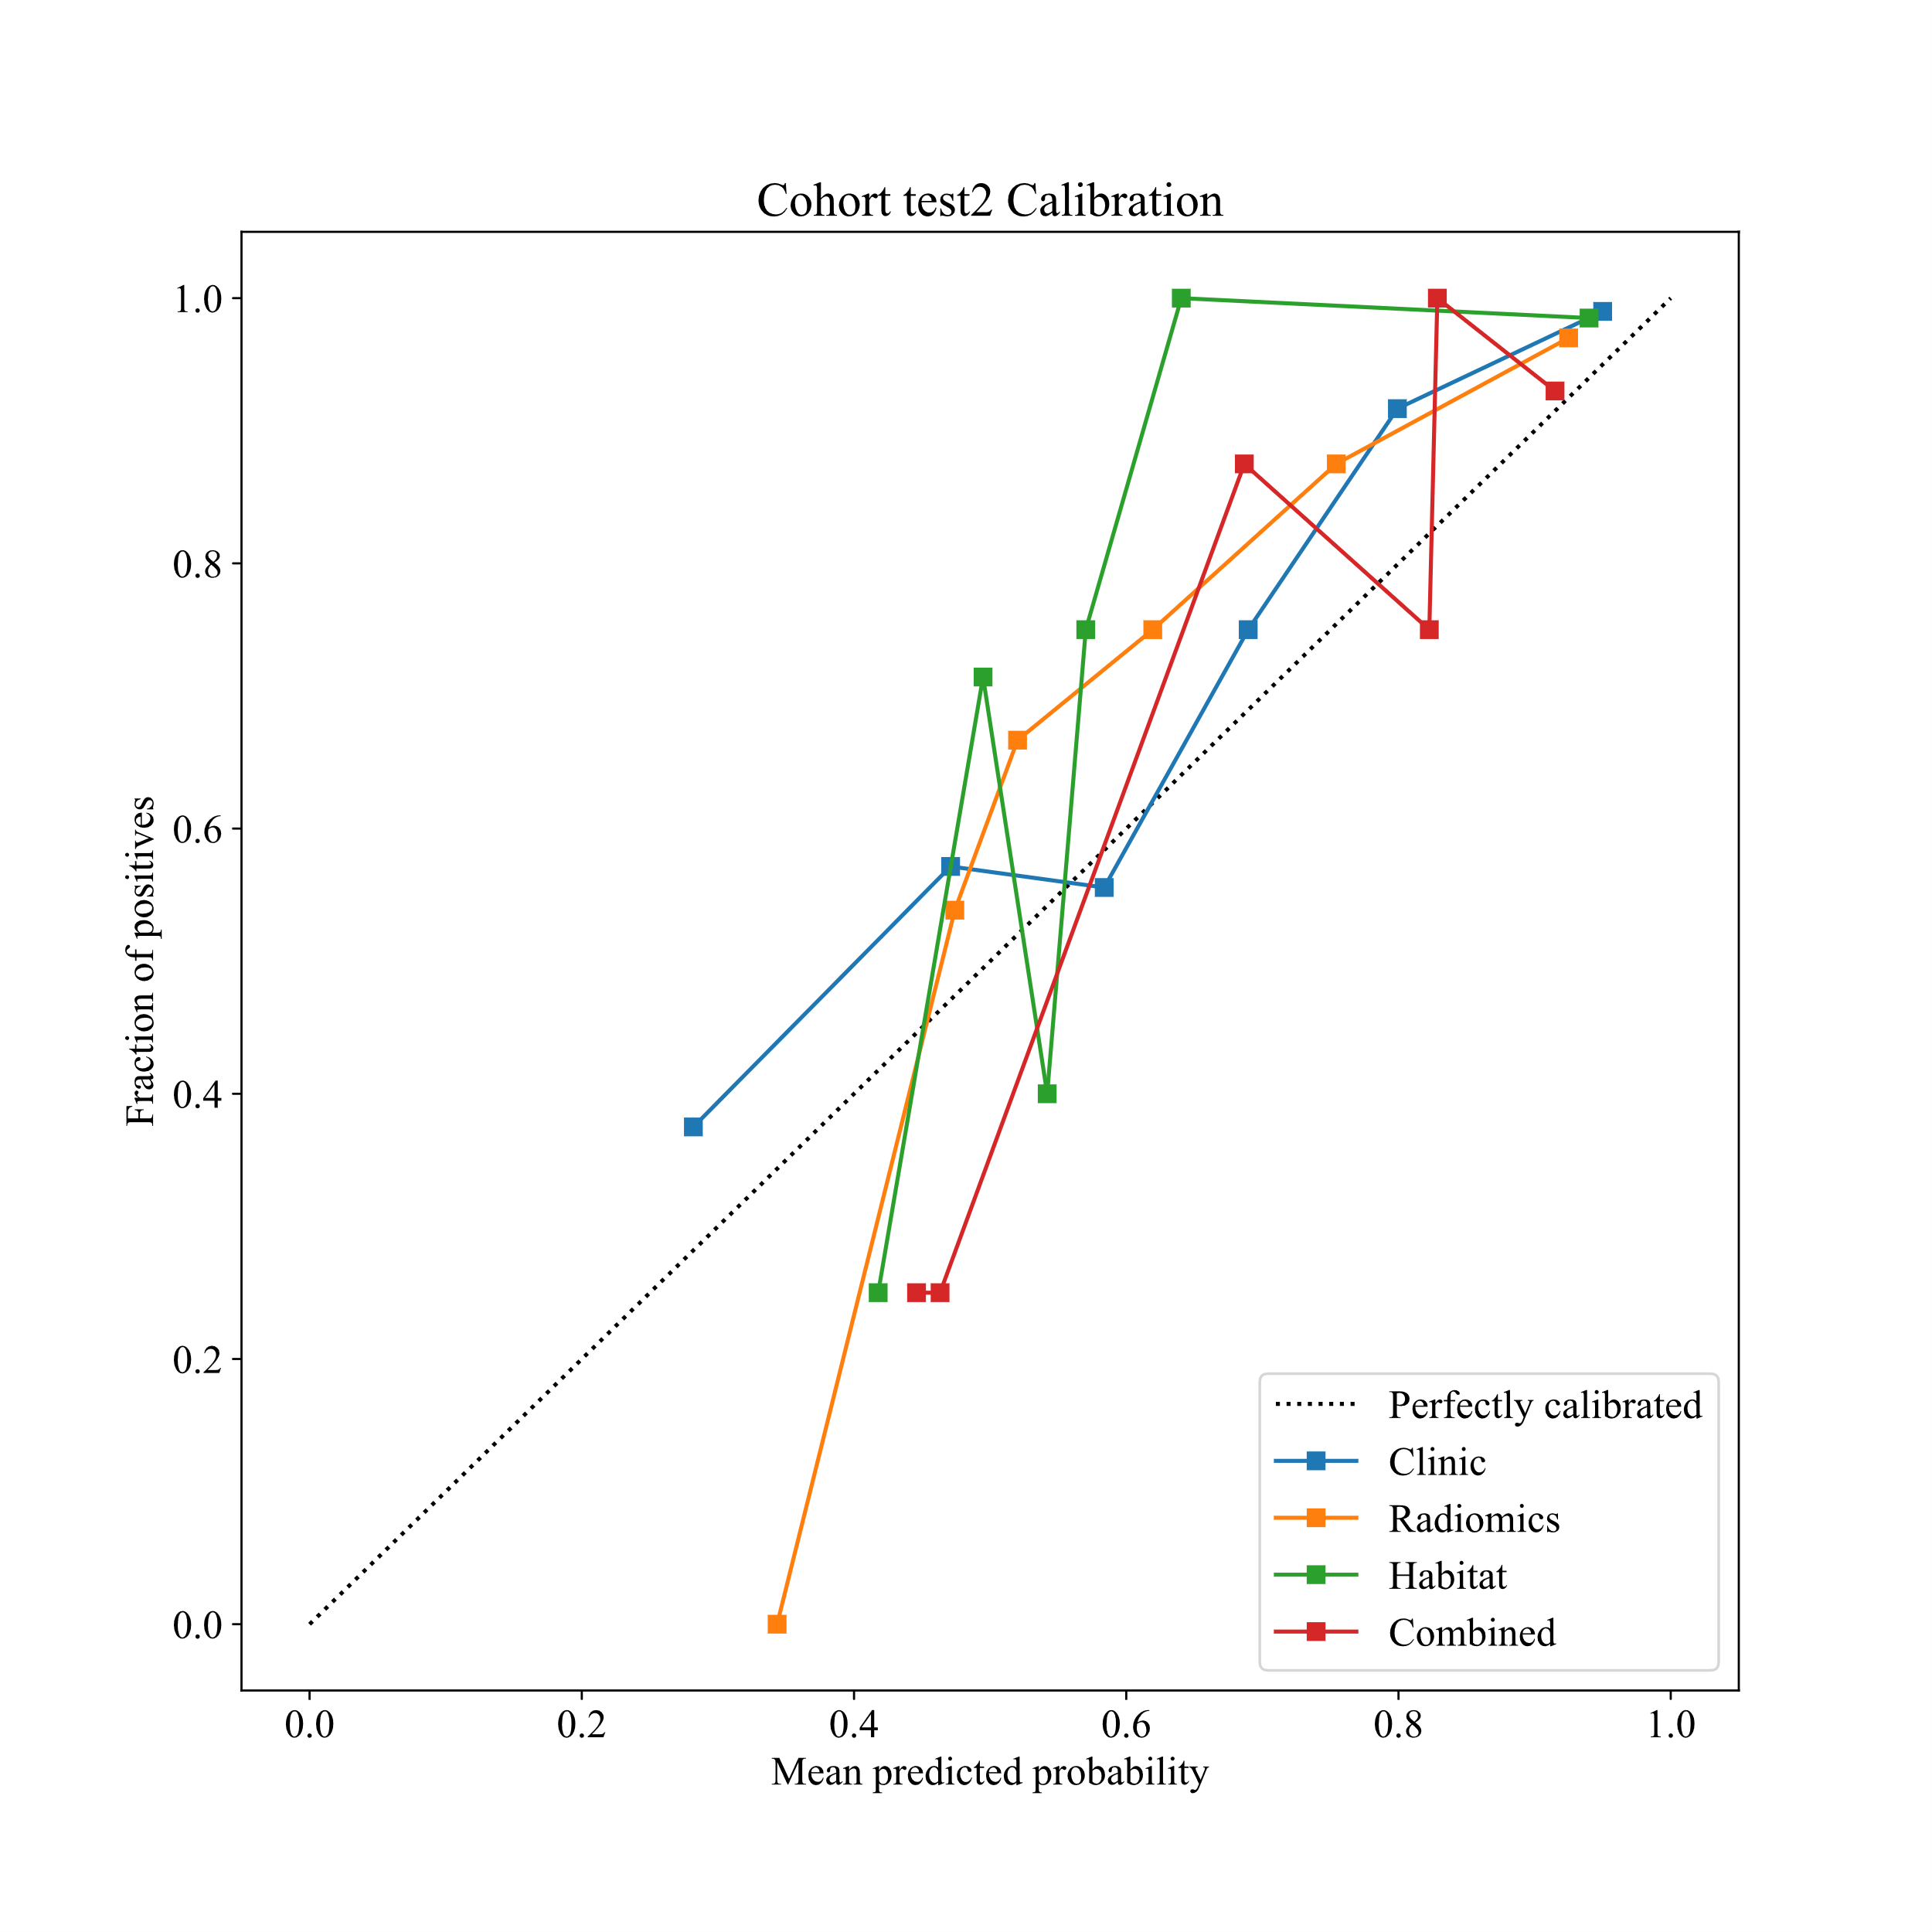
Figure S8. Delong et. al. of different signature
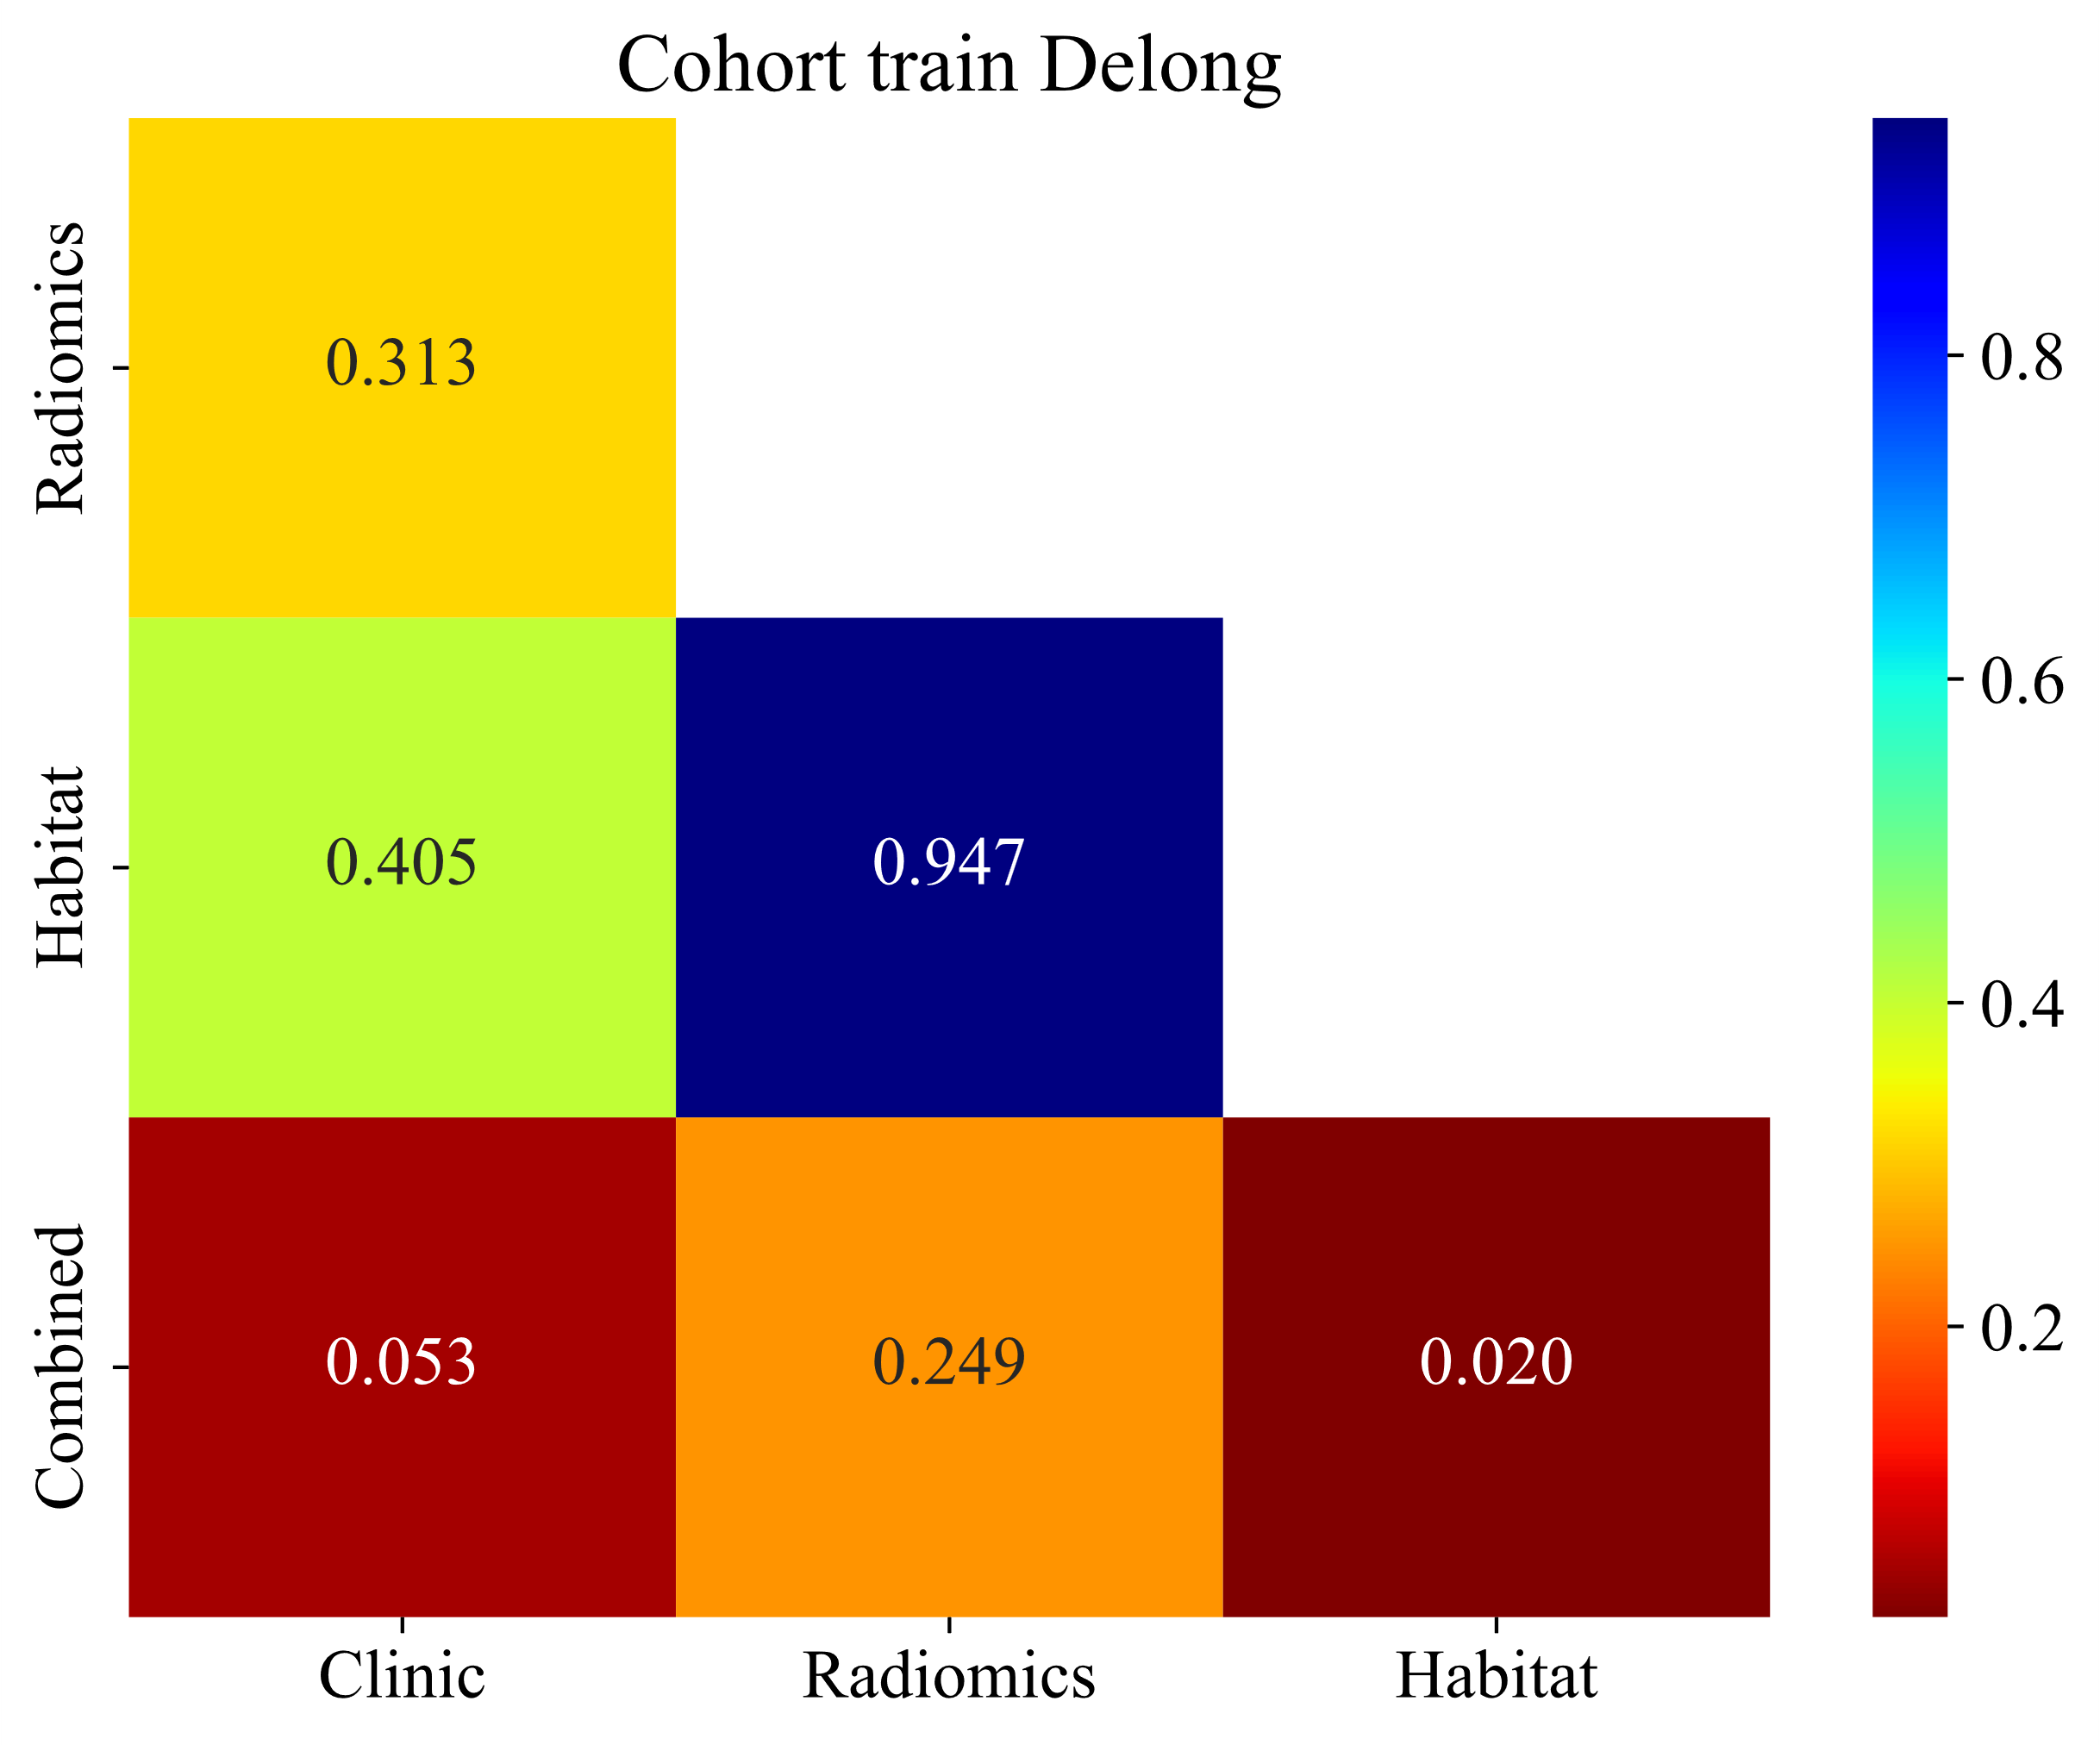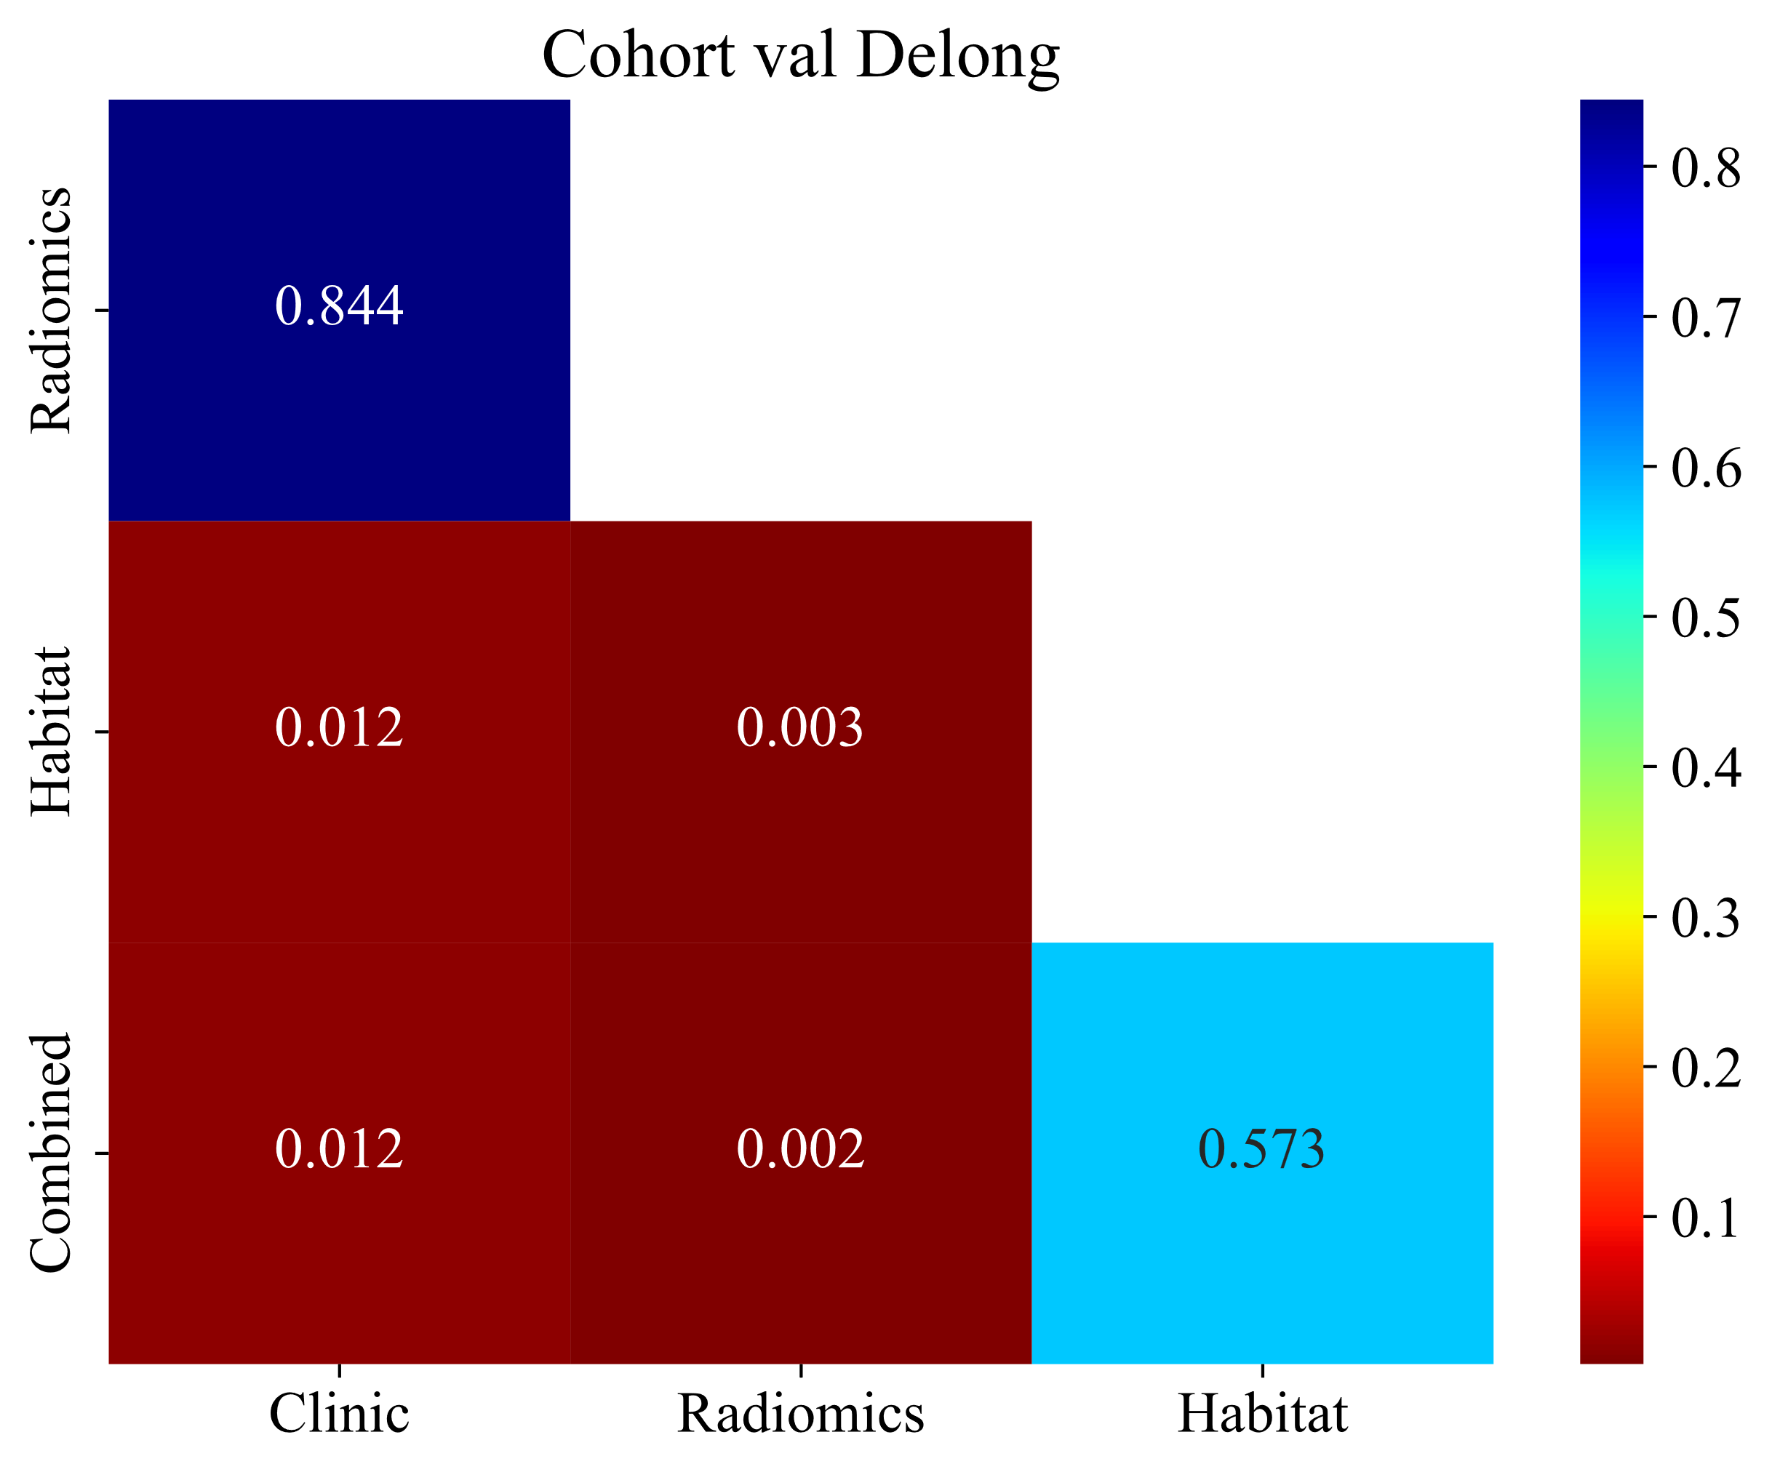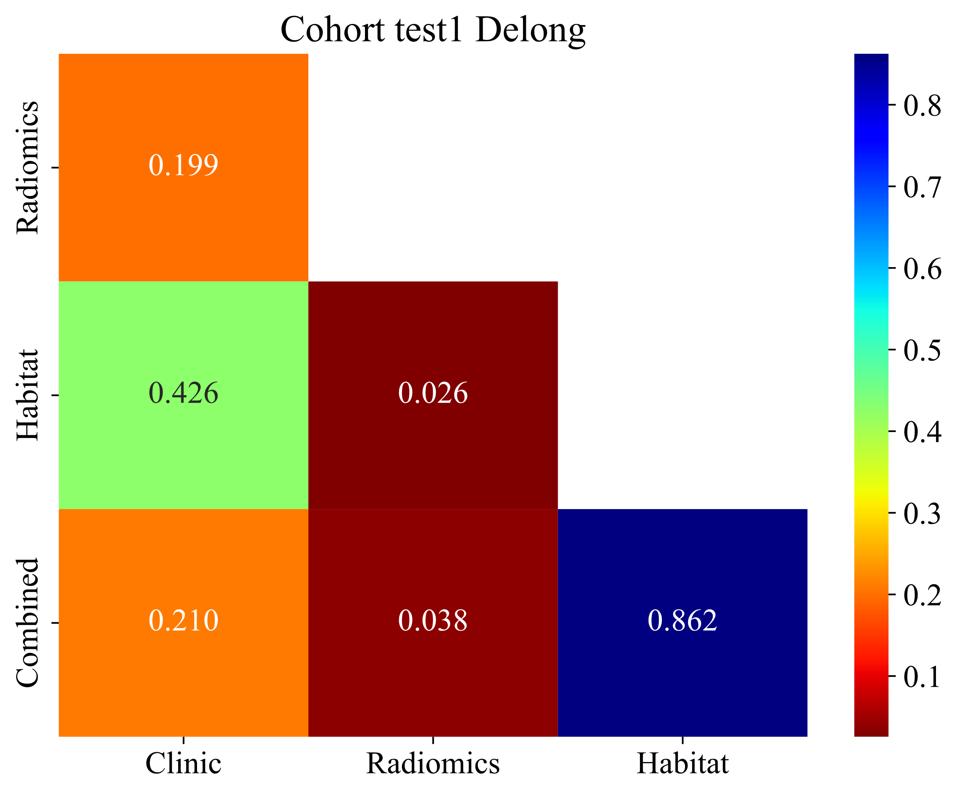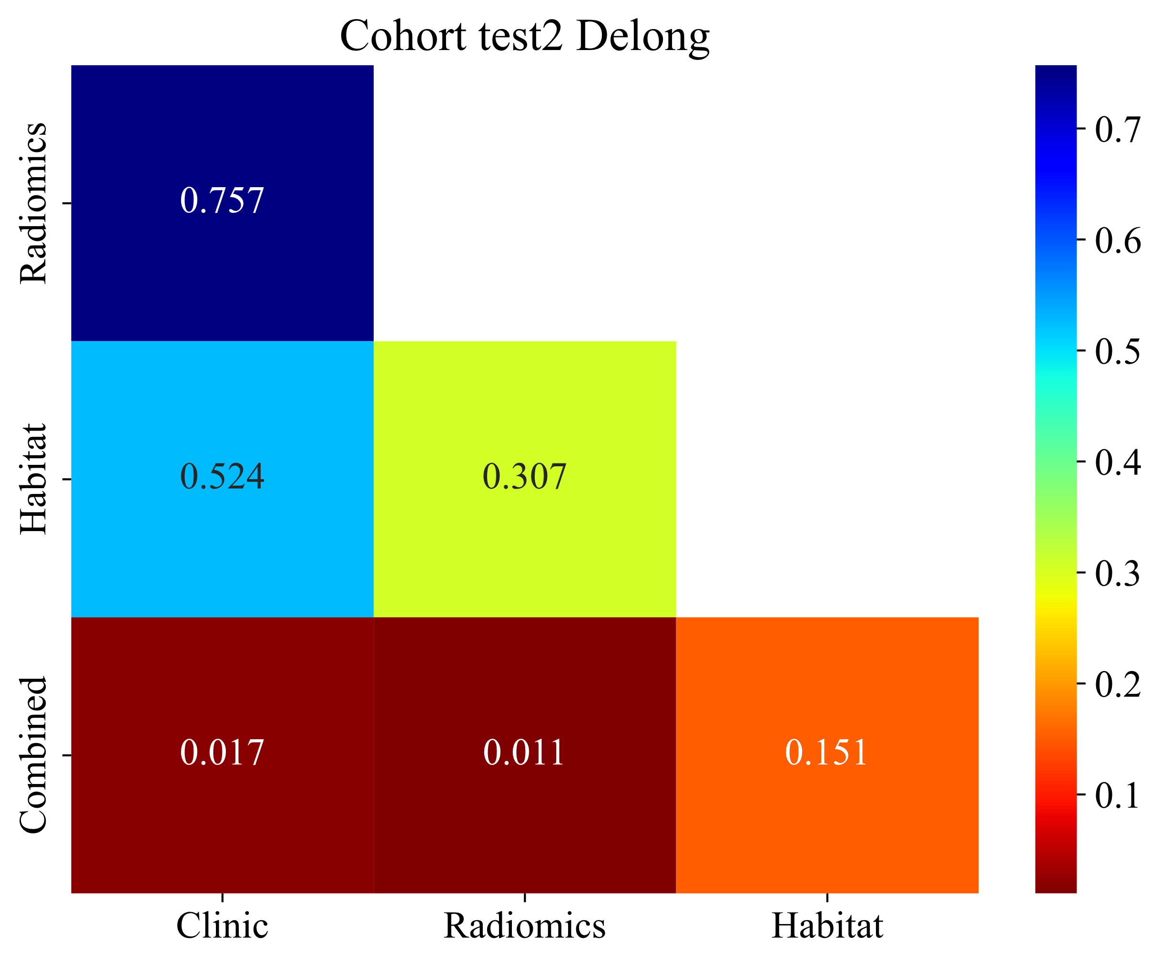
Table S2. Model Performance of Different Machine Learning Algorithms in the different cohorts.
model_name | Accuracy | AUC | 95% CI | Sensitivity | Specificity | PPV | NPV | Cohort
LR | 0.804 | 0.874 | 0.808 - 0.941 | 0.705 | 0.879 | 0.816 | 0.797 | train
LR | 0.659 | 0.649 | 0.479 - 0.818 | 0.455 | 0.864 | 0.769 | 0.613 | val
LR | 0.571 | 0.513 | 0.331 - 0.695 | 0.789 | 0.391 | 0.517 | 0.692 | test1
LR | 0.700 | 0.734 | 0.567 - 0.900 | 0.786 | 0.654 | 0.550 | 0.850 | test2
ExtraTrees | 0.824 | 0.889 | 0.824 - 0.955 | 0.773 | 0.862 | 0.810 | 0.833 | train
ExtraTrees | 0.795 | 0.822 | 0.694 - 0.950 | 0.727 | 0.864 | 0.842 | 0.760 | val
ExtraTrees | 0.738 | 0.810 | 0.690 - 0.930 | 0.789 | 0.696 | 0.682 | 0.800 | test1
ExtraTrees | 0.675 | 0.809 | 0.676 - 0.942 | 0.571 | 0.731 | 0.533 | 0.760 | test2
LightGBM | 0.853 | 0.927 | 0.879 - 0.974 | 0.818 | 0.879 | 0.837 | 0.864 | train
LightGBM | 0.682 | 0.705 | 0.545 - 0.864 | 0.545 | 0.818 | 0.750 | 0.643 | val
LightGBM | 0.619 | 0.564 | 0.385 - 0.743 | 0.158 | 1.000 | 1.000 | 0.590 | test1
LightGBM | 0.700 | 0.720 | 0.547 - 0.893 | 0.571 | 0.769 | 0.571 | 0.769 | test2
Table S3. Model Performance of Different Machine Learning Algorithms in the Training and Testing Sets.
model_name | Accuracy | AUC | 95% CI | Sensitivity | Specificity | PPV | NPV | Cohort
LR | 0.725 | 0.801 | 0.717 - 0.885 | 0.773 | 0.690 | 0.654 | 0.800 | train
LR | 0.568 | 0.535 | 0.357 - 0.713 | 0.364 | 0.773 | 0.615 | 0.548 | val
LR | 0.595 | 0.529 | 0.341 - 0.716 | 0.632 | 0.565 | 0.545 | 0.650 | test1
LR | 0.675 | 0.651 | 0.464 - 0.838 | 0.500 | 0.769 | 0.538 | 0.741 | test2
ExtraTrees | 0.814 | 0.892 | 0.832 - 0.951 | 0.841 | 0.793 | 0.755 | 0.868 | train
ExtraTrees | 0.591 | 0.552 | 0.373 - 0.731 | 0.500 | 0.682 | 0.611 | 0.577 | val
ExtraTrees | 0.571 | 0.558 | 0.376 - 0.741 | 0.053 | 1.000 | 1.000 | 0.561 | test1
ExtraTrees | 0.625 | 0.706 | 0.530 - 0.882 | 0.643 | 0.615 | 0.474 | 0.762 | test2
LightGBM | 0.569 | 0.767 | 0.683 - 0.852 | 0.000 | 1.000 | 0.000 | 0.569 | train
LightGBM | 0.500 | 0.517 | 0.355 - 0.678 | 0.000 | 1.000 | 0.000 | 0.500 | val
LightGBM | 0.548 | 0.603 | 0.453 - 0.753 | 0.000 | 1.000 | 0.000 | 0.548 | test1
LightGBM | 0.650 | 0.670 | 0.518 - 0.823 | 0.000 | 1.000 | 0.000 | 0.650 | test2

Table S4. prediction performance of different signatures
Signature | Accuracy | AUC | 95% CI | Sensitivity | Specificity | PPV | NPV | Cohort
Clinic | 0.706 | 0.842 | 0.7652 - 0.9198 | 0.586 | 0.864 | 0.850 | 0.613 | train
Radiomics | 0.794 | 0.892 | 0.8322 - 0.9511 | 0.724 | 0.886 | 0.894 | 0.709 | train
Habitat | 0.814 | 0.889 | 0.8235 - 0.9547 | 0.810 | 0.818 | 0.855 | 0.766 | train
Combined | 0.853 | 0.931 | 0.8851 - 0.9761 | 0.845 | 0.864 | 0.891 | 0.809 | train
Clinic | 0.568 | 0.572 | 0.4002 - 0.7444 | 0.273 | 0.864 | 0.667 | 0.543 | val
Radiomics | 0.545 | 0.552 | 0.3725 - 0.7308 | 0.545 | 0.545 | 0.545 | 0.545 | val
Habitat | 0.795 | 0.822 | 0.6945 - 0.9502 | 0.818 | 0.773 | 0.783 | 0.810 | val
Combined | 0.795 | 0.831 | 0.7038 - 0.9573 | 0.773 | 0.818 | 0.810 | 0.783 | val
Clinic | 0.714 | 0.727 | 0.5648 - 0.8883 | 0.652 | 0.789 | 0.789 | 0.652 | test1
Radiomics | 0.571 | 0.557 | 0.3743 - 0.7401 | 0.870 | 0.211 | 0.571 | 0.571 | test1
Habitat | 0.714 | 0.810 | 0.6902 - 0.9299 | 0.478 | 1.000 | 1.000 | 0.613 | test1
Combined | 0.786 | 0.822 | 0.6949 - 0.9482 | 0.783 | 0.789 | 0.818 | 0.750 | test1
Clinic | 0.650 | 0.740 | 0.5855 - 0.8953 | 0.538 | 0.857 | 0.875 | 0.500 | test2
Radiomics | 0.625 | 0.706 | 0.5302 - 0.8819 | 0.538 | 0.786 | 0.824 | 0.478 | test2
Habitat | 0.700 | 0.809 | 0.6759 - 0.9422 | 0.654 | 0.786 | 0.850 | 0.550 | test2
Combined | 0.825 | 0.907 | 0.8159 - 0.9973 | 0.808 | 0.857 | 0.913 | 0.706 | test2

Table S5. DeLong test comparisons of AUC between different models.

Cohort | Comparison | p value
Internal validation (val) | Clinic vs. Radiomics | 0.012
 | Clinic vs. Habitat | 0.012
 | Clinic vs. Combined | 0.012
 | Radiomics vs. Habitat | 0.026
 | Radiomics vs. Combined | 0.249
 | Habitat vs. Combined | 0.573
Test1 | Clinic vs. Radiomics | 0.313
 | Clinic vs. Habitat | 0.253
 | Clinic vs. Combined | 0.210
 | Radiomics vs. Habitat | 0.249
 | Radiomics vs. Combined | 0.038
 | Habitat vs. Combined | 0.862
Test2 | Clinic vs. Radiomics | 0.524
 | Clinic vs. Habitat | 0.524
 | Clinic vs. Combined | 0.017
 | Radiomics vs. Habitat | 0.038
 | Radiomics vs. Combined | 0.011
 | Habitat vs. Combined | 0.151

Imaging Protocols for Different Datasets

1. Training Cohort (Dade Road Headquarters) - Italy IMS Giotto System
Mammography Imaging Protocol (IMS Giotto)
Equipment & Environment
- Model: IMS Giotto Class (Italy)
- Detector: Amorphous selenium direct digital flat panel, 70 µm pixel size, 3328 × 4096 matrix
- Target-filter: Tungsten (W)/Rhodium (Rh); optional Mo/Mo or Mo/Rh for specific cases
- Tube voltage: 28 kVp (AEC automatic, manual range 26–32 kVp)
- AEC mode: Semi-automatic; Mean Glandular Dose (MGD) 1.0–1.3 mGy at 53 mm standard breast thickness (below NHSBSP limit of 2.5 mGy)
Projection Views
- Standard views: Bilateral Craniocaudal (CC) + Bilateral Mediolateral Oblique (MLO)
- Supplementary views: Magnification, Exaggerated Mediolateral Oblique (XCCL), or Cleopatra view (tangential) as needed
Compression & Dose
- Force: 120–180 N (auto-pressure control, maximized to patient tolerance)
- Thickness: Recorded actual value (mm)
- Dose output: MGD automatically calculated and stored in DICOM header
Post-processing & Storage
- Software: Raffaello (built-in IMS)
- Algorithm: Spectral Contrast Enhancement (SCE) + noise reduction
- Storage: Lossless JPEG-LS compression, 16-bit grayscale
- Quality control: Daily ACR phantom test; weekly repeatability, linearity, and Contrast-to-Noise Ratio (CNR) checks

2. Ersha Branch - Hologic Selenia Dimensions System
Equipment & System
- Model: Hologic Selenia Dimensions
- Detector: Amorphous selenium (a-Se) direct digital flat panel, 70 µm pixel size, 2560 × 3328 or 3328 × 4096 matrix
- Target-filter: Tungsten (W) + 50 µm Rh (2D standard); W + 50 µm Ag + 700 µm Al (3D Tomosynthesis)
- Focus-detector distance: 700 mm; Focus-table distance: 675 mm
Projection Views
- Standard views: Bilateral CC + Bilateral MLO
- Compression paddle: Standard flat or optional curved paddle
Exposure Parameters (AEC Automatic)
- kVp: 28 kVp (AEC automatic; manual range 26–32 kVp)
- Pre-exposure mAs: 5 mAs for ≤50 mm thickness; 10 mAs for >50 mm thickness
- Compression force: 120–180 N (SmartCurve auto-compression, patient-tolerance maximized)
- Thickness: Real-time recording (mm)
Dose & Image Quality
- Mean Glandular Dose (MGD): ≤0.78 mGy for 60 mm equivalent breast (3Dimensions)
- HVL & Output: Validated per NHSBSP/EUREF QC protocols every 3 kV interval
Post-processing & Display
- Software: C-View (synthetic 2D) or Standard 2D
- Processing: Contrast enhancement (SCE), noise reduction, gradient equalization
- Viewing: SecurView® DX workstation, 5 MP grayscale dual monitors, one-click hanging protocol

3. External Validation (Guangzhou First People’s Hospital) - Finland Planmed Oy System
Equipment & Detector
- Model: Planmed Nuance™ Excel (Finland)
- Detector: 24 × 31 cm amorphous selenium (a-Se) direct digital flat panel, 70 µm pixel size, 3328 × 4096 matrix
- Gantry: Side-Access design, auto-rotation ±180°, focus-detector distance 66 cm
Target-filter & Exposure Parameters
- Target: Tungsten (W)
- Filter: Rhodium (Rh) default; switchable to W/Ag for dense breasts
- Tube voltage: 28 kVp (Flex-AEC automatic); manual range 26–32 kVp
- AEC: Flex-AEC auto-selects mAs based on thickness/density; manual 20–120 mAs adjustable
- Focus: Dual 0.1/0.3 mm; small focus (0.1 mm) for magnification
- Compression: 120–180 N; auto-stop at force-image quality balance (smart mode)
Projection Views
- Standard views: Bilateral CC + MLO
- Supplementary views:
  - Magnification (×1.5 or ×1.8, 0.1 mm small focus)
  - Exaggerated Mediolateral (XCML), Exaggerated Mediolateral Oblique (XCCL)
  - ATAN tangential view (skin calcification localization)
Post-processing & Storage
- Software: Planmed ClearView™ with SCE and noise reduction
- Default window: Width 1.8, Level 1.2 (adjustable at workstation)
- Archive: 16-bit lossless + 12-bit compressed DICOM, IHE-Mammo compliant
Dose & QC
- Mean Glandular Dose (MGD): ≤1.2 mGy for 4 cm PMMA phantom; complies with EUREF/NHSBSP limits
- QC procedures: Daily ACR phantom; weekly repeatability, linearity, CNR checks; semi-annual HVL testing

