Supplementary Table 1 Patient-derived questions used to inform the DA content and how they were addressed in the final DA
 | Question | Keyword | Category | How it was addressed in the DA
KCR website | What are the symptoms? | Clinical manifestations | 05. Rheumatoid arthritis: diagnosis and treatment | Included in the disease information section
KCR website | What is the rate of disease progression? | Pathogenesis | 05. Rheumatoid arthritis: diagnosis and treatment | Included in the disease information section
KCR website | How does the disease progress? | Clinical manifestations | 05. Rheumatoid arthritis: diagnosis and treatment | Included in the disease information section
KCR website | How is it treated? | Principles of treatment | 05. Rheumatoid arthritis: diagnosis and treatment | Included in the treatment planning section
KCR website | How long does injectable treatment last? | Principles of treatment | 05. Rheumatoid arthritis: diagnosis and treatment | Included in the treatment planning section
Patient education room | How is it administered? | Oral or injectable | 10. Treatment decision options (bDMARDs and tsDMARDs)  - Route of administration | Included in the treatment options materials
Patient education room | Is storage complicated? | Storage method | 10. Treatment decision options (bDMARDs and tsDMARDs)  - Storage | Included in the treatment options materials
Patient education room | Which drug is most effective? | Effectiveness comparison | 10. Treatment decision options (bDMARDs and tsDMARDs)  -Drug efficacy | Included in the treatment options materials
Patient education room | When was it approved and first used? | Time of use and approval | 10. Treatment decision options (bDMARDs and tsDMARDs)  - Approval timeline | Included in the treatment options materials
Patient education room | Which drug is the safest? | Side effects | 10. Treatment decision options (bDMARDs and tsDMARDs)  - Safety | Included in the treatment options materials
Patient education room | Does it hurt? | Injection pain* |  | Not incorporated into the DA; instead addressed during individual counselling
Patient education room | Do I need frequent hospital visits? | Visit interval | 10. Treatment decision options (bDMARDs and tsDMARDs)  - Follow-up visits | Included in the treatment options materials
Patient education room | What adverse effects may occur? | Side effects | 10. Treatment decision options (bDMARDs and tsDMARDs)  - Major adverse effects | Included in the treatment options materials
Patient education room | Can it be used during pregnancy and breastfeeding? | Pregnancy and breastfeeding | 10. Treatment decision options (bDMARDs and tsDMARDs)  - Pregnancy | Included in the treatment options materials
Patient education room | Why are tests required before starting treatment? | Pre-treatment check | 10. Treatment decision options (bDMARDs and tsDMARDs)  - Pre-treatment testing | Included in the treatment options materials
Patient education room | When is the evaluation performed? | Evaluation | 10. Treatment decision options (bDMARDs and tsDMARDs)  - Insurance evaluation | Included in the treatment options materials
Patient education room | Which is the cheapest option? | Price* |  | Not incorporated into the DA; instead addressed during individual counselling
* Explained verbally during patient education
DA, decision aid; KCR, Korean College of Rheumatology; bDMARDs, biologic disease-modifying antirheumatic drugs; tsDMARDs, targeted synthetic disease-modifying antirheumatic drugs

Supplementary Table 2 Preliminary test: feedback and resolutions
Expert | Item | Feedback and resolution
Expert A | Structure | Recommended a separate section to ensure adherence to the IPDAS process→ Restructuring completed.
Expert A | Content | Advised a comprehensive review from the user perspective→ Content adjusted accordingly and readability confirmed through patient feedback.
Expert A | Pictograms and figures | Suggested including actual drug images→ Drug photographs added.
Expert A | Additional remarks | Emphasised detailed explanations in the extended version to strengthen understanding of decision-making and emphasised readability→ Overall flow and wording revised.
Expert B | Structure | Flow and content were appropriate→ no changes required.
Expert B | Content | Evidence-based explanations were reasonable; recommended highlighting drug names to improve readability→ Drug names highlighted.
Expert B | Pictograms and figures | Noted that side-effect pictograms were missing→ Side-effect pictograms added.
Expert B | Additional remarks | Recommended supplementary materials for treatment options (leaflet or instructional video) and inclusion of drug cost information→ Supplementary explanatory text developed.
Expert C | Structure | Flow was good; medical terminology may need clarification→ No structural changes required.
Expert C | Content | Recommended a larger font size for drug names→ Font size increased and drug names highlighted.
Expert C | Pictograms and figures | Recommended a larger font size for drug names→ Font size increased and drug names highlighted.
Expert C | Additional remarks | Also suggested explanatory materials for treatment options→ Supplementary explanatory text prepared.

Supplementary Table 3 Usability and satisfaction questionnaire for the decision aid
Domain |  | Question
Usability evaluation (Likert scale, 1 = strongly disagree to 5 = strongly agree) |  | Was the amount of information sufficient?
 |  | Was the information clear?
 |  | Were the font size, colours, and images appropriate for reading and understanding?
 |  | Did the included graphs, tables, and figures aid understanding?
 |  | After using the decision aid, did you feel more confident selecting a treatment option?
 |  | Would this tool be helpful to use with your healthcare provider during a clinical visit?
 |  | Would you recommend this decision aid to other patients with rheumatoid arthritis?
Opinions on the decision aid | Information | Which information did you find most useful?
Opinions on the decision aid | Additional information | Did you want any additional information to be included?
Opinions on the decision aid | Design | Do the font size, colours, or images require further improvement? If yes, please specify.
Opinions on the decision aid | Content | After using the decision aid, did it help you choose a treatment option?
Opinions on the decision aid | Usefulness outpatient clinic | Would the decision aid be useful in routine clinical practice? If yes, please explain.
Opinions on the decision aid | Usability | Please provide overall opinions and suggestions for improving the decision aid.
Opinions on the decision aid | Satisfaction | Overall, were you satisfied with the decision aid?

Supplementary Figure 1 Abridged educational materials of RA
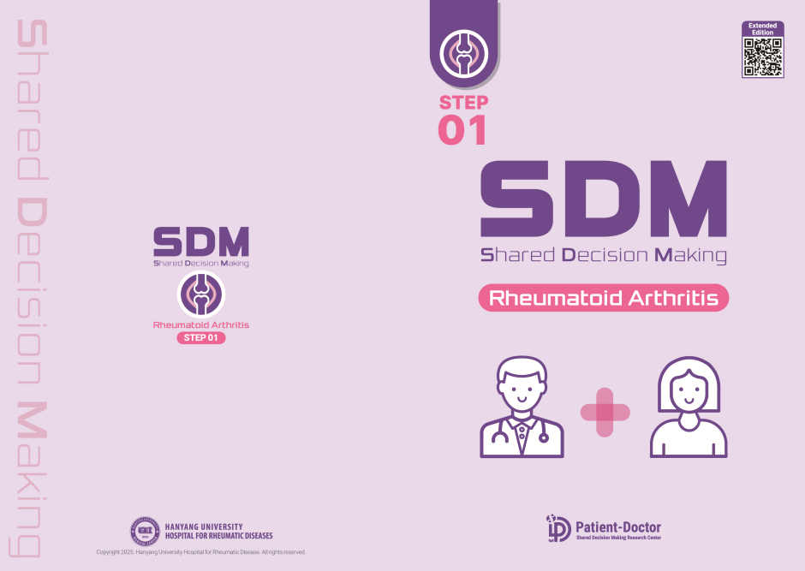
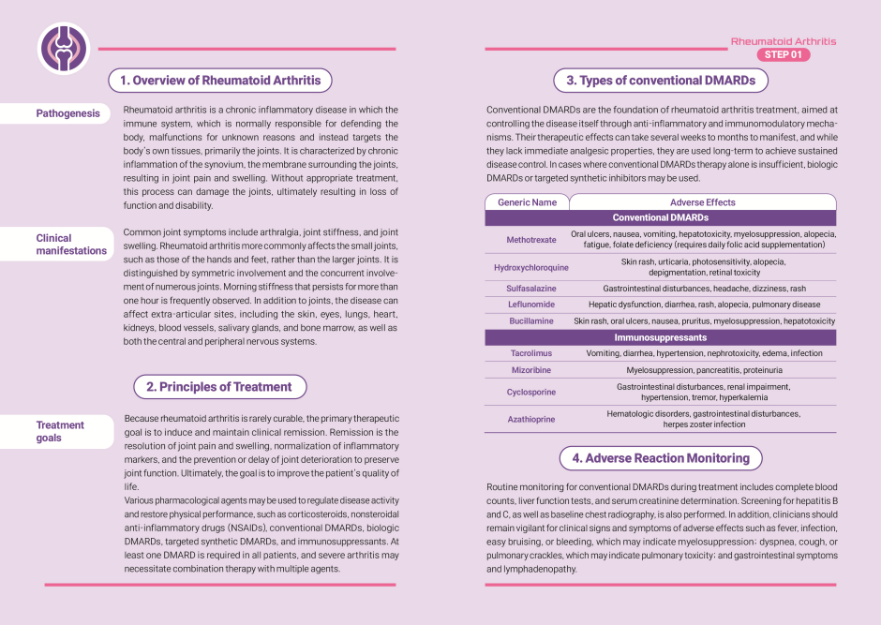
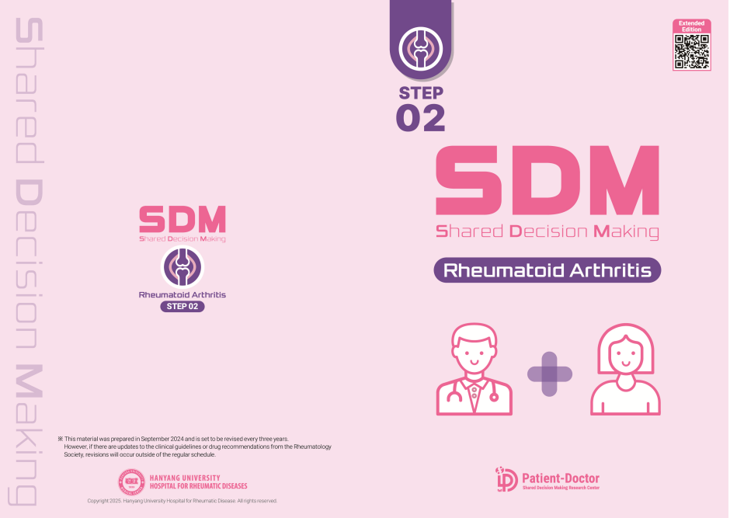
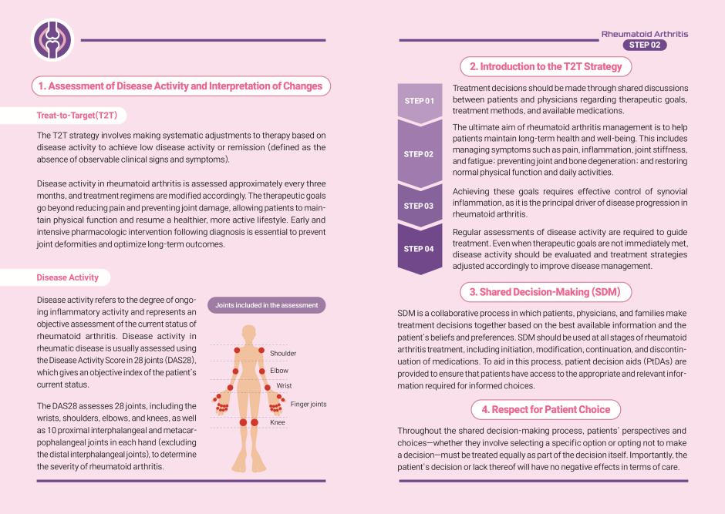
The extended version elaborates on the diagnosis and treatment of rheumatoid arthritis in contexts requiring shared decision-making, with full content publicly accessible via the official website (http://www.rheucare.com/)
Supplementary Figure 2 Treatment options materials of RA
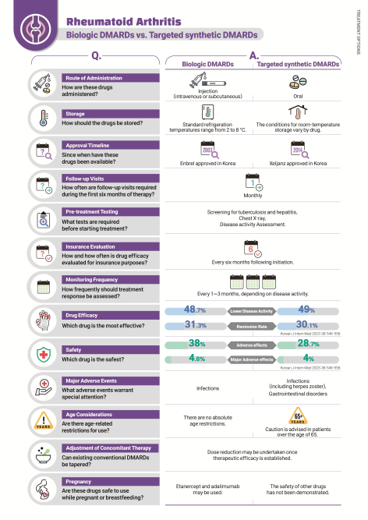
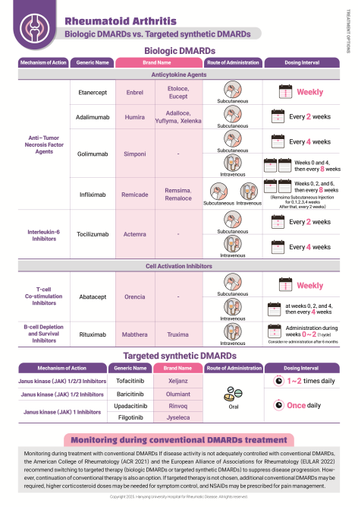

Supplementary Figure 3 Abridged educational materials of AS
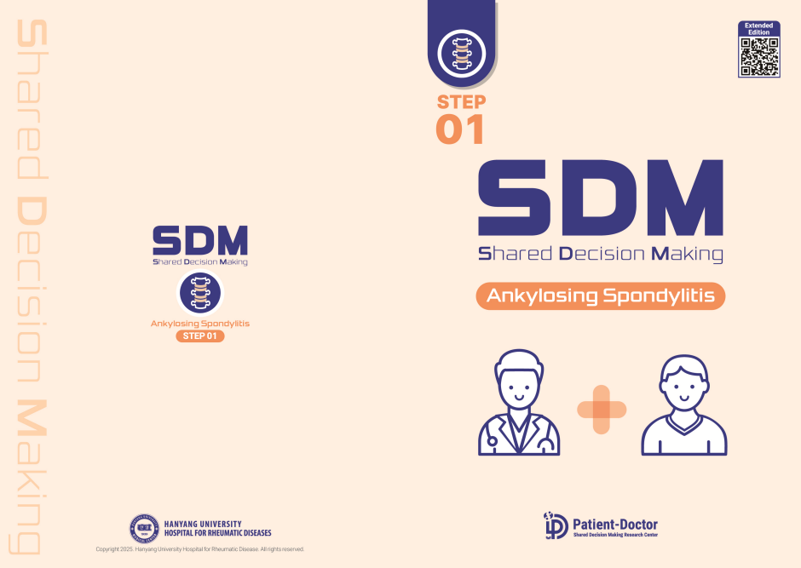
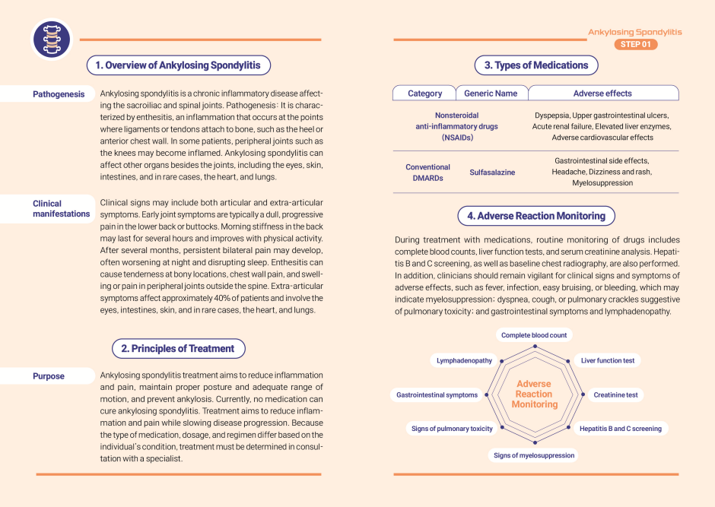
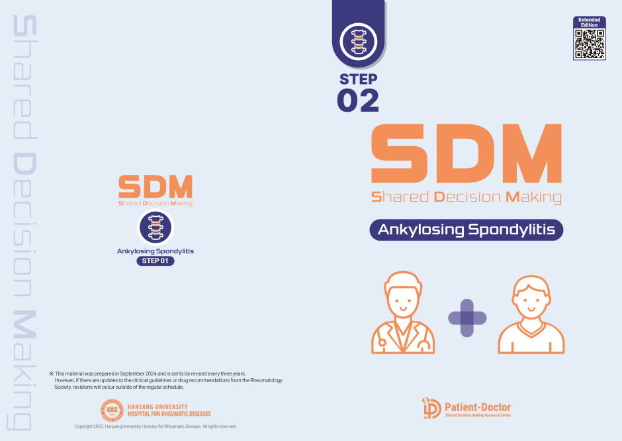
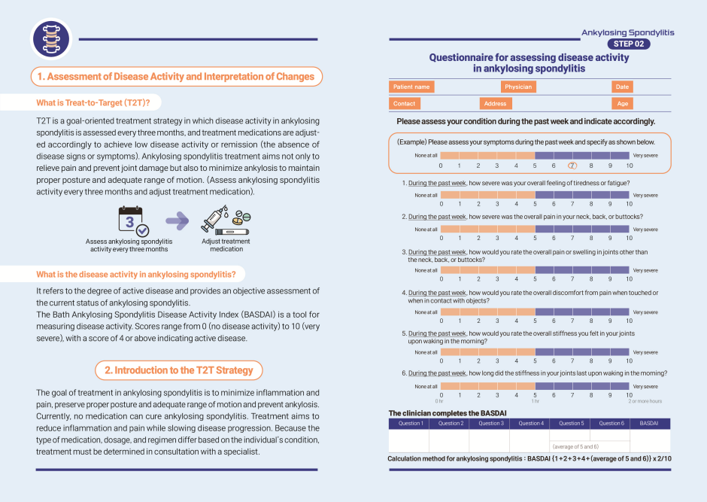
The extended version elaborates on the diagnosis and treatment of ankylosing spondylitis in contexts requiring shared decision-making, with full content publicly accessible via the official website (http://www.rheucare.com/)
Supplementary Figure 4 Treatment options materials of AS
