Supplementary material
Table S1 The GO-FAR scores and the probabilities of survival
Table S2 The variables under study
Table S1 Go-FAR Score system
Variables | Score
Neurologically intact at admission | -15
Major trauma | 10
Acute stroke | 8
Metastatic or hematologic cancer | 7
Septicemia | 7
Medical non-cardiac diagnosis | 7
Hepatic insufficiency | 6
Admission from skilled nursing facility | 6
Hypotension or hypoperfusion | 5
Renal insufficiency including dialysis | 4
Respiratory insufficiency | 4
Pneumonia | 1
Age (years)
70–74 | 2
75–79 | 5
80–84 | 6
≥85 | 11
The Go-FAR score was developed to predict neurologically intact survival after In-Hospital cardiopulmonary resuscitation was by Mariana. The scoring metrics of Go-FAR Score are shown in Appendix 1. GO-FAR classifies the likelihood of surviving with good neurological function after cardiopulmonary resuscitation into four levels: very low (< 1%), low (1%-3%), moderate (3%-15%), and above average (> 15%)
Table S2 The variables under study
 | Variable
Dataset | Gender(1:Male, 0:Female)  Age  Hypertensive(1:Yes,0:No)  Diabetes(1:Yes,0:No)  Heart Disease(1:Yes,0:No)  Kidney Failure(1:Yes,0:No)  Malignant tumor(1:Yes,0:No)  Shockable rhythm(1:Yes,0:No)  Witness Cardiac Arrest(1:Yes,0:No)  Neurological outcomes(0:Poor,1:good )  Resuscitation Time  White blood cell(WBC)  Albumin  Sodium bicarbonate  Go-FAR score  ALB/WBC
The variables of the dataset were as shown in Table S2.

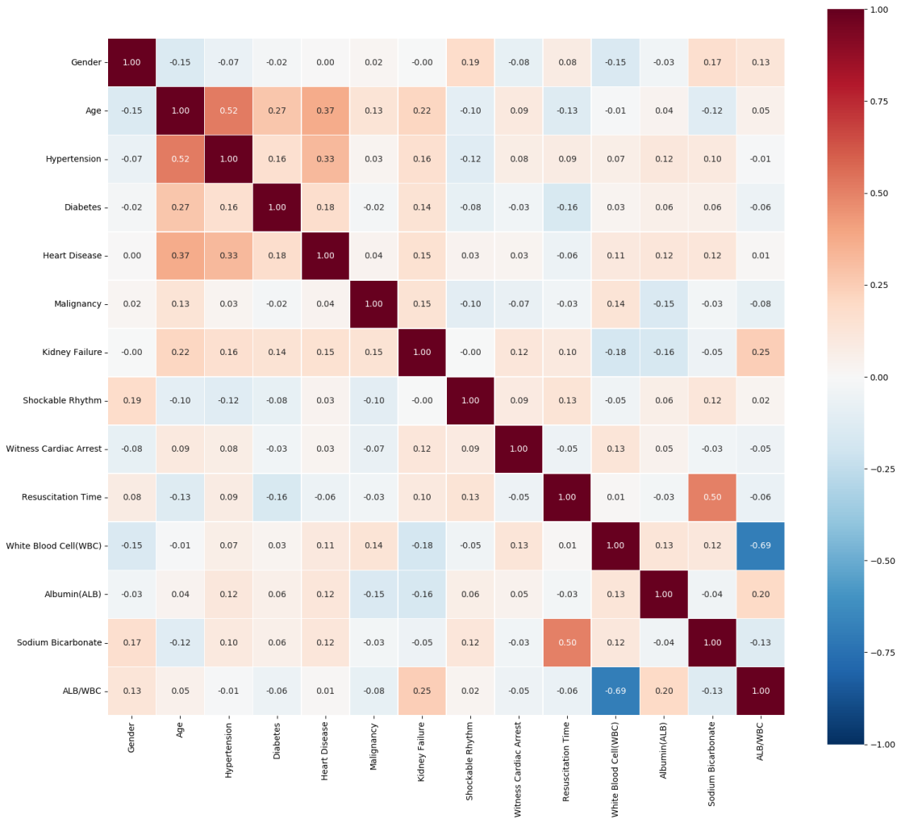
Figure S1 Correlation heatmap of Research Variables
The rows and columns of the heatmap correspond to variables in the study. Each cell (x, y) represents the correlation coefficient between the xth variable and the yth variable. Colors closer to blue indicate correlation coefficients closer to -1, signifying a strong negative linear relationship, while colors closer to red indicate a strong positive linear relationship. Diagonal property: The diagonal running from top-left to bottom-right represents the "correlation coefficient of a variable with itself" with a value of 1.
Figure S2 Median AUC-ROC with 95% Confidence Intervals Across Algorithms
Box plots showing the distribution of out-of-bag (OOB) AUC-ROC values for nine machine learning algorithms (XGBoost, LightGBM, Random Forest, Logistic Regression, Support Vector Machine, Naive Bayes, Multilayer Perceptron, K-Nearest Neighbors, and Decision Tree) across 1,000 bootstrap iterations. The central red line in each box represents the median AUC-ROC, and the error bars indicate the bias-corrected and accelerated (BCa) 95% confidence intervals. The dashed horizontal line at 0.80 denotes the threshold for acceptable discriminative performance. Algorithms are ranked in descending order based on their median AUC-ROC values.

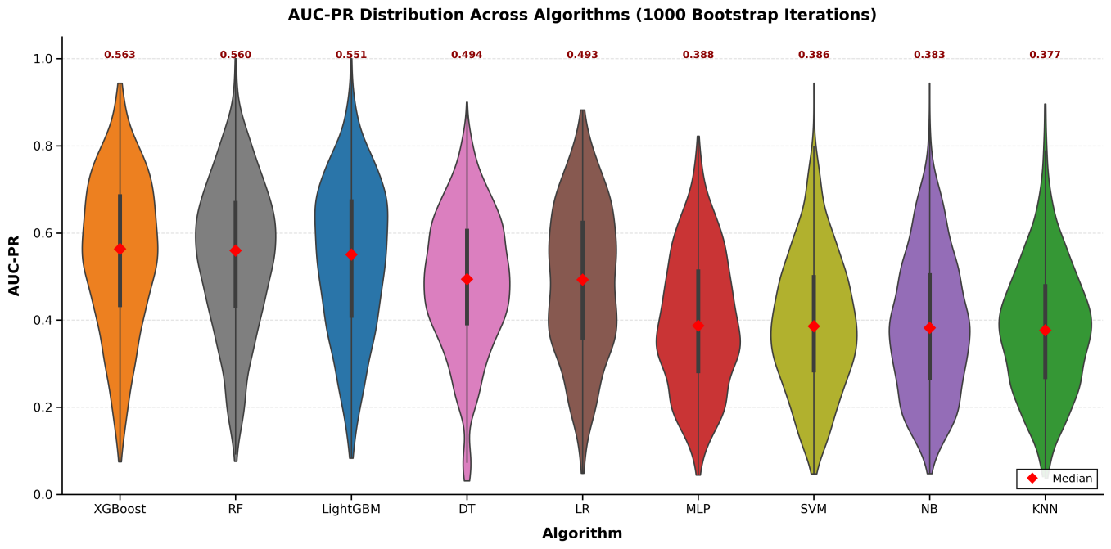
Figure S3. Violin plots showing the distribution of out-of-bag (OOB) AUC-Precision-Recall (AUC-PR) values for nine machine learning algorithms
Red dots indicate the median AUC-PR score for each algorithm. Compared with the AUC-ROC metric, the AUC-PR metric yielded a markedly different performance ranking. Under the AUC-PR metric, tree-based ensemble models (XGBoost, LightGBM, and Random Forest) achieved the highest median scores, indicating their superior precision-recall trade-off. In contrast, KNN and SVM performed poorly. Notably, the median AUC-PR for all models was substantially lower than the corresponding AUC-ROC value, with distributions concentrated in the lower range. This divergence is characteristic of datasets with low outcome prevalence (17.7%), where the precision-recall curve specifically penalizes false negatives in the minority class, making it more difficult to improve the precision-recall ratio than the ROC curve area.
Figure S4 Calibration Curves with 95% Confidence Intervals for Machine Learning Algorithms (1000 Bootstrap Iterations)
The diagonal dashed line represents perfect calibration (predicted probability = observed frequency). Each solid line depicts the mean predicted probability across pooled out-of-bag predictions, with shaded areas indicating 95% confidence intervals. Brier scores are reported in parentheses. RF, Random Forest; LR, Logistic Regression; DT, Decision Tree; NB, Naive Bayes; KNN, K-Nearest Neighbors; MLP, Multilayer Perceptron; SVM, Support Vector Machine; XGB, XGBoost; LGB, LightGBM.
Random Forest had the lowest Brier score (0.12) and the narrowest 95% confidence interval. XGBoost also lay close to the diagonal across most of the probability range, with slight deviation at predicted probabilities > 0.8. LightGBM showed moderate overall agreement with the diagonal but consistently trended below it in the high-probability region (> 0.8). SVM remained near the diagonal at lower probabilities but exhibited wider confidence intervals and non-negligible deviation above 0.8.Logistic regression, decision tree, and KNN deviated markedly from the diagonal. Logistic regression and KNN displayed S-shaped or reverse S-shaped curves. Multilayer perceptron tracked below the diagonal at higher predicted probabilities, similar to LightGBM.

