Supplementary Materials

Supplementary Table S1. Subject-level data partition and AKI events
Dataset | N | AKI events | AKI rate | Unique subjects
Training | 2,720 | 1,291 | 47.46% | 2,720
Validation | 778 | 369 | 47.43% | 778
Independent test | 389 | 185 | 47.56% | 389
No subject identifier overlapped across the training, validation, and independent test sets.

Supplementary Table S2. Predictor roles, temporal windows, and leakage safeguards
Variable group | Representative variables | Temporal definition | Processing and leakage safeguard
Identifiers | subject_id | Not a clinical time window | Used only for subject-level linkage and partitioning; excluded from all model predictors.
Primary outcome and event time | AKI status, AKI stage, and first AKI onset time derived from serum creatinine and/or urine output | AKI occurring from ICU admission to ICU discharge | Used only to define the primary outcome and event timing. AKI onset time was not used to define predictor eligibility or the predictor window; no outcome-derived variable was included as a predictor.
Dynamic lactate time series | lactate, lactate measurement time, relative time, first-order differences, slopes, peak value, trend direction, and lactate–time AUC | Fixed pre-admission window from −168 to −1 h before ICU admission (t = 0) | Times were anchored to ICU admission and mapped to an hourly grid. Linear interpolation was restricted to each patient’s observed lactate interval, with no extrapolation. The 30 hourly points closest to ICU admission were selected after regularization; shorter sequences were padded at the beginning. All lactate inputs preceded ICU admission and AKI outcome ascertainment.
Static baseline characteristics | age, sex, ethnicity, height, weight, and chronic conditions | Baseline information available before ICU admission / first ICU admission | Treated as static covariates. Missing non-lactate covariates were handled using the stated MICE pipeline. Imputation rules, winsorization thresholds, and standardization parameters were determined using the training set only and applied unchanged to the validation and test sets.
Pre-admission clinical measurements | SOFA, medication indicators, blood counts, electrolytes, vital signs, PEEP, glucose, albumin, and other clinical variables | Records available before ICU admission; SOFA was the most recent score within 24 h before ICU admission | Aligned by timestamp to the pre-admission eligibility window. No post-admission or post-AKI measurements were used. Continuous features were winsorized and standardized using parameters estimated from the training set only.
Creatinine as predictor | serum creatinine | Most recent available measurement before ICU admission | Strictly predates the prediction time point. Kept distinct from post-admission creatinine and urine-output records used only to determine KDIGO AKI status, stage, and event time.
Secondary outcomes | in-hospital mortality and 1-year mortality | Outcome-specific follow-up periods | Used only as labels in secondary analyses and excluded from the AKI predictor set.

Supplementary Table S3. Sensitivity analyses excluding serum creatinine and/or SOFA score
Analysis | Variables excluded | ROC-AUC (95% CI) | PR-AUC (95% CI) | Brier score (95% CI)
Primary model | None | 0.808 (0.764–0.851) | 0.802 (0.747–0.855) | 0.187 (0.171–0.202)
Sensitivity analysis 1 | Serum creatinine | 0.776 (0.728–0.821) | 0.754 (0.690–0.812) | 0.207 (0.198–0.217)
Sensitivity analysis 2 | SOFA score* | 0.776 (0.725–0.818) | 0.756 (0.689–0.815) | 0.205 (0.195–0.216)
Sensitivity analysis 3 | Serum creatinine and SOFA score* | 0.752 (0.705–0.799) | 0.724 (0.658–0.789) | 0.212 (0.202–0.223)
Note: The primary-model results are taken from the original manuscript analysis.
All sensitivity analyses used the same study cohort and the same subject-level training, validation, and test sets as the primary analysis.
*When the SOFA score was excluded, the derived SOFA × mean lactate interaction term was also excluded.
Abbreviations: ROC-AUC, area under the receiver operating characteristic curve; PR-AUC, area under the precision–recall curve; SOFA, Sequential Organ Failure Assessment.
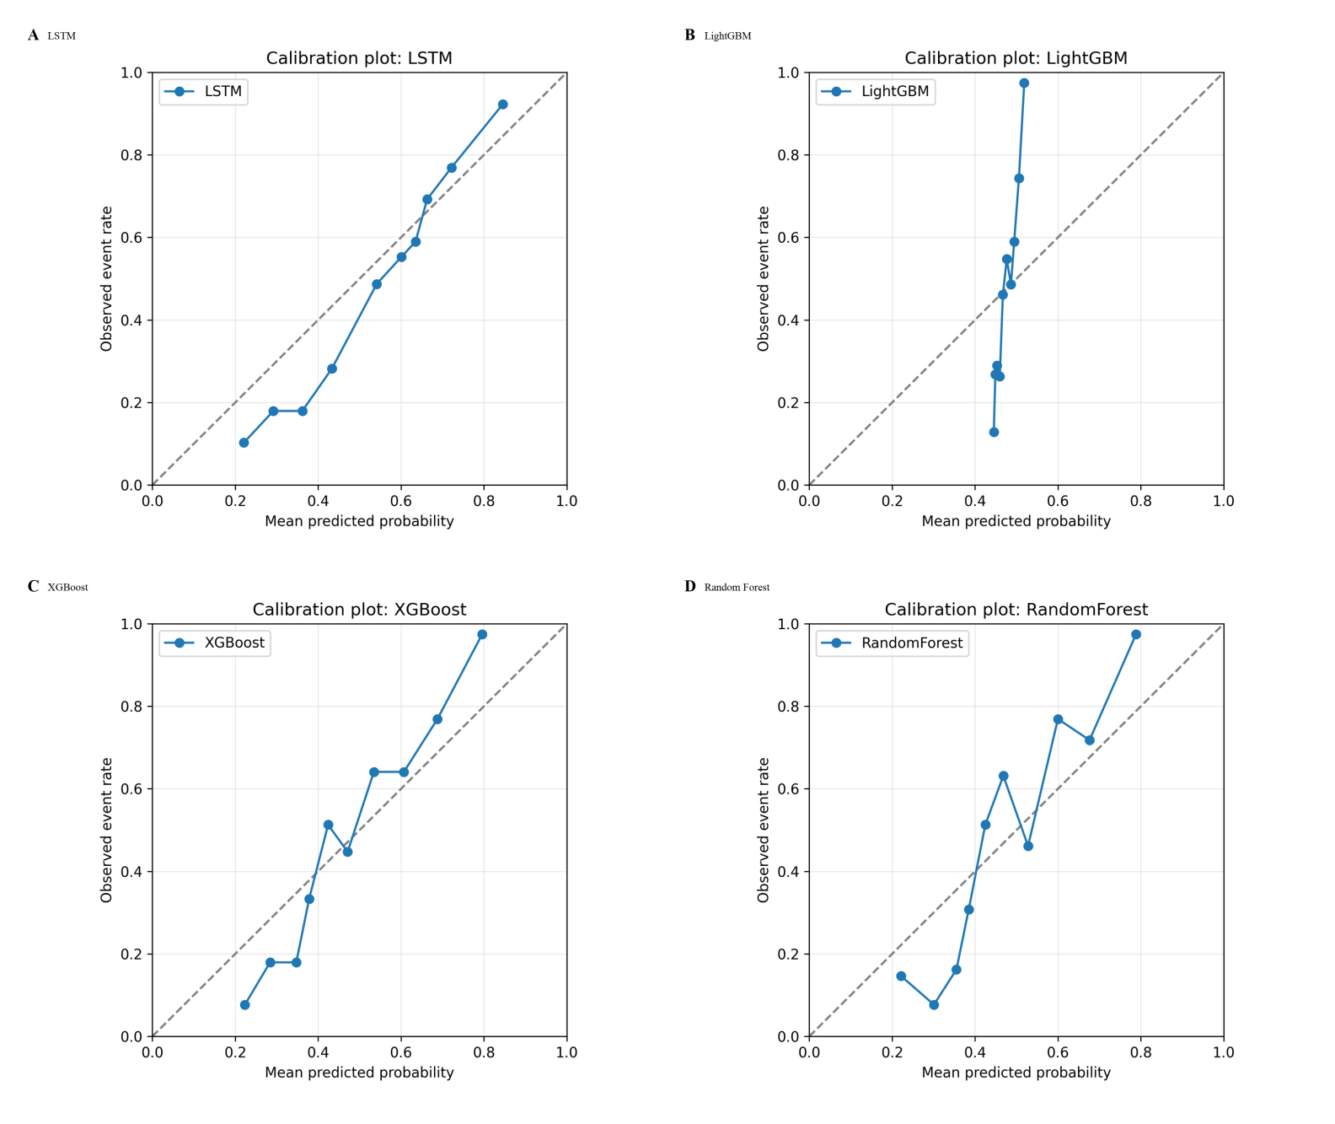
Supplementary Figure S1. Calibration plots. Calibration plots for (A) LSTM, (B) LightGBM, (C) XGBoost, and (D) Random Forest on the independent test set. The diagonal dashed line indicates perfect calibration. Calibration intercepts and slopes are reported in Table 2.

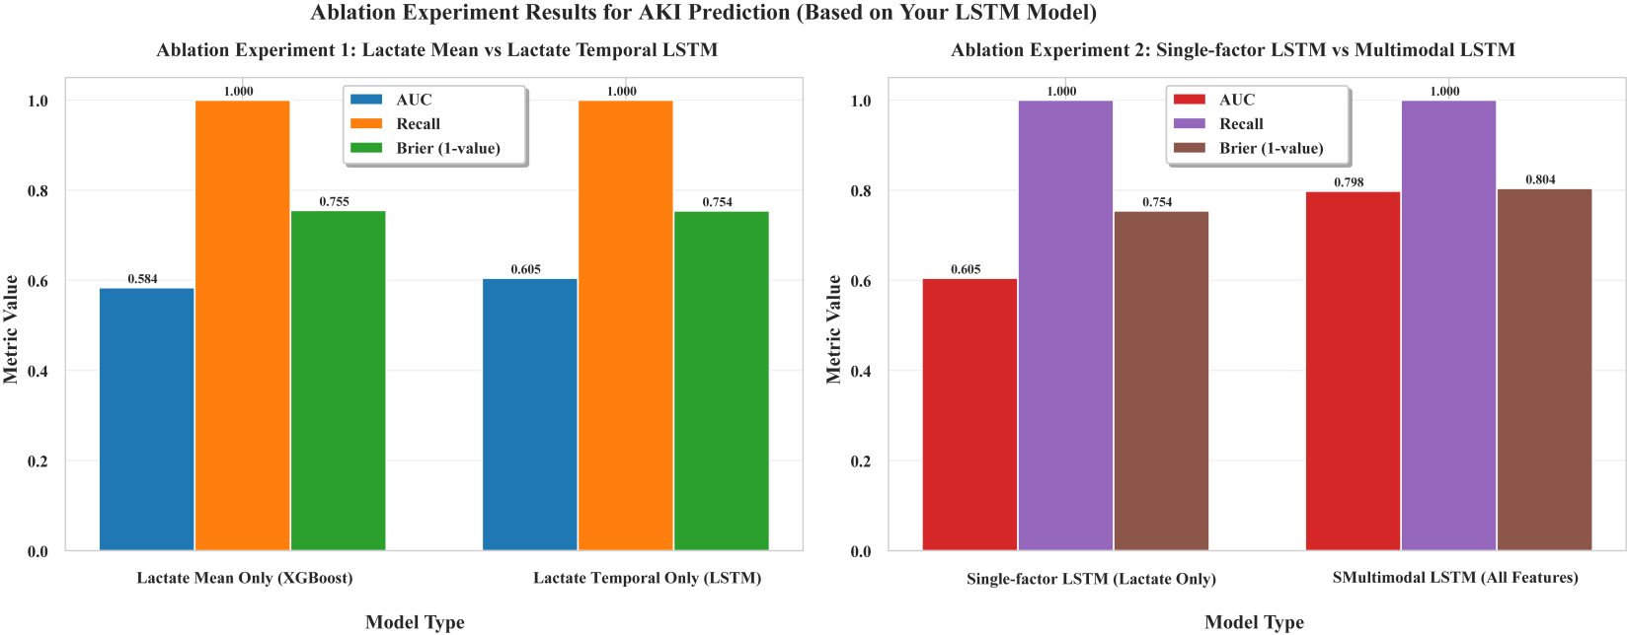
Supplementary Figure S2. Ablation analysis. Ablation analyses comparing a lactate mean feature with a lactate-temporal LSTM and comparing a lactate-only LSTM with the multimodal LSTM. These analyses are interpreted as model sensitivity analyses rather than causal or mechanistic attribution.

Supplementary Data S1
Threshold-level decision-curve net-benefit values for LSTM, LightGBM, XGBoost, and Random Forest are provided as a separate spreadsheet.

