Supplementary materials
Table S1: Optimal Hyperparameters of the Pertussis Positive and Negative Group Classification Model Based on 10-Fold Cross-Validation. 2
Table S2: Optimal Hyperparameters of a Classification Model for Pertussis-Positive Groups and Healthy Individuals Based on 10-Fold Cross-Validation 4
Table S3: Distribution of Routine Laboratory Parameters in Pertussis Patients 6
Table S4: Evaluation Results of the Test Set for Different Models on the Pertussis-Positive and Negative Sample Groups. 9
Table S5: Evaluation results of the Test Set for Different Models on the Pertussis-Positive and Healthy Check-Up Sample Groups. 10
Table S6: Internal Validation Evaluation Results for Different Models on the Pertussis-Positive and Negative Sample Groups. 11
Table S7: Internal Validation Evaluation Results for Different Models on the Pertussis-Positive and Healthy Check-Up Sample Groups. 12
Fig. S1: Flow diagram of participant screening and data allocation. 13
Fig. S2: Calibration Plots of the Optimal Models on the Temporal Validation set. 13
Fig. S3: Homepage Interface. 14
Fig. S4: View Overall Data Interface. 14
Fig. S5: Add Data Interface. 14
Fig. S6: View Input Data Interface 15
Fig. S7: View Diagnostic Report Interface. 15
Fig. S8: Add Data Interface. 16
Fig. S9: View Input Data Interface. 16
Fig. S10: View Diagnostic Report Interface 16

Table S1. Optimal Hyperparameters of the Pertussis Positive and Negative Group Classification Model Based on 10-Fold Cross-Validation
ML algorithms | Hyperparameters | Range of hyperparameter values | Values
KNN | weights | uniform, distance | distance
KNN | n_neighbors | 1-30 | 9
KNN | leaf_size | 1-59 | 2
KNN | algorithm | auto, ball_tree, kd_tree, brute | kd_tree
NB | var_smoothing | 10⁰-10⁻⁹, taking 100 values at logarithmic intervals | 0.8111308307896871
SVM | kernel | linear, poly, rbf, sigmoid | rbf
SVM | gamma | scale, auto, 10⁻³-10³ (7 logarithmic equidistant values) | 0.1
SVM | C | 0.1, 1, 10, 100 | 100
DT | min_samples_split | 2-20 | 15
DT | min_samples_leaf | 1-20 | 6
DT | max_depth | None, 1–10 | 10
DT | criterion | gini, entropy | gini
RF | n_estimators | 10-100 (step size 10) | 80
RF | min_samples_split | 2–20 | 13
RF | min_samples_leaf | 1–20 | 9
RF | max_depth | None, 1–10 | 6
GBDT | subsample | 0.5-1.0 (step size 0.1) | 0.8
GBDT | n_estimators | 50-200 (step size 50) | 100
GBDT | min_samples_split | 2-10 | 9
GBDT | min_samples_leaf | 1-10 | 3
GBDT | max_depth | 3-10 | 6
GBDT | learning_rate | 0.01, 0.05, 0.1, 0.2 | 0.2
XGBoost | subsample | 0.5-1.0 (step size 0.1) | 0.7
XGBoost | n_estimators | 50-200 (step size 50) | 150
XGBoost | max_depth | 3-10 | 3
XGBoost | learning_rate | 0.01, 0.05, 0.1, 0.2 | 0.05
XGBoost | gamma | 0-0.4 (step size 0.1) | 0.3
XGBoost | colsample_bytree | 0.5-1.0 (step size 0.1) | 0.5
AdaBoost | n_estimators | 50-200 (step size 50) | 150
AdaBoost | learning_rate | 0.01, 0.05, 0.1, 0.2 | 0.2
AdaBoost | algorithm | SAMME, SAMME.R | SAMME
CatBoost | learning_rate | 0.01, 0.05, 0.1, 0.2 | 0.05
CatBoost | iterations | 100, 200, 300 | 100
CatBoost | depth | 3-8 | 6
Note: All random seeds in the above models are set to 52. The optimization criterion is AUC.
KNN, K-Nearest Neighbor; NB, Naive Bayes; SVM, Support Vector Machine; DT, Decision Tree; RF, Random Forest; GBDT, Gradient Boosting Decision Tree; XGBoost, eXtreme Gradient Boosting; AdaBoost, Adaptive Boosting; CatBoost, Categorical Boosting.

Table S2. Optimal Hyperparameters of a Classification Model for Pertussis-Positive Groups and Healthy Individuals Based on 10-Fold Cross-Validation
ML algorithms | Hyperparameters | Range of hyperparameter values | Values
KNN | weights | uniform, distance | distance
KNN | n_neighbors | 1-30 | 9
KNN | leaf_size | 1-59 | 2
KNN | algorithm | auto, ball_tree, kd_tree, brute | kd_tree
NB | var_smoothing | 10⁰-10⁻⁹, taking 100 values at logarithmic intervals | 1.0
SVM | kernel | linear, poly, rbf, sigmoid | rbf
SVM | gamma | scale, auto, 10⁻³-10³ (7 logarithmic equidistant values) | 1.0
SVM | C | 0.1, 1, 10, 100 | 10
DT | min_samples_split | 2-20 | 6
DT | min_samples_leaf | 1-20 | 19
DT | max_depth | None, 1–10 | None
DT | criterion | gini, entropy | gini
RF | n_estimators | 10-100 (step size 10) | 90
RF | min_samples_split | 2–20 | 8
RF | min_samples_leaf | 1–20 | 4
RF | max_depth | None, 1–10 | None
GBDT | subsample | 0.5-1.0 (step size 0.1) | 0.8
GBDT | n_estimators | 50-200 (step size 50) | 50
GBDT | min_samples_split | 2-10 | 4
GBDT | min_samples_leaf | 1-10 | 8
GBDT | max_depth | 3-10 | 9
GBDT | learning_rate | 0.01, 0.05, 0.1, 0.2 | 0.2
XGBoost | subsample | 0.5-1.0 (step size 0.1) | 1.0
XGBoost | n_estimators | 50-200 (step size 50) | 200
XGBoost | max_depth | 3-10 | 5
XGBoost | learning_rate | 0.01, 0.05, 0.1, 0.2 | 0.2
XGBoost | gamma | 0-0.4 (step size 0.1) | 0.3
XGBoost | colsample_bytree | 0.5-1.0 (step size 0.1) | 0.7
AdaBoost | n_estimators | 50-200 (step size 50) | 200
AdaBoost | learning_rate | Range of hyperparameter values | 0.05
AdaBoost | algorithm | uniform, distance | SAMME.R
CatBoost | learning_rate | 1-30 | 0.2
CatBoost | iterations | 1-59 | 100
CatBoost | depth | auto, ball_tree, kd_tree, brute | 5
Note: All random seeds in the above models are set to 52. The optimization criterion is AUC.
KNN, K-Nearest Neighbor; NB, Naive Bayes; SVM, Support Vector Machine; DT, Decision Tree; RF, Random Forest; GBDT, Gradient Boosting Decision Tree; XGBoost, eXtreme Gradient Boosting; AdaBoost, Adaptive Boosting; CatBoost, Categorical Boosting.

Table S3. Distribution of Routine Laboratory Parameters in Pertussis Patients
Parameters | Total (Mean±std  Median [Q1-Q3]) | P group (Mean±std  Median [Q1-Q3]) | N group (Mean±std Median [Q1-Q3]) | H group (Mean±std Median [Q1-Q3]) | p values (P vs N) | p values (P vs H)
Baso# | 0.02 ± 0.02  0.01[0.00-0.03] | 0.04 ± 0.03  0.03[0.02-0.05] | 0.02 ± 0.03  0.02 [0.01-0.03] | 0.01 ± 0.01  0.00 [0.00-0.00] | ＜0.001ª | ＜0.001
Baso% | 0.18 ± 0.22  0.10 [0.00-0.30] | 0.32 ± 0.22  0.30 [0.20-0.40] | 0.20 ± 0.19  0.20 [0.10-0.30] | 0.09 ± 0.19  0.00 [0.00-0.04] | ＜0.001 | ＜0.001
Eos# | 0.28 ± 0.25  0.21 [0.12-0.37] | 0.42 ± 0.27  0.35 [0.23-0.53] | 0.23 ± 0.27  0.15 [0.07-0.32] | 0.24 ± 0.19  0.18 [0.12-0.29] | ＜0.001 | ＜0.001
Eos% | 3.14 ± 2.43  2.50 [1.48-4.20] | 3.84 ± 2.11  3.60 [2.30-4.90] | 2.31 ± 2.29  1.50 [0.70-3.30] | 3.51 ± 2.53  2.64 [1.80-4.30] | ＜0.001 | 0.074
Hb | 128.53 ± 13.88  130.00 [120.00-138.00] | 129.93 ± 11.88  130.00 [123.00-138.00] | 121.41 ± 15.36  121.00 [111.00-132.00] | 134.34 ± 10.06  134.00 [128.00-141.00] | ＜0.001 | ＜0.001
Hct | 39.24 ± 4.02  39.50 [36.80-41.90] | 39.73 ± 3.64  39.40 [37.18-42.00] | 37.55 ± 4.74  37.30 [34.40-40.90] | 40.52 ± 2.77  40.60 [38.80-42.40] | ＜0.001 | ＜0.05^{b}
Lymph# | 4.46 ± 2.64  3.71 [2.82-5.31] | 5.38 ± 3.30  4.43 [3.38-6.13] | 5.30 ± 2.82  4.74 [3.47-6.49] | 3.13 ± 0.88  3.00 [2.50-3.59] | 0.73 | ＜0.001
Lymph% | 48.23 ± 13.93  47.50 [39.23-57.42] | 46.57 ± 14.15  44.85 [36.77-55.80] | 51.20 ± 16.79  51.90 [40.30-65.90] | 46.45 ± 9.82  45.80 [40.17-53.17] | ＜0.001 | 0.89
MCH | 27.57 ± 2.38  27.70 [26.70-28.80] | 27.28 ± 2.03  27.50 [26.60-28.50] | 27.66 ± 2.84  27.50 [26.10-29.10] | 27.66 ± 2.08  27.90 [27.10-28.80] | 0.058 | ＜0.05
MCHC | 327.51 ± 10.37  328.00 [321.00-335.00] | 327.13 ± 10.71  329.00 [321.00-334.00] | 323.52 ± 10.90  323.00 [317.00-331.00] | 331.47 ± 7.91  332.00 [326.50-337.00] | ＜0.001 | ＜0.001
MCV | 84.16 ± 6.50  84.20 [81.10-87.50] | 83.38 ± 5.45  83.85 [80.67-86.80] | 85.45 ± 7.62  85.40 [81.20-89.30] | 83.43 ± 5.71  84.00 [81.40-86.55] | ＜0.001 | 0.911
MPV | 9.77 ± 1.12  9.70 [9.00-10.40] | 9.61 ± 1.06  9.60 [8.97-10.20] | 9.58 ± 1.20  9.50 [8.70-10.20] | 10.04 ± 1.02  9.90 [9.40-10.60] | 0.694 | ＜0.001
Mono# | 0.69 ± 0.54  0.53 [0.37-0.85] | 0.72 ± 0.32  0.63 [0.51-0.86] | 1.00 ± 0.72  0.85 [0.57-1.27] | 0.38 ± 0.13  0.36 [0.29-0.45] | ＜0.001 | ＜0.001
Mono% | 7.24 ± 3.53  6.30 [5.00-8.30] | 6.50 ± 2.11  6.20 [5.10-7.43] | 9.46 ± 4.46  8.60 [6.20-11.90] | 5.62 ± 1.65  5.40 [4.60-6.50] | ＜0.001 | ＜0.001
NEUT# | 3.79 ± 2.41  3.17 [2.30-4.54] | 4.81 ± 2.66  4.28 [2.96-6.08] | 3.98 ± 2.99  3.00 [1.95-4.90] | 3.01 ± 0.97  2.88 [2.28-3.64] | ＜0.001 | ＜0.001
NEUT% | 41.20 ± 14.83  42.09 [30.80-51.00] | 42.77 ± 14.38  44.30 [33.15-52.30] | 36.83 ± 18.06  33.30 [21.50-49.40] | 44.34 ± 10.04  44.16 [37.66-50.80] | ＜0.001 | 0.086
P-LCR | 23.50 ± 7.60  22.95 [18.27-28.00] | 22.53 ± 7.67  22.10 [16.60-26.62] | 22.21 ± 7.59  21.30 [16.40-26.80] | 25.30 ± 7.22  24.60 [20.20-29.05] | 0.591 | ＜0.001
PCT | 0.34 ± 0.10  0.32 [0.27-0.39] | 0.33 ± 0.08  0.32 [0.28-0.37] | 0.40 ± 0.12  0.39 [0.31-0.46] | 0.30 ± 0.06  0.30 [0.26-0.34] | ＜0.001 | ＜0.001
PDW | 12.80 ± 2.78  12.20 [10.40-15.70] | 13.04 ± 2.85  13.10 [10.30-15.80] | 13.22 ± 2.92  13.30 [10.50-15.90] | 12.28 ± 2.53  11.60 [10.40-13.85] | 0.418 | ＜0.001
PLT | 355.45 ± 110.69  335.00 [278.75-410.00] | 346.69 ± 82.30  339.50 [294.25-392.00] | 417.48 ± 131.67  408.00 [327.00-495.00] | 302.85 ± 66.56  301.00 [259.50-344.00] | ＜0.001 | ＜0.001
RBC | 4.69 ± 0.54  4.73 [4.43-5.00] | 4.77 ± 0.41  4.73 [4.52-5.00] | 4.43 ± 0.66  4.50 [3.94-4.89] | 4.87 ± 0.38  4.86 [4.63-5.07] | ＜0.001 | ＜0.05
RDW-CV | 13.55 ± 1.29  13.30[12.80-13.93] | 13.43 ± 1.21  13.20[12.78-13.90] | 13.85 ± 1.55  13.50 [12.90-14.40] | 13.33 ± 0.98  13.20 [12.70-13.60] | ＜0.001 | 0.238
WBC | 9.22 ± 4.12  8.07 [6.56-10.80] | 11.36 ± 4.76  10.29 [8.04-12.97] | 10.51 ± 4.31  9.57 [7.63-12.46] | 6.75 ± 1.35  6.68 [5.73-7.69] | ＜0.05 | ＜0.001
CRP | 3.51 ± 8.72  1.33 [0.40-3.28] | 3.03 ± 4.28  1.27 [0.28-4.14] | 5.64 ± 13.62  0.82 [0.22-4.77] | 1.81 ± 1.27  1.59 [0.65-2.77] | ＜0.05 | ＜0.001
Age | 4.75 ± 3.89  5.00 [0.92-6.00] | 5.24 ± 3.23  5.00[2.46-7.15] | 1.66 ± 2.35  0.50 [0.17-3.00] | 7.33 ± 3.35  6.00[6.00-12.00] | < 0.001 | < 0.001
ª<0.001: Indicates a p-value of less than 0.001, showing a highly statistically significant difference between the pertussis-positive and negative groups, and between the pertussis-positive and healthy check-up groups.
^{b}<0.05: Indicates a p-value of less than 0.05, showing a statistically significant difference between the pertussis-positive and negative groups, and between the pertussis-positive and healthy check-up groups.

Table S4. Evaluation Results of the Test Set for Different Models on the Pertussis-Positive and Negative Sample Groups
Classifier | Accuracy | PPV | NPV | Sensitivity | Specificity | F1-score | AUC
KNN | 0.800  (0.745, 0.855) | 0.732  (0.704, 0.777) | 0.863  (0.836, 0.895) | 0.799  (0.747, 0.852) | 0.811  (0.781, 0.846) | 0.788  (0.729, 0.846) | 0.906  (0.855, 0.952)
NB | 0.745  (0.664, 0.809) | 0.594  (0.571, 0.633) | 0.938  (0.920, 0.961) | 0.940  (0.912, 0.967) | 0.586  (0.537, 0.640) | 0.739  (0.644, 0.816) | 0.858  (0.781, 0.929)
SVM | 0.845  (0.800, 0.900) | 0.858  (0.830, 0.894) | 0.899  (0.872, 0.928) | 0.842  (0.788, 0.892) | 0.910  (0.883, 0.934) | 0.831  (0.777, 0.893) | 0.920  (0.865, 0.968)
DT | 0.773  (0.718, 0.827) | 0.799  (0.765, 0.853) | 0.840  (0.821, 0.861) | 0.739  (0.694, 0.782) | 0.880  (0.840, 0.915) | 0.758  (0.691, 0.820) | 0.791  (0.713, 0.862)
RF | 0.855  (0.809, 0.891) | 0.901  (0.857, 0.957) | 0.880  (0.853, 0.908) | 0.799  (0.737, 0.852) | 0.943  (0.907, 0.973) | 0.841  (0.796, 0.893) | 0.934  (0.889, 0.972)
GBDT | 0.827  (0.791, 0.864) | 0.879  (0.849, 0.920) | 0.903  (0.881, 0.933) | 0.846  (0.788, 0.897) | 0.925  (0.894, 0.952) | 0.819  (0.775, 0.875) | 0.917  (0.872, 0.957)
XGBoost | 0.873  (0.836, 0.909) | 0.877  (0.839, 0.917) | 0.895  (0.867, 0.925) | 0.832  (0.770, 0.884) | 0.925  (0.888, 0.952) | 0.867  (0.828, 0.913) | 0.920  (0.872, 0.961)
AdaBoost | 0.864  (0.791, 0.936) | 0.827  (0.788, 0.884) | 0.899  (0.877, 0.927) | 0.846  (0.798, 0.894) | 0.886  (0.848, 0.923) | 0.860  (0.784, 0.934) | 0.924  (0.853, 0.975)
CatBoost | 0.836  (0.773, 0.900) | 0.888  (0.855, 0.931) | 0.904  (0.879, 0.930) | 0.846  (0.792, 0.894) | 0.931  (0.901, 0.958) | 0.828  (0.768, 0.893) | 0.937  (0.905, 0.968)
PPV, Positive Predictive Value; NPV, Negative Predictive Value; AUC, Area Under the ROC Curve; KNN, K-Nearest Neighbor; NB, Naive Bayes; SVM, Support Vector Machine; DT, Decision Tree; RF, Random Forest; GBDT, Gradient Boosting Decision Tree; XGBoost, eXtreme Gradient Boosting; AdaBoost, Adaptive Boosting; CatBoost, Categorical Boosting.

Table S5. Evaluation results of the Test Set for Different Models on the Pertussis-Positive and Healthy Check-Up Sample Groups
Classifier | Accuracy | PPV | NPV | Sensitivity | Specificity | F1-score | AUC
KNN | 0.793  (0.744, 0.843) | 0.946  (0.918, 0.977) | 0.862  (0.845, 0.878) | 0.737  (0.696, 0.772) | 0.975  (0.961, 0.989) | 0.744  (0.674, 0.814) | 0.932  (0.899, 0.958)
NB | 0.731  (0.667, 0.813) | 0.987  (0.979, 1.000) | 0.723  (0.706, 0.745) | 0.356  (0.299, 0.424) | 0.997  (0.992, 1.000) | 0.610  (0.492, 0.733) | 0.971  (0.949, 0.989)
SVM | 0.870  (0.826, 0.921) | 0.936  (0.911, 0.967) | 0.940  (0.925, 0.957) | 0.896  (0.867, 0.929) | 0.964  (0.947, 0.980) | 0.853  (0.802, 0.908) | 0.938  (0.905, 0.969)
DT | 0.834  (0.808, 0.864) | 0.886  (0.860, 0.920) | 0.949  (0.922, 0.977) | 0.915  (0.862, 0.962) | 0.930  (0.911, 0.950) | 0.816  (0.782, 0.853) | 0.924  (0.887, 0.952)
RF | 0.896  (0.871, 0.929) | 0.951  (0.930, 0.976) | 0.948  (0.928, 0.973) | 0.910  (0.867, 0.953) | 0.972  (0.958, 0.986) | 0.898  (0.864, 0.935) | 0.988  (0.969, 1.000)
GBDT | 0.870  (0.811, 0.922) | 0.942  (0.921, 0.966) | 0.951  (0.935, 0.965) | 0.915  (0.886, 0.940) | 0.967  (0.955, 0.980) | 0.869  (0.820, 0.914) | 0.978  (0.963, 0.991)
XGBoost | 0.880  (0.822, 0.930) | 0.938  (0.918, 0.963) | 0.953  (0.936, 0.972) | 0.919  (0.886, 0.953) | 0.964  (0.950, 0.978) | 0.869  (0.811, 0.923) | 0.981  (0.964, 0.996)
AdaBoost | 0.913  (0.877, 0.948) | 0.920  (0.895, 0.943) | 0.925  (0.901, 0.949) | 0.868  (0.824, 0.915) | 0.955  (0.942, 0.967) | 0.904  (0.865, 0.941) | 0.983  (0.967, 0.996)
CatBoost | 0.938  (0.918, 0.964) | 0.937  (0.919, 0.960) | 0.945  (0.929, 0.968) | 0.905  (0.868, 0.943) | 0.964  (0.950, 0.977) | 0.932  (0.908, 0.962) | 0.988  (0.975, 1.000)
PPV, Positive Predictive Value; NPV, Negative Predictive Value; AUC, Area Under the ROC Curve; KNN, K-Nearest Neighbor; NB, Naive Bayes; SVM, Support Vector Machine; DT, Decision Tree; RF, Random Forest; GBDT, Gradient Boosting Decision Tree; XGBoost, eXtreme Gradient Boosting; AdaBoost, Adaptive Boosting; CatBoost, Categorical Boosting.

Table S6. Internal Validation Evaluation Results for Different Models on the Pertussis-Positive and Negative Sample Groups
Classifier | Accuracy | PPV | NPV | Sensitivity | Specificity | F1-score | AUC
KNN | 0.805  (0.727, 0.869) | 0.714  (0.625, 0.805) | 0.918  (0.842, 0.978) | 0.890  (0.797, 0.983) | 0.753  (0.657, 0.842) | 0.783  (0.694, 0.854) | 0.888  (0.815, 0.945)
NB | 0.737  (0.665, 0.802) | 0.620  (0.543, 0.691) | 0.951  (0.898, 1.000) | 0.940  (0.880, 1.000) | 0.610  (0.504, 0.710) | 0.740  (0.677, 0.793) | 0.856  (0.791, 0.913)
SVM | 0.812  (0.734, 0.870) | 0.760  (0.646, 0.863) | 0.874  (0.809, 0.935) | 0.783  (0.663, 0.900) | 0.826  (0.749, 0.906) | 0.757  (0.655, 0.841) | 0.872  (0.803, 0.932)
DT | 0.738  (0.675, 0.792) | 0.678  (0.583, 0.776) | 0.798  (0.738, 0.866) | 0.653  (0.546, 0.780) | 0.786  (0.707, 0.865) | 0.649  (0.562, 0.731) | 0.774  (0.700, 0.854)
RF | 0.832  (0.754, 0.914) | 0.850  (0.717, 0.967) | 0.828  (0.764, 0.895) | 0.673  (0.533, 0.810) | 0.931  (0.871, 0.978) | 0.743  (0.613, 0.867) | 0.923  (0.881, 0.969)
GBDT | 0.832  (0.759, 0.907) | 0.806  (0.700, 0.907) | 0.857  (0.793, 0.922) | 0.750  (0.627, 0.870) | 0.883  (0.815, 0.940) | 0.768  (0.665, 0.870) | 0.897  (0.828, 0.959)
XGBoost | 0.891  (0.825, 0.950) | 0.854  (0.773, 0.933) | 0.921  (0.864, 0.975) | 0.863  (0.763, 0.960) | 0.907  (0.854, 0.956) | 0.855  (0.765, 0.934) | 0.940  (0.891, 0.980)
AdaBoost | 0.824  (0.761, 0.886) | 0.778  (0.677, 0.876) | 0.866  (0.801, 0.928) | 0.770  (0.643, 0.887) | 0.858  (0.794, 0.917) | 0.764  (0.662, 0.854) | 0.923  (0.875, 0.967)
CatBoost | 0.875  (0.814, 0.940) | 0.857  (0.774, 0.933) | 0.894  (0.834, 0.950) | 0.803  (0.680, 0.923) | 0.918  (0.874, 0.964) | 0.820  (0.718, 0.916) | 0.933  (0.872, 0.983)
PPV, Positive Predictive Value; NPV, Negative Predictive Value; AUC, Area Under the ROC Curve; KNN, K-Nearest Neighbor; NB, Naive Bayes; SVM, Support Vector Machine; DT, Decision Tree; RF, Random Forest; GBDT, Gradient Boosting Decision Tree; XGBoost, eXtreme Gradient Boosting; AdaBoost, Adaptive Boosting; CatBoost, Categorical Boosting.

Table S7. Internal Validation Evaluation Results for Different Models on the Pertussis-Positive and Healthy Check-Up Sample Groups
Classifier | Accuracy | PPV | NPV | Sensitivity | Specificity | F1-score | AUC
KNN | 0.860  (0.805, 0.916) | 0.905  (0.826, 0.975) | 0.859  (0.794, 0.930) | 0.733  (0.607, 0.877) | 0.943  (0.887, 0.989) | 0.788  (0.697, 0.882) | 0.948  (0.906, 0.980)
NB | 0.819  (0.738, 0.897) | 0.821  (0.600, 1.000) | 0.811  (0.719, 0.903) | 0.597  (0.380, 0.797) | 0.965  (0.911, 1.000) | 0.661  (0.458, 0.836) | 0.954  (0.897, 0.988)
SVM | 0.909  (0.872, 0.950) | 0.912  (0.841, 0.980) | 0.930  (0.875, 0.972) | 0.877  (0.790, 0.960) | 0.929  (0.869, 0.988) | 0.883  (0.833, 0.934) | 0.981  (0.962, 0.996)
DT | 0.860  (0.795, 0.923) | 0.909  (0.816, 1.000) | 0.861  (0.788, 0.927) | 0.740  (0.603, 0.877) | 0.943  (0.875, 1.000) | 0.794  (0.694, 0.881) | 0.939  (0.881, 0.980)
RF | 0.930  (0.887, 0.965) | 0.932  (0.880, 0.983) | 0.938  (0.888, 0.990) | 0.897  (0.810, 0.980) | 0.954  (0.918, 0.989) | 0.907  (0.853, 0.953) | 0.980  (0.957, 0.996)
GBDT | 0.922  (0.880, 0.959) | 0.947  (0.893, 1.000) | 0.917  (0.867, 0.968) | 0.857  (0.770, 0.947) | 0.964  (0.926, 1.000) | 0.893  (0.833, 0.953) | 0.990  (0.981, 0.998)
XGBoost | 0.944  (0.900, 0.979) | 0.966  (0.917, 1.000) | 0.937  (0.884, 0.979) | 0.893  (0.823, 0.967) | 0.976  (0.950, 1.000) | 0.925  (0.870, 0.971) | 0.990  (0.977, 0.998)
AdaBoost | 0.930  (0.886, 0.972) | 0.951  (0.903, 0.986) | 0.931  (0.875, 0.982) | 0.873  (0.767, 0.967) | 0.964  (0.926, 1.000) | 0.901  (0.834, 0.959) | 0.992  (0.977, 1.000)
CatBoost | 0.950  (0.922, 0.979) | 0.952  (0.902, 0.986) | 0.956  (0.921, 0.990) | 0.927  (0.867, 0.983) | 0.965  (0.931, 1.000) | 0.935  (0.902, 0.970) | 0.988  (0.969, 1.000)
PPV, Positive Predictive Value; NPV, Negative Predictive Value; AUC, Area Under the ROC Curve; KNN, K-Nearest Neighbor; NB, Naive Bayes; SVM, Support Vector Machine; DT, Decision Tree; RF, Random Forest; GBDT, Gradient Boosting Decision Tree; XGBoost, eXtreme Gradient Boosting; AdaBoost, Adaptive Boosting; CatBoost, Categorical Boosting.

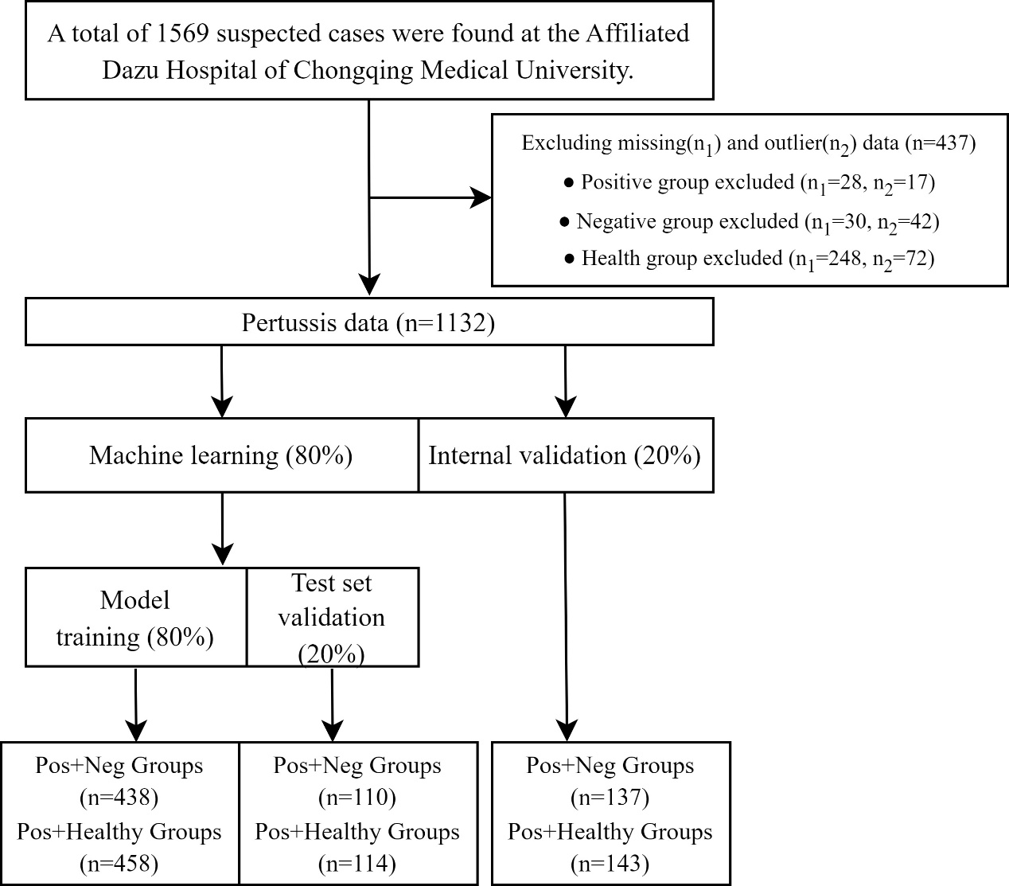

Fig. S1. Flow diagram of participant screening and data allocation

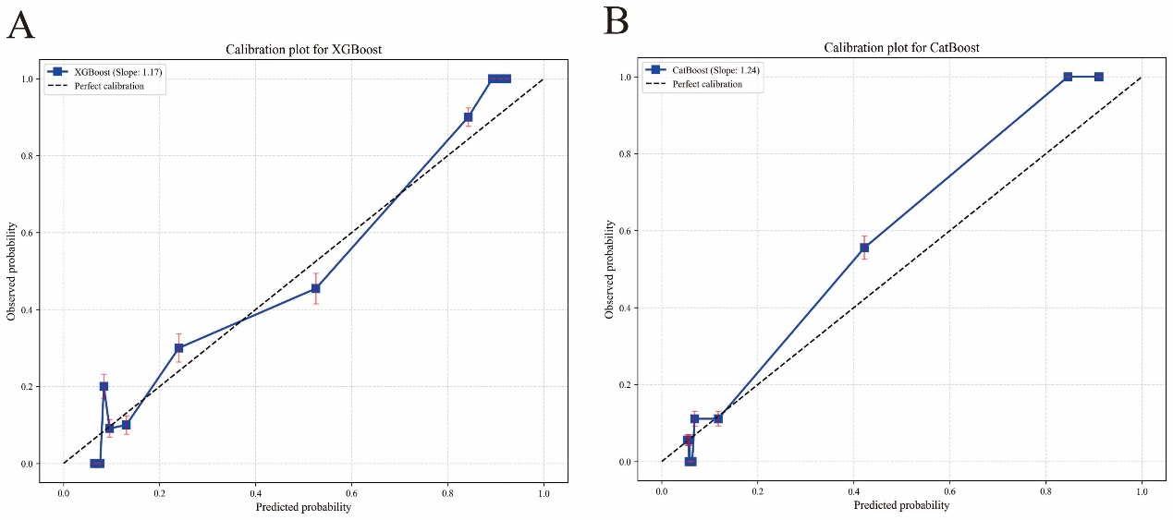

Fig. S2. Calibration Plots of the Optimal Models on the Temporal Validation set

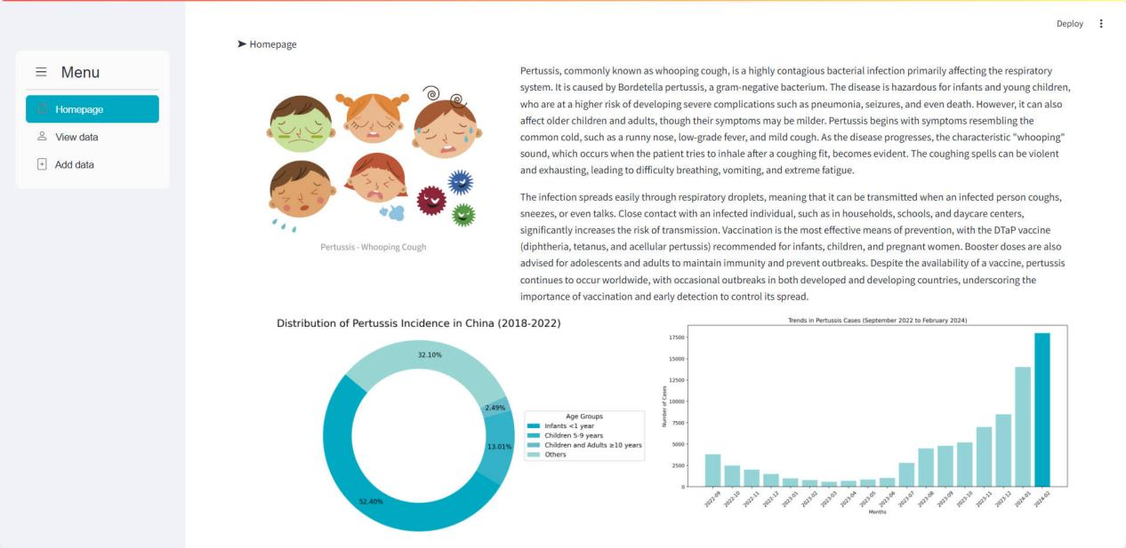

Fig. S3. Homepage Interface
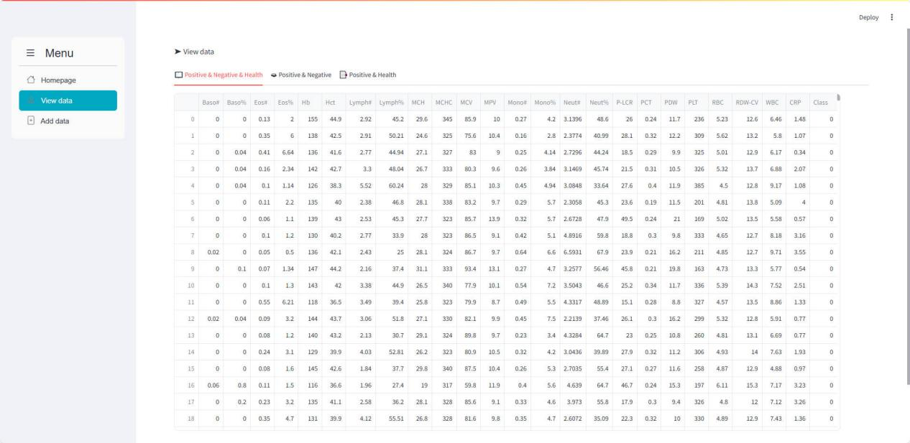

Fig. S4. View Overall Data Interface
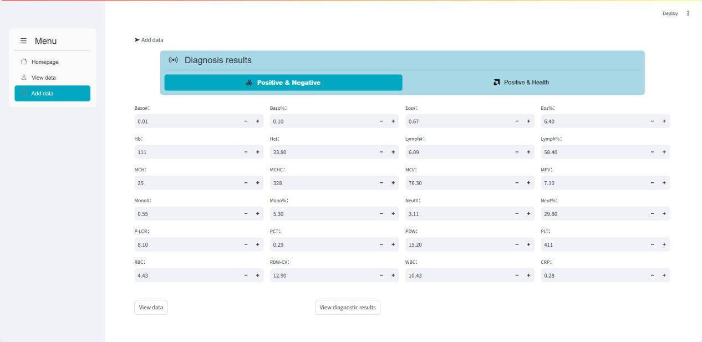

Fig. S5. Add Data Interface

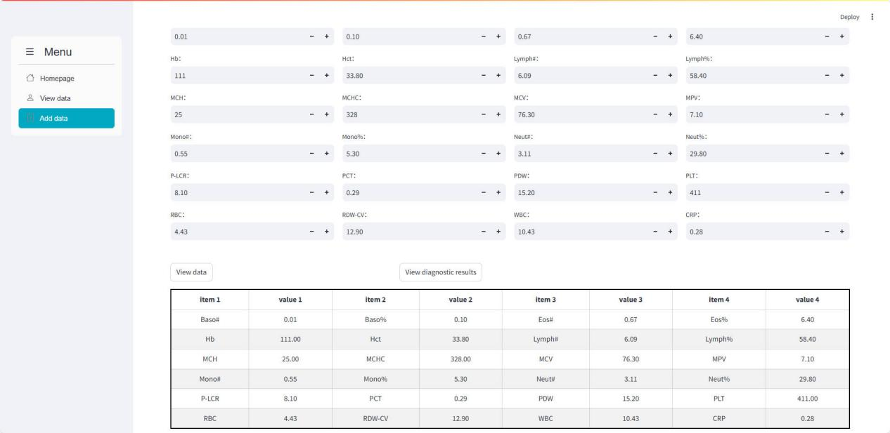

Fig. S6. View Input Data Interface
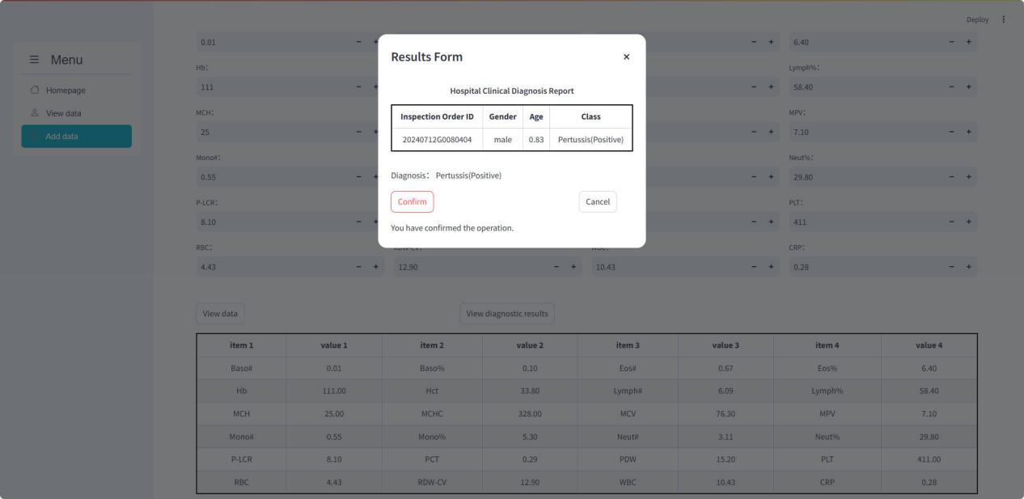

Fig. S7. View Diagnostic Report Interface

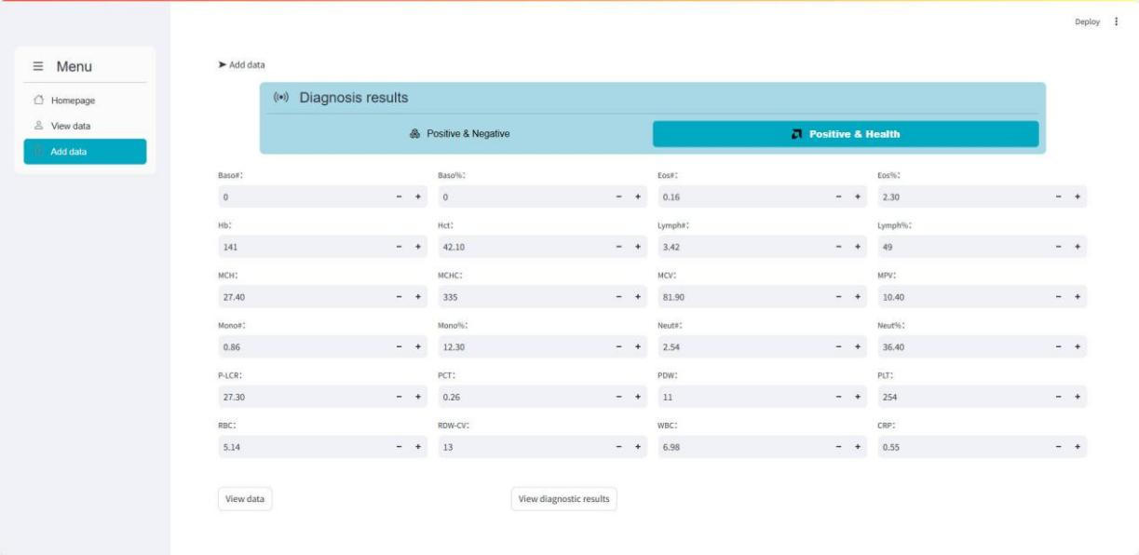Fig. S8. Add Data Interface
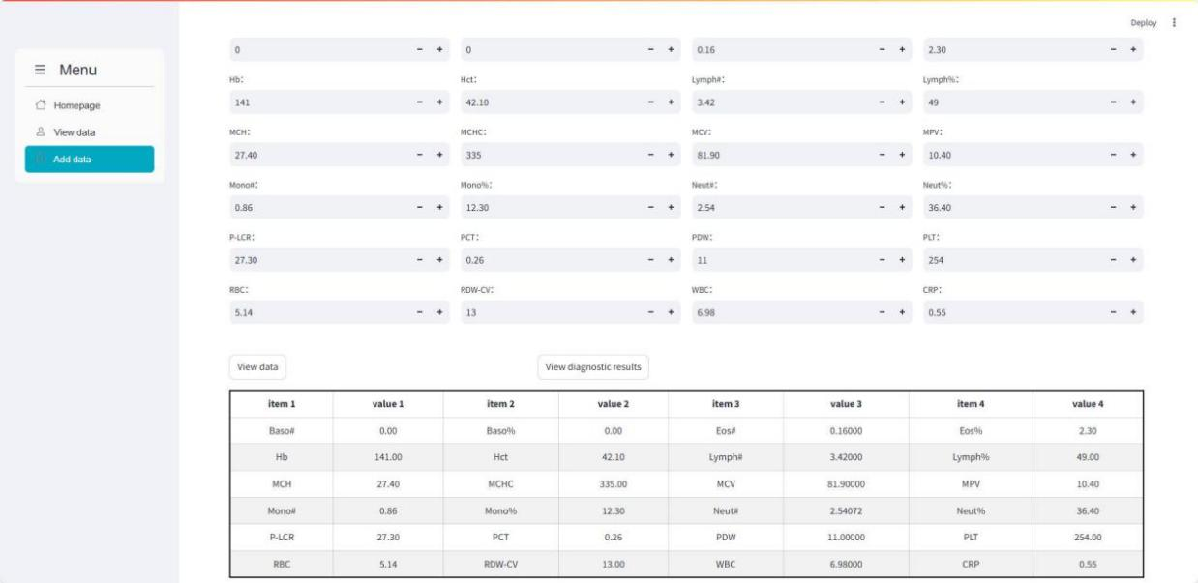

Fig. S9. View Input Data Interface
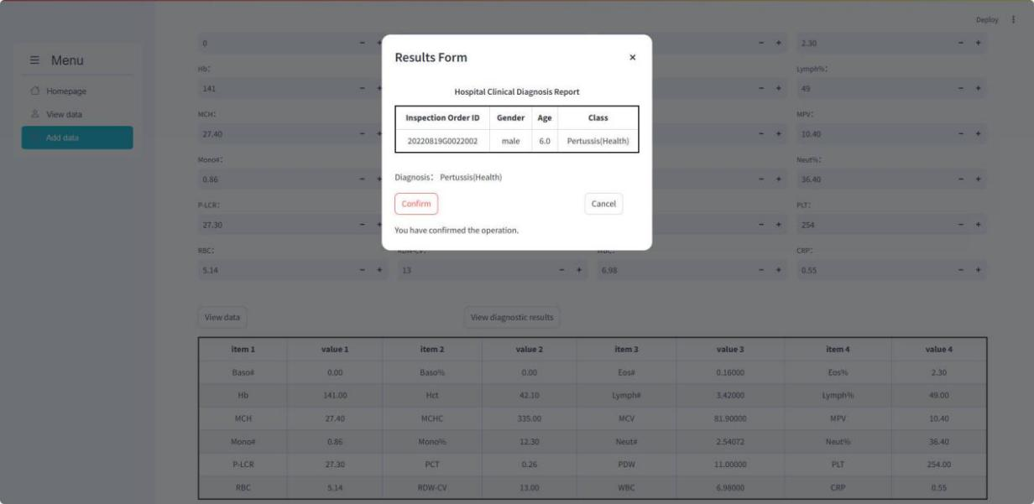

Fig. S10. View Diagnostic Report Interface

