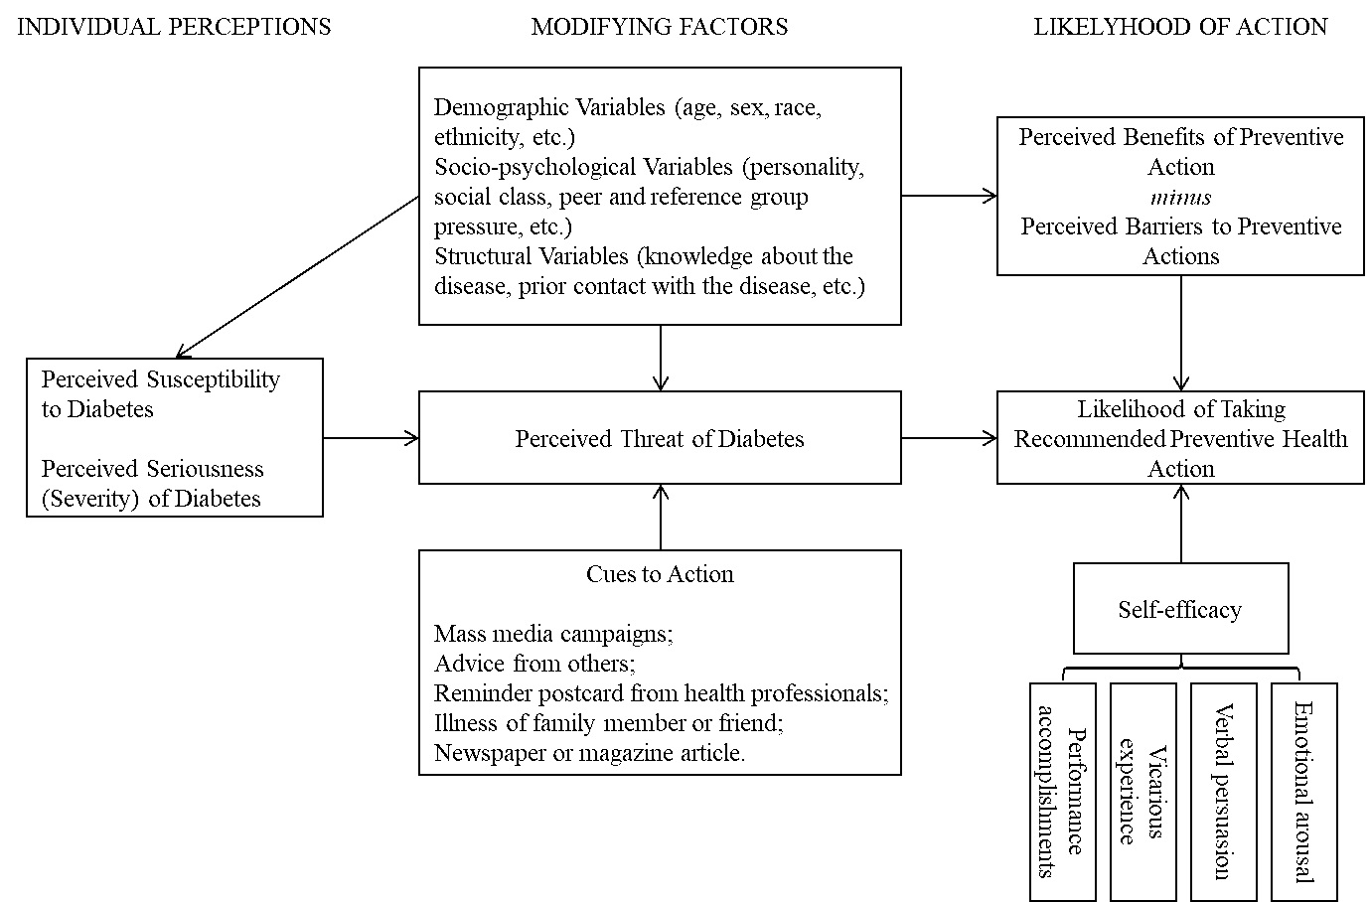
Supplementary Fig.1. Theoretical framework of the Health Belief Model and Self-Efficacy Theory

