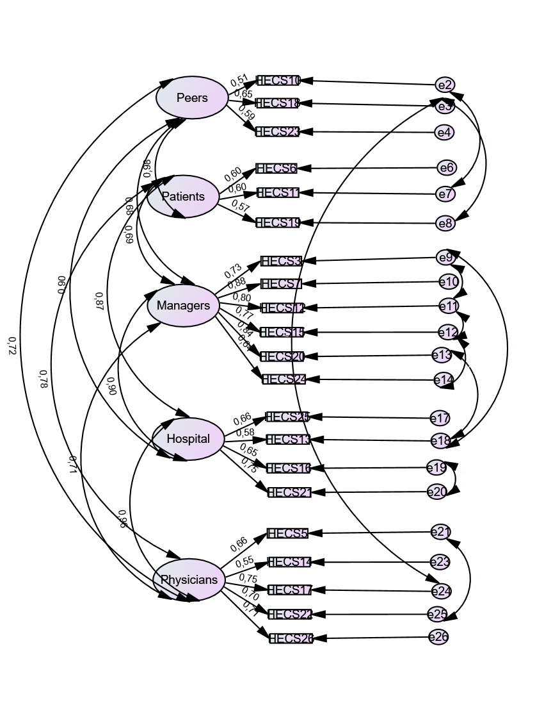
Additional file 2. Confirmatory factor analysis of the HECS-Pol

