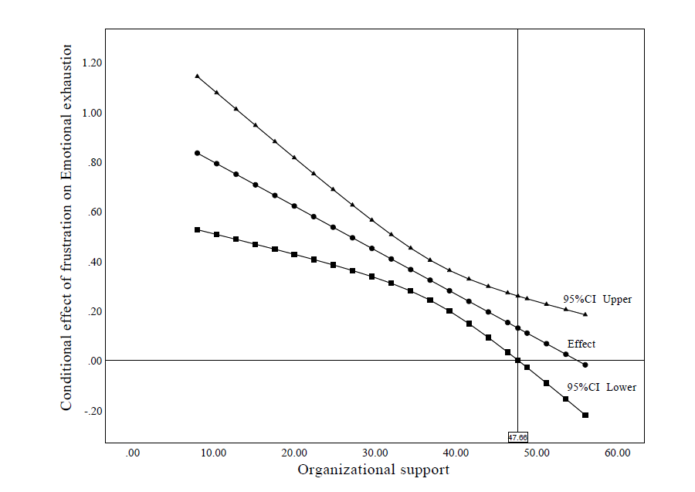
Fig.S1
The conditional effect of work frustration on emotional exhaustion at the values of perceived organizational support.

Table S1. Differences in emotional exhaustion, depersonalization, and diminished personal accomplishment among ICU nurses (n=479)
Variable | n (%) | Emotional exhaustion (M±SD) | Depersonalization  (M±SD) | Diminished personal accomplishment (M±SD)
Age | 29.67±4.76 |  | a>c/d, b>d
≤25 ª | 80(16.7) | 30.44±9.91 | 11.44±6.41 | 16.64±8.08
26-30 ^{b} | 226(47.2) | 29.21±10.50 | 10.53±6.73 | 16.59±8.76
31-35 ^{c} | 134(28.0) | 27.95±9.68 | 9.49±6.46 | 17.16±8.67
＞35 ^{d} | 39(8.1) | 27.69±12.00 | 7.62±6.58 | 15.79±8.51
F (P) |  | 1.213(0.304) | 3.646(0.013) | 0.287(0.835)
Gender
male | 97(20.3) | 28.85±10.64 | 10.93±6.95 | 16.72±9.48
female | 382(79.7) | 28.97±10.25 | 9.96±6.56 | 16.69±8.35
t (P) |  | 0.103(0.918) | 1.288(0.198) | 0.034(0.973)
Marital status
married | 344(71.8) | 28.57±10.44 | 9.69±6.64 | 16.46±8.63
single or others | 135(28.2) | 29.89±9.98 | 11.33±6.54 | 17.30±8.46
t (P) |  | 1.260(0.208) | 2.434(0.015) | 0.972(0.332)
Education
College and below | 115(24.0) | 28.42±10.76 | 9.78±5.92 | 16.28±8.83
Undergraduate and above | 364(76.0) | 29.10±10.18 | 10.27±6.86 | 16.83±8.51
t (P) |  | 0.614(0.539) | 0.684(0.494) | 0.597(0.551)
Income satisfaction |  | a<b<c | a<b<c | a<b/c
Satisfaction ª | 73(15.2) | 25.45±9.27 | 7.49±5.68 | 14.37±8.93
General ^{b} | 257(53.7) | 28.10±10.23 | 9.80±6.54 | 16.70±8.74
Dissatisfaction ^{c} | 149(31.1) | 32.10±10.18 | 12.07±6.76 | 17.83±7.94
F (P) |  | 12.596(<0.001) | 13.019(<0.001) | 4.037(0.018)
Work Experience(years) | 7.01±5.56 |  | a>c/d, b>d
≤2 ª | 82(17.1) | 30.43±9.82 | 12.07±6.59 | 16.87±8.90
2-5 ^{b} | 143(29.9) | 28.92±10.60 | 10.62±6.56 | 16.54±8.53
5-10 ^{c} | 186(38.8) | 28.75±10.02 | 9.56±6.31 | 16.54±8.28
＞10 ^{d} | 68(14.2) | 27.72±11.09 | 8.49±7.27 | 17.24±9.26
F (P) |  | 0.906(0.438) | 4.534(0.004) | 0.135(0.939)
- Professional title
Nurse practitioner | 389(81.2) | 29.16±10.35 | 10.59±6.56 | 16.96±8.56
Nurse-in-charge | 83(18.8) | 28.01±10.18 | 8.28±6.74 | 15.53±8.63
t (P) |  | 0.949(0.171) | 2.994(0.003) | 1.427(0.154)
Shift-work
yes | 449(93.7) | 29.11±10.24 | 10.29±6.62 | 16.67±8.54
no | 30(6.3) | 26.43±11.31 | 8.17±6.88 | 17.03±9.33
t (P) |  | 1.377(0.169) | 1.694(0.091) | 0.223(0.824)
M mean, SD standard deviation, t independent t-test, F analysis of variance.

Table S2 Moderation model (n=479)
Dependent  variable | Independent variable | β | SE | t | P | 95%CI
Emotional exhaustion | Satisfaction of income | 0.086 | 0.063 | 1.374 | 0.170 | -0.037 to 0.209
Emotional exhaustion | Work frustration | 0.318 | 0.041 | 7.784 | <0.001 | 0.238 to 0.394
 | POS | -0.259 | 0.045 | 5.806 | <0.001 | -0.346 to -0.171
 | Interaction term | -0.140 | 0.040 | 3.457 | <0.001 | -0.219 to -0.061
Depersonalization | Age | 0.075 | 0.093 | 0.806 | 0.421 | -0.108 to 0.257
 | Marital status | -0.141 | 0.122 | 1.161 | 0.246 | -0.380 to 0.098
 | Satisfaction of income | 0.124 | 0.073 | 1.690 | 0.092 | -0.020 to 0.267
 | Years of working | 0.049 | 0.814 | 0.605 | 0.546 | -0.111 to 0.209
 | Professional title | -0.233 | 0.144 | 1.619 | 0.106 | -0.513 to 0.050
 | Work frustration | -0.116 | 0.047 | 2.463 | 0.014 | -0.209 to -0.024
 | POS | -0.165 | 0.051 | 3.215 | 0.001 | -0.266 to -0.064
 | Interaction term | -0.024 | 0.047 | 0.516 | 0.606 | -0.116 to 0.068
Diminished personal accomplishment | Satisfaction of income | 0.136 | 0.072 | 1.891 | 0.059 | -0.005 to 0.278
Diminished personal accomplishment | Work frustration | -0.124 | 0.047 | 2.642 | 0.009 | -0.216 to -0.031
Diminished personal accomplishment | POS | -0.168 | 0.051 | 3.275 | 0.001 | -0.269 to -0.067
 | Interaction term | -0.019 | 0.047 | 0.417 | 0.677 | -0.111 to 0.278
SE standard error.CI confidence interval, POS Perceived organizational support.
Interaction term means the interaction of work frustration and perceived organizational support.

Table S3 Conditional effects of work frustration on emotional exhaustion at different levels of organizational support (n=479)
Conditional Of POS | Effect | SE | t | p | 95%CI
M-1SD | 0.458 | 0.059 | 7.712 | <0.001 | 0.341 to 0.575
M | 0.318 | 0.041 | 7.784 | <0.001 | 0.238 to 0.398
M+1SD | 0.178 | 0.055 | 3.214 | 0.001 | 0.069 to 0.287
POS Perceived organizational support, SE standard error.CI confidence interval, M mean, SD standard deviation.

