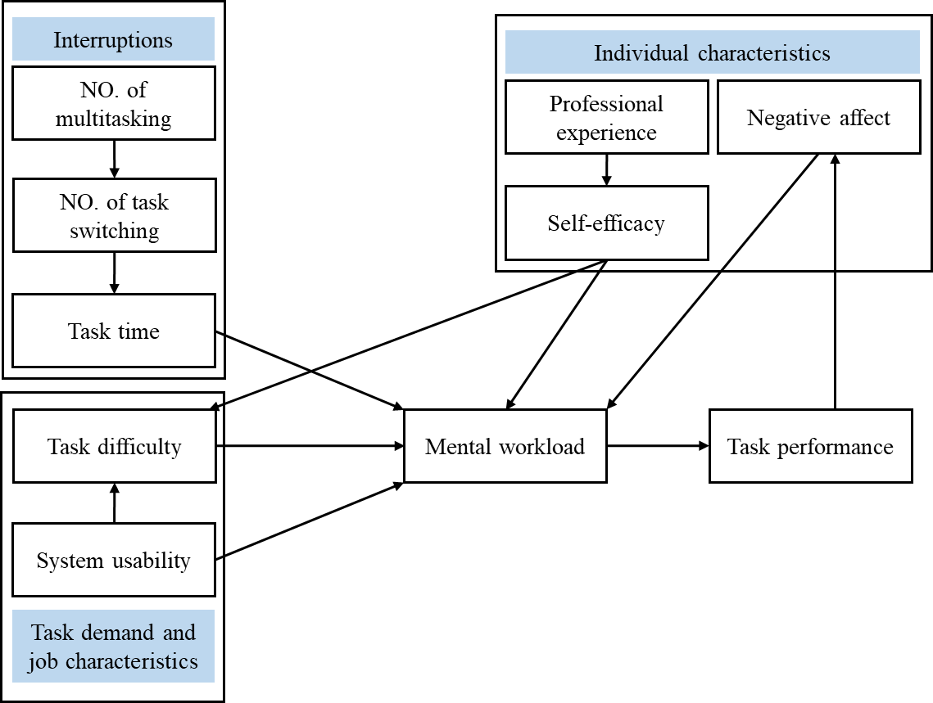
Appendix Figure 1 Hypothetical framework of influencing variables on nurses’ mental workload and performance in EHR tasks in interruptive clinical setting

