Supplementary Table 1. The caregivers' sociodemographic and patient' disease characteristics (N=265)
Sociodemographic variables | N(%) | Disease variables | N(%)
Age |  | Cancer diagnosis
18-35 | 63 (23.8%) | Breast cancer | 164 (61.9%)
36-59 | 176 (66.4%) | Lung cancer | 101 (38.1%)
≥60 | 26 (9.8%) | Cancer stage
Gender |  | Ⅰ | 86 (32.5%)
Male | 117 (44.2%) | Ⅱ | 111 (41.9%)
Female | 148 (55.8%) | Ⅲ | 44 (16.9%)
Education |  | Ⅳ | 24 (9.1%)
Primary school or less | 44 (16.6%) | Cancer diagnosis time
High school | 46 (17.4%) | ＜6 months | 155 (58.5%)
Bachelor and above | 175 (66.0%) | 6-12 months | 55 (20.8%)
Religion |  | ＞12 months | 55 (20.8%)
Yes | 18 (6.8%)
No | 247 (93.2%)
Marital
Never married | 35 (13.2%)
Married | 219 (82.6%)
Divorced/widowed | 11 (4.2%)
Income/month
Low | 92 (34.8%)
Moderate | 78 (29.4%)
High | 95 (35.8%)
Duration of caregiving
1 to 6 months | 89 (33.6%)
7 to 12 months | 99 (37.3%)
More than a year | 77 (29.1%)
Work situation
Working | 183 (69.1%)
Retired | 40 (15.1%)
No job | 42 (15.8%)
Relationship with patients
Spouse | 82 (30.9%)
Children | 134 (50.6%)
Parents | 7 (2.6%)
Other | 42 (15.8%)

Supplementary Table2. Bayesian SEM path coefficient test
Path |  |  | coefficients | Standard | Standard | P | 95%CI
 |  |  |  | coefficients | error |  | Lower | Upper
CB | → | CAT | -0.345 | -0.481 | 0.046 | *** | -0.568 | -0.386
CB | → | CO | -0.001 | -0.002 | 0.070 | 0.934 | -0.137 | 0.135
CB | → | AG | 0.590 | 0.757 | 0.043 | *** | 0.667 | 0.839
FR | → | CAT | 0.128 | 0.241 | 0.062 | *** | 0.120 | 0.360
FR | → | CO | 0.033 | 0.104 | 0.072 | 0.159 | -0.041 | 0.240
FR | → | AG | -0.002 | -0.003 | 0.056 | 0.949 | -0.115 | 0.111
PC | → | CAT | 0.063 | 0.189 | 0.059 | 0.001 | 0.069 | 0.301
PC | → | CO | 0.047 | 0.236 | 0.066 | *** | 0.102 | 0.364
PC | → | AG | -0.003 | -0.007 | 0.052 | 0.932 | -0.107 | 0.096
CAT | → | CO | 0.145 | 0.245 | 0.070 | *** | 0.108 | 0.381
CAT | → | AG | -0.059 | -0.054 | 0.058 | 0.314 | -0.166 | 0.061
CO | → | AG | -0.189 | -0.103 | 0.050 | 0.027 | -0.201 | -0.007
Note: AG, Anticipatory grief; CB, Caregiver burden; FR, Family resilience; PC, Psychological capital; CAT, Cognitive appraisal tendency; CO, Coping tendency. Bolded values are statistically significant.

Supplementary Figure 1. The hypothesized model.
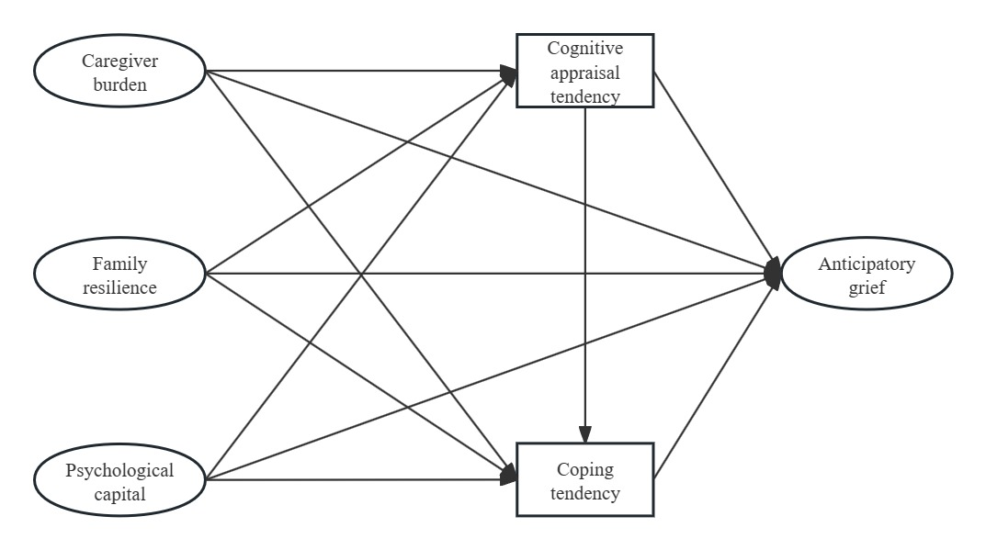

Supplementary Figure 2. Iteration trace plots. AG, Anticipatory grief; CB, Caregiver burden; FR, Family resilience; PC, Psychological capital
