Supplementary Table 1 Sample characteristics of participants with and without mental problems (depression, anxiety and PTSD).
Variable | Overall ( %) |  | Anxiety |  |  | Depression |  |  |  | PTSD |  |  |  | Anxiety/Depression/PTSD
Variable |  |  | Positive(%) | χ² | P | Positive(%) | χ² | P | Positive(%) |  | χ² | P | Positive(%) |  | χ² | P
Age |  |  |  | 0.706 | 0.703 |  | 0.142 | 0.931 |  |  | 0.093 | 0.054 |  |  | 0.568 | 0.753
≤30 |  | 170(33.33) | 19(11.18) |  |  | 33(19.41) |  |  | 30(17.65) |  |  |  | 44(25.88)
31-50 |  | 333(65.29) | 46(13.81) |  |  | 62(18.62) |  |  | 56(16.82) |  |  |  | 89(26.73)
≥51 |  | 7(1.37) | 1(14.29) |  |  | 1(14.29) |  |  | 1(14.29) |  |  |  | 1(14.29)
Gender |  |  |  | 1.709 | 0.191 |  | 1.870 | 0.171 |  |  | 4.697 | 0.030 |  |  | 1.426 | 0.232
Female |  | 469(91.96) | 58(12.37) |  |  | 85(18.12) |  |  | 75(15.99) |  |  |  | 120(25.59)
Male |  | 41(8.04) | 8(19.51) |  |  | 11(26.83) |  |  | 12(29.27) |  |  |  | 14(34.15)
Years of experience |  |  |  | 4.520 | 0.104 |  | 1.648 | 0.439 |  |  | 3.690 | 0.158 |  |  | 1.581 | 0.454
≤4 |  | 80(15.69) | 6(7.50) |  |  | 14(17.50) |  |  | 12(15.00) |  |  |  | 19(23.75)
5-10 |  | 194(38.04) | 32(16.49) |  |  | 42(21.65) |  |  | 41(21.13) |  |  |  | 57(29.38)
≥11 |  | 236(46.27) | 28(11.86) |  |  | 40(16.95) |  |  | 34(14.41) |  |  |  | 58(24.58)
Marital status |  |  |  | 1.093 | 0.296 |  | 1.643 | 0.200 |  |  | 0.345 | 0.557 |  |  | 2.184 | 0.139
unmarried |  | 128(25.10) | 20(15.63) |  |  | 29(22.66) |  |  | 24(18.75) |  |  |  | 40(31.25)
Married |  | 382(74.90) | 46(12.04) |  |  | 67(17.54) |  |  | 63(16.49) |  |  |  | 94(24.61)
Number of children |  |  |  | 3.783 | 0.151 |  | 3.676 | 0.159 |  |  | 1.634 | 0.442 |  |  | 3.442 | 0.179
0 |  | 155(30.39) | 23(14.84) |  |  | 36(23.23) |  |  | 30(19.35) |  |  |  | 48(30.97)
1 |  | 211(41.37) | 31(14.69) |  |  | 39(18.48) |  |  | 37(17.54) |  |  |  | 55(26.07)
≥2 |  | 144(28.24) | 12(8.33) |  |  | 21(14.58) |  |  | 20(13.89) |  |  |  | 31(21.53)
Education level |  |  |  | 4.908 | 0.055 |  | 1.766 | 0.434 |  |  | 0.761 | 0.700 |  |  | 0.554 | 0.758
Junior college or below |  | 18(3.53) | 3(16.67) |  |  | 5(27.78) |  |  | 4(22.22) |  |  |  | 6(33.33)
Bachelor degree |  | 471(92.35) | 57(12.10) |  |  | 86(18.26) |  |  | 79(16.77) |  |  |  | 122(25.90)
Master degree or above |  | 21(4.12) | 6(28.57) |  |  | 5(23.81) |  |  | 4(19.05) |  |  |  | 6(28.57)
Title |  |  |  | 0.361 | 0.948 |  | 0.218 | 0.975 |  |  | 2.851 | 0.415 |  |  | 1.384 | 0.709
Nurse |  | 62(12.16) | 7(11.29) |  |  | 12(19.35) |  |  | 10(16.13) |  |  |  | 14(22.58)
Nurse Practitioner |  | 190(37.25) | 24(12.63) |  |  | 36(18.95) |  |  | 39(20.53) |  |  |  | 53(27.89)
Supervisor/Associate Supervisor Nurse |  | 232(45.49) | 32(13.79) |  |  | 44(18.97) |  |  | 35(15.09) |  |  |  | 62(26.72)
Chief/Associate Chief Nurse |  | 26(5.10) | 3(11.54) |  |  | 4(15.38) |  |  | 3(11.54) |  |  |  | 5(19.23)
Number of night shifts per month |  |  |  | 12.062 | 0.007 |  | 9.860 | 0.020 |  |  | 9.688 | 0.021 |  |  | 11.119 | 0.011
None |  | 81(15.88) | 6(7.41) |  |  | 8(9.88) |  |  | 6(7.41) |  |  |  | 12(14.81)
1-4 |  | 75(14.71) | 11(14.67) |  |  | 15(20.00) |  |  | 11(14.67) |  |  |  | 19(25.33)
5-9 |  | 275(53.92) | 30(10.91) |  |  | 50(18.18) |  |  | 50(18.18) |  |  |  | 73(26.55)
≥10 |  | 79(15.49) | 19(24.05) |  |  | 23(29.11) |  |  | 20(25.32) |  |  |  | 30(37.97)
Authorized strength |  |  |  | 0.392 | 0.531 |  | 3.484 | 0.062 |  |  | 2.408 | 0.121 |  |  | 1.701 | 0.192
No |  | 370(72.55) | 50(13.51) |  |  | 77(20.81) |  |  | 69(18.65) |  |  |  | 103(27.84)
Yes |  | 140(27.45) | 16(11.43) |  |  | 19(13.57) |  |  | 18(12.86) |  |  |  | 31(22.14)
Department |  |  |  | 2.104 | 0.835 |  | 1.957 | 0.855 |  |  | 2.142 | 0.829 |  |  | 2.614 | 0.759
Internal medicine |  | 149(29.22) | 16(10.74) |  |  | 26(17.45) |  |  | 24(16.11) |  |  |  | 34(22.82)
Surgery |  | 97(19.02) | 12(12.37) |  |  | 15(15.46) |  |  | 18(18.56) |  |  |  | 27(27.84)
Obstetrics and gynecology |  | 9(1.76) | 2(22.22) |  |  | 2(22.22) |  |  | 1(11.11) |  |  |  | 3(33.33)
Pediatric |  | 29(5.69) | 3(10.34) |  |  | 7(24.14) |  |  | 4(13.79) |  |  |  | 8(27.59)
Emergency/critical care |  | 183(35.88) | 27(14.75) |  |  | 38(20.77) |  |  | 35(19.13) |  |  |  | 53(28.96)
Other |  | 43(8.43) | 6(13.95) |  |  | 8(18.60) |  |  | 5(11.63) |  |  |  | 9(20.93)

Supplementary Table 2 Correlation matrices for each node of anxiety, depression and PTSD network
 | A1 | A2 | A3 | A4 | A5 | A6 | A7 | D1 | D2 | D3 | D4 | D5 | D6 | D7 | D8 | D9 | P1 | P2 | P3 | P4
A1
A2 | 0.197
A3 | 0.158 | 0.231
A4 | 0.184 | 0.130 | 0.348
A5 | 0.000 | 0.169 | 0.000 | 0.033
A6 | 0.169 | 0.052 | 0.138 | 0.165 | 0.096
A7 | 0.111 | 0.171 | 0.032 | 0.046 | 0.283 | 0.132
D1 | 0.065 | 0.000 | 0.000 | 0.009 | 0.000 | 0.000 | 0.000
D2 | 0.051 | 0.062 | 0.048 | 0.000 | 0.000 | 0.017 | 0.024 | 0.365
D3 | 0.000 | 0.000 | 0.095 | 0.093 | 0.000 | 0.000 | 0.000 | 0.000 | 0.077
D4 | 0.000 | 0.000 | 0.000 | 0.009 | 0.000 | 0.039 | 0.000 | 0.371 | 0.106 | 0.282
D5 | 0.000 | 0.000 | 0.000 | 0.089 | 0.000 | 0.000 | 0.019 | 0.063 | 0.000 | 0.162 | 0.200
D6 | 0.000 | 0.000 | 0.053 | 0.022 | 0.000 | 0.052 | 0.000 | 0.000 | 0.219 | 0.000 | 0.000 | 0.095
D7 | 0.000 | 0.000 | 0.000 | 0.000 | 0.039 | 0.000 | 0.000 | 0.037 | 0.014 | 0.040 | 0.000 | 0.058 | 0.214
D8 | 0.000 | 0.000 | 0.000 | 0.000 | 0.144 | 0.000 | 0.000 | 0.025 | 0.017 | 0.000 | 0.000 | 0.094 | 0.174 | 0.388
D9 | 0.000 | 0.028 | 0.000 | 0.000 | 0.000 | 0.000 | 0.187 | 0.000 | 0.000 | 0.000 | -0.006 | 0.000 | 0.101 | 0.145 | 0.179
P1 | 0.012 | 0.061 | 0.007 | 0.015 | 0.026 | 0.000 | 0.011 | 0.000 | 0.000 | 0.000 | 0.000 | 0.000 | 0.000 | 0.000 | 0.000 | 0.000
P2 | 0.000 | 0.000 | 0.000 | 0.000 | 0.015 | -0.036 | 0.045 | 0.000 | 0.000 | 0.000 | -0.003 | 0.000 | 0.000 | 0.003 | 0.023 | 0.068 | 0.383
P3 | 0.000 | 0.000 | 0.000 | 0.032 | 0.000 | 0.177 | -0.050 | 0.000 | 0.037 | 0.000 | 0.010 | 0.000 | 0.000 | 0.000 | 0.000 | 0.000 | 0.384 | 0.018
P4 | 0.000 | 0.000 | -0.030 | 0.000 | 0.073 | -0.051 | 0.000 | 0.000 | 0.000 | 0.000 | 0.000 | 0.000 | 0.000 | 0.064 | 0.000 | 0.105 | 0.250 | 0.379 | 0.163 | 0.000
Note: Edge-weights represent the size and direction of the link between two nodes. A1: Nervousness; A2: Uncontrollable worry; A3: Excessive worry; A4: Trouble relaxing; A5: Restlessness; A6: Irritability; A7: Feeling afraid; D1: Anhedonia; D2: Sad mood; D3: Sleeping; D4: Fatigue; D5: Appetite; D6: Worthless; D7: Concentration; D8: Motor; D9: Suicidality ideation; P1: Startle; P2: Physiological arousal; P3: Anger; P4: Numbness

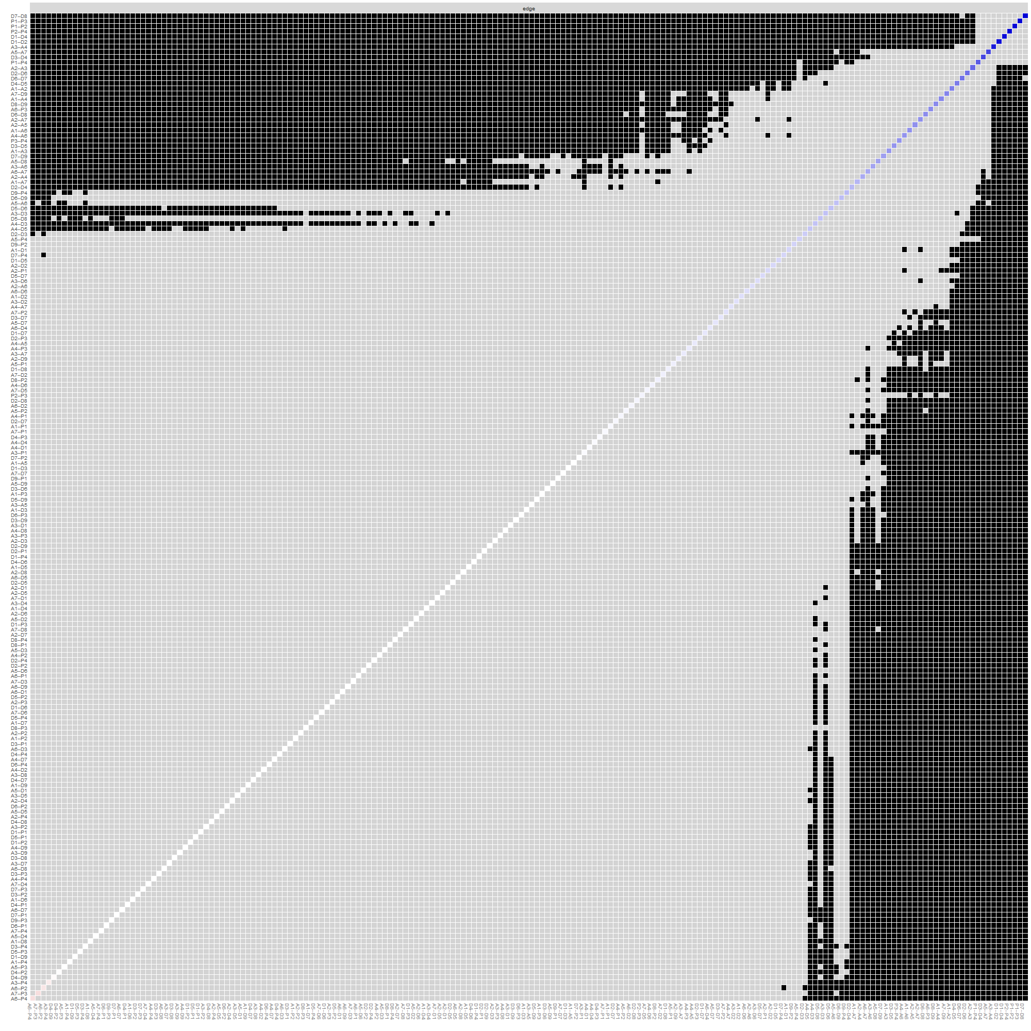
Supplementary Fig. 1 Bootstrapped difference tests for edge weights
Note: Gray boxes represent no significant difference between edge weights, while black boxes represent significant difference. Blue boxes on the diagonal represent edge weights with positive correlations. Red boxes on the diagonal represent edge weights with negative correlations.A1: Nervousness; A2: Uncontrollable worry; A3: Excessive worry; A4: Trouble relaxing; A5: Restlessness; A6: Irritability; A7: Feeling afraid; D1: Anhedonia; D2: Sad mood; D3: Sleeping; D4: Fatigue; D5: Appetite; D6: Worthless; D7: Concentration; D8: Motor; D9: Suicidality ideation; P1: Startle; P2: Physiological arousal; P3: Anger; P4: Numbness

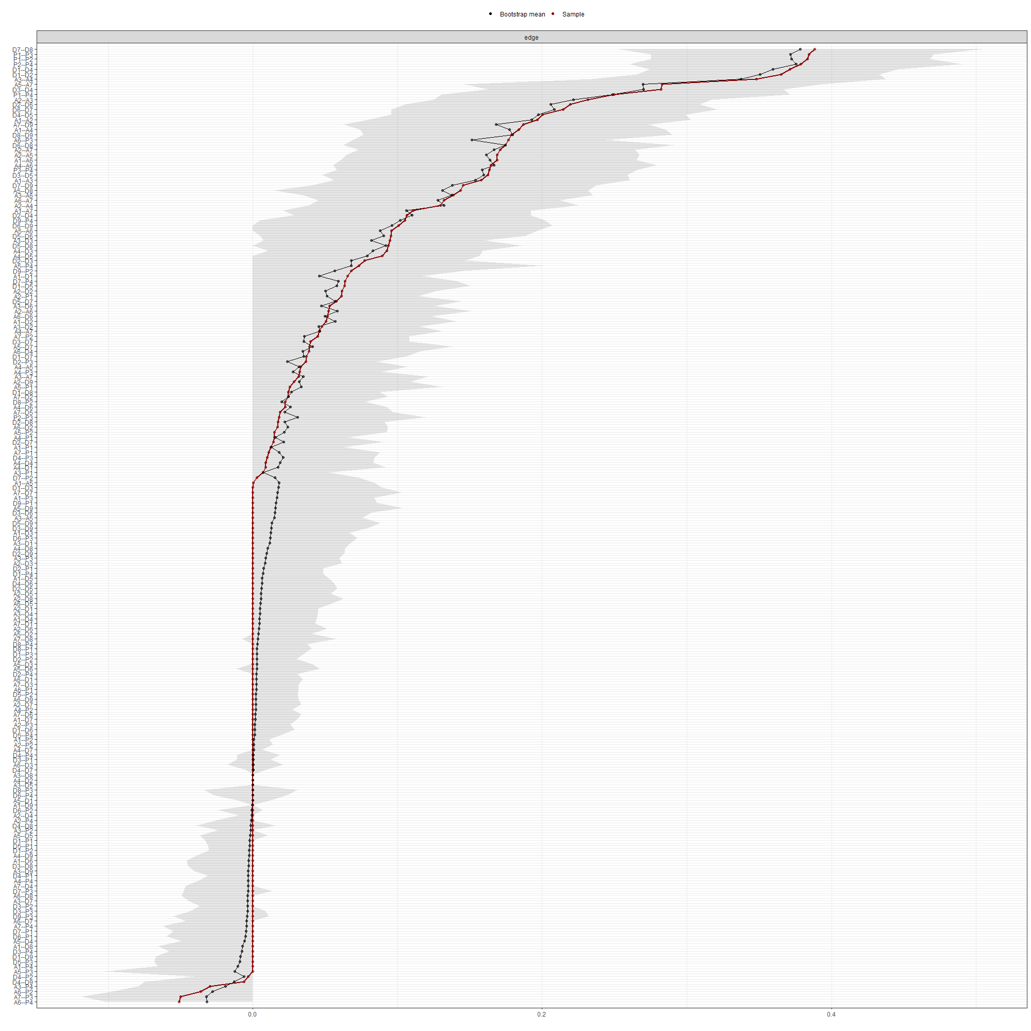
Supplementary Fig. 2 Bootstrapped 95% confidence intervals (CIs) of edge weights
Note: The red line represents the edge weights. The gray area depicts the 95% CIs of edge weights. A1: Nervousness; A2: Uncontrollable worry; A3: Excessive worry; A4: Trouble relaxing; A5: Restlessness; A6: Irritability; A7: Feeling afraid; D1: Anhedonia; D2: Sad mood; D3: Sleeping; D4: Fatigue; D5: Appetite; D6: Worthless; D7: Concentration; D8: Motor; D9: Suicidality ideation; P1: Startle; P2: Physiological arousal; P3: Anger; P4: Numbness

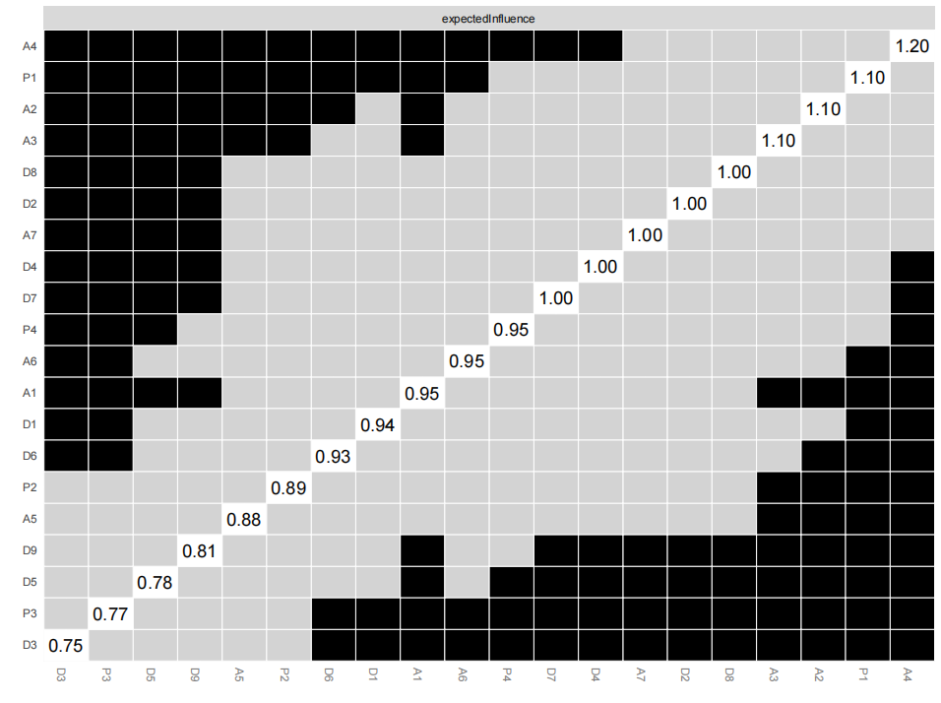
Supplementary Fig. 3 Bootstrapped difference tests for node EI
Note: Gray boxes represent no significant difference between nodes, while black boxes represent significant difference. White boxes on the diagonal represent the values of node EI. A1: Nervousness; A2: Uncontrollable worry; A3: Excessive worry; A4: Trouble relaxing; A5: Restlessness; A6: Irritability; A7: Feeling afraid; D1: Anhedonia; D2: Sad mood; D3: Sleeping; D4: Fatigue; D5: Appetite; D6: Worthless; D7: Concentration; D8: Motor; D9: Suicidality ideation; P1: Startle; P2: Physiological arousal; P3: Anger; P4: Numbness

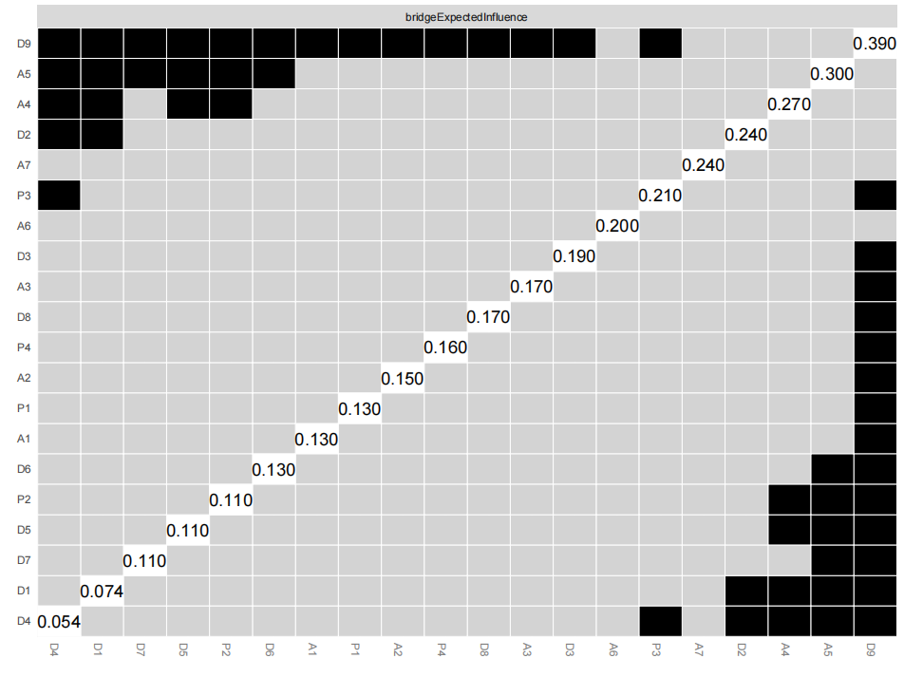
Supplementary Fig. 4 Bootstrapped difference tests for BEI
Note: Gray boxes represent no significant difference between nodes, while black boxes represent significant difference. White boxes on the diagonal represent the values of node BEI. A1: Nervousness; A2: Uncontrollable worry; A3: Excessive worry; A4: Trouble relaxing; A5: Restlessness; A6: Irritability; A7: Feeling afraid; D1: Anhedonia; D2: Sad mood; D3: Sleeping; D4: Fatigue; D5: Appetite; D6: Worthless; D7: Concentration; D8: Motor; D9: Suicidality ideation; P1: Startle; P2: Physiological arousal; P3: Anger; P4: Numbness

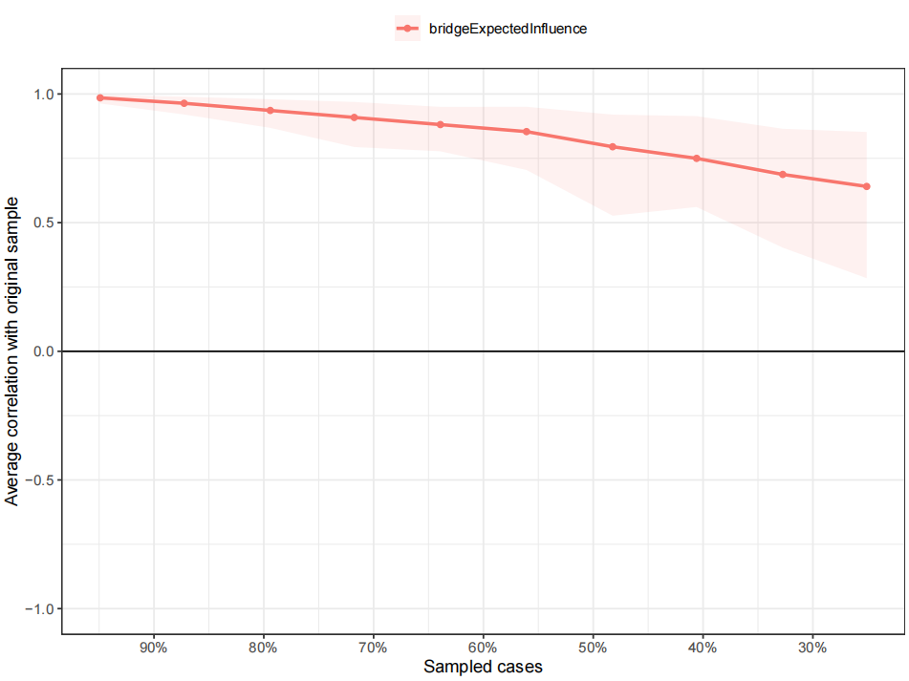
Supplementary Fig. 5 The stability of BEI by the case-dropping bootstrapping
Note: The x-axis represents the percentage of cases in the original sample used at each step. The y-axis represents the average of the correlations between the centrality index in the original network and the centrality index in the network re-estimated after dropping increasing percentages of cases. The dark red line represents the average correlation coefficient enclosed with red shade representing the 95% confidence interval.

