Analysis Following the Inclusion of the Control Group
To further compare the autonomic state of nurses after night shifts, particularly during the six-minute walk test (6MWT), we recruited 35 additional subjects as a new control group (Group B). Of these, 20 participants were from the previous trial (Group A), and 15 were newly enrolled because 15 of the original subjects were unable to rejoin the study due to reasons such as marriage, vacation, or illness (e.g., diarrhea).
The trial began the day before their night shift, typically an evening shift. The average age of the control group was 28.2 ± 4.4 years, the duration of night shift work was 5.3 ± 4.2 years, the frequency of night shifts in last 1 month was 6.3 ± 1.9 days, and the time since their last night shift was 5.3 ± 2.6 days (range, 1–14 days) before participating in the experiment.
Compared to the 6MWT conducted on the first morning following the night shift in Group A, the heart rate variability (HRV) of Group B showed a similar performance to that observed on the second morning following the night shift in Group A. For detailed data, please refer to Supplementary Tables S1, S2, and S3.
Additionally, a line chart was used to depict the three 6MWTs. We compared the statistical differences in HRV indices between the first and second 6MWTs, as well as between the first and third 6MWTs. Details can be found in Figure S1 of Supplementary materials.
Although the inclusion of subjects in Group B was suboptimal, as 15 participants were not recruited from Group A, the statistical results were generally consistent with those from the previous phase of the study. These findings suggest that night shifts have a measurable impact on nurses' autonomic regulation, as assessed by HRV.

Table S1 Clinical features of the study population
 | N (%) |  | Group A |  | Group B
 | Group A | Group B | Mean (SD) | Range | Mean (SD) | Range
Marital status (married) | 13 (37.1) | 11 (31.4)
Smoking status | 0 (0) | 0 (0)
Alcohol consumption status | 0 (0) | 0 (0)
Caffeine consumption (years) | 7 (20.0) | 5 (14.3) | 0.5 (1.2) | 0.0-5.0 | 0.6 (1.7) | 0.0-8.0
Tea consumption (years) | 5 (14.3) | 2 (5.7) | 0.4 (1.1) | 0.0-5.0 | 0.4 (1.8) | 0.0-10.0
Age (years) |  |  | 28.7 (4.3) | 21.0-37.0 | 28.2 (4.4) | 22.0-37.0
Weight (kg) |  |  | 55.9 (5.8) | 43.0-67.0 | 55.5 (7.6) | 46.0-83.0
Height (cm) |  |  | 161.1 (4.6) | 152.0-170.0 | 160.9 (4.5) | 152.0-170.0
BMI (kg/m²) |  |  | 21.6 (2.3) | 17.4-27.8 | 21.4 (2.8) | 17.6-30.9
Duration of night shift work (years) |  |  | 6.0 (4.1) | 1.0-15.0 | 5.3 (4.2) | 1.0-16.0
Frequency of night shifts (days) |  |  | 6.6 (1.5) | 5.0-10.0 | 6.3 (1.9) | 4.0-13.0
Sleep duration before night shift (hours) |  |  | 9.9 (2.1) | 6.0-15.0 | 8.3 (2.5) | 5.0-16.0
Number of arousals before night shift |  |  | 1.8 (1.3) | 0.0-6.0 | 1.2 (1.2) | 0.0-5.0
Sleep quality before night shift (0-10) |  |  | 6.6 (1.7) | 3.0-10.0 | 7.3 (1.5) | 4.0-9.0
Intensity of night shift work (0-10) |  |  | 6.5 (2.4) | 1.0-10.0 | 5.9 (2.0) | 2.0-10.0
Sleep duration after night shift (hours) |  |  | 11.4 (2.3) | 6.5-16.0
Number of arousals after night shift |  |  | 2.4 (1.8) | 0.0-10.0
Sleep quality after night shift (0-10) |  |  | 6.9 (1.9) | 3.0-10.0
Note: Group A, representing the 35 participants included for the first time, was enrolled in the six-minute walk test on the first and second postshift morning; Group B, representing the 35 participants in the control group who were additionally included, walked a six-minute walk test 1 day before the night shift; BMI, body mass index; SD, standard deviation.

Table S2 General information concerning the 6MWT
Variable | First 6MWT |  | Second 6MWT |  | Third 6MWT | P₁ | P₂ | P₃
 | Mean (SD) |  | Mean (SD) |  | Mean (SD) | P₁ | P₂ | P₃
Walking distance (meters) | 560.1 (56.1) |  | 576.4 (54.8) |  | 575.6 (60.8) | 0.009** | 0.274 | 0.952
RPE before 6MWT | 13.6 (3.4) |  | 12.3 (2.4) |  | 11.4 (2.7) | 0.032* | 0.003** | 0.273
RPE after 6MWT | 15.2 (2.8) |  | 13.8 (2.7) |  | 13.2 (2.4) | 0.003** | 0.003** | 0.346
Delta RPE | 1.6 (2.4) |  | 1.5 (2.0) |  | 1.9 (2.4) | 0.947 | 0.712 | 0.794
Borg before 6MWT | 1.2 (1.5) |  | 0.5 (0.8) |  | 0.5 (0.8) | 0.005** | 0.047* | 0.700
Borg after 6MWT | 1.9 (1.7) |  | 1.2 (1.0) |  | 1.2 (1.2) | 0.004** | 0.027* | 0.704
Delta Borg | 0.7 (0.7) |  | 0.6 (0.7) |  | 0.6 (0.8) | 0.533 | 0.342 | 0.613
SBP before 6MWT (mmHg) | 106.9 (9.4) |  | 106.5 (8.8) |  | 101.7 (10.8) | 0.793 | 0.011* | 0.012*
SBP after 6MWT (mmHg) | 107.9 (9.4) |  | 108.7 (9.9) |  | 106.3 (11.8) | 0.611 | 0.532 | 0.361
Delta SBP | 1.0 (6.8) |  | 2.2 (8.9) |  | 4.6 (7.3) | 0.531 | 0.040* | 0.078
DBP before 6MWT (mmHg) | 75.1 (6.9) |  | 73.9 (7.6) |  | 74.2 (7.9) | 0.245 | 0.617 | 0.948
DBP after 6MWT (mmHg) | 77.1 (7.9) |  | 76.8 (7.0) |  | 76.9 (8.9) | 0.808 | 0.955 | 0.929
Delta DBP | 1.9 (5.4) |  | 2.8 (6.0) |  | 2.7 (5.5) | 0.535 | 0.555 | 0.958
Pulse rate before 6MWT (bpm) | 79.0 (10.7) |  | 83.1 (11.0) |  | 89.5 (12.0) | 0.044* | 0.000*** | 0.058
Pulse rate after 6MWT (bpm) | 86.5 (10.9) |  | 91.2 (10.9) |  | 99.1 (14.2) | 0.003** | 0.000*** | 0.011*
Delta pulse rate | 7.5 (7.0) |  | 8.1 (7.6) |  | 9.7 (9.3) | 0.655 | 0.287 | 0.459
Note: 6MWT, six-minute walk test; SD, standard deviation; RPE, rating of perceived exertion; SBP, systolic blood pressure; DBP, diastolic blood pressure; bpm, beat per minute; Group A, representing the 35 participants included for the first time, was enrolled in the 6MWT on the first and second postshift morning; Group B, representing the 35 participants in the control group who were additionally included, walked a 6MWT 1 day before the night shift; First 6MWT, Group A subjects walked the 6MWT on the first postshift morning; Second 6MWT, Group A subjects walked the 6MWT on the second postshift morning; Third 6MWT, Group B subjects walked the 6MWT 1 day before the night shift; p_{1,} first vs. second 6MWT; p_{2,} first vs. third 6MWT; p_{3,} second vs. third 6MWT; * p < 0.05, ** p < 0.01, *** p < 0.001.

Table S3 HRV during the 6MWT
Variable | First 6MWT |  | Second 6MWT |  | Third 6MWT | P₁ | P₂ | P₃
 | Mean (SD) |  | Mean (SD) |  | Mean (SD) | P₁ | P₂ | P₃
Stage 1
SDNN (ms) | 50.3 (20.7) |  | 39.7 (13.5) |  | 35.4 (11.9) | 0.001** | 0.001** | 0.163
RMSSD (ms) | 28.9 (28.5) |  | 20.1 (9.1) |  | 16.1 (7.2) | 0.001** | 0.000*** | 0.054
pNN50 (%) | 6.2 (10.2) |  | 2.6 (4.6) |  | 0.7 (2.4) | 0.006** | 0.000*** | 0.017*
TP (ms²) | 1727.5 (1268.4) |  | 1184.8 (1083.4) |  | 1057.4 (1306.0) | 0.020* | 0.008** | 0.534
VLF (ms²) | 1195.1 (982.3) |  | 838.4 (847.8) |  | 723.4 (1074.8) | 0.042* | 0.005** | 0.618
LF (ms²) | 411.8 (325.2) |  | 279.9 (247.1) |  | 275.8 (211.5) | 0.023* | 0.094 | 0.814
HF (ms²) | 110.9 (117.9) |  | 60.8 (57.6) |  | 54.0 (75.0) | 0.011* | 0.004** | 0.372
LF/HF | 6.2 (7.2) |  | 7.1 (6.6) |  | 9.5 (7.5) | 0.169 | 0.017* | 0.101
Stage 2- Stage 1
Delta1-SDNN (ms) | 9.3 (29.0) |  | 17.7 (18.4) |  | 10.8 (14.0) | 0.130 | 0.526 | 0.084
Delta1-TP (ms²) | 241.7 (2451.5) |  | 336.6 (2350.6) |  | 295.2 (1669.0) | 0.706 | 0.593 | 0.986
Delta1-RMSSD (ms) | -15.2 (26.5) |  | -7.0 (8.9) |  | -4.6 (6.9) | 0.014* | 0.002** | 0.176
Delta1-pNN50 (%) | -5.6 (9.4) |  | -1.7 (4.3) |  | -0.4 (2.5) | 0.004** | 0.000*** | 0.163
Delta1-HF (ms²) | -92.9 (114.4) |  | -48.8 (56.6) |  | -45.6 (70.9) | 0.053 | 0.011* | 0.485
Delta1-LF (ms²) | -315.8 (301.0) |  | -228.6 (240.8) |  | -220.6 (188.8) | 0.080 | 0.341 | 0.747
Delta1-VLF (ms²) | 655.8 (2267.1) |  | 616.4 (2289.0) |  | 563.0 (1675.2) | 0.909 | 0.874 | 0.972
Delta1-LF/HF | -1.0 (8.0) |  | -2.2 (6.6) |  | -3.2 (8.3) | 0.061 | 0.171 | 0.934
Stage 3- Stage 2
Delta2-SDNN (ms) | 8.0 (17.2) |  | 6.5 (16.6) |  | 3.2 (11.3) | 0.596 | 0.075 | 0.336
Delta2-TP (ms²) | -584.6 (2768.1) |  | -228.0 (2734.0) |  | -412.7 (2468.3) | 0.302 | 0.499 | 0.577
Delta2-RMSSD (ms) | 2.0 (5.0) |  | 3.7 (11.1) |  | 1.3 (4.3) | 0.510 | 0.238 | 0.616
Delta2-pNN50 (%) | 0.5 (1.4) |  | 1.1 (5.1) |  | -0.1 (0.8) | 0.857 | 0.126 | 0.306
Delta2-HF (ms²) | 19.8 (33.2) |  | 21.5 (40.1) |  | 14.5 (25.7) | 0.762 | 0.526 | 0.655
Delta2-LF (ms²) | 136.0 (268.5) |  | 144.2 (261.2) |  | 108.1 (174.2) | 0.731 | 0.711 | 0.760
Delta2-VLF (ms²) | -741.8 (2579.0) |  | -395.4 (2572.5) |  | -536.5 (2385.2) | 0.342 | 0.463 | 0.690
Delta2-LF/HF | 1.7 (5.9) |  | 2.2 (4.7) |  | 3.3 (5.4) | 0.550 | 0.108 | 0.353
Note: Results derived from Wilcoxon signed rank test; HRV, heart rate variability; 6MWT, six-minute walk test; SD, standard deviation; SDNN, standard deviation of normal to normal R-R intervals; RMSSD, root mean square of the successive differences; pNN50, percentage of intervals >50 ms different from the preceding interval; TP, total power; VLF, very low frequency; LF, low frequency; HF, high frequency; Stage 1, six minutes before the 6MWT; Stage 2, six minutes during the 6MWT; Stage 3, six minutes after the 6MWT; Group A, representing the 35 participants included for the first time, was enrolled in the 6MWT on the first and second postshift morning; Group B, representing the 35 participants in the control group who were additionally included, walked a 6MWT 1 day before the night shift; First 6MWT, Group A subjects walked the 6MWT on the first postshift morning; Second 6MWT, Group A subjects walked the 6MWT on the second postshift morning; Third 6MWT, Group B subjects walked the 6MWT 1 day before the night shift; p_{1,} first vs. second 6MWT; p_{2,} first vs. third 6MWT; p_{3,} second vs. third 6MWT; * p < 0.05, ** p < 0.01, *** p < 0.001.

Figure S1 HRV-related indicators at different stages of the 6MWT
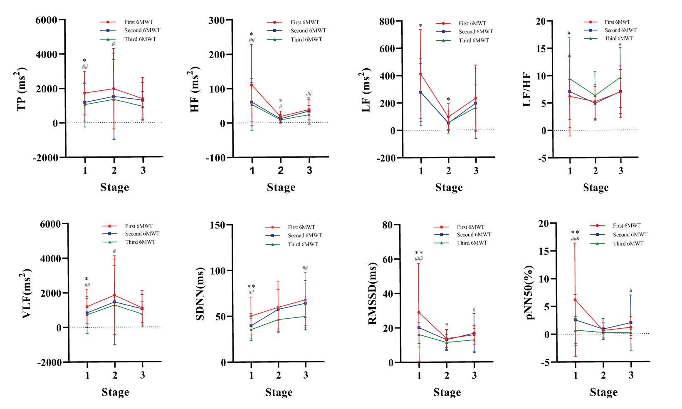
Note: HRV, heart rate variability; 6MWT, six-minute walk test; TP, total power; HF, high frequency; LF, low frequency; VLF, very low frequency; SDNN, standard deviation of normal to normal R‒R intervals; RMSSD, root mean square of the successive differences; pNN50, percentage of intervals >50 ms different from the preceding interval; Stage 1, six minutes before the 6MWT; Stage 2, six minutes during the 6MWT; Stage 3, six minutes after the 6MWT; Group A, representing the 35 participants included for the first time, was enrolled in the 6MWT on the first and second postshift morning; Group B, representing the 35 participants in the control group who were additionally included, walked the 6MWT 1 day before the night shift; First 6MWT, Group A subjects walked the 6MWT on the first postshift morning; Second 6MWT, Group A subjects walked the 6MWT on the second postshift morning; Third 6MWT, Group B subjects walked the 6MWT 1 day before the night shift; * first vs. second 6MWT; # first vs. third 6MWT; * p < 0.05, ** p < 0.01; # p < 0.05, ## p < 0.01, ### p < 0.001.

