Supplementary materials
Supplementary Table 1. Correlation matrix of the IPSM-CS and NGSES items
Supplementary Figure 1. Bootstrapped stability test for edge-weight
Supplementary Figure 2. Bootstrapped confidence intervals of edge weights.
Supplementary Figure 3. Network comparisons of interpersonal sensitivity and self-efficacy by gender in Chinese nursing students.

Supplementary Table 1. Correlation matrix of the IPSM-CS and NGSES items
 | 1 | 2 | 3 | 4 | 5 | 6 | 7 | 8 | 9 | 10 | 11 | 12 | 13 | 14 | 15 | 16 | 17 | 18
1 |  | 0.67 | 0.49 | 0.50 | 0.24 | 0.34 | 0.38 | 0.73 | 0.02 | -0.02 | 0.07 | 0.27 | 0.5 | 0.45 | 0.37 | -0.11 | -0.11 | -0.11
2 | 0.67 |  | 0.54 | 0.60 | 0.23 | 0.40 | 0.45 | 0.63 | 0.02 | -0.02 | 0.09 | 0.33 | 0.62 | 0.54 | 0.47 | -0.15 | -0.15 | -0.15
3 | 0.49 | 0.54 |  | 0.57 | 0.30 | 0.39 | 0.36 | 0.44 | 0.17 | 0.12 | 0.16 | 0.27 | 0.43 | 0.39 | 0.34 | -0.02 | -0.02 | -0.01
4 | 0.50 | 0.60 | 0.57 |  | 0.51 | 0.54 | 0.53 | 0.46 | 0.33 | 0.22 | 0.20 | 0.54 | 0.42 | 0.38 | 0.60 | -0.07 | -0.06 | -0.07
5 | 0.24 | 0.23 | 0.30 | 0.51 |  | 0.56 | 0.52 | 0.29 | 0.55 | 0.45 | 0.27 | 0.51 | 0.20 | 0.22 | 0.48 | 0.10 | 0.11 | 0.10
6 | 0.34 | 0.40 | 0.39 | 0.54 | 0.56 |  | 0.57 | 0.42 | 0.39 | 0.34 | 0.31 | 0.48 | 0.32 | 0.34 | 0.44 | 0.07 | 0.07 | 0.05
7 | 0.38 | 0.45 | 0.36 | 0.53 | 0.52 | 0.57 |  | 0.49 | 0.40 | 0.38 | 0.27 | 0.46 | 0.34 | 0.33 | 0.47 | 0.07 | 0.06 | 0.07
8 | 0.73 | 0.63 | 0.44 | 0.46 | 0.29 | 0.42 | 0.49 |  | 0.07 | 0.06 | 0.17 | 0.33 | 0.54 | 0.42 | 0.35 | -0.07 | -0.07 | -0.09
9 | 0.02 | 0.02 | 0.17 | 0.33 | 0.55 | 0.39 | 0.40 | 0.07 |  | 0.79 | 0.48 | 0.54 | 0.03 | 0.06 | 0.37 | 0.32 | 0.33 | 0.34
10 | -0.02 | -0.02 | 0.12 | 0.22 | 0.45 | 0.34 | 0.38 | 0.06 | 0.79 |  | 0.50 | 0.44 | 0.00 | 0.04 | 0.24 | 0.34 | 0.36 | 0.35
11 | 0.07 | 0.09 | 0.16 | 0.20 | 0.27 | 0.31 | 0.27 | 0.17 | 0.48 | 0.50 |  | 0.35 | 0.12 | 0.11 | 0.20 | 0.28 | 0.26 | 0.2
12 | 0.27 | 0.33 | 0.27 | 0.54 | 0.51 | 0.48 | 0.46 | 0.33 | 0.54 | 0.44 | 0.35 |  | 0.33 | 0.30 | 0.59 | 0.06 | 0.08 | 0.06
13 | 0.56 | 0.62 | 0.43 | 0.42 | 0.20 | 0.32 | 0.34 | 0.54 | 0.03 | 0.00 | 0.12 | 0.33 |  | 0.63 | 0.46 | -0.10 | -0.11 | -0.11
14 | 0.45 | 0.54 | 0.39 | 0.38 | 0.22 | 0.34 | 0.33 | 0.42 | 0.06 | 0.04 | 0.11 | 0.30 | 0.63 |  | 0.45 | -0.12 | -0.10 | -0.11
15 | 0.37 | 0.47 | 0.34 | 0.60 | 0.48 | 0.44 | 0.47 | 0.35 | 0.37 | 0.24 | 0.20 | 0.59 | 0.46 | 0.45 |  | -0.05 | -0.07 | -0.07
16 | -0.11 | -0.15 | -0.02 | -0.07 | 0.10 | 0.07 | 0.07 | -0.07 | 0.32 | 0.34 | 0.28 | 0.06 | -0.10 | -0.12 | -0.05 |  | 0.86 | 0.85
17 | -0.11 | -0.15 | -0.02 | -0.06 | 0.11 | 0.07 | 0.06 | -0.07 | 0.33 | 0.36 | 0.26 | 0.08 | -0.11 | -0.10 | -0.07 | 0.86 |  | 0.87
18 | -0.11 | -0.15 | -0.01 | -0.07 | 0.10 | 0.05 | 0.07 | -0.09 | 0.34 | 0.35 | 0.25 | 0.06 | -0.11 | -0.11 | -0.07 | 0.85 | 0.87
Note: 1: IPSM-CS1, 2: IPSM-CS2, 3: IPSM-CS3, 4: IPSM-CS4, 5: IPSM-CS5, 6: IPSM-CS6, 7: IPSM-CS7, 8: IPSM-CS8, 9: IPSM-CS9, 10: IPSM-CS10, 11: IPSM-CS11, 12: IPSM-CS12, 13: IPSM-CS13, 14: IPSM-CS14, 15: IPSM-CS15, 16: NGSES1, 17:NGSES2, 18: NGSES3.
IPSM-CS, the Chinese Version of the Short-Form of Interpersonal Sensitivity Measure; NGSES, the New General Self-Efficacy Scale.
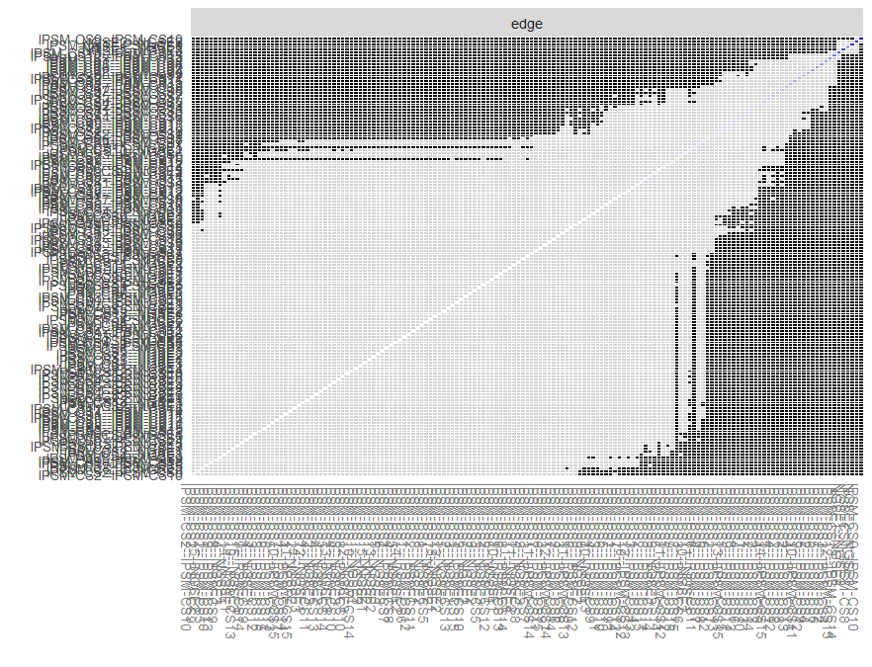
Supplementary Figure 1. Bootstrapped stability test for edge-weight
IPSM-CS1: I feel insecure when I say goodbye to people, IPSM-CS2: If others knew the real me, they would not like me, IPSM-CS3: I do not get angry with people for fear that I may hurt them, IPSM-CS4: I worry about being criticized for things that I have said or done, IPSM-CS5: I worry about losing someone close to me, IPSM-CS6: I will do something I do not want to do rather than offend or upset someone, IPSM-CS7: I will go out of my way to please someone I am close to, IPSM-CS8: I feel anxious when I say goodbye to people, IPSM-CS9: I feel happy when someone compliments me IPSM-CS10: I can make other people feel happy, IPSM-CS11: I find it hard to get angry with people, IPSM-CS12: If someone is critical of something I do, I feel bad , IPSM-CS13: If other people knew what I am really like, they would think less of me, IPSM-CS14: I do not like people to really know me, IPSM-CS15: I worry about what others think of me; NGSES1: Faced with difficult tasks, confident that it can be accomplished, NGSES2: Ability to successfully overcome many challenges, NGSES3: Confidence to perform many tasks effectively;
The results of the bootstrapped difference tests (α=0.05) for edge-weights were shown in this figure. There was a total of (18*(18-1))/2=153 edges between all 18 symptoms. The color of the boxes indicates whether edge-weights differ significantly from each other (i.e., black) or do not differ significantly (i.e., grey). The diagonal line indicates the strength of edge-weights, shifting from red (negative associations), to white (representing weaker edges) and ultimately blue (representing stronger edge-weights).
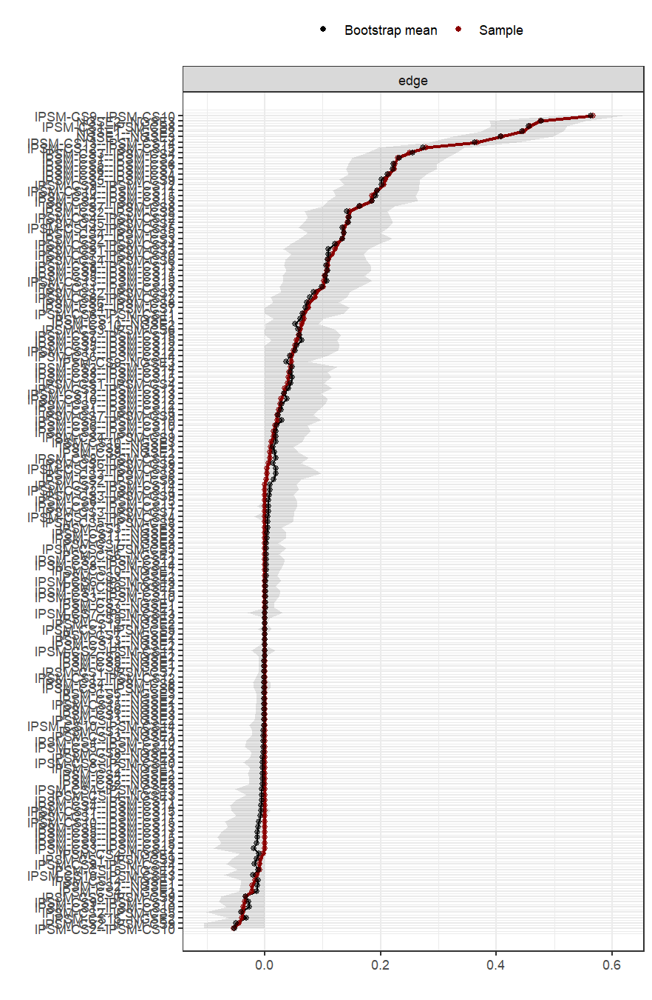
Supplementary Figure 2. Bootstrapped confidence intervals of edge weights.
IPSM-CS1: I feel insecure when I say goodbye to people, IPSM-CS2: If others knew the real me, they would not like me, IPSM-CS3: I do not get angry with people for fear that I may hurt them, IPSM-CS4: I worry about being criticized for things that I have said or done, IPSM-CS5: I worry about losing someone close to me, IPSM-CS6: I will do something I do not want to do rather than offend or upset someone, IPSM-CS7: I will go out of my way to please someone I am close to, IPSM-CS8: I feel anxious when I say goodbye to people, IPSM-CS9: I feel happy when someone compliments me IPSM-CS10: I can make other people feel happy, IPSM-CS11: I find it hard to get angry with people, IPSM-CS12: If someone is critical of something I do, I feel bad , IPSM-CS13: If other people knew what I am really like, they would think less of me, IPSM-CS14: I do not like people to really know me, IPSM-CS15: I worry about what others think of me; NGSES1: Faced with difficult tasks, confident that it can be accomplished, NGSES2: Ability to successfully overcome many challenges, NGSES3: Confidence to perform many tasks effectively; The red dots indicate the values of each edge weight from the network and the black dots indicate the value of each edge weight by bootstrap procedure, both ordered from the highest to the lowest value. The gray area represents the 95% Confidence Intervals of edge weights, estimated with the non-parametric bootstrap procedure. Wide intervals indicate lower stability and narrow intervals indicate higher stability.

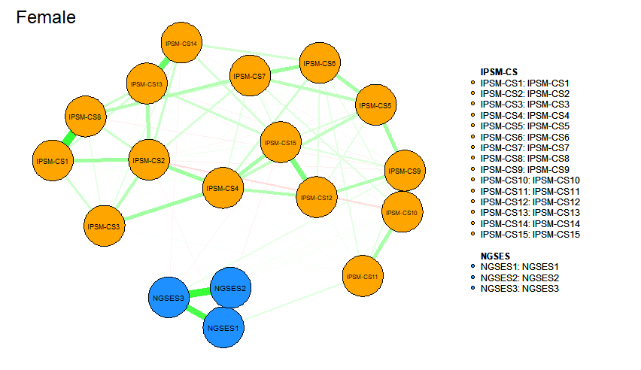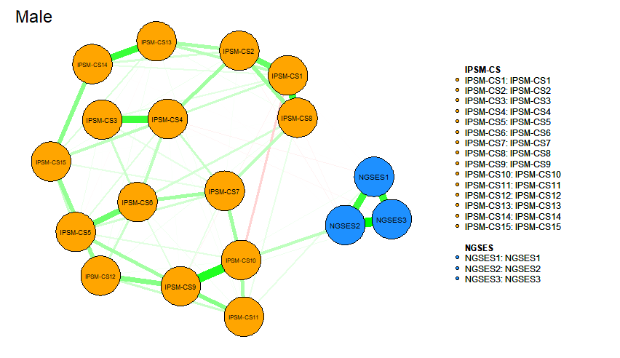
Supplementary Figure 3. Network comparisons of interpersonal sensitivity and self-efficacy by gender in Chinese nursing students.

