Contents
Figure S1 The effects of dyadic care interventions on the (a) quality of life, (b) neuropsychiatric symptoms, (c) anxiety, (d) depression, (e) stress, (f) self-efficacy, (g) sexual function, (h) sexuality-related mental health, (i) relationship satisfaction and (j) dyadic coping of prostate cancer patients. 1
Figure S2 The effects of dyadic care interventions on the (a) quality of life, (b) neuropsychiatric symptoms, (c) anxiety, (d) depression, (e) stress, (f) self-efficacy, (g) sexual function, (h) relationship satisfaction, and (i) dyadic coping of informal caregivers of prostate cancer. 7
Figure S3 Publication bias assessment: funnel plot 12
Table S1 Search strategy 13
Table S2 Characteristics of the included studies (N=19) 21
Table S3 Summary of meta-analysis results 24

Figure S1 The effects of dyadic care interventions on the (a) quality of life, (b) neuropsychiatric symptoms, (c) anxiety, (d) depression, (e) stress, (f) self-efficacy, (g) sexual function, (h) sexuality-related mental health, (i) relationship satisfaction and (j) dyadic coping of prostate cancer patients.
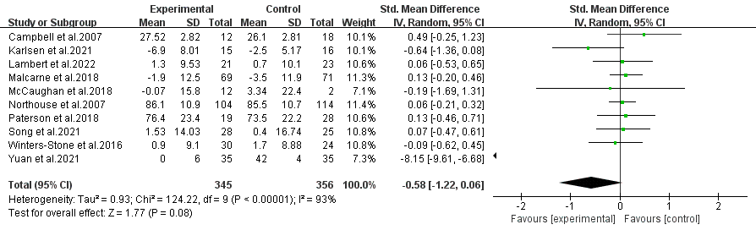
(a) quality of life

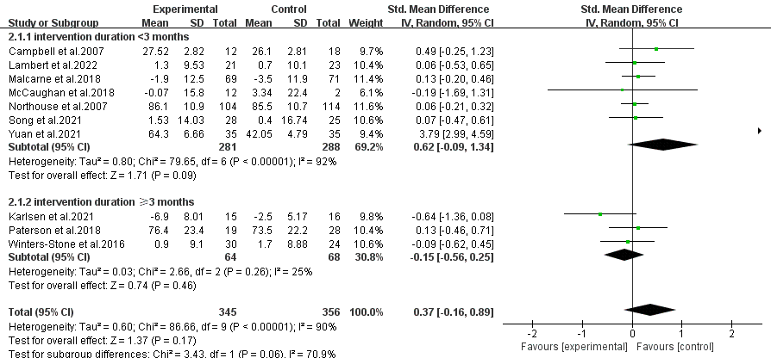
(a-1)

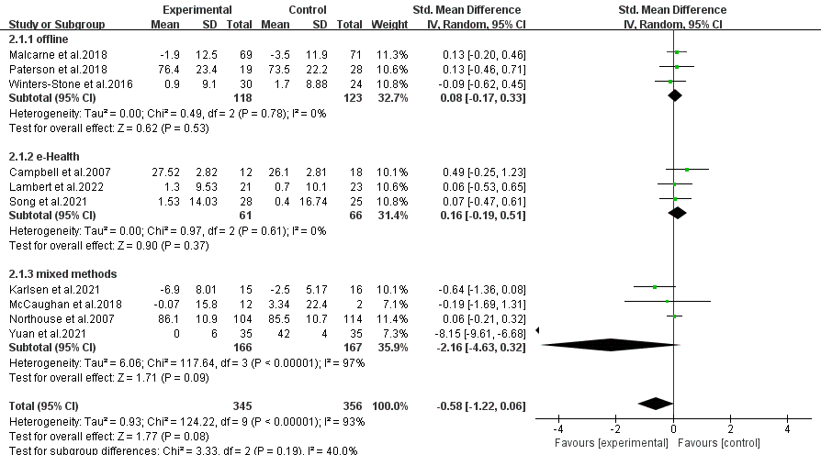
(a-2)

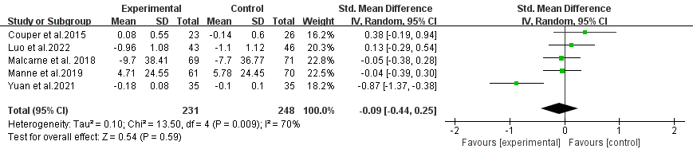
(b) neuropsychiatric symptoms

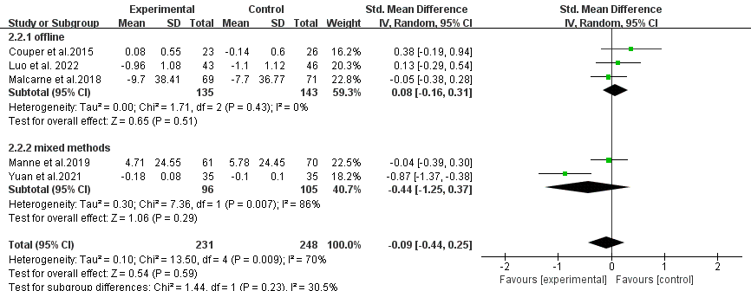
(b-1)

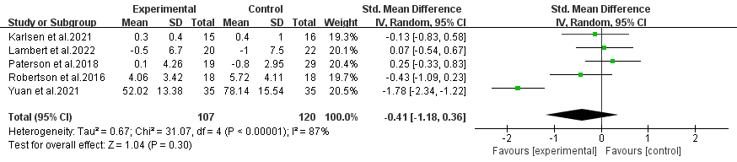
(c) anxiety

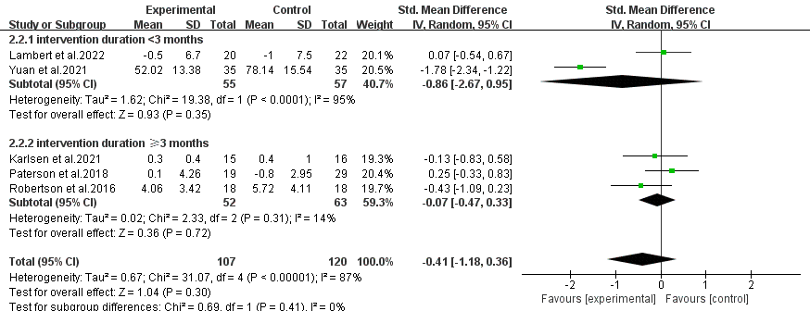
(c-1)

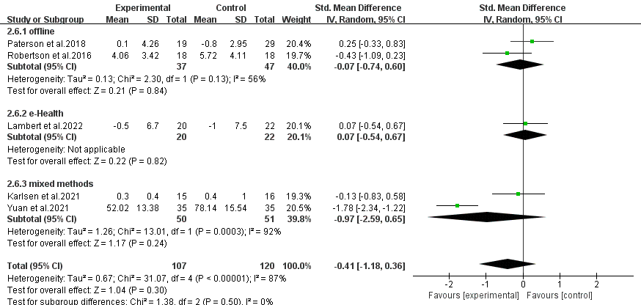
(c-2)

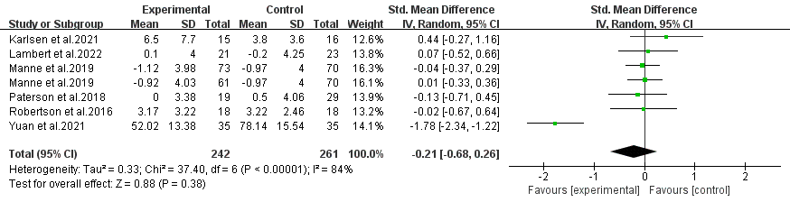
(d) depression

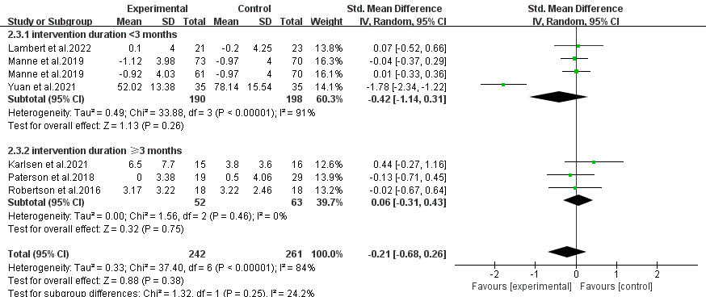
(d-1)

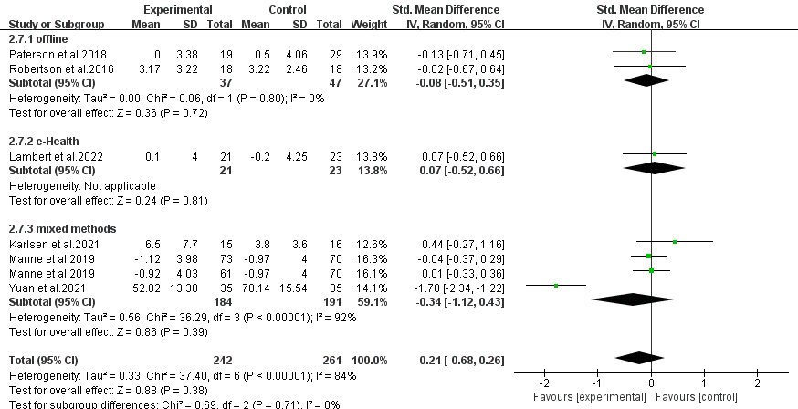
(d-2)

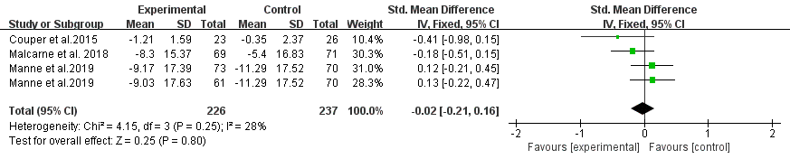
(e) stress

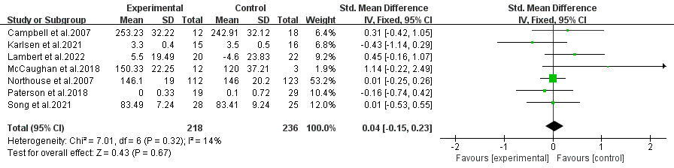
(f) self-efficacy

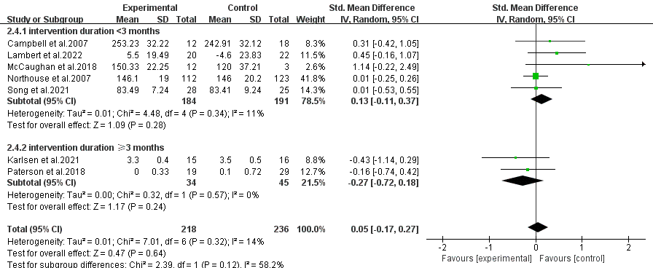
(f-1)

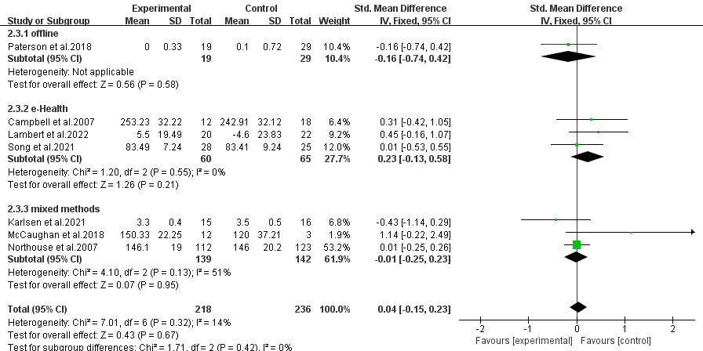
(f-2)

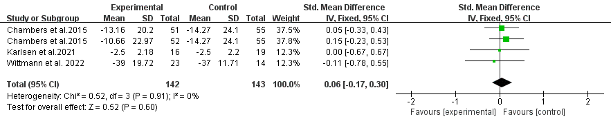
(g) sexual function

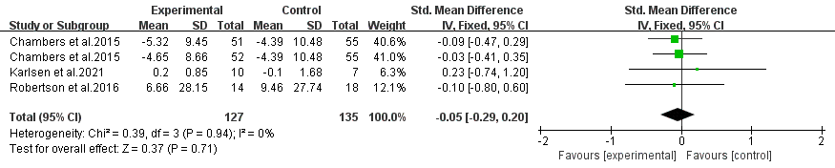
(h) sexuality-related mental health
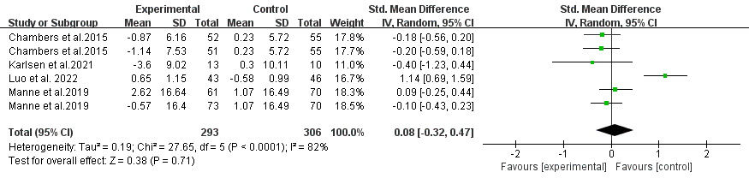
(i) relationship satisfaction

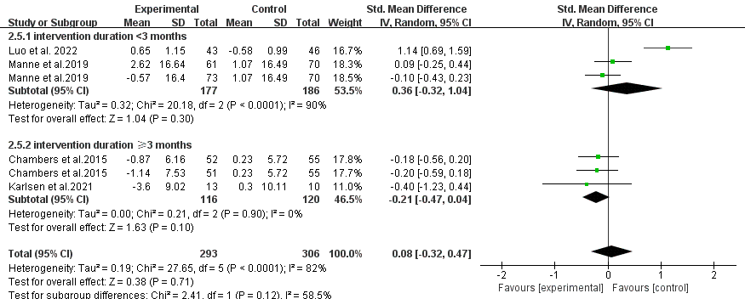
(i-1)

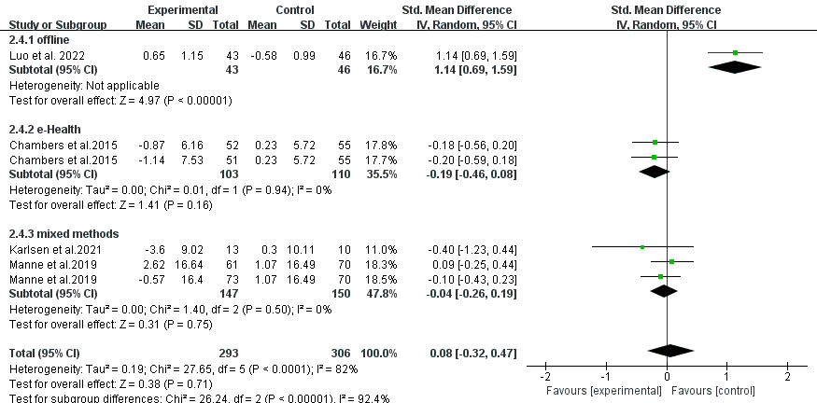
(i-2)

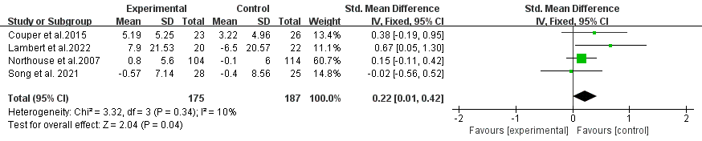
(j) dyadic coping

Figure S2 The effects of dyadic care interventions on the (a) quality of life, (b) neuropsychiatric symptoms, (c) anxiety, (d) depression, (e) stress, (f) self-efficacy, (g) sexual function, (h) relationship satisfaction, and (i) dyadic coping of informal caregivers of prostate cancer.
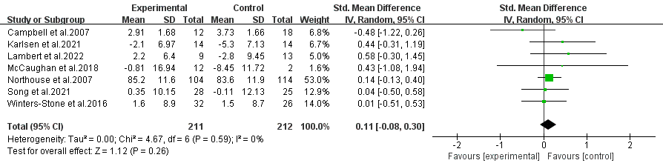
(a) quality of life

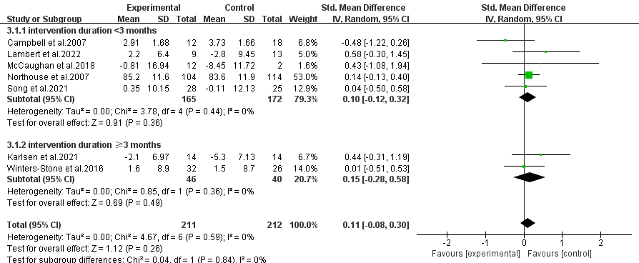
(a-1)

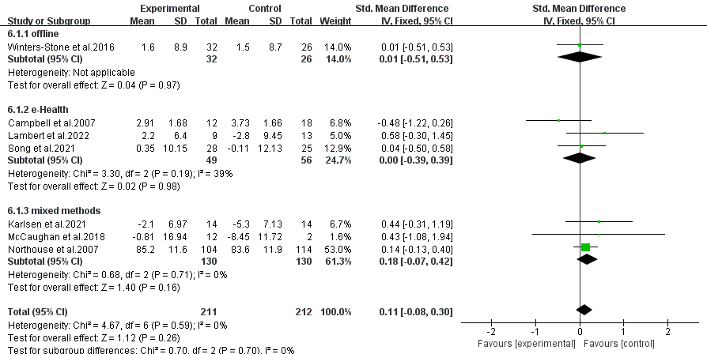
(a-2)

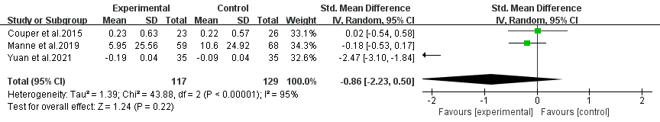
(b) neuropsychiatric symptoms

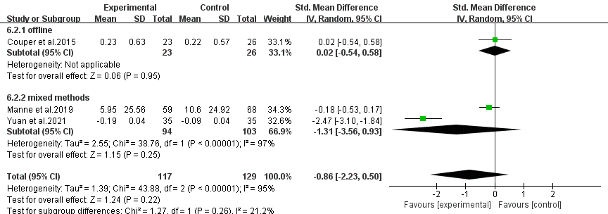
(b-1)

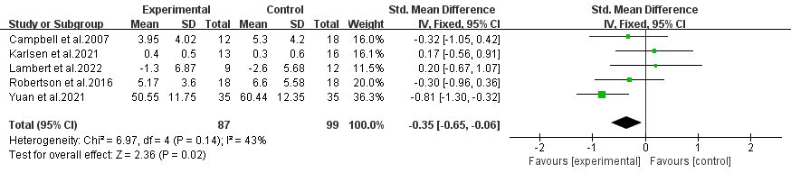
(c) anxiety

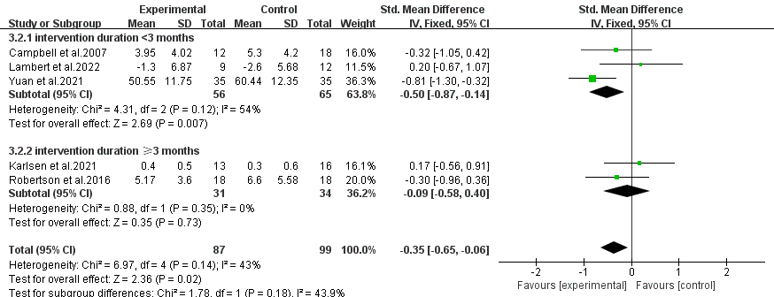
(c-1)

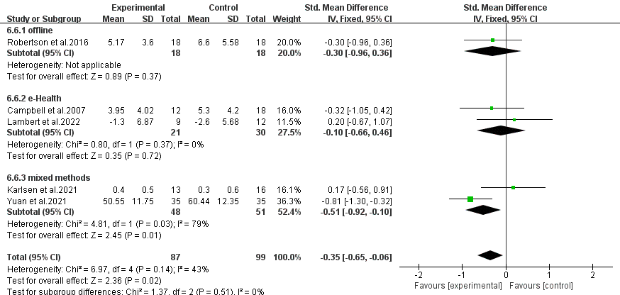
(c-2)

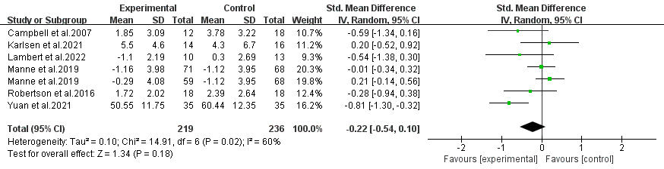
(d) depression

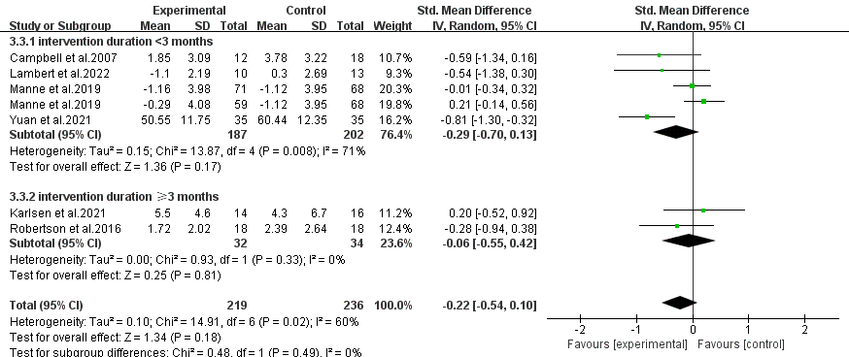
(d-1)

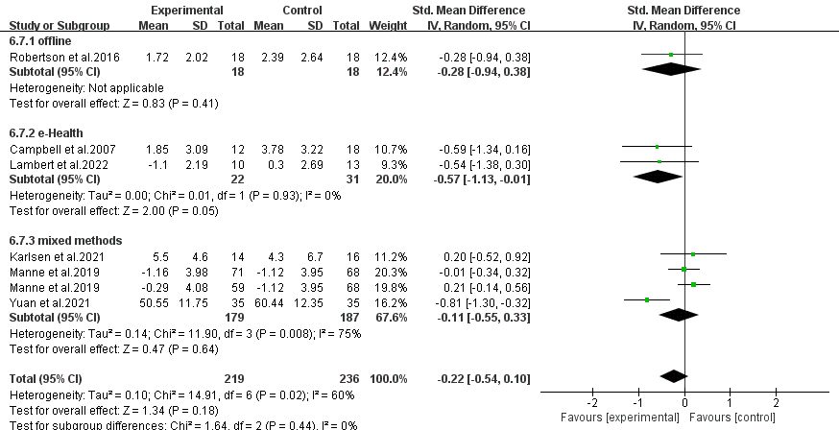
(d-1)

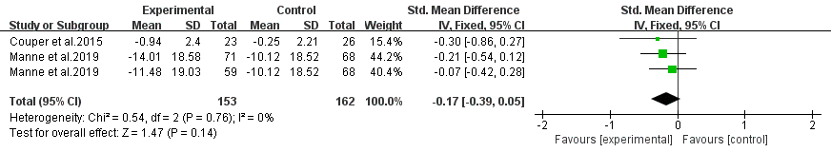
(e) stress
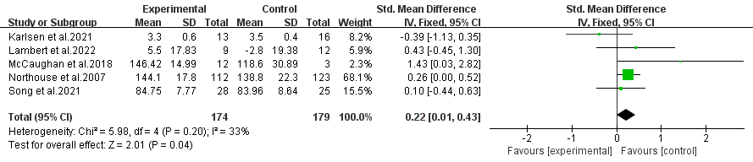
(f) self-efficacy

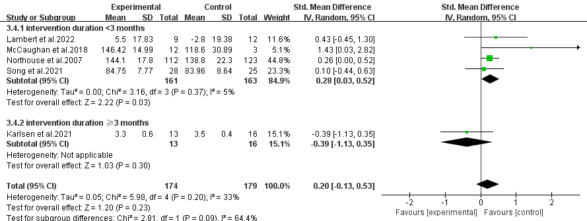
(f-1)

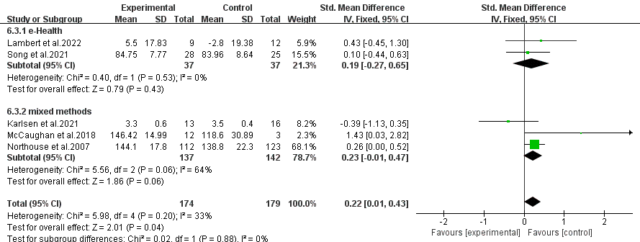
(f-2)

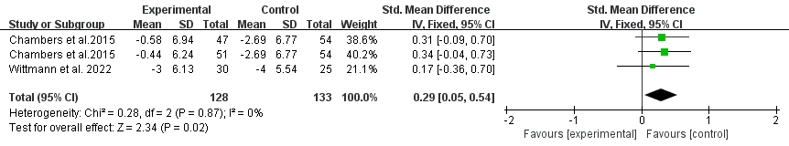
(g) sexual function

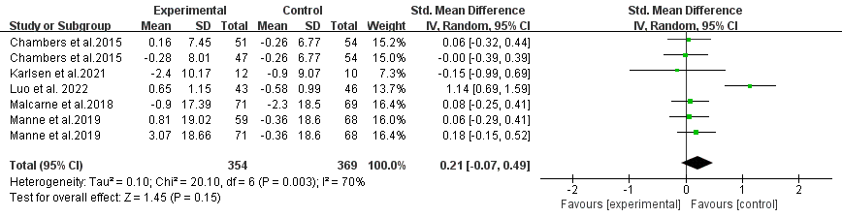
(h) relationship satisfaction

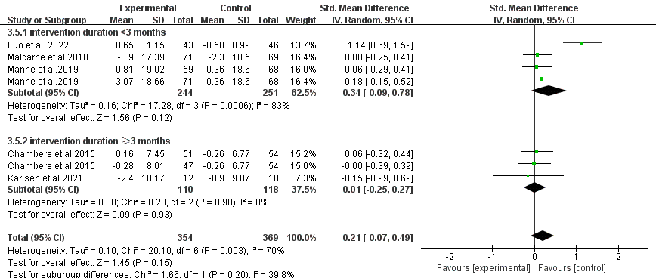
(h-1)

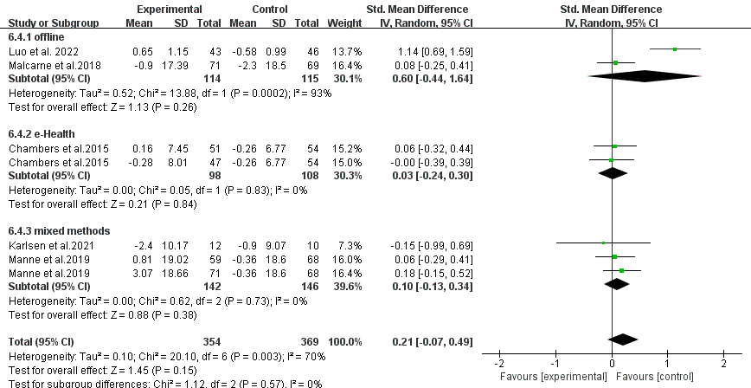
(h-2)

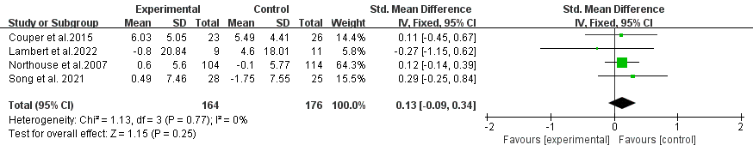
(i) dyadic coping

Figure S3 Publication bias assessment: funnel plot

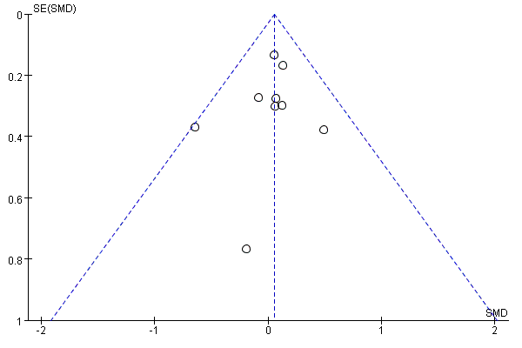
Notes. SE = Standard error; SMD = Standardized mean difference

Table S1 Search strategy
Web of Science
Search Number | Search terms | Search results (from inception to April 2024)
#1 | (((((((((((((((((TS=(Prostatic Neoplasms)) OR TS=(Prostate Neoplasms)) OR TS=(Neoplasms, Prostate)) OR TS=(Neoplasm, Prostate)) OR TS=(Prostate Neoplasm)) OR TS=(Neoplasms, Prostatic)) OR TS=(Neoplasm, Prostatic)) OR TS=(Prostatic Neoplasm)) OR TS=(Prostate Cancer)) OR TS=(Cancer, Prostate)) OR TS=(Cancers, Prostate)) OR TS=(Prostate Cancers)) OR TS=(Cancer of the Prostate)) OR TS=(Prostatic Cancer)) OR TS=(Cancer, Prostatic)) OR TS=(Cancers, Prostatic)) OR TS=(Prostatic Cancers)) OR TS=(Cancer of Prostate) and Preprint Citation Index (Exclude – Database) | 427039
#2 | (((((((((((((((((TS=(caregivers)) OR TS=(care$giv*)) OR TS=(care giv*)) OR TS=(caregiver )) OR TS=(caregiv*)) OR TS=(carer*)) OR TS=(family)) OR TS=(famil*)) OR TS=(spouse)) OR TS=(coupl*)) OR TS=(spous*)) OR TS=(relativ*)) OR TS=(relatives or spouse*)) OR TS=(partner)) OR TS=(partner*)) OR TS=(dyad*)) OR TS=(wife)) OR TS=(wives) and Preprint Citation Index (Exclude – Database) | 10486640
#3 | (((((((((((((((((((((((((((((((((((((TS=(intervention)) OR TS=(therapy)) OR TS=(program)) OR TS=(counselling)) OR TS=(effect)) OR TS=(effectiveness)) OR TS=(Exercise)) OR TS=(Physical)) OR TS=(physical exercise)) OR TS=(Training)) OR TS=(physical activity )) OR TS=(PA)) OR TS=(psychosocial interventions)) OR TS=(Behavior Therapy)) OR TS=(Psychotherapy)) OR TS=(mindfulness)) OR TS=(Behavioral)) OR TS=(psychosocial)) OR TS=(Psychotherapy)) OR TS=(cognitive training)) OR TS=(mindfulness and group cognitive behavioral therapy)) OR TS=(Conitive Behavior Therapy)) OR TS=(CBT)) OR TS=(Cognitive Therapy)) OR TS=(Cognitive existential couple therapy)) OR TS=(CECT)) OR TS=(coping skills training)) OR TS=(Problem-solving therapy)) OR TS=(PST)) OR TS=(counselling)) OR TS=(educational intervention)) OR TS=(dyadic intervention)) OR TS=(Technology)) OR TS=(Internet)) OR TS=(technology based)) OR TS=(web based)) OR TS=(Computer based)) OR TS=(mobile) and Preprint Citation Index (Exclude – Database) | 41211286
#4 | (((((TS=(Randomized Controlled Trial )) OR TS=(randomized)) OR TS=(randomly)) OR TS=(Randomized controlled trial)) OR TS=(RCTs)) OR TS=(RCT) and Preprint Citation Index (Exclude – Database) | 2033549
#5 | #4 AND #3 AND #2 AND #1 and Preprint Citation Index (Exclude – Database) | 3469

PsycINFO
Search Number | Search terms | Search results (from inception to April 2024)
1 | title("Prostatic Neoplasms" OR "Prostate Neoplasms" OR "Neoplasms, Prostate" OR "Neoplasm, Prostate" OR "Prostate Neoplasm" OR "Neoplasms, Prostatic" OR "Neoplasm, Prostatic" OR "Prostatic Neoplasm" OR "Prostate Cancer" OR "Cancer, Prostate" OR "Cancers, Prostate" OR "Prostate Cancers" OR "Cancer of the Prostate" OR "Prostatic Cancer" OR "Cancer, Prostatic" OR "Cancers, Prostatic" OR "Prostatic Cancers" OR "Cancer of Prostate") OR abstract("Prostatic Neoplasms" OR "Prostate Neoplasms" OR "Neoplasms, Prostate" OR "Neoplasm, Prostate" OR "Prostate Neoplasm" OR "Neoplasms, Prostatic" OR "Neoplasm, Prostatic" OR "Prostatic Neoplasm" OR "Prostate Cancer" OR "Cancer, Prostate" OR "Cancers, Prostate" OR "Prostate Cancers" OR "Cancer of the Prostate" OR "Prostatic Cancer" OR "Cancer, Prostatic" OR "Cancers, Prostatic" OR "Prostatic Cancers" OR "Cancer of Prostate") | 3401
2 | title(“caregivers” OR “care$giv*” OR “care giv*” OR “caregiver “ OR “caregiv*” OR “carer*” OR “family” OR “famil*” OR “spouse” OR “coupl*” OR “spous*” OR “relativ*” OR “relatives or spouse*” OR “partner” OR “partner*” OR “dyad*” OR “wife” OR “wives” ) OR abstract(“caregivers” OR “care$giv*” OR “care giv*” OR “caregiver “ OR “caregiv*” OR “carer*” OR “family” OR “famil*” OR “spouse” OR “coupl*” OR “spous*” OR “relativ*” OR “relatives or spouse*” OR “partner” OR “partner*” OR “dyad*” OR “wife” OR “wives” ) | 930499
3 | title(“intervention” OR “therapy” OR “program” OR “counselling” OR “effect” OR “effectiveness” OR “Exercise” OR “Physical” OR “physical exercise” OR “Training” OR “physical activity” OR “PA” OR “psychosocial interventions” OR “Behavior Therapy” OR “Psychotherapy” OR “mindfulness” OR “Behavioral” OR “psychosocial” OR “Psychotherapy” OR “cognitive training” OR “mindfulness and group cognitive behavioral therapy” OR “Cognitive Behavior Therapy” OR “CBT” OR “Cognitive Therapy” OR “Cognitive existential couple therapy” OR “CECT” OR “coping skills training” OR “Problem-solving therapy” OR “PST” OR “counselling” OR “educational intervention” OR “dyadic intervention” OR “Technology” OR “Internet” OR “technology based” OR “web based” OR “Computer based” OR “mobile”) OR abstract(“intervention” OR “therapy” OR “program” OR “counselling” OR “effect” OR “effectiveness” OR “Exercise” OR “Physical” OR “physical exercise” OR “Training” OR “physical activity” OR “PA” OR “psychosocial interventions” OR “Behavior Therapy” OR “Psychotherapy” OR “mindfulness” OR “Behavioral” OR “psychosocial” OR “Psychotherapy” OR “cognitive training” OR “mindfulness and group cognitive behavioral therapy” OR “Cognitive Behavior Therapy” OR “CBT” OR “Cognitive Therapy” OR “Cognitive existential couple therapy” OR “CECT” OR “coping skills training” OR “Problem-solving therapy” OR “PST” OR “counselling” OR “educational intervention” OR “dyadic intervention” OR “Technology” OR “Internet” OR “technology based” OR “web based” OR “Computer based” OR “mobile”) | 2032217
4 | title("Randomized Controlled Trial" OR RCT) OR abstract("Randomized Controlled Trial" OR RCT) | 29108
5 | 1 and 2 and 3 and 4 | 24

EMBASE
Search Number | Search terms | Search results (from inception to April 2024)
#1 | 'prostate tumor'/exp OR 'prostate neoplasms' OR 'neoplasms, prostate' OR 'neoplasm, prostate' OR 'prostate neoplasm' OR 'prostatic neoplasms' OR 'neoplasms, prostatic' OR 'neoplasm, prostatic' OR 'prostatic neoplasm' OR 'prostate cancer' OR 'cancer, prostate' OR 'cancers, prostate' OR 'prostate cancers' OR 'cancer of the prostate' OR 'prostatic cancer' OR 'cancer, prostatic' OR 'cancers, prostatic' OR 'prostatic cancers' OR 'cancer of prostate' | 337362
#2 | 'caregivers'/exp OR 'family'/exp OR 'spouse'/exp OR ‘care$giv*’ OR 'carer*' OR 'caregiv*' OR family OR 'famil*' OR 'coupl*' OR 'spous*' OR 'relativ*' OR 'relatives or spouse*' OR partner OR 'partner*' OR 'dyad*' OR wife OR wives | 5571730
#3 | 'technology'/exp OR 'internet'/exp OR 'exercise'/exp OR 'behavior therapy'/exp OR 'mindfulness'/exp OR 'psychotherapy'/exp OR technology OR 'technology based' OR 'web based' OR internet OR 'computer based' OR mobile OR 'physical exercise' OR 'physical activity' OR physical OR training OR pa OR 'psychosocial interventions' OR 'cognitive training' OR 'mindfulness and group cognitive behavioral therapy' OR 'cognitive behavior therapy' OR 'cognitive therapy' OR 'cognitive existential couple therapy' OR behavioral OR psychosocial OR psychotherapy OR cbt OR cect | 8132512
#4 | randomized OR randomised OR randomization OR randomisation OR randomly OR 'randomized controlled trial' OR rcts OR rct | 1965024
#5 | #1 AND #2 AND #3 AND #4 | 1060

Cochrane Library
Search Number | Search terms | Search results (from inception to April 2024)
#1 | MeSH descriptor: [Prostatic Neoplasms] explode all trees | 8761
#2 | (prostate neoplasms OR neoplasms, prostate OR neoplasm, prostate OR prostate neoplasm OR prostatic neoplasms OR neoplasms, prostatic OR neoplasm, prostatic OR prostatic neoplasm OR prostate cancer OR cancer, prostate OR cancers, prostate OR prostate cancers OR cancer of the prostate OR prostatic cancer OR cancer, prostatic OR cancers, prostatic OR prostatic cancers OR cancer of prostate):ti,ab,kw | 18387
#3 | #1 OR #2 | 18387
#4 | MeSH descriptor: [Family] explode all trees | 14737
#5 | MeSH descriptor: [Spouses] explode all trees | 504
#6 | (care$giv* OR carer* OR caregiv* OR family OR famil* OR coupl* OR spous* OR relativ* OR relatives or spouse* OR partner OR partner* OR dyad* OR wife OR wives):ti,ab,kw | 201832
#7 | #4 OR #5 OR #6 | 207324
#8 | (Technology OR technology based OR web based OR Internet OR Computer based OR mobile OR physical exercise OR exercise OR physical activity OR Physical OR Training OR PA OR psychosocial interventions OR cognitive training OR mindfulness OR mindfulness and group cognitive behavioral therapy OR Cognitive Behavior Therapy OR Cognitive Therapy OR Behavior Therapy OR Cognitive existential couple therapy OR Behavioral OR psychosocial OR Psychotherapy OR CBT OR CECT):ti,ab,kw | 476238
#9 | MeSH descriptor: [Randomized Controlled Trial] explode all trees | 37
#10 | (Randomized Controlled Trial OR Randomized OR Randomised OR Randomization OR Randomisation):ti,ab,kw | 1182489
#11 | #9 OR #10 | 1182489
#12 | #3 AND #7 AND #8 AND #11 | 449

CINAHL
Search Number | Search terms | Search results (from inception to April 2024)
S1 | (MH " Prostatic Neoplasms ") OR TI (prostate neoplasms OR neoplasms, prostate OR neoplasm, prostate OR prostate neoplasm OR prostatic neoplasms OR neoplasms, prostatic OR neoplasm, prostatic OR prostatic neoplasm OR prostate cancer OR cancer, prostate OR cancers, prostate OR prostate cancers OR cancer of the prostate OR prostatic cancer OR cancer, prostatic OR cancers, prostatic OR prostatic cancers OR cancer of prostate) OR AB (prostate neoplasms OR neoplasms, prostate OR neoplasm, prostate OR prostate neoplasm OR prostatic neoplasms OR neoplasms, prostatic OR neoplasm, prostatic OR prostatic neoplasm OR prostate cancer OR cancer, prostate OR cancers, prostate OR prostate cancers OR cancer of the prostate OR prostatic cancer OR cancer, prostatic OR cancers, prostatic OR prostatic cancers OR cancer of prostate) | 44381
S2 | (MH "Caregivers") OR (MH "Family+") OR (MH "Spouses") OR TI (carer* OR caregiv* OR care give* OR famil* OR parent OR parents OR relative OR relatives OR spouse OR spouses OR partner OR partners OR wife OR wives OR dyad*) OR AB (carer* OR caregiv* OR care give* OR famil* OR parent OR parents OR relative OR relatives OR spouse OR spouses OR partner OR partners OR wife OR wives OR dyad*) | 767361
S3 | (MH " Technology ") OR (MH " Internet ") OR (MH " Exercise ") OR (MH " Behavior Therapy ") OR (MH " mindfulness ") OR (MH " Psychotherapy ") OR TI (Technology OR technology based OR web based OR Internet OR Computer based OR mobile OR physical exercise OR physical activity OR Physical OR Training OR PA OR psychosocial interventions OR cognitive training OR mindfulness and group cognitive behavioral therapy OR Cognitive Behavior Therapy OR Cognitive Therapy OR Cognitive existential couple therapy OR Behavioral OR psychosocial OR Psychotherapy OR CBT OR CECT) OR AB (Technology OR technology based OR web based OR Internet OR Computer based OR mobile OR physical exercise OR physical activity OR Physical OR Training OR PA OR psychosocial interventions OR cognitive training OR mindfulness and group cognitive behavioral therapy OR Cognitive Behavior Therapy OR Cognitive Therapy OR Cognitive existential couple therapy OR Behavioral OR psychosocial OR Psychotherapy OR CBT OR CECT) | 915089
S4 | (PT "Randomized Controlled Trial") OR “Randomized Controlled Trial” OR “Randomized” OR “Randomised” OR “Randomization” OR “Randomisation” | 357785
S5 | S1 AND S2 AND S3 AND S4 | 90

PubMed
Search Number | Search terms | Search results (from inception to April 2024)
#1 | "Prostatic Neoplasms"[Mesh] | 152617
#2 | (((((((((((((((((Prostate Neoplasms) OR (Neoplasms, Prostate)) OR (Neoplasm, Prostate)) OR (Prostate Neoplasm)) OR (Neoplasms, Prostatic)) OR (Neoplasm, Prostatic)) OR (Prostatic Neoplasm)) OR (Prostate Cancer)) OR (Cancer, Prostate)) OR (Cancers, Prostate)) OR (Prostate Cancers)) OR (Cancer of the Prostate)) OR (Prostatic Cancer)) OR (Cancer, Prostatic)) OR (Cancers, Prostatic)) OR (Prostatic Cancers)) OR (Cancer of Prostate)) OR (Prostatic Neoplasms) | 219560
#3 | #1 OR #2 | 219560
#4 | ((((((((((((((((((caregivers[MeSH Terms]) OR (family[MeSH Terms])) OR (spouse[MeSH Terms])) OR (care$giv*)) OR (care giv*)) OR (carer*)) OR (caregiver)) OR (caregiv*)) OR (family)) OR (famil*)) OR (coupl*)) OR (spous*)) OR (relativ*)) OR (relatives or spouse*)) OR (partner)) OR (partner*)) OR (dyad*)) OR (wife)) OR (wives) | 4422753
#5 | (((((((((((((((((((((((((((((((((((Exercise[MeSH Terms]) OR (Behavior Therapy[MeSH Terms])) OR (Psychotherapy[MeSH Terms])) OR (mindfulness[MeSH Terms])) OR (Technology[MeSH Terms])) OR (Internet[MeSH Terms])) OR (Physical)) OR (physical exercise)) OR (Training)) OR (physical activity)) OR (PA)) OR (psychosocial interventions)) OR (Behavioral)) OR (Behavior Therapy)) OR (psychosocial)) OR (Psychotherapy)) OR (cognitive training)) OR (mindfulness and group cognitive behavioral therapy)) OR (mindfulness)) OR (Cognitive Behavior Therapy)) OR (CBT)) OR (Cognitive Therapy)) OR (Cognitive existential couple therapy)) OR (CECT)) OR (coping skills training)) OR (Problem-solving therapy)) OR (PST)) OR (counselling)) OR (educational intervention)) OR (dyadic intervention)) OR (Technology、technology based)) OR (web based)) OR (Computer based)) OR (mobile)) OR (Technology)) OR (Internet) | 15037813
#6 | (((((Randomized Controlled Trial[Publication Type]) OR (randomized)) OR (randomly)) OR (Randomized controlled trial)) OR (RCTs)) OR (RCT) | 1765245
#7 | #3 AND #4 AND #5 AND #6 | 1690

CNKI
Search Number | Search terms | Search results (from inception to April 2024)
1 | (SU=前列腺肿瘤+前列腺癌+前列腺癌症) AND (SU=家属+家庭+家人+照护者+照顾者+居家+配偶+夫妻+二元交互+伙伴) AND (SU=干预+支持+教育+咨询+疗法+护理+认知+运动+锻炼) | 59
Wanfang
Search Number | Search terms | Search results (from inception to April 2024)
1 | 主题:( 前列腺肿瘤 OR 前列腺癌 OR 前列腺癌症) and 主题:(家属 OR 家庭 OR 家人 OR 照护者 OR 照顾者 OR 居家 OR 配偶 OR 夫妻 OR 二元交互 OR 伙伴) and 主题:(干预 OR 支持 OR 教育 OR 咨询 OR 疗法 OR 护理 OR 认知 OR 运动 OR 锻炼) | 231
VIP
Search Number | Search terms | Search results (from inception to April 2024)
1 | (M=(前列腺肿瘤+前列腺癌+前列腺癌症 ) OR R=(前列腺肿瘤+前列腺癌+前列腺癌症 )) AND (M=(家属+家庭+家人+照护者+照顾者+居家+配偶+夫妻+二元交互+伙伴) OR R=(家属+家庭+家人+照护者+照顾者+居家+配偶+夫妻+二元交互+伙伴)) AND (M=(干预+支持+教育+咨询+疗法+护理+认知+运动+锻炼) OR R=(干预+支持+教育+咨询+疗法+护理+认知+运动+锻炼)) | 162

SinoMed
Search Number | Search terms | Search results (from inception to April 2024)
#1 | title("Prostatic Neoplasms" OR "Prostate Neoplasms" OR "Neoplasms, "前列腺肿瘤"[摘要] OR "前列腺癌"[摘要] OR "前列腺癌症"[摘要] | 25879
#2 | "家属"[摘要] OR "家庭"[摘要] OR "家人"[摘要] OR "照护者"[摘要] OR "照顾者"[摘要] OR "居家"[摘要] OR "配偶"[摘要] OR "夫妻"[摘要] OR "二元"[摘要] OR "伙伴"[摘要] | 219742
#3 | "干预"[摘要] OR "支持"[摘要] OR "教育"[摘要] OR "咨询"[摘要] OR "疗法"[摘要] OR "护理"[摘要] OR "认知"[摘要] OR "运动"[摘要] OR "锻炼"[摘要] | 2215726
#4 | (#3) AND (#2) AND (#1) | 83

Table S2 Characteristics of the included studies (N=19)
Study/Year/Country | Participants |  | Intervention |  | Outcomes
Study/Year/Country | Intervention group | Control group | Intervention group | Control group | Assessment time | Outcomes
Chambers et al.(2015)/Australia | Nurse Intervention Group (N= 62 dyads)  Peer Intervention Group: (N= 63 dyads) | (N= 64 dyads) | Nurse counselling intervention  - Strategies: phone support/counseling  - Content: (1) education about prostate cancer, menopause and sexuality; (2)behavioral homework including increasing expression of affection and non-demanding sexual touch; (3)challenging negative beliefs about prostate cancer, aging, and sexuality; (4)helping the couple choose medical treatment for ED and integrating this into a sexual relationship  - Provider: experienced prostate cancer nurse counselors  - Duration: mean session time：36.46 min (SD = 15.2)  Peer support intervention  - Strategies: phone support/counseling  - Content:(1)psychoeducation;(2)common surgical and recovery experiences; (3)managing side effects; (4)improving communication between the couple and with health professionals; (5)maintaining intimacy in relationships;(6) sexual problems and recovery; (7)ED management;(8) managing and reviewing goals; and (9)moving forward  - Provider: prostate cancer survivors  - Duration: mean session time：29.07 min (SD = 15.33) | UC | Baseline,3 months, 6 months, and 12 months | Patients  - Utilization of erectile dysfunction treatments  - Masculine self-esteem  - Sexual function and satisfaction  Caregiver  - Sexual function and satisfaction  Patient-caregiver dyad  - Sexual supportive care needs  - Sexual self-confidence  - Marital satisfaction  - Program evaluation
Chambers et al.(2015)/Australia | - Men-mean age: 62.70(SD = 6.80)  - Women-mean age: 59.78(SD = 7.38)
Karlsen et al.(2021)/Denmark | - Patients (N=19)  mean age: 63.4(45.2-74.2)  - Spouses (N=19)  mean age: 60.7(40.5-73.1) | - Patients (N=19)  mean age: 63.4(45.2-74.2)  - Spouses (N=19)  mean age: 60.7(40.5-73.1) | ProCan intervention  - Strategies: Couple counseling: PFMT  - Content: (1) two couple counseling (active learning, psychoeducation on sexual problems, use of different treatments for ED) and (2) PFMT  - Provider: sexual counselor and physiotherapists  - Duration: six 1-h couple counseling sessions | UC | Baseline, 8 months and 12 months | Patient  - Erectile function  - Urinary function  Caregiver  - Sexual function  - Sexual distress  Patient-caregiver dyad  - Relationship function  - Health-related quality of life  - Anxiety  - Depression  - Self-efficacy
Chien et al.(2020)/China | PIP Group (N = 25 dyads)  - Patients  mean age: 68.9(SD = 6.7)  - Partners  mean age: 65.6(SD = 7.7)  MPI Group: (N = 28 dyads)  - Patients  mean age: 68.4(SD = 4.6)  - Partners  mean age: 64.4(SD = 6.5) | (N= 50 dyads)  - Patients  mean age: 67.0(SD = 6.7)  - Partners  mean age: 62.1(SD = 7.7) | PIP Group  - Strategies: information manuals; telephone counseling  - Content: (1)the information manual is mailed to the participants weekly. (2) experienced nurses confirm and make appointments with participants over the phone and provide guidance  - Provider: nurse  - Duration: 6-week  MPI Group  - Strategies: multimedia films;information manuals;professional support  - Content: (1)a weekly psychosocial information film via the mobile messaging application (MMA) (2) psychosocial information manuals are mailed weekly to the participants (3)experienced nurses conduct phone confirmations and conversations with participants to learn any knowledge about the PCa  - Provider: nurse  - Duration: 6-week | UC | At 6 weeks, 10 weeks, 18 weeks and 24 weeks after the pre-test | Patients in the MPI group  - Satisfaction with MPI  Patient-caregiver dyad  - Disease appraisal  - Emotion status  - Relationship satisfaction  - Health-related quality of life
Couperet et al.(2015)/Australia | - Patients (N=30)  mean age: 64((SD = 1.9)  - Partners (N=30)  mean age: 60(SD = 1.9) | - Patients (N=32)  mean age: 65((SD = 1.5))  - Partners (N=32)  mean age: 62(SD = 1.5) | CECT  - Strategies:Six 60–90 min sessions  - Content:  Session 1: Exploring the effects of prostate cancer on the couple and setting the agenda for the couple's program of cognitive existential couple therapy  Session 2: Open communication styles  Session 3: Promoting mutual support within the couple  Session 4: Facing future uncertainties and addressing existential themes  Session 5: Adaptive coping strategies and problem-solving techniques  Session 6: Reviewing and previewing  - Provider: CECT therapists  - Duration: 60–90 min | Usual medical care | T0 (baseline), T1 (10 weeks after T0) and T2 (9 months after T0) | Patient-caregiver dyad  - Relationship Function  - Coping  - Cancer-specific Distress  - Mental Health
Lambert et al.(2022)/Canada | - Men (N=26)  ≤60:6 (23.1)  ≥61:20 (76.9)  - Caregivers (N=16)  ≤60:4 (25.0)  ≥61:12 (75.0) | - Men (N=23)  ≤60: 6 (26.1)  ≥61:17 (73.9)  - Caregivers (N=17)  ≤60:6 (35.3)  ≥61:11 (64.7) | TEMPO  - Strategies:5 modules of web-based guidance; health library  - Content:  5 modules  (1) identification of needs and priorities, (2) setting goals, (3) tracking progress and developing a coping plan, (4) strengthening support systems, and (5) maintaining behavior change beyond TEMPO  Health Library  (1) communicating with your health care team, (2) treatment decision-making, (3) dealing with stress and worry,(4) supporting each other, (5) getting the support you need, (6) wanting to feel more fit and healthy,(7) getting on top of symptoms, and (8) caregiving  - Provider: a self-directed intervention  - Duration: 10-week | UC | T0 (eligibility screening checklist at the time of recruitment), T1 (a baseline questionnaire), and T2 (a 3-month follow-up questionnaire) | Patient-caregiver dyad  - Quality of life  - Anxiety and Depression  - Stress  - Self-Management  - Health Literacy  - Physical Activity  - Dyadic Coping  - Dyadic Adjustment
Manne et al.(2019)/USA | IET Group (N = 80)  - Patients  mean age: 60.5 (6.9)  - Spouse  mean age: 58.1 (7.7)  GHW Group: (N = 76)  - Patients  mean age: 60.0 (7.4)  - Partners  mean age: 55.6 (9.5) | (N = 81)  - Patients  mean age: 61.2 (7.6)  - Spouse  mean age: 57.5 (8.2) | IET Group  - Provider: psychologists or social workers.  GHW Group  - Provider: psychologists or social workers.  - Strategies and Content:  Five 90-min audio-recorded couples' sessions; one 30– 45 min booster call including dietary assessment, setting goals, adopting a plant-based diet, relaxations, education about and increasing regular activity | UC | At baseline, 5 weeks, 3 months, and 6 months post-baseline | Patient-caregiver dyad  - General psychological adjustment  - Depression  - Cancer-specific distress  - Cancer-related concerns  - Relationship satisfaction
McCaughan et al.(2018)/UK | (N= 13 dyads)  - Men  mean age: 67.5(SD = 6.54; range: 56–79)  - Partners  mean age: 64.1(SD: 8.8; range:54–76) | (N= 4 dyads)  - Men  mean age: 63.8 (SD: 6.95; range: 56–71)  - Partners  mean age: 60(SD = 4.6; range: 50–74) | CONNECT intervention  - Strategies: three 2-hour small group sessions (on weeks 1, 3 and 9) + two telephone sessions  - Content: symptom management, sexual and urinary dysfunction, uncertainty management, positive thinking and healthy lifestyles  - Provider: facilitators  - Duration: 9 weeks | UC | Baseline, immediately post-intervention, and 1 month post-intervention | Patient-caregiver dyad  - Self-efficacy  - Quality of life  - Symptom distress  - Communication about the illness  - Uncertainty surrounding the cancer experience  - Illness benefit  - Social support
Campbell et al. (2007)/ USA | - Patients (N=12)  mean age: 60.9((SD = 8.0)  - Partners (N=12)  mean age: 58.3(SD = 8.8) | - Patients (N=18)  mean age: 62.9((SD = 9.7)  - Partners (N=18)  mean age: 58.9(SD = 10.7) | CST  - Strategies: telephone sessions  - Content:(1) a rationale for CST, (2) PMR training, (3) communication skills training; (4) symptoms management, (5) cognitive restructuring, and (6) developing a coping maintenance plan  - Provider: psychologists  - Duration: six 1-h telephone sessions | UC | Pre and post-intervention | Patient-caregiver dyad  - Self-efficacy  - Quality of life
Northouse et al.(2007)/USA | (N= 112 dyads)  - Patients  mean age: 63(SD = 9.1; range: 42-90)  - spouses  mean age: 59(SD: 9.7; range:34-84) | (N= 123 couples)  - Patients  mean age: 63(SD = 9.1; range: 42-90)  - spouses  mean age: 59(SD: 9.7; range:34-84) | FOCUS program  - Strategies: three 90-minute home visits; two 30-minute telephone sessions  - Content: family involvement, optimistic attitude, coping effectiveness, uncertainty reduction, and symptom management  - Provider: nurses  - Duration: 4 months | Standard clinic care | Baseline, 4 months, 8 months, and 12 months | Patient-caregiver dyad  - Quality of life  - Appraisal variable  - Coping resource variables  - Symptoms  - Risk for distress
Paterson et al.(2018)/UK | (N= 19)  - Age:74.9 (SD 8.2, min 60–86) years | (N= 29)  - Age:77.5 (SD 6.2, min 66–93) years | A multimodality supportive care(ThriverCare; Standard care)  - Strategies: (1) informational materials, (2) holistic needs assessment, (3) individualized self-management care plans, and (4)group-based seminar.  - Content:  (1)informational materials: how to self-care, managing side-effects of ADT, nutrition and exercise, relationships and sexual well-being, healthy lifestyle approaches and community-based support resources.  (2)holistic needs assessment: an individualized, nurse-led face-to-face session  (4)group-based seminar：1)introduction to ADT and potential side-effects；2)self-managing side-effects；3)managing emotions and mind changes；4)erectile dysfunction and relationships；5)nutrition and exercise；6)finance and benefits；7)relaxation and stress management；8)ign-posting to community-based services and open question session  - Provider:  (1) informational materials: none  (2)holistic needs assessment: nurse  (3) individualized self-management care plans: nurse  (4) group-based seminar: a senior prostate cancer specialist nurse, physical activity instructor and a trained counselor.  - Duration: 3 months | SC | Baseline, 3 months | Patient-caregiver dyad  - Unmet supportive care need  - Self-efficacy  - Health-related quality of life  - Anxiety  - Depression
Robertson et al.(2016)/UK | Intervention group  - Patients (N=21, mean age:64.15)  - Spouse: none | Control group  - Patients (N=22, mean age: 63.27)  - Spouse: none | Relational psychosexual treatment  - Strategies: six 50-minute sessions  - Content: assistance with emotional disclosure, psychoeducation, relational and sexual needs, and dyadic adjustment and coping  - Provider: psychotherapy practitioners  - Duration:4 months | SC | Baseline, post-intervention, and 6 months post-intervention | Patient-caregiver dyad  - Health-related quality of life  - Anxiety  - Depression
Walker et al.(2013)/Canada | - Patients (mean age:73; range:52-85)  - Spouse: none |  | Educational intervention  - Strategies: read a booklet;1-hour educational review session  - Content: 1)booklet: focused on managing the side effects.2)session: provided an opportunity for both patients and partners to address concerns that may have arisen for them while reading the booklet, and to address issues that may not have been covered there  - Provider: Researchers  - Duration:1)read a booklet: two weeks 2)session：1-hour | UC | Before randomization、6 months | Patient-caregiver dyad  - Intimacy  - Dyadic adjustment  - Rates of sexual activity
Thornton et al. (2004)/ USA | - Patients (N=80, mean age: 61.16 SD = 7.22, range = 41–78 )  - Spouse (N=65, mean age: 59 SD = 9.7, range = 34-84 ) |  | Communication enhancement intervention  - Content: (1) helped patients and partners identify questions they had for the medical team and ways they could meet their information needs; (2) helped the patient and partner identify and discuss their support needs  - Provider: nurses  - Duration:45 min immediately before the presurgical appointment | SC | Baseline, and at 3 weeks, 6 months, and 1-year postsurgery | Patient-caregiver dyad  - General Health-Related Quality of Life  - Disease-Specific Quality of Life  - Urinary and Erectile Functioning  - Affect  - Cancer-Specific Stress  - General Stress  - Relationship Quality
Song et al. (2021)/ USA | Intervention group  - Patients (N=31, mean age: 63.59)  - Spouses (N=31, mean age: 61.65) | Control group  - Patients (N=31, mean age: 65.44)  - Spouses (N=31, mean age: 61.82) | ESCP  - Strategies:web-based mHealth program  - Content: (1) symptom management and (2) social support  - Provider: nurses  - Duration: not mentioned | SCP | Baseline, 4–6 months later | Patient-caregiver dyad  - Quality of Life  - Appraisal of symptoms  - Coping resources  - Healthcare utilization
Malcarne et al. (2018)/ USA | Intervention group  - Patients (none)  - Spouses (N=78) | Control group  - Patients (none)  - Spouses (N=86) | PST  - Strategies: sessions  - Content: (1) introducing the PST approach, (2) positive problem orientation and the five key component PST skills of the bright IDEAS model, and (3) applying the methods to solve problems  - Provider: trained staff  - Duration: six to eight sessions | Usual psychosocial care | Baseline, 2–3 months post-baseline, 6 months post-baseline | Patient-caregiver dyad  - Cancer‐related distress  - Mood disturbance  - Health‐related quality of life  - Quality of romantic relationships
Malcarne et al. (2018)/ USA | Spouses’ ages ranged from 32 to 86 years (M=61.54 years)
Winters-Stone et al.(2016)/USA | Intervention group  - Patients (N=32, mean age: 70.6)  - Spouses (N=32, mean age: 66.5) | Control group  - Patients (N=32, mean age:72.9)  - Spouses (N=32, mean age: 69.7) | Exercising together  - Strategies: exercise sessions  - Content: (1) couples performed some exercises simultaneously or in tandem; (2) participants performed 8–10 different exercises, evenly split between upper and lower body training  - Provider: exercise physiologist  - Duration: 6 months (48 sessions) | UC | Baseline, 3, and 6 months follow up | Patient-caregiver dyad  - Body composition  - Physical function  - Physical and mental health
Wittmann et al. (2022)/USA | Intervention group  - Patients (N=62, age: 62 (56-65))  - Partners (N=62, age: 60 (53-64)) | Control group  - Patients (N=80, age:61 (57-67))  - Partners (N=80, age:59 (53-63)) | The TrueNTH Sexual Recovery Intervention  - Strategies: a tailored, interactive, web-based tool  - Content: 6 modules  (1)preparation for treatment-related sexual side effects and emotional impact, (2) an overview of sexual aid, (3) preparation for sexual encounters, (4) strategies for expanding sexual repertoire, (5) the incorporation of the new sexual paradigm into daily life, and (6)guidance for speaking to health care providers about sexual concerns.  - Duration: 6-month | UC | Baseline，3 and 6 months after treatment | Patient-caregiver dyad  - Global Satisfaction with Sex Life  - Interest in sex  - Sexual activity  - The use of sexual aids  - Dyadic coping  - Knowledge about sexual recovery  - Grief about the loss of sexual function  - Quality of life
Yuan et al. (2021)/China | Intervention group  (N=35 dyads, mean age: 58-85) | Control group  (N=35 dyads, mean age: 60-84) | Dyadic coping intervention  - Strategies: Face-to-face or text communication during hospitalisation, and telephone or WeChat video communication at discharge  - Content: (1) disease education; (2) psychological care; (3) dietary care to enhance nutrition; (4) improvement of dyadic relationship  - Provider: dyadic coping intervention team members (doctor, urology nurse, nurse practitioner)  - Duration: 3 weeks | General care | Within 24 hours after treatment (pre-intervention), 1 week after intervention | Patient-caregiver dyad  - Anxiety  - Depression  - Psychological distress  - Quality of life
Luo et al. (2022)/China | (N= 43 dyads)  - Patients  (64.23±4.05)  - spouses  (59.02±3.31) | N= 46 dyads)  - Patients  (66.22±2.21)  - spouses  (57.33±5.03) | Spouse-based self-disclosure intervention  - Strategies: Face-to-face communication intervention  - Content: (1) Week 1-Emotional Expression; (2) Week 2-Cognitive Evaluation; (3) Week 3-Benefit Discovery; (4) Week 4-Group Intervention; (5) Week 5-Looking Ahead; (6) Week 6-Harvest Summary  - Provider: intervention team (researcher, oncology specialist nurse and head nurse from the radiotherapy unit, radiologist from the radiotherapy unit, counsellor)  - Duration: 6 weeks | UC | Pre-intervention, post-intervention and 1 month, 3 months post-discharge | Patient-caregiver dyad  - The distress disclosure  - Psychological distress  - The quality of the relationship
Abbreviations: SD: standard deviation; UC: usual care; SC: standard care; ED: erectile dysfunction; PCa: prostate cancer; ADT: androgen deprivation therapy; PFMT: pelvic floor muscle training; PIP: psychosocial information package; MPI: multimedia psychosocial intervention; CECT: cognitive existential couple therapy; TEMPO: tailored, web-based, psychosocial and physical activity self-management program; IET: intimacy-enhancing therapy; GHW: general health and wellness intervention; CST: coping skills training; FOCUS: family involvement, optimistic attitude, coping effectiveness, uncertainty reduction, and symptom management; ESCP: enhanced survivorship care plans; SCP: survivorship care plans; PST: problem-solving therapy; PMR: progressive muscle relaxation

Table S3 Summary of meta-analysis results
Outcomes |  | Subgroup | Patients |  |  |  |  | Caregivers
 |  | Subgroup | No. of studies | SMD | Pooled effect size  [95 %CI] | P-value for pooled result | I² (%) | No. of studies | SMD | Pooled effect size  [95 %CI] | P-value for pooled result | I² (%)
Psychosocial health | Quality of life  （N=10) |  | 10 | -0.58 | (-1.22,0.06) | 0.08 | 93 | 7 | 0.11 | (-0.08,0.30) | 0.26 | 0
Psychosocial health | Quality of life  （N=10) | Duration of interventions
Psychosocial health | Quality of life  （N=10) | <3 months | 7 | 0.62 | (-0.09,1.34) | 0.09 | 92 | 5 | 0.1 | (-0.12,0.32) | 0.36 | 0
Psychosocial health | Quality of life  （N=10) | ≥3 months | 3 | -0.15 | (-0.56,0.25) | 0.46 | 25 | 2 | 0.15 | (-0.28,0.58) | 0.49 | 0
Psychosocial health | Quality of life  （N=10) | Delivery methods of interventions
Psychosocial health | Quality of life  （N=10) | offline | 3 | 0.08 | (-0.17,0.33) | 0.53 | 0 | 1 | - | - | - | -
Psychosocial health | Quality of life  （N=10) | e-Health | 3 | 0.16 | (-0.19,0.51) | 0.37 | 0 | 3 | 0 | (-0.39,0.39) | 0.98 | 39
Psychosocial health | Quality of life  （N=10) | mixed methods | 4 | -2.16 | (-4.63,0.32) | 0.09 | 97 | 3 | 0.18 | (-0.07,0.42) | 0.16 | 0
Psychosocial health | Neuropsychiatric symptoms  （N=5) |  | 5 | -0.09 | （-0.44，0.25） | 0.59 | 70 | 3 | -0.86 | （-2.23，0.50） | 0.22 | 95
Psychosocial health | Neuropsychiatric symptoms  （N=5) | Duration of interventions
Psychosocial health | Neuropsychiatric symptoms  （N=5) | <3 months | - | - | - | - | - | - | - | - | - | -
Psychosocial health | Neuropsychiatric symptoms  （N=5) | ≥3 months | - | - | - | - | - | - | - | - | - | -
Psychosocial health | Neuropsychiatric symptoms  （N=5) | Delivery methods of interventions
Psychosocial health | Neuropsychiatric symptoms  （N=5) | offline | 3 | 0.08 | (-0.16,0.31) | 0.51 | 0 | 1 | - | - | - | -
Psychosocial health | Neuropsychiatric symptoms  （N=5) | e-Health | - | - | - | - | - | - | - | - | - | -
Psychosocial health | Neuropsychiatric symptoms  （N=5) | mixed methods | 2 | -0.44 | (-1.25,0.37) | 0.29 | 86 | 2 | 1.31 | (-3.56,0.93) | 0.25 | 97
Psychosocial health | Anxiety  （N=5) |  | 5 | -0.41 | (-1.18,0.36) | 0.3 | 87 | 5 | -0.35 | (-0.65,-0.06) | 0.02 | 43
Psychosocial health | Anxiety  （N=5) | Duration of interventions
Psychosocial health | Anxiety  （N=5) | <3 months | 2 | -0.86 | （-2.67，0.95） | 0.35 | 95 | 3 | -0.5 | （-0.87，-0.14） | 0.007 | 54
Psychosocial health | Anxiety  （N=5) | ≥3 months | 3 | -0.07 | （-0.47，0.33） | 0.72 | 14 | 2 | -0.09 | （-0.58，-0.40） | 0.73 | 0
Psychosocial health | Anxiety  （N=5) | Delivery methods of interventions
Psychosocial health | Anxiety  （N=5) | offline | 2 | -0.07 | （-0.74，0.60） | 0.84 | 56 | 1 | - | - | - | -
Psychosocial health | Anxiety  （N=5) | e-Health | 1 | - | - | - | - | 2 | -0.1 | （-0.66，0.46） | 0.72 | 0
Psychosocial health | Anxiety  （N=5) | mixed methods | 2 | -0.97 | （-2.59，0.65） | 0.24 | 92 | 2 | -0.51 | （-0.92，-0.10） | 0.01 | 79
Psychosocial health | Depression  （N=6) |  | 6 | -0.21 | (-0.68,0.26) | 0.38 | 84 | 6 | -0.22 | (-0.54,0.10) | 0.18 | 60
Psychosocial health | Depression  （N=6) | Duration of interventions
Psychosocial health | Depression  （N=6) | <3 months | 3 | -0.42 | （-1.14，0.31） | 0.26 | 91 | 4 | -0.29 | （-0.70，0.13） | 0.17 | 71
Psychosocial health | Depression  （N=6) | ≥3 months | 3 | 0.06 | （-0.31，0.43） | 0.75 | 0 | 2 | -0.06 | （-0.55，0.42） | 0.81 | 0
Psychosocial health | Depression  （N=6) | Delivery methods of interventions
Psychosocial health | Depression  （N=6) | offline | 2 | -0.08 | （-0.51，0.35） | 0.72 | 0 | 1 | - | - | - | -
Psychosocial health | Depression  （N=6) | e-Health | 1 | - | - | - | - | 2 | -0.57 | （-1.13，-0.01） | 0.05 | 0
Psychosocial health | Depression  （N=6) | mixed methods | 3 | -0.34 | （-1.12，0.43） | 0.39 | 92 | 3 | -0.11 | （-0.55，0.33） | 0.64 | 75
Psychosocial health | Stress  （N=3) |  | 3 | -0.02 | (-0.21,0.16) | 0.8 | 28 | 2 | -0.17 | (-0.39,0.05) | 0.14 | 0
Psychosocial health | Stress  （N=3) | Duration of interventions
Psychosocial health | Stress  （N=3) | <3 months | - | - | - | - | - | - | - | - | - | -
Psychosocial health | Stress  （N=3) | ≥3 months | - | - | - | - | - | - | - | - | - | -
Psychosocial health | Stress  （N=3) | Delivery methods of interventions
Psychosocial health | Stress  （N=3) | offline | - | - | - | - | - | - | - | - | - | -
Psychosocial health | Stress  （N=3) | e-Health | - | - | - | - | - | - | - | - | - | -
Psychosocial health | Stress  （N=3) | mixed methods | - | - | - | - | - | - | - | - | - | -
Psychosocial health | Self-efficacy  （N=7) |  | 7 | 0.04 | (-0.15,0.23) | 0.67 | 14 | 5 | 0.22 | (0.01,0.43) | 0.04 | 33
Psychosocial health | Self-efficacy  （N=7) | Duration of interventions
Psychosocial health | Self-efficacy  （N=7) | <3 months | 5 | 0.13 | (-0.11,0.37) | 0.28 | 11 | 4 | 0.28 | (0.03,0.52) | 0.03 | 5
Psychosocial health | Self-efficacy  （N=7) | ≥3 months | 2 | -0.27 | (-0.72,0.18) | 0.24 | 0 | 1 | - | - | - | -
Psychosocial health | Self-efficacy  （N=7) | Delivery methods of interventions
Psychosocial health | Self-efficacy  （N=7) | offline | 1 | - | - | - | - | - | - | - | - | -
Psychosocial health | Self-efficacy  （N=7) | e-Health | 3 | 0.23 | （-0.13，0.58） | 0.21 | 0 | 2 | 0.19 | （-0.27，0.65） | 0.43 | 0
Psychosocial health | Self-efficacy  （N=7) | mixed methods | 3 | -0.01 | （-0.25，0.23） | 0.95 | 51 | 3 | 0.23 | （-0.01，0.47） | 0.06 | 64
Sexual health | Sexual function  （N=3) |  | 3 | 0.06 | (-0.17,0.30) | 0.6 | 0 | 2 | 0.29 | (0.05,0.54) | 0.02 | 0
Sexual health | Sexual function  （N=3) | Duration of interventions
Sexual health | Sexual function  （N=3) | <3 months | - | - | - | - | - | - | - | - | - | -
Sexual health | Sexual function  （N=3) | ≥3 months | - | - | - | - | - | - | - | - | - | -
Sexual health | Sexual function  （N=3) | Delivery methods of interventions
Sexual health | Sexual function  （N=3) | offline | - | - | - | - | - | - | - | - | - | -
Sexual health | Sexual function  （N=3) | e-Health | - | - | - | - | - | - | - | - | - | -
Sexual health | Sexual function  （N=3) | mixed methods | - | - | - | - | - | - | - | - | - | -
Sexual health | Sexuality-related mental health  （N=3) |  | 3 | -0.05 | (-0.29,0.20) | 0.71 | 0 | - | - | - | - | -
Sexual health | Sexuality-related mental health  （N=3) | Duration of interventions
Sexual health | Sexuality-related mental health  （N=3) | <3 months | - | - | - | - | - | - | - | - | - | -
Sexual health | Sexuality-related mental health  （N=3) | ≥3 months | - | - | - | - | - | - | - | - | - | -
Sexual health | Sexuality-related mental health  （N=3) | Delivery methods of interventions
Sexual health | Sexuality-related mental health  （N=3) | offline | - | - | - | - | - | - | - | - | - | -
Sexual health | Sexuality-related mental health  （N=3) | e-Health | - | - | - | - | - | - | - | - | - | -
Sexual health | Sexuality-related mental health  （N=3) | mixed methods | - | - | - | - | - | - | - | - | - | -
Dyadic relationship | Relationship satisfaction  （N=5) |  | 4 | 0.08 | (-0.32,0.47) | 0.71 | 82 | 5 | 0.21 | (-0.07,0.49) | 0.15 | 70
Dyadic relationship | Relationship satisfaction  （N=5) | Duration of interventions
Dyadic relationship | Relationship satisfaction  （N=5) | <3 months | 2 | 0.36 | (-0.32,1.04) | 0.3 | 90 | 3 | 0.34 | (-0.09,0.78) | 0.12 | 83
Dyadic relationship | Relationship satisfaction  （N=5) | ≥3 months | 2 | -0.21 | (-0.47,0.04) | 0.1 | 0 | 2 | 0.01 | (-0.25,0.27) | 0.93 | 0
Dyadic relationship | Relationship satisfaction  （N=5) | Delivery methods of interventions
Dyadic relationship | Relationship satisfaction  （N=5) | offline | 1 | - | - | - | - | 2 | 0.6 | （-0.44，1.64） | 0.26 | 93
Dyadic relationship | Relationship satisfaction  （N=5) | e-Health | 1 | - | - | - | - | 1 | - | - | - | -
Dyadic relationship | Relationship satisfaction  （N=5) | mixed methods | 2 | -0.04 | （-0.26，0.19） | 0.75 | 0 | 2 | 0.1 | （-0.13，0.34） | 0.38 | 0
Dyadic relationship | Dyadic coping  （N=4) |  | 4 | 0.22 | (0.01,0.42) | 0.04 | 10 | 4 | 0.13 | (-0.09,0.34) | 0.25 | 0
Dyadic relationship | Dyadic coping  （N=4) | Duration of interventions
Dyadic relationship | Dyadic coping  （N=4) | <3 months | - | - | - | - | - | - | - | - | - | -
Dyadic relationship | Dyadic coping  （N=4) | ≥3 months | - | - | - | - | - | - | - | - | - | -
Dyadic relationship | Dyadic coping  （N=4) | Delivery methods of interventions
Dyadic relationship | Dyadic coping  （N=4) | offline | - | - | - | - | - | - | - | - | - | -
Dyadic relationship | Dyadic coping  （N=4) | e-Health | - | - | - | - | - | - | - | - | - | -
Dyadic relationship | Dyadic coping  （N=4) | mixed methods | - | - | - | - | - | - | - | - | - | -
Abbreviations: SMD: standard mean difference; CI: confidence interval

