Supplementary Table 1. Centrality measures for interpersonal sensitivity, openness, anxiety symptoms, well-being, loneliness, and perceived social support.
Variables | Network
Variables | Betweenness | Closeness | Strength
Openness | -0.598 | -1.798 | -1.889
Anxiety symptoms | -0.598 | 0.008 | 0.482
Interpersonal sensitivity | 0.598 | 1.270 | 1.046
Well-being | -0.598 | 0.043 | -0.008
Loneliness | -0.598 | 0.100 | 0.319
Perceived social support | 1.793 | 0.377 | 0.049

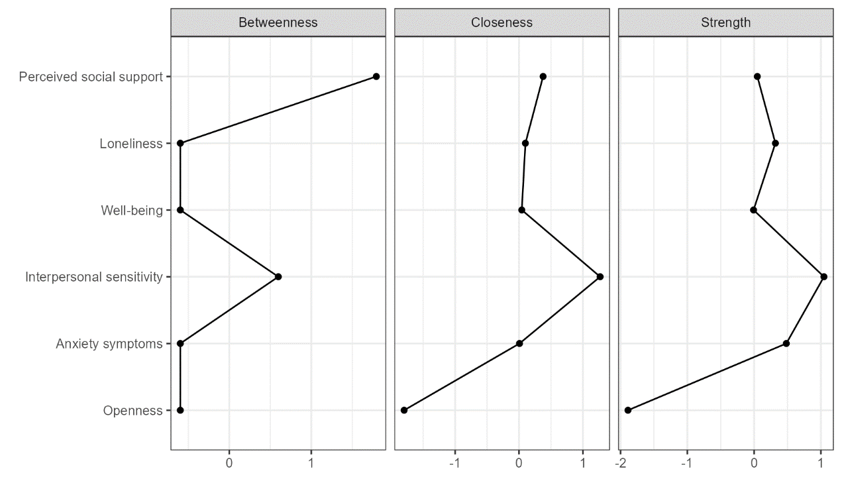
Supplementary Figure 1. Betweenness, closeness, and strength centrality measures for the estimated network of interpersonal sensitivity, openness, anxiety symptoms, well-being, loneliness, and perceived social support.

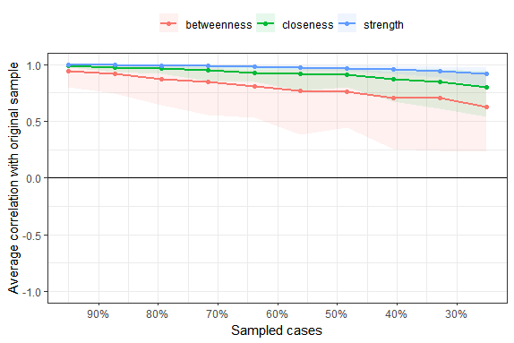
Supplementary Figure 2. Stability of the centrality indices for the estimated network of interpersonal sensitivity measure. Lines represent the means, and areas represent the range from the 2.5th quantile to the 97.5th quantile.

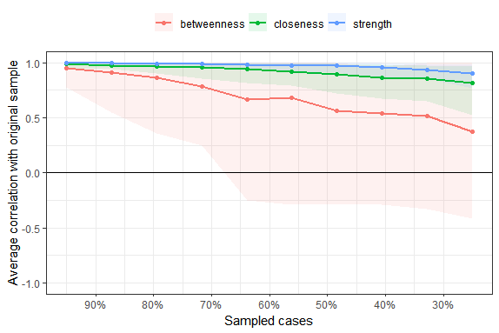
Supplementary Figure 3. Stability of the centrality indices for the estimated network of interpersonal sensitivity, openness, anxiety symptoms, well-being, loneliness, and perceived social support. Lines represent the means, and areas represent the range from the 2.5th quantile to the 97.5th quantile.

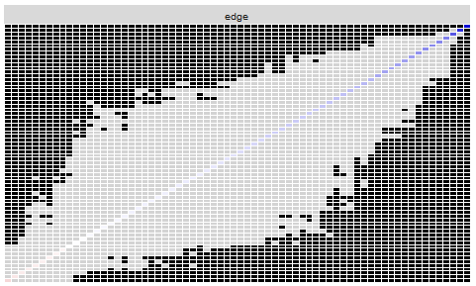
Supplementary Figure 4. Statistical difference tests for edge weight. The results are based on the network structure of the interpersonal sensitivity measure. The figure illustrates the results of bootstrapped difference tests (α=0.05) for edge weights. The color of the boxes represents whether the edge weights significantly differ from each other (black) or do not differ significantly (gray). The diagonal line represents the strength of the edge weights, transitioning from red (indicating negative associations) to white (representing weaker edges) and ultimately blue (representing stronger edge weights). To maintain a clear and uncluttered visualization, the x-axis and y-axis labels have been excluded.
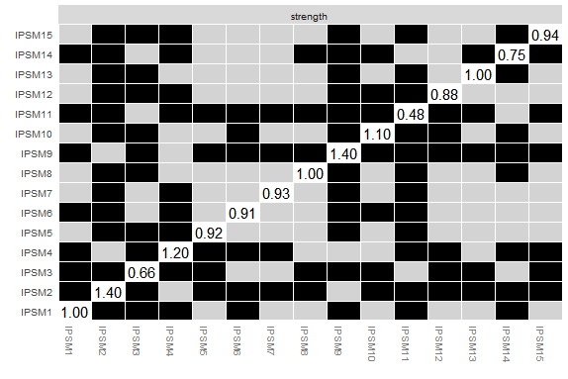
Supplementary Figure 5. Statistical difference test for node strength. The results based on the network structure of the interpersonal sensitivity measure. The figure displays the stability difference tests (α=0.05) for “node strength.” The color of the boxes indicates the presence of significant differences between symptoms: gray boxes indicate no significant differences, while black boxes indicate significant differences. The value of node strength for a specific node is denoted by the number in the white boxes (i.e., along the diagonal line).
Abbreviation: IPSM, Interpersonal Sensitivity Measure.
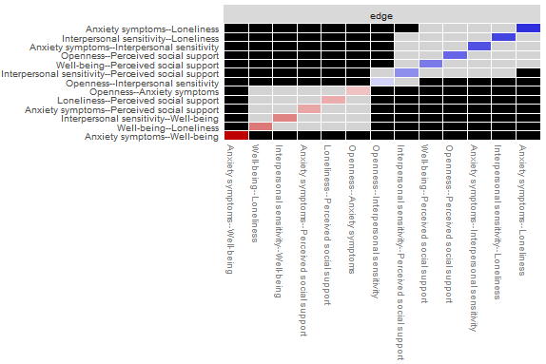
Supplementary Figure 6. Statistical difference tests for edge weight. The results are based on the network structure of interpersonal sensitivity, openness, anxiety symptoms, well-being, loneliness, and perceived social support. The figure illustrates the results of bootstrapped difference tests (α=0.05) for edge weights. The color of the boxes represents whether the edge weights significantly differ from each other (black) or do not differ significantly (gray). The diagonal line represents the strength of the edge weights, transitioning from red (indicating negative associations) to white (representing weaker edges) and ultimately blue (representing stronger edge weights).
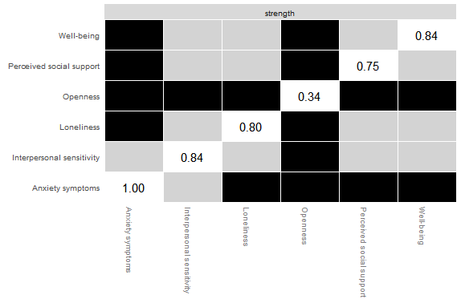
Supplementary Figure 7. Statistical difference test for node strength. The results are based on the network structure of interpersonal sensitivity, openness, anxiety symptoms, well-being, loneliness, and perceived social support. The figure displays the stability difference tests (α=0.05) for “node strength.” The color of the boxes indicates the presence of significant differences between symptoms: gray boxes indicate no significant differences, while black boxes indicate significant differences. The value of node strength for a specific node is denoted by the number in the white boxes (i.e., along the diagonal line).
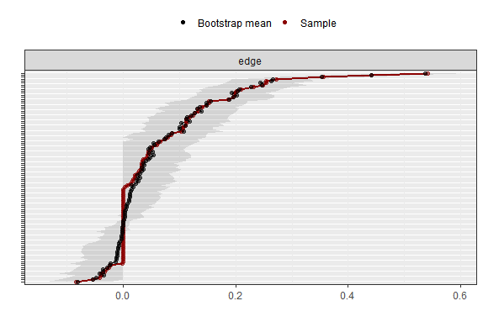
Supplementary Figure 8. Ninety-five percent confidence intervals around the edge weights of the interpersonal sensitivity measure. The red line denotes the sample values, while the gray area indicates the bootstrapped confidence intervals. Each horizontal line corresponds to an edge of the network, ordered in descending fashion according to the edge weight, ranging from the highest to the lowest. In cases where ties occur (e.g., when multiple edge weights are precisely estimated as 0), the edges are ordered based on the mean value of the bootstrap samples. To maintain a clear and uncluttered visualization, the y-axis labels have been excluded.
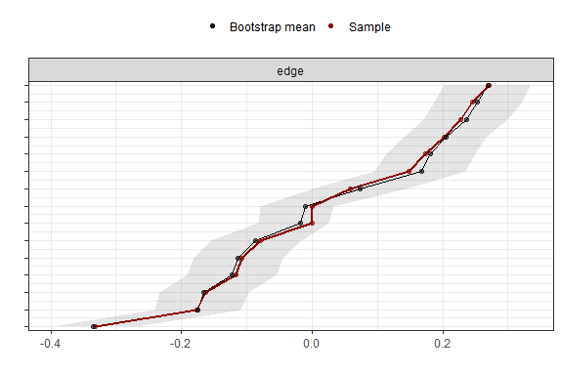
Supplementary Figure 9. Ninety-five percent confidence intervals around the edge weights of interpersonal sensitivity, openness, anxiety symptoms, well-being, loneliness, and perceived social support. The red line denotes the sample values, while the gray area indicates the bootstrapped confidence intervals. Each horizontal line corresponds to an edge of the network, ordered in descending fashion according to the edge weight, ranging from the highest to the lowest. In cases where ties occur (e.g., when multiple edge weights are precisely estimated as 0), the edges are ordered based on the mean value of the bootstrap samples. To maintain a clear and uncluttered visualization, the y-axis labels have been excluded.

