Supplementary information
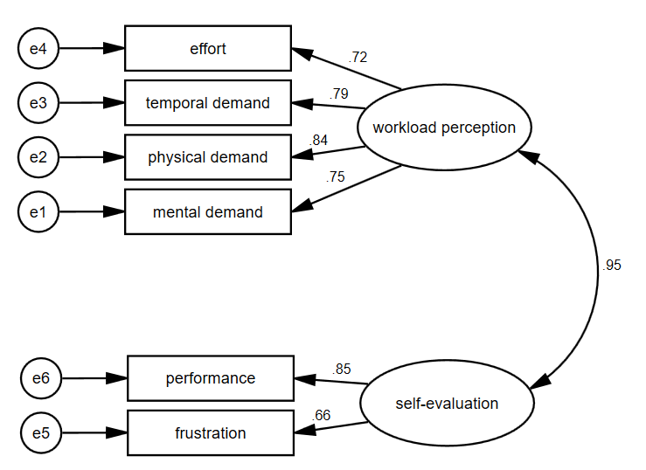
Figure 1 Confirmatory factor analysis for the 2-factor structure of the Nurse’s version of NASA’s task load index scale. Legend: F1-F6 are items in the Nurse’s version of NASA-TLX.

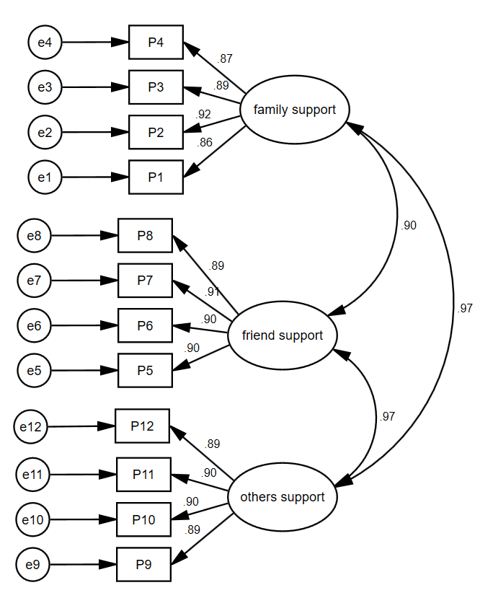
Figure 2 Confirmatory factor analysis for the 3-factor structure of the Perceived Social Support Scale. Legend: F1-F12 are items in the PSSS.
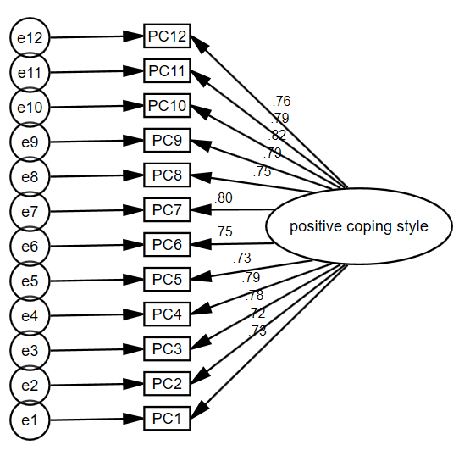
Figure 3 Confirmatory factor analysis for the 3-factor structure of the Simplified Coping Style Questionnaire-Positive Coping Style. Legend: PC1-PC12 are items in the SCSQ-PCS.

