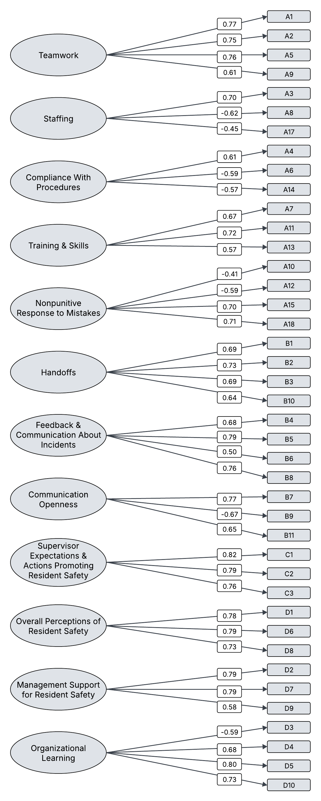
Figure S1. Nursing Home Survey on Patient Safety Culture dimensions and factor loadings
Teamwork
A1: Staff in this nursing home treat each other with respect
A2: Staff support one another in this nursing home
A5: Staff feel like they are part of a team
A9: When someone gets really busy in this nursing home, other staff help out
Staffing
A3: We have enough staff to handle the workload
A8: Staff have to hurry because they have too much work to do (negatively worded)
A17: It is hard to keep residents safe here because so many staff quit their jobs (negatively worded)
Compliance With Procedures
A4: Staff follow standard procedures to care for residents
A6: Staff use shortcuts to get their work done faster (negatively worded)
A14: To make work easier, staff often ignore procedures (negatively worded)
Training & Skills
A7: Staff get the training they need in this nursing home
A11: Staff have enough training on how to handle difficult residents
A13: Staff understand the training they get in this nursing home
Nonpunitive Response to Mistakes
A10: Staff are blamed when a resident is harmed (negatively worded)
A12: Staff are afraid to report their mistakes (negatively worded)
A15: Staff are treated fairly when they make mistakes
A18: Staff feel safe reporting their mistakes
Handoffs
B1: Staff are told what they need to know before taking care of a resident for the first time
B2: Staff are told right away when there is a change in a resident’s care plan
B3: We have all the information we need when residents are transferred from the hospital
B10: Staff are given all the information they need to care for residents
Feedback & Communication About Incidents
B4: When staff report something that could harm a resident, someone takes care of it
B5: In this nursing home, we talk about ways to keep incidents from happening again
B6: Staff tell someone if they see something that might harm a resident
B8: In this nursing home, we discuss ways to keep residents safe from harm
Communication Openness
B7: Staff ideas and suggestions are valued in this nursing home
B9: Staff opinions are ignored in this nursing home (negatively worded)
B11: It is easy for staff to speak up about problems in this nursing home
Supervisor Expectations & Actions Promoting Resident Safety
C1: My supervisor listens to staff ideas and suggestions about resident safety
C2: My supervisor says a good word to staff who follow the right procedures
C3: My supervisor pays attention to resident safety problems in this nursing home

Overall Perceptions of Resident Safety
D1: Residents are well cared for in this nursing home
D6: This nursing home does a good job keeping residents safe
D8: This nursing home is a safe place for residents
Management Support for Resident Safety
D2: Management asks staff how the nursing home can improve resident safety
D7: Management listens to staff ideas and suggestions to improve resident safety
D9: Management often walks around the nursing home to check on resident care
Organizational Learning
D3: This nursing home lets the same mistakes happen again and again (negatively worded)
D4: It is easy to make changes to improve resident safety in this nursing home
D5: This nursing home is always doing things to improve resident safety
D10: When this nursing home makes changes to improve resident safety, it checks to see if the changes worked

