Supplementary Figure Legends
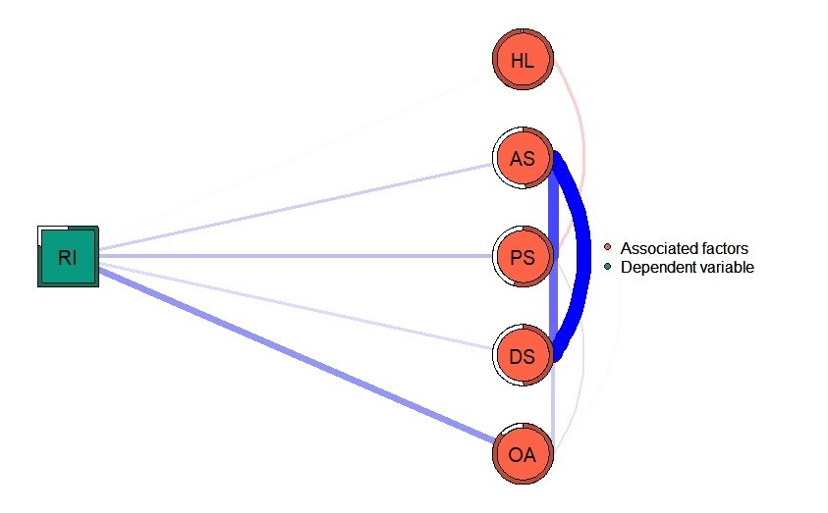
Figure S1 The flow diagram of network showing how rest intolerance is connected to its associated factors.
Notes: Items in the middle of the figure indicate the direct connection to rest intolerance and items located on the right represent the indirect connection. RI: Rest intolerance; OA: Online social networking addiction; DS: Depressive symptoms; PS: Perceived stress; AS: Anxiety symptoms; HL: Health literacy. Ring-shaped pie charts represent predictability (a fully filled dark ring would indicate that 100% of the nodes’ variance is explained by its intercorrelations with the other nodes in the network). The thickness of the edges indicates the strength of the associations, where blue edges signify positive associations and red edges indicate negative associations. Square symbolizes dependent variable, whereas circles depict its associated factors.
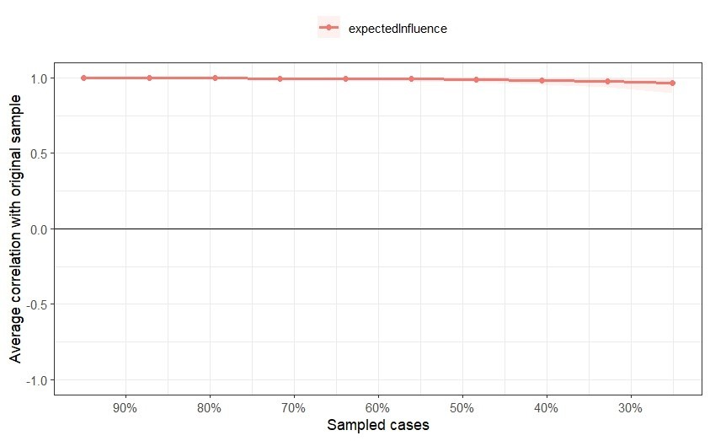
Figure S2 The stability of expected influence for the estimated network of rest intolerance among nursing students was assessed using case-dropping bootstrap.
Notes: The x-axis indicates the percentage of cases of the original sample included at each step. The y-axis indicates the average of correlations between the centrality indices from the original network and the centrality indices from the networks that were re-estimated after excluding increasing percentages of cases.
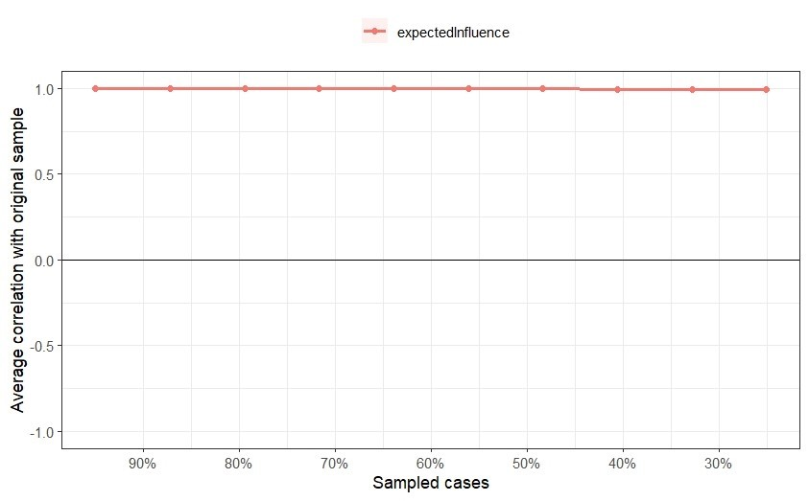
Figure S3 The stability of expected influence for the estimated network of rest intolerance and its associated factors among nursing students was assessed using case-dropping bootstrap.
Notes: The x-axis indicates the percentage of cases of the original sample included at each step. The y-axis indicates the average of correlations between the centrality indices from the original network and the centrality indices from the networks that were re-estimated after excluding increasing percentages of cases.
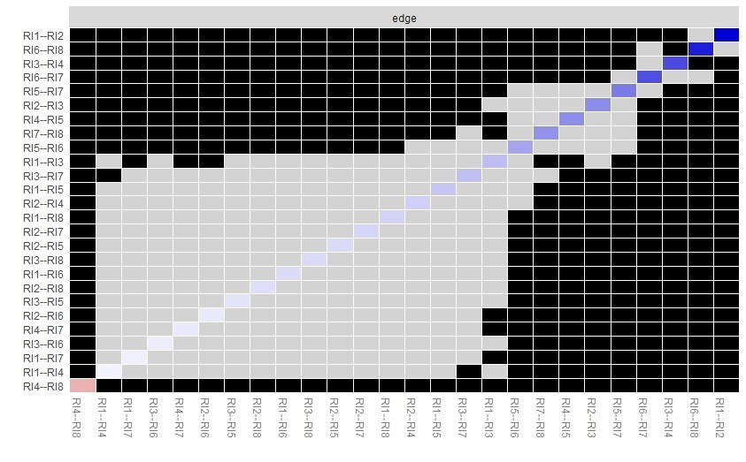
Figure S4 Bootstrapped stability test for edge-weight.
Notes: The results are based on the network structure of the rest intolerance among nursing students. RI1: When I am resting or having fun, I worry about being passed by someone else; RI2: When I am resting or having fun, I consider whether my peers are studying or working; RI3: I think I should need to spend more time studying and working rather than resting; RI4: I thought I should use my time off to do something more meaningful; RI5: When I am resting or having fun, I always feel that there is something else I am not doing; RI6: When I am resting or having fun, I feel guilty; RI7: When I am resting or having fun, I cannot help but think about studying or working; RI8: When I am resting or having fun, I feel so bad about myself. The results of the bootstrapped difference tests (α=0.05) for edge-weights were shown in this figure. There was a total of (8*(8-1))/2=28 edges between all 8 nodes. The color of the boxes indicates whether edge-weights differ significantly from each other (i.e., black) or do not differ significantly (i.e., grey). The diagonal line indicates the strength of edge-weights, shifting from red (negative associations), to white (representing weaker edges) and ultimately blue (representing stronger edge-weights)
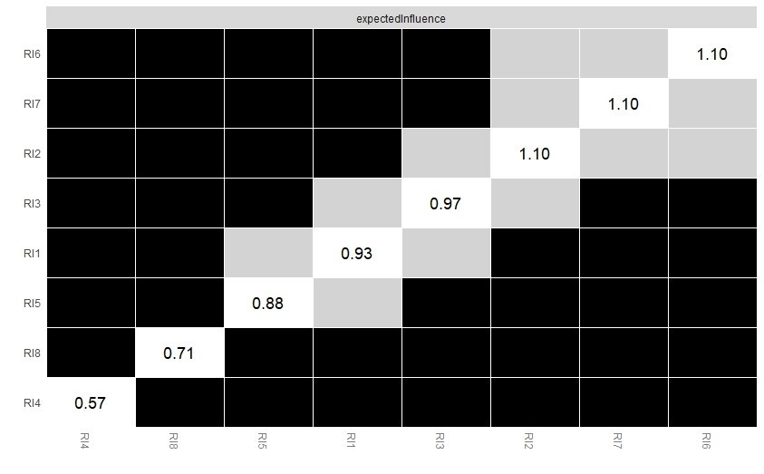
Figure S5 Bootstrapped stability test for node expected influence.
Notes: The results are based on the network structure of the rest intolerance among nursing students. RI1: When I am resting or having fun, I worry about being passed by someone else; RI2: When I am resting or having fun, I consider whether my peers are studying or working; RI3: I think I should need to spend more time studying and working rather than resting; RI4: I thought I should use my time off to do something more meaningful; RI5: When I am resting or having fun, I always feel that there is something else I am not doing; RI6: When I am resting or having fun, I feel guilty; RI7: When I am resting or having fun, I cannot help but think about studying or working; RI8: When I am resting or having fun, I feel so bad about myself. The stability difference tests (α=0.05) for “node expected influence” are shown in this Figure. The color of the boxes indicates whether there is a significant difference between nodes (i.e., grey boxes reflect no significant differences and black boxes reflect significant differences). The number in the white boxes (i.e., the diagonal line) denotes the value of node expected influence of a specific node.
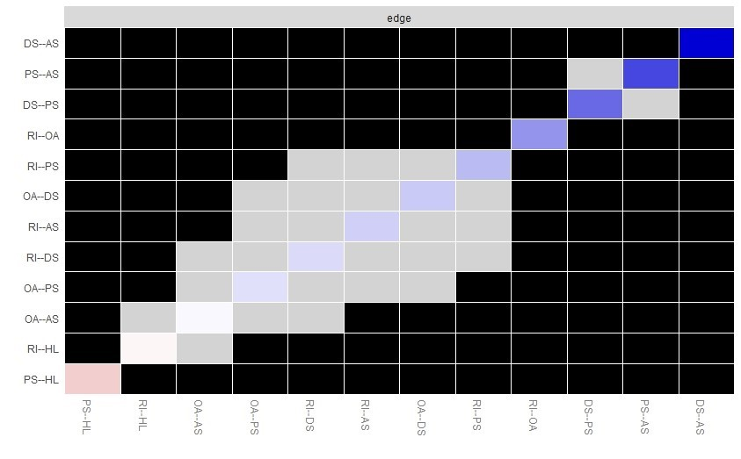
Figure S6 Bootstrapped stability test for edge-weight.
Notes: The results are based on the network structure of the rest intolerance and its associated factors among nursing students. RI: Rest intolerance; OA: Online social networking addiction; DS: Depressive symptoms; PS: Perceived stress; AS: Anxiety symptoms; HL: Health literacy. The results of the bootstrapped difference tests (α=0.05) for edge-weights were shown in this figure. There was a total of (6*(6-1))/2=15 edges between all 6 nodes. The color of the boxes indicates whether edge-weights differ significantly from each other (i.e., black) or do not differ significantly (i.e., grey). The diagonal line indicates the strength of edge-weights, shifting from red (negative associations), to white (representing weaker edges) and ultimately blue (representing stronger edge-weights).
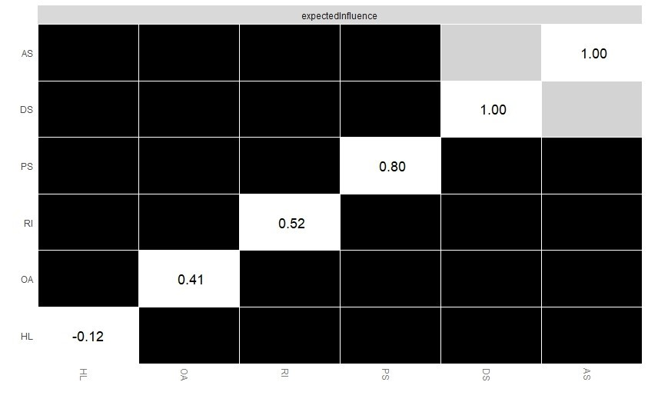
Figure S7 Bootstrapped stability test for node expected influence.
Notes: The results are based on the network structure of the rest intolerance and its associated factors among nursing students. RI: Rest intolerance; OA: Online social networking addiction; DS: Depressive symptoms; PS: Perceived stress; AS: Anxiety symptoms; HL: Health literacy. The stability difference tests (α=0.05) for “node expected influence” are shown in this Figure. The color of the boxes indicates whether there is a significant difference between nodes (i.e., grey boxes reflect no significant differences and black boxes reflect significant differences). The number in the white boxes (i.e., the diagonal line) denotes the value of node expected influence of a specific node.
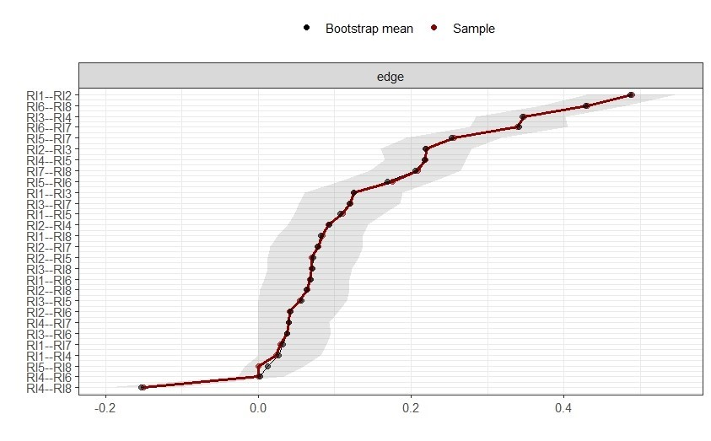
Figure S8 Bootstrapped confidence intervals of all edges.
Notes: The results are based on the network structure of the rest intolerance among nursing students. RI1: When I am resting or having fun, I worry about being passed by someone else; RI2: When I am resting or having fun, I consider whether my peers are studying or working; RI3: I think I should need to spend more time studying and working rather than resting; RI4: I thought I should use my time off to do something more meaningful; RI5: When I am resting or having fun, I always feel that there is something else I am not doing; RI6: When I am resting or having fun, I feel guilty; RI7: When I am resting or having fun, I cannot help but think about studying or working; RI8: When I am resting or having fun, I feel so bad about myself. The red dots indicate the values of each edge weight from the network and the black dots indicate the value of each edge weight by bootstrap procedure, both ordered from the highest to the lowest value. The gray area represents the 95% Confidence Intervals of edge weights, estimated with the non-parametric bootstrap procedure. Wide intervals indicate lower stability and narrow intervals indicate higher stability.
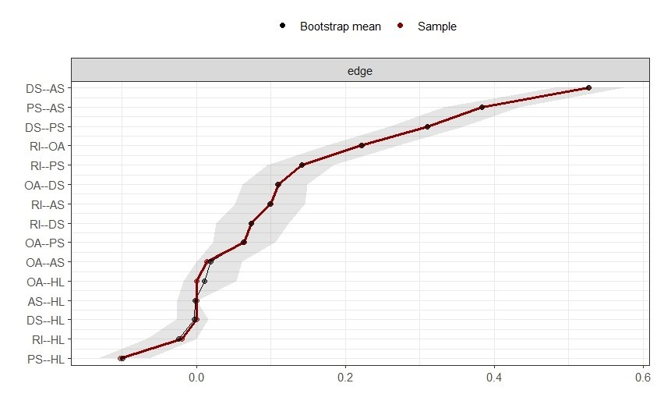
Figure S9 Bootstrapped confidence intervals of all edges.
Notes: The results are based on the network structure of the rest intolerance and its associated factors among nursing students. RI: Rest intolerance; OA: Online social networking addiction; DS: Depressive symptoms; PS: Perceived stress; AS: Anxiety symptoms; HL: Health literacy. The red dots indicate the values of each edge weight from the network and the black dots indicate the value of each edge weight by bootstrap procedure, both ordered from the highest to the lowest value. The gray area represents the 95% Confidence Intervals of edge weights, estimated with the non-parametric bootstrap procedure. Wide intervals indicate lower stability and narrow intervals indicate higher stability.

