Documentation on search strategy on the topic COVID-19 and nursing education.

Medline
Date of search: 20th June 2022
Number of hits (before duplication removal): 649
Comments:
Documentation of search:

Database: Ovid MEDLINE(R) and Epub Ahead of Print, In-Process, In-Data-Review & Other Non-Indexed Citations and Daily <1946 to June 17, 2022>
Search Strategy:
--------------------------------------------------------------------------------
1 exp Faculty, Nursing/ (10580)
2 exp Education, Nursing/ (87738)
3 ((nurse or nursing) adj (school* or college* or teach* or facult* or educat* or training or lecture* or teach* or curriculum or learn* or program* or class*)).ti,ab. (31959)
4 or/1-3 (101185)
5 exp COVID-19/ (168281)
6 exp SARS-CoV-2/ (128891)
7 exp Pandemics/ (88937)
8 exp Coronavirus Infections/ (179288)
9 ((COVID adj "19") or COVID-19 or COVID19).ti,ab. (223589)
10 exp Coronavirus/ (142062)
11 exp Coronavirus 229E, Human/ (332)
12 (Coronavirus* or (corona adj virus*)).ti,ab. (97607)
13 exp Pneumovirus Infections/ (8297)
14 (Pneumonia adj virus*).ti,ab. (335)
15 (COVID or NCOV or 2019NCOV or CORONAVIRINAE).ti,ab. (226999)
16 exp Severe Acute Respiratory Syndrome/ (5692)
17 (("19" or "2019") adj2 (epidem* or epidemy or epidemic* or pandem*)).ti,ab. (90344)
18 (sars cov 2 or sars2 or sarscov2 or sarscov-2 or cov 2019 or sars coronavirus 2 or sars corona virus 2 or sars-cov-2).ti,ab. (75979)
19 or/5-18 (298654)
20 4 and 19 (660)
21 limit 20 to yr="2019 -Current" (649)

***************************

Embase
Date of search: 20th June 2022
Number of hits (before duplication removal): 685
Comments:
Documentation of search:

Database: Embase <1974 to 2022 Week 24>
Search Strategy:
--------------------------------------------------------------------------------
1 exp nursing education/ (86806)
2 ((nurse or nursing) adj (school* or college* or teach* or facult* or educat* or training or lecture* or teach* or curriculum or learn* or program* or class*)).ti,ab. (32188)
3 or/1-2 (95937)
4 exp coronavirus disease 2019/ (225957)
5 exp Severe acute respiratory syndrome coronavirus 2/ (67121)
6 exp pandemic/ (125851)
7 exp Coronavirus infection/ (245818)
8 ((COVID adj "19") or COVID-19 or COVID19).ti,ab. (239904)
9 exp Coronavirinae/ (89314)
10 exp Human coronavirus 229E/ (656)
11 (Coronavirus* or (corona adj virus*)).ti,ab. (99557)
12 exp Pneumovirus infection/ (6943)
13 (Pneumonia adj virus*).ti,ab. (336)
14 (COVID or NCOV or 2019NCOV or CORONAVIRINAE).ti,ab. (244254)
15 exp severe acute respiratory syndrome/ (10824)
16 (("19" or "2019") adj2 (epidem* or epidemy or epidemic* or pandem*)).ti,ab. (94158)
17 (sars cov 2 or sars2 or sarscov2 or sarscov-2 or cov 2019 or sars coronavirus 2 or sars corona virus 2 or sars-cov-2).ti,ab. (82616)
18 or/4-17 (342610)
19 3 and 18 (706)
20 limit 19 to yr="2019 -Current" (685)

***************************

Cinahl
Date of search: 20th June 2022
Number of hits (before duplication removal): 1192
Comments:
Documentation of search:

# | Query | Limiters/Expanders | Last Run Via | Results
S1 | (MH "Faculty, Nursing") | Expanders - Apply equivalent subjects  Search modes - Boolean/Phrase | Interface - EBSCOhost Research Databases  Search Screen - Advanced Search  Database - CINAHL | 17,347
S2 | (MH "Education, Nursing+") | Expanders - Apply equivalent subjects  Search modes - Boolean/Phrase | Interface - EBSCOhost Research Databases  Search Screen - Advanced Search  Database - CINAHL | 79,760
S3 | TI ( (nurse or nursing) N0 (school* or college* or teach* or facult* or educat* or training or lecture* or teach* or curriculum or learn* or program* or class*) ) OR AB ( (nurse or nursing) N0 (school* or college* or teach* or facult* or educat* or training or lecture* or teach* or curriculum or learn* or program* or class*) ) | Expanders - Apply equivalent subjects  Search modes - Boolean/Phrase | Interface - EBSCOhost Research Databases  Search Screen - Advanced Search  Database - CINAHL | 51,656
S4 | S1 OR S2 OR S3 | Expanders - Apply equivalent subjects  Search modes - Boolean/Phrase | Interface - EBSCOhost Research Databases  Search Screen - Advanced Search  Database - CINAHL | 113,843
S5 | (MH "COVID-19+") | Expanders - Apply equivalent subjects  Search modes - Boolean/Phrase | Interface - EBSCOhost Research Databases  Search Screen - Advanced Search  Database - CINAHL | 33,594
S6 | (MH "SARS-CoV-2") | Expanders - Apply equivalent subjects  Search modes - Boolean/Phrase | Interface - EBSCOhost Research Databases  Search Screen - Advanced Search  Database - CINAHL | 963
S7 | (MH "Disease Outbreaks+") | Expanders - Apply equivalent subjects  Search modes - Boolean/Phrase | Interface - EBSCOhost Research Databases  Search Screen - Advanced Search  Database - CINAHL | 70,540
S8 | (MH "Coronavirus Infections") | Expanders - Apply equivalent subjects  Search modes - Boolean/Phrase | Interface - EBSCOhost Research Databases  Search Screen - Advanced Search  Database - CINAHL | 2,332
S9 | TI ( (COVID N0 "19") or COVID-19 or COVID19 ) OR AB ( (COVID N0 "19") or COVID-19 or COVID19 ) | Expanders - Apply equivalent subjects  Search modes - Boolean/Phrase | Interface - EBSCOhost Research Databases  Search Screen - Advanced Search  Database - CINAHL | 81,407
S10 | (MH "Coronavirus+") | Expanders - Apply equivalent subjects  Search modes - Boolean/Phrase | Interface - EBSCOhost Research Databases  Search Screen - Advanced Search  Database - CINAHL | 2,715
S11 | TI ( Coronavirus* or (corona N0 virus*) ) OR AB ( Coronavirus* or (corona N0 virus*) ) | Expanders - Apply equivalent subjects  Search modes - Boolean/Phrase | Interface - EBSCOhost Research Databases  Search Screen - Advanced Search  Database - CINAHL | 24,725
S12 | TI Pneumonia N0 virus* OR AB Pneumonia N0 virus* | Expanders - Apply equivalent subjects  Search modes - Boolean/Phrase | Interface - EBSCOhost Research Databases  Search Screen - Advanced Search  Database - CINAHL | 65
S13 | TI ( COVID or NCOV or 2019NCOV or CORONAVIRINAE ) OR AB ( COVID or NCOV or 2019NCOV or CORONAVIRINAE ) | Expanders - Apply equivalent subjects  Search modes - Boolean/Phrase | Interface - EBSCOhost Research Databases  Search Screen - Advanced Search  Database - CINAHL | 86,220
S14 | (MH "Severe Acute Respiratory Syndrome") | Expanders - Apply equivalent subjects  Search modes - Boolean/Phrase | Interface - EBSCOhost Research Databases  Search Screen - Advanced Search  Database - CINAHL | 2,502
S15 | TI ( ("19" or "2019") N2 (epidem* or epidemy or epidemic* or pandem*) ) OR AB ( ("19" or "2019") N2 (epidem* or epidemy or epidemic* or pandem*) ) | Expanders - Apply equivalent subjects  Search modes - Boolean/Phrase | Interface - EBSCOhost Research Databases  Search Screen - Advanced Search  Database - CINAHL | 4,724
S16 | TI ( sars cov 2 or sars2 or sarscov2 or sarscov-2 or cov 2019 or sars coronavirus 2 or sars corona virus 2 or sars-cov-2 ) OR AB ( sars cov 2 or sars2 or sarscov2 or sarscov-2 or cov 2019 or sars coronavirus 2 or sars corona virus 2 or sars-cov-2 ) | Expanders - Apply equivalent subjects  Search modes - Boolean/Phrase | Interface - EBSCOhost Research Databases  Search Screen - Advanced Search  Database - CINAHL | 14,251
S17 | S5 OR S6 OR S7 OR S8 OR S9 OR S10 OR S11 OR S12 OR S13 OR S14 OR S15 OR S16 | Expanders - Apply equivalent subjects  Search modes - Boolean/Phrase | Interface - EBSCOhost Research Databases  Search Screen - Advanced Search  Database - CINAHL | 133,254
S18 | S4 AND S17 | Expanders - Apply equivalent subjects  Search modes - Boolean/Phrase | Interface - EBSCOhost Research Databases  Search Screen - Advanced Search  Database - CINAHL | 1,293
S19 | S4 AND S17 | Limiters - Published Date: 20190101-20221231  Expanders - Apply equivalent subjects  Search modes - Boolean/Phrase | Interface - EBSCOhost Research Databases  Search Screen - Advanced Search  Database - CINAHL | 1,192

Scopus
Date of search: 20th June 2022
Number of hits (before duplication removal): 640
Comments:
Documentation of search:

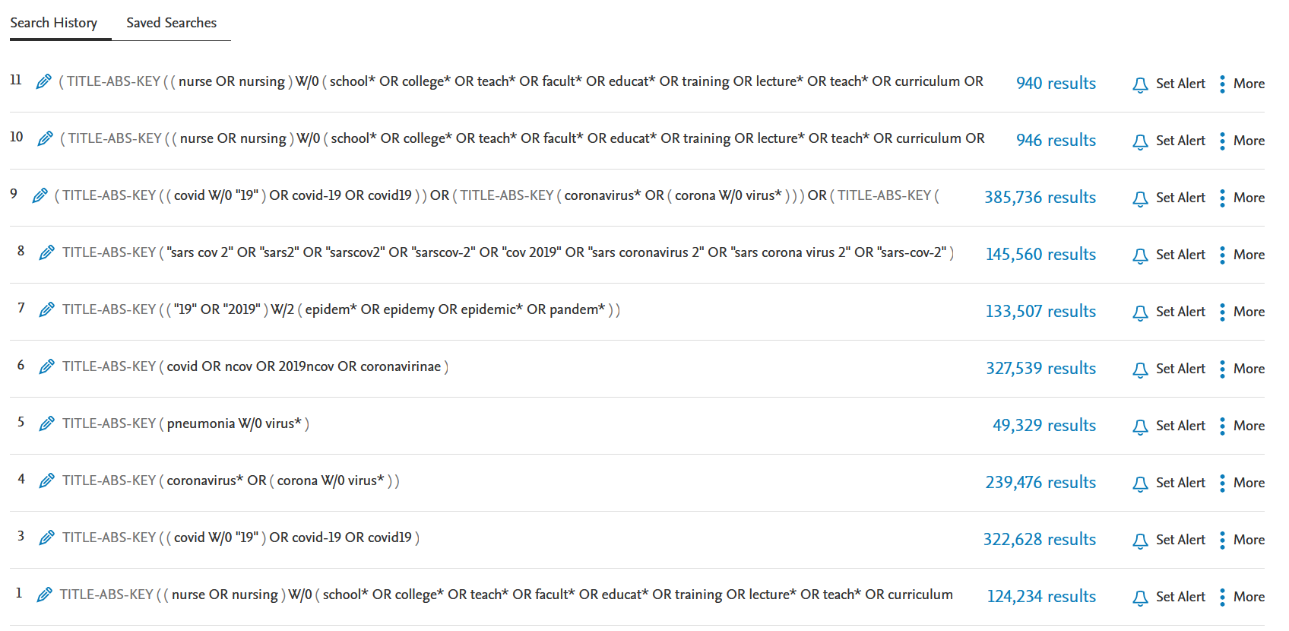

Web of Science
Date of search: 20th June 2022
Number of hits (before duplication removal): 569
Comments:
Documentation of search:

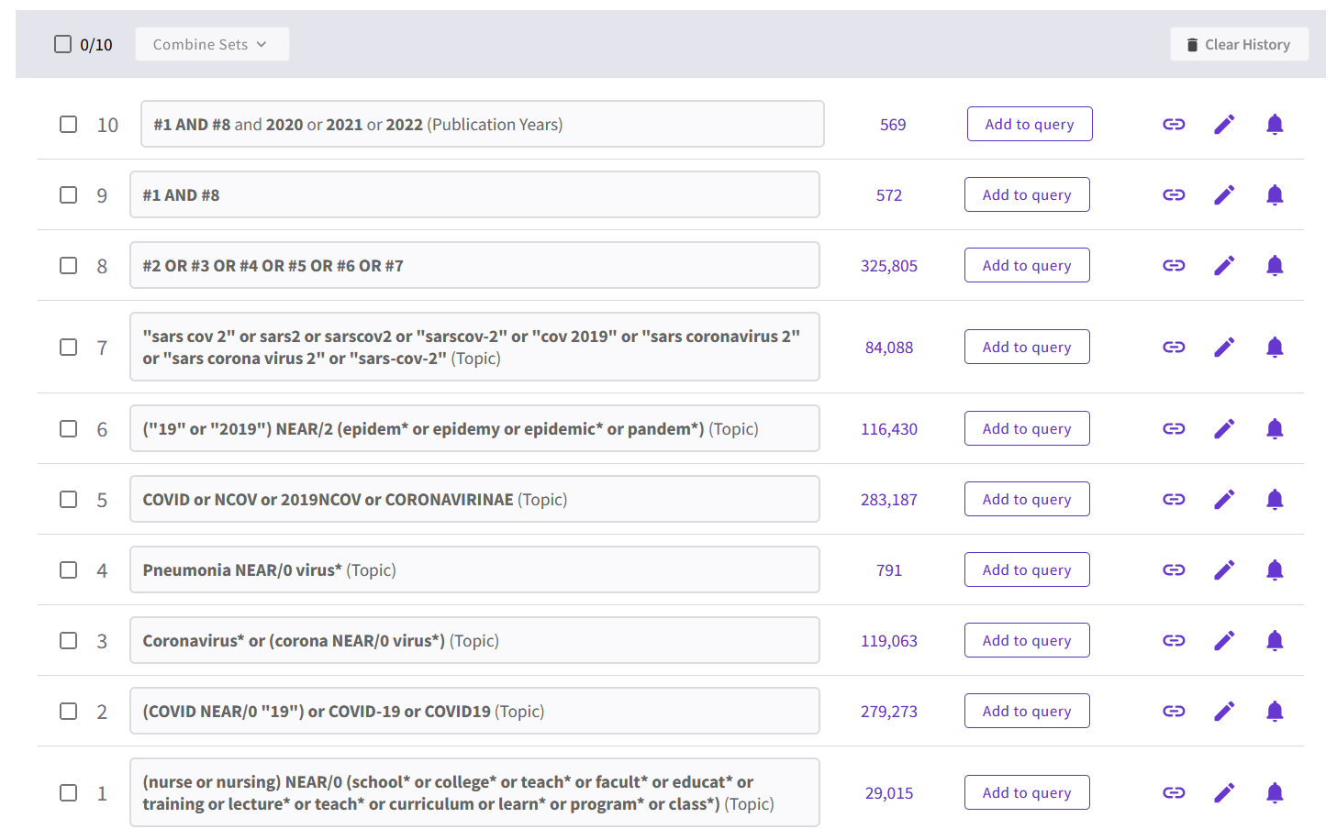

Cochrane
Date of search: 20th June 2022
Number of hits (before duplication removal): 0 reviews, 5 trials
Comments: Limited the search to publications from 2019 to today.
Documentation of search:

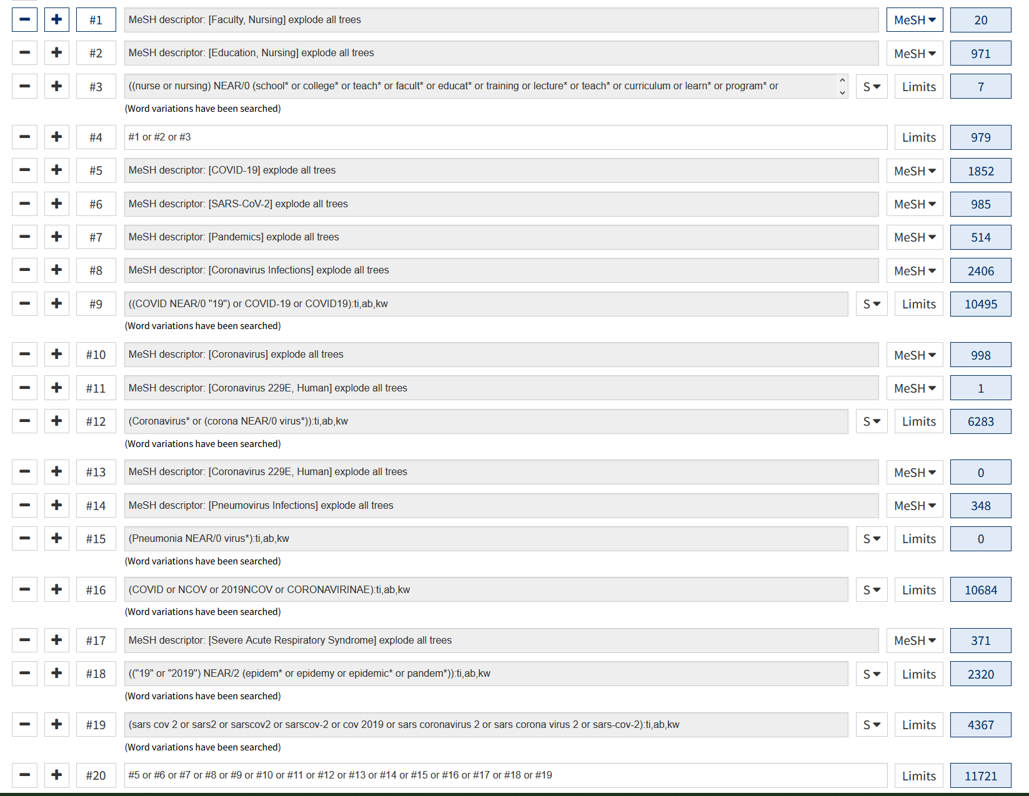

ERIC
Date of search: 20th June 2022
Number of hits (before duplication removal): 12
Comments:
Documentation of search:

# | Query | Limiters/Expanders | Last Run Via | Results
S1 | TI ( (nurse or nursing) N0 (school* or college* or teach* or facult* or educat* or training or lecture* or teach* or curriculum or learn* or program* or class*) ) OR AB ( (nurse or nursing) N0 (school* or college* or teach* or facult* or educat* or training or lecture* or teach* or curriculum or learn* or program* or class*) ) | Expanders - Apply equivalent subjects  Search modes - Boolean/Phrase | Interface - EBSCOhost Research Databases  Search Screen - Advanced Search  Database - ERIC | 5,028
S2 | DE "COVID-19" OR DE "Pandemics" | Expanders - Apply equivalent subjects  Search modes - Boolean/Phrase | Interface - EBSCOhost Research Databases  Search Screen - Advanced Search  Database - ERIC | 5,046
S3 | TI ( (COVID N0 "19") or COVID-19 or COVID19 ) OR AB ( (COVID N0 "19") or COVID-19 or COVID19 ) | Expanders - Apply equivalent subjects  Search modes - Boolean/Phrase | Interface - EBSCOhost Research Databases  Search Screen - Advanced Search  Database - ERIC | 4,612
S4 | TI ( Coronavirus* or (corona N0 virus*) ) OR AB ( Coronavirus* or (corona N0 virus*) ) | Expanders - Apply equivalent subjects  Search modes - Boolean/Phrase | Interface - EBSCOhost Research Databases  Search Screen - Advanced Search  Database - ERIC | 821
S5 | TI ( COVID or NCOV or 2019NCOV or CORONAVIRINAE ) OR AB ( COVID or NCOV or 2019NCOV or CORONAVIRINAE ) | Expanders - Apply equivalent subjects  Search modes - Boolean/Phrase | Interface - EBSCOhost Research Databases  Search Screen - Advanced Search  Database - ERIC | 4,631
S6 | TI ( ("19" or "2019") N2 (epidem* or epidemy or epidemic* or pandem*) ) OR AB ( ("19" or "2019") N2 (epidem* or epidemy or epidemic* or pandem*) ) | Expanders - Apply equivalent subjects  Search modes - Boolean/Phrase | Interface - EBSCOhost Research Databases  Search Screen - Advanced Search  Database - ERIC | 139
S7 | TI ( "sars cov 2" or sars2 or sarscov2 or "sarscov-2" or "cov 2019" or "sars coronavirus 2" or "sars corona virus 2" or "sars-cov-2" ) OR AB ( "sars cov 2" or sars2 or sarscov2 or "sarscov-2" or "cov 2019" or "sars coronavirus 2" or "sars corona virus 2" or "sars-cov-2" ) | Expanders - Apply equivalent subjects  Search modes - Boolean/Phrase | Interface - EBSCOhost Research Databases  Search Screen - Advanced Search  Database - ERIC | 63
S8 | S2 OR S3 OR S4 OR S5 OR S6 OR S7 | Expanders - Apply equivalent subjects  Search modes - Boolean/Phrase | Interface - EBSCOhost Research Databases  Search Screen - Advanced Search  Database - ERIC | 5,574
S9 | S1 AND S8 | Expanders - Apply equivalent subjects  Search modes - Boolean/Phrase | Interface - EBSCOhost Research Databases  Search Screen - Advanced Search  Database - ERIC | 12
S10 | S1 AND S8 | Limiters - Date Published: 20190101-20211231  Expanders - Apply equivalent subjects  Search modes - Boolean/Phrase | Interface - EBSCOhost Research Databases  Search Screen - Advanced Search  Database - ERIC | 12
S11 | S1 AND S8 | Limiters - Date Published: 20200101-20221231  Expanders - Apply equivalent subjects  Search modes - Boolean/Phrase | Interface - EBSCOhost Research Databases  Search Screen - Advanced Search  Database - ERIC | 12

Teacher Reference Center
Date of search: 20th June 2022
Number of hits (before duplication removal): 7
Comments:
Documentation of search:

# | Query | Limiters/Expanders | Last Run Via | Results
S1 | TI ( (nurse or nursing) N0 (school* or college* or teach* or facult* or educat* or training or lecture* or teach* or curriculum or learn* or program* or class*) ) OR AB ( (nurse or nursing) N0 (school* or college* or teach* or facult* or educat* or training or lecture* or teach* or curriculum or learn* or program* or class*) ) | Expanders - Apply equivalent subjects  Search modes - Boolean/Phrase | Interface - EBSCOhost Research Databases  Search Screen - Advanced Search  Database - Teacher Reference Center | 685
S2 | (ZU "covid-19") or (ZU "covid-19 pandemic") or (ZU "sars-cov-2") or (ZU "pandemics") or (ZU "coronaviruses") | Expanders - Apply equivalent subjects  Search modes - Boolean/Phrase | Interface - EBSCOhost Research Databases  Search Screen - Advanced Search  Database - Teacher Reference Center | 3,515
S3 | TI ( (COVID N0 "19") or COVID-19 or Coronavirus* or (corona N0 virus*) ) OR AB ( (COVID N0 "19") or COVID-19 or Coronavirus* or (corona N0 virus*) ) | Expanders - Apply equivalent subjects  Search modes - Boolean/Phrase | Interface - EBSCOhost Research Databases  Search Screen - Advanced Search  Database - Teacher Reference Center | 3,042
S4 | TI ( COVID or NCOV or 2019NCOV or CORONAVIRINAE or sars cov 2 or sars2 or sarscov2 or sarscov-2 or cov 2019 or sars coronavirus 2 or sars corona virus 2 or sars-cov-2 ) OR AB ( COVID or NCOV or 2019NCOV or CORONAVIRINAE or sars cov 2 or sars2 or sarscov2 or sarscov-2 or cov 2019 or sars coronavirus 2 or sars corona virus 2 or sars-cov-2 ) | Expanders - Apply equivalent subjects  Search modes - Boolean/Phrase | Interface - EBSCOhost Research Databases  Search Screen - Advanced Search  Database - Teacher Reference Center | 2,747
S5 | TI ( ("19" or "2019") N2 (epidem* or epidemy or epidemic* or pandem*) ) OR AB ( ("19" or "2019") N2 (epidem* or epidemy or epidemic* or pandem*) ) | Expanders - Apply equivalent subjects  Search modes - Boolean/Phrase | Interface - EBSCOhost Research Databases  Search Screen - Advanced Search  Database - Teacher Reference Center | 105
S6 | S2 OR S3 OR S4 OR S5 | Expanders - Apply equivalent subjects  Search modes - Boolean/Phrase | Interface - EBSCOhost Research Databases  Search Screen - Advanced Search  Database - Teacher Reference Center | 4,137
S7 | S1 AND S6 | Expanders - Apply equivalent subjects  Search modes - Boolean/Phrase | Interface - EBSCOhost Research Databases  Search Screen - Advanced Search  Database - Teacher Reference Center | 7
S8 | S1 AND S6 | Limiters - Published Date: 20190101-20221231  Expanders - Apply equivalent subjects  Search modes - Boolean/Phrase | Interface - EBSCOhost Research Databases  Search Screen - Advanced Search  Database - Teacher Reference Center | 7

Epistemonikos
Date of search: 20th June 2022
Number of hits (before duplication removal): 77
Comments: I’ve limited the hits to systematic reviews
Documentation of search:

((nurse or nursing) and (school* or college* or teach* or facult* or educat* or training or lecture* or teach* or curriculum or learn* or program* or class*)) and (COVID-19 or COVID19 OR
Coronavirus* or COVID or NCOV or 2019NCOV or CORONAVIRINAE)

Google Scholar
Date of search: 20th June 2022
Number of hits (before duplication removal): 200
Comments:I’ve only included the first 200 hits, as relevance is decreasing after this.
Documentation of search:

- covid|corona|coronavirus (nurse|nursing
school|college|faculty|education|training|lecture|curriculum|programme|class)

