Documentation on search strategy on the topic COVID-19 and nursing education (updated).

Medline
Date of search: 19th September 2023
Number of hits (before duplication removal): 614
Comments:
Documentation of search:

Database: Ovid MEDLINE(R) and Epub Ahead of Print, In-Process, In-Data-Review & Other Non-Indexed Citations and Daily <1946 to September 18, 2023>
Search Strategy:
1 exp Faculty, Nursing/ (10870)
2 exp Education, Nursing/ (89595)
3 ((nurse or nursing) adj (school* or college* or teach* or facult* or educat* or training or lecture* or teach* or curriculum or learn* or program* or class*)).ti,ab. (34111)
4 or/1-3 (104266)
5 exp COVID-19/ (239702)
6 exp SARS-CoV-2/ (159363)
7 exp Pandemics/ (120067)
8 exp Coronavirus Infections/ (251331)
9 ((COVID adj "19") or COVID-19 or COVID19).ti,ab. (323718)
10 exp Coronavirus/ (173263)
11 exp Coronavirus 229E, Human/ (398)
12 (Coronavirus* or (corona adj virus*)).ti,ab. (128023)
13 exp Pneumovirus Infections/ (8928)
14 (Pneumonia adj virus*).ti,ab. (339)
15 (COVID or NCOV or 2019NCOV or CORONAVIRINAE).ti,ab. (329307)
16 exp Severe Acute Respiratory Syndrome/ (5735)
17 (("19" or "2019") adj2 (epidem* or epidemy or epidemic* or pandem*)).ti,ab. (137306)
18 (sars cov 2 or sars2 or sarscov2 or sarscov-2 or cov 2019 or sars coronavirus 2 or sars corona virus 2 or sars-cov-2).ti,ab. (109573)
19 or/5-18 (416766)
20 4 and 19 (1068)
21 limit 20 to yr="2022 -Current" (614)

Embase
Date of search: 19th September 2023
Number of hits (before duplication removal): 596
Comments:
Documentation of search:

Database: Embase <1974 to 2023 Week 37>
Search Strategy:
1 exp nursing education/ (89465)
2 ((nurse or nursing) adj (school* or college* or teach* or facult* or educat* or training or lecture* or teach* or curriculum or learn* or program* or class*)).ti,ab. (34455)
3 or/1-2 (99505)
4 exp coronavirus disease 2019/ (349511)
5 exp severe acute respiratory syndrome/ (11534)
6 exp pandemic/ (182260)
7 exp Coronavirus infection/ (369677)
8 ((COVID adj "19") or COVID-19 or COVID19).ti,ab. (361374)
9 exp Coronavirinae/ (124351)
10 exp Human coronavirus 229E/ (946)
11 (Coronavirus* or (corona adj virus*)).ti,ab. (133292)
12 exp Pneumovirus infection/ (8109)
13 (Pneumonia adj virus*).ti,ab. (341)
14 (COVID or NCOV or 2019NCOV or CORONAVIRINAE).ti,ab. (369788)
15 (("19" or "2019") adj2 (epidem* or epidemy or epidemic* or pandem*)).ti,ab. (147239)
16 (sars cov 2 or sars2 or sarscov2 or sarscov-2 or cov 2019 or sars coronavirus 2 or sars corona virus 2 or sars-cov-2).ti,ab. (125086)
17 or/4-16 (502462)
18 3 and 17 (1107)
19 limit 18 to yr="2022 -Current" (596)

Cinahl
Date of search: 19th September 2023
Number of hits (before duplication removal): 953
Comments:
Documentation of search:

# | Query | Results
S1 | (MH "Faculty, Nursing") | 17,552
S2 | (MH "Education, Nursing+") | 80,602
S3 | TI ( (nurse or nursing) N0 (school* or college* or teach* or facult* or educat* or training or lecture* or teach* or curriculum or learn* or program* or class*) ) OR AB ( (nurse or nursing) N0 (school* or college* or teach* or facult* or educat* or training or lecture* or teach* or curriculum or learn* or program* or class*) ) | 53,736
S4 | S1 OR S2 OR S3 | 115,641
S5 | (MH "COVID-19+") | 44,101
S6 | (MH "SARS-CoV-2") | 1,443
S7 | (MH "Disease Outbreaks+") | 87,248
S8 | (MH "Coronavirus Infections+") | 48,163
S9 | TI ( (COVID N0 "19") or COVID-19 or COVID19 ) OR AB ( (COVID N0 "19") or COVID-19 or COVID19 ) | 117,594
S10 | (MH "Coronavirus+") | 3,230
S11 | TI ( Coronavirus* or (corona N0 virus*) ) OR AB ( Coronavirus* or (corona N0 virus*) ) | 31,273
S12 | TI Pneumonia N0 virus* OR AB Pneumonia N0 virus* | 72
S13 | TI ( COVID or NCOV or 2019NCOV or CORONAVIRINAE ) OR AB ( COVID or NCOV or 2019NCOV or CORONAVIRINAE ) | 124,706
S14 | (MH "Severe Acute Respiratory Syndrome") | 2,535
S15 | TI ( ("19" or "2019") N2 (epidem* or epidemy or epidemic* or pandem*) ) OR AB ( ("19" or "2019") N2 (epidem* or epidemy or epidemic* or pandem*) ) | 6,408
S16 | TI ( sars cov 2 or sars2 or sarscov2 or sarscov-2 or cov 2019 or sars coronavirus 2 or sars corona virus 2 or sars-cov-2 ) OR AB ( sars cov 2 or sars2 or sarscov2 or sarscov-2 or cov 2019 or sars coronavirus 2 or sars corona virus 2 or sars-cov-2 ) | 19,682
S17 | S5 OR S6 OR S7 OR S8 OR S9 OR S10 OR S11 OR S12 OR S13 OR S14 OR S15 OR S16 | 177,385
S18 | S4 AND S17 | 1,977
S19 | S4 AND S17 | 953

Web of Science
Date of search: 19th September 2023
Number of hits (before duplication removal): 679
Comments:
Documentation of search:

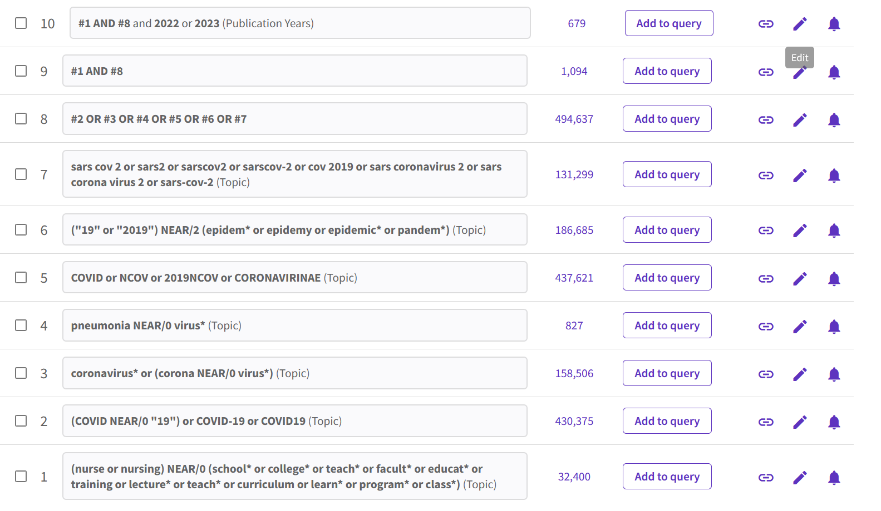

Cochrane
Date of search: 19th September 2023
Number of hits (before duplication removal): 0 reviews, 29 trials
Comments:
Documentation of search:

ID Search Hits
#1 MeSH descriptor: [Faculty, Nursing] explode all trees 29
#2 MeSH descriptor: [Education, Nursing] explode all trees 1147
#3 ((nurse or nursing) NEXT (school* or college* or teach* or facult* or educat* or training or lecture* or teach* or curriculum or learn* or program* or class*)):ti,ab,kw (Word variations have been searched) 2468
#4 #1 or #2 or #3 2897
#5 MeSH descriptor: [COVID-19] explode all trees 4737
#6 MeSH descriptor: [SARS-CoV-2] explode all trees 2376
#7 MeSH descriptor: [Pandemics] explode all trees 1494
#8 MeSH descriptor: [Coronavirus Infections] explode all trees 5328
#9 ((COVID NEXT "19") or COVID-19 or COVID19):ti,ab,kw (Word variations have been searched) 16722
#10 MeSH descriptor: [Coronavirus] explode all trees 2406
#11 MeSH descriptor: [Coronavirus 229E, Human] explode all trees 1
#12 (coronavirus* or (corona NEXT virus*)):ti,ab,kw (Word variations have been searched) 10536
#13 MeSH descriptor: [Pneumovirus Infections] explode all trees 459
#14 (pneumonia NEXT virus*):ti,ab,kw (Word variations have been searched) 16
#15 (COVID or NCOV or 2019NCOV or CORONAVIRINAE):ti,ab,kw (Word variations have been searched) 17107
#16 MeSH descriptor: [Severe Acute Respiratory Syndrome] explode all trees 389
#17 (("19" or "2019") NEAR/2 (epidem* or epidemy or epidemic* or pandem*)):ti,ab,kw (Word variations have been searched) 4261
#18 (sars cov 2 or sars2 or sarscov2 or sarscov-2 or cov 2019 or sars coronavirus 2 or sars corona virus 2 or sars-cov-2):ti,ab,kw (Word variations have been searched) 6727
#19 #5 OR #6 OR #7 OR #8 OR #9 OR #10 OR #11 OR #12 OR #13 OR #14 OR #15 OR #16 OR #17 OR #18 18761
#20 #4 and #19 29

ERIC
Date of search: 19th September 2023
Number of hits (before duplication removal): 26
Comments:
Documentation of search:

# | Query | Results
S1 | TI ( (nurse or nursing) N0 (school* or college* or teach* or facult* or educat* or training or lecture* or teach* or curriculum or learn* or program* or class*) ) OR AB ( (nurse or nursing) N0 (school* or college* or teach* or facult* or educat* or training or lecture* or teach* or curriculum or learn* or program* or class*) ) OR KW ( (nurse or nursing) N0 (school* or college* or teach* or facult* or educat* or training or lecture* or teach* or curriculum or learn* or program* or class*) ) | 5,228
S2 | DE "COVID-19" OR DE "Pandemics" | 12,855
S3 | TI ( (COVID N0 "19") or COVID-19 or COVID19 ) OR AB ( (COVID N0 "19") or COVID-19 or COVID19 ) OR KW ( (COVID N0 "19") or COVID-19 or COVID19 ) | 11,914
S4 | TI ( Coronavirus* or (corona N0 virus*) ) OR AB ( Coronavirus* or (corona N0 virus*) ) OR KW ( Coronavirus* or (corona N0 virus*) ) | 1,599
S5 | TI ( COVID or NCOV or 2019NCOV or CORONAVIRINAE ) OR AB ( COVID or NCOV or 2019NCOV or CORONAVIRINAE ) OR KW ( COVID or NCOV or 2019NCOV or CORONAVIRINAE ) | 11,954
S6 | TI ( ("19" or "2019") N2 (epidem* or epidemy or epidemic* or pandem*) ) OR AB ( ("19" or "2019") N2 (epidem* or epidemy or epidemic* or pandem*) ) OR KW ( ("19" or "2019") N2 (epidem* or epidemy or epidemic* or pandem*) ) | 329
S7 | TI ( "sars cov 2" or sars2 or sarscov2 or "sarscov-2" or "cov 2019" or "sars coronavirus 2" or "sars corona virus 2" or "sars-cov-2" ) OR AB ( "sars cov 2" or sars2 or sarscov2 or "sarscov-2" or "cov 2019" or "sars coronavirus 2" or "sars corona virus 2" or "sars-cov-2" ) OR KW ( "sars cov 2" or sars2 or sarscov2 or "sarscov-2" or "cov 2019" or "sars coronavirus 2" or "sars corona virus 2" or "sars-cov-2" ) | 136
S8 | S2 OR S3 OR S4 OR S5 OR S6 OR S7 | 14,464
S9 | S1 AND S8 | 42
S10 | S1 AND S8 | 26

Teacher Reference Center
Date of search: 19th September 2023
Number of hits (before duplication removal): 2
Comments:
Documentation of search:

# | Query | Results
S1 | TI ( (nurse or nursing) N0 (school* or college* or teach* or facult* or educat* or training or lecture* or teach* or curriculum or learn* or program* or class*) ) OR AB ( (nurse or nursing) N0 (school* or college* or teach* or facult* or educat* or training or lecture* or teach* or curriculum or learn* or program* or class*) ) | 701
S2 | (ZU "covid-19") or (ZU "covid-19 pandemic") or (ZU "sars-cov-2") or (ZU "pandemics") or (ZU "coronaviruses") | 4,507
S3 | TI ( (COVID N0 "19") or COVID-19 or Coronavirus* or (corona N0 virus*) ) OR AB ( (COVID N0 "19") or COVID-19 or Coronavirus* or (corona N0 virus*) ) | 4,052
S4 | TI ( COVID or NCOV or 2019NCOV or CORONAVIRINAE or sars cov 2 or sars2 or sarscov2 or sarscov-2 or cov 2019 or sars coronavirus 2 or sars corona virus 2 or sars-cov-2 ) OR AB ( COVID or NCOV or 2019NCOV or CORONAVIRINAE or sars cov 2 or sars2 or sarscov2 or sarscov-2 or cov 2019 or sars coronavirus 2 or sars corona virus 2 or sars-cov-2 ) | 3,726
S5 | TI ( ("19" or "2019") N2 (epidem* or epidemy or epidemic* or pandem*) ) OR AB ( ("19" or "2019") N2 (epidem* or epidemy or epidemic* or pandem*) ) | 137
S6 | S2 OR S3 OR S4 OR S5 | 5,388
S7 | S1 AND S6 | 8
S8 | S1 AND S6 | 2

Epistemonikos
Date of search: 19th September 2023
Number of hits (before duplication removal): 104
Comments: I’ve only included systematic reviews.
Documentation of search:

((nurse or nursing) and (school* or college* or teach* or facult* or educat* or training or lecture* or teach* or curriculum or learn* or program* or class*)) and (COVID-19 or COVID19 OR Coronavirus* or COVID or NCOV or 2019NCOV or CORONAVIRINAE)

Scopus
Date of search: 19th September 2023
Number of hits (before duplication removal): 986
Comments:
Documentation of search:

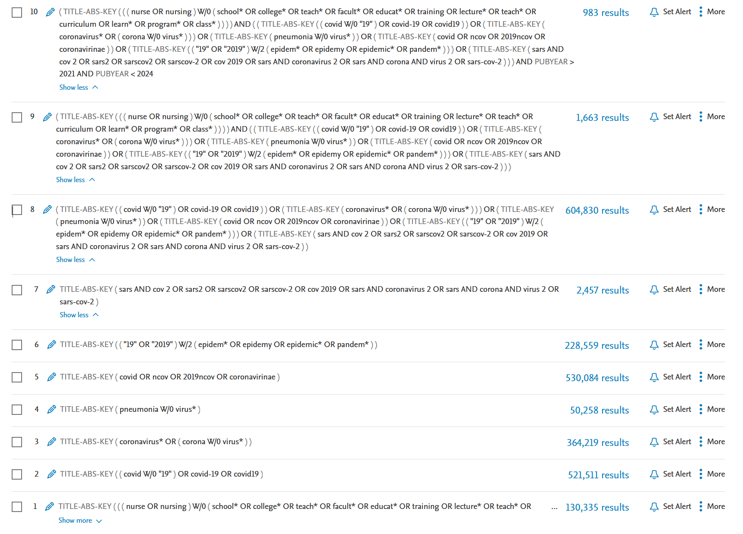

Google Scholar
Date of search: 19th September 2023
Number of hits (before duplication removal): 200
Comments:I’ve only imported the first 200 hits. This is because relevance is usually reduced after the the first 200 hits.
Documentation of search:

- covid|corona|coronavirus (nurse|nursing
school|college|faculty|education|training|lecture|curriculum|programme|class)

