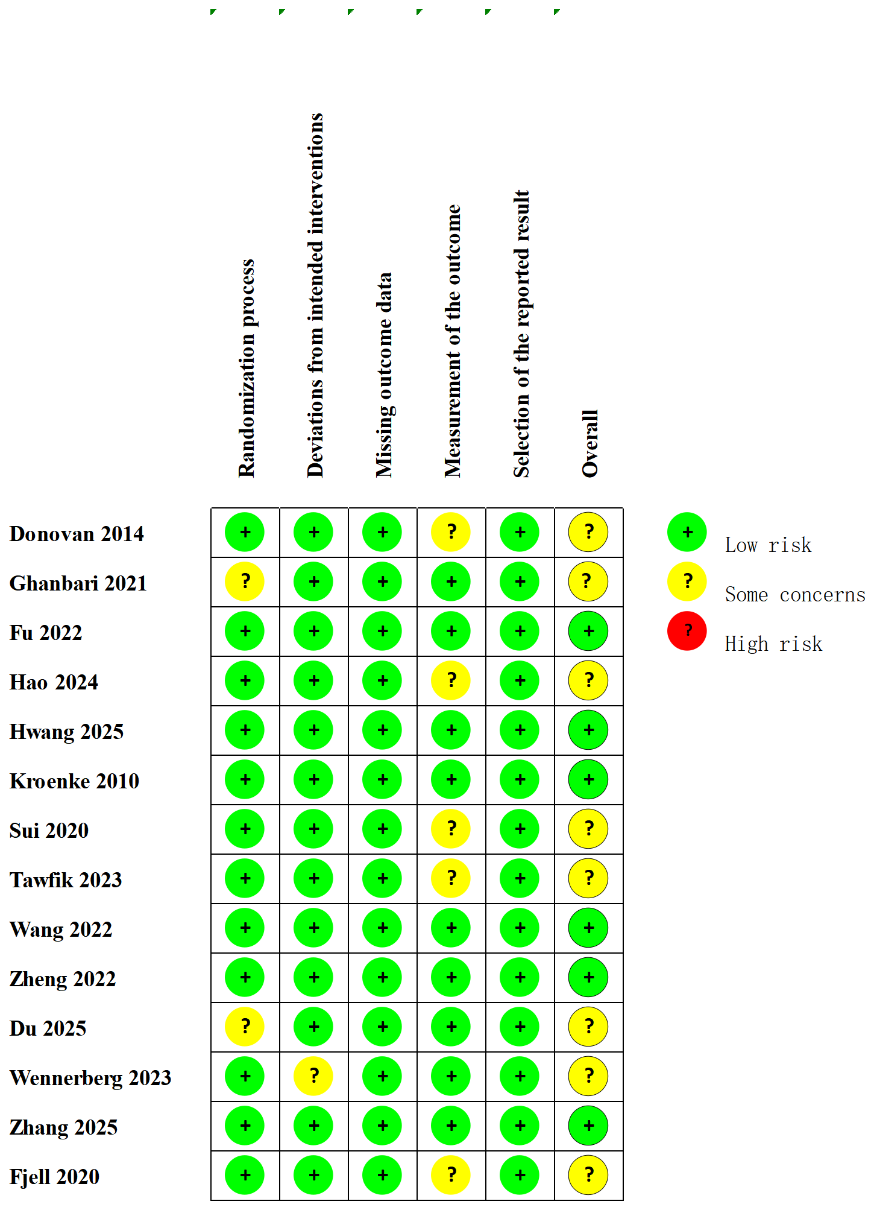

Figure S1. Risk of Bias Summary
Note. Green represents a low risk of bias, yellow a moderate risk, and red a high risk.

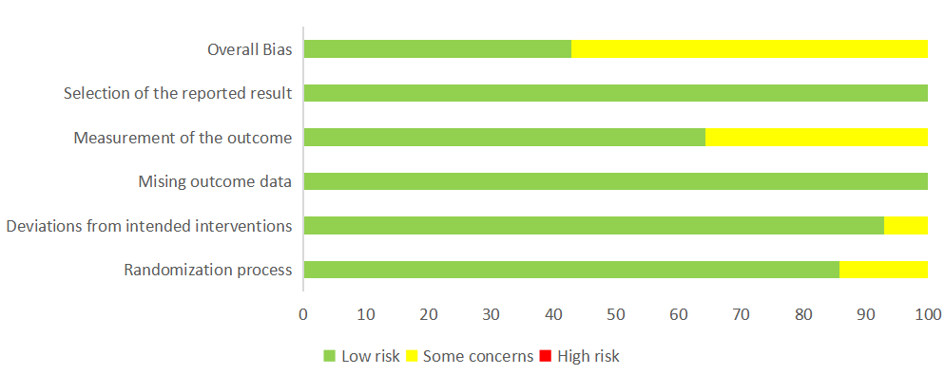
Figure S2. Graphical Representation of the Risk of Bias Summary by Risk Category

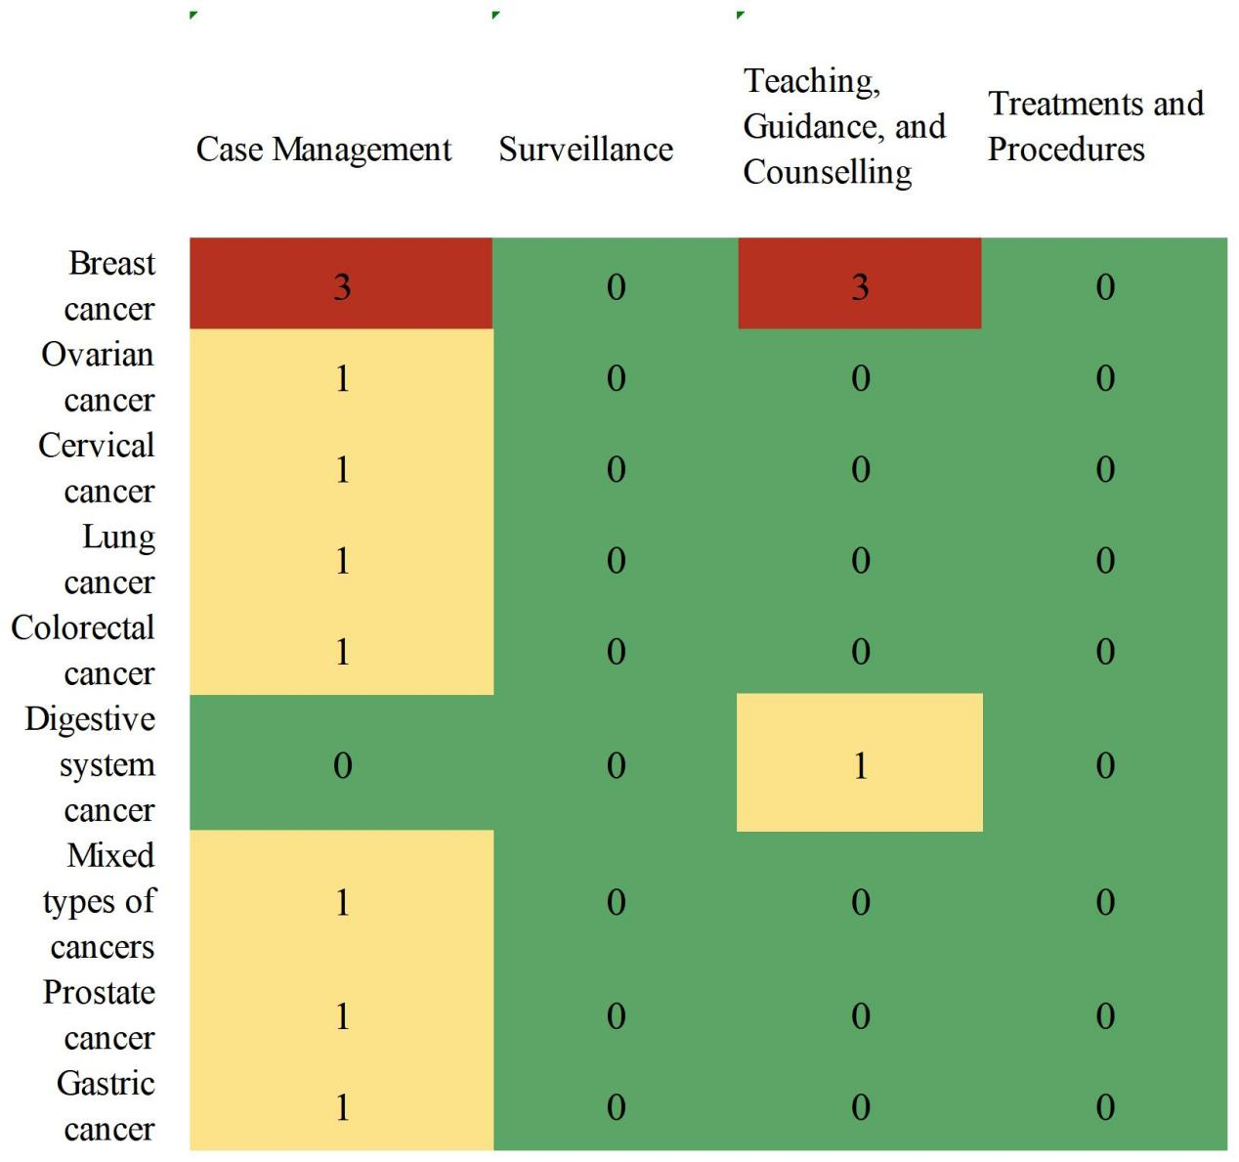
Figure S3. Distribution of the OMAHA Heat Map Categories Across all Included Studies (n=14) by Cancer Type
Note: Values with the highest frequency were assigned a red color, middle values a yellow color and lowest values a green color

